Character Profiles

Choose one interesting main character in the book/story you are reading and take a closer look at his/her personality. Who is he/she really? Look at the different levels of their personalities, starting with the environment (setting) they live in and move in towards their spiritual centers. Draw a circle diagram like the one on this page and write a few keywords or sentences into each layer of the character's personality.
Slip into the character's mind and consider the following questions:

Environment: Where does your character live/work? What is this place like? How does it affect him/her? Who else is there? How do these other people influence him/her? How does your character get along with them?

Behavior: What does your character do? List a few important or typical actions or activities of your character

Capability: What is your character good at? What strategies does he/she use in the story? Does he/she use them openly and consciously? What skills does he/she have?

Beliefs: What are your character’s basic beliefs? Think of the various ideas that he/she thinks are true, and that your character uses as a basis of daily action. Beliefs can be both permissions and limitations. (e.g.: "I am strong! The positive forces will always win!" or "I am afraid of my stronger enemy, he will certainly kill me." or "I don't do this or that because I think it's wrong.)

Identity: What are your character’s core values and his/her mission in life? What does your character want to achieve?

Spiritual: This is the deepest level of any character or person. Here we consider such metaphysical questions as "Why are we here? What is our purpose?" These questions are hardly ever asked or answered openly. Try to slip into your character's mind and answer these questions for him/her. What would he/she say?

Title of Book/Story ......................................................

Author: .......................................................

Character's name: .......................................................

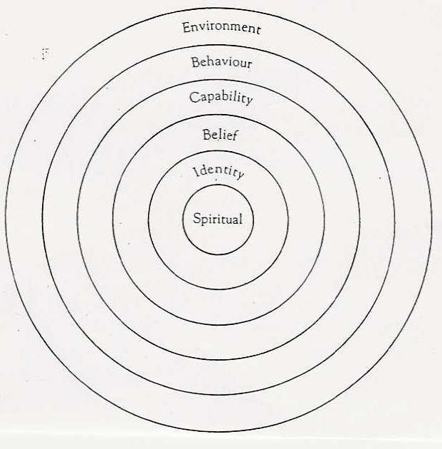

Now do a character profile for one of the main characters in your book:

