Story Pyramid for................................................................................

1.____________________

2._________________________________

3.______________________________________________

4.__________________________________________________________

5._______________________________________________________________________

6.___________________________________________________________________________________

7.___________________________________________________________________________________________

8________________________________________________________________________________________________________

1. The main character's name  2. Two words that describe the main character  3. Three words about the setting (the places)  4. Four words about the main character's problem and goal | 5. Five words about important events in the story  6. Six words about the conclusion (How does it end?)  7. Seven words about your favorite part  8. Eight words: What would you tell your friends about the story?

Story Pie for ........................................................................................................

1. On scrap paper, write down the 10 most important events in your story. Put the main events in the correct order and write them into the story pie below.
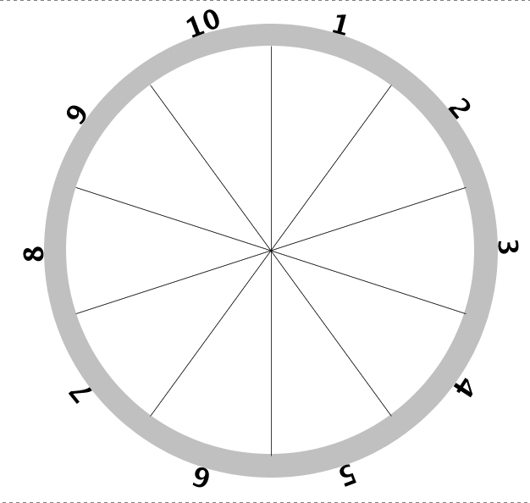
2. Use your story pie to tell the story to your teacher and/or a friend.

Which of the events in your story do you like best?

WHO -WHERE - WHAT -WHY - HOW

WHO? Who is the main character in the story? What do you know about him or her? Write 2-3 sentences.

WHERE does the story play? Describe the place in a few sentences. What do you see in the pictures?

WHAT does the main character want?

WHY does it not work? What is his/her problem?

HOW is the problem solved?

Opinion Page

My favorite part of the story is when…

My favorite picture in this story is on page …………. In this picture I can see …

The happiest moment in the story is when…….

The saddest moment in the story is when ……

