The true story of…

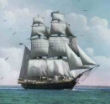
- Listen to the story: Listen to the first chapter of the story ´The sailing ship ´and answer these questions:

- How old is Pocahontas?
- What is the name of Pocahontas´ father?
- What did Pocahontas see in the bay?
- Who smiled at Pocahontas and her brother?
- Who is dangerous for the Indians?
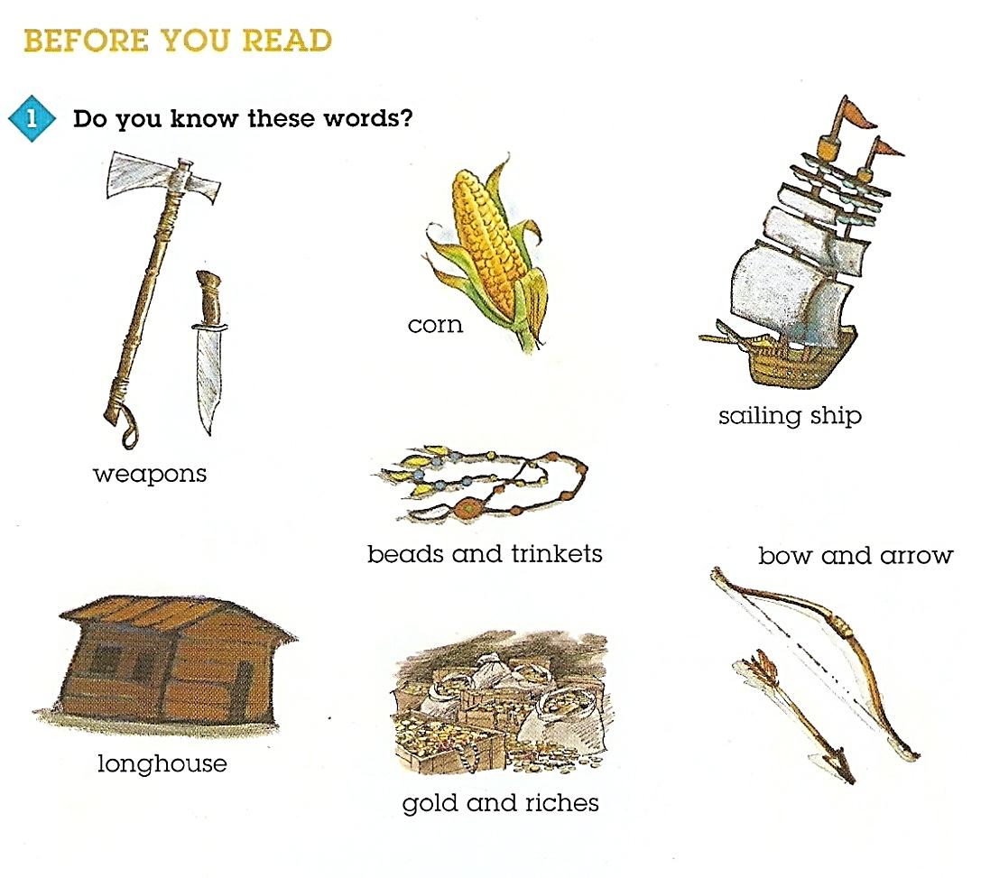

Step 2: Read on…
Read chapter 4 of the story. Work with a partner and read the text slowly and carefully. Underline or highlight the most important information in the text.
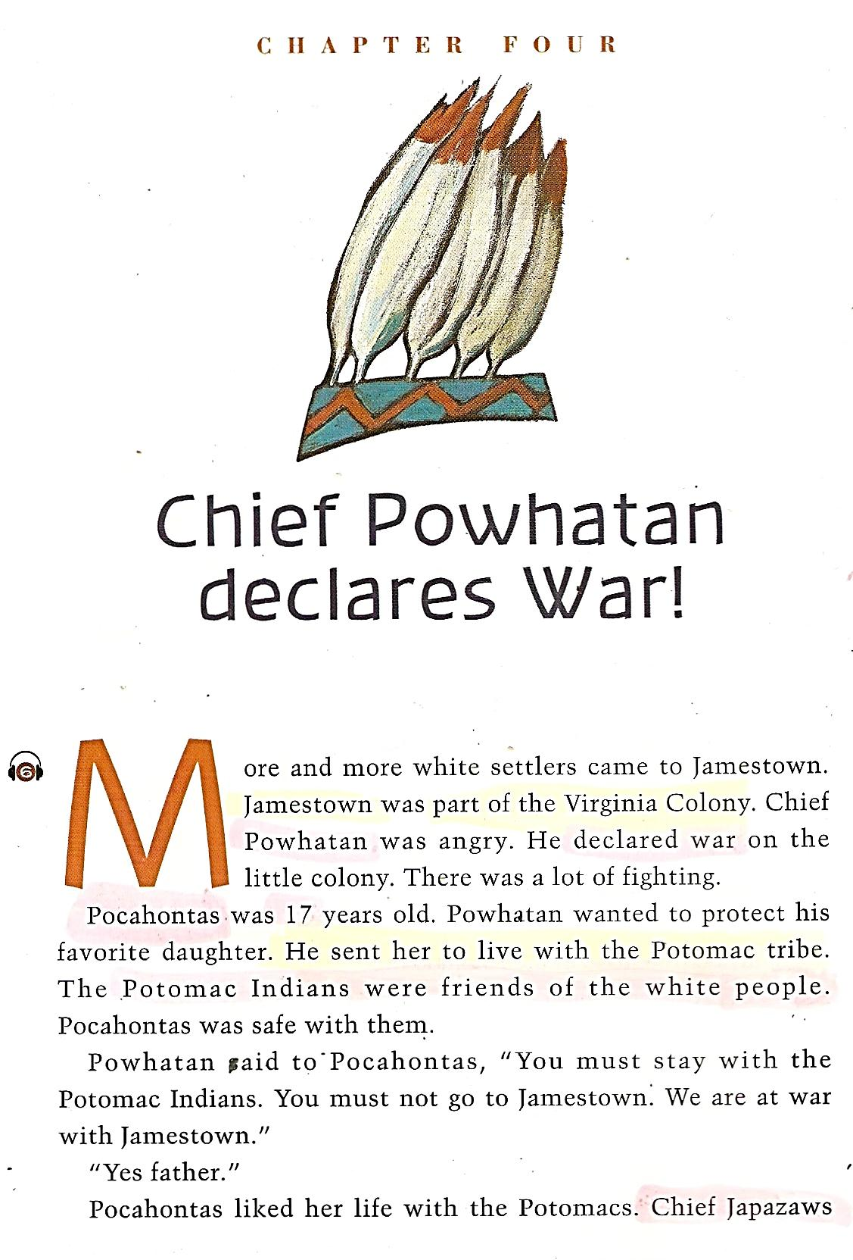
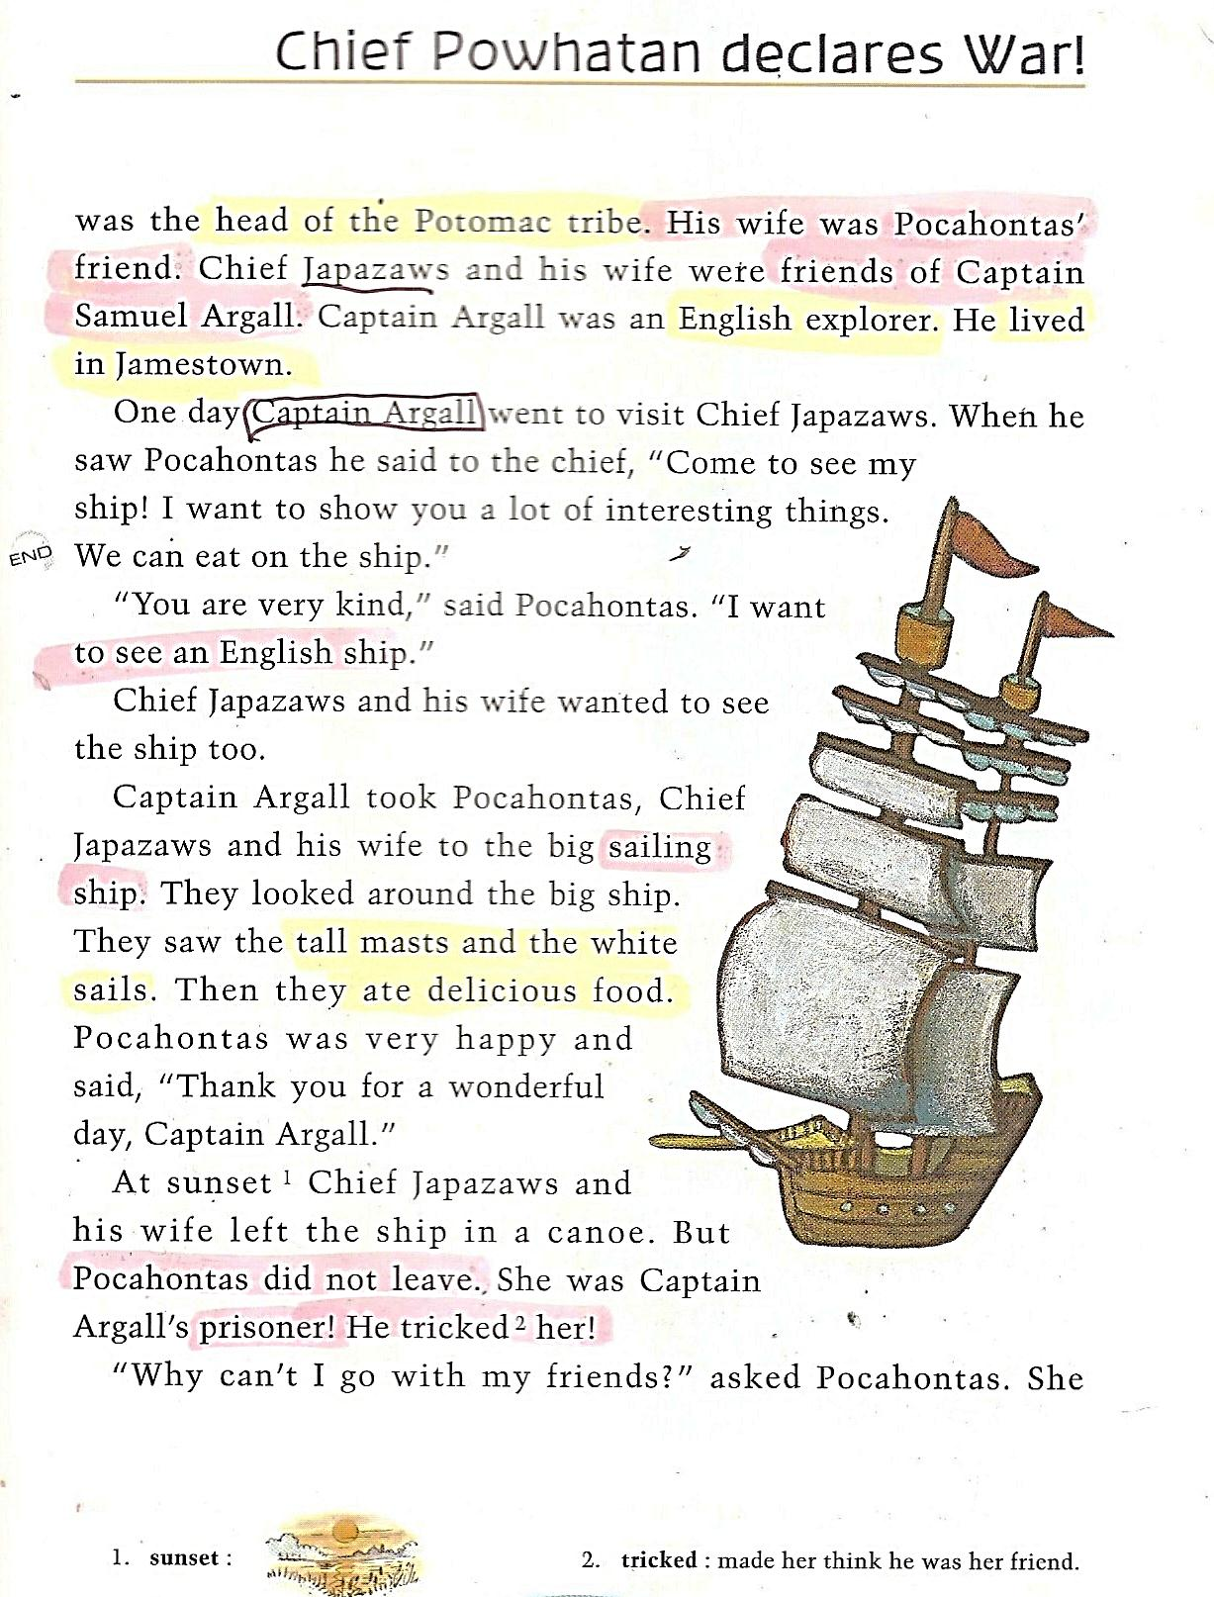

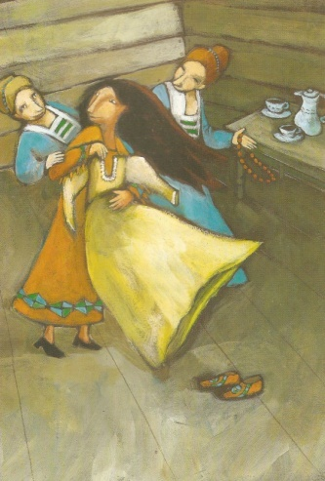
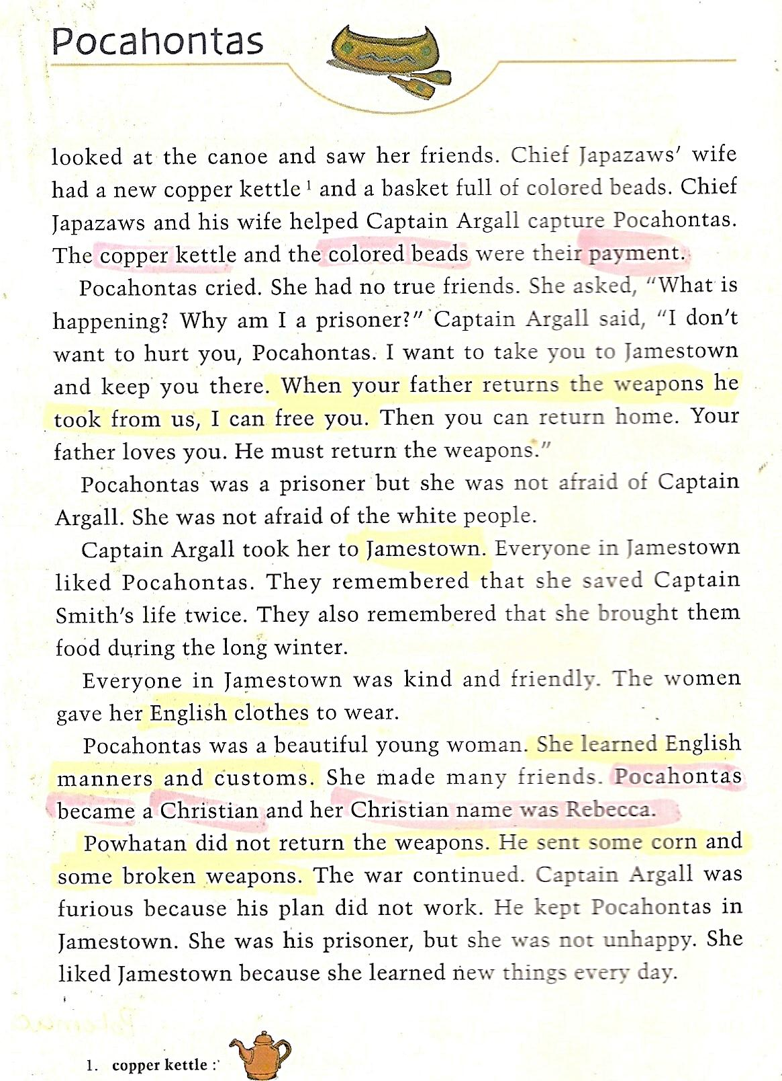
Step 3: Asking Questions
What is the most important information in this part of the story? Ask 5 good questions about it. Your friends will have to answer your questions later, after the story-telling in step 5.

Step 4: Native American Pictograms:
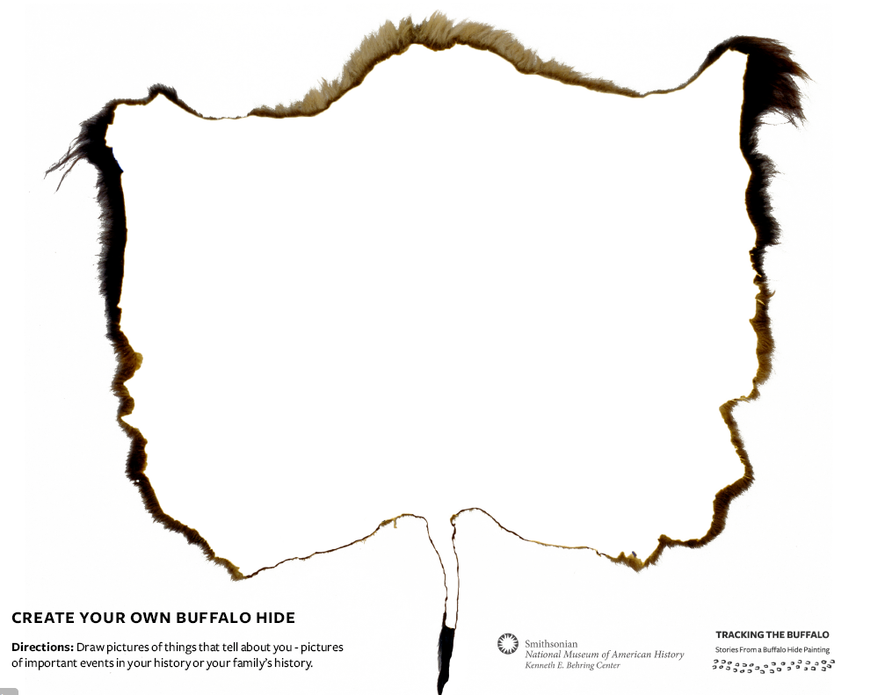
Use the drawing of the Native American buffalo hide and “write” your part of the story using simple pictograms (=sign-language --NO WORDS). Practice telling the story with your partner.

- Draw your story:
- Draw your story on the second sheet of paper. Use the Indian symbols. This sheet should help you to remember your story.

- Now tell your story to your two partners, then ask them your questions
- Tell your story your two partners. You can use your “cheat sheet”.
- Ask them your questions. They should answer your questions.

- Form questions about your story:
- Try to form 5 questions about your story and write them on the first sheet of paper.

Sailing ship:
http://images.search.conduit.com/ImagePreview/?q=Sailing%20ship&ctid=CT2851647&searchsource=10&start=35&pos=5
Tepee:

Step 5: Storytime
Meet with two classmates who have read different parts of the story. Take turns telling each other what you have read. Show your buffalo-hide drawings and make sure your friends understand all the important details of your story.

Picture sources:
http://americanhistory.si.edu/buffalo/files/pdf/buffalo_printOut.pdf

http://images.search.conduit.com/ImagePreview/?q=Tepee&ctid=CT2851647&SearchSource=10&FollowOn=true&PageSource=ImagePreview&SSPV=&start=0&pos=4
Sailing ship: http://images.search.conduit.com/ImagePreview/?q=Sailing%20ship&ctid=CT2851647&searchsource=10&start=35&pos=5
Tepee: http://images.search.conduit.com/ImagePreview/?q=Tepee&ctid=CT2851647&SearchSource=10&FollowOn=true&PageSource=ImagePreview&SSPV=&start=0&pos=4

