Greyfriars Bobby

1. Guess the story

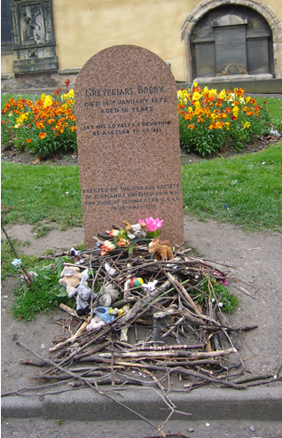
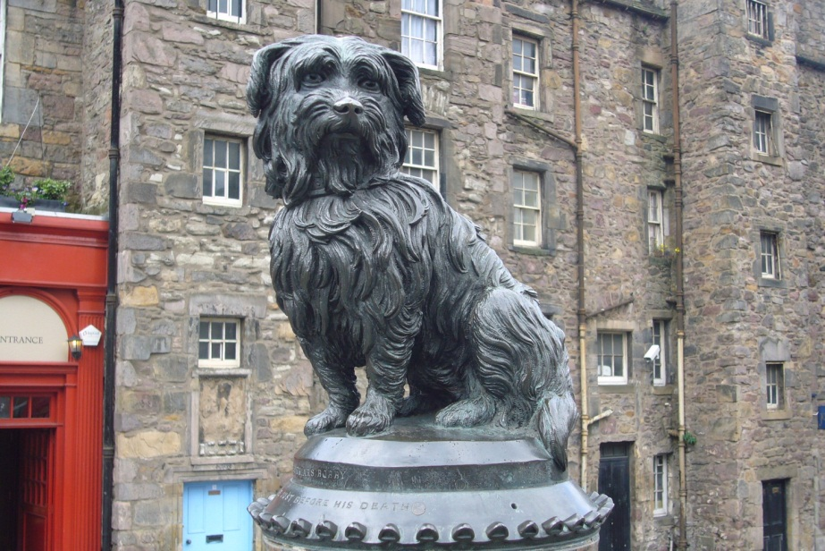
GUESS…

Who was Bobby?

Where did he live?

What happened?

Why did they build a statue of Bobby?

Now listen to Bobby’s story.

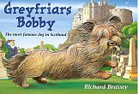
2. Correct the mistakes

Somebody hasn’t been listening carefully here.

Read the story of Greyfriars Bobby

and correct the mistakes.

Greyfriars Bobby is the most famous dog who ever lived in America. He was so famous that a statue was put up to him in New York. We know that Bobby belonged to an Edinburgh teacher named John Gray. He was a Skye Terrier and his job was to help catch thieves. Bobby was very bad at that.

But one bitterly cold summer day John Gray fell ill with a terrible fever. Bobby snuggled close to him to keep him warm. He stayed beside his master even when John Gray died.
He followed the funeral procession to Greyfriars churchyard.

After the funeral Bobby stayed at his master’s house. He stood there and howled. He was very happy. The days came and went, and still Bobby did not leave his master’s house.

Dogs were not allowed in the churchyard, but James Brown, the grave-digger felt sorry for Bobby and let him stay. On cold nights he even invited him into his house and gave him some food.

When spring came, Bobby chased away all the birds in the churchyard. Mr. Brown was pleased, he didn’t like the birds in the churchyard.

Bobby soon made lots of friends. Many people brought him books and pencils. The waiters of the restaurants nearby gave him leftovers to eat. Lonely old ladies sang to him when they came to the graveyard.

Bobby became very famous. The story of the happy and faithful dog was reported in all the newspapers. Soon the churchyard was crowded with sightseers, painters and photographers. Now there is even a bronze statue of Bobby outside Greyfriars churchyard and an Walt Disney made a song about him.

Bobby spent fourteen years close to his master’s grave. When he died, he was buried in a flowerpot in front of Greyfriars church. A hundred years later, a stone was put up to mark the spot. You can go to Greyfriars churchyard and see John Gray’s and Bobby’s graves.

3. Telling stories in the past

Reread the story summary of Greyfriars Bobby and highlight all the verbs (Zeitwörter, Tunwörter) in the past. Look at them carefully.
Some of the verbs have a regular past tense form (regelmäßig).
Write them here:

CHALLENGE: Find a rule: How do you build the past tense form of a verb?

Some of the words have an irregular past tense form (unregelmäßig).
Write them here: 

4. Past tense forms: Find the past tense forms in the text and write them into column two.
Base form (present) | Past tense form
to be (Bobby is famous)
to be (The nights are cold.)
he lives in Scotland
We know
he belongs to
he falls ill
he snuggles close to his master
he stays with his master
he stands there and waits
he howls unhappily
he comes back
I go
I do / he does
he invites him into the house
they give him food
he chases the cats away
he makes friends
They bring him food
I sing a song
He becomes famous
They make a film
He spends a lot of time there.

5. Sum up Bobby’s story in this story pie. Write in pencil or use an erasable pen. Show your page to your teacher.

Then cut out the circle and glue it into your reading diary. Design a nice page for the story “Greyfriars Bobby”.

What else can you write about?

