Year 1: The Snagglegrollop
Teacher's Notes:

Prereading: Orally talk about the following topics.

- Do you have a pet?
- Would you like to have a pet if your parents allowed it?

Read page 1
- What other arguments do parents have against pets? (collect on board)
Read pages 2-5 stop before showing them the snagglegrollop

- Picture dictation: teacher describes the snagglegrollop, students draw the creature
- (Start with legs - like a Hippo's, add 3 toes or claws, blue warts, pear-shaped, fat, furry body, head like an elefant's, trunk, tusks, but long thin ears, curled horns....)
- Then show page 6 and kids compare their drawings with the original.
Read pages 7-9
- Collect all kinds of pet food on board
Read up to p. 17 but do not show the quibblesnuff
- Do coloring activity and group finding activity as described on the following page (Print out the coloring sheets in reduced size -- I usually print 4 pages per sheet -- that is big enough.
Read rest of story.

Follow up and Homework: My fantasy pet

Design your own fantasy animal. Use two sheets. On one sheet you draw your animal. On the other sheet write a detailed description of your fantasy pet.
Your description must include
- the animal's name
- what your animal looks like
- what your animal eats
- pet care information (what does the owner have to do regularly)
- other information (what your animal likes doing, doesn't like or is afraid of...)
Do not write your name on these sheets -- we need them for a guessing game.

........................................................................................................................

In the next lesson prepare a clothesline and ask the students to pin their texts to the line (bring enough clothespegs!)
Collect the drawings at the beginning of the lesson.
Hand out the shuffled drawings to the learners and ask them to find the matching text on the clothesline.
When they have found the perfect match they pin the drawing on top of the text and return to their seats.

The Quibblesnuff
1. Color the Quibblesnuff according to the info at the bottom of your sheet.
2. Cover your sheet or fold it in two. DO NOT SHOW IT to anybody. Walk around and find your Quibblesnuff's family. They will be colored just like your Quibblesnuff.
LANGUAGE TIPS.: You can ask questions like these:
What color is your quibblesnuff's body?
What color are your quibblesnuff's eyes/ears/wings/...
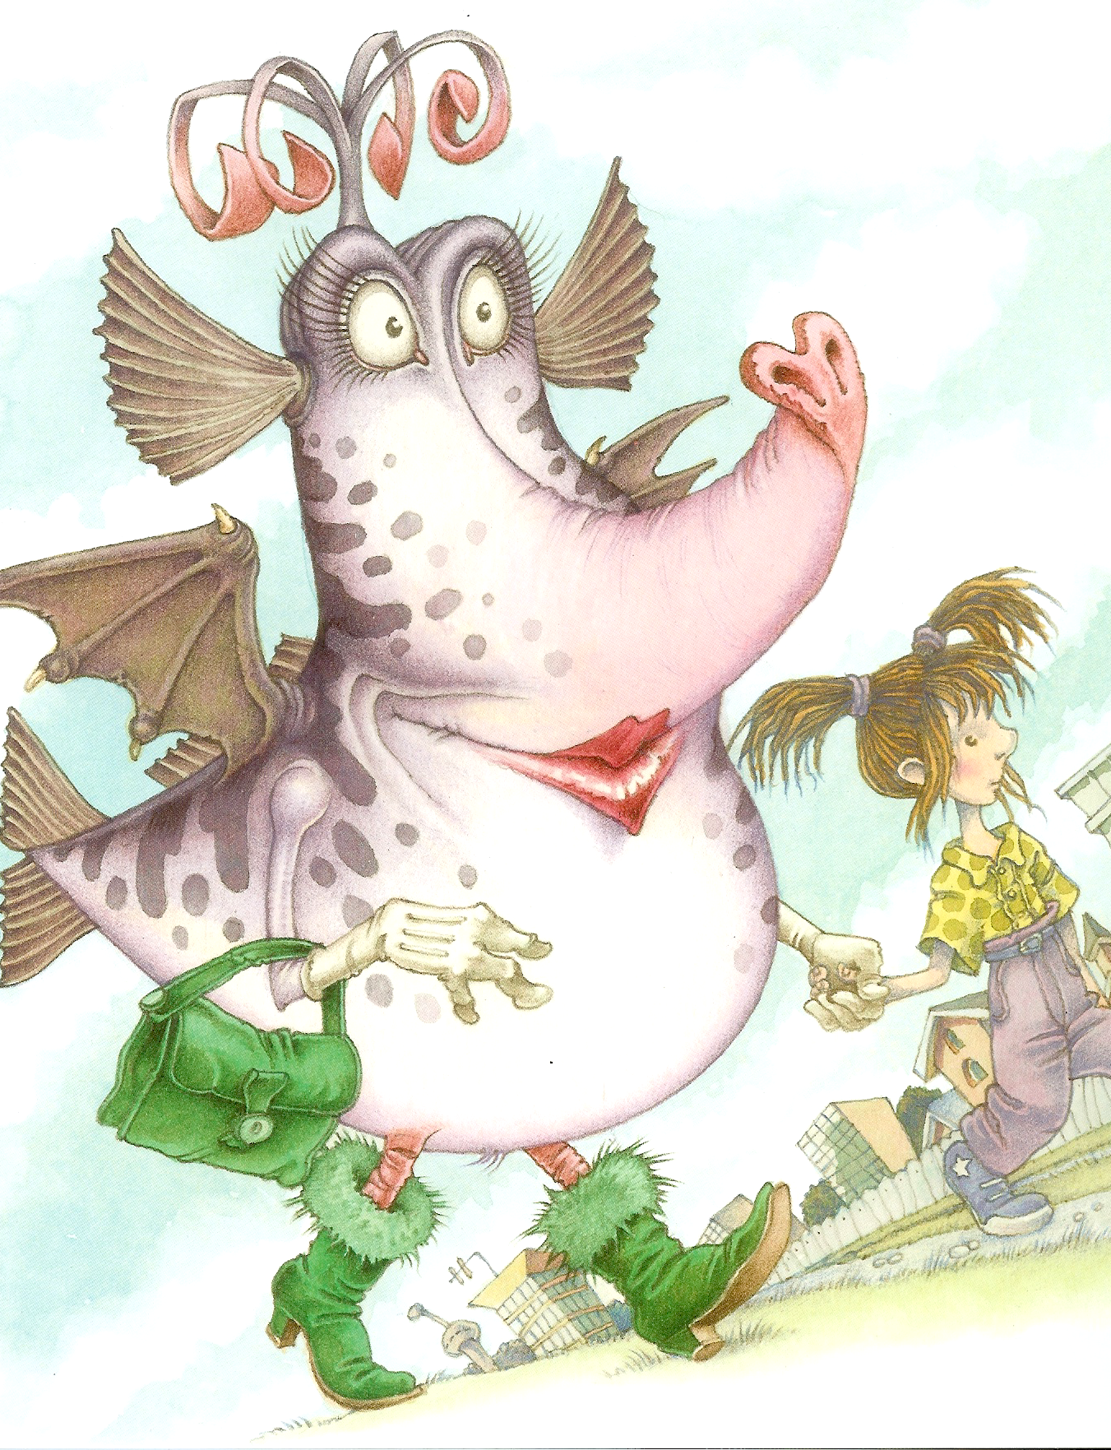
Your quibblesnuff's body is light blue. Your quibblesnuff's lips are bright red. and the tip of her trunk is also red. Her eyes are orange. Your quibblesnuff's wings are pink and her ears are green. Your quibblesnuff's hands and fingers are purple. The curls on top of her head are black. She is wearing a yellow handbag and gray boots with a bit of pink fur on top.

The Quibblesnuff
1. Color the Quibblesnuff according to the info at the bottom of your sheet.
2. Cover your sheet or fold it in two. DO NOT SHOW IT to anybody. Walk around and find your Quibblesnuff's family. They will be colored just like your Quibblesnuff.
LANGUAGE TIPS.: You can ask questions like these:
What color is your quibblesnuff's body?
What color are your quibblesnuff's eyes/ears/wings/...

Your quibblesnuff's body is light green. Your quibblesnuff's lips are bright red. and the tip of her trunk is also red. Her eyes are orange. Your quibblesnuff's wings are blue and her ears are pink. Your quibblesnuff's hands and fingers are purple. The curls on top of her head are black. She is wearing a yellow handbag and gray boots with a bit of pink fur on top.

The Quibblesnuff
1. Color the Quibblesnuff according to the info at the bottom of your sheet.
2. Cover your sheet or fold it in two. DO NOT SHOW IT to anybody. Walk around and find your Quibblesnuff's family. They will be colored just like your Quibblesnuff.
LANGUAGE TIPS.: You can ask questions like these:
What color is your quibblesnuff's body?
What color are your quibblesnuff's eyes/ears/wings/...
Your quibblesnuff's body is light blue. Your quibblesnuff's lips are bright red. and the tip of her trunk is also red. Her eyes are blue. Your quibblesnuff's wings are orange and her ears are green. Your quibblesnuff's hands and fingers are purple. The curls on top of her head are black. She is wearing a yellow handbag and gray boots with a bit of pink fur on top.
The Quibblesnuff
1. Color the Quibblesnuff according to the info at the bottom of your sheet.
2. Cover your sheet or fold it in two. DO NOT SHOW IT to anybody. Walk around and find your Quibblesnuff's family. They will be colored just like your Quibblesnuff.
LANGUAGE TIPS.: You can ask questions like these:
What color is your quibblesnuff's body?
What color are your quibblesnuff's eyes/ears/wings/...

Your quibblesnuff's body is light green. Your quibblesnuff's lips are bright red. and the tip of her trunk is also red. Her eyes are pink. Your quibblesnuff's wings are blue and her ears are green. Your quibblesnuff's hands and fingers are purple. The curls on top of her head are black. She is wearing a yellow handbag and gray boots with a bit of pink fur on top.

