Year 1: The Snagglegrollop
Teacher's Notes:

Prereading: Orally talk about the following topics.

- Do you have a pet?
- Would you like to have a pet if your parents allowed it?

Read page 1
- What other arguments do parents have against pets? (collect on board)
Read pages 2-5 stop before showing them the snagglegrollop

- Picture dictation (to practice body parts): teacher describes the snagglegrollop, students draw the creature
- (Start with legs - like a Hippo's, add 3 toes or claws, blue warts, pear-shaped, fat, furry body, head like an elefant's, trunk, tusks, but long thin ears, curled horns....)
- Then show page 6 and kids compare their drawings with the original.
Read pages 7-9
- Collect all kinds of pet food on board

Read up to p. 17 but do not show the quibblesnuff (to practice body parts and possessive s)
- Do coloring activity and group finding activity as described on the following page (Print out the coloring sheets in reduced size -- I usually print 4 pages per sheet -- that is big enough.
Read rest of story.

Follow up and/or homework: My fantasy pet

Design your own fantasy animal. Use two sheets. On one sheet you draw your animal. On the other sheet write a detailed description of your fantasy pet.
Students who need more guidance can use the form: “What you need to know about …”
Your description must include
- the animal's name
- what your animal looks like
- what your animal eats
- pet care information (what does the owner have to do regularly)
- other information (what your animal likes doing, doesn't like or is afraid of...)
Do not write your name on these sheets -- we need them for a guessing game.

........................................................................................................................

In the next lesson prepare a clothesline and ask the students to pin their texts to the line (bring enough clothespegs!)
Collect the drawings at the beginning of the lesson.
Hand out the shuffled drawings to the learners and ask them to find the matching text on the clothesline.
When they have found the perfect match they pin the drawing on top of the text and return to their seats.

The Quibblesnuff
1. Color the Quibblesnuff according to the info at the bottom of your sheet.
2. Cover your sheet or fold it in two. DO NOT SHOW IT to anybody. Walk around and find your Quibblesnuff's family. They will be colored just like your Quibblesnuff.
LANGUAGE TIPS.: You can ask questions like these:
What color is your quibblesnuff's body?
What color are your quibblesnuff's eyes/ears/wings/...
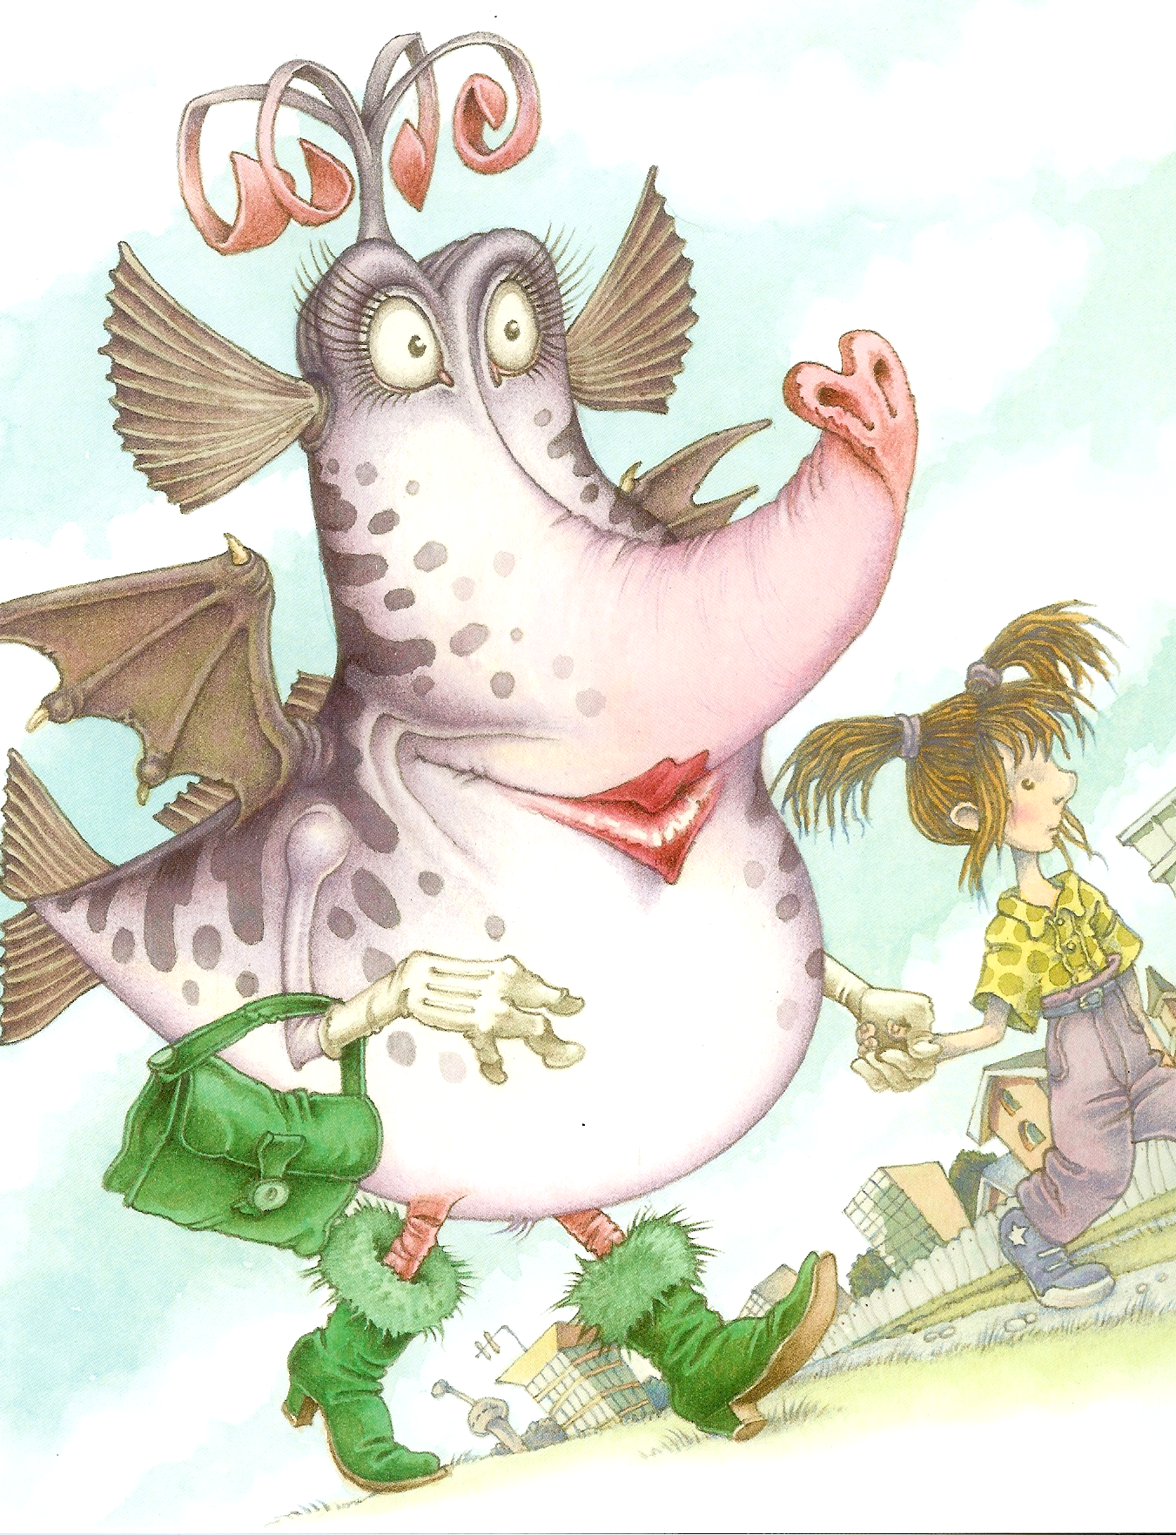
Your quibblesnuff's body is light blue. Your quibblesnuff's lips are bright red. and the tip of her trunk is also red. Her eyes are orange. Your quibblesnuff's wings are pink and her ears are green. Your quibblesnuff's hands and fingers are purple. The curles on top of her head are black. She is wearing a yellow handbag and gray boots with a bit of pink fur on top.

The Quibblesnuff
1. Color the Quibblesnuff according to the info at the bottom of your sheet.
2. Cover your sheet or fold it in two. DO NOT SHOW IT to anybody. Walk around and find your Quibblesnuff's family. They will be colored just like your Quibblesnuff.
LANGUAGE TIPS.: You can ask questions like these:
What color is your quibblesnuff's body?
What color are your quibblesnuff's eyes/ears/wings/...

Your quibblesnuff's body is light green. Your quibblesnuff's lips are bright red. and the tip of her trunk is also red. Her eyes are orange. Your quibblesnuff's wings are blue and her ears are pink. Your quibblesnuff's hands and fingers are purple. The curles on top of her head are black. She is wearing a yellow handbag and gray boots with a bit of pink fur on top.

The Quibblesnuff
1. Color the Quibblesnuff according to the info at the bottom of your sheet.
2. Cover your sheet or fold it in two. DO NOT SHOW IT to anybody. Walk around and find your Quibblesnuff's family. They will be colored just like your Quibblesnuff.
LANGUAGE TIPS.: You can ask questions like these:
What color is your quibblesnuff's body?
What color are your quibblesnuff's eyes/ears/wings/...
Your quibblesnuff's body is light blue. Your quibblesnuff's lips are bright red. and the tip of her trunk is also red. Her eyes are blue. Your quibblesnuff's wings are orange and her ears are green. Your quibblesnuff's hands and fingers are purple. The curles on top of her head are black. She is wearing a yellow handbag and gray boots with a bit of pink fur on top.

The Quibblesnuff
1. Color the Quibblesnuff according to the info at the bottom of your sheet.
2. Cover your sheet or fold it in two. DO NOT SHOW IT to anybody. Walk around and find your Quibblesnuff's family. They will be colored just like your Quibblesnuff.
LANGUAGE TIPS.: You can ask questions like these:
What color is your quibblesnuff's body?
What color are your quibblesnuff's eyes/ears/wings/...

Your quibblesnuff's body is light green. Your quibblesnuff's lips are bright red. and the tip of her trunk is also red. Her eyes are pink. Your quibblesnuff's wings are blue and her ears are green. Your quibblesnuff's hands and fingers are purple. The curles on top of her head are black. She is wearing a yellow handbag and gray boots with a bit of pink fur on top.

Pet Info
What you need to know about horsotigopigchicks.

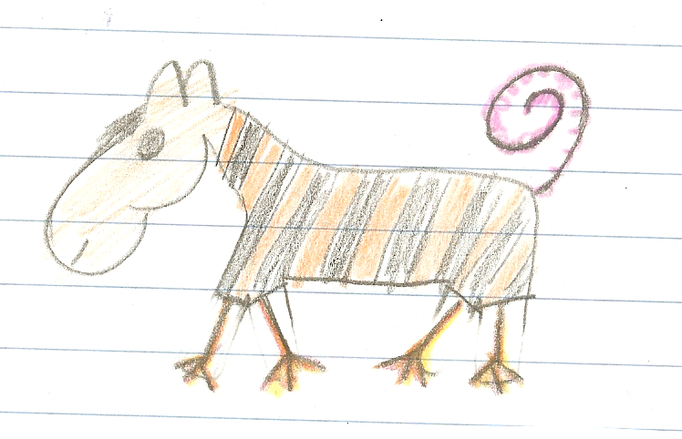
Looks:
Horsotigopigchicks are really great pets.

These animals have the head of a horse, the body of a tiger, the tail of a pig and the legs of a chicken.
They have short hair and a short black mane. The tails of the horsotigopigchick is pink and very thin. It does not have any hair. Horsotigopigchicks are the size of a dog and they weigh about 15 to 20 kilograms.
Home:
Hortotigopigchicks can live in the house or they can live outside in the garden. They need a doghouse to keep them warm and to spend the night.
In the winter, when it is very cold you should keep them inside during the night.

How do they move?

Horsotigopigchicks can walk. They do not run very fast because their legs are short and weak. This is great, because they do not need a big garden.

.

What do they eat?
Horsotigopigchicks eat almost everything. Their favorite foods are spaghetti, pizza, bread and sweets. They also like fruits and they eat grass and leaves in the garden. The only thing these animals do not like is hot and spicy food like pepperoni or chili.

Other information:
Hortotigopigchicks are very shy animals. They get along well with children, but they are scared of loud noise and big dogs. You can take them for short walks in the streets, but you have to walk slowly and you need to keep them on a leash.

Now it’s your turn to describe your animal in detail. Design a pet-info page like this one. The words and ideas on the next page will help you.

Useful words and ideas to describe your animal:

The animal’s name
Make up a new name for your animal. For example:
a mousodogobird has the head of a mouse, the body of a dog and it has wings like a bird.

What body parts?
giraffes have long, thin legs, monkeys have strong arms, birds have wings, a giraffe has a very long neck, a hippo has a big head, mice have small ears, eyes, squirrels have a bushy tail, pigs have a fat body, monkeys have fingers and toes, cats have claws, fish have fins, lions have a mane, dogs have strong teeth.

What is its skin and hair like?
a rabbit has a soft, fluffy fur, soft fur, smooth skin, dragons and fish have scales, an elephant has a thick skin, some dogs have long hair, others have short hair, horses and lions have a mane

How does it move?
cats can walk and climb on trees, frogs jump, birds fly, mice run very fast, ants and caterpillars crawl, fish swim,

What does it eat?
horses eat grass, cats eat meat, some insects drink blood, pigs eat everything (they are omnivores – Allesfresser), sheep eat grass and leaves, (they are herbivores –Pflanzenfresser)

Home:
Does your animal need a cage? Does it live outside? Does it need a dog house or a big stable?
Can it live in your room?
Do you have to walk it on a leash?

Is it a good family pet?
Does it like children? Is it dangerous? Does it bite?
Do you need a leash to walk it outside? Does it sleep during the day or at night? Does it need any toys to be happy?
How does your animal get along with other animals? Does it fight? Does it like other animals.
What is it afraid of?

