Bookchoosing cards for the Refugee Reading Project

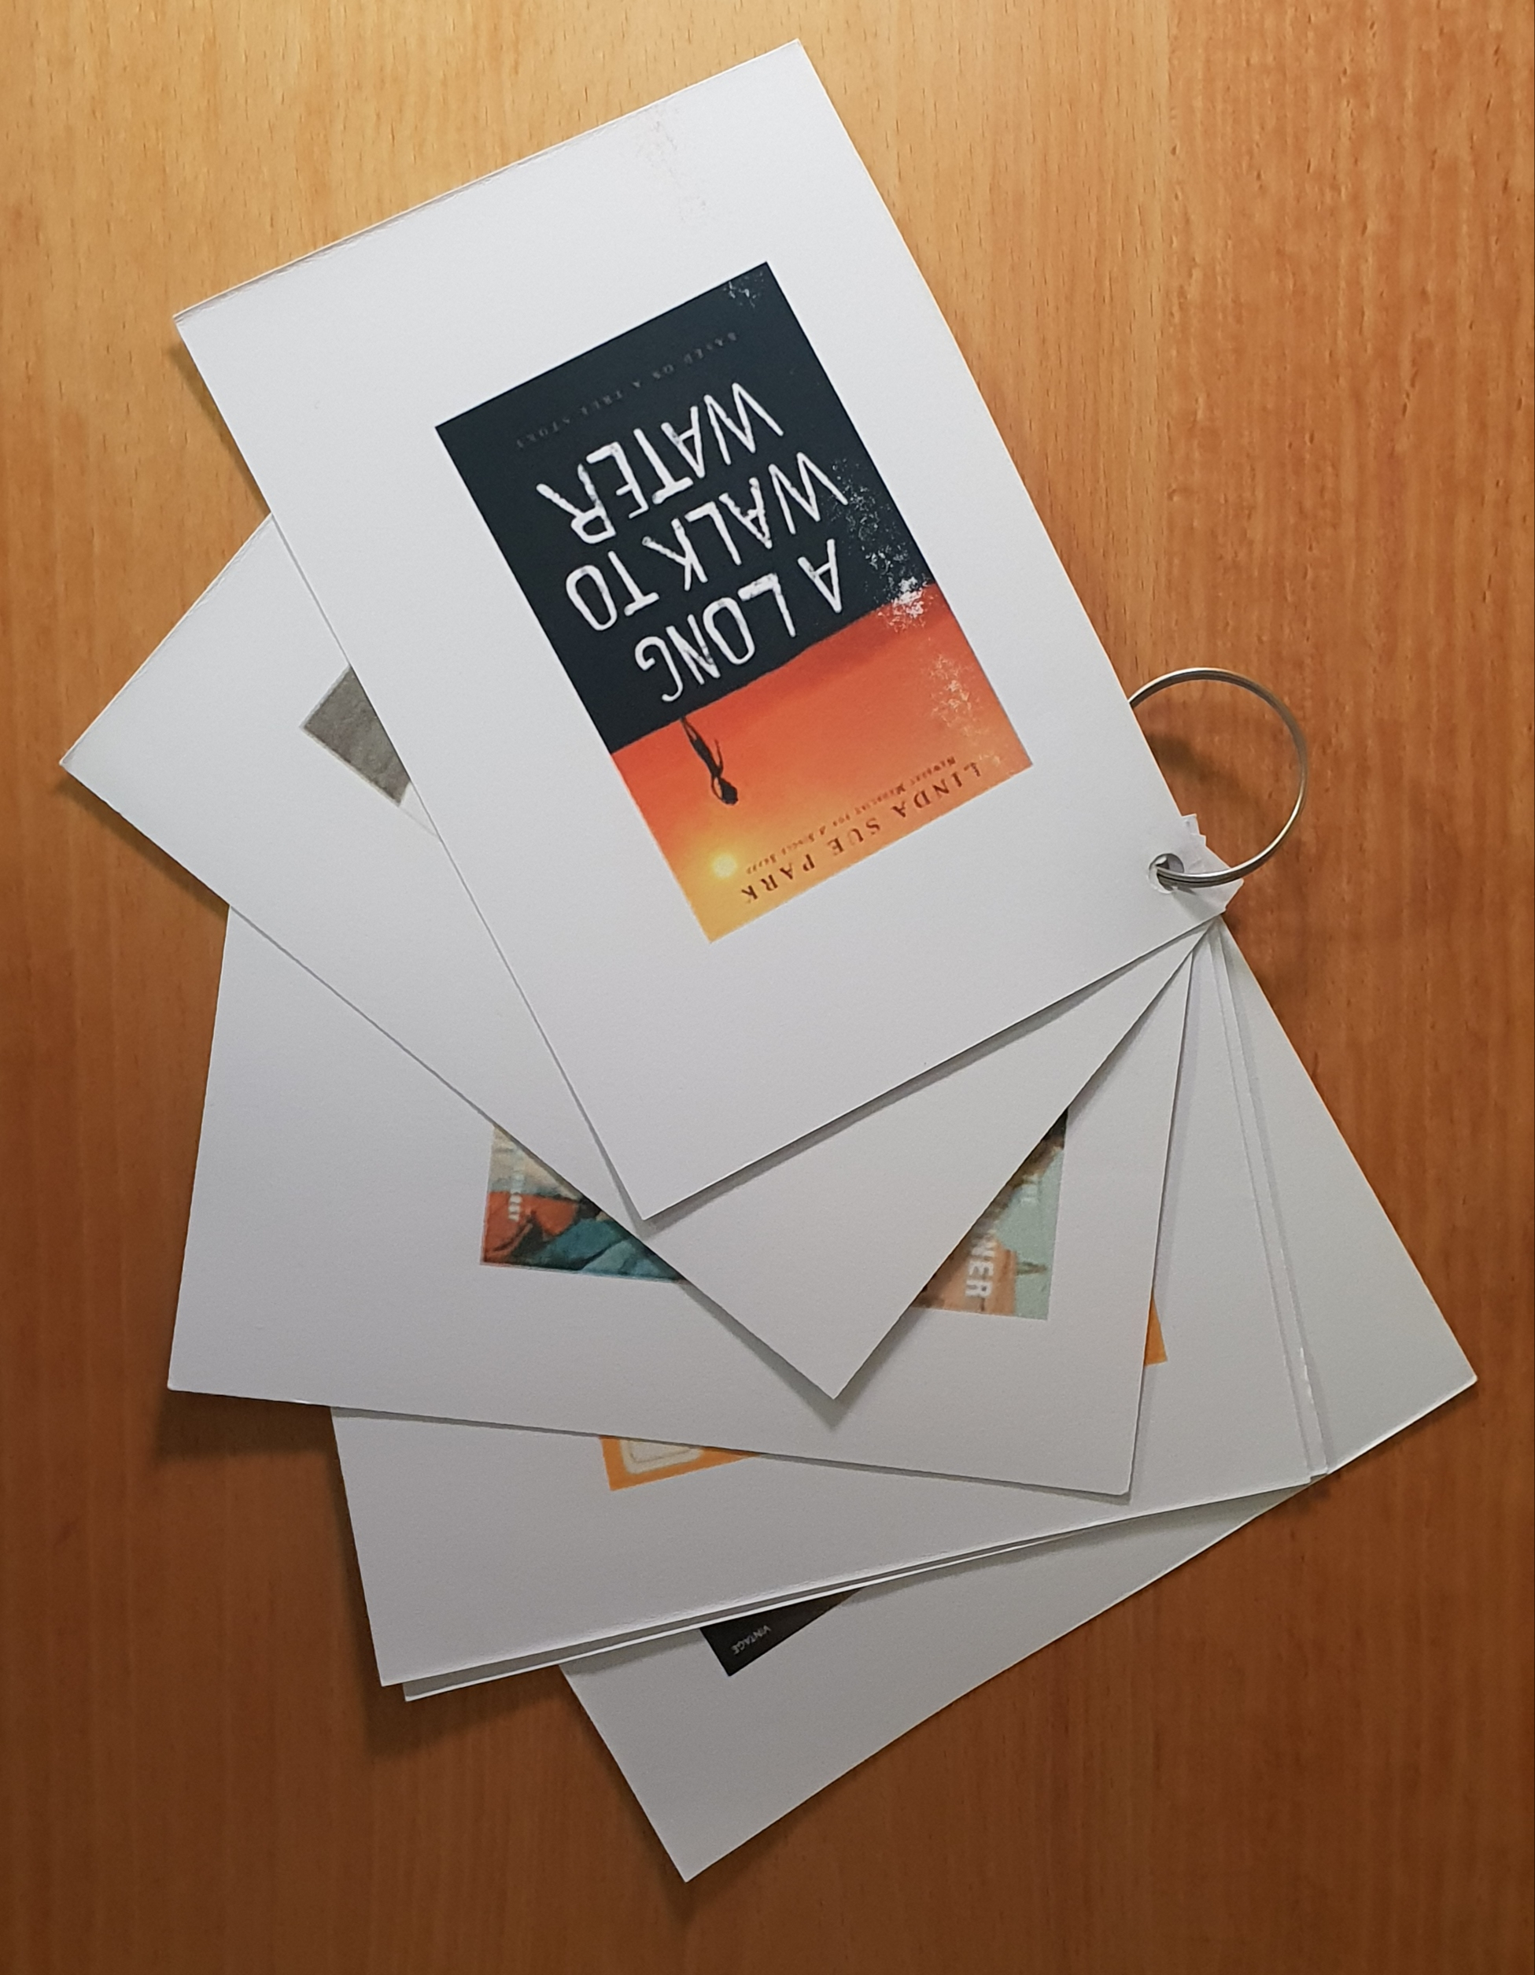

Each students gets 6 postcard-size book-choosing cards. In order to print these cards in the right format follow these instructions:

Print pages 2 to 15 .

Print 4 pages on 1 (A4)

Print double sided.

Bring a copy of each of the novels to class and make photocopies of the first few pages of each book, so all the students can get an idea what the books are about.
Alternative idea: Ask the kids to read the first few pages on Amazon. Most books have the “open book” option where you can read the first few pages online.
The students read the first 3 pages of each book and fill out their cards. Then they decide which of the books they would like to read.

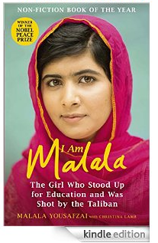

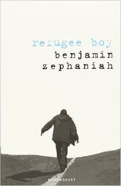

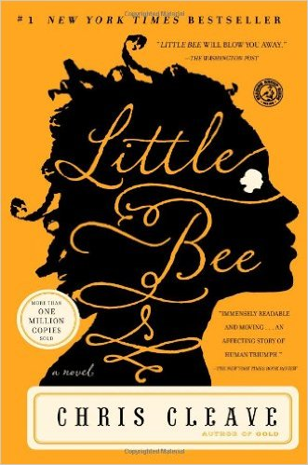

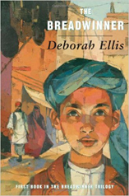

Finding out about the book:

Setting: Where and when…
Main character and his/her problem
Dangers and obstacles
Wishes and hopes
Interest factor 

Finding out about the book:

Setting: Where and when…
Main character and his/her problem
Dangers and obstacles
Wishes and hopes
Interest factor

Finding out about the book:

Setting: Where and when…
Main character and his/her problem
Dangers and obstacles
Wishes and hopes
Interest factor

Finding out about the book:

Setting: Where and when…
Main character and his/her problem
Dangers and obstacles
Wishes and hopes
Interest factor

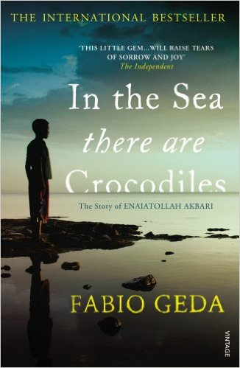

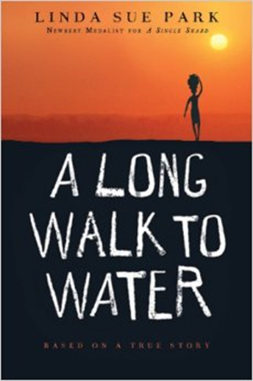

Finding out about the book:

Setting: Where and when…
Main character and his/her problem
Dangers and obstacles
Wishes and hopes
Interest factor

Finding out about the book:

Setting: Where and when…
Main character and his/her problem
Dangers and obstacles
Wishes and hopes
Interest factor

