The Body of Christopher Creed, by Carol Plum-Ucci
- Secretly think of a student in our school who is often an outsider, whom you don’t particularly like or have teased...
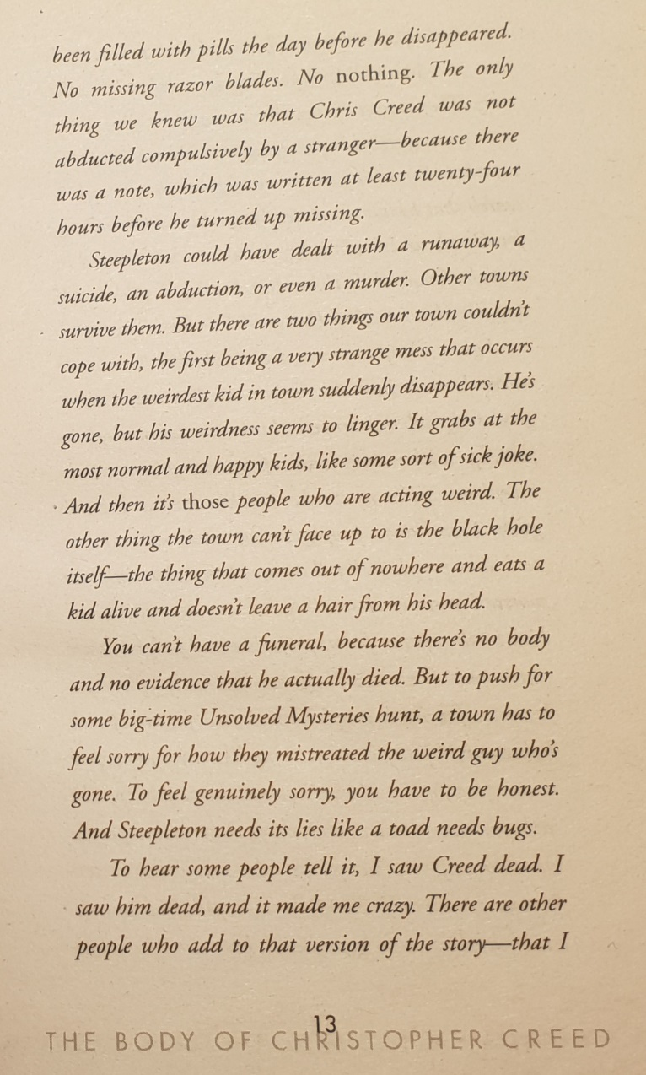
- Imagine that student has suddenly disappeared, and nobody knows whether he or she has run away or has been the victim of a crime or accident or whether this student has even committed suicide.
- Read the following extract from the novel.
- What is all this about?
