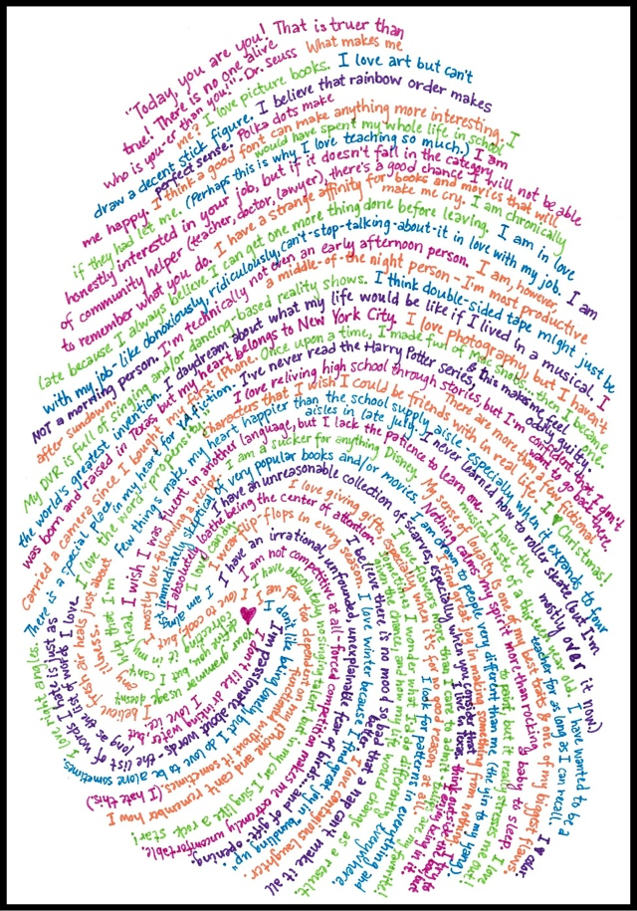
http://julieballew.com/blog/?p=36

