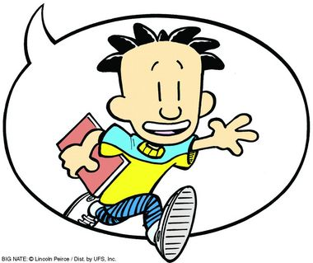
Big Nate
In a class by Himself
Reading Project
Do all of the tasks in your reading diary at least 5 pages

Design your own page of greatness
- Use page 8 for ideas – your entry can include pictures and explanations
- Include some examples using the present perfect for general experience
Ex: I have won many soccer tournaments. Remember - if you talk about specific events in the past use the past simple. EX: Last week I won a soccer tournament.
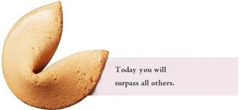
Design your own fortune cookies
- Come up with different fortunes. Use page 66 for ideas.

Design a Poetry Page
- As it says on page 96 “you may write any kind of poem you like”. Nate has written some examples on page 95 – a limerick, a Haiku, and an ode to a cheez doodle – can you work out the structures of these poems? If you need some help ask your teacher.

Research a world record and write a page about it
- Nate tries to break a world record in chapter 8, but it backfires! Do you think there is a world record you could break? Use the internet or a book of world records to help you with your research.

What would you do to make Mr. Galvin Laugh?
- In chapter 11 Nate sets out to make Mr. Galvin laugh, but fails miserable. Design a page with your own ideas to make him laugh.

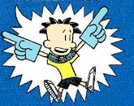
Big Nate
Strikes Again
Reading project
DO all of the tasks in your reading diary
At least 5 pages

Design your own SPOFF PAge
- On page 49-50 Nate describes his spoff history. Create your own spoff and include the rules, team size, scoring, your team name, and what the trophy looks like.
Write a fun fact page about a historical figure
- Choose a historical figure you are interested in and do internet research to find out about them. Then create a page of fun facts about this person like Nate does on page 68 and 69.
Approved school yard activities
- On page 101 Nate describes break time activities which are teacher approved! Create your own List of teacher approved Activities and from your own general experience include some of the things you have done during your break. Ex: I have spent many of my breaks playing table tennis in the yard. Remember - if you talk about specific events in the past use the past simple. EX: Last week during break I did my English Homework.
Mister Lucky
- On page 125 Nate describes Artur as Mr. Lucky. Imagine you are Mr or Miss Lucky what do you think would happen to you? Design a page with your ideas.
In the Zone
- Have you ever been in the zone like Nate on page 140? Create your own dramatic flashback page to tell us about it.
You’ve never studied a day in your life!
- On page 213 Gina accuses nate of never having studied. Is there anything that you have never done? Come up with as many examples as you can and write full sentences. EX: I have never gotten a 5 on a test.

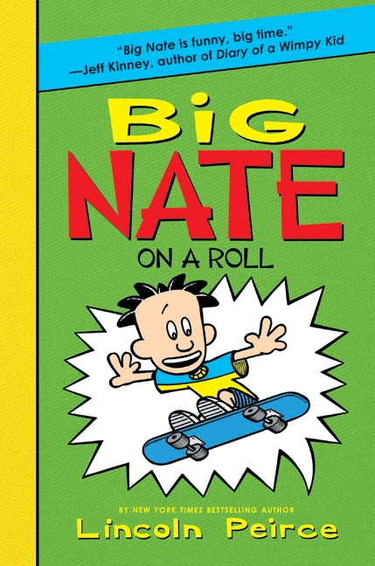
Big Nate
On a roll
Reading project
DO all of the tasks in your reading diary
At least 5 pages
Scouts
- Have you ever been a scout? If you still are which badges have you earned? What other organizations/teams have you belonged to?
Francis’ Factoids
- Create a page including your own fun factoids about things you are interested in. Use the internet or a book to find your facts.
Warm Fuzzy
- On page 32 we see what the warm fuzzies that Nate has to sell look like. Design your own warm fuzzy.
Nate’s door to door disasters!
- On page 33 and 34 Nate describes having to go door to door selling things. Have you ever tried to sell something? Describe what, to whom, why, and if there was a prize involved. If you have never had to sell anything can you imagine having to and what would motivate you to go door to door?
Hike to Nowhere or Dramatic Flashback
- Nate describes his horrific camping experience in chapter 4. Have you ever been camping or hiking? Design a page describing your experience.
- Have you ever had a disastrous weekend? Write a dramatic Flashback describing it like the one Nate does in chapter 7.
Poetic Mood
- Nate wrote a poem about Artur pg. 100. Write your own poem about Artur.
Exciting Activities while you are stuck inside
- Think of your own general experience and write a page about things you have done while being stuck inside. Ex: I have played computer games for an entire day. Remember - if you talk about specific events in the past use the past simple. EX: Last week when I was grounded I played computer games all day.

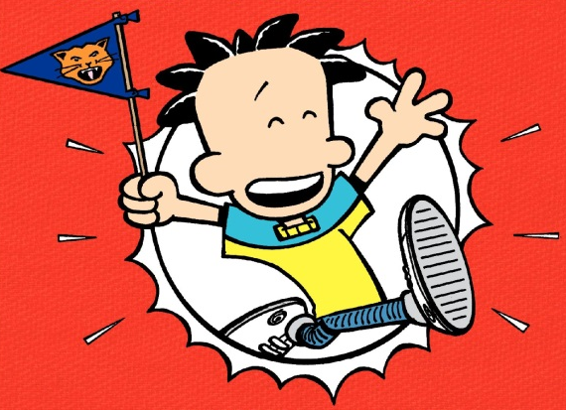
Big Nate
Goes for broke
Reading project
DO all of the tasks in your reading diary
At least 5 pages
CLUBS
- Which clubs do you belong to? Writing about your own general experience what are some of the things you have done in these clubs. EX: we have performed at many school events. Remember - if you talk about specific events in the past use the past simple. EX: we performed at the Christmas show last year.
- Are there any school clubs you would like to have?
- Come up with some ridiculous clubs and create a page like Nate does in chapter 1.
Injuries
- Nate talks about ‘good injuries’ and ‘Bad injuries’ on page 45. Design your own page of good vs bad injuries. Have you ever had one of these injuries? Which category did it fall under and why?
Dee Dee’s costume closet
- If you were Dee Dee what sort of extra outfit would you pack for the school dance?
School closure
- What would you do if they closed GIBS?
Winning and loosing
- Have you ever won something? Have you ever lost something? Describe the event in as much detail as possible, including all of the highs and lows.
Competitions
- Have you ever entered a competition? What was it and How did it go?
Add-on
- On page 153 Mr. Rosa describes the game ‘add-on’. Play a round in your group and include your creation in your reading diary.
Achilles Heel
- The book often mentions Achilles heel, and Nate’s sister Ellen finally explains it to him on page 165. Use the internet or a book to help you Create a page about another Greek god.
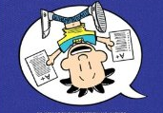
Big Nate
Flips out
Reading project
DO all of the tasks in your reading diary
At least 5 pages
Photo fiasco
- The first page describes some photo fiascos. Have any of these things ever happened to you? Describe the worst photo you have ever been in, seen or taken.
Messy
- Has being messy ever gotten you into trouble?
Double whammy
- Have you ever lost something important? Or blabbed a secret you meant to keep?
Hypnosis
- Do you believe in hypnosis? Why or why not?
Locker inventory
- Do a group locker inventory. What is the weirdest thing you find? Did you find any of the things Nate does?
True Confessions
- On page 181 Nate confesses, “I’ve never been in a real fight before.” Think about your own general experience, have you ever been put in the position where you needed to decide if you would fight or not? EX: I have been in many fights. Remember - if you talk about specific events in the past use the past simple. EX: I got into a snowball fight last year.
Stupid things
- Nate describes what he thinks is the stupidest thing he has ever done. Do you think this is the stupidest thing Nate has ever done? Design a page of stupider things Nate could have done.
Trivia Time
- Do internet or book research and come up with trivia questions and have a group trivia slam.

