2nd Test Joowon Kim January 2013

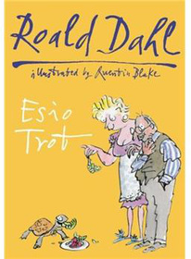
Write Mr. Hoppy’s letter:

Mr. Hoppy and Mrs Silver are going to get married. Mr. Hoppy writes a letter to his friends and family. In his letter
- he invites them all to his wedding and
- he tells them how he and Mrs Silver met and fell in love.

Start like this:
My dear friends,
I have great news. …

