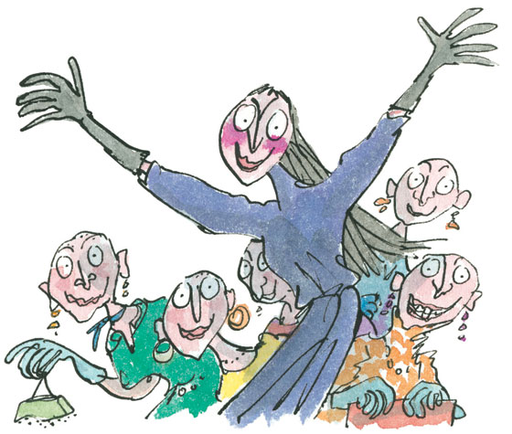

The Witches
  - By Roald Dahl

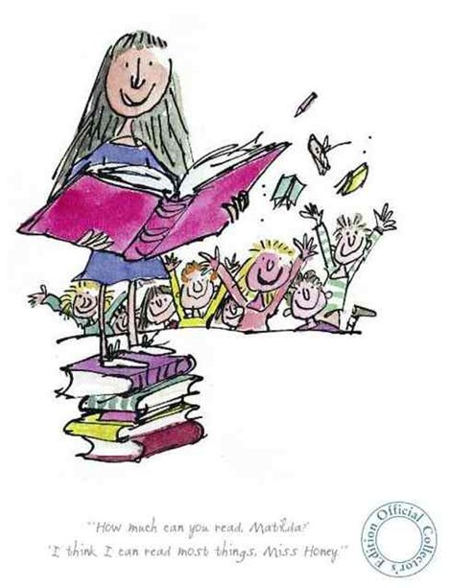

Matilda
  - By Roald Dahl

  - 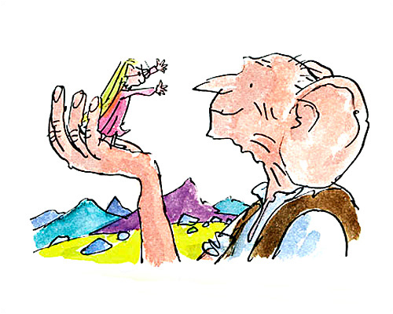

The BFG
  - By Roald Dahl

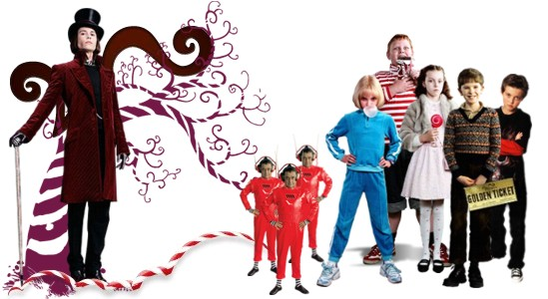

Charlie and the Chocolate Factory
  - By Roald Dahl

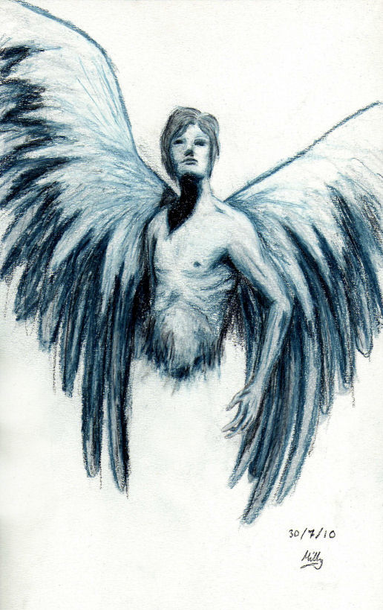

Skellig
  - By David Almond

