2nd Test 2c January 2013
Reading Project

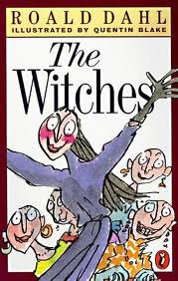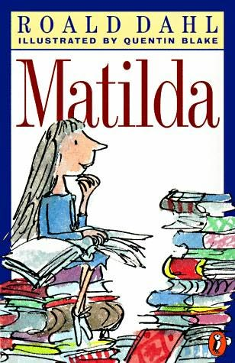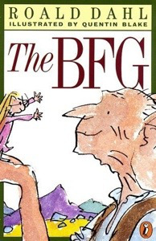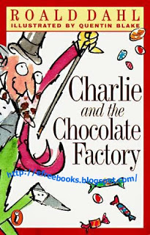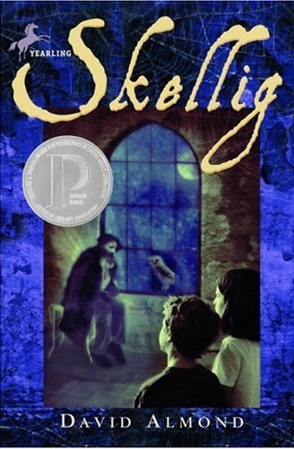

Write about 200 words for each of the two texts.

Be a friend

When you are faced with a problem, it often helps to get some good advice and tips from a friend. Go through your novel and choose a moment where your main character is in trouble or sad and needs some help from a friend. Write him/her a letter giving encouragement and advice in this difficult situation.


Diary
Choose an interesting point in your novel (a high point or a low point) and slip into your character’s mind. Write a diary entry for that day.
In your diary write about the events that have happened, your feelings about them and possible solutions or consequences in the future.

