Print 2 pages on 1 sheet for this cover!
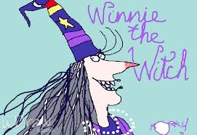

Winnie’s New Adventures
  - By ……………………………………………………………………………………………………………….


Winnie’s house
Winnie’s diary
Winnie’s magic letters
Winnie’s favorite food
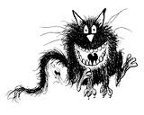
and other interesting facts about Winnie.
Winnie’s latest adventure

