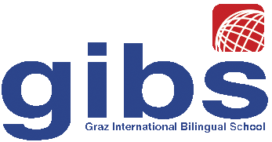 | Graz International Bilingual School  Georgigasse 85-89  A-8020 Graz, Austria  Tel.: 0316/771050; Fax: 0316/7710504;  e-mail: office@gibs.at http://www.gibs.at  SKZ: 601256, DVR:0064360

Reference for Ms Andrea Taras
Graz, April 2016
To Whom It May Concern,

I have had the pleasure of knowing Ms Andrea Taras for about 4 years, first a student in my methodology classes at Graz University and later as a native speaker co-teacher at Graz International Bilingual School. At university, Ms Taras immediately caught my attention due to her active participation and clever remarks in class, as well as her excellent work in all the courses. When Ms Taras joined GIBS as a co-teacher for English, she immediately became a valuable asset to our school. Ms Taras has assisted us with many tasks. Her main responsibilities have been working with students in groups, improving their oral fluency through discussion and role-playing activities and helping students with text improvement. Ms Taras has by far exceeded these responsibilities and has contributed very actively and creatively to the success of our language classes.
She has prepared excellent, highly motivating teaching materials and can choose appropriate teaching methods for different age-groups and situations. She is very creative and has contributed many excellent ideas to our projects. Moreover, Ms Taras is very well organized, efficient and extremely competent – which all contribute to the outstanding quality of her teaching and materials.
In addition Ms Taras has helped us with marking and assessing student work and can give very thoughtful, appropriate feedback to students of all levels. Students take her feedback as advice rather than punishment for mistakes. Many of our students have come to see Ms Taras in their spare time to discuss their written work with her and get her feedback.
Although Ms Taras was not initially hired to teach classes on her own, she has had many chances to do this. Whenever I was away and needed someone to teach my students in my absence, I have asked Ms Taras to take over. Even during longer absences (caused by class-trips abroad for example), Ms Taras has taught my classes extremely well. She is a very responsible, reliable person and is capable of handling any teaching situation with thoughtfulness and maturity. During her lessons, she is fully in charge and students accept her natural authority easily.
In addition to being organized, efficient and extremely competent, Ms Taras has a very pleasant, outgoing personality and gets along very well with both students and colleagues. She is highly intelligent, dedicated and energetic. Her energy and creativity are contagious, she can bring some sunshine into a hard working day.
In summary, I highly recommend Ms Taras for any teaching position. I shouldn’t be doing this – I don’t want to lose her. GIBS won’t be the same without her.
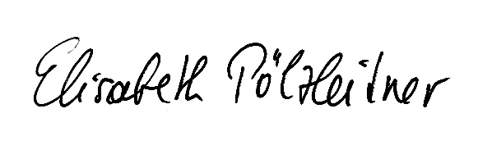
Dr. Elisabeth Pölzleitner

