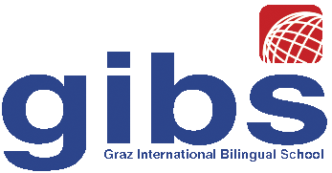 | Graz International Bilingual School  Georgigasse 85  A-8020 Graz, Austria  Tel.: 0316/771050; Fax: 0316/7710504;  e-mail: office@gibs.at http://www.gibs.at  SKZ: 601256, DVR:0064360

Reference for Nina Kahr

Graz, December 2010

I have taught Nina Kahr for five years as her English teacher at the Graz International Bilingual School (GIBS). GIBS is an internationally orientated school for grades 5-12 whose demanding entrance requirements, innovative teaching methods and qualitatively high standards have earned national public recognition in recent years including that of being ranked by an independent survey in 2006 as the best school in Austria. Nearly 100% of graduating GIBS students pursue higher education at institutions across the world.

Miss Kahr has always been a very diligent and highly motivated student and has always had excellent grades in all subjects. Her language skills are excellent, she reaches a level of C2 of the CEFR in all the five skills. Moreover her work shows great creative talent as well as highly structured and logical thinking. Her intellectual abilities are truly excellent; so are her work habits.
On a personal level I have experienced Miss Kahr as a very outgoing young woman who has clear goals and pursues them very actively. She gets along very well with both peers and teachers and is a conscientious and reliable young lady.

I can highly recommend Miss Kahr for her chosen field of studies. She is one of the top 5% students in our school. Since our school teaches highly talented students in general, I would rank her in the top 2% of our national average.

If you have any questions, please do not hesitate to contact me.

Sincerely,

Dr. Elisabeth Pölzleitner
English teacher

e-mail: lis.polzleitner@gibs.at

