Graz, February 24th, 2021
To Whom It May Concern:
I am a member of the English department of the University College of Teacher Education, Styria, and the University of Graz, Austria, where I teach a variety of courses on language teaching methodology.
I have had the pleasure of teaching Ms Sabine Esterle in one of my ESL methodology courses, and was genuinely impressed by the excellent quality of her work and her active participation and genuine interest in teaching methodology issues.
The course “Pädagogische Praktische Studien 4” accompanies the students’ last internship where students design and teach custom-tailored language units for their target groups.
Ms Esterle has designed excellent materials that show that she can adapt very well to learner needs and that she knows a large variety of task-types and methods. Her instructions are clear and precise and the materials she has designed are highly motivating and carefully planned.
This is even more noteworthy, since she had to do her practicum during school lockdown and had to come up with a mix of digital and analog teaching methods for a group of young learners in lower secondary school.
Ms Esterle is very well organized, highly responsible and competent. In addition, she has a very pleasant, outgoing personality. In my course she always seemed genuinely interested and curious to learn. In summary, I highly recommend Ms Esterle for any language teaching position. She will be a valuable asset for any organization.
If you have any questions, please do not hesitate to contact me.
Sincerely,

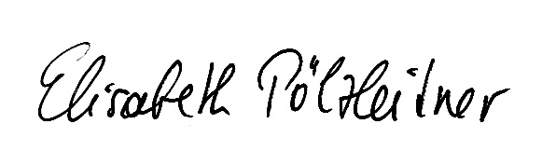

Dr. Elisabeth Pölzleitner

