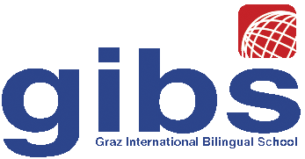 | Graz International Bilingual School  Georgigasse 85  A-8020 Graz, Austria  Tel.: 0316/771050; Fax: 0316/7710504;  e-mail: office@gibs.at http://www.gibs.at  SKZ: 601256, DVR:0064360

Graz, July 8th, 2015

Progress Report for Orlando Solís Chavarría,

To whom it may concern,
I have taught Orlando Solís Chavarría, in my English class at the Graz International Bilingual School for 6 months. When Orlando joined the class in February his English was very limited and it was difficult to communicate with him. His English was at the level of A2 of the Common European Framework of Reference (CEFR). Due to the big difference in the level of English Orlando was not able to participate in the regular program but worked on his own most of the time, using materials that I supplied as well as materials he had brought from his host family. Orlando’s progress in these six months has been excellent. Due to his steady and highly focused work on the books that he read in class throughout the semester he has strongly improved his reading skills as well as his vocabulary. Orlando has also made big progress in his speaking and listening skills and can now communicate quite fluently about everyday topics and topics of his personal interest. He has now reached a level of B1 in these skills-areas.
On a personal level Orlando has been a very mature and independent student. He stayed on task throughout the semester and managed to compensate his limited language skills with his friendly personality and his curiosity to learn from the new cultural environment he was in.
With his high commitment and quiet and steady work-habits Orlando will be a valuable member in any team or class. We will all miss him at our school.

Dr. Elisabeth Pölzleitner (English teacher)

