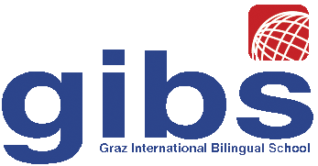 | Graz International Bilingual School  Georgigasse 85  A-8020 Graz, Austria  Tel.: 0316/771050; Fax: 0316/7710504;  e-mail: office@gibs.at http://www.gibs.at  SKZ: 601256, DVR:0064360

Reference for Sabine Hain

Graz, December 2011

I’ve taught Sabine Hain for 8 years. She has always been a very diligent and highly motivated student and has always had excellent grades in her English class. Her language skills are outstanding – Miss Hain is fully bilingual in English and German. Moreover her work shows great creative talent as well as highly structured and logical thinking. Her intellectual abilities are truly excellent; so are her work habits.

On a personal level I have experienced Miss Hain as a very outgoing young woman who has clear goals and pursues them very actively. She gets along very well with both peers and teachers and is a very conscientious and reliable young lady.

Miss Hain has also shown high responsibility and exceptional social skills as well as organizational skills when she was our school representative in the parent-teacher-student council. I can highly recommend her for her chosen field of studies. She is one of the top 5% students in our school. Since our school teaches highly talented students in general, I would rank her in the top 2% of our national average.

Sincerely,

Dr. Elisabeth Pölzleitner
English teacher

