



Assessment for Learning
Dr. Elisabeth Pölzleitner

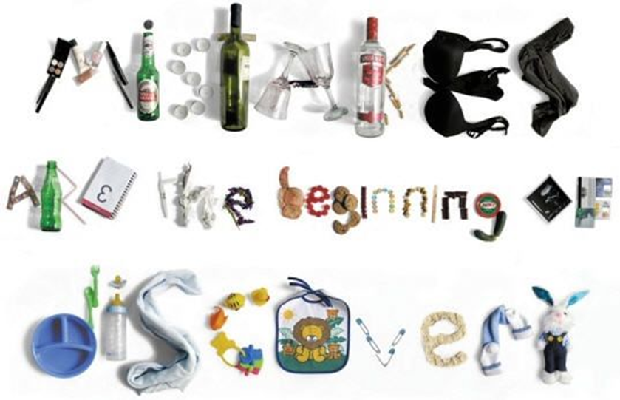
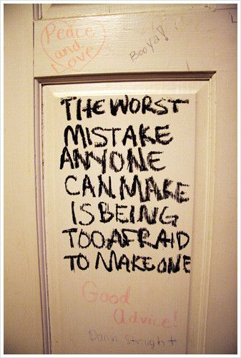 | 

Assessment and the role of mistakes in my classrooms…

I could use some new ideas in these areas… |  | These ideas have worked well…
Today I would like to….

Teachers' attitudes: Are mistakes important?

Group discussions
- Discuss the following quote in your group. What does it mean to you? Do you agree?
“A teacher’s attitude to mistakes and corrections is central to what is done, avoided and valued in the classroom on a day to day basis. A misguided, or more likely unformulated, view of error and correction can undermine everything else.” (Lewis, 1993, 164)

- Use the cards provided by your trainer and discuss whether you agree or disagree. What do the pictures mean for your teaching?
”Many of the things we call mistakes and see as problems are in fact signals that our students are successfully learning the language. They are taking the necessary learning steps.”(Edge, 1989: 14)

“If the teacher wants accuracy above all things and never mind what ideas the students express, then that teacher will get attempts at accuracy: no mistakes and no learning steps.! (Edge, 1989: 16)

“In other words, the importance of mistakes is that they should often be ignored. Students need the experience of being listened to as people with things to say.” (Edge, 1989: 20)

“Correction is a way of reminding students of the forms of standard English. It should not be a kind of criticism or punishment. (Edge, 1989: 20)

“If students are criticized for trying, they will stop trying.” (Bartram&Walton, 2002: 15)

“Teachers tend to see mistakes only in terms of what the student actually says. These could be called 'mistakes of commission'. Another way of looking at mistakes is in terms of what the student did not attempt to say – in other words, 'mistakes of omission'.

Why should it matter what the student did not say? Simply because, if language is communication, then non-communication is a kind of mistake. If the student wants to say to say something, but is prevented, that is surely unsatisfactory. One of the reasons they do not say it is because they are worried about the possibility of making a mistake.” (Bartram&Walton, 2002: 17)

“Many language teachers see correction as an area where they can be certain in the uncertain world of language teaching.” (Lewis , in his intro to Bartam&Walton, 2002)

“We also believe that certain groups of teachers – perhaps those who lack confidence in their own English – worry more because they feel they have to make decisions about the rightness/wrongness of their students' English. (Bartram&Walton, 2002: 2)
The successful language learner will be confident, fluent, accurate and creative. Whatever teaching strategy is employed, accuracy is always achieved last. Over-emphasising accuracy in the early stages of learning isto demand the impossible of the student, and often to inhibit confidence, fluency and creativity. (Lewis, 1993: 172)

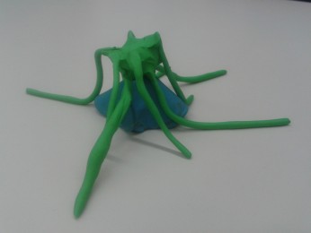
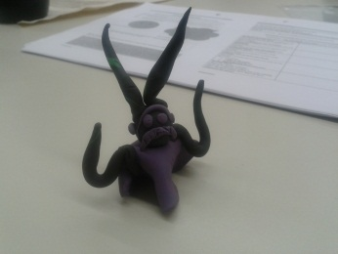
Assessing Monsters
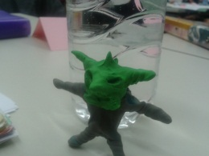
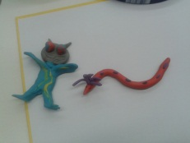

Criteria-based Assessment Systems
 | pros | cons
Holistic scoring

Analytic scoring

Trait-based scoring

Look at the following examples of rating scales. Decide whether they are holistic, analytic or trait-based and discuss in what circumstances they might be useful.

Evaluating the Radio Shows: (criteria collected by 3b)
Clear introduction: Do we know where we are, who is speaking, clear typical format… what is the problem… | 1/2/3 | Comments
Interesting, new facts and information
Clarity: Do we always know who is speaking, where we are…
Language: Good expressions, mystery words, correct grammar
Sound quality and good pronunciation
Fun and special effects

Sum
THIRD GRADE WRITING RUBRIC
http://classroom.jc-schools.net/read/rubric/3rd.htm[2009, October 26].
4 Mature The writing is focused on a topic and supported with details and/or examples. The writing shows a clear beginning, middle, and end with ideas separated into paragraphs. Author's voice/personality contributes to the writing through effective word choice and varied sentence structure. Sentences are complete, and surface errors (spelling, grammar, punctuation) are minimal.
3 Capable The writing is focused on a topic and includes details. The writing shows a beginning, middle, and end; the writer may attempt to separate ideas into paragraphs. Author's voice/personality is evident through use of descriptive words and simple and compound sentences. Sentences are complete, and surface feature errors (spelling, grammar, punctuation) don't interfere with understanding.
2 Developing Topic is presented but not developed; focus may wander. There is an attempt to organize ideas, but writing may lack connections. The writing may show limited vocabulary and/or simple sentences structure, but surface errors may make understanding difficult.
1 Emerging Writing shows minimal focus on topic or is too limited in length. The writing shows little direction or organization. Vocabulary is limited and sentences are simple. Minimal control of surface features (spelling, grammar, punctuation) makes understanding difficult.
Assessment Scales for Writing: Pölzleitner/Bauer and BIFIE-Scale
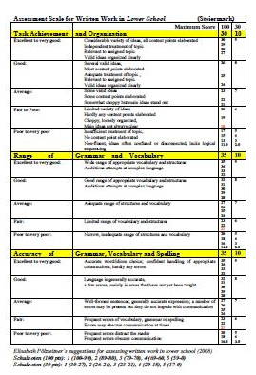
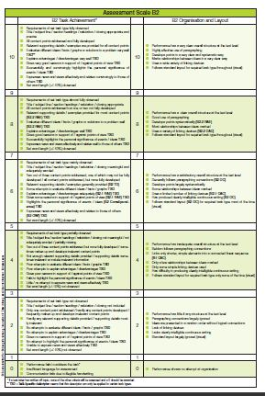
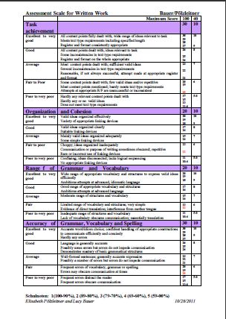
(see full-size copies in the brochure “All the scales you need”)

Defining clear criteria: Students write their own text-recipes.

Ingredients:
Spooky Background
Spooky Characters
New Grammar
Other ingredients and useful phrases

Ingredients:
Spooky Background | Spooky places: cemetery, castle, dark cellars or basements, dark forest, lonely streets, small village, moving shadows…foggy night in October/ November, Halloween…  spooky sounds :the leaves are rustling, the door is creaking, you hear footsteps, the wind is howling, the owl is hooting, the rain is drumming on the windows, a child is screaming,
Spooky Characters | ghosts, spiders, witches, children, gravedigger, owl is hooting, scull, skeleton, bones, dogs, rats, black cats, mice, ravens,  …
New Grammar | past progressive form: to describe the background (the owl was hooting, the moon was shining, it was raining...)
Other ingredients and useful phrases | Surprise ending, danger, child is afraid (he has goosebumps, his hair stands on end, he screams, he hides, his heart beats like mad, he shivers,


What makes a good, spooky story?

Check if your story (or your partner’s story) meets all the following criteria.

Criteria | You can give up to 3 stars for each category.   If you only give 1-2 stars explain what could be improved and how this can be done best.
Title: The story has a promising, spooky title.

Setting and Vocab:
The setting is described well.
I can hear spooky sounds and I can see the scene in front of my eyes. The writer has used lots of good, spooky vocabulary.
Grammar: The setting/background is described in the past progressive tense (the moon was shining…)
Grammar: The actions /events are told in the past simple tense. (the door flew open, lightning struck…)
Characters: The characters react like normal human beings. We can see that they are scared and they have good reasons for their actions.
Ending and suspense: I am surprised by the ending – it is not predictable. The story is interesting to read – it is full of suspense (Spannung).
Further tips:
How else could this story be improved?

Defining criteria for other text-types:

Work in pairs or threes. Choose a text type from the list on p.3 in the brochure “All the scales you need” and list all the features and details you would expect in such a text. Use one of the assessment scales as a basis and refine some of the descriptors.

Peer assessment and peer feedback:
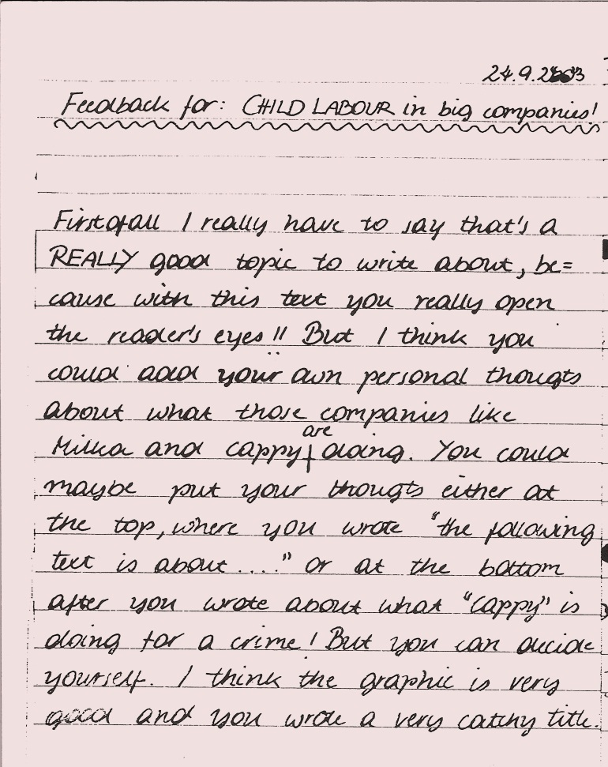
Peer conferencing helps learners to see the strengths and weaknesses in other learners’ texts. This helps them to refine their understanding of the criteria of good writing.
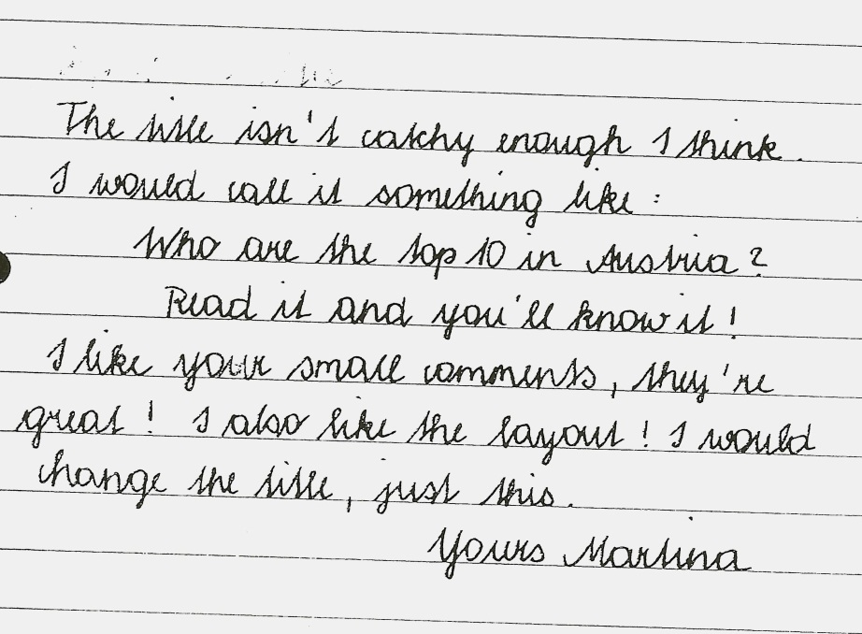
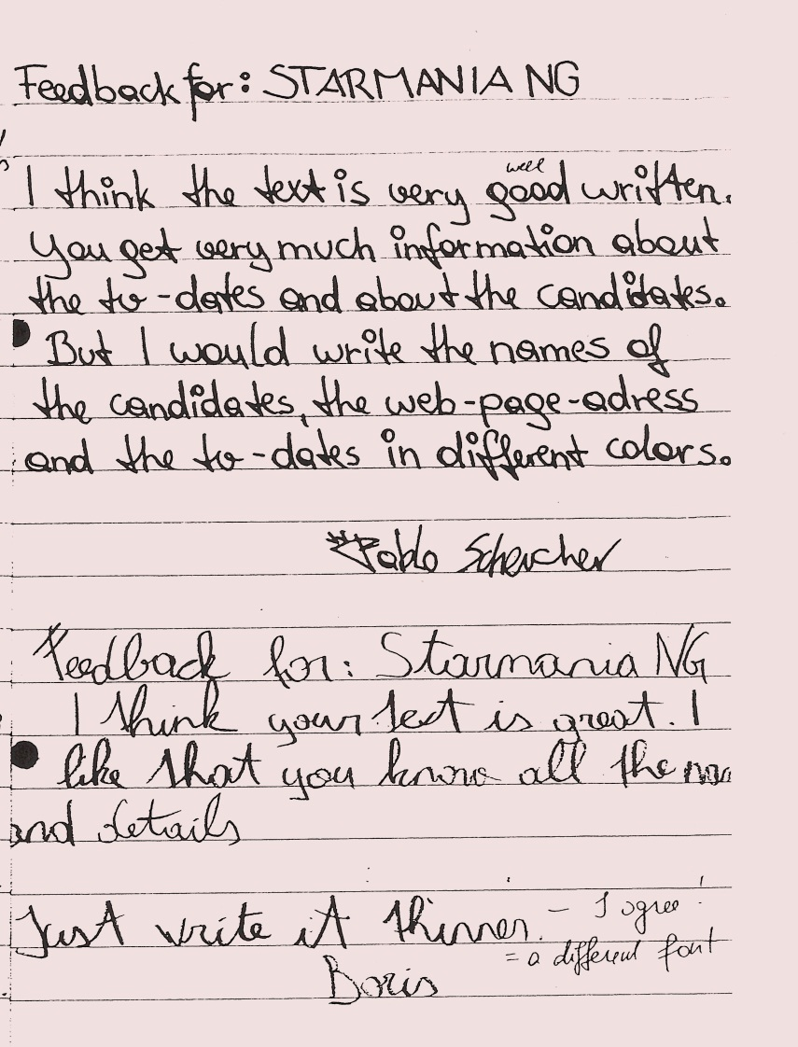

Upper school feedback…
Dear Xin,
I find your story very confusing indeed. It's well written and all, good vocab, but the content is confusing. So are the characters, if you can call them that. Who on earth are Sue and Dan, are they Anthony's parents? What Anthony's father says at the end is totally unexpected, and doesn't seem to fit to the rest of the story. 'Gay people don't go to heaven. Anthony you know that? You can pray for them, but it won't help.' According to that sentence it would seem that a friend of Anthony's is gay, and Anthony is praying form him. You definitely have to explain a little more, the story isn't coherent. And the end is very abrupt as well, and leaves the reader (me anyways) very confused. The scene where he and his brother are running, and Anthony's bible hits the mud seems to be more connected to his promise not to cry rather than being an indication that he's gay. So, you should try and make the whole thing a bit clearer, and if Anthony is supposed to be gay, then make him gay. All in all the story is good, but confusing and incoherent. The language and so on and so forth is great as usual, there are still some small mistakes, but nothing too bad. So work on it a bit, and it'll be great!
Ben
Dear Sarah,
I have just finished reading your story and I find it
really good. It was unpredictable and unexpected .
At the parts where Paul is afraid you used short
sentences and I think that has a good effect!
Also the description in the beginning is very good.

Maybe you could describe Paul more and also put
more description into the part when the neighbor
comes into his room. Like maybe, 'the door
creaked and the footsteps got louder...' so there is
more suspense. Otherwise I enjoyed reading your
story.
Victoria

Dear Christoph,
I can see very well that the hectic
atmosphere of a metropolitan area like
New York has inspired you. The main
character comes across very good, he is a
perfect 'victim' of Wall Street. I also think
that the mobile phone as the symbol for his
society fits perfectly. What you could add
are some street names. You could think of
some street or place which stands for his
behavior like Times Square or something
close to Wall Street. At the end you could
describe the fact that he feels irrelevant
more indirectly. Instead of letting him
scream his situation out you could portrait
him being lost in the City and feeling out
of touch with the rest of the world. Besides
this I really have no complains, well done.
Arno

Writer's answer to his friend's tips:
I really have to admit, that this sort of correction/first feedback was of great help to me. To be honest it helped more than I had expected. Despite the obvious fact that the reader found some mistakes, this exercise even encouraged me to read through the text again after some while and even to find some mistakes by myself. I guess the reason for this is that if you leave the text for at least 24 hours and afterwards read through it again, you may see some extracts from a different and more objective point of view.
All in all I included all the corrections made by my first reader, apart from the word 'opponent' (on the first page), for which I didn't manage to find another similar and more fitting word.

Writer’s name: Peer editor’s name:

Manuscript title:

- Things I like best about this piece of writing are

- To make your text better , I suggest that you

Using the new assessment scales

Spooky Stories: October Year 2
These stories were written after a Halloween project where students collected lots of spooky vocabulary from stories they had read. They also worked on the past progressive tense for describing the background and circumstances in stories.
Use the assessment scale for lower school to grade these texts and put special emphasis on the feedback comments you write for the children.
Text 1: Sophie
The Skeleton
I was slowly going on the path to the graveyard. It was the last day of October, Halloween. The graveyard is the coolest place on Haloween. I was going to meat my friends there, it was the perfect place for a little meeting on the 31st of October. I was hearing leaves rustling, wind howling and twigs were breaking every step I went. Suddenly, a skeleton comes toward me. Not a dressed up childreen, a real skeleton like the one in our bigology lab. The bones knocks and it gave me a goose bumps, my knees felt like butter and my head turned hot and red. The bit light that were coming from an old latern made shadows on to the ground and this made the skeleton more spooky.
“Don't be so afraid,this is a dressed up friend”, I spoke against my fear. “Kill somebody to be a friend of main, or I will kill you!” Was this the voice of a skeleton? The spooky figure came with a knife, it wasn't a joke from my friends, this was a real skeleton and it really wanted to kill me.
I wanted to run for my life, you can't imagian how I feared but I didn't move. A icy shiver ran down my spine. Then, I know the answer. I had to bring the skeleton to the biology lap. It was really important, a life was on the game.
And then I ran like I will never run in my life again. But how can I go into the school? I had to go with the skeleton, it cut fly. “Go in here!” I said. And when I now saw into the biology lap, there were two skeletons. I don't know why.☺

A spooky Story
by Pauli
It was a dark night,k the wind was howling. Anna was walking in the graveyard along a trodden, winding path. There stood a little graveyardhouse the door opened with a rusty, heavy creak.
It made her hair stand up straight.
Anna walked in the little graveyardhouse and there was a growling dog with glaring eyes.
Anna shouted: “Aaa help!”
But what was that? The dog cries.
Anna laughed. “You are a nice dog but why do you cry?”
“ Aaaah my family is not here!” “I have to find my family.” said the dog.
“I saw winding paths in the trodden. I think a man has your family” said Anna.
“Please help me to find my family!”
“Yes, shure I help you.”
After two houers search they became tired.
Suddenly Paul (that's the name of the dog) and Anna haeard a scared laugheat: “Uaauhuhu”
I know that's enough, it's the laugh of my grandfather. Paul ran behind a big stone were the laugh came from. And behind the big stone were the hole family.

Assess the following magazine texts using the Pölzleitner scale for lower school. (yellow scale). Before you start discuss the expected features and refine your criteria for this task.
Students’ Homework task: Write an article for the 2c magazine. Write about a topic that will be interesting for your classmates. Level: year 2, bilingual class


Is a store simular to Abercrombie & Fitch and Hollister. But maby eaven cooler!!!

Aèroapostale is a store that was foundet (gegründet) in 1987 in the US, New York by a guy called Thomas P. and Johnson. At first you could find the store in big shopping mals.
Aèropostale has about 26.000 employees (Mittarbeiter). Most of the employees were.
Since 2005 Aèropostale has there own webside. So now they could sell there cloth and accessories over the howle world.




At first they could only shift the clothe threw America. Then a company called FiftyOne

Could deliver and ship cloth to Germany. In the US are 885 Aèropostale stores in 49 states, there are 36 Aéropostal stores in Canada and 20 in Europe and Asia.

In the year 2010 the made 2,4 bilion US-Dollars. That is Quite alot. If you like Aèroposale there is a stor in Vienna or you can buy the things online.
By Anna

Mislabeled food

Horse-meet found in a “100% beef” product. Free-range eggs were
not ok because the chicken had no space.

Horse-meet In the last few days you heard maybe of the horse-meet scandal. First the meet isn´t so bad. Only if the horses get food with antibiotic. That´s medicine and if we eat it, it can be harmful for health. The first time they found horse meet it was in lasagne. It had between 60 and 100% horse-meet but the label was saying: 100% beef. The lasagne was mainly sold in other countries.
Why? The producer don´t buy the expensive beef but the cheap horse-meet. Per package there is not so much profit but if you produce many packages it is profitable (gewinnbringend).
Austria
Here, at the supermarket Lidl, experts found horse-meet in tortellini. The producer, Hilcona (comes from Liechtenstein), and the supermarket ordered all packages back. At the 20th of February experts found horse-meet in “Kärntner Hauswürstl “ and “Lavanttaler Bauernwurst”. These products were sold in all parts of austria! The producer in Carinthia first said that he didn´t knew that false meet was in his ware. After a few days he confessed (gebeichtet) that he knew the thing with the meet. The meet came from a depot in carinthia. It was imported from Canada. In Vienna experts found horse- and pork meet in Kepab. The pork is for us not such a big problem, but for muslims. Strict muslims are not allowed to eat pork because they think it is dirty. They are also not allowed to eat predators (Raubtiere) because they eat other animals.

Eggs Do you know when you were the last time shopping at a supermarket? Then you maybe bought some free-range eggs (Freilandeier). If you buy these eggs you can be sure that the chicken who made the egg: saw the sunlight, had enough space to move, got no medicine witch is not dangerous for us and got feed with good food. Most time you can be sure but now the police found something interesting. The egg producer sold cheaper eggs for more money. The chicken had no space and were caught in a big hall. That´s cheaper. Usually you sell them cheep but he sold it as free-range eggs (so they were more expensive). An insider sad that about 50 million eggs are smuggled per year from other countries to Austria, not labeled.
By Emily ; )

An example from upper school:
Assess the following text using the Pölzleitner/Bauer scale or the BIFIE scale (B2)

The Assignment


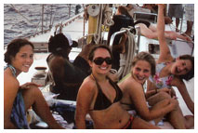
Essay: Write 350 - 400 words. Do not copy whole phrases from the task instructions to use in your essay.

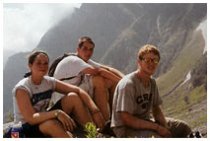

Many high-school students in Austria go together as a class on a graduation trip (“Maturareise”) after their final exams. However, it is often difficult for the class members to agree on where to go and what to do on their holiday. Is the graduation trip a tradition worth keeping? If not, why not? If so, what form should the graduation trip take and why?
Write an opinion essay in which you
- state clearly your opinion on whether a graduation trip is worth doing
- support your opinion with valid arguments and examples
- comment on the summer splash type of graduation trip

Graduation trip, heaven or hell?
Everyone wants it and everyone knows it, the famous graduation trip after having successfully finished your school career. Almost all of the Austrian students choose to go on one of the biggest events on the continent in order to celebrate together with thousands of other students from different cities. However it is sometimes forgotten that this tradition doesn't impress everyone and alot of people are against the mass-party because of different reasons...
First of all, lets take a look if a graduation trip is actually worth doing and why there is this tradition. The answer for this is pretty easy and fast explained, its a tradition because it gives the students the feeling of freedom. After eight years of school, having the same procedure every day, its the event, that symbolizes the change from a little, monotonic world to the new and bigger one. This can be done with seven days of having fun, meeting new people or just relax as much as possible. I'm sure that every student will agree on this, however there are a few people against Summer Spalsh and other graduation trips, argumenting for a class trip to the mountains or simply a cultural event. I am sure that this can also be very funny but frankly speaking, who wants to make another class trip after having spend eight years together. Believe me, you will have enough time for the cultural trip once you are having your summer holidays.
I tend to say that the graduation trip should stay the same and no bigger changes should be made because traditions are not there to be changed...
Furthermore, if you decide to go on the Summer Splash type of graduation trip you can be sure that you actually get something for the money you pay. Knowing that 1000€ is alot, I still think that it is hard to disagree with the fact that you will get 100% of entertainment and a good time. In the hotels you will get all-inclusive, speaking of good food and alcohol is not the whole deal. The organizer provides you with the best party locations, on ships, lonely beaches or underground caves ensuring that you are having the best time of your life. More factors that contribute to the perfect trip can be seen as water sports activities. Every day you have the chance to choose your free time when you are having a little break form the awesome parties. Jet-ski, diving, paragliding, or riding floatable plastic things (like the banana) are only waiting to amuse you. The entertainers also know exactly what they are doing and can explain you every activity as precise as possible, ensuring you also the maximum of safety.
Personally, I believe that the people which are attending huge graduation trips, are the essential factor for a good and non forgetable trip.
As I always use to say: "Every party is only as good as the people which are attending it". This can also be said for the graduation trip. It always depends on how motivated the people are but I ensure you that you will only find the best and funniest party people, ever! Additionally you make new friends and connections, which can be important in your future and who knows, maybe you find the person of your dreams?! I'm sure that you will not do so when you make a trip to the mountains or somewhere else...
I have shown you that the Summer Splash type of graduation trip is defenitively something you must have done once in your lifetime, an experience that you only can make when you are young and good looking! Ultimately I want to say that Summer Splash might be the last chance were you can enjoy your freedom before the university life starts and you are dragged into your studies!
Task Achievement:
Organization and Cohesion:
Range of Grammar and Vocabulary
Accuracy of Grammar, Vocabulary and Spelling

Designing Tests

1. Preparing Students for a Test:
Learners at all levels need to know exactly what goals they will have to reach in a test and how to prepare for the test. Give them
- checklists (topics, grammatical notions,...)
- text-writing recipes showing the criteria of a good text of this type
- good examples
Look at the following example of such study-tips for a year 1 class.

Our 2nd English Test will be on ..........................................
Revise the following topics:
- People’s appearance and clothes
- Houses/ apartments, rooms, furniture
- Family
- Hobbies
- Daily routine
- …old topics
Grammar:
- present simple tense (I play, she plays, he doesn’t play, do they play?)
- present simple tense + question words (What does it mean? Where do you live?...)
- present simple tense + adverb of frequency (I often go running; he never swims…)
- going to (I’m going to visit Jan tomorrow… )
- possessive adjectives (my coat, her boots, their hair…)
- this/these (this pullover is practical, these clothes are nice, these jeans are flared…)
- …old grammar
Revise with your vocab box, your worksheets, your portfolio ...
Tip: Read the short sample texts aloud in funny ways:
- read and walk up and down your room,
- sing them to yourself at different speeds (Trauermarsch, Pop-song, Opera…)
- write them as running dictations

Work with a partner and compare the two sample tests (year 1) provided by your trainer. What differences do you notice?
English Test 1c, Jan 15th 2013 | English test 1b, January 2013,

Learning Objectives – TEST 1 | 20.11.2009 | YEAR 2

Topic | How can I practice this …
Language revision
- I can write about habits (Gewohnheiten) in the present simple and describe present activities in the present progressive (peep-show tense)
Trees
- I can write about past events (Ereignisse in der Vergangenheit) using the past simple
- I can form the past simple and past participle of irregular verbs correctly
Halloween and spooky stories
- I know a lot of spooky vocabulary: spooky places, sounds, characters, ...
- I can use this vocabulary to write a really thrilling and suspenseful spooky story (recipe for spooky stories)
- I can describe the background of a story (setting the scene) using the past progressive
- I can describe the action using the past simple

2c First Test November 2012

Write a spooky story:
Listen to the beginning of the story ‘The house on a lake’. Then describe Arthur’s first night in the new house.
Make your story really spooky by describing the eerie atmosphere in the house. What happened during that night?
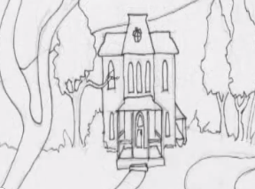 | 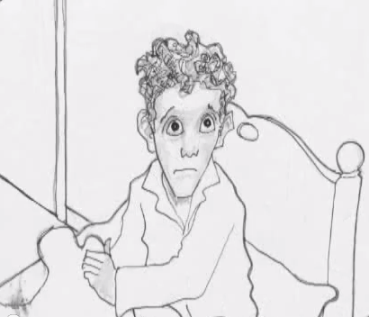
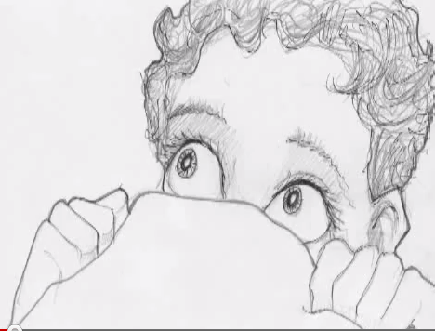 | 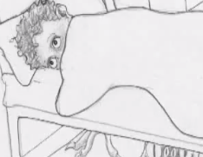

After the test: If you want to know how the story continues, check on Moodle.

3rd test 2b April 2nd, 2001
I. Skiing:
  - Label the picture of the skier. Use as many words as you can. (15 would be great!)
  - What might the skiing instructor be saying to the lady? Write 5 sentences.
II. Experience:
a. How many times have you done the following? Write sentences using the expressions in the box
go in an airplane; milk a cow; break an arm or leg; cook a meal; fail an exam; see a poisonous snake; take a ferry-boat; cut your finger; lose a key; catch a fish;
b. Choose one of the above sentences and write a short paragraph about this experience. When did it happen? Describe the event in detail.

III. Letter to the BBC
The BBC are looking for the most daring and courageous teenagers of the year.
Mr./Miss Daredevil will be elected in a quiz show next week. Young people are invited to send in their applications to take part in the show and contest.
Write a short letter to the BBC and tell them how courageous and daring you are. Tell them about all the dangerous and extraordinary experiences you have had in your life. (Invent some incredible experiences)
Start like this:
Dear Mr. Showdy,
I would like to take part in your next show and courage contest. I am the most courageous and daring person in my whole school...

2nd test 5b January 2013
CIVIL RIGHTS READING PROJECT


Newspaper article: write about 200 -250 words
Choose an event in your novel that would make it into a local newspaper. Write a well-structured article informing your reader about the event.
Tip: Don’t forget to find a catchy title, a lead (intro sentence that will capture the readers’ interest and tell them what to expect). Answer the 5 Ws: Who? What? When? Where? Why?. Remember: use formal language in your article.

Choose ONE of the following tasks and write about 200-250 words.

a: Be a Friend

When you are faced with a problem, it often helps to get some good advice and tips from a friend. Go through your novel and choose a moment where your main character is in trouble or sad and needs some help from a friend. Write him/her a letter giving encouragement and advice in this difficult situation.


or b: Diary
Choose an interesting point in your novel (a high point or a low point) and slip into your character’s mind. Write a diary entry for that day.
In your diary reflect upon the events that have happened, your feelings about them and possible solutions or consequences in the future.

Designing Transparent Grading Systems
Discuss the following extract from the brochure of the LSR f. Steiermark. How can you fulfill these requirements?
Wer Leistungen von SchülerInnen beurteilt, wird sich von Zeit zu Zeit die Frage stellen, ob die gebräuchlichen Verfahrensweisen der Leistungsfeststellung und –beurteilung geeignet sind, um schulisches Lernen anzuregen, zu begleiten und um ausreichend über den Lernertrag und Lernprozess zu informieren. Veränderungen in der Lernkultur und neue gesetzliche Rahmenbestimmungen (z.B. Lehrpläne) verlangen es, dynamische Fähigkeiten, also fächerübergreifende persönliche, soziale und methodische Ziele, als Leistungen einzubeziehen. Ebenso wird gefordert, dass Schüler/innen vielfältige Rückmeldungen über ihre Teilleistungen erhalten, um ein differenzierteres Bild über Stärken und Schwächen zu bekommen.

Assessment Year 1- 1st semester
Efficient work during workshops  10 | You stay on task and you work quietly without disturbing others.  You work independently and  you can read instructions and ask for help when necessary.  You find partners for group or pair-activities easily.  You finish all your tasks carefully. | 1 | 2 | 3 | 4  very poor | 5  poor | 6  fair | 7  average | 8  good | 9  very good | 10  excellent
Homework and  time-management  20 | You’ve handed in your homework regularly.  It’s carefully done and you have corrected your errors.
Quality of your written work (tests and other texts that you have written without help)  50 | Your texts are carefully written.  Your texts are long and interesting.  There are only a few mistakes in the  areas that we have already learned.  You use a wide range of vocabulary.
Oral work and listening comprehension  10 | You can understand your teacher and co-teacher as well as simple texts on tapes.  You respond in English most of the time.  Your pronunciation is good.
Reading  (only required for English speakers in the first semester) | You can read simple texts and answer comprehension questions.  You can read simple books and stories (stage 1-2) and write about them in your reading diary.
Effort and Extra Work  10 | You do all your work carefully.  You have worked with your vocab box and vocab scrapbook regularly.  Your Me-book and Portfolio are carefully done.  You have read lots of little books.  Any extra work:
≤60% = fair (genügend), ≤70% = average, ≤ 80% = good, ≤90% = very good, 100% = excellent

Assessment Year 2
Efficient work in class  10 | You stay on task and you work quietly without disturbing others.  You work independently and  you can read instructions and ask for help when necessary.  You find partners for group or pair-activities easily.  You work quickly and efficiently. | 1 | 2 | 3 | 4  very poor | 5  poor | 6  fair | 7  average | 8  good | 9  very good | 10  excellent
Quality of your written work  50 | Task Achievement  Your texts are carefully written and meet the text type requirements.  Your texts are long and interesting, full of relevant ideas and facts.  Text types:  Organization  Your ideas are clearly organized. You can use basic link-words correctly.  Range of Vocabulary and Grammar  You use a wide range of vocabulary and grammatical structures.  You are using the new words and phrases we have recently learned.  Accuracy:  There are only a few mistakes in the  areas that we have already learned.  Your spelling and punctuation are mostly correct.

Homework and time-management  10 | You’ve handed in your homework regularly.  It’s carefully done and you have corrected your errors and revised your texts regularly.
Oral work and listening comprehension  10 | You understand your teacher and co-teacher as well as authentic texts on tapes. You listen to your teacher carefully and can follow instructions.  You respond in English most of the time.  Your pronunciation is good.  You can present a book or topic in class.  You speak English during group-work.
Reading  10 | You have read several English books and have written personal responses into your reading diary.  You understand our workshop texts and can answer detailed comprehension questions.
Effort  10 | You do all your work carefully.  You have collected lots of new phrases in your LP book and you can use these phrases actively.  Your materials are well organized.  You correct and revise your texts regularly.  You have done well in the little progress checks.
<60% = fair (genügend), <70% = average,< 80% = good, <90% = very good, 100% = excellent

What grade ...................................(earn) this semester?
Past Tense or Present Perfect Tense, that is the question!!!!
Dear Mrs Pölzleitner,
I think that I .............................. (work) very well this semester. I ..............................................(always do) my homework except once. That ......................(is) the week after Easter. I ..........................(forget) to write about my dream job.
Concerning magazine work I must say that I .......................................... (always write) my articles on time. I ......................................... (improve ) them after the peer-conferences , so I can say that I .................................... (do) my very best. I am proud of our magazine.
In my magazine work I ............................................ (also learn) to do research on the internet. Once I .................................. (write) about the Titanic and I ................................ (find) 15 pages of information on the internet. I ................................. (have to read) all 15 pages to filter out the most important information. Then I .................................. (write) a two-page text about the sinking of the Titanic. In this text I ......................................... (follow) all the rules of paraphrasing and really ................................. (try) to use my own words as much as possible. At the end of the article I ........................................ (quote) my sources. I ................................. (am) very happy when I ................................(get) a big plus!!! on this text. It ...........................(is) really a lot of work. I think I am going to put it into my portfolio.
You should also look at my beautiful reading diary. I...................................(read) three English books this semester and I ............................... (write) very long entries for my reading diary. I really like reading English books and I am going to read a few books in the summer holidays. I might even write short entries for my reading diary. I can use them next year!
I ............................... (improve) my vocabulary a lot this year. I .............................. (always write) my new words into my vocab. book and I ........................... (always study) them well. Only once, when we ................................ (have to study) the new job-vocabulary, I ............................. (forget) to write the words. But I .................. (did) it on the next day and ................................(hand in) the vocab. book in the next English period.
I'd like to say something about my team-spirit and social skills. I think that I ............................(always be) a very reliable team member in our magazine group. Once we ................................ (have) a problem with a team-member who .............................. (not hand in) his texts on time. We................................(decide) to call him at home the day before our next deadline and remind him of the text. This ........................... (work) really well and he .....................(bring) all the other texts on time.
All in all I can say that I ........................................ (work) very well this semester and I think that I ...............................(earn) a one.
Best regards,
………………………………………….

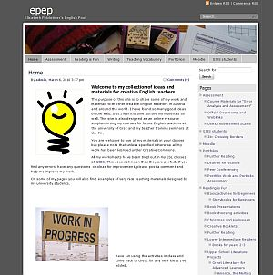
Portfolio Assessment:

For details go to: http://epep.at
On this page you will find more information, examples and links to helpful websites.

Groupwork:

Choose a grade-level that you are teaching at the moment. Work with a few colleagues who are following a similar approach (and use the same textbook if possible).
Design a transparent, criteria-based grading system for this class (semester-grades or final grades).
Present your system to the plenary.

