Assessment: ………./ 100 pts.
Listening: (8p)
1 | Listen to Mrs Dimple and tick T (True) or F (False). (8p) |  | 9

 |  | T | F
1 | Mrs Dimple lives in London. | 
2 | She's got a son* and his name's Robert.
3 | Her son collects stones.
4 | All the stones are grey.
5 | Her son makes things out of the stones.
6 | Her son's stones are not in the garden.
7 | Her son thinks the stones are beautiful.
8 | Mrs Dimple thinks the stones are very beautiful.
*son – Sohn

Reading: (8p)
2 | Read and tick T (True) or F (False). (8p)

Darren’s got a strange hobby. He makes musical instruments*. He makes them out of old tins and boxes*. He makes instruments out of things he finds in the house, in the park – anywhere*. Darren says, “I think it’s great to make instruments. It’s not difficult, and every instrument I make is different. I’ve got lots of instruments now. I give them to my friends. They think they’re great. A lot of my friends play their instruments. Four of my friends play the instruments in a little band.”
*musical instruments - Musikinstrumente
*tins and boxes - Blechdosen und Schachteln
*anywhere - überall
 | T | F
1 Darren’s hobby isn’t strange.
2 Darren makes instruments out of tins and boxes.
3 Darren says his hobby is difficult.
4 Darren has got a lot of instruments.
5 Darren gives his instruments to his friends.
6 Darren’s friends think his instruments are crazy.
7 One or two of Darren’s friends play his instruments.
8 Four of Darren’s friends play the instruments in a band.
Grammar: (48p)
3 | Write Am, Is or Are in the questions. Then complete the answers. (16p)

1 | ............... you hungry? Yes, ...............................
2 | ............... she your sister? No, ...............................
3 | ............... I your friend? Yes, ...............................
4 | ............... this your English homework? Yes, ...............................
5 | ............... Fred your brother? No, ...............................
6 | ............... I strong? No, ...............................
7 | ............... you and your sister happy? Yes, ...............................
8 | ............... the children excited? No, ...............................
4 |  | Possessive Pronouns: complete the sentences with one word. (10p)

1 Hi, I’m Marina and this is .................. sister, Annabel.
2 Look! There’s Sam’s brother. ............... name’s Jasper.
3 I like Ruth and Jane and ............... sister, Nina.
4 There’s the teacher! ............... name’s Peter.
5 This is my mum. ............... name is Cheryl.
6 This is Dora and Vicky and ............... friend Karen.
7 We’re Sue and Sally. Barbara is ............... mum.
8 Judy, ............... brother is great!
9 Look at the dog with ............... ball.
10 George, is this ............... guitar?
5 | Write can or can’t. (4p)

1 | 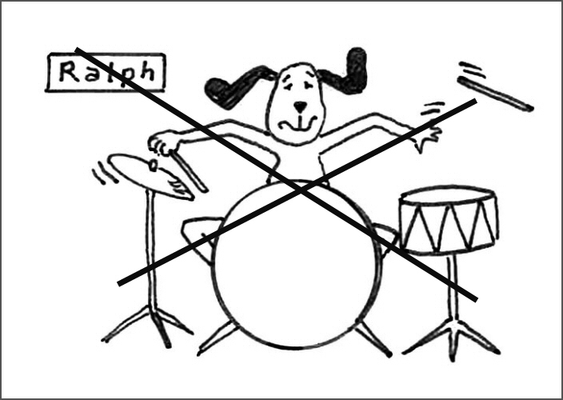  Ralph ........................ play the drums. |  | 2 | 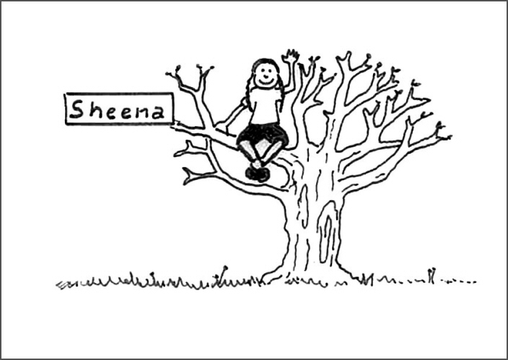  Sheena ........................ climb trees.
3 | 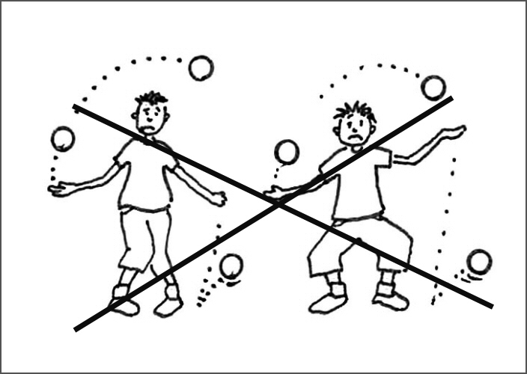  They ........................ juggle. |  | 4 | 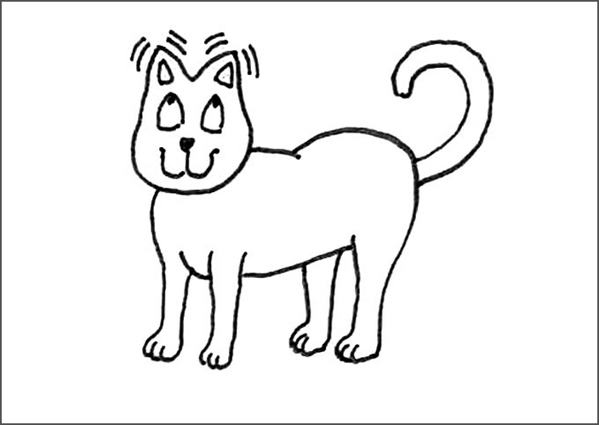  It ........................ wiggle its ears!

6 | Fill in the correct forms of the verbs in the box. (10p)

bump carry fall go can like climb bump fall climb

Nigel 1............... to the woods with his dog in the afternoons. Nigel’s dog isn’t very clever. It 2............... into trees in the woods. There’s a river in the woods. Nigel’s dog 3............... into the river. But Nigel’s dog 4............ do one clever thing – it can 5............... trees! Yes, Nigel’s dog 6............... trees in the woods. And ... it 7............... out of the trees, too! When the dog 8............... its head, Nigel 9............... it home. Then Nigel’s tired. But the dog isn’t tired. It’s excited. It 10............... its walks in the woods!
7 | Complete the sentences with the possessive ’s form of the names. (8p)

1 | They are ........................... garden gnomes. (Mrs Ball)
2 | Is that ........................... cat? (Harry)
3 | ........................... sister eats a lot of food. (Sannam)
4 | I think that’s ........................... parrot. (Jenny)
5 | Pepper is ........................... cat. (Lady Grey)
6 | This is one of ........................... pasta pictures. (Stephen)
7 | This is my ice cream and this is ............................ (Anne)
8 | Where’s ........................... football? (Paul)

Vocabulary: (16p)
8 | Translate the words and phrases below into English! (16p)

aufgeregt ………………………….. Abend …………………………………..
Mittwoch …………………………… schwer…………………………………..
Welt ………………………………… Brücke ………………………………….
trinken ……………………………… Zunge ………………………….……….

Sie spiel Gitarre. ……………………………………………………………………………….
Tom ist mein Freund. ………………………………………………………………………….
Morgen ist Samstag. …………………………………………………………………………..
Gib mir deinen Regenschirm. ………………………………………………………………..

Writing (20p)
9 | Write the story behind the pictures. Write 50 words.

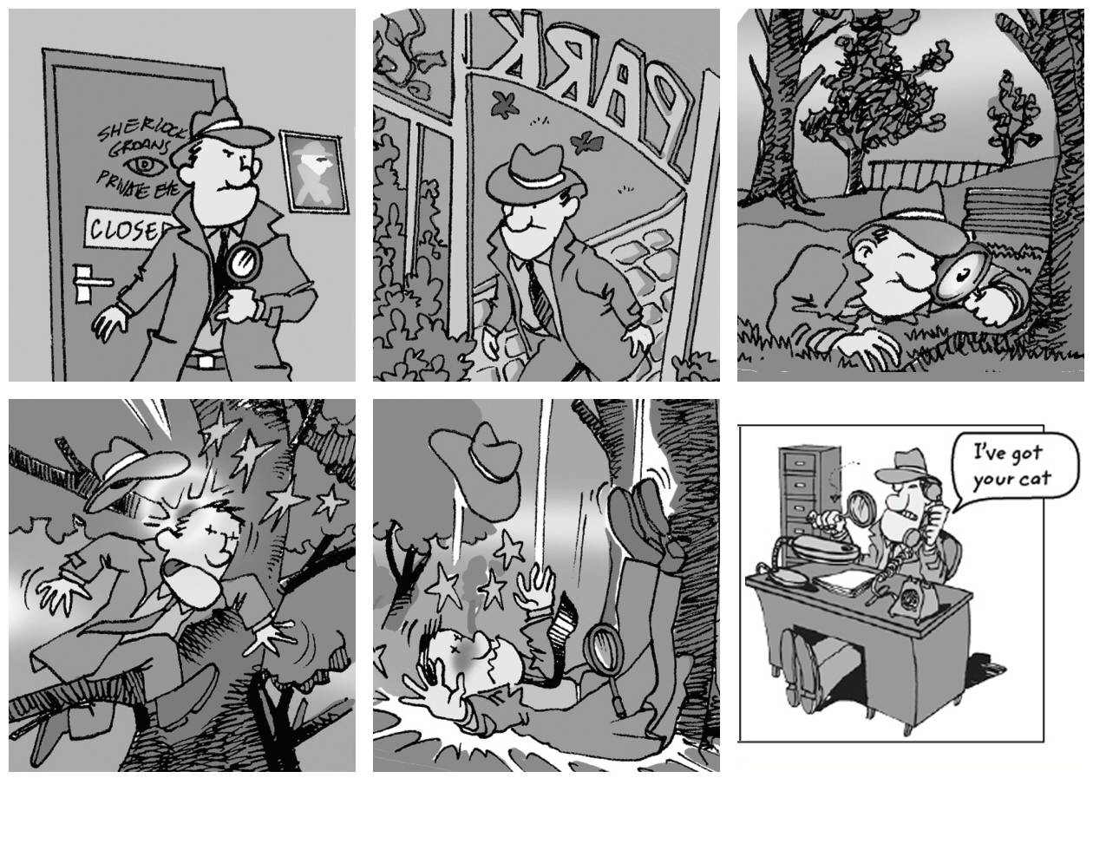

GOOD LUCK!

(100-90) Sehr Gut / (89-80) Gut / (79-70) Befriedigend / (69-60) Genügend

