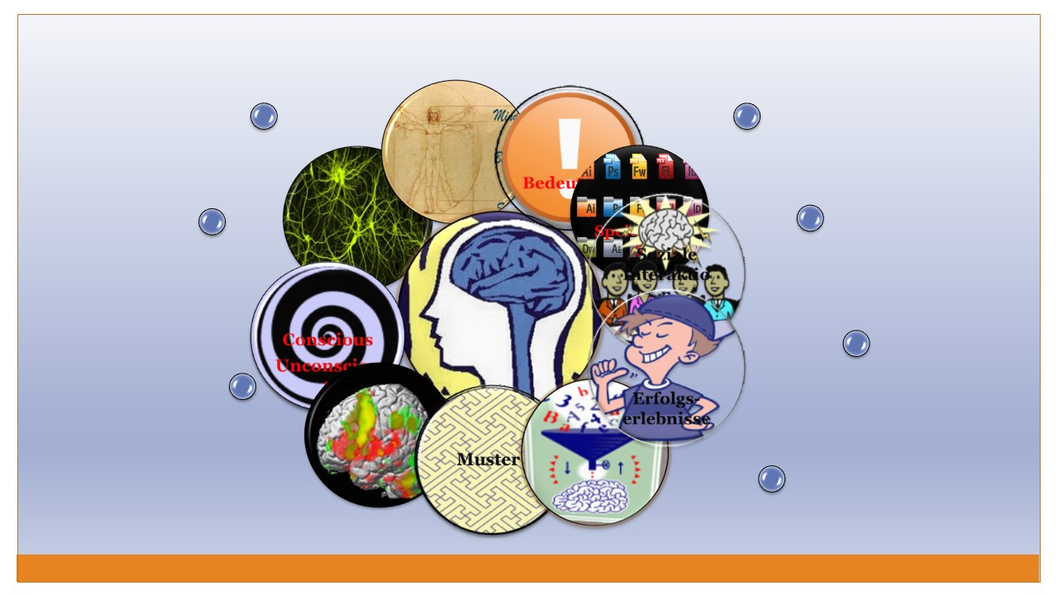
Brain-Friendly Language Teaching
How can research on the brain help language teachers and learners?
Dr. Elisabeth Pölzleitner | UNI-Graz | PH-Steiermark

Contents
K W L 4
10 Principles of brain-friendly learning 5
Types of Memory (Stevick) 7
Practical Examples: Teaching grammar to the whole brain 8
Examples of Efficient Grammar Activities 9
Inductive Learning: Making Hypotheses and Building Rules from Examples 10
FIP: Format, Imagination and Pride 11
Mini-books Online 11
Origami Books 11
Interactive Posters 11
Audiobooks 11
Blogs 11
Die Didaktik des leeren Blattes: Diaries, Booklets, Catalogues, Magazines… 12
Fair 12
Teaching Vocabulary to the Whole Brain 13
How to create multisensory images in the learners’ brains 13
The ISM Model 13
VMIs: Voice Movement Icons 13
Dos and Don'ts 13
Vocabulary Practice Session 14
1. VMIs: 14
2. Doodling: 14
3. Colors: 14
4. Sounds: 14
5. Opposites: 14
6. Usage -- Find a second example: 14
7. Lexical Furniture: 14
Blackout 15
Running Dictations for all ages 15
Making Associations – Building Networks 16
The Vocab-Box 17
Working with the box: 17
Vocab Books and Vocab Cards 18
Whole class activities for practicing collocations 19
As Easy as Possible (Lewis, 2000, p. 104) 19
The Collocation Game 19
Odd verb out 19
Vocabulary Quilt 20
Synonyms: 20
Oral Gaps: 20
Voctivity 20
Testing Vocabulary 21
Useful test-formats: 21
Appendix: 22
Sample texts for vocab activities 22
Checklist for brain-friendly language teaching 24
Bibliography: 25

You will find downloadable worksheets and examples of all the projects on epep.at

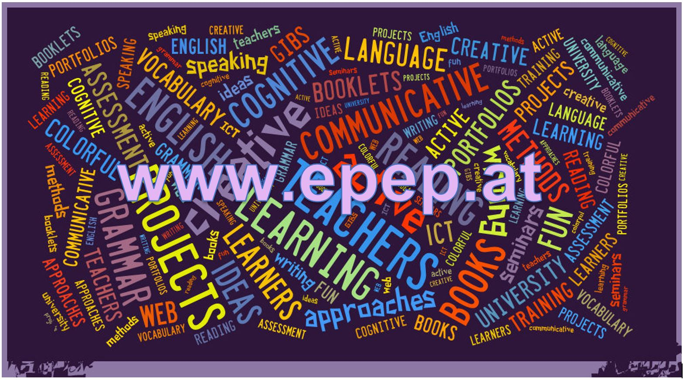

Brain-friendly Language Teaching
  - How can Research on the brain help language teachers and learners?
  - What kind of learning environments support efficient language learning and how can we support learning processes that will lead to long-term language competences in our learners?




K W L
What I know about this topic: | What I want to find out. | What I have learned

10 Principles of brain-friendly learning

A | Learning is a physical, chemical process
1 | Learning is the chemical and physical process of adding new synapse connections to the existing networks.  The existing networks (prior knowledge) play an important role and must be activated in order to add new information. Learning is supported by first looking at the big picture and then zooming in on new details.  Priming – Warming up – Advance Organizer – KWL | 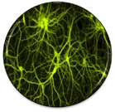
2 | Our brain stores content in different places and ways.  - Declarative memory: “Knowing what” is the memory of facts (semantic memory) and events (episodic memory) that we can recall consciously.  - Procedural memory: “Knowing how” is the unconscious memory of skills and unconscious patterns that have been acquired through repetition and practice. (riding a bike, typing, grammatical forms of the native language…) | 
B | Turning the brain “on”
3 | Learning engages the entire physiology. Body, mind and emotions are closely linked.  - positive emotions facilitate learning, negative feelings and fear inhibit learning  - the limbic system acts as a “doorman” and decides whether information is relevant and interesting or whether the incoming information is irrelevant and will be filtered out. | 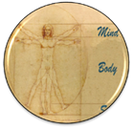
4 | Long-term learning only happens in meaningful, relevant contexts  - Context-free data are filtered out by the brain or stored in short-term memory. The brain only integrates information that seems new, interesting and relevant.  - Relevant details are connected to/ associated with prior knowledge and experiences  - Elements of choice and autonomous decision making trigger positive chain reactions in the limbic system: choice – sense of self –determination – challenge – dopamine -- acetylcholine… lead to a positive learning spiral.  Examples: That’s me // True grammar sentences (write yourself in) // personalized grammar exercises// FIP: Format – Imagination-Pride | 
5 | Challenge and success are motivating  - Positive challenge and success trigger the release of dopamine, the “feel-good” transmitter. Dopamine signals to the body to “wake up”. Dopamine is addictive – we want more of the same good feeling.  Example: Pride: students who are proud of their products (booklets, portfolios) will experience this kind of “dopamine shower”. | 
6 | Learning works best in social interaction. Social interaction influences neural circuits.  - mirror neurons : empathy, resonance  - limbic system : doorman to the brain  - anterior gyrus cinguly (Vordere Gürtelwindung) : sense of self, mindsets  - groupwork settings encourage authentic use of language, fun and good feelings when creating something together, joint success, acceptance in the group… | 
C | Constructing Knowledge
7 | Learners must actively construct new knowledge and skills.  Information cannot be fed to the brain by the teacher. Constructing knowledge consists of four stages:  - experiencing something new (input)  - awareness raising  - building abstract hypotheses  - active monitoring and proceduralizing (making it automatic)  Example: describing the background (circumstances) in spooky stories | 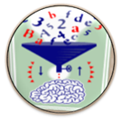
8 | Our brain extracts patterns from meaningful examples  - attention: meaningless examples without context are filtered out and will not lead to this kind of patterning (see next principle)  Examples:  German forms of nonsense verbs  - Ich „moodle“ gerne und oft. Auch gestern habe ich …………..  - Meine Nachbarn „pferden“ gerne. Letzes Wochenende haben sie den ganzen Tag ……….  - Wir „hirnen“ den ganzen Tag. Heute habe ich schon um 6 Uhr früh …..  - Ich „neuroliere“ gerne. Gestern habe ich ganz ausführlich …………………  Notional grammar: concepts (notions) develop slowly as patterns and frames. | 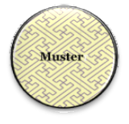
9 | The brain can process many things simultaneously. Multi-sensory input facilitates learning  - multi-sensory input creates wider neural networks.  - learning involves the whole body  - ISM Model (Ahsen 1984): Images – Somatic response - Meaning  - doodling  - colors  - lexical furniture  - voctivity  - Manner Mimes  - Movement facilitates learning.  - VMI (Manuela Macedonia)  - Walk and talk | 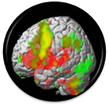
10 | Learning involves conscious and unconscious processes  - Krashen: acquisition and learning play an important role. Allow more room for acquisition in school. Trust your students.  - Peripheral learning (vocab quilts, using the target language, reading…)  - Conscious learning: awareness raising, hypothesis building (finding rules) | 

Types of Memory (Stevick)
Draw a sketch of these processes.
short term memory | - recall within 15-18 seconds  - unintentional, unconscious  - electrically disruptible storage
working memory or “The Worktable” (Stevick 27) | - gives access to whatever is currently in the electrically disruptible short term memory (Stevick 29).  - We can use this memory intentionally, to repeat items, to compare things … (strategies)  - limited capacity, influenced by the “affective filter”  - capacity can be increased by “chunking” (Stevick 31)  - the chunks increase in size as the student gains in experience
long term memory | - can store an amazing amount and variety of information for a long time  - no direct access, content can only be modified by activities on the “Worktable”. Stevick describes a “two-way traffic between the Worktable and the Files (which is) both continuous and complex. Configurations of sensory data are constantly appearing on the Worktable and evoking the retrieval of various kinds of memories from the Files. These memories in turn work with the other material on the Worktable to trigger the formation of new configurations for storage in the Files, and so on. “ (Stevick 30)
declarative memory (Stevick 32 f.) | - conscious, articulable, explicit knowledge  - not all learning starts with declarative knowledge (e.g. child learning to walk, swim, speak…)  - can lead to procedural knowledge by doing sth. (knitting, driving…)  - explicit knowledge (the ability to recite the rules) is quickly lost (e.g. position of letters on keyboard – vs. typing)
procedural memory | - implicit knowledge, e.g. driving, knitting, patterns and regularities of language  - cannot be articulated (only by painstakingly reconstituating the rules)  - can be influenced by activity on the Worktable
episodic memory  (Stevick 37) | - memories of specific situations, including information about different context aspects (place, time, emotions, sounds…..)  - contains personal, dated, autobiographical experiences
semantic memory | - general knowledge of concepts and meanings  - includes information about what usually belongs together (context, collocations, sensations…)
purposes, motifs, intentions | - purposes, motifs and intentions strongly influence the processes on the Worktable and thus have a strong effect on the learning outcomes (Stevick 7)  - only relevant information is processed, the rest (99% or more) is discarded immediately
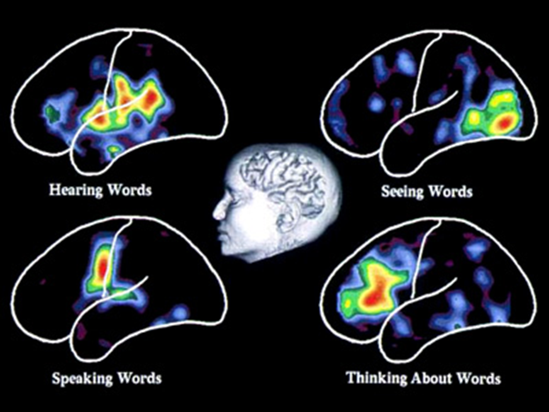
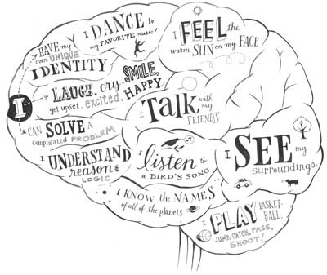

Practical Examples: Teaching grammar to the whole brain

 | Quick Check Grammar Chart | - |  | +
Learning Stages | Awareness raising |  |  |  |  | - Present and practice new grammar in realistic, authentic, contexts that are close to the learners’ experiences.  - Give your learners time to make their own hypotheses and find rules inductively.  - Support the construction of new grammatical concepts (notions) in the learners’ minds through scaffolded (guided) activities where meaning and form connections can be made by the learners.  - Focus on one new concept (notion) at a time or contrast a new concept with one that your learners have already mastered. Do NOT confuse learners by mixing several new concepts and sending them into grammatical minefields.  - Create personalized exercises and activities in which the learners can associate new grammatical concepts and forms with experiences in their (episodic) memory.  - Offer open-ended tasks that require the search for meaning. They lead to more brain activity and more depth of processing.  - Offer grammar tasks that involve several senses (speaking, listening, gestures, images…)  - Use tasks that lead to authentic cognitive processing. e.g.: search for meanings rather than forms. Ask yourself: would anybody do this outside a language classroom?  - Organize group activities. These lead to higher engagement and more “chemical support” of the limbic system.  - Consider your learners‘ affective needs: sense of achievement, fun, relevance. These will strongly influence learning.
Learning Stages | Conceptualization and hypothesis building
Learning Stages | Proceduralization in scaffolded conditions
Learning Stages | Performance in real-time context
Pedagogical Principles and Communicative Criteria | Depth of processing and Complex encoding : Will the learners be mentally active and process grammar, lexis and their “world knowledge”?
Pedagogical Principles and Communicative Criteria | Commitment filter:  Will the learners’ cognitive and affective needs be met? (e.g.: curiosity, problem solving, enjoyment, fun, success)
Pedagogical Principles and Communicative Criteria | Peer and social learning and interaction:  Pair – or groupwork, sharing, oral activities, jigsaw activities…
Pedagogical Principles and Communicative Criteria | Personalisation:  Do the learners have the opportunity to draw on their personal experiences and express their own ideas?
Pedagogical Principles and Communicative Criteria | Contextualisation:  Is the exercise embedded in a clear communicative context?
Pedagogical Principles and Communicative Criteria | Authenticity of process:  Will the learners use language in natural, “language-like” ways (rather than manipulate forms)?
Pedagogical Principles and Communicative Criteria | Task-based:  Do the students fulfil a purposeful task that will have an outcome or end product?
Pedagogical Principles and Communicative Criteria | Testing versus teaching:  Does the exercise support learning or only test it?
Pedagogical Principles and Communicative Criteria | This exercise supports learning processes… |  | 

Examples of Efficient Grammar Activities
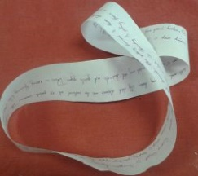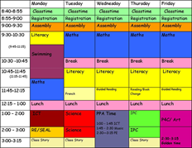 | Talking about routines  and  Describing present activities (What are they doing?)
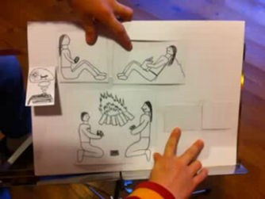 | Describing story backgrounds and circumstances (past progressive)  Talking about past events (past simple)
Do you know how ketchup is made? | Describing processes in the Passive Voice
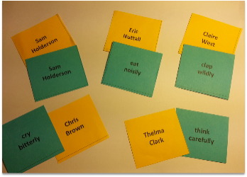 | Describing HOW people do something: Adverbs
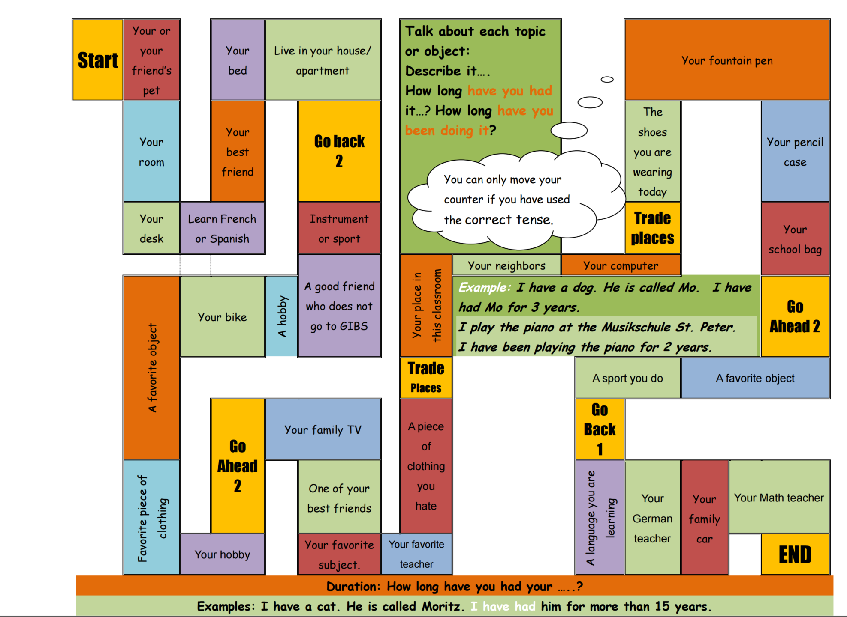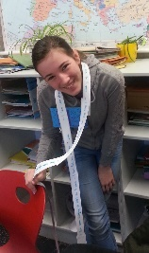 | Talking about how long I have had or done something. Duration: present perfect tense
 | Irregular verb forms:  Verbs raps: memorizing what sounds right
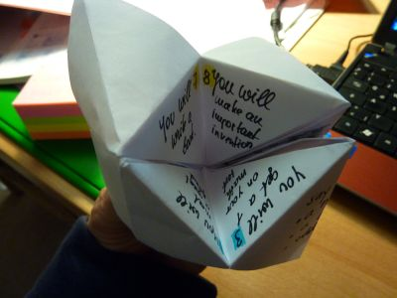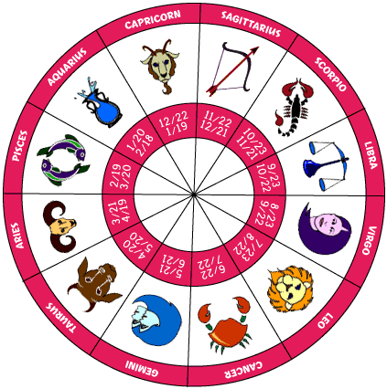 | Predicting the future: (will future)
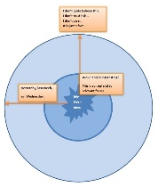 | Reporting and Announcing
Find all these and more materials on www.epep.at

Inductive Learning: Making Hypotheses and Building Rules from Examples
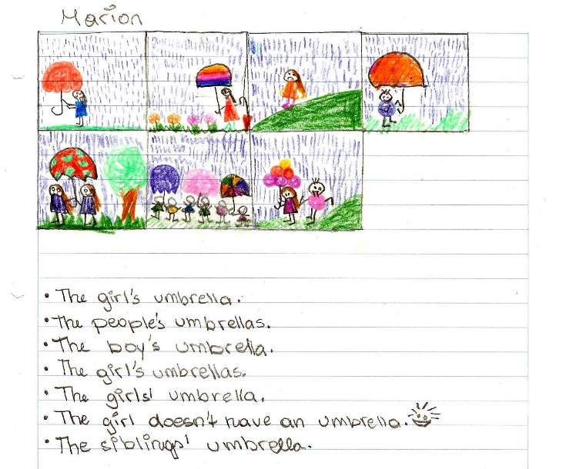
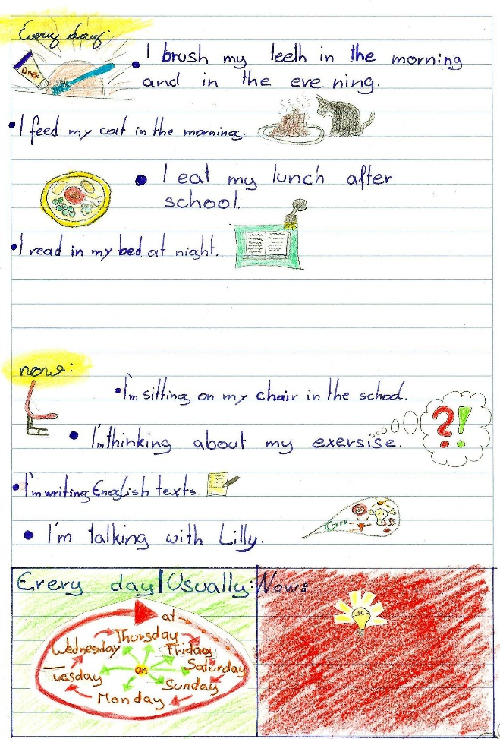
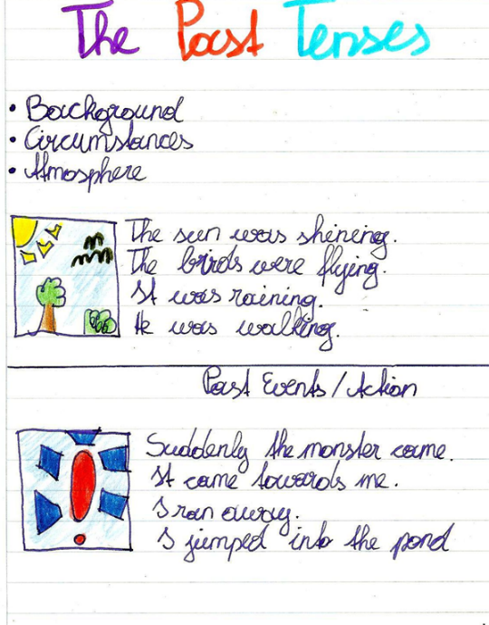
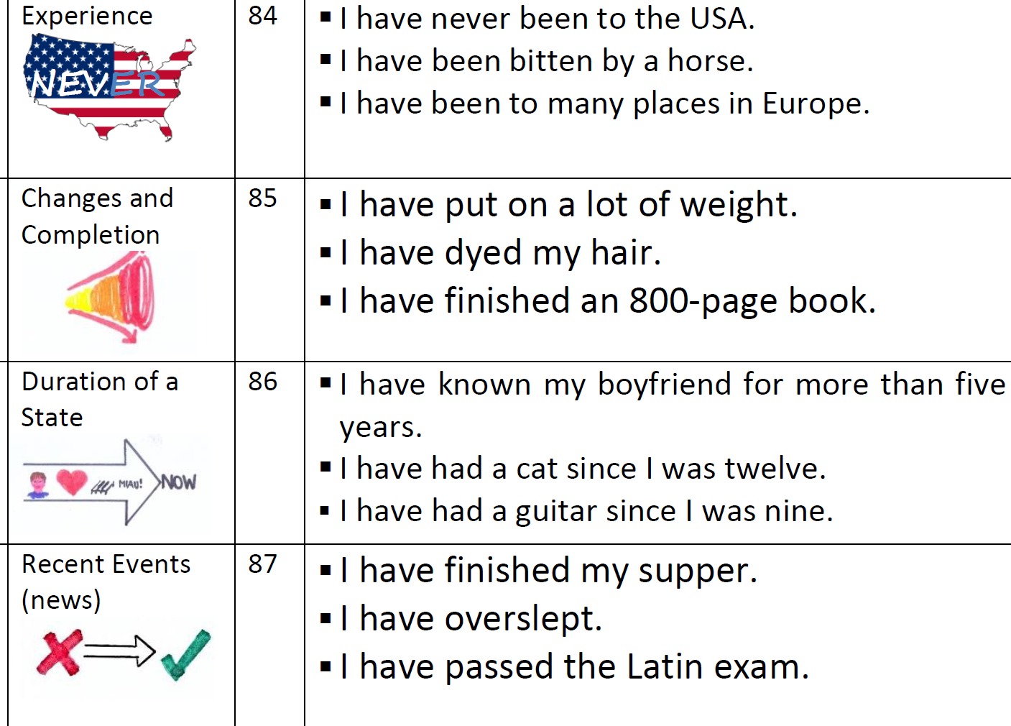
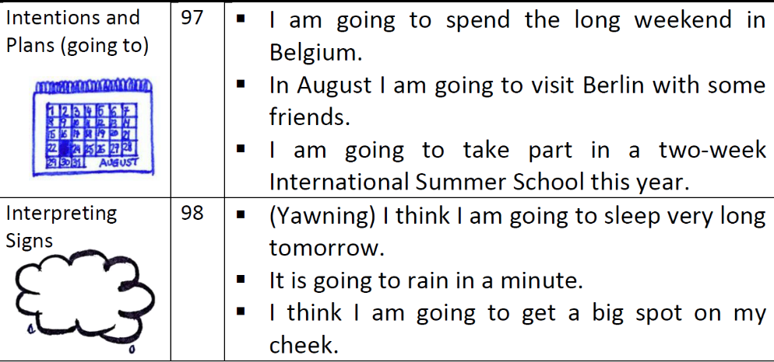

FIP: Format, Imagination and Pride

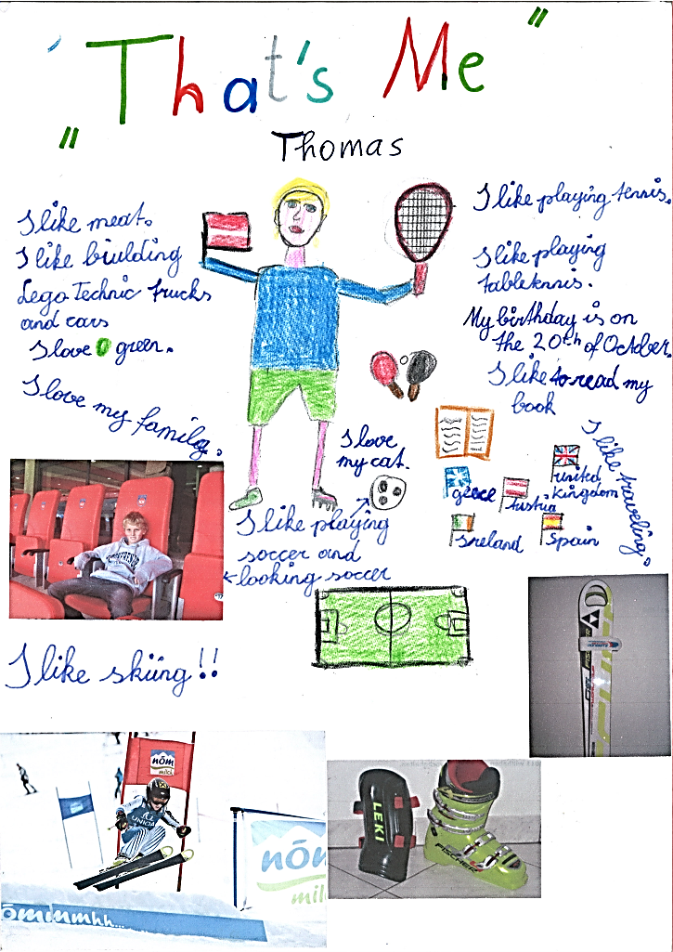
While many textbook units seem only remotely interesting and relevant to the learners, task based learning and project work lead to deeper engagement of the students. The main focus in these projects lies on the content and the meaning. The learners use authentic processes to make sense of the language and use it in realistic, communicative situations. These authentic processes use the learners’ brains in natural ways and thus lead to efficient learning (changes of the neural networks).
Effective projects must be interesting and challenging on the content level and should produce visible results that the learners are proud of. The sense of achievement and pride sets off a positive chain reaction of the limbic system (dopamine cycle) that facilitates learning and encourages the learners to take up the next challenge.
Mini-books Online |  | Origami Books
 | 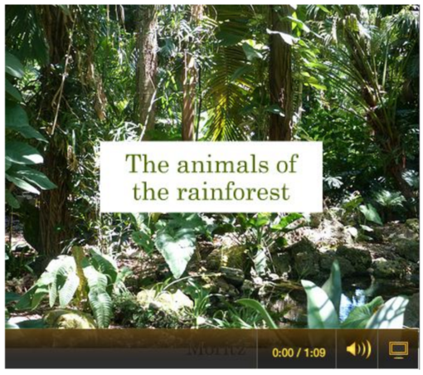 | 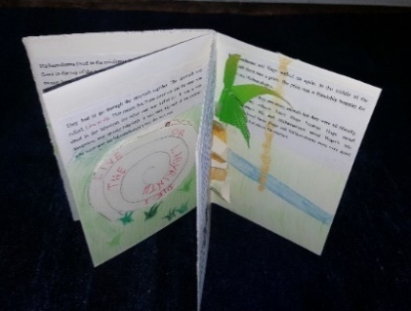 | 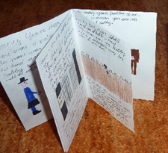
Interactive Posters |  | Audiobooks
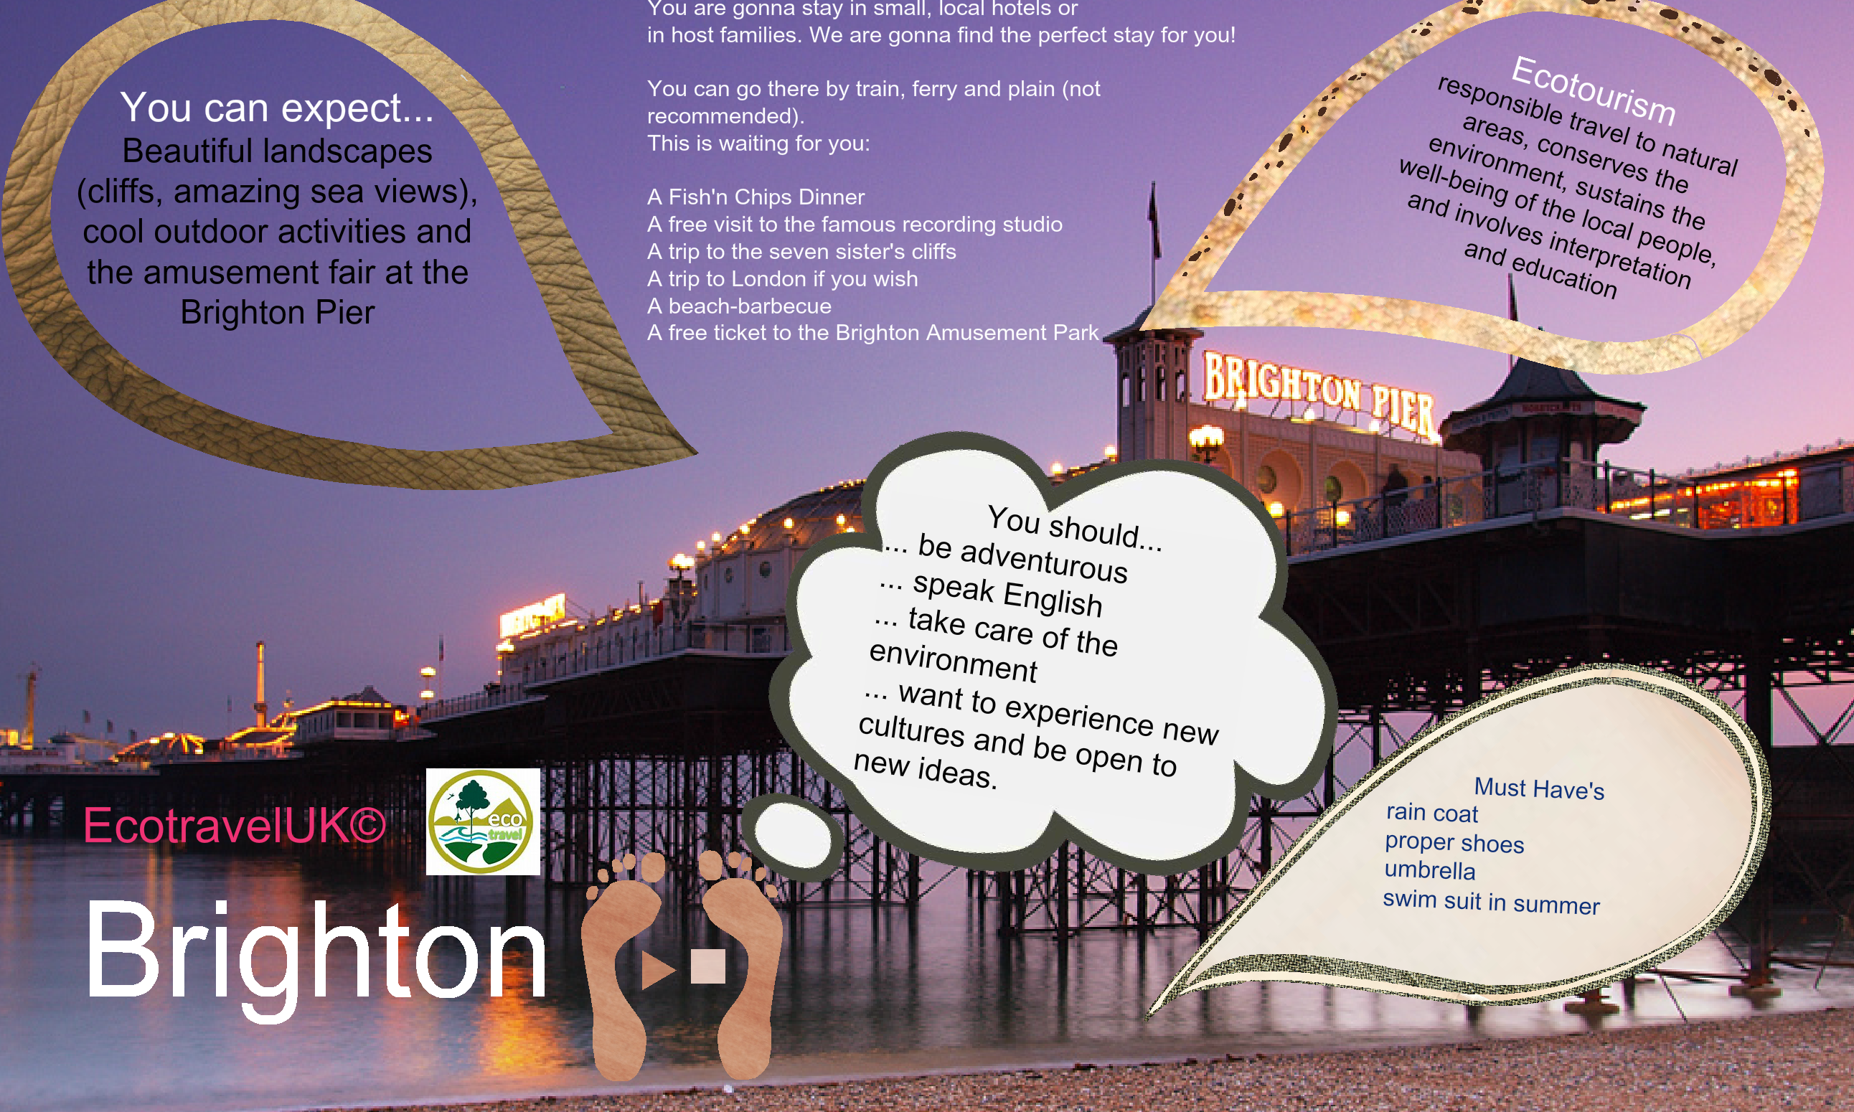 |  | 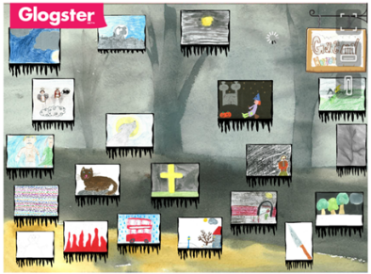 | 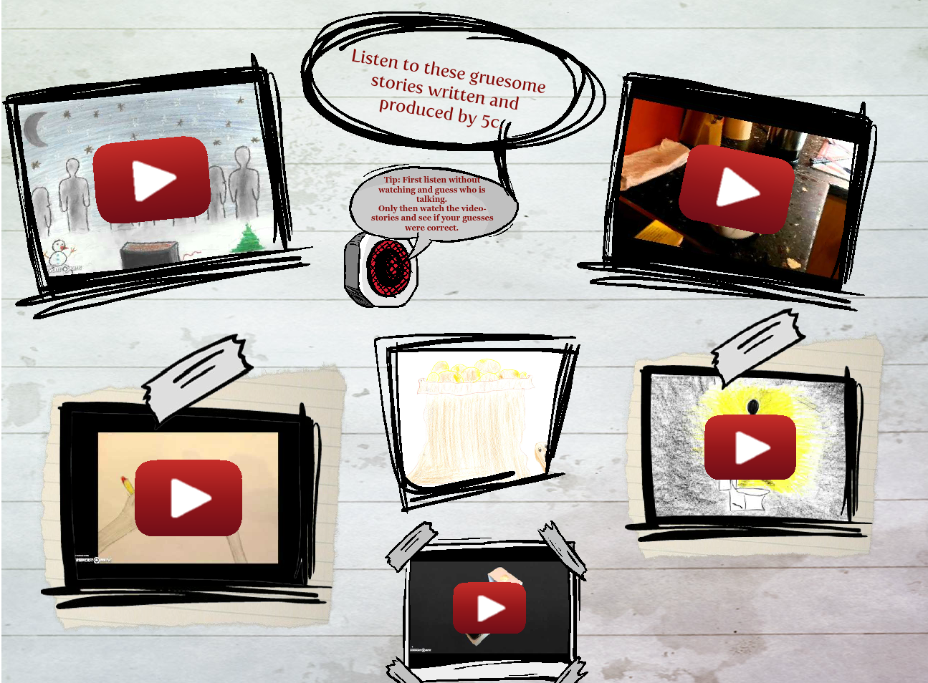

Blogs
 |  | 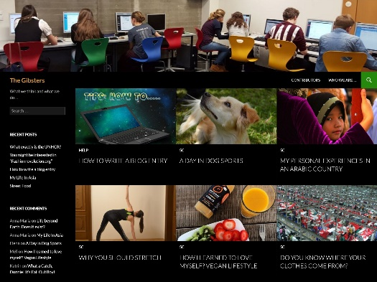

Die Didaktik des leeren Blattes: Diaries, Booklets, Catalogues, Magazines…
„Unser wichtigstes Arbeitsmaterial ist das weiße Blatt Papier, unseres Erachtens das kreativste Material, das es gibt. Es stellt "wahrscheinlich die größte Herausforderung an die Imagination der Kinder dar" stellt Peschel (1996, S.38) fest, nachdem er unsere "Pädagogik des weißen Blattes" kennengelernt hatte. Das leere Blatt fordert oder provoziert geradezu die kindliche Phantasie es zu füllen. Wie, das sagt ihm weder das leere Blatt, noch sagen wir´s. Das Kind muss selber entscheiden und gestalten. Ein Arbeitsergebnis ist zu dokumentieren, ein Sachthema zusammengefasst darzustellen, um in ein gemeinsames Buch zu kommen. Welche Informationsquellen benutzt werden und wie, überlassen wir vollständig dem Kind. (Zehnpfennig/Zehnpfennig 1992)“

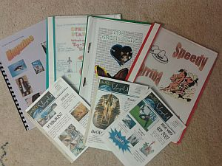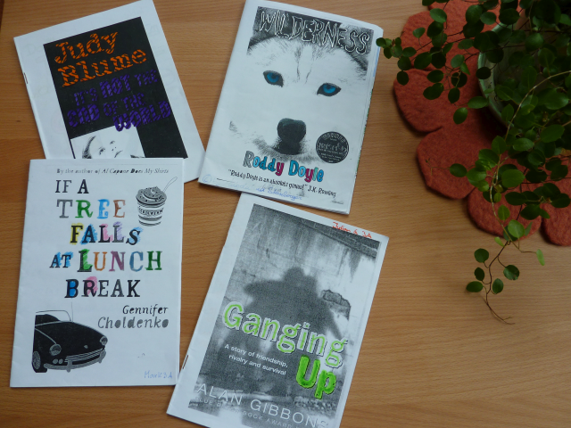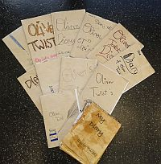


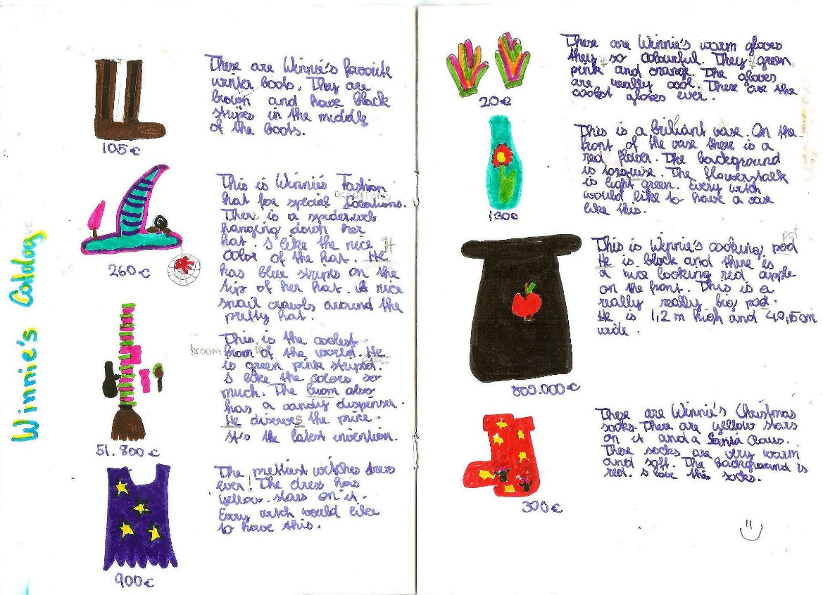

Fair
Have a look at the booklets displayed on the tables and discuss the following questions:
- What have the students learned?
- How much effort have the learners put into these projects/products?
- What skills were involved?
- What can you say about the learners’ range of vocabulary and accuracy?
- What might be missing? What have the students NOT learned here that they would have learned from a textbook unit?
Creativity
Commitment
Effort
Text-types

Teaching Vocabulary to the Whole Brain

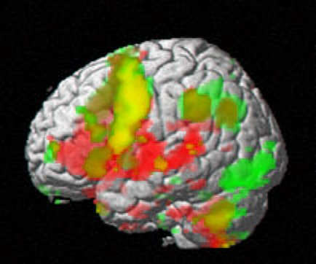

How to create multisensory images in the learners’ brains

The ISM Model
According to Ahsen’s ISM model (Ahsen, 1984) our memory stores “multisensory images” consisting of Images, Somatic responses and Meanings (ISM). These three elements are constantly interacting and interlocking. In general it can be said, that what has been experienced personally is most memorable and will have the most visual and somatic elements attached, followed by richly imagined input, and lastly by input that has only been understood form words. (Stevick, 1996, S. 49)
Images:
- visual stimuli, things we have actually experienced
- mental images, things we have actively imagined
- imagery derived from descriptions in words
Somatic response:
- our body’s reaction to the sensory images (skeletal, muscular, endocrine changes…)
- may be very strong or fleeting and negligible, depending on the input
Meaning:
- includes the full spectrum including lexical meaning, expectations, involvements, purposes
- example: What does the word “bakery” include for you?

VMIs: Voice Movement Icons
The research of Macedonia also shows that meaningful multisensory input leads to better learning of new items. (Macedonia & Müller, 2011)

Dos and Don'ts
- students select useful phrases from meaningful contexts | - never teach single words
- when writing vocab always write phrases rather than individual words | - discourage learners from writing vocab lists in the traditional 2-column vocab-books
- practice collocations
- use all the senses (see activities on the next page)
- make learners say the new phrases out loud several times
- when writing vocabulary use lots of space for each new item so learners can add collocations, sample sentences, doodles etc.
- translating a phrase is often more helpful than long and complex definitions in the target language

Vocabulary Practice Session
Work with a partner (no big groups, please)

1. VMIs: Choose 10 difficult phrases from your vocab-collection and find fitting voice-movement-icons for them. Play with these VMIs. Make the moves, your partner says the words, find a rhythm…

2. Doodling: Open your vocab collection on the first page, start with the first phrase of student A. Read out the phrase and imagine a scene around it. Try to visualize it, see a clear picture or situation. Then draw a quick and simple doodle/symbol/logo that somehow represents your phrase. Explain your doodles to each other. Do they have anything in common?
Now it’s student B`s turn. Role a die and land on a new phrase on your first vocab page. Design new doodles for this phrase…
Do this for 5 phrases each.

3. Colors: Keep rolling the die to select random phrases.
For the next 10 phrases (5 of student A, 5 of student B) choose a typical color that reminds you of the phrase. Again try to visualize as much as possible. Explain your choice of color to each other.

4. Sounds: For the next 10 phrases try to “listen” to your phrases. What do you hear? Can you hear any background noises (e.g. For the phrase “Black Americans were discriminated against.” You might hear shouting, gunfire, rioting, sighs, crying…) Be creative and list all the sounds and noises you can imagine “around” your phrase.

5. Opposites: Find opposites or “diagonal opposites” for 10 recent phrases in your collection.

6. Usage -- Find a second example: Choose 10 new phrases from the texts we have recently read. Find a second example of the word’s usage in your MLD (or freesearch.co.uk) and add these to your collection.


7. Lexical Furniture: Find suitable places for 10 new phrases in your home and discuss them with your partner(s) Imagine your phrases were pieces of furniture. Where would you put them in your house? E.g.: I’d put the “scientist” into my bathroom, because it is white and sterile like a lab.
I’d put the phrase “the amount of water vapor will increase…” in my kitchen or bathroom. When I take a shower, there is a lot of water vapor in the air, when I boil water for pasta, the water vapor or steam rises from the pot.

Blackout
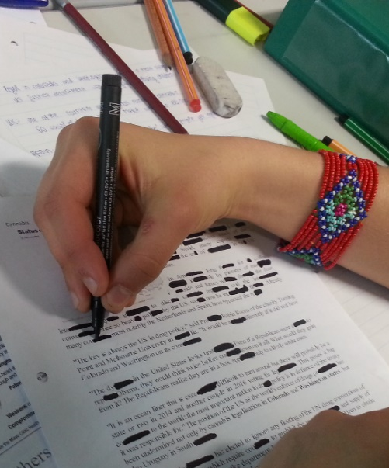
Hand out a page of text that is interesting and suitable for the learners your teaching topic. Allow students to read it and ask any vocab questions they might have. Make sure the learners understand the text.
Pairs then start blacking out parts of words and sentences with thick black markers. They read and re-read the text and keep blacking out more and more letters and words.
How far can they go --- and still read the text?
Option: The pair that can black out most wins a prize.

Try this with the following text:
Learning vocabulary by reading
The way you learned very many of the words in your own language was by meeting them in the books and magazines you read. The context of a new word in a sentence or story was often enough for you to guess the meaning. Meeting the word again and again in your reading helped you learn it for use in your own speaking and writing. Doing lots of extra reading for pleasure - both fiction and non-fiction - is an excellent way to learn new English words, too. But choose books that you find quite easy to read. Difficult stories or texts that you struggle to understand will not help you to develop your vocabulary the natural way. But remember: to learn new words from reading you have to read A LOT! For a more detailed explanation of the role of reading read Stephen Krashen’s book Free Voluntary Reading, Libraries Unlimited, 2011

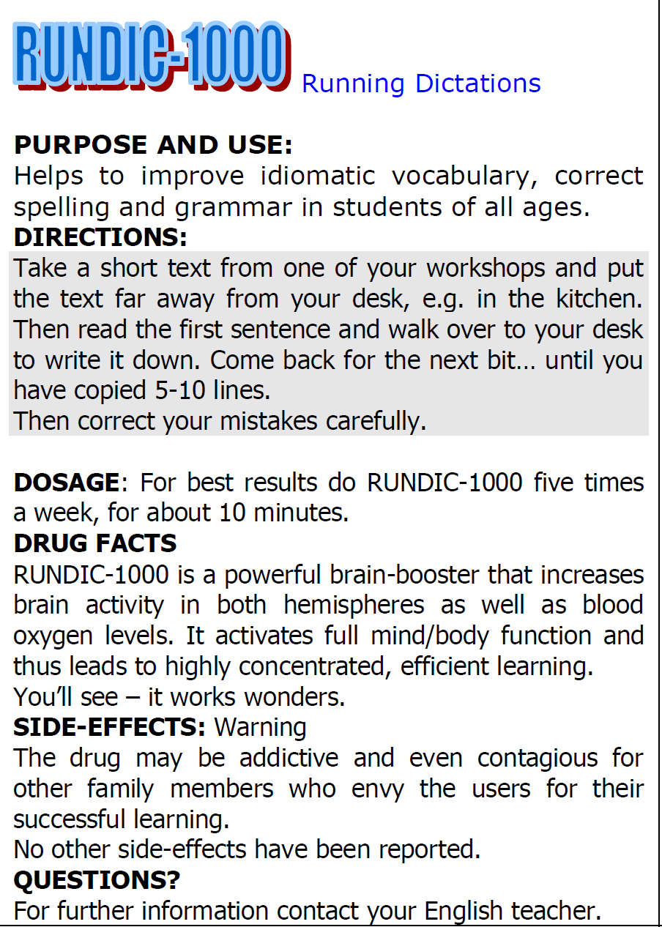
Running Dictations for all ages
Running dictations practice language (vocab and grammar) in meaningful contexts. Movement and high concentration make this a highly effective activity.
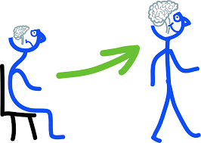

Making Associations – Building Networks
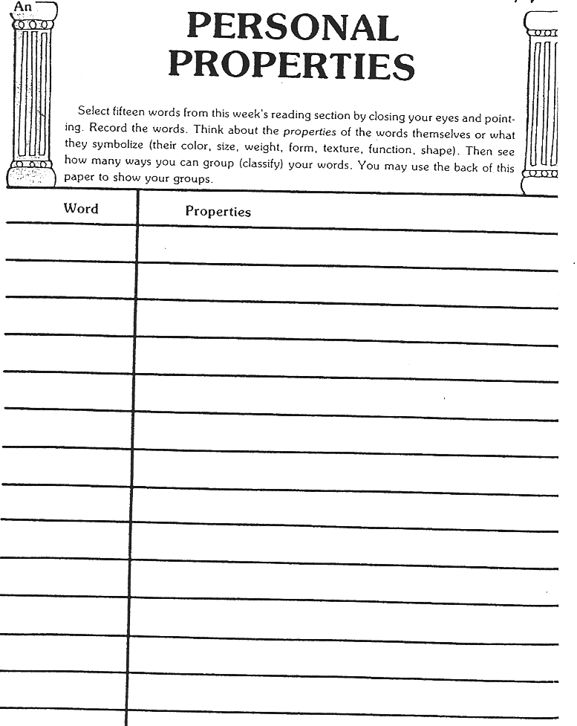

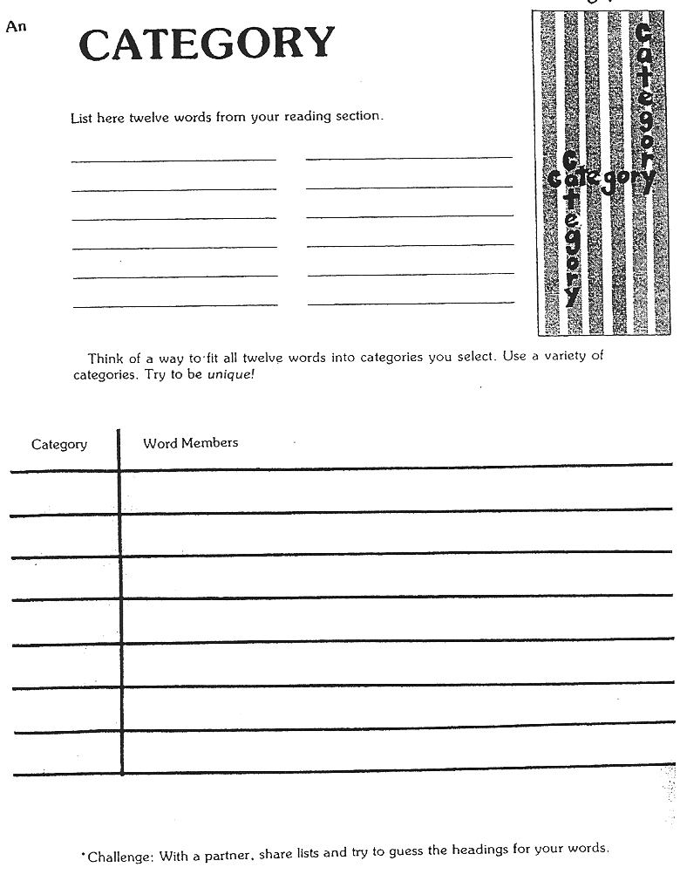

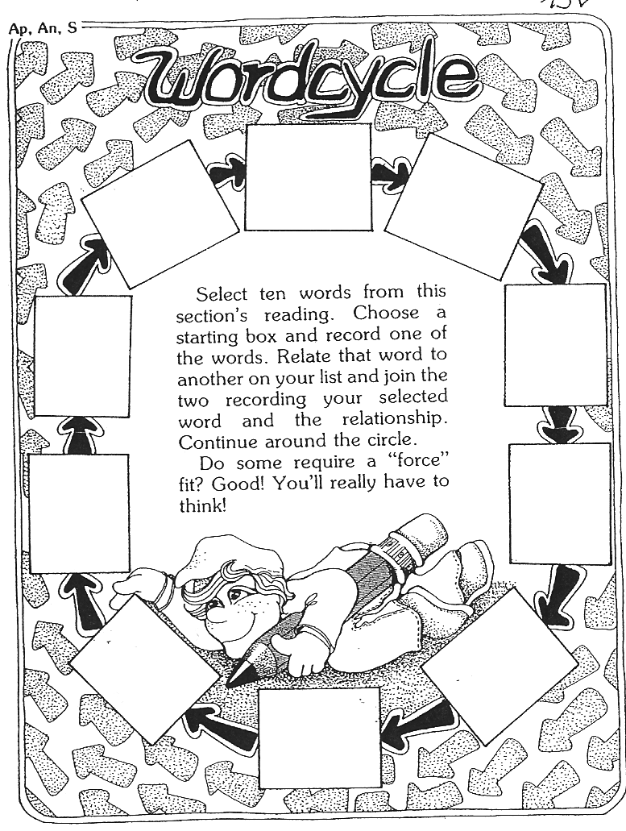
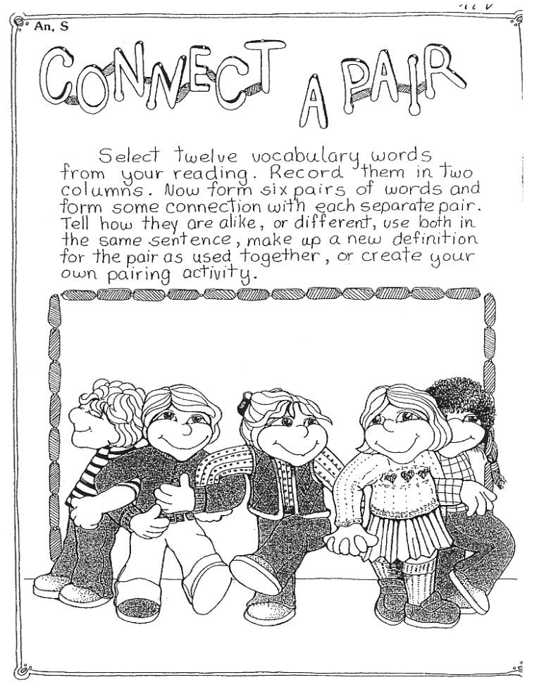

Find these and many more excellent activities in Janice Szabos et al., Reading, A Novel Approach, Good Apple Inc., 1984 (Szabos & Filkins, 1984)

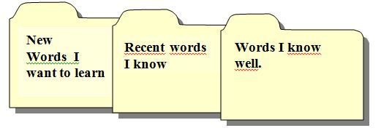
The Vocab-Box
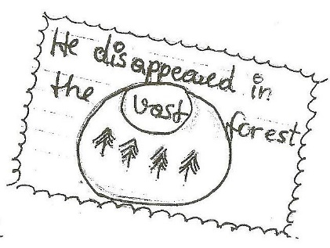

It would be even better to write: Tobi discovered the mouse behind the sofa. – This would remind the student of the story context where he/she encountered the word.

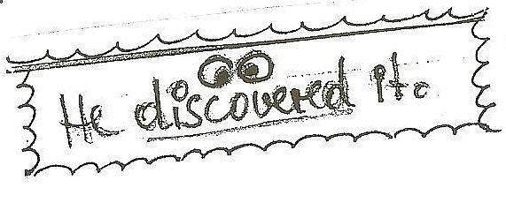

Pro: By working with the vocab. box students regularly revise difficult words rather than going through endless lists of known words as they do with vocab. books. They use their hands and “manipulate” each expression
Con: Cardfiles may be messy, they are hard to check. Tip: Students write the new words on cards and keep this new set in the very front of the box for the teacher to check. Only then can the cards be moved back! Also ask willing parents to help check the box!

Procedure:
Students write their new words on cards (A8) . The cards only contain one expression! The nicer they are the better!!! (Depending on the level of your students, encourage them to use some of the techniques below: drawing words, write yourself in, shapes, calligraphy, collocations, synonyms, antonyms...) SS then put the cards in the first category:
1. New Words I Want to Learn.
When studying vocab. the students work with the cards and are allowed to move them into the next category if they know the item and can spell it correctly. The following categories are titled:
front of card: German translation and/or drawing/doodle of the word
back of card: English word (always used in a short personalized sentence or a collocation:
e.g: “I’ve never been to Greece.” “Our English teacher is very strict”)

2. Recent words I know
These cards will eventually be stored in a shoe-box when vocab.box is full)

3. Words I know well

Working with the box:
Important: Practice this in class several times. Then students will do it at home.

Step 1. Walk and Talk
Students take a selection of new cards and walk up and down the hallway speaking the new phrases out loud. They try to find a rhythm for each phrase and repeat it many times until it sounds natural to them. For difficult phrases they also find a voice-movement-icon (VMI) that they associate with the word.
Encourage the learners to use gestures, facial expressions and tone of voice to express the meaning of the new item. This will create more associations and wider neural networks.
Example: The boy was appalled. (make a face, say it in an emotional way, use your hands…)

Step 2: Write and check
Students read the German phrase on a card and write the English translation into their vocab-practice books. Then turn over the card and check + correct if necessary.
The teacher can easily check the work by collecting the vocab-practice books from time to time.

Vocab Books and Vocab Cards
Word: Color/Picture/Doodle

Sentence I found in my reading:

Second example sentence from my dictionary:

Useful collocations:

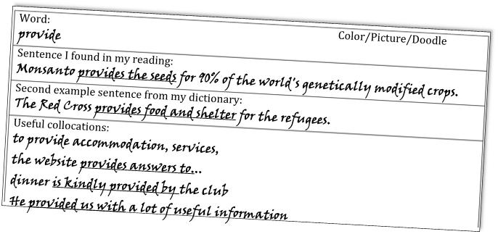

Word: Color/Picture/Doodle
criticism
Sentence I found in my reading:
The government has received a lot of criticism for increasing taxes
Second example sentence from my dictionary:
Scientists have raised strong criticisms of creationist ideas.
Useful collocations  receive criticism  express criticism  provoke criticism  respond to criticism  avoid criticism | heavy criticism  constructive criticism  severe criticism  fierce criticism  bitter criticism

Whole class activities for practicing collocations

Remember: the best way to learn new vocabulary is to use it actively in meaningful contexts. This is best done in a task-based approach where students work on a project actively and produce a high quality product. These products can be oral (interviews, radio-shows, presentations) or written (project books, articles, diaries…). By preparing their products in groups the students will be using the language more actively and they will speak and hear the new expressions many times and thus integrate them well into their existing networks.
Find ideas for such projects on epep.at: Reading projects, book-making, booklets, interviews, presentations, blogs…
Once in a while, it might still be helpful to do specific vocab-activities in class. The following games might be used for this purpose.

As Easy as Possible (Lewis, 2000, p. 104)
Two teams are competing against another. You will need one collocation dictionary per group.
Give each team a list of 10 nouns which are headwords in the collocation dictionary. Choose nouns that are appropriate to the level and interests of the learners.
Groups get 10 minutes to prepare: They list 5 common collocates from the dictionary for each noun.
Team A then slowly read out their collocates while team B try to guess the noun. Team B may write down the collocates as they are being read out.
If they guess correctly after one collocate, Team A scores 5 points, if they need 2 collocates team A scores 4 points and so on.
Teams A and B take turns guessing and reading their lists.

The Collocation Game: adapted from (Lewis, 2000, p. 104)
Prepare a list of nouns with lots of verb or adjective collocates.
Tell the learners that all the words in one list collocate with the same noun. They have to guess that noun.
When they think they know the noun, they stand up/or say “Bingo” and write the noun on their sheet.
This game can be played in teams or as a whole class. Learners collect points for their teams or for themselves.

Odd verb out
One verb in each line does not collocate with the noun. Cross out the one which does not fit.
- accept ,act on ,disregard ,follow ,ignore, make ,solicit, take ADVICE
- come up with, do, expect, get, require, supply AN ANSWER
- build up, close down, set up, put off ,take over ,wind up A BUSINESS
- deal with, do, examine, ignore, reject, respond to A COMPLAINT
- accept, answer ,come in for, give rise to ,make, reject CRITICISM
- describe, do, enjoy, have, recall ,share AN EXPERIENCE
- crash, finish ,hire, park, repair, run, service, start ,write off A CAR
- arrange, do, gatecrash, go to, have ,throw A PARTY

Vocabulary Quilt
Choose one of your favorite new expressions from your book and write it on a piece of colored paper. Write a short, typical sentence and decorate the paper in a suitable way. Your paper must include:
- the new word written in big letters
- a typical sentence
- a drawing that will help you remember the new phrase.
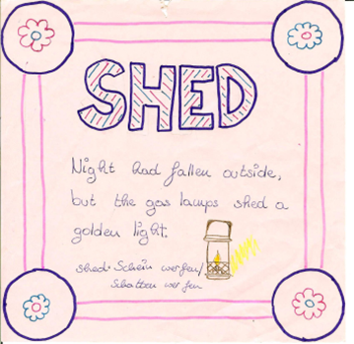
We will put all our word cards together to make a Vocabulary Quilt. Please design your cards nicely.
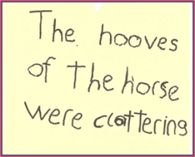

Synonyms:
Three essays, each pair gets one only
- Work with a partner. With the help of your dictionary find suitable synonyms for 10 words or phrases in the text.
- Write a list of these synonyms on a sheet in random order.
- Pass your text and the list of synonyms on to another group. Ask them to find the matching phrases in the text and write them next to your synonyms on the list
- Then work on the lists you get from the other two groups.

Oral Gaps:
Work with a partner. First read through one of the essays very carefully and make sure you know all the words. Use your dictionary. Together underline all the fancy expressions that you might not be able to use actively yourself.
Now take turns. Read a paragraph to your partner and stop before each underlined word. Ask your partner to supply the word…
download the boards from epep.at

Voctivity
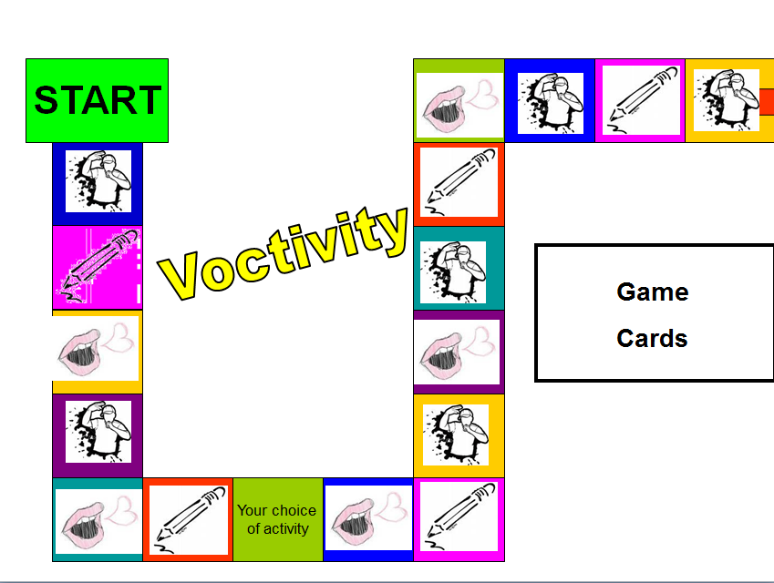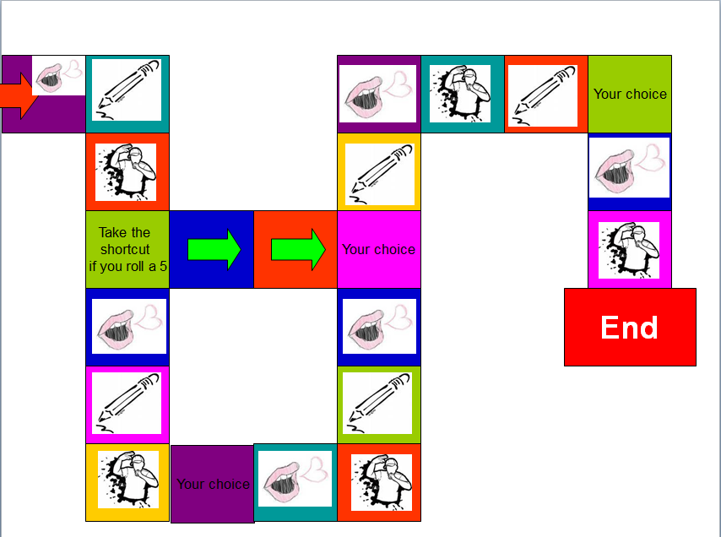
Rules of the Game:
Write or choose 5 new vocab cards per person. Put them in the center. Use these cards as in the game “Activity”. Act, draw or paraphrase the word or phrase on your card. The player who guesses what you are showing may go next.
If you find the game very difficult, go through all the cards before you play and make sure you understand all the phrases that your friends have chosen.

Testing Vocabulary

Remember: Use 99% of your class-time for teaching and only 1% for testing. If you teach a lot and students are ACTIVELY using the language in class, they will learn a lot more than by studying vocab for a test or revision. In task-based learning the students will meet and use the new vocabulary items many times in order to complete a project. By doing these activities they will build multidimensional networks as discussed above and will thus integrate the new vocabulary into their permanent storage. Encourage the learners to choose items they find useful and want to remember and transfer these on vocab cards or into their vocab books.
In some cases a short vocab revision might still be useful. Just like teaching vocab, always test vocabulary IN MEANINGFUL CONTEXT.
What do you want to test? For a good presentation about testing vocabulary, go to
http://www.slideshare.net/songoten77/testing-vocabulary
You will also find the link on the vocab page on http://epep.at
- Word recognition and comprehension?
- Word usage?
- Word building and word form?
- Spelling?

Useful test-formats:
- Textwriting: In the new assessment scales “lexical and structural range” are important criteria for assessment. Make this visible for the learners. Always give feedback on style and range of vocabulary. Do not only mark the wrong expressions. This will lead to avoidance strategies.
- Describe the picture: (e.g.: picture of classroom// Name 10 things you see in Sally’s pencil case// What is Peter wearing today? // Describe the atmosphere of the picture. For more advanced students use postcards, pictures from the textbooks… Describing a picture can also be used as an oral vocab exam.
- Writing short text passages or dialogues: (e.g.: Give weather symbols, students write forecast for the following days.)

- Gap filling: Give the first letter or a jumbled version of the missing word where the first and last letters are correct. If a student knows the word he/she will immediately recognize it, if the student doesn’t know the word, these letters won’t help much.
Try this: Arocdnicg to rsceearch at Cmabrigde Uinervtisy, it deosn’t mttaer in waht oredr the ltteers in a wrod are, the olny iprmoatnt tihng is taht the frist and lsat ltteer are in the rghit pcale. The rset can be a toatl mses and you can sitll raed it wouthit pobelrm. Tihs is buseace the huamn mnid deos not raed ervey lteter by istlef, but the wrod as a wlohe.

- Oral Vocab Revisions: Students bring their vocab box, teacher asks 10 random cards while the class is working on other things.
- Crosswords: Use very clear clues or pictures.
- Matching and multiple-choice: not recommended – It is very difficult to produce good tests. If you really want to use these, check this website for ready-made tests: http://www.vocaboly.com/vocabulary-test/

Appendix:

Sample texts for vocab activities
Read the following text and collect 10 useful collocations
Sample texts to be used with the vocab activities
Then prepare vocabulary cards for 5 of them.

The World According to Monsanto' - Exposing One of the Most Evil Corporations on Earth
- The Real News Network, June 23, 2008
Straight to the Source
Monsanto is a world leader in industrial agriculture, providing the seeds for 90 percent of the world's genetically modified crops. In an interview with The Real News Network, filmmaker Marie-Monique Robin discussed her recent film 'The World According to Monsanto' in which she exposes many of Monsanto's controversial practices, from concealing knowledge of toxicity of PCBs to producing genetically modified seeds and related herbicides.
Monsanto has a long history of manufacturing dangerous products. In 1949, an explosion in Nitro, a Monsanto factory in the US, caused 228 workers to develop an extremely disfiguring illness caused by dioxin, a highly toxic by-product of 2,4,5-T, a powerful herbicide manufactured in the factory.
Monsanto's product Roundup, an herbicide which Monsanto advertised as biodegradable, is still sprayed on crops by unprotected farmers in Paraguay even though Monsanto has already been convicted twice of false advertising for the product.
Robin also denounces Monsanto for not only denying that it ever heard of Agent Orange, a herbicide sprayed by the US Army on crops during the Vietnam war and which Monsanto had in fact manufactured, but also for manipulating scientific studies to hide links between Agent Orange and cancer.
According to Robin, Monsanto has bought fifty seed companies in the last ten years. In a clip from Robin's film, physicist and ecologist Dr. Vandana Shiva warns: "Once [Monsanto has] established the norm that seed can be owned as their property, we will depend on them. If they control seed they control food. It's more powerful than bombs. This is the best way to control the populations of the world."
In a Monsanto declassified file is found the sentence, "we can't afford to lose one dollar of business" even as toxicity of PCBs was discussed. This, Robin says, sums Monsanto's philosophy rather well.
Watch the full interview here: "The World According to Monsanto"
CONTACT: The Real News Network Alain Latour, 416-916-5202 smcommunications@therealnews.com
Read the following text and collect 5 useful collocations for lower intermediate learners.
Then prepare vocabulary cards for them.

A Note about Witches
from Roald Dahl, The Witches

In fairy-tales, witches always wear silly black hats and black cloaks, and they ride on broomsticks. But this is not a fairy-tale. This is about REAL WITCHES.
The most important thing you should know about REAL WITCHES is this. Listen very carefully. Never forget what is coming next.
REAL WITCHES dress in ordinary clothes and look very much like ordinary women. They live in ordinary houses and they work in ORDINARY JOBS.
That is why they are so hard to catch.
A REAL WITCH hates children with a red-hot sizzling hatred that is more sizzling and red-hot than any hatred you could possibly imagine.
A REAL WITCH spends all her time plotting to get rid of the children in her particular territory. Her passion is to do away with them, one by one. It is all she thinks about the whole day long. Even if she is working as a cashier in a supermarket or typing letters for a businessman or driving round in a fancy car (and she could be doing any of these things), her mind will always be plotting and scheming and churning and burning and whizzing and phizzing with murderous bloodthirsty thoughts.

Checklist for brain-friendly language teaching
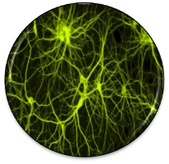 | - How am I going to activate my students‘ prior knowledge?
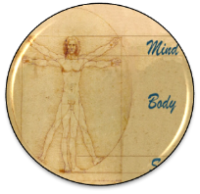 | - What am I going to do in order to create a positive, relaxed and challenging atmosphere?
 | - Is the topic / text / task really interesting and relevant form my learners?
Speicherung | - How am I going to help the learners to proceduralize the new concepts?  - How can I activate episodic memory?  - How can I create pictures in my learners‘ minds?
 | - How can I create opportunities for social interaction among the learners?
 | - How will the learners be able to see their own success and feel proud of their work?  - How will the learners present their products?
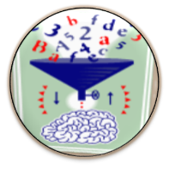 | - How am I going to create opportunities for hypothesis making?  - How am I going to prevent mindless application of the grammar rules given in the textbook?
 | - What examples of authentic communication am I going to present to my learners in order to support pattern building?  - What exercises will support pattern building?
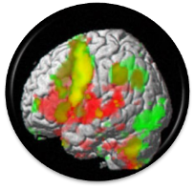 | - How can I activate different areas of my learners’ brains?
 | - How can I create opportunities for peripheral learning and unconscious learning?

Bibliography:
Ahsen, A. "ISM: The triple code model for imagery and psychophysiology." Journal of Mental Imagery 8.4 (1984): 15-43.
"becindonesia.com." 07 2009. 6 11 2011. <http://www.becindonesia.com/smg/wp-content/uploads/2009/07/Brain-Functions.jpg>.
Buchers, Sam. Vocabulary Cartoons II. Punta Gorda FL: New Monic Books, 2007.
Caine, R.N. and G. Caine. "Understanding a Brain-Based Approach to Learning and Teaching." Educational Leadership 48.2 (1990): 66-70. 06 11 2011. <http://www.sedl.org/scimath/compass/v03n02/1.html>.
Caspary, Ralf. "Dopamindusche im Klassenzimmer." Caspary, Ralf. Lernen und Gehirn. Freiburg im Breisgau: Herder, 2006.
"Flickr." 21 03 2009. Flickr. 06 11 2011. <http://www.cogiscent.com/wp-content/themes/thesis/rotator/neural%20network%20rotator.jpg>.
Gough, Chris. English Vocabulary Organizer. Andover, UK: Heinle, Cengage Learning, 2002.
Hannaford, Carla. Smart Moves: Why learning is not all in your head. Arlington, Virginia: Great Ocean Publishers,, 1995.
Herrmann, Ulrich. "Gehirnforschung und die neurodidaktische Revision schulisch organisierten Lehrens und Lernens." Herrmann, Ulrich. Neurodidaktik. Weinheim und Basel: Beltz, 2006.
Lee, Rebecca. "Flickr." 06 10 2011. Rebecca Lee. 06 11 2011. <http://dickinsonn.ism-online.org/files/2011/10/Neurons-in-the-brain-illustration-by-Rebecca-Lee-on-flickr.jpg>.
Lewis, Michael. Teaching Collocation. Heine, 2000.
"Living with Alzheimer's." 06 08 2011. alz.org. 06 11 2011. <http://www.alz.org/living_with_alzheimers_your_brain.asp>.
Macedonia, Manuela and Karsten Müller. "The impact of iconic gestures on foreign language word learning and its neural substrate." Human Brain Mapping (2011): 982-998.
McCarthy, Michael and Felicity O'Dell. English Phrasal Verbs in Use, Advanced. Cambridge: Cambridge University Press, 2007.
McCarthy, Michael and O'Dell Felicity. Academic Vocabulary in Use. Cambridge: Cambridge University Press, 2008.
Mercer, Sarah. "Mindful Use of Praise." erscheint demnächst. 2011.
Morgan, John and Mario Rinvolucri. Vocabulary, Resource Books For Teachers. Oxford: Oxford University Press, 1986.
Newby, David. Grammar for Communication. Wien: Österreichischer Bundesverlag, 2001.
—. Grammar for Communication: Exercises and Creative Activities. Wien: Österreichischer Bundesverlag, 2001.
Redman, Stuart and Robert Ellis. A Way With Words, Book 1. Cambridge: Cambridge University Press, 1989.
Ridzka, B., et al. The Words You Need. London: Macmillan , 1981.
Roth, Gerhard. "Warum sind Lehren und Lernen so schwierig?" Herrmann, Ulrich. Neurodidaktik: Grundlagen und Vorschläge für gehirngerechtes Lehren und Lernen. Weinheim und Basel: Belz, 2006.
Schachl, Hans. Was haben wir im Kopf? Die Grundlagen für gehirngerechtes Lehren und Lernen. Linz: Veritas, 2006.
Scholastic Professional Books. Super-Fun Reading and Writing Skill Builders. Scholastic Professional Books, 1999.
Spitzer, Manfred. Lernen. Gehirnforschung und die Schule des Lebens. Heidelberg/Berlin, 2002.
Spitzer, Manfred. "Medizin für die Schule." Caspary, Ralf. Lernen und Gehirn. Freiburg im Breisgau: Herder, 2006.
Stevick, Earl W. Memory, Meaning and Method. Boston: Heinle, 1996.
Szabos, Janice and Vanessa Filkins. Reading, A Novel Approach. Good Apple Inc., 1984.
Tanushree. 04 03 2011. India Talkies. 06 11 2011. <http://www.indiatalkies.com/2011/03/brain-functions-based-familys-genes.html>.
Woolard, George. Key Words for Fluency, Intermediate. London: Thomson, 2005.
Zull, James. The Art of Changing the Brain: enriching teaching by exploring the biology of learning. Sterling, Virginia: Stylus Publishing, 2002.

Older students can also add a few collocates.

