Checklist for brain-friendly language teaching
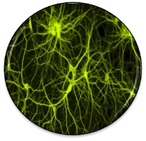 | - How am I going to activate my students‘ prior knowledge?
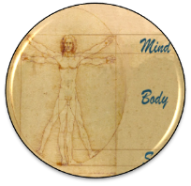 | - What am I going to do in order to create a positive, relaxed and challenging atmosphere?
 | - Is the topic / text / task really interesting and relevant form my learners?
Speicherung | - How am I going to help the learners to proceduralize the new concepts?  - How can I activate episodic memory?  - How can I create pictures in my learners‘ minds?
 | - How can I create opportunities for social interaction among the learners?
 | - How will the learners be able to see their own success and feel proud of their work?  - How will the learners present their products?
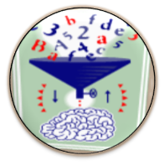 | - How am I going to create opportunities for hypothesis making?  - How am I going to prevent mindless application of the grammar rules given in the textbook?
 | - What examples of authentic communication am I going to present to my learners in order to support pattern building?  - What exercises will support pattern building?
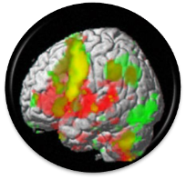 | - How can I activate different areas of my learners’ brains?
 | - How can I create opportunities for peripheral learning and unconscious learning?
©E. Pölzleitner Find examples of brain-friendly tasks on :http://www.epep.at
Checklist for brain-friendly language teaching
 | - How am I going to activate my students‘ prior knowledge?
 | - What am I going to do in order to create a positive, relaxed and challenging atmosphere?
 | - Is the topic / text / task really interesting and relevant form my learners?
Speicherung | - How am I going to help the learners to proceduralize the new concepts?  - How can I activate episodic memory?  - How can I create pictures in my learners‘ minds?
 | - How can I create opportunities for social interaction among the learners?
- How will the learners be able to see their own success and feel proud of their work?
- How will the learners present their products?
- How am I going to create opportunities for hypothesis making?
- How am I going to prevent mindless application of the grammar rules given in the textbook?
- What examples of authentic communication am I going to present to my learners in order to support pattern building?
- What exercises will support pattern building?
 | - How can I activate different areas of my learners’ brains?
 | - How can I create opportunities for peripheral learning and unconscious learning?
©E. Pölzleitner Find examples of brain-friendly tasks on :http://www.epep.at
Checklist for brain-friendly language teaching
 | - How am I going to activate my students‘ prior knowledge?
 | - What am I going to do in order to create a positive, relaxed and challenging atmosphere?
 | - Is the topic / text / task really interesting and relevant form my learners?
Speicherung | - How am I going to help the learners to proceduralize the new concepts?  - How can I activate episodic memory?  - How can I create pictures in my learners‘ minds?
 | - How can I create opportunities for social interaction among the learners?
- How will the learners be able to see their own success and feel proud of their work?
- How will the learners present their products?
- How am I going to create opportunities for hypothesis making?
- How am I going to prevent mindless application of the grammar rules given in the textbook?
- What examples of authentic communication am I going to present to my learners in order to support pattern building?
- What exercises will support pattern building?
 | - How can I activate different areas of my learners’ brains?
 | - How can I create opportunities for peripheral learning and unconscious learning?
©E. Pölzleitner Find examples of brain-friendly tasks on :http://www.epep.at
Checklist for brain-friendly language teaching
 | - How am I going to activate my students‘ prior knowledge?
 | - What am I going to do in order to create a positive, relaxed and challenging atmosphere?
 | - Is the topic / text / task really interesting and relevant form my learners?
Speicherung | - How am I going to help the learners to proceduralize the new concepts?  - How can I activate episodic memory?  - How can I create pictures in my learners‘ minds?
 | - How can I create opportunities for social interaction among the learners?
- How will the learners be able to see their own success and feel proud of their work?
- How will the learners present their products?
- How am I going to create opportunities for hypothesis making?
- How am I going to prevent mindless application of the grammar rules given in the textbook?
- What examples of authentic communication am I going to present to my learners in order to support pattern building?
- What exercises will support pattern building?
 | - How can I activate different areas of my learners’ brains?
 | - How can I create opportunities for peripheral learning and unconscious learning?
©E. Pölzleitner Find examples of brain-friendly tasks on :http://www.epep.at

