Workshop: Communicative Grammar in Practice
David Newby, Univ. Graz, Vienna, Bergen,
Elisabeth Pölzleitner, Graz International Bilingual School (GIBS), Univ. Graz

Some quotations from applied linguists
‘The integration of grammar in communicative models currently constitutes one of the hardest pedagogical challenges foreign-language teachers face.’ (Achard, 2004: 165)

‘Most SLA theories, and most SLA theorists, are not primarily interested in language teaching, and in some cases not at all interested.’ Long (2000: 4-5)

‘No pedagogical decision can be made in the absence of a learning theory.’ (Achard: 2004: 176)

Main tasks of grammar pedagogy
Pedagogical grammar refers to measures taken by teachers, learners, materials designers, grammarians etc. to facilitate the development of grammatical competence and the skill of using grammar.

- Grammar rules: describe grammar based on a suitable theoretical model in ways that are transparent for learners; use of appropriate metalanguage/terminology
pedagogical reference grammar, school textbook, lessons etc.
Question for teacher: how shall I explain grammar to my students?
- Grammatical objectives: decide how to specify grammatical objectives
reference grammar, school textbook, lesson plans, teaching materials etc.
Question for teacher: what exactly am I teaching?
- Selection & grading: delimit those areas of grammar to be presented to the learner and establish criteria for the sequencing of grammar
curriculum, school textbook etc.
Question for teacher: how much shall I teach and when shall I teach it?
- Learning aims and processes: consider aims of individual exercises of sequence of teaching in terms of learning processes; how can learning processes be activated and supported?
lesson plans, school textbook, teaching materials etc.
Question for teacher: what do I expect the students to learn from an activity?
- Methodology: devise methodology to facilitate learning - presentation forms, exercises, activities etc.
school textbook, teaching materials etc.
Question for teacher: how can learning aims best be achieved?
- Testing grammar: select areas of grammar and exercise types which fulfil criteria of testing theory (validity, reliability etc.)
Class test design, Matura etc.
Question for teacher: what exactly do I want to test and how can I best do this? Am I testing something that reflects the overall aims of learning and teaching grammar?

Traditional grammar
Traditional grammar refers to a set of pedagogical practices which, it should be noted, would appear to have little theoretical basis, and which can be briefly characterised as follows:
- grammar is regarded as static knowledge rather than as a communicative skill;
- grammatical objectives are defined in terms of grammatical forms, as opposed to meanings;
- methodology is essentially teacher-centred;
- grammar rules are made explicit by coursebook and teacher and used deductively by students;
- a limited range of heavily guided exercises types is used.

Cognitive+Communicative Grammar (C+CG)
(The following is based on Newby, 2003, 2012, 2014a, 2014b, 2015)
C+CG is a theoretical approach to the description and learning of grammar whose principles serve as a comprehensive basis for the design of grammar pedagogy. C+CG theory relates to two separate but complementary aspects of analysis: language description and language learning. It draws on theories and principles from Cognitive Linguistics and the Communicative Approach, or Communicative Language Teaching (CLT) and from cognitive psychology. It thus draws on insights both from linguistics, second-language acquisition and language didactics.
Underlying the C+CG approach are three guiding principles which steer the development of grammar pedagogy:
- the importance of seeing the process of using/ learning grammar from the perspective of the language user/learner;
- the need to understand the cognitive resources available to the learner and the cognitive processes which are activated when human beings use and learn grammar;
- a belief in the centrality of meaning both in the use and in the learning of grammar – grammar is used and learned to express messages.

Notional grammar
- ‘Language is a system for the expression of meaning’ (Richards & Rodgers, 2001: 161)
- ‘Grammar is conceptualisation’ (Croft and Cruse, 2004)

Figure 1: Notional vs. Formal objectives (based on ‘Grammar for Communication’)

Notional objective | Utterance | Formal objective
[referring to a present activity] | You’re being stupid! | present progressive
[arranged activity] | I'm playing tennis tonight. | present progressive
[expressing intention] | I’m going to use my new racket. | ‘going to’ future
[interpreting signs] | It’s going to be a tough match. | ‘going to’ future
[making a prediction] | I’ll probably be back by six. | ‘will’ future
[spontaneous decisions] | I think I’ll change my racket. | ‘will’ future
[reporting experiences] | Have you ever been to France? | present perfect
[expressing duration] | She’s been away for hours. | present perfect
[making an assumption] | I think they must be Irish. | modal - ‘must’
[expressing compulsion] | Your must go to bed now. | modal - ‘must’
[reporting compulsion] | I have to do my homework. | modal – ‘have to’

Notional objectives can be expressed in terms of ‘I can’ self-assessment descriptors like those found in the Common European Framework and European Language Portfolio:
✓ I can express an intention using ‘going to’.
✓ I can refer to past events using the past tense
✓ I can talk about my experiences using the present perfect.

Exercises and activities
It is the task of learning theory to help materials designers and teachers to address three fundamental questions:
a) What causes students to pay attention to, process and make sense of new items of grammar?
b) How do grammatical concepts and forms become stored in long-term memory?
c) How does this new knowledge become automatised so that it is available when students engage in real-time authentic communication?

Learning stages
‘Learning a language entails a stagewise progression from initial awareness and active manipulation of information and learning processes to full automaticity in language use’ (O’Malley and Chamot, 1990: 217).
Figure 2 shows the C+C view of learning stages which can be used in the analysis and design of grammar activities.

Figure 2: A cognitive model of learning stages


INPUT
PROCEDURAL-ISATION
CONCEPTUAL-ISATION
AWARENESS
PERFORMANCE
OUTPUT

Explanation of cognitive learning stages

Input – material provided by the teacher/coursebook with new input + and how it is processed by learners using existing knowledge und schemata and cognitive processes
Learning stages | Awareness | students attend, focus on and notice a new grammar concept or pattern
Learning stages | Conceptualisation | students internalise a rule/generalisation (e.g. through explanation or discovery), and confirm and consolidate this rule (e.g. by heavily guided exercises) so that it enters long-term memory – declarative knowledge
Learning stages | Proceduralisation | students do scaffolded but open-ended activities; they further consolidate the rule and store it long-term memory; they embed the rule within their personal experiences and schemata, the rule become automatised as they use the grammar to generate their own utterances; grammar becomes a skill – procedural knowledge
Learning stages | Performance | skill development, students are able to use grammar in open contexts; focus on the overall message
Output – what students say/ write and their monitoring of their own, and other students’, production

Principles and criteria for assessing grammar activities

Pedagogical Principles – to what extent does a grammar activity support learning by activating and optimising learning processes and thus contribute to the overall aims of learning grammar?
Communicative Criteria – to what extent does a grammar activity support the development of both grammatical and communicative performance by simulating conditions of language use?

Pedagogical principles for evaluating grammar activities
1. Repetition
Learners need multiple contacts with the new language. However, quantity alone is not a sufficient criterion: the quality of the contacts must also be taken into account .
2. Depth of processing
The extent to which a new item grammar becomes stored in the memory of the learner is partly dependent on how mentally active the learner is when doing grammar tasks. A cognitive view stresses the maximising of mental resources, and tasks are designed with this in mind. Depth of processing will be determined by the nature of the grammar task given to students. “The general principle that deeper and more elaborate processing leads to better memory has been supported by many other studies” (Baddeley et al., 2009:100). Traditional methodology tends to provide activities which are ‘cognitively shallow’.
3. Commitment filter
Students must be encouraged to ‘commit themselves’ to learning grammar. The degree of commitment will be partly dependent on the extent to which certain needs are met: cognitive (curiosity, problem solving etc.), affective (enjoyment, fun, feeling of success/ Erfolgserlebnisse etc.), communicative (self-expression, creativity, interaction etc.)
4. Peer/social learning
All learning is influenced by the learner’s social environment. The contribution to learning made by interaction between learners and their peers is an important factor. Group work activities can include peer monitoring as part of their design.
5. Summative vs. formative exercises (testing vs. teaching/supporting learning)
A summative exercise has the main aim of testing whether an item of grammar has been learnt, whereas a formative activity has the specific aim of supporting the learning process. A shorthand way of distinguishing between them is testing vs. learning activities. Many exercises found in school coursebooks do not help the learner to learn but merely test declarative knowledge – whether a rule has been learnt.
6. Do you know vs. can you use?
A distinction is often made between declarative and procedural knowledge. Many grammar exercises focus only on the former. However, students need exercises which require them to use grammar if they are to foster skill development.

Communicative criteria for evaluating grammar exercises
1. Contextualisation (communicative value)
Language used in an explanation or exercise is embedded in a clear context, or the exercise facilitates contextualisation (imagining a context) by the student. This, its communicative value becomes apparent.
2. Personalisation
When we produce language we are drawing on our personal bank of information, ideas, knowledge etc. and representing it from our own personal perspective. Grammar activities need to take into account this ‘personalisation’ aspect of language use and to provide students with activities which give them the opportunity to apply their own schematic constructs, and express their own ideas, from their own perspective.
3. Complex encoding
Whenever human beings produce language, they are processing two general areas of cognition. On the one hand, they represent the world around them – what they see, think, remember, experience etc.; on the other hand, they map their perceptions of the world onto language. If students are to get to the Performance stage of the Cognitive Stage model, they must be given the opportunity to rehearse this complex encoding. Grammar exercises in which students merely fill in prompted gaps require grammar encoding but no other language encoding. More complex encoding is required if the student has to produce both grammar and lexis – for example, in unprompted fill-in-the-gap exercises. In order to increase the complexity of encoding so that students encode whole sentences, different exercise formats such as composition must be used.
4. Authenticity of process
This criterion is concerned with the extent to which the various exercise formats require learners to use language in ‘language-like’ ways. Prompted fill-in-the-gap or transformation (active passive; direct indirect speech) are totally lacking in process authenticity, whereas paraphrasing an utterance or composition correspond more closely to authentic processing.
5. Interaction (applies to oral activities)
Learners use the grammar item to interact with other learners in ways which require a response – for example, in an oral group work activity.
6. Task-based
In addition to producing correct utterances, students fulfil a purposeful task which will have some kind of outcome or end product .

References
Achard, M. (2004). ‘Grammatical Instruction in the Natural Approach: a Cognitive Grammar View. In: Achard, M. and Niemeier, S. Cognitive Linguistics, Second Language Acquisition, and Foreign Language Teaching. Berlin: Walter de Gruyter. 166- 194.
Achard, M. and Niemeier, S. (2004). Cognitive Linguistics, Second Language Acquisition, and Foreign Language Teaching. Berlin: Walter de Gruyter.
Baddeley, A., Eysenck, M.W. and Anderson, M.C. (2009). Memory. Hove/New York: Psychology Press.
Croft, W. and Cruse, D.A. (2004). Cognitive Linguistics. Cambridge: Cambridge University Press.
Heindler, D., Huber, R. Kuebel, G., Newby, D., Schuch, A., Sornig, K., Wohofsky, H., (1993) Your Ticket to English. Vienna: Österreichischer Bundesverlag.
Langacker, R.W. (2008). Cognitive Grammar. A Basic Introduction. Oxford: Oxford University Press.
Littlemore, J. (2009). Applying cognitive linguistics to second language learning and teaching. Basingstoke: Palgrave MacMillan.
Newby, D. (1989) Grammar for Communication. Vienna: ÖBV.
Newby, D. (1992) Grammar for Communication: Exercises and Creative Activities. Vienna: ÖBV.
Newby, D. (2003). A Cognitive+Communicative Theory of Pedagogical Grammar. Habilitationsschrift. Karl-Franzens Universität Graz.
Newby, D. (2012). Cognitive+Communicative Grammar in Teacher Education. In J. Huettner, B. Mehlmauer-Larcher, S. Reichl, B. Schiftner. Bridging the Gap: Theory and Practice in EFL Teacher Education. Clevedon: Multilingual Matters.
Newby, D. (2013a). ‘Notions and Functions’. In M. Byram and A. Hu (eds.). Routledge Encyclopedia of Language Teaching and Learning (revised 2nd edition). London: Routledge.
Newby, D. (2013b) ‘Pedagogical Grammar’. In M. Byram (ed.) Routledge Encyclopedia of Language Teaching and Learning (revised 2nd edition). London: Routledge.
Newby, D. (2014a) ‘Do grammar exercises help? Assessing the Effectiveness of Grammar Pedagogy’. In C. Haase and N. Orlova (eds.) ELT: Harmony and Diversity. Newcastle: Cambridge Scholars Publishing.
Newby, D. (2014b) Harmonising the teaching and learning of grammar: a Cognitive+Communicative approach. Comano: Fondazione Lingue e Culture, Babylonia, 2/2014, 23-29.
Newby, D. (2015). The role of theory in pedagogical grammar: A Cognitive + Communicative approach. Eurasian Journal of Applied Linguistics ,Vol 1, No 2 (2015). Online: http://www.ejal.eu/.
O’Malley, J.M. and Chamot, A. (1990). Learning Strategies in Second Language Acquisition. Cambridge: Cambridge University Press.
Radden, G. and Dirven, R. (2007). Cognitive English Grammar. Amsterdam: John Benjamins Publishing Company.
Richards, J.C. and Rodgers, T.S. (2001). Approaches and Methods in Language Learning, Cambridge: Cambridge University Press.
Robinson, P. and Ellis, N.C. (eds.). (2008). Handbook of Cognitive Linguistics and Second Language Acquisition. New York: Routledge.
Skehan, P. (1998). A Cognitive Approach to Language Learning. Oxford: Oxford University Press.

Practical Examples of Communicative Grammar Tasks

Teaching Objectives:
My students should be able to write effective, spooky stories.
  - In order to do this they need to be able to SET THE SCENE
  - describe the BACKGROUND and CIRCUMSTANCES in detail (sound effects, dark shadows dancing on the walls….)
  - and develop the plot by describing a series of EVENTS
Age group: AHS, 2nd grade (age 11)

I: Awareness raising and first conceptualisation

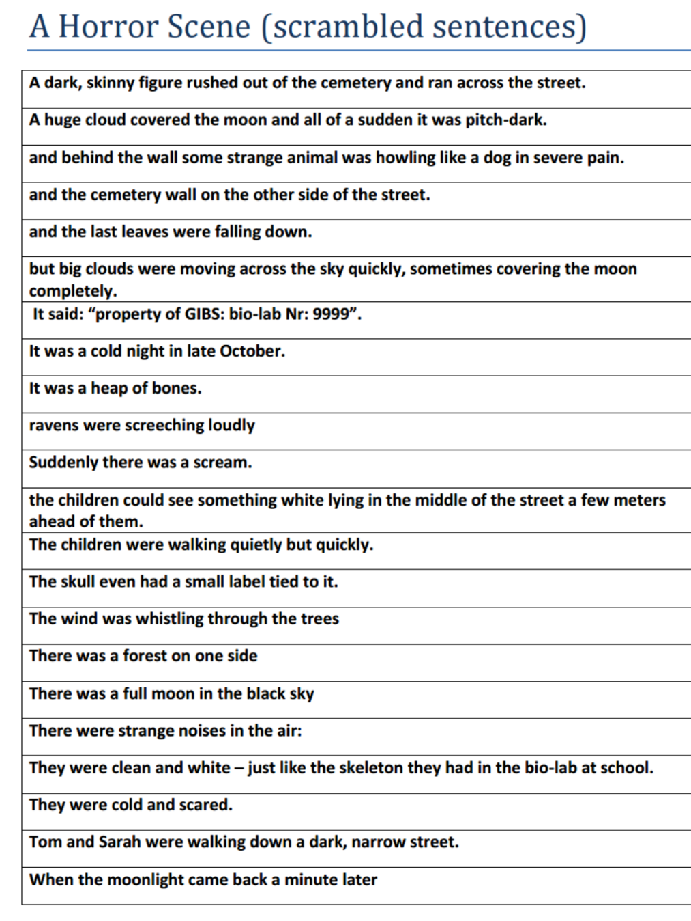
- Reading comprehension: Work in pairs. Cut up the text and glue the sentences on a sheet in the correct order.

- Noticing the 2 forms and making hypotheses:
Use two colours: one for the simple past and one for the past progressive (-ing form). What do you notice? Find a rule.

- Acting out and seeing the scene:
Whole class activity: Act out the story in class in the style of “jeux dramatiques”. Every student plays a role.

- First we need the “background activity” actors: full moon…clouds moving across sky,….

- Then we need the “events” actors who will appear on the scene: scream, skeleton…

- Your teacher will read the story – you act it out without words.

II. Conceptualisation:

Students work out their rules and design their own grammar-rule pages. For each notion they find some typical examples and draw a logo that will remind them of this notion.

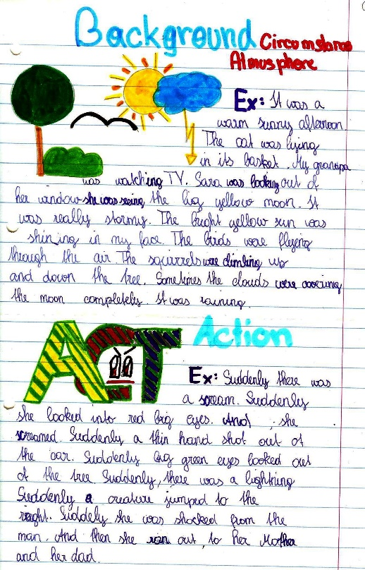
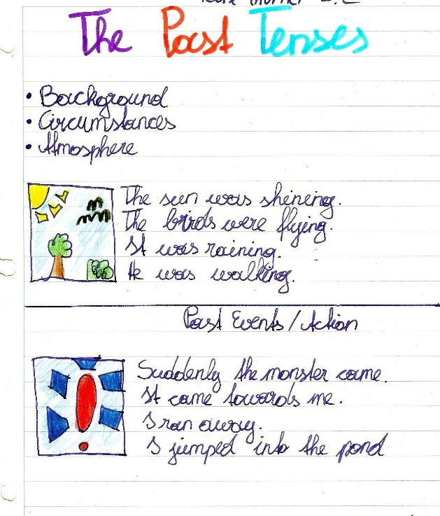

III. Proceduralising: Practicing in scaffolded conditions

Flip-Flap Stories:
Plan a short spooky story that you can tell in about 10 sentences.
Decide which parts of your story are PAST EVENTS
and which parts describe the BACKGROUND and CIRCUMSTANCES.

To prepare your fold an A4 sheet in half. Draw simple pictures for the CIRCUMSTANCES on the front of the sheet. Then cut some windows or doors into the sheet and draw pictures for the EVENTS behind these doors.
Practice telling your story. Then record it on Eyejot and post it on Moodle.

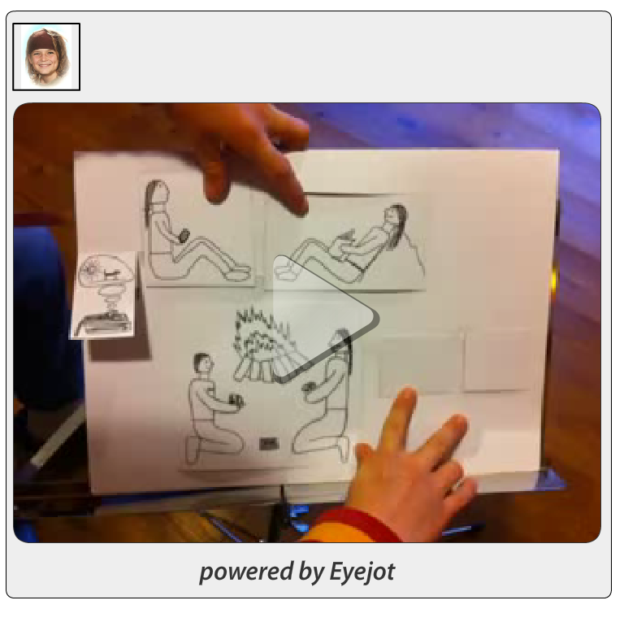more examples on www.epep.at

IV. Performance TASK: Write a spooky story.
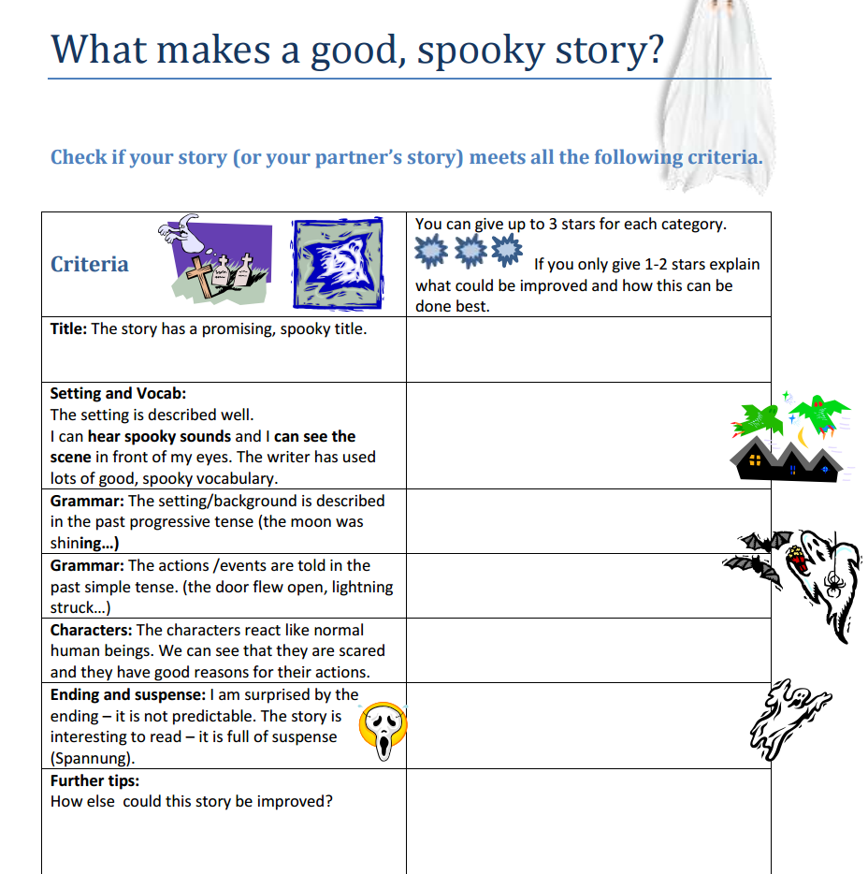
Students plan and write their own spooky stories. In order to make the stories really spooky they add lots of background details (an owl was hooting, the storm was howling…)
Vocabulary phrases for these details have previously been collected in a story reading phase where the learners collected “spooky vocabulary”.
Grammar focus!!!

After writing a first draft the students meet in groups of 3 to give each other feedback on their stories. The criteria sheet on the right guides them through their peer-conferences.

V. Publishing the stories as audio-storybooks:
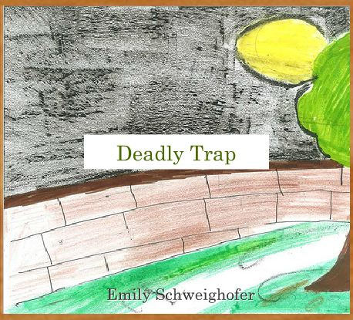
Online storybooks: In order to create an incentive to create really good stories that will give the readers goose bumps, the learners “publish” their stories in online picture books with hand-drawn pictures.
We use the online software “bookr pimpampum” to create these books.

In the last step the learners practice reading their stories and then record them using simple screen recording software such as Jing or Screencast-o-matic.
Bookr:pimpampum



Listen to the stories on http://epep.at/?page_id=2490
Or follow the path:www.epep.at Writing Intermediate learners Spooky Stories

Grammar Quick-Checkers:
  - A tool to assess the quality of grammar exercises
