Elisabeth Pölzleitner

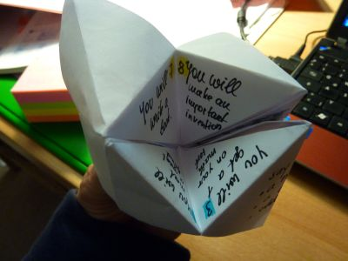


Knowing Grammar or Using Grammar?
Seminar Handout

Contents
Contents 2
Materials 3
Practical Materials 3
Quick Check Grammar Chart 4
How efficient are these exercises? 5
Adverbs of frequency 5
Adverbs of frequency: 6
Asking Questions in English 6
What do you think they asked? 7
Form questions 7
Finding out about my friends 8
Challenge1: Find the rule 9
Practicing questions and the third person -s in an authentic context: 10
Asking questions: 10
No! No! No! : 11
Dogs, dogs, dogs. 12
Homework: 12
Examples of Efficient Grammar Activities: Find details on epep.at 13
Inductive Learning: Making Hypotheses and Building Rules from Examples 16
12 Principles of Brain-based Learning 17
Theory and practice in communicative grammar 19
1 Influences on modern grammar teaching 19
2 Theories underlying communicative grammar teaching 20
3 Language: grammar as a communication system 20
4 Grammar as a skill: from description to methodology 24
5 Final Comment 27
Relevant Publications 27

Materials

This handout summarizes the ideas presented in the seminar and is meant to remind you of the activities and tasks that you have seen and discussed.
You will find master-copies of all the student materials and full-size pictures of the scanned student samples in the Grammar section of my homepage:
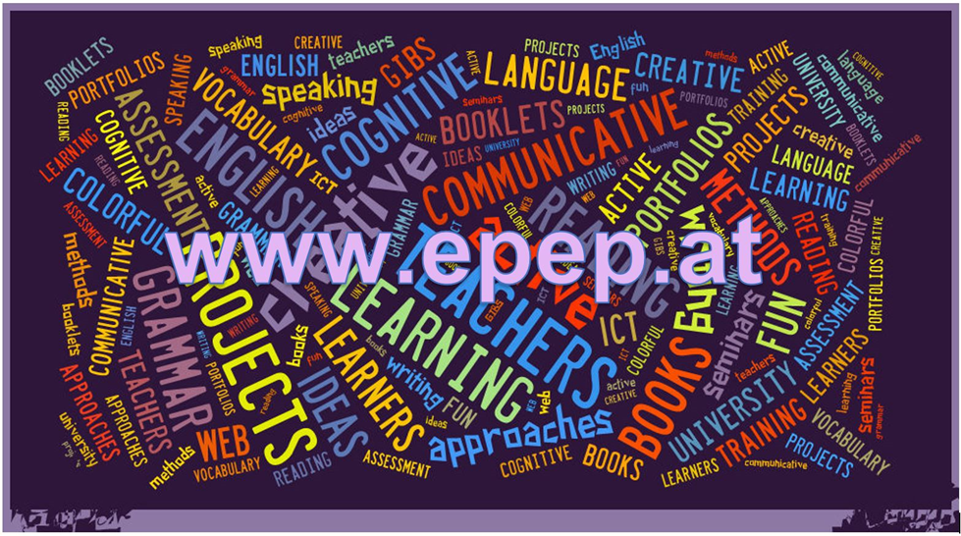

Practical Materials
The theories presented in this seminar have been implemented in “Grammar for Communication”, a reference grammar book, which is approved for use in Austrian schools, and the accompanying book of activities:
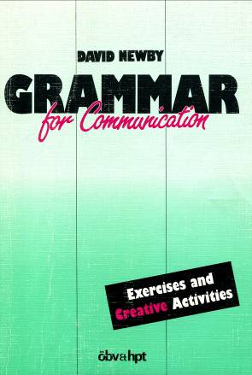
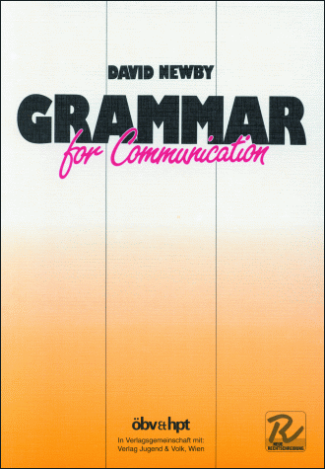

Newby, D. (1989) Grammar for Communication. Vienna: Österreichischer Bundesverlag

Newby, D. (1992) Grammar for Communication – Exercises and Creative Activities. Vienna: ÖBV

Quick Check Grammar Chart

 | Quick Check Grammar Chart | - |  | +
Learning Stages | Awareness raising |  |  |  |  | - Present and practice new grammar in realistic, authentic, contexts that are close to the learners’ experiences.  - Give your learners time to make their own hypotheses and find rules inductively.  - Support the construction of new grammatical concepts (notions) in the learners’ minds through scaffolded (guided) activities where meaning and form connections can be made by the learners.  - Focus on one new concept (notion) at a time or contrast a new concept with one that your learners have already mastered. Do NOT confuse learners by mixing several new concepts and sending them into grammatical minefields.  - Create personalized exercises and activities in which the learners can associate new grammatical concepts and forms with experiences in their (episodic) memory.  - Offer open-ended tasks that require the search for meaning. They lead to more brain activity and more depth of processing.  - Offer grammar tasks that involve several senses (speaking, listening, gestures, images…)  - Use tasks that lead to authentic cognitive processing. e.g.: search for meanings rather than forms. Ask yourself: would anybody do this outside a language classroom?  - Organize group activities. These lead to higher engagement and more “chemical support” of the limbic system.  - Consider your learners‘ affective needs: sense of achievement, fun, relevance. These will strongly influence learning.
Learning Stages | Conceptualization and hpothesis building
Learning Stages | Proceduralization in scaffolded conditions
Learning Stages | Performance in real-time context
Pedagogical Principles and Communicative Criteria | Depth of processing and Complex encoding : Will the learners be mentally active and process grammar, lexis and their “world knowledge”?
Pedagogical Principles and Communicative Criteria | Commitment filter:  Will the learners’ cognitive and affective needs be met? (e.g.: curiosity, problem solving, enjoyment, fun, success)
Pedagogical Principles and Communicative Criteria | Peer and social learning and interaction:  Pair – or groupwork, sharing, oral activities, jigsaw activities…
Pedagogical Principles and Communicative Criteria | Personalisation:  Do the learners have the opportunity to draw on their personal experiences and express their own ideas?
Pedagogical Principles and Communicative Criteria | Contextualisation:  Is the exercise embedded in a clear communicative context?
Pedagogical Principles and Communicative Criteria | Authenticity of process:  Will the learners use language in natural, “language-like” ways (rather than manipulate forms)?
Pedagogical Principles and Communicative Criteria | Task-based:  Do the students fulfil a purposeful task that will have an outcome or end product?
Pedagogical Principles and Communicative Criteria | Testing versus teaching:  Does the exercise support learning or only test it?
Pedagogical Principles and Communicative Criteria | This exercise supports learning processes… |  | 

How efficient are these exercises?
Work with a partner.
Have a look at these exercises and do them yourself.
What do they practice?
What’s going on in your brain while you do them?
Watch yourself and take a few notes after each exercise.

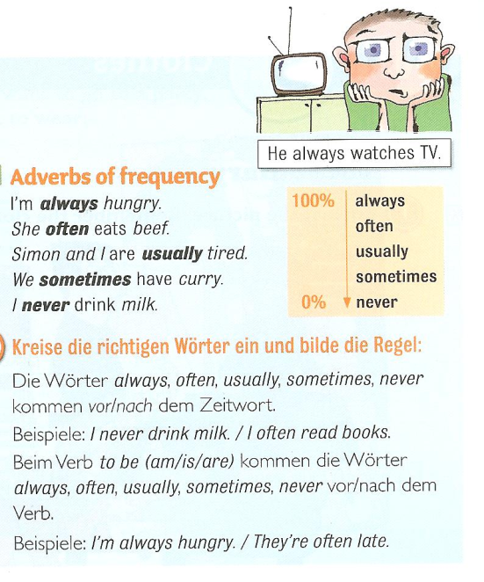
Figure 1

Adverbs of frequency
Our friend helps us. (always)
I go shopping in Paris. (never)
She is late. (usually)
I get headaches. (often)
He forgets my birthday. (always)
You are right. (usually)
They stay in bed late. (sometimes
I don’t go to the doctor. (often)
Source: 1

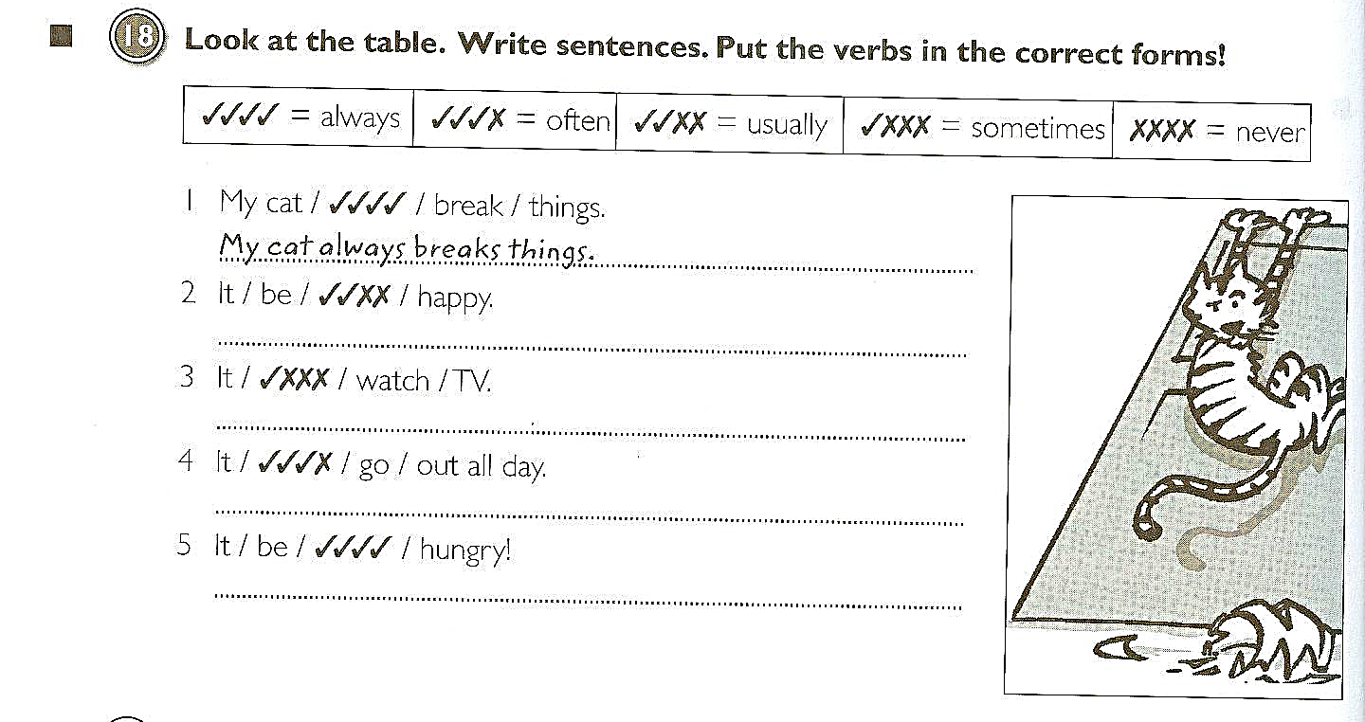

Adverbs of frequency:
Source: 2
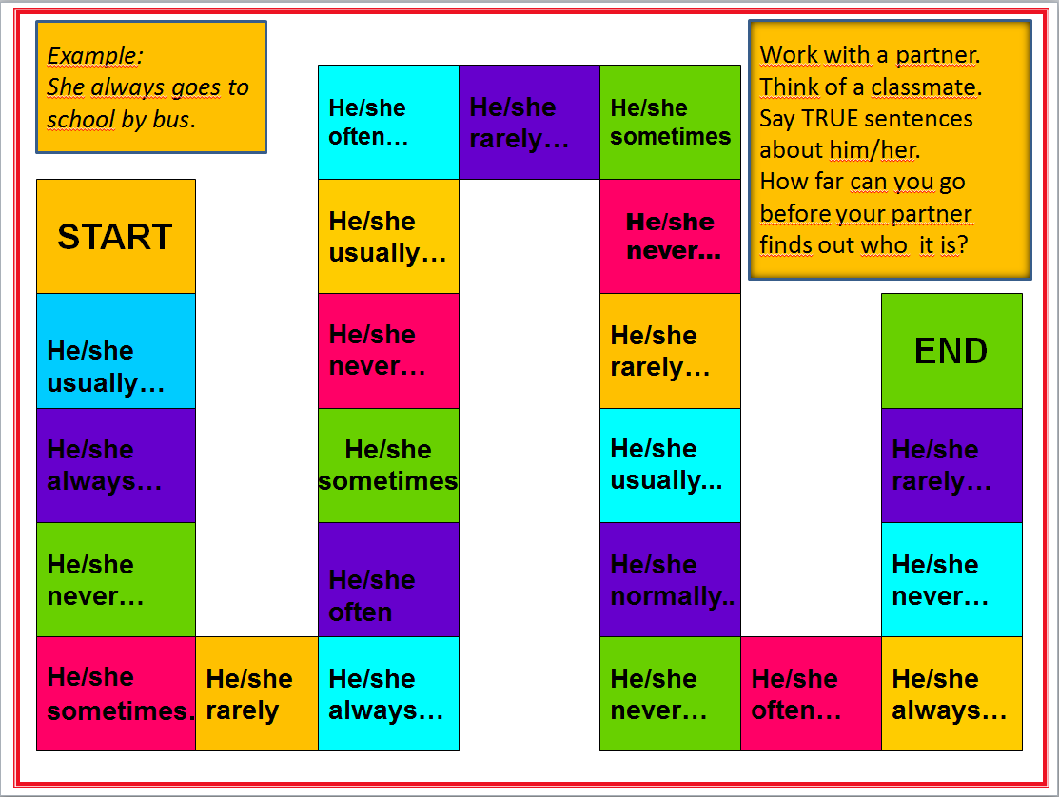
Boardgame

Asking Questions in English

Compare the following exercises
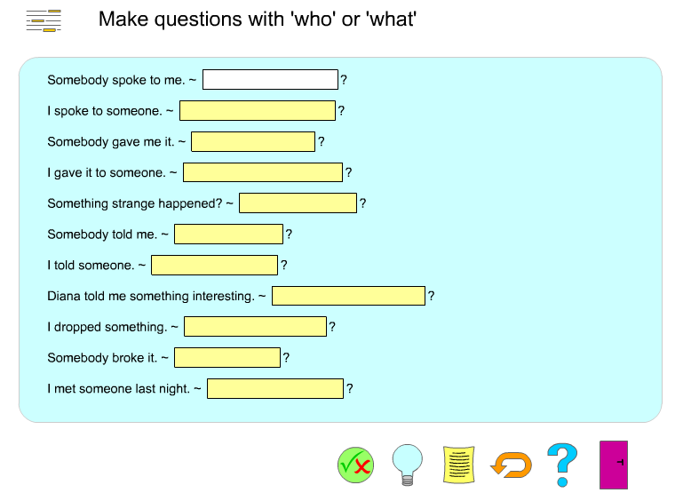

http://www.englishgrammarsecrets.com/questions1/menu.php

What do you think they asked?
? | John’s in the garden and Sylvia is in town.
? | Put on your blue trousers.
? | Because I wasn’t feeling well.
? | Mum gave it to me for my birthday.
? | I did. I’m sorry. I’ll buy you a new one.
? | Yesterday. The postman brought it just before I went to work.
? | I think it’s M-I-S-S-I-S-S-I-P-P-I but you’d better look it up.
? | I went by taxi. I missed the bus!
Source 3

Form questions
Ask for the underlined part. Write the complete English question into the gap.
Example:
The class plays football.
_______________________
Answer:
The class plays football.
What does the class play?
1) John is writing a letter.
?
2) She walks home from school.
?
3) The children are sitting in the garden.
?
4) Peter runs with his dog on Sundays.
?
5) My rabbit has a cage in the garden.
?
6) They go to work by bus.
?
7) David likes cats because they are nice.
?
8) Jenny isn't sleeping late today.
?

http://www.englisch-hilfen.de/en/exercises/questions/form.htm

Finding out about my friends
- What is the question? Read Mrs. Pölzleitner’s answers and write the fitting question (passende Frage) into column 1.
- What about you? Write your answers.
- ENGLISH ONLY: Now interview a classmate. Remember: We speak ENGLISH only!
- Practice your interview. Then record it on fliprid.
What are your favorite foods?
What’s your email address?
What’s your name?
What are your favorite hobbies?
What languages do you speak?
Do you have any brothers and sisters?
Where do you live?
Where do you come from?
Do you have any pets?
What’s your phone number?

What’s the question? | Mrs. Pölzleitner’s answers | Your answers
 | My name is Elisabeth Pölzleitner
 | I live in Graz, St. Peter.
 | I come from Austria, from Bruck an der Mur.
 | Yes, I have one sister. She is called Maria.
 | Yes, I have a cat and four ducks.
 | I really like reading, skiing and learning languages.
 | I speak German, English, French, Greek and Italian.
 | I like all fruits and vegetables. I do not eat meat. One of my favorite foods is Indian curry.
 | My e-mail address is elisabeth.poelzleitner@phst.at
 | My phone number at school is 0316 80671222

Help card
Hobbies: I like playing tennis, playing the piano, watching TV, playing computer games, painting, dancing, singing, skiing, reading, …
Family: I do not have any brothers and sisters. I am an only child. I have … brother(s) and … sister(s). They are called Max, Moritz and Anna.
Pets: I have a dog, a hamster, some fish, a guinea pig, a horse, a budgie, three white mice (one mouse), a rat, a turtle, …

Challenge1: Find the rule
This is Mrs. Pölzleitner.
She lives in a blue house in Graz. She is an English teacher. She loves reading books and learning languages. She speaks English, German, French, Italian and Greek. She also likes sports. In winter she goes skiing and in summer she goes jogging. She rides her bike to school every day. Her favorite food is Indian curry. She is vegetarian, so she does not eat meat.


Hello, I am Mrs. Pölzleitner.
I live in a blue house in Graz. I am an English teacher. I love reading books and learning languages. I speak English, German, French, Italian and Greek. I also like sports. In winter I go skiing and in summer I go jogging. I ride my bike to school every day. My favorite food is Indian curry. I am vegetarian, so I do not eat meat.

What do you notice?



Challenge: Read the texts and find a rule!
This is Mrs. Bergmann.
She lives in a yellow house in Graz. She has a big family. She loves reading books and watching English TV series. She also likes sports. In summer she goes swimming and jogging, and she rides her bike to school every day. She also likes dancing a lot.
Hello, I am Mrs. Bergmann.
I live in a yellow house in Graz. I have a big family. I love reading books and watching English TV series. I also like sports. In summer I go swimming and jogging, and I ride my bike to school every day. I also like dancing a lot.

Challenge part 2: Use the rule:

Now it's your turn
Step 1: Draw a large speech bubble and write a similar text about yourself. Hand it in to your teacher.
Step2: Correct your speech bubble and out it on the pin board.
Step 3: Find a speech bubble from a classmate at the pin board or get one from your teacher. Then draw a box and write about the classmate. Hand it to your teacher.

Practicing questions and the third person -s in an authentic context:
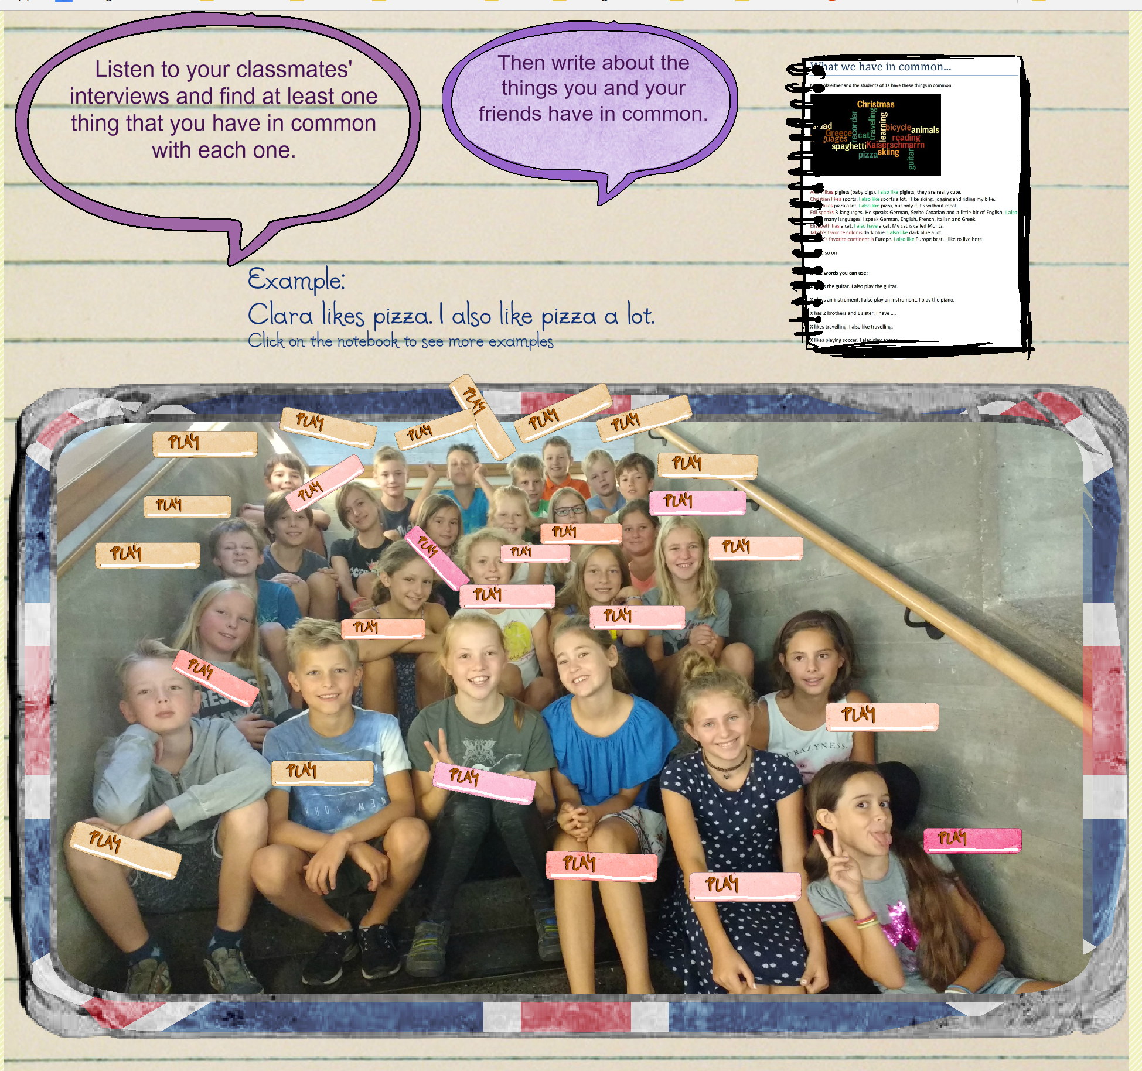


Asking questions:
Use the words from the boxes to write five questions. Use each word once.
When  What  Why  How  Where | does  are  is  does  do | the children  Sue and Katy  Thomas  Anna  Mrs. Pölzleitner’s | have for dinner  birthday  not at school today  live  go to school | ?

Now find out more about your teacher(s). Write questions and guess the answers. Then ask your teacher and find out if your guesses were correct.
What… | Tick off your correct answers:
Your answer:
When
The learners will need a lot more space, of course
Your answer:
Where
Your answer:
Why
Your answer:
How
Your answer:
How many
Your answer:
Who
Your answer:

No! No! No! :
  - I do not like/ X does not like…
  - I don’t like / X doesn’t like…
What are the things you do not like at all? Write down five sentences.
Then ask three classmates what they do not like at all and write sentences.
1.Example: I do not like….
2
3
4
5
1 My friend...
2
3
4
5
1 My friend …
2
3
4
5
What do you have in common? Are there any things none of you likes?
Example: Peter and I do not like…

Dogs, dogs, dogs.

- Whose dogs are these? Match the pictures with the words.
Peter’s dog.
Tom’s dogs.


The boys’ dog.
The boys’ dogs.
The dog’s tricks.
No dogs allowed here.


- Now label these pictures. Where do you need an apostrophe?



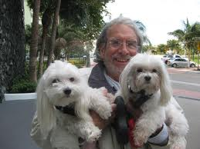
Example: Our neighbors’ dogs








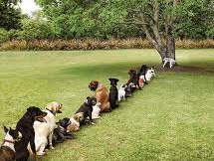

Homework:
Make your own matching exercise (like exercise 1). Choose a different topic – find or draw 6 pictures and write 6 sentences. Bring your page to class and ask one of your classmates to match the pictures and the phrases.
Sources:
- Gerngross et al. (2007) More 1, Student’s Book. Helbling. 53
- Gerngross et al.(2007) More 1, Workbook. Helbling. 64
- Newby, D. (1992) Grammar for Communication. Vienna: Österreichischer Bundesverlag. 187
All others: Elisabeth Pölzleitner
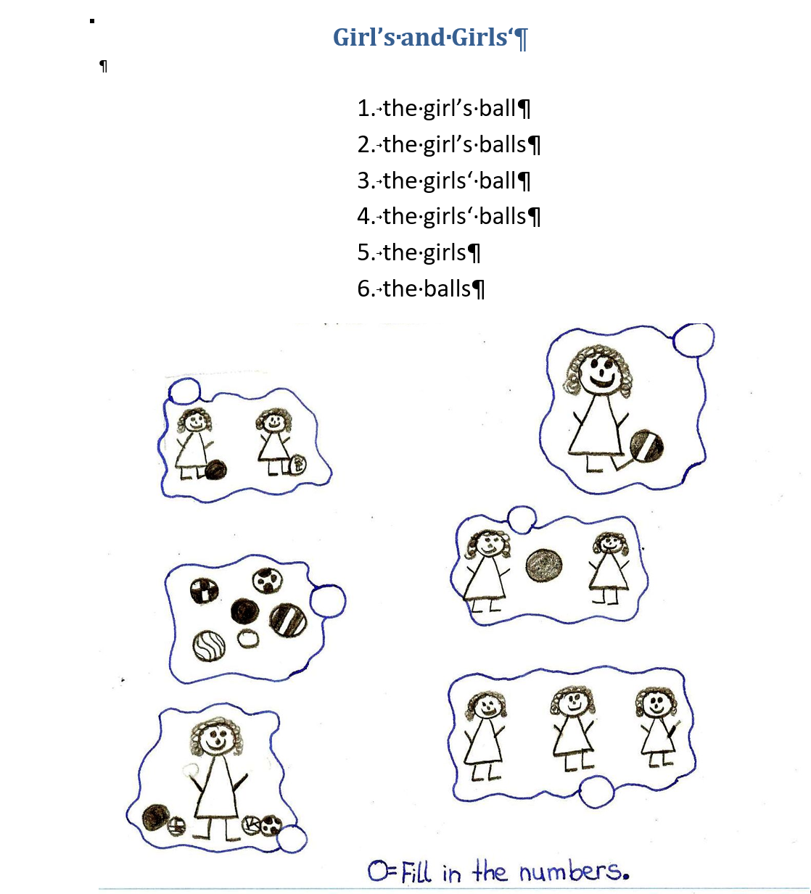

Examples of Efficient Grammar Activities: Find details on epep.at
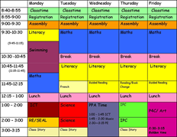 | Talking about routines  and
 | Describing present activities (What are they doing?)
 | Describing story backgrounds and circumstances (past progressive)  Talking about past events (past simple)
Do you know how ketchup is made? | Describing processes in the Passive Voice
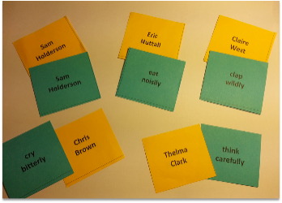 | Describing HOW people do something: Adverbs
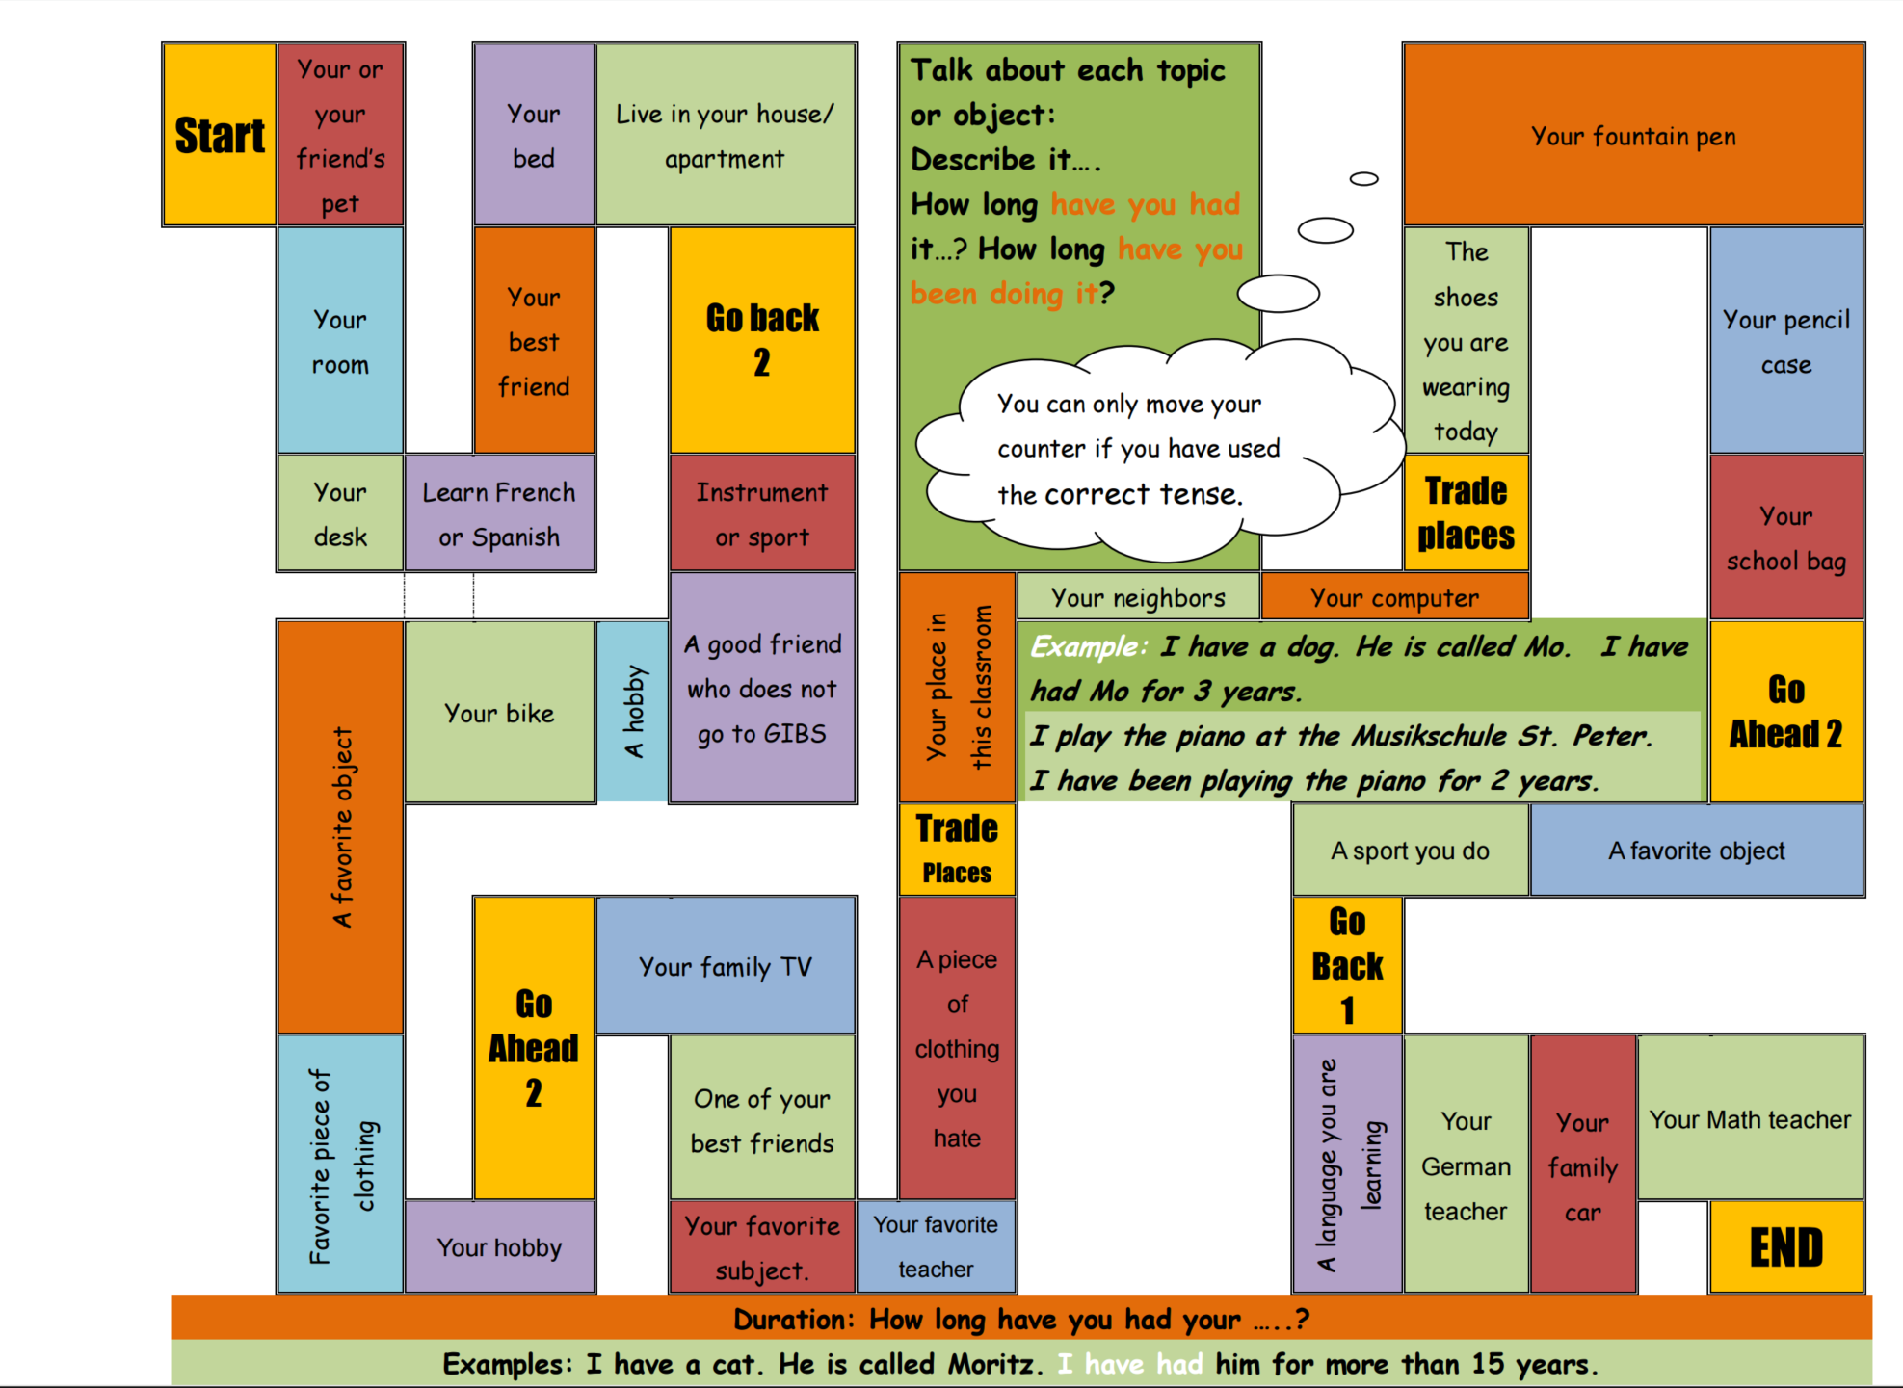 | 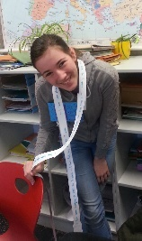  Talking about how long I have had or done something. Duration: present perfect tense
 | Irregular verb forms:  Verbs raps: memorizing what sounds right
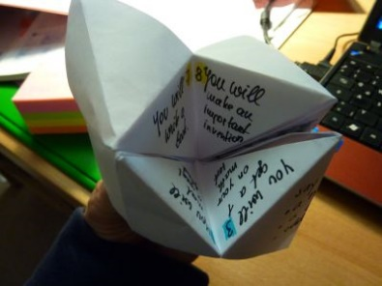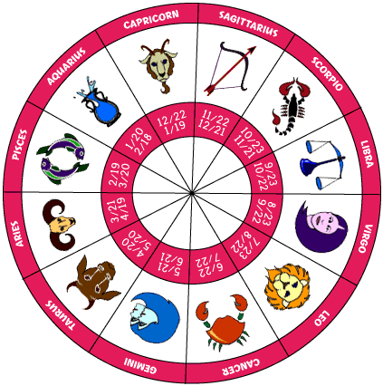 | Predicting the future: (will future)
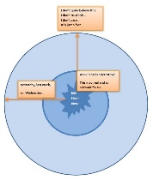 | Reporting and Announcing
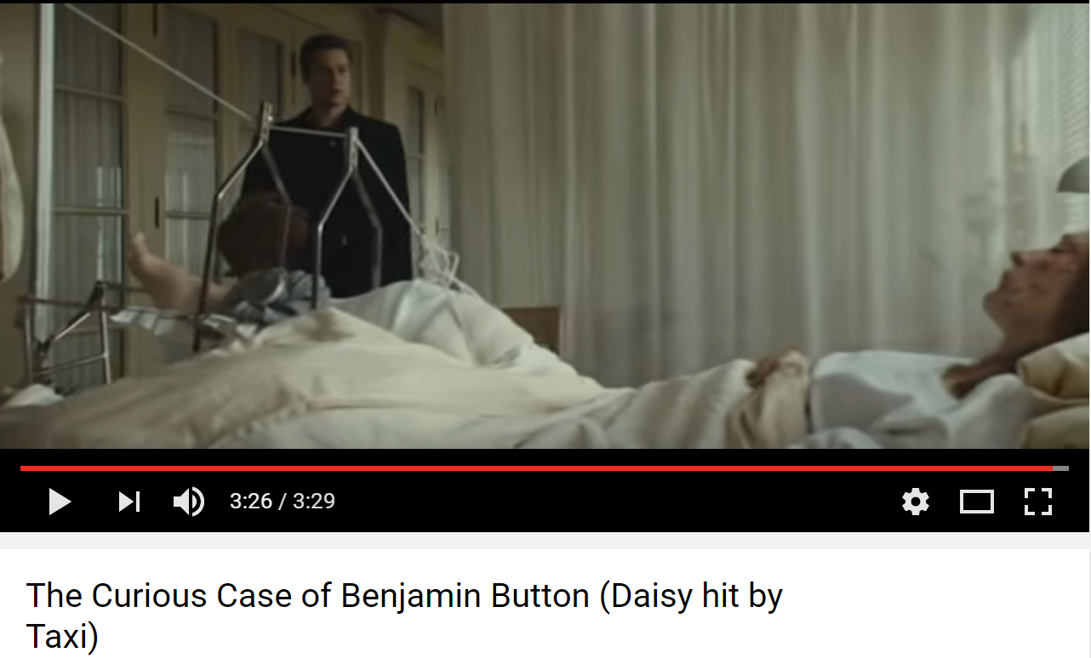 | If III: If we could turn back time  If that taxi had come one second earlier…
 | If II: If I could do whatever I wanted for a whole day….
Find all these and more materials on www.epep.at

Inductive Learning: Making Hypotheses and Building Rules from Examples
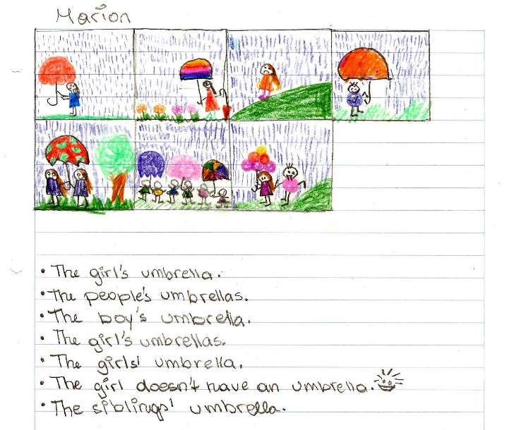
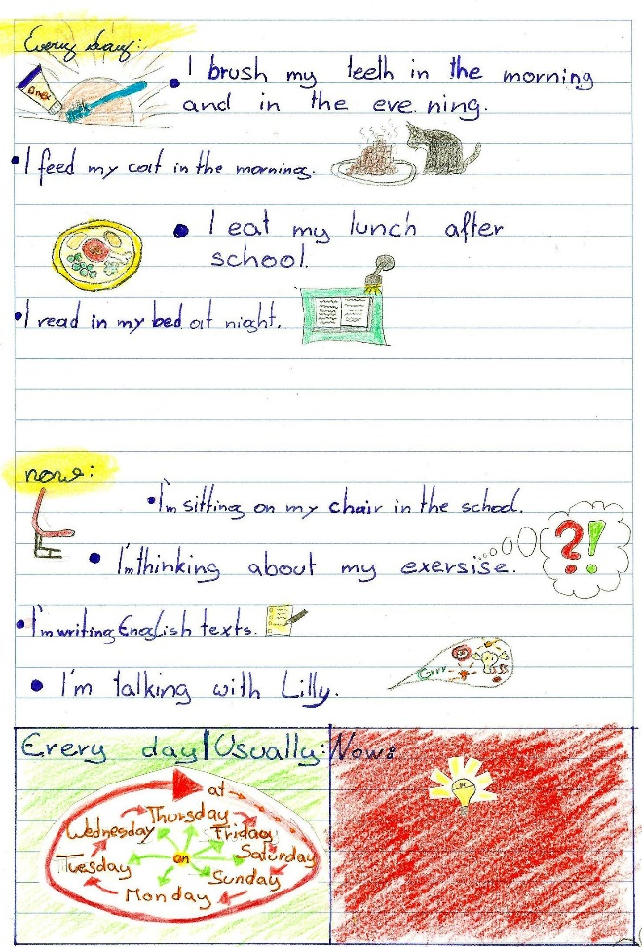
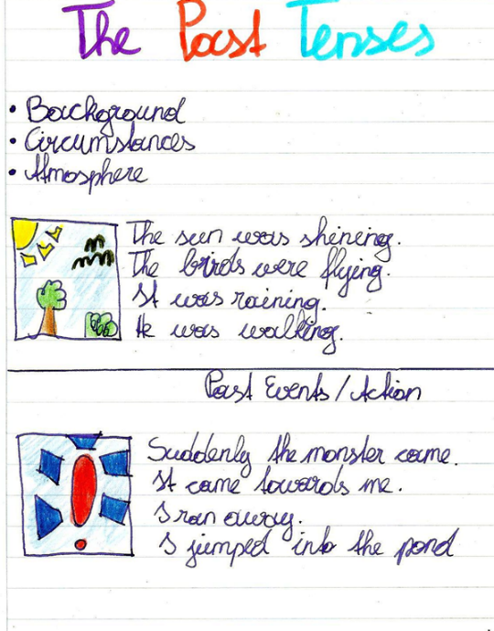
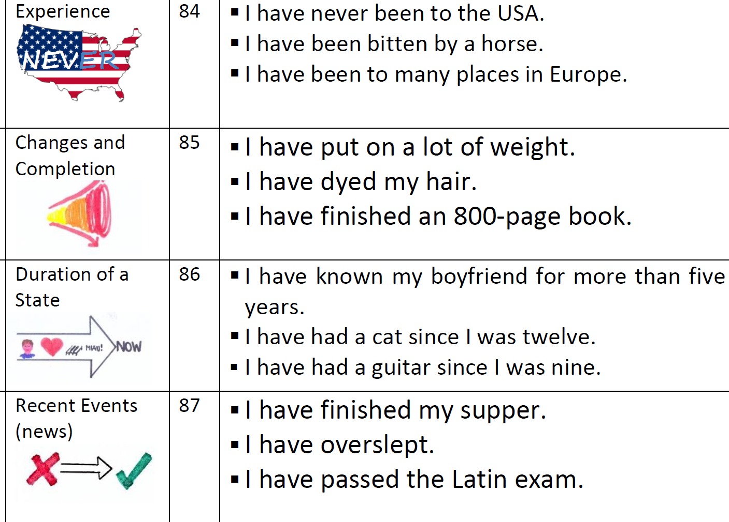
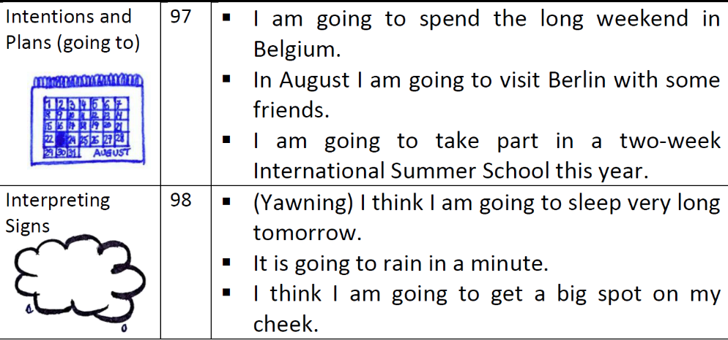

12 Principles of Brain-based Learning
http://www.nea.org/teachexperience/braik030925.html?mode=print 1 of 3 6/13/07 10:17 AM

NEA:National Education Association
Great Public Schools for Every Child
Implications for the Classroom
Previously published in NEA's Doubts & Certainties
The Caines developed their 12 principles for brain-based learning in 1989 and have modified
and refined them over the years. This article from NEA's Doubts & Certainties (1994) discusses
the implications of these principles for the classroom.

Educators Renate and Geoffrey Caine define brain-based learning as that which immerses children in a multiplicity of complex experiences -- both authentic and fantasy -- and then provides a number of ways for them to process those experiences, including reflection, critical thinking, and artistic elaboration. The Caines propose the following 12 principles for brain-based learning:

- The brain is a parallel processor. The brain ceaselessly performs many functions simultaneously. Thoughts, emotions, imagination, and predispositions operate concurrently and interact with other brain processes involving health maintenance and the expansion of knowledge.
Education must embrace and use all the dimensions of parallel processing.

- Learning engages the entire physiology. The brain functions according to physiological rules. Learning is as natural as breathing, and it is possible to either inhibit or facilitate it. In fact, the actual "wiring" of the brain is affected by our life and educational experiences.
Anything that affects our physiological functioning affects our capacity to learn.

- The search for meaning is innate. The search for meaning (making sense of our experiences) is survival-oriented and basic to the human brain. The brain needs and automatically registers the familiar while simultaneously searching for and responding to novel stimuli.
Both familiarity and novelty must be combined in a learning environment.
Effective education must give learners an opportunity to formulate their own patterns of understanding. That means learners need a chance to put skills and ideas together in their own way.

- The search for meaning occurs through "patterning." In a way, the brain is both scientist and artist, attempting to discern and understand patterns as they occur and giving expression to unique and creative patterns of its own. The brain resists having meaninglessness imposed on it.

- Emotions are critical to patterning. What we learn is influenced and organized by emotions and mindsets involving expectancy, personal biases and prejudices, self-esteem, and the need for social interaction. Emotions and thoughts literally shape each other and cannot be separated.
An appropriate emotional climate is indispensable to sound education.

- Every brain simultaneously perceives and creates parts and wholes. Although there is some truth to the "left-brain, right-brain" distinction, that is not the whole story. In a healthy person both hemispheres interact in every activity, from art and computing to sales and accounting. The "two-brain" doctrine is most useful for reminding us that the brain reduces information into parts and perceives holistically at the same time.
Good training and education recognizes this simultaneous perceiving and creating of parts and wholes. One way to accomplish this is by introducing global projects and ideas from the very beginning.

- Learning involves both focused attention and peripheral perception. The brain absorbs information of which it is directly aware, but it also absorbs information that lies beyond the immediate focus of attention. In fact, the brain responds to the entire sensory context in which teaching and communication occur. These "peripheral signals" are extremely potent.
Educators, therefore, can and should pay extensive attention to all facets of the educational
environment.

- Learning always involves conscious and unconscious processes. Much of our learning is the result of unconscious processing. Moreover, it is the entire experience that is processed. That means that much understanding may NOT occur during a class, but may occur hours, weeks, or months later.
Educators must organize what they do so as to facilitate the subsequent unconscious processing
of experience by students.

- We have (at least) two types of memory systems: spatial and rote learning. Our natural spatial/autobiographical memory system registers everything -- down to the details of your meal last night. It is always engaged, is inexhaustible, and is motivated by novelty. We also have a set of systems for rote learning, or recalling relatively unrelated information. These systems are motivated by reward and punishment. Thus, meaningful and meaningless information are organized and stored differently.
The only way for people to deal effectively with vast amounts of new information and regular
retraining is to learn for meaning.

- The brain understands and remembers best when facts and skills are embedded in natural spatial memory. Our native language is learned through multiple, interactive experiences. It is shaped by internal processes and by social interaction.
Any complex subject is given meaning when embedded in real experience.

- Learning is enhanced by challenge and inhibited by threat. The brain learns optimally -- makes maximum connections -- when appropriately challenged. But the brain "downshifts" -- becomes less flexible and reverts to primitive attitudes and procedures -- under perceived threat.
Educators must create and maintain an atmosphere of relaxed alertness, involving low threat and
high challenge. That also needs to be the state of mind of the instructor. Above all, learners need
to acquire a belief in their capacity to change and learn.

- Every brain is unique. We all have the same set of systems, and yet we are all different.
Choice, variety, and multisensory processes are essential for brain-based learning and instruction.

Source: National Education Association. Doubts & Certainties, January/February 1994. Material adapted
from Renate Nummela Caine and Geoffrey Caine, Making Connections: Teaching and the Human Brain,
ASCD, 1991; Addison Wesley, 1994.

Theory and practice in communicative grammar
- David Newby

The purpose of this article is:
a) To focus on some of the issues discussed in modern grammar teaching and to indicate some of the changes that have taken place in recent years in the theories and practice of learning and teaching.
b) To present my personal views of communicative grammar. My approach is based on the one hand on my own theoretical work in what I term ‘notional grammar’; on the other, on my experiences of teaching grammar, of writing grammar books and other teaching materials and of working with teachers in different countries.
This article first appeared as:
'Theory and Practice in Communicative Grammar' in R. de Beaugrande, M. Grosman, B. Seidlhofer, (eds.) (1998) Language Policy and Language Education in Emerging Nations, Series: Advances in Discourse Processes Vol. LXIII, pp 151-164. Stamford, Conneticut: Ablex Publishing Corporation

1 Influences on modern grammar teaching
Modern grammar teaching shows influences from the following general areas: what might be called ‘traditional grammar’; communicative teaching, dating from the late 1970s, the learner-based approaches that became influential in the 1980s; recent theories of second-language acquisition from applied linguistics. The influences are reflected in the following ways:

Traditional grammar:
Language is seen primarily as a set of forms and structures, grammatical meaning playing a secondary role. The sentence is the main unit of analysis and emphasis is placed on the student’s ability to form correct sentences. Grammar rules are given prominence and learning is seen as a mainly cognitive process. The most common forms of exercise type are gapped sentences and sentences for transformation, reflecting a form-based, rather uncontextualized view of grammar and an extremely passive role on the part of the learner. Contrary to popular belief, there is relatively little theory to support traditional modes of description and pedagogical practices, but the force of tradition plays a very strong role and should not be underestimated!

Communicative approach:
Language is seen not as a formal system but as a means of communicating messages between human beings in actual contexts. It follows from this that language is redefined as a set of skills, grammar being seen as a way of expressing certain types of meanings through grammatical forms. Meaningfulness and contextual appropriacy are stressed and formal correctness is given less prominence. Methodological innovations based on semi-authentic tasks and communication in small groups reflect this approach. Although in theory grammar could have been integrated into communicative teaching, in practice linguists and pedagogical grammarians failed to provide adequate theory to support a genuinely communicative approach to grammar and it therefore remained a problem area. On the more extreme fringes, there was in fact a complete swing away from the overt teaching of grammar, though this phenomenon was largely confined to Great Britain.

Learner-based approaches:
Unlike with the communicative approach, which takes an analysis of language as its starting point, learner-based approaches - partly ‘humanistic’ in their orientation - give centre stage to language learners and to acquisition processes and learning strategies. Underlying some of these approaches is the view that a language ‘cannot be taught’ but can only by acquired by the learner, the teacher taking on the role of a facilitator of this process. Thus, grammar rules explained by the teacher give way to discovery techniques and awareness-raising tasks by the pupil. As in the communicative approach, student-centred activities predominate, though additional stress is given to affective factors and to the emotional, rather than functional, needs of the learner.

Second-language acquisition:
A view of acquisition held by certain applied linguists which feeds on Chomsky’s notion of ‘Universal Grammar’ and which might also be described as ‘post-Krashen’. The central tenet is that - as with first-language acquisition - the learner’s brain is already ‘wired up’ to acquire language and this process cannot be greatly influenced by actual teaching. The teacher’s primary function is therefore to provide input through exposure to the language and to allow nature to take over. These views are especially popular amongst certain linguists and some native-speaker methodologists but do not seem to be given very much credence by the majority of teachers.

Summary
In as far as we can generalize, it appears to be the case that most modern grammar teaching is a mosaic of the above approaches. Interestingly, traditional grammar still tends to form the core both of classroom practices and of grammar books; some of the bestsellers among EFL books are those that list grammar rules and contain exercises consisting mainly of the ‘fill-in-the-gap’ variety. Although the layout of these books is perhaps more user-friendly than their forerunners and although their modes of description are more geared to modern usage, they are still very much in the traditional mould. On the other hand, elements of communicative methodology in the form of oral activities and games are available in an increasing number of EFL books; many teachers and coursebooks supplement the traditional grammar base with such activities. ‘Hard-core’ learner-based approaches as outlined above tend to be more popular with native speaker teachers and methodologists than with non-natives, but many teachers have moved some way in the direction of a more student-centred approach.
How do my own ideas fit into this mosaic? I believe that many practices from traditional grammar which still dominate the FL classroom have a negative effect on language learning, so we must begin by putting traditional grammar under the microscope and replacing certain elements with a more communication-based theory of grammar. Second, the focus on the learner and on language acquisition has brought many important insights, which can be incorporated directly into grammar teaching. I should add, however, that I am highly suspicious of methodologists who take a very dogmatic view of language learning and believe that their favoured approach provides all the answers!

2 Theories underlying communicative grammar teaching
If we are to challenge the traditions and dogma, old and new, that figure prominently in discussions of grammar, we must begin by giving some consideration to certain theoretical areas. The word ‘theory’ is often regarded with suspicion by teachers, perhaps since we are all ‘burnt children’ to some extent and have experienced that theory can mean the very opposite of practice! In reality, most of our classroom activities are the result of a mixture of theory and intuition, but it is important to get the balance right and to be open to those elements of theory that will lead to more efficient teaching and effective learning. Concerning grammar, there are three theoretical areas that might be of use to us. They are:
a) Language: a theory of what grammar is and how it functions as a communication system
b) Learning: an understanding of learning processes and of the learner’s functional and emotional needs
c) Teaching: using our understanding of a) and b) to apply the most efficient methodology and classroom techniques will help us in the formulation of teaching objectives, in how we present grammar and deal with rules; b) and c) will determine the form that our teaching takes. In the following pages I shall consider these three areas and present my own view of grammar with regard to each one.

3 Language: grammar as a communication system

3.1 The communication model
Since the mid-1970s most language teaching coursebooks and books on methodology have been firmly embedded within the so-called ‘communicative approach’, although today the term itself sounds slightly dated. At the heart of this approach is the view that in real life language is used to exchange meaningful messages in actual contexts and that this fact should also be reflected as strongly as possible in the classroom. This view of language can be illustrated in the ‘communication model’ of figure 1, which attempts to depict in simple diagrammatic form ‘how language happens’:

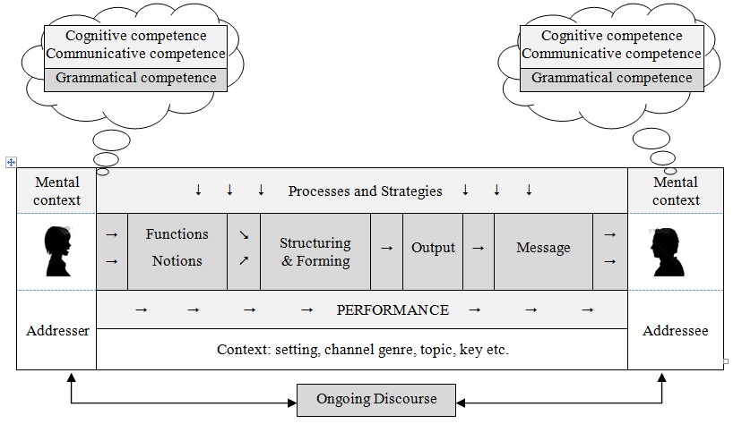
Figure 1: Communication model
It is this simple communication model view of language which lies at the heart of how we view language nowadays and goes some way to explaining some of the changes that have taken place in the description of modern grammar. Traditional grammatical descriptions began by setting up form categories, only then looking at meaning; as a result, syllabuses were defined, and teaching materials organised, according to forms (present progressive, definite article, gerund etc.). ‘Grammatical competence’ was seen largely as the ability to master forms and recognize meanings, usually without much consideration of context, the role of the speaker etc.
In the communicative approach, however, it was recognized that the forms of grammar represent the final stage of an interaction process, in which speakers communicate messages to other human beings in a context. It therefore seemed logical to begin at the beginning of this process and to attempt to define grammar in terms of context and meanings. This entailed taking a much broader view of grammar and attempting to relate grammar to other elements of the communication model such as context, speaker’s purpose etc. It follows from the model that grammatical competence means not only knowing how to form a sentence or knowing the rules for using, say, the past vs the present perfect, but the ability to choose meaningful grammar in real contexts, which might be referred to as part of a more general communicative competence. The overall result of this re-orientation towards context and meaning was that grammar was seen more as a skill and objectives in syllabuses and coursebooks tended to be redefined in terms more closely related to meaning categories.

3.2 Grammatical competence
A speaker’s grammatical competence, part of a wider communicative competence in general, consists of various components of ‘knowledge’.
Knowledge of forms: This tells us:
  - how to form words and structures correctly in:
- word forms: e.g. irregular verbs, comparison of adjectives
- structures: e.g. conditional sentences
  - how to order or pattern these forms within a sentence:
- e.g. word order of adverbs of time, question forms
Knowledge of meanings: notions : This tells us:
- what meanings are available to us when we express our thoughts through grammatical forms
- which choices to make in a specific context:
e.g. definite/indefinite/no article: the/some/0/ boys
past vs present perfect: I went vs I have been
This knowledge also helps us to distinguish different meanings of the same form:
e.g. present progressive referring to now
Sue is playing tennis at the moment.

present progressive for future arrangement
Sue is playing tennis this evening.

Knowledge of purpose: speech functions
Using grammar not only entails knowing how to express meanings through forms but also knowing that grammar can be used to show a speaker’s intention or wish, or to influence the behaviour or attitude of the listener. For example, the conditional form would can be used to express the following functions:
Giving advice: I would buy a new car if I were you.
Requesting help: Would you carry my suitcase for me?

Knowledge of style: appropriacy
This kind of knowledge tells the speaker whether one grammatical form might be more stylistically appropriate than another in a certain context where two or more forms are possible.
For example:
MORE FORMAL  May I borrow this?  Tom and I are going out.  I shall be there next week. | LESS FORMAL  Can I borrow this?  Tom and me are going out.  I will/’ll be there next week.
Knowledge of previous and following language: discourse
In traditional grammar there has been an overwhelming tendency to teach and practise grammar as single items within sentence-level exercises. If more than one grammatical item occurs in an exercise, then the purpose is usually to contrast two grammatical areas which are considered to represent potential areas of difficulty for the learner - past vs present perfect etc. In the past few years, the relatively new linguistic discipline of discourse analysis has led to a broadening of our perspective of language from sentence level to text level, both spoken and written. This has provided important insights for language teaching. If we look at how grammar operates beyond the sentence, we will often discover that there is a tendency for certain grammatical meanings to co-occur in discourse. For example, the present perfect meaning of what I call ‘experience’ is often followed by the past tense, as in the following short dialogue:
A: Have you been to Chile?
B: Yes, I have.
A: Did you like it?
B: Yes, it was brilliant!

Also, an area of grammar such as past simple vs past progressive can only be properly understood by taking a discourse view of grammar and knowing how actions relate to each other, as in the following examples:
I didn’t watch the film on television last night because I was doing my homework.
I didn’t do my homework last night because I was playing football.

Summary
The relationship between these types of knowledge can be illustrated in the following chart, which shows how the different types of knowledge work together to produce the message that the speaker wishes to convey:
Previous discourse  +Context | SPEAKER | Functions  Meanings  Appropriacy | Forms | MESSAGE

Figure 2: Grammar and communication
It is a fallacy that modern language teaching is ‘weak on grammar’, as is sometimes suggested. As can be seen from our discussions, communicative grammar introduces additional categories and, given appropriate methodology, has the potential to provide the learner with the means to communicate through grammar in actual situations.

3.3. Implications for teaching?
A ‘communication model’ view of language will bring various changes to how we define our teaching objectives, in syllabus design and in the type of rules we present to our students. I shall consider some of these changes.
Meaning categories
I stated earlier that by seeing grammar as part of a communicative system, we recognise that in actual language use meanings give rise to forms and not vice versa. As a result of this ‘meaning-priority’ approach, many coursebooks, some syllabuses and even the occasional reference grammar define grammatical objectives no longer as a set or forms, as used to be the case in traditional teaching, but as a set of meanings, either notional or functional. A glance at the contents pages of modern coursebooks will confirm this. In order to describe meaning systematically, however, we need to establish categories of meaning and corresponding terminology with which we can formulate our objectives and which will reflect the meaning system that underlies English grammar. The ‘tag words’ (‘intention’, ‘experience’, ‘recent activities’ etc) that figure in my own books and other materials result from my theoretical work on what I term grammatical ‘notions’, that is to say, single meanings that are expressed through forms, which I believe form the core of a speaker’s grammatical competence. An example of notional categorisation can be seen in the following chart, which contains some of the ‘notions’ I consider to reflect most accurately the categories that speakers of English employ when talking about the future.
Notion | Form | Example
Intention | going to | I’m going (to go) to a party tonight.
Signs/evidence | going to | I’m going to be sick!
Prediction | will | It will be a boring party.
Spontaneous decision | will | I think I’ll go to bed.
Fixed Arrangement | pres. prog. | Dad’s fetching me at midnight.
Figure 3: Ways of expressing the future in English.
Two important points emerge from the above chart. Firstly, one form - for example going to - can express different meanings. It is therefore not logical to talk about ‘the going to future’. Second, if we wish to teach grammatical meaning coherently, then we must take as our teaching objectives the notional categories in the left-hand column rather than those in the centre column, as was the case in traditional, formal grammar. Some of the advantages of taking a notional, meaning-based approach to grammar are the following:
- A ‘meaning into form’ approach reflects the way that grammar is used in real life, as indicated in the ‘communication model’. This makes it possible to integrate grammar into contexts and to apply communicative methodology in the classroom.
- Defining individual meanings in this way and presenting them one at a time makes the teaching objective clear both to teacher and student.
- It therefore avoids the danger of confusing different meanings, which is likely to happen if we define our objectives purely in terms of a grammatical form.
- It provides us with a more systematic overview of grammar; for example, a teacher will know exactly which meanings of a form have been covered.
- It assists in grading: the teacher can decide which meanings to teach and at what stage to introduce them.
- It can lead to more reliable rule formulation as we look at grammatical meaning more systematically.
Context categories
Some areas of grammar might be clearer or more meaningful to students if taught as ‘speech functions’. Some examples are:
Likes and dislikes - gerund:
I love writing essays but I hate learning vocabulary.
Giving advice - modal should, conditional:
You should stop smoking. I would stop smoking if I were you.
Discourse categories
We can look for common discourse structures where different items of grammar co-occur and in this way show how they work together in texts or dialogues. For example:
a/some for first reference, the for subsequent reference:
Boil a litre of water and add some noodles. Take the noodles out of the water ...
intention + prediction
Jill’s going to have a party tomorrow night. It will be very noisy.
Language as a process
Of course, grammar is not only a set of meanings expressed in forms but results from a series of mental processes, which come into play as speakers convert their thoughts and perceptions of the world into words. In communicative grammar teaching the term ‘authenticity’ can be applied not only to the four skills but to how speakers of English actually use grammatical structures. For example, if we consider areas of grammar such as the passive or indirect speech, it is clearly the case that traditional classroom practices such as transforming one tense into another, active into passive, direct into indirect speech are artificial pedagogical techniques, which in no way reflect how this grammar operates in actual use. As a result, communicative grammar teaching will attempt to apply both a form of description and methodological practices which reflect a process-oriented view of grammar.

3.4 Disadvantages of a meaning/communication-based approach
For hundreds of years until the 1970s grammarians had categorized grammar almost exclusively according to formal categories. Both at school and when training to become teachers most of us worked within this formal framework. In crossing the line to semantic categories, we are therefore confronted with a system that contradicts the mighty weight of tradition and what at first sight we might believe to represent the ‘logic’ of grammar. The main - and perhaps the only - disadvantage of this type of approach is that it requires us to rethink grammatical categories and to re-orient ourselves towards meaning. This needs a certain flexibility as well as a willingness to question the dogma of traditional grammar.

4 Grammar as a skill: from description to methodology

4.1 Competence and performance
Competence refers to a speaker’s knowledge of the forms and meanings that exist in (English) grammar and a theoretical knowledge of how to use them. This type of knowledge is reflected in the ‘rules’ found in reference grammars and coursebooks. If cognitive strategies are applied by the learner, competence will help the learner to monitor his/her production, might assist in comprehension and will be a resource when the learner is doing the kind of sentence-based grammar exercises that are widely used in the foreign language classroom.
Performance on the other hand refers to the ability to use grammar correctly and appropriately in real-life situations when the learner is exposed to all the psychological and physical pressures that accompany language use. In a nutshell, competence is what is in the head, whereas performance refers to what comes out of the mouth in real interaction. Most learners and teachers would regard performance as the ultimate goal of language learning yet as we know from experience, there is often a gap between competence and performance: the latter does not follow automatically from the former but needs to be developed both in the classroom and outside. The bridge from one to the other has to be built jointly by student and teacher. In the final part of this article I shall consider some aspects of this ‘joint venture’.

4.2 Aims of grammar teaching
In stressing performance rather than competence we have moved a stage closer to answering a question that is often avoided in grammar teaching: what are our expectations or aims with regard to grammar? For my own students, I like to formulate some general objectives in the following way:
‘My overall aim in teaching grammar is that my students should be able to express their own ideas in real situations in language that is as correct, meaningful and appropriate as possible. It is my task to facilitate this grammatical skill with maximum efficiency.’
Four important implications emerge from this statement:
- we recognize the importance of performance over competence as the main criterion of proficiency
- we stress the meaningfulness of grammar
- we admit that absolute correctness is not an attainable goal and take a more realistic view of this thorny question!
- we state that grammar is an active and creative activity and will therefore adopt an appropriate methodology
So far in our discussions we have been concerned with explaining how language operates as a communication system and how these insights can be incorporated into teaching materials. Point d) of the above list will take us into the second general area: how is grammar acquired by learners and what methodology can be applied?

4.3 Learning and teaching
In traditional grammar, learning processes were seen very much in cognitive terms and were fairly rigidly controlled by the teacher and the teaching materials. The procedural core was as follows: presentation of language - focus on a rule - controlled sentence-level practice - testing of grammar. Whilst these elements can all still be found in most classrooms and coursebooks, in modern teaching we attempt to show more understanding of acquisition processes by a adopting a far greater variety of classroom techniques. In particular, we lay greater stress on increasing motivation and on learner-centred activities which allow the learner to be as active as possible. Some of the key words that are important in my own teaching are the following:
The Teacher’s rôle
The final part of my definition of aims referred to teachers as ‘facilitators’ of learning, reflecting their changing rôle in modern language teaching. Whereas we used to function on the one hand as the source of all knowledge and on the other as the arbiter of what is right of wrong, nowadays we take on a greater range of roles, including some which reflect a move towards greater learner autonomy and a less teacher-centred approach, such as that of an ‘organizer’ or of an ‘observer’. However, this does not mean that we need to abandon our traditional roles, rather that they have been supplemented by additional ones. Part of our professionalism entails expanding our range and knowing which rôle to take at which point in the lesson or at which stage of the learning process.
Motivation
One of the few things that virtually all methodologist seem to agree on is that successful learning can be greatly enhanced by increasing motivation within the classroom and by reducing the rather stressful experience of learning. This applies particularly to grammar, which is often regarded by learners as the least motivating part of language and where teachers often lay too much emphasis on formal correctness at too early a stage of learning. By choosing appropriate activities and by showing a supportive, positive and tolerant attitude to pupils, we can make an important contribution to the learning process.
The learning continuum
One important finding resulting from the increased focus on the learner in the past few years is that grammar is learnt in different ways by different learners, in different situations and at different stages of learning. If follows from this that teachers need to have at their disposal a wide range of methodological techniques together with an awareness of how and when to apply these techniques in order to optimize the learning processes. I shall briefly discuss three aspects of the learning continuum, which I consider to represent important bricks in the ‘bridge to performance’ which I referred to earlier.
Understanding: the rôle of grammar rules
Until the early 1980s it was relatively undisputed among methodologists that an under-standing by the learner of how grammar functions through a knowledge of rules was an important requisite to performance. Then as the methodological pendulum swung away both from instructed grammar and from teacher-based approaches, the new dogma was that cognitive approaches in general and grammar rules given by the teacher in particular had little effect: as in first language acquisition, students could best acquire grammar automatically by means of interaction. In the meantime, this message has been adjusted: cognitive knowledge is back in fashion among methodologists, but with the proviso that students should discover the rules themselves, for example in the course of ‘language-awareness’ activities.
My own view is that for the vast majority of students learning a foreign language in the classroom, some sort of cognitive focus on grammar rules is important for what I have termed their grammatical competence. On the other hand, there is little doubt that in traditional grammar teaching too much emphasis was placed on this aspect of the learning process. It is important therefore that this type of learning is given its proper place and is supplemented by a range of acquisition activities. Also, we should recognize that teacher-given explanations are not the only way of providing a cognitive focus, but that this might also take the form of an activity in which students discover rules for themselves. As with many areas of language teaching, it is the task of the teacher to recognise which type of approach will be most productive in a particular situation and to achieve the right balance between different methods. Discovery techniques and language-awareness activities are an interesting and additional resource and can co-exist quite happily in the classroom alongside teacher-given rules.
Minefields or bridges? Activities and exercises
I said earlier that one of the main - and perhaps the most difficult - tasks of the teacher of grammar is to build the bridge between competence and performance. In traditional grammar very often just the opposite happened: once the teacher had explained grammar and provided a little bit of controlled practice, students were then presented with written exercises, usually of the contrastive variety, in which they had to ‘prove themselves’ by filling in correct forms. (This is what I call the ‘minefield approach’ to grammar!) In my view there is a danger of giving such exercises at too early a stage of learning since we are likely to inhibit rather than assist learning and in doing so are badly confusing testing and teaching. An awareness of the important distinction will lead to our providing different types of activities.
Feeling grammar/confidence building
I believe that, especially in the earlier stages of learning, our grammar methodology should give much more space to controlled oral activities which give the student the chance to ‘get the idea’ underlying a piece of grammar and feel for themselves how it works. In theoretical terms, this might be referred to as ‘internalization’. These may take the form of what I term ‘communicative drills’. In the 1960s and 70s drilling was one of the fundamental techniques in language teaching, based on the belief that frequent repetition led to automatization. In the meantime, this view has been rejected and the word ‘drill,’ like the language laboratories it used to be practised in, has become obsolete. However, I feel that there is something sound about the repetition principle - as long as it does not entail the students being reduced to performing parrot-like activities. Communicative drills are those which entail repetition but include two additional elements: firstly, students practise not just a form but a meaning embedded in a situation; secondly, students make meaningful statements which they relate to their own knowledge or experience. These are activities in which there is not much chance of making mistakes but which serve to build up the students’ confidence. It is interesting that teachers often regard as ‘too easy’ - and therefore tend to reject - exercises which all or most of the pupils get right, a belief that stems from the confusion between teaching and testing. I feel this is fundamentally wrong: this confidence-building stage is an important part of learning.
Learning by doing
As learners become more confident in a certain area of grammar, we can provide them with activities in which they can integrate their newly acquired knowledge into other areas of their competence. This might take the form of exercises or activities which require them to combine this grammatical item with others, for example in connection with discourse structures; activities which focus not only on grammar but on vocabulary as well or those in which students make use of all the linguistic resources they have acquired so far. The principle underlying these activities is ‘learning by doing’. It follows from this principle that oral activities, games etc are often a much more efficient learning device than the more common type of written exercises, which require no interaction between students.
Personalization and creativity
In my definition of aims I included the words ‘own ideas’ and ‘real situation’. In traditional grammar teaching it was often the case that exercises required students to manipulate the teacher’s or the coursebook’s sentences, grammatical competence being equated with their ability to do this successfully. Thus, grammar was reduced to a form of mathematics and had little to do with the communication of ideas. In real life grammar is on the one hand always used to express the speaker’s own thoughts, wishes, needs etc and on the other, it is part of a creative process, which the speaker constantly creates new utterances. These two aspects, which can be referred to as ‘personalization’ and ‘creativity’ respectively, are important elements of human communication and it is important that we integrate them into our methodology at as early a stage as possible.

5 Final Comment
Despite the rather confused patchwork that modern grammar teaching represents, the potential for developing a methodology compatible with communicative teaching is very great. However, this requires us to reflect on our beliefs about grammar and our classroom practices and to adapt them as necessary. Greater professionalism and more efficient grammar teaching and learning entails constantly expanding our knowledge of language, of learning and of teaching; being open-minded to, but also critical of, all methodological approaches; selecting what works best in the classroom for teacher and students.
──────────────────────────────────────

Relevant Publications
Grammar theory:
‘Towards a Notional Grammar of English’ in Kettemann, B, et al (eds) Englisch als Zweitsprache. Gunter Narr, Tübingen: 1989
‘Why dodos and ostriches don’t lay fertile eggs: input and intake in the acquisition of grammar.’ In B. Kettemann and W. Wieden (eds.) Current Issues in European Second Language Research, Gunter Narr, Tübingen: 1992
Methodology:
‘Do methodologists educate or intimidate teachers?’, In Best of ELTECS; Manchester, The British Council: 1995
Reference grammar:
Grammar for Communication, Vienna, Bundesverlag: 1989*
Exercise book:
Grammar for Communication: Exercises and Activities, Vienna, Bundesverlag: 1992*
Coursebook:
Heindler, D. et al, Your Ticket to English (Coursebook in four volumes) Vienna, Bundesverlag: 1993
*Versions of these books have been published by Klett Verlag (Germany, 1994), DZS (Slovenia, 1995), Nemzeti Tankönyvkiado (Hungary, 1996), Skolska Knjiga (Croatia, 1996 and Practice in Communicative Grammar, by David Newby

