Dr. Elisabeth Pölzleitner
PH Steiermark PraxisNMS and Uni-Graz

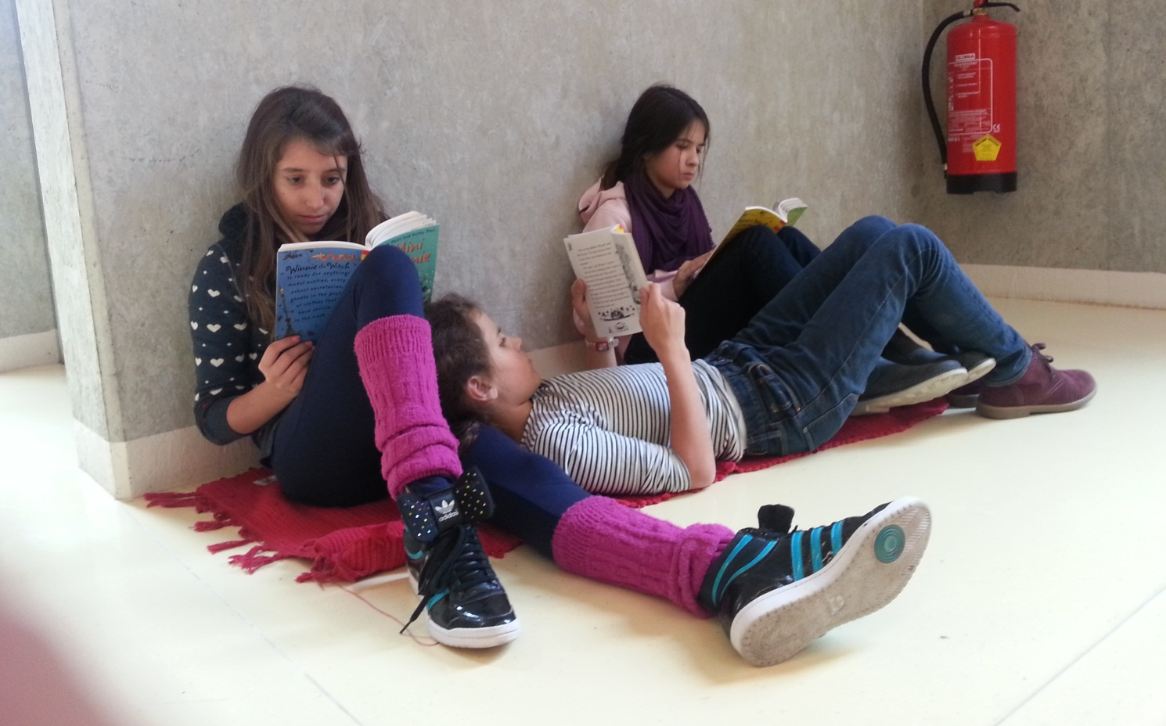
Reading is fun
Ideas for using children’s books and young adult literature in secondary school.

Table of Contents and Schedule

Getting Started 4
Common reading activities for narrative texts 8
Exploiting texts for vocabulary expansion 11
Reading whole books: How do we start? 13
Reading diaries 17
Planning and Organizing Reading Projects 31
Booklets: The pedagogy of the blank sheet 42
Ideas for Book Presentations 52
Contract 59

Schedule

Option A | Option B
09:00 – 10:30 | 09:00 – 10:30
Coffee 30’  10:30 – 11:00 | Coffee 15’  10:40 – 10:45
11:00 – 12:30 | 10:45 – 12:30 (+15)
Lunch  12:30 – 14:00 | Lunch  12:30 – 14:00
14:00 – 15:30 | 14:00 – 15:30
Coffee 30’  15:30 – 16:00 | Coffee 15’  15:30 – 15:45
16:00 – 17:30 | 15:45 – 17:00 (-15)

Materials
This handout summarizes the ideas presented in the seminar and is meant to remind you of the activities and tasks that you have seen and discussed.
You will find master-copies of all the student materials and full-size pictures of the scanned student samples in the READING section of my homepage:

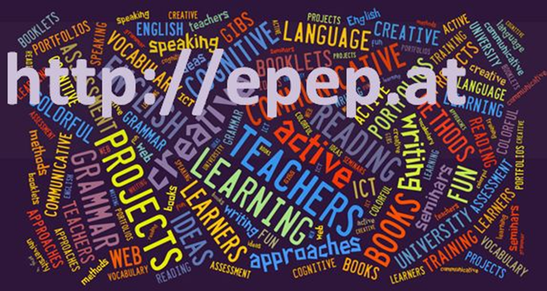

Further Reading
Find links to excellent, useful books on teaching literature on epep.at -- Reading – Further Reading

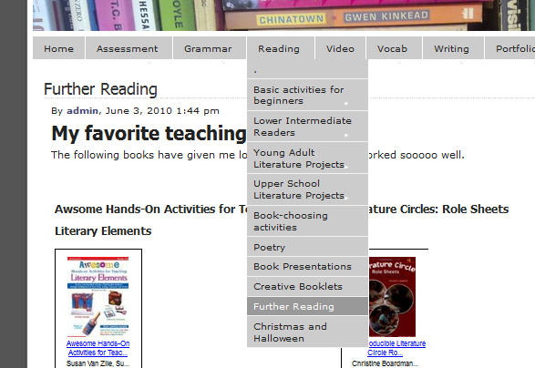

Getting Started

The ten commandments of teaching reading
- Make reading an everyday topic. Reading is fun. Reading is cool. WE all read.
- Read stories in relaxed atmosphere. Read stories as a special treat after hard work.
- Create a class library: Good bookshops are:
http://www.Amazon.de
Wolfgang Steinhauser's bookshop http://www.thebookshop.at
- Start reading whole books (picture books, stage 1 readers) as early as possible.
- Use reading logs and reading diaries to keep track of Ss reading.
- Give credit to book reports and reading
- Invite students to present books regularly, reserve space for book recommendations on pin-board.
- Create reading circles to discuss books.
- Use books for active vocabulary expansion.
- Allow as much free choice as possible. Consider different reading tastes and reading abilities.

Purpose of reading
Brainstorm the multiple purposes of reading in the foreign language classroom.

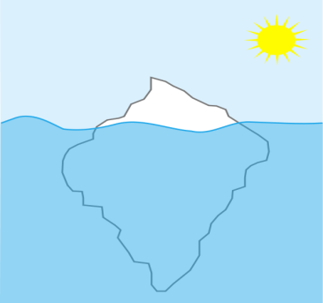
Culture versus culture

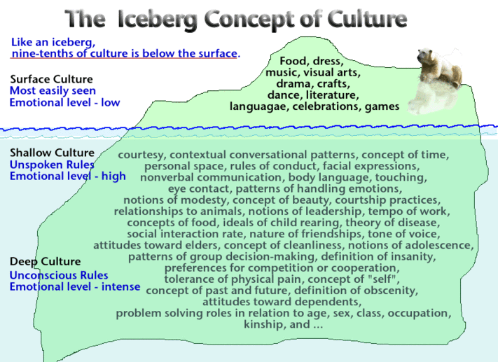

1Indiana Department of Education: http://crossculturalargentina.files.wordpress.com/2012/03/icebergculture

Language: Expansion of vocabulary and grammar

Reading ACTIVELY involves the whole brain. We make connections and associations between language and concepts in our memory. Reading activities (pre- while- post –reading activities) enrich these processes and strengthen the newly developed neural networks.
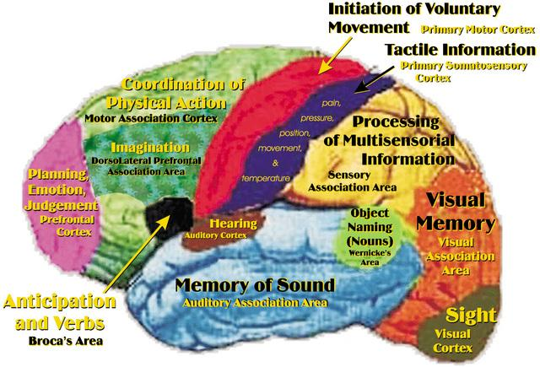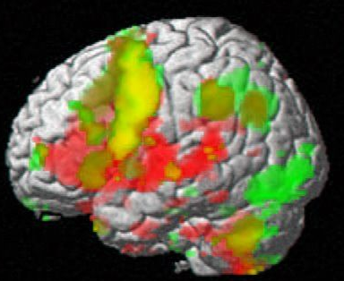

How do we read?

- Skimming: quickly running one's eyes over a text to get the gist of it.
- Scanning: quickly going through a text to find a particular piece of information.
- Extensive reading: reading longer texts, usually for one's own pleasure. This is a fluency activity, mainly involving global understanding
- Intensive reading: reading shorter texts to extract specific information.

NOTE: The different ways of reading are not mutually exclusive.
Example: We often skim through a passage to see what it is about before deciding whether it is worth scanning a particular paragraph for the information one is looking for. In real life reading purposes vary constantly. Therefore, exercise types should also vary according to the text studied and the purpose of reading it. It would be highly artificial to work on a page of classified ads and propose exercises that require detailed reading of every single advertisement.

You don't have to know every single word in a text.

1. Read the text and try to understand the general meaning of the story. (All the words in italics are nonsense words.)
A country girl was walking along the snerd with a roggle of milk on her head. She began saying to herself, 'The money for which I will sell this milk will make me enough money to increase my trund of eggs to three hundred. These eggs will produce the same number of chickens, and I will be able to sell the chickens for a large wunk of money. Before long, I will have enough money to live a rich and fallentious life. All the young men will want to marry me. But I will refuse them all with a ribble of the head - like this . . .'
And as she ribbled her head, the roggle fell to the ground and all the milk ran in a white stream along the snerd, carrying her plans with it.
Now look at the nonsense words again. Can you guess what they might mean?
Would you feel comfortable to read a text with as many unknown words?

The 5 Finger Rule: Students read the first and second page of a book and use their fingers to count the number of unknown words that they cannot easily guess from the context. If the number exceeds 5 unknown words per page, the text is probably too difficult for joyful reading.

Improving students’ confidence

Encourage “top-down” reading skills rather than focusing on every unknown word:
Fast reading activities help students gain confidence and focus on content and gist.
Fast Reading: Basically skimming, give Ss 30 seconds to "read" text, collect info on board. Give them 2 - 3 minutes to read the text again (1 page), collect inf. on board. Ask Ss to write a 50 word summary of the text (in groups). Only then allow them to read the text slowly!
Try out fast-reading with following text.

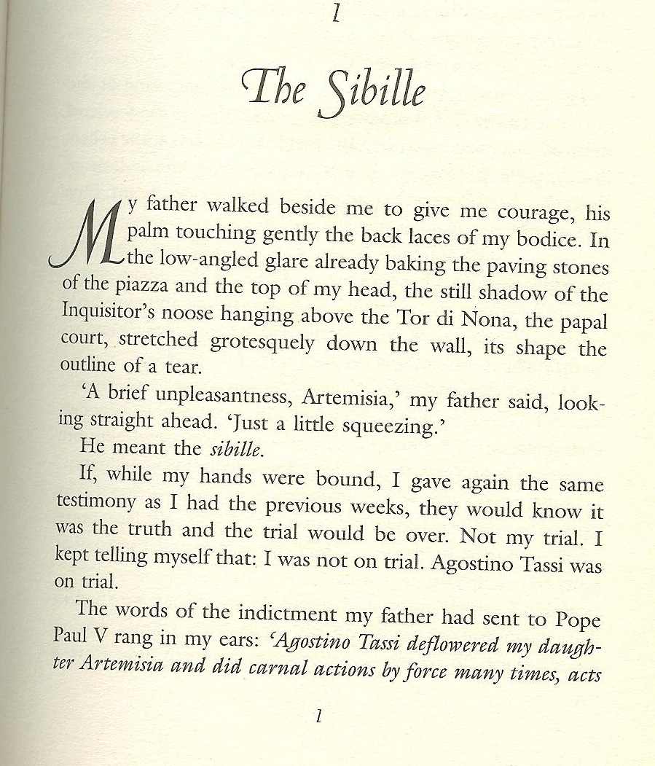
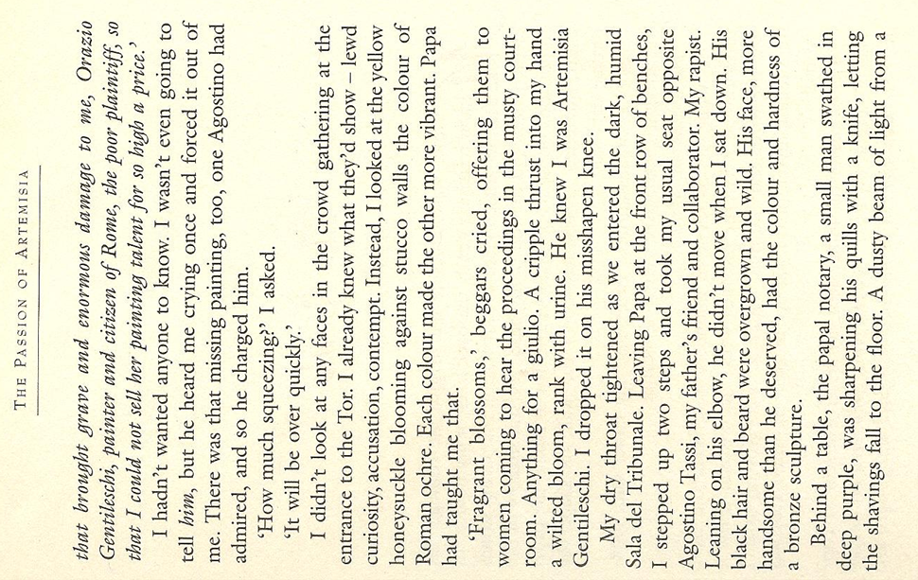
by Susan Vreeland

Common reading activities for narrative texts

Important: Reading is a silent activity --- encourage silent reading.

Why? Work with a partner and collect arguments why students should read silently and on their own.

Can you think of any exceptions? When and where would it be meaningful to read a text aloud?

Constructing reading comprehension exercises.

Pre-reading
Purpose: Creating a reason to read (awaken interest/expectations) or give some idea of the content before the students see the text.
Prepare the brain: “priming”
Prepare difficult vocabulary before students see the text.

While reading
Start with global understanding and move towards detailed understanding.
Don't ask too many questions - don't "kill" the text.

Post reading
Design a follow-up activity. Don't separate reading comprehension from the other skills. A following oral or written activity will give the reading text a purpose.

Pre-reading activities

- Pictures: Show a picture related to the text. Students guess what the text might be about. For books: show book-cover only. Ss imagine story (plan for a few minutes, then Ss mill around exchanging their invented stories. Can also be done in carousel format. To make it even more exciting: Divide class in 4 groups, show each group a different picture from the book. Then crossgroup- Ss exchange what they’ve seen and discuss what the story could be about.
- Kim’s game: Show Ss a picture for about 1 minute (best done on OHT), they jot down all the details they remember. This can also be done at a later stage in the story.

- Titles, Headlines: Give title. Have students guess what the story might be about. They might start like this: I think …. is going to…// I hope ….// I don’t want …..//

- Select 4-5 words: Write these words on board. Ask students for associated words. What might the story be about?

While reading and post reading tasks and activities

- Matching: text and pictures
- Ordering pictures: For picture books, copy picture pages without text (1 set per group), read story, Ss find matching pictures, put them in correct order. Then compare.

- Ordering jumbled sentences or paragraphs: Cut into strips if possible

- Two in one stories: cut up two short texts, mix. Ss sort and reconstruct the two stories (Works well with the short texts from children’s books

- Text market: Cut text into N (e.g. 5) pieces. Provide enough cut copies of the text for each student to be able to put together one complete version. Hand out pieces randomly. Each student has N pieces, some of them might be the same. In order to complete their text they will have to exchange those that are surplus for those that they need. In order to do this Ss sell their unwanted pieces as if they were in a market. They walk around describing their pieces and swapping them for the ones they need. The most important rule of the game is that text pieces must never be shown before they are exchanged. When the students have bought all N pieces of the text they sit down and reconstruct the text. Note: The market-phase may be quite chaotic at first, noise dies down as more Ss have bought all the pieces. Fast Ss can then help others.

- Gap filling: any short text, leave out words or phrases. Leave space where the word is missing.

- Gap finder: Leave out words but don't leave any empty space (more difficult). Ss have to find out where a word is missing and write it in. Print texts with double line spacing for this exercise or leave a margin where Ss can write the missing words.

- C-test: print first half of each word, Ss complete the text.

- Picture corrections: Separate the picture and the text. Change the text so that it represents things slightly differently from the picture. Students spot the mistakes and correct the pictures!!!
- Draw a picture: Listen to the story, imagine the scenes in detail, then draw or paint a scene…
- Carousel: Divide your story into 6 to 8 short pieces. Copy sets on different colors, enough pieces to serve the whole class. Distribute the pieces randomly. Students with the same color go together, then meet another group of a different color. The two groups build two concentric circles. (Do this in the hallway or any open area) Then the two students facing each other exchange their story bits (they must not show the cards). After one minute (more or less, depending on the length of the texts) the students in the outer circle move one person to the left. The new partners now exchange the content of their pieces… Do this until the students have heard the content of all the pieces.
- Writing and answering questions: Students write questions for another group
- For further ideas (esp. ideas for novels) see epep.at

Potatoes
Text market
retold by S. E. Schlosser

Teacher instructions: Use for TEXT MARKET. Copy one sheet for each student, cut up. Hand out titles and task boxes to everybody. Shuffle all other cards and hand out 4 to each student. Ss must not show their cards to others. They buy and sell cards as described in the TEXT MARKET activity. (Reading Activities sheet) Students who have got all 4 parts then glue the slips on a worksheet in the correct order and do the follow-up tasks.

We here in Idaho are right proud of our potatoes. Our fields are so chock full of potatoes that you can hear them grumbling when you stick your ear on the ground. "Roll over, you’re crowding me," they say.

Potatoes grow bigger in Idaho than anywhere else. Once, a greenhorn asked me for a hundred pounds of potato. I set him straight real fast. I don't believe in cutting into one of my potatoes. "You buy the whole potato, or you take your business elsewhere," I told him.

Why do our potatoes grow so big? Well, it’s because we feed them like family. Cornmeal and milk every day for breakfast, lunch and dinner. You should taste my wife's mashed potatoes! They are the creamiest mashed potatoes in the whole United States. It’s all the milk our potatoes drink while they’re growing. Makes them so creamy that all my wife needs to do is just boil them and mash them up.

Sometimes, the size of our potatoes creates a problem for the farmers. One fellow I know got trapped for eight hours beneath a potato. His wife came looking for him when he was late to dinner. She had to get the neighbors to help roll it off. But that's just they way it goes when you're farming potatoes in Idaho.

How does the storyteller describe potatoes in Idaho?
Idaho potatoes are:

Design an ad for Idaho potatoes. Be creative. Use your computer or handwrite and draw your ad. Decorate it nicely.

Gap finder
Frozen Dawn
retold by S. E. Schlosser
Gapfinder: Some words have been lost in this text. Write the missing words in the margin and put numbers to indicate where the words should go.
One winter, it was so that the dawn froze solid. The sun got caught two ice blocks, and the earth iced up so much that it couldn't turn. The first of sunlight froze halfway over the mountain tops. They looked like yellow icicles dripping towards the ground.  Now Davy Crockett was headed home after a successful night hunting when the dawn froze up so solid. Being a smart, he knew he had to do something quick or the earth was a goner. He had a freshly killed bear on his back, so he whipped it off, climbed right up on those rays of and began beating the hot bear carcass against the ice blocks which were squashing the sun. Soon a gush of hot oil burst out of the bear and it melted the. Davy gave the sun a good hard kick to get it started, and the sun's heat unfroze the earth and started it spinning again. So Davy lit his pipe on the sun, shouldered the bear, slid himself down the sun rays before they and took a bit of sunrise in his pocket. | 1: cold

Exploiting texts for vocabulary expansion

- Choosing vocab phrases: Students choose 3-5 new phrases that they want to remember and write them on vocab cards.

- Lexical Furniture: put the new phrases in suitable places in your house/home. E.g: the verb “to separate” would go into the kitchen, under the sink, because there I separate my waste….

- Connect a Pair: Take 10-12 vocab cards that you want to remember and put them on the desk in front of you. Now form five to six pairs and find some connection for each pair. Example: use both in the same sentence or make up a little story, of match opposites or say how they are alike...

- Word Webs: On an A4 sheet create a web of words around a topic in your story.

- Acrostic Puzzles: Write the title of your book on the page vertically. Then find one fitting word or a short sentence for each letter. Your words should have something to do with the story.

- Personal Properties: Choose 10-15 new words that you want to remember and collect your personal associations with each of them.
  - Weight
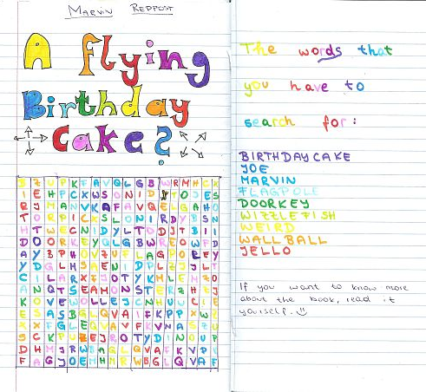
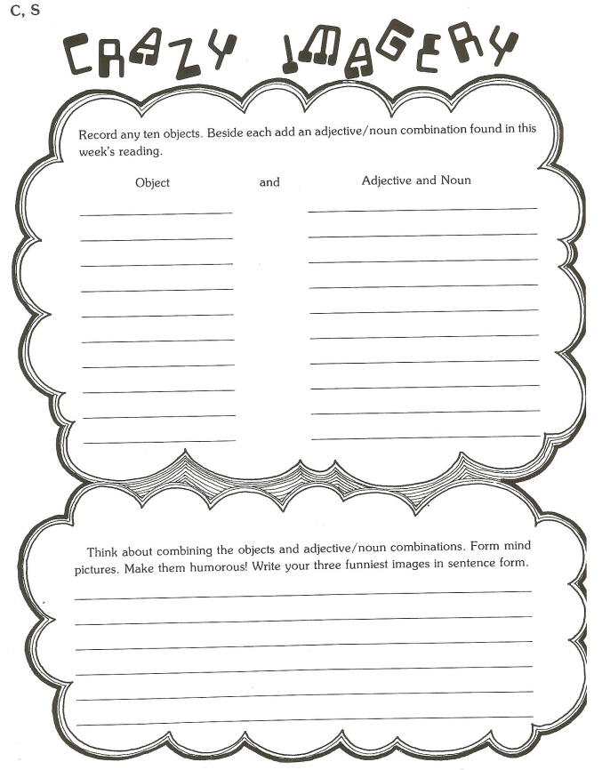
  - Shape
  - Texture

- Wordcycle

- Word Search

- Crosswords

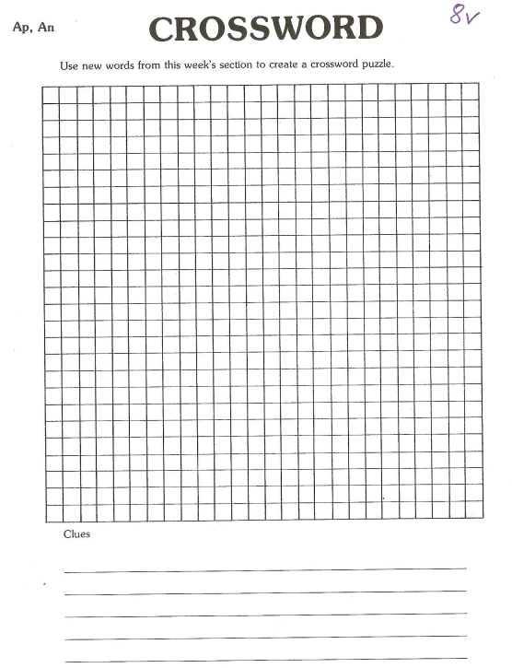

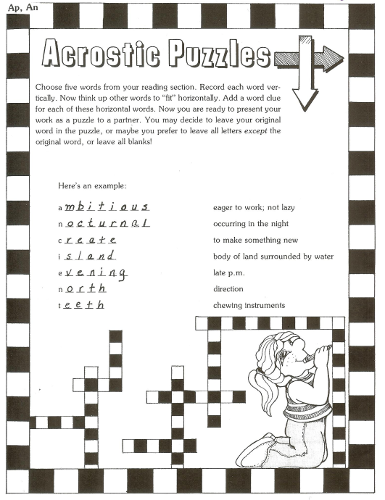

Find these and more great ideas in
J. Szabos, Reading, A Novel Approach, Good Apple Inc. 1984

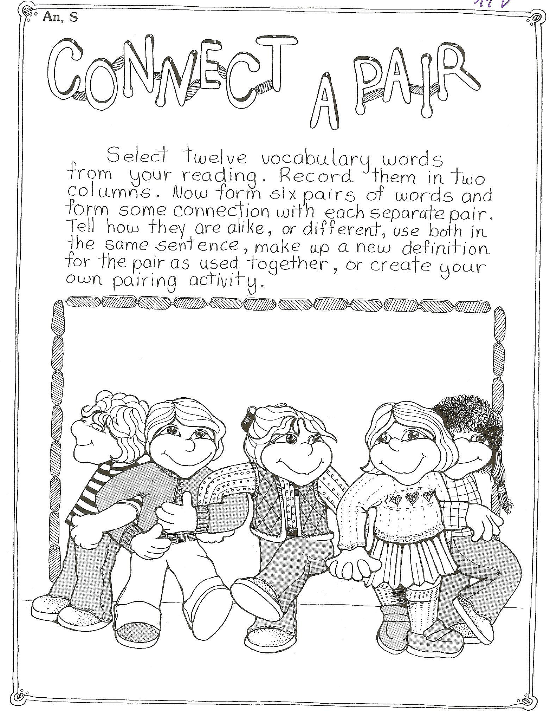 | 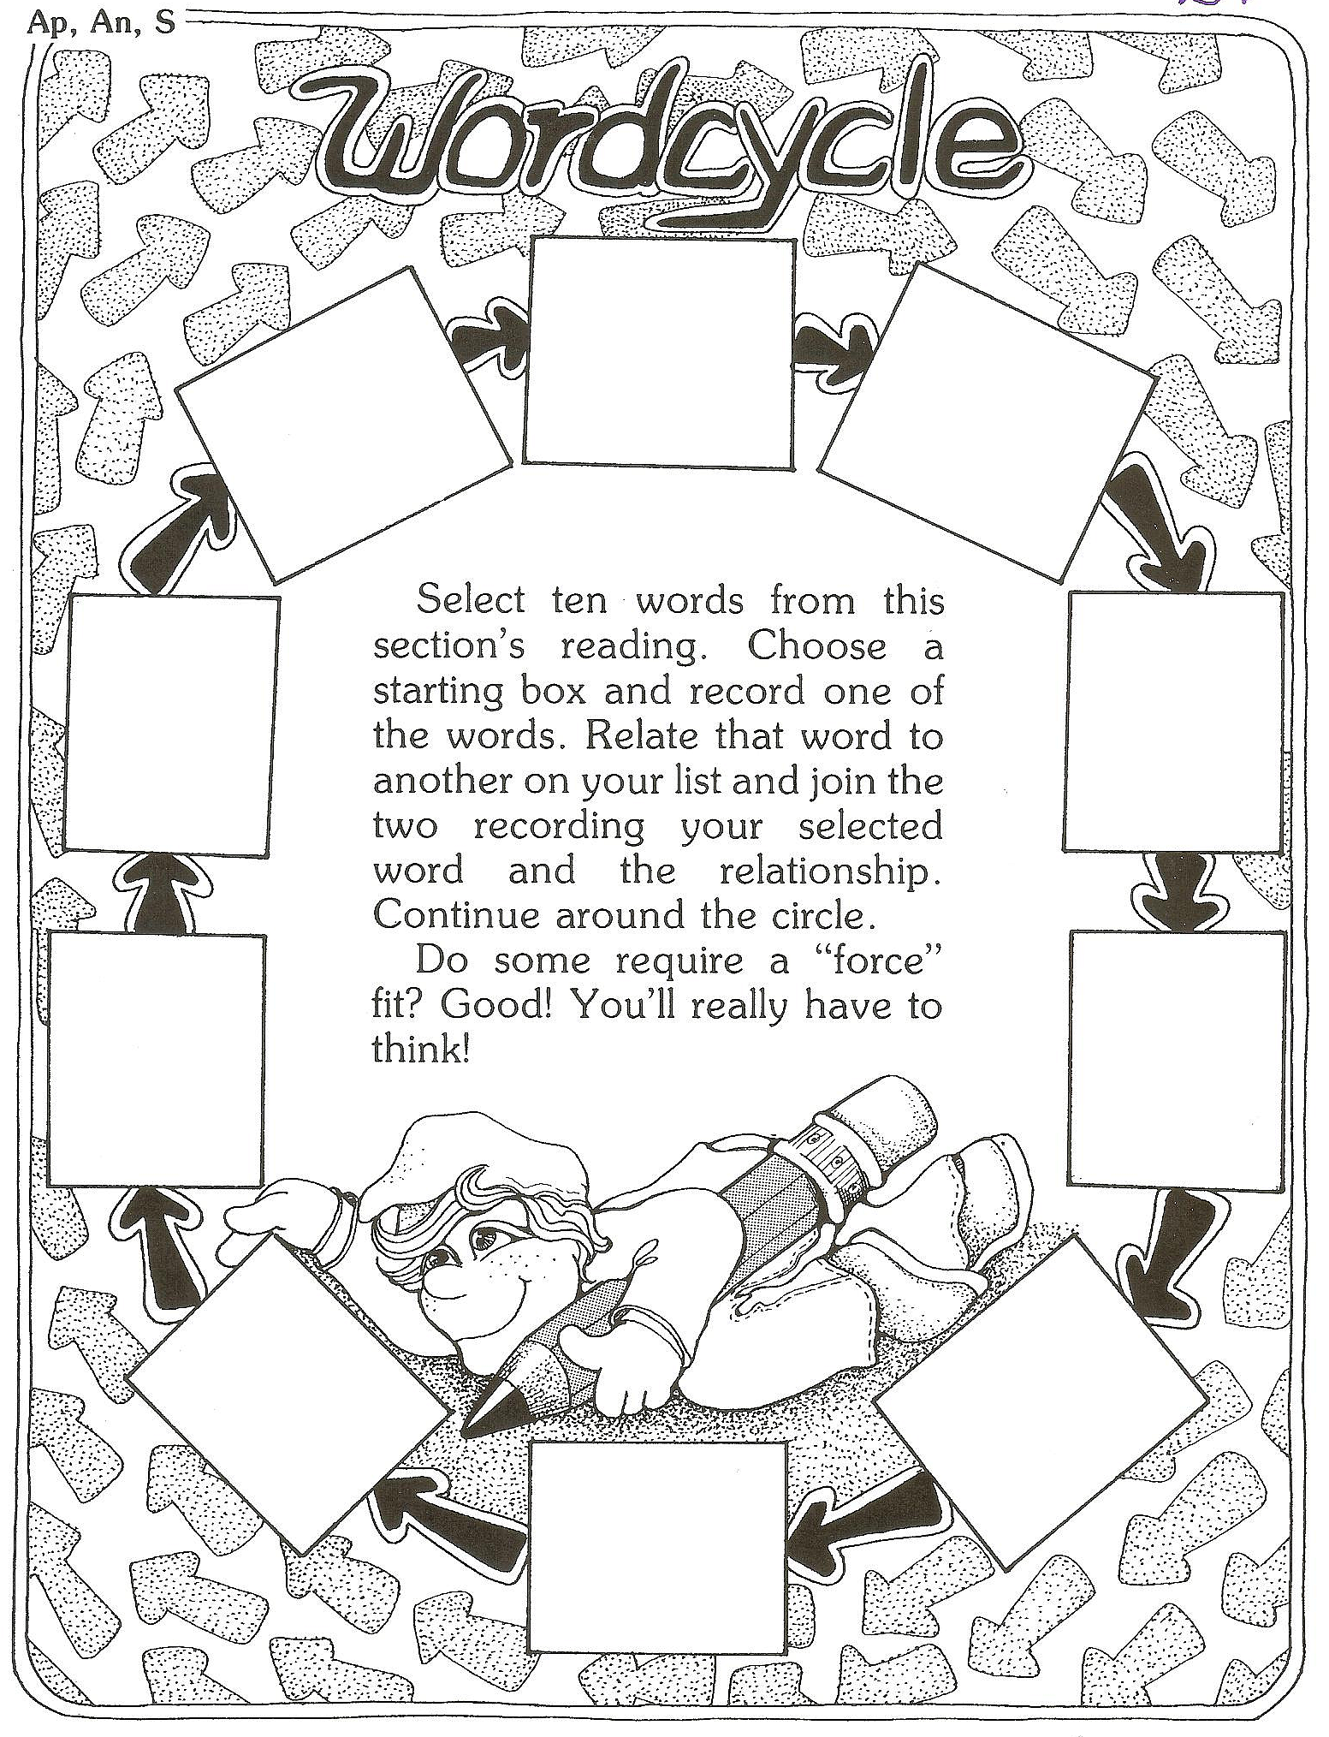
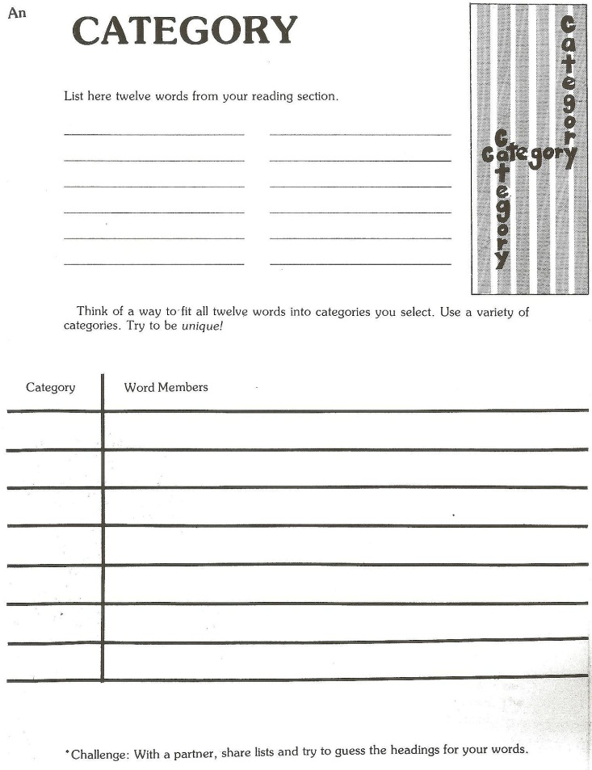 | 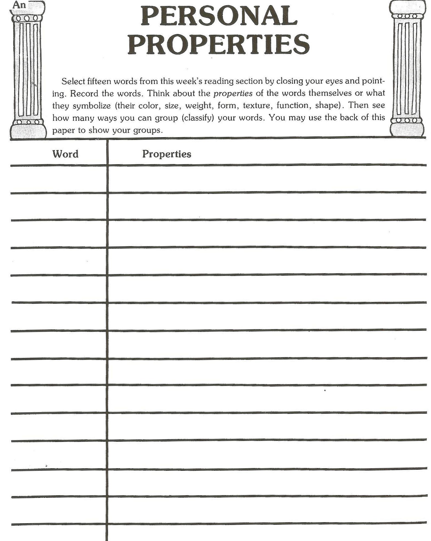

Homework: Go to our library and have a look at the special shelf for our course (Handapparat). Find three to five other interesting reading and vocab building activities and bring copies along to our next session.

Reading whole books: How do we start?

Which of these stories would you like to hear? Ask questions to find out what they are about.
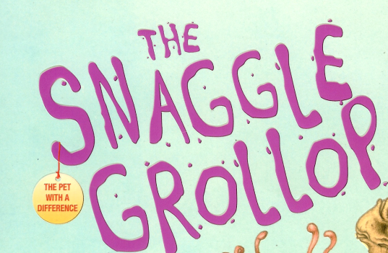 | 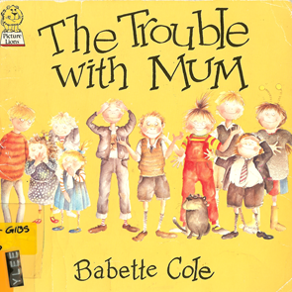
Find the teacher’s notes and the student materials for these activities on www.epep.at
There you will also find other suitable picture books for beginners.
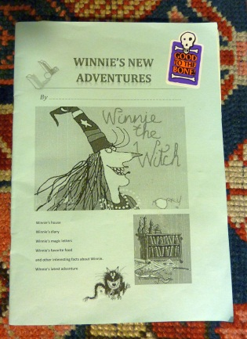
Picture books that have worked well in my classes:
Babette Cole, The Trouble with Mom
The Troule with Gran
Prince Cinders
Princess Smartypants
The Smelly Book
Valerie Thomas and Korky Paul, Winnie the Witch
Daniel Postgate, The Snagglegrollop
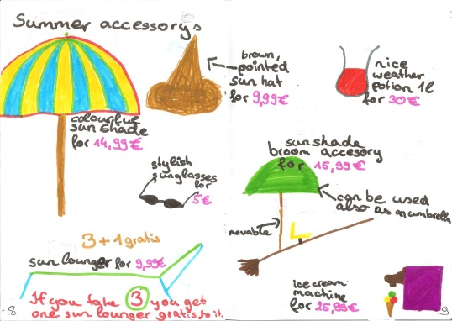
Julia Donaldson, The Gruffalo
Michael Foreman, All the King’s Horses
Richard Brassey, Greyfriar’s Bobby
Simon James, Dear Mr. Blueberry
Peggy Parish, Amelia Bedelia goes Camping
Shirley Mozelle, James Watts, Zack’s Alligator
Angela MCAllister, Monster Pet
Jackie French, Diary of a Wombat
Norman Bridwell,, The Witch next door
Find these and other suitable books on epep.at, Storybooks for beginners

Basic tasks for storybooks
The purpose of these tasks is to make the learners read parts of the text in detail and use some of the new language actively. These tasks should be short and easy – we do not want to spoil the fun of reading.
Find the printable worksheets on www.epep.at  Book Chat:  Choose your favorite page in the book and describe it to your teacher or co-teacher.  What do you see?  What is happening in the picture?  Write a Postcard  Imagine you are one of the characters and write a postcard to a good friend. Tell your friend where you are and what it is like there. (no past tense necessary for this task!) Draw a picture on the front side of your card. | 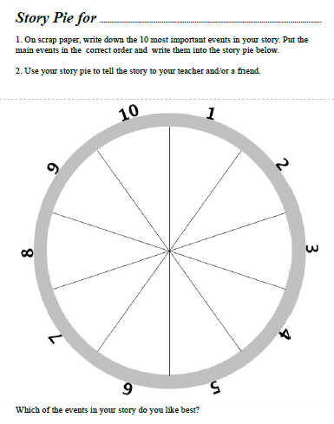
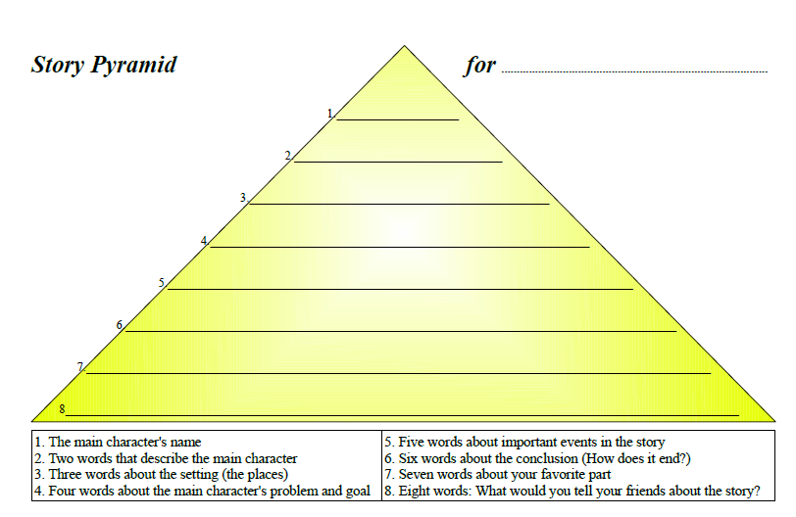 | 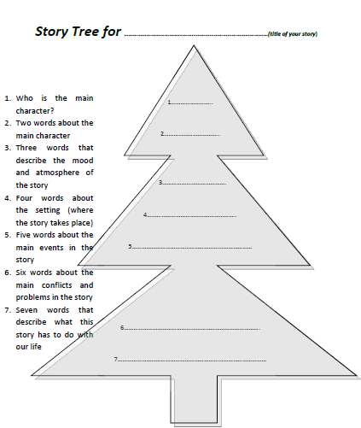

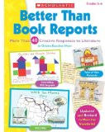
More useful ideas from
Find this and similar books in the “Anglistik library” or get your own copy. Find a link on epep.at

Christine Boardman Moen, Better than Book Reports, Scholastic Professional Books, 1992,
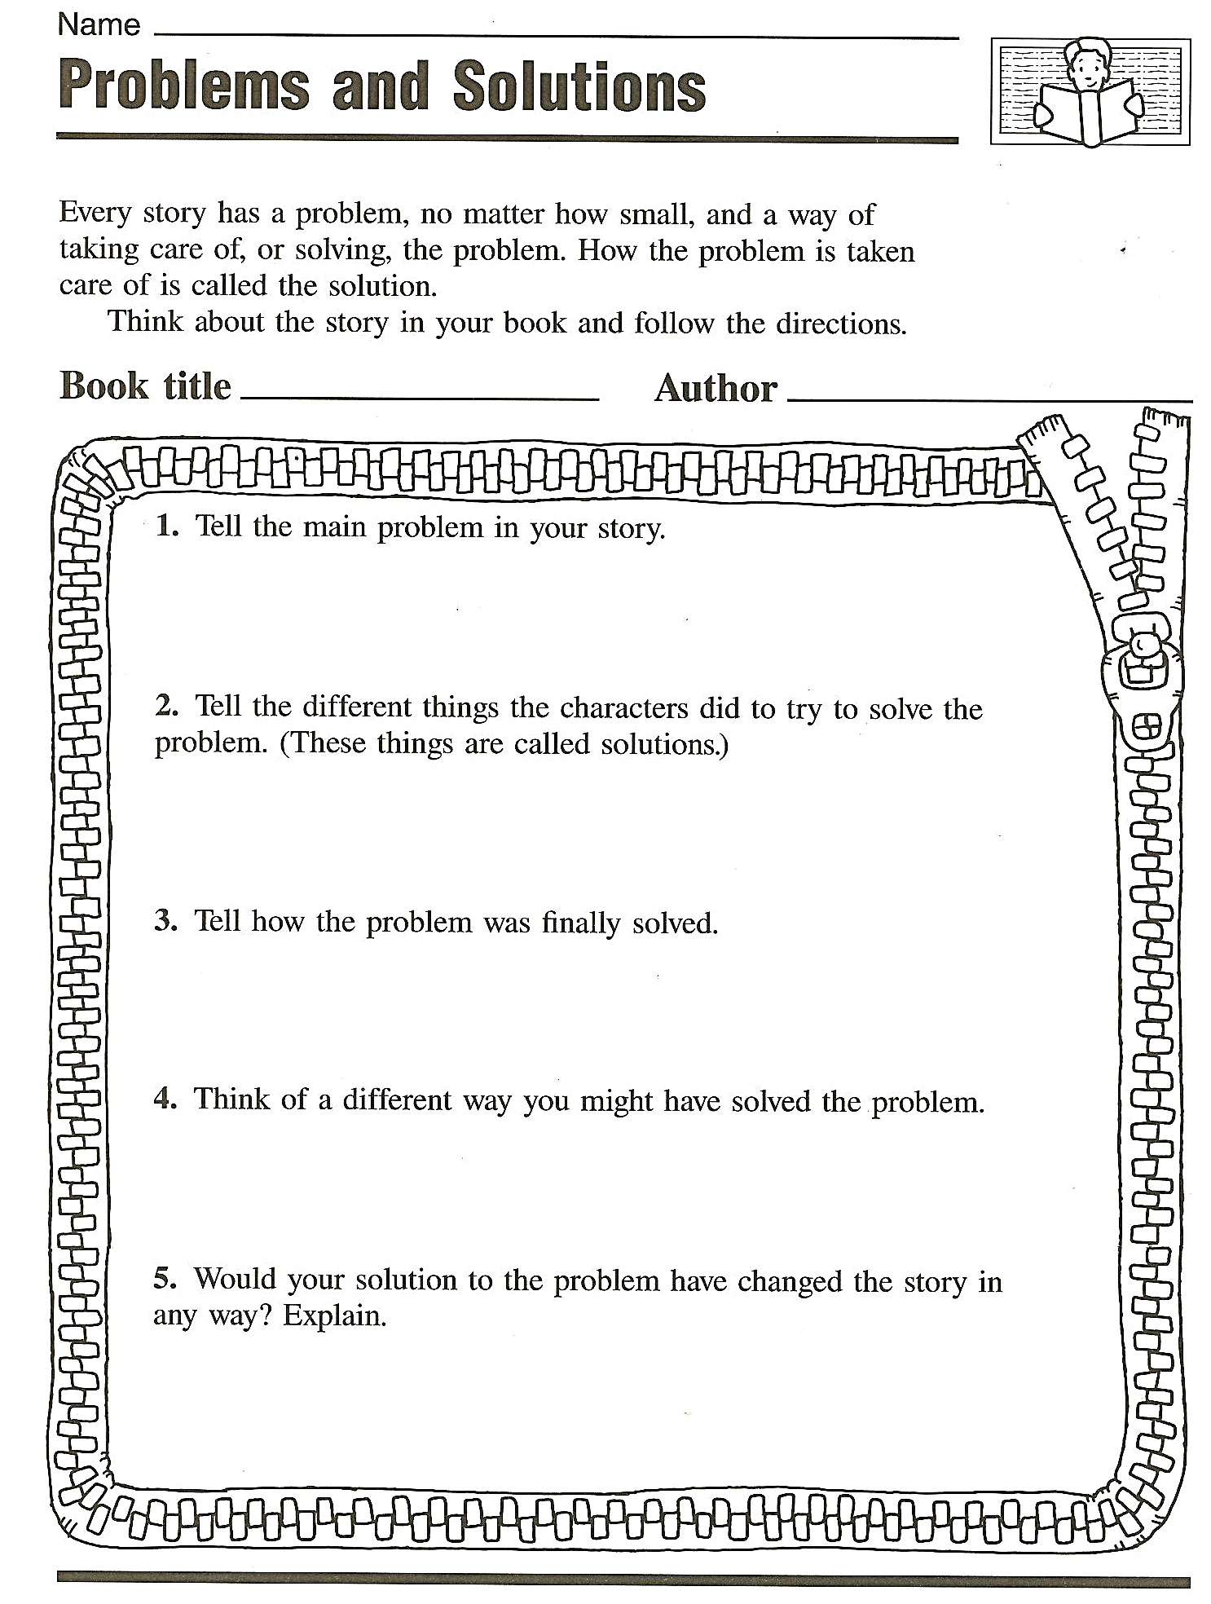 | 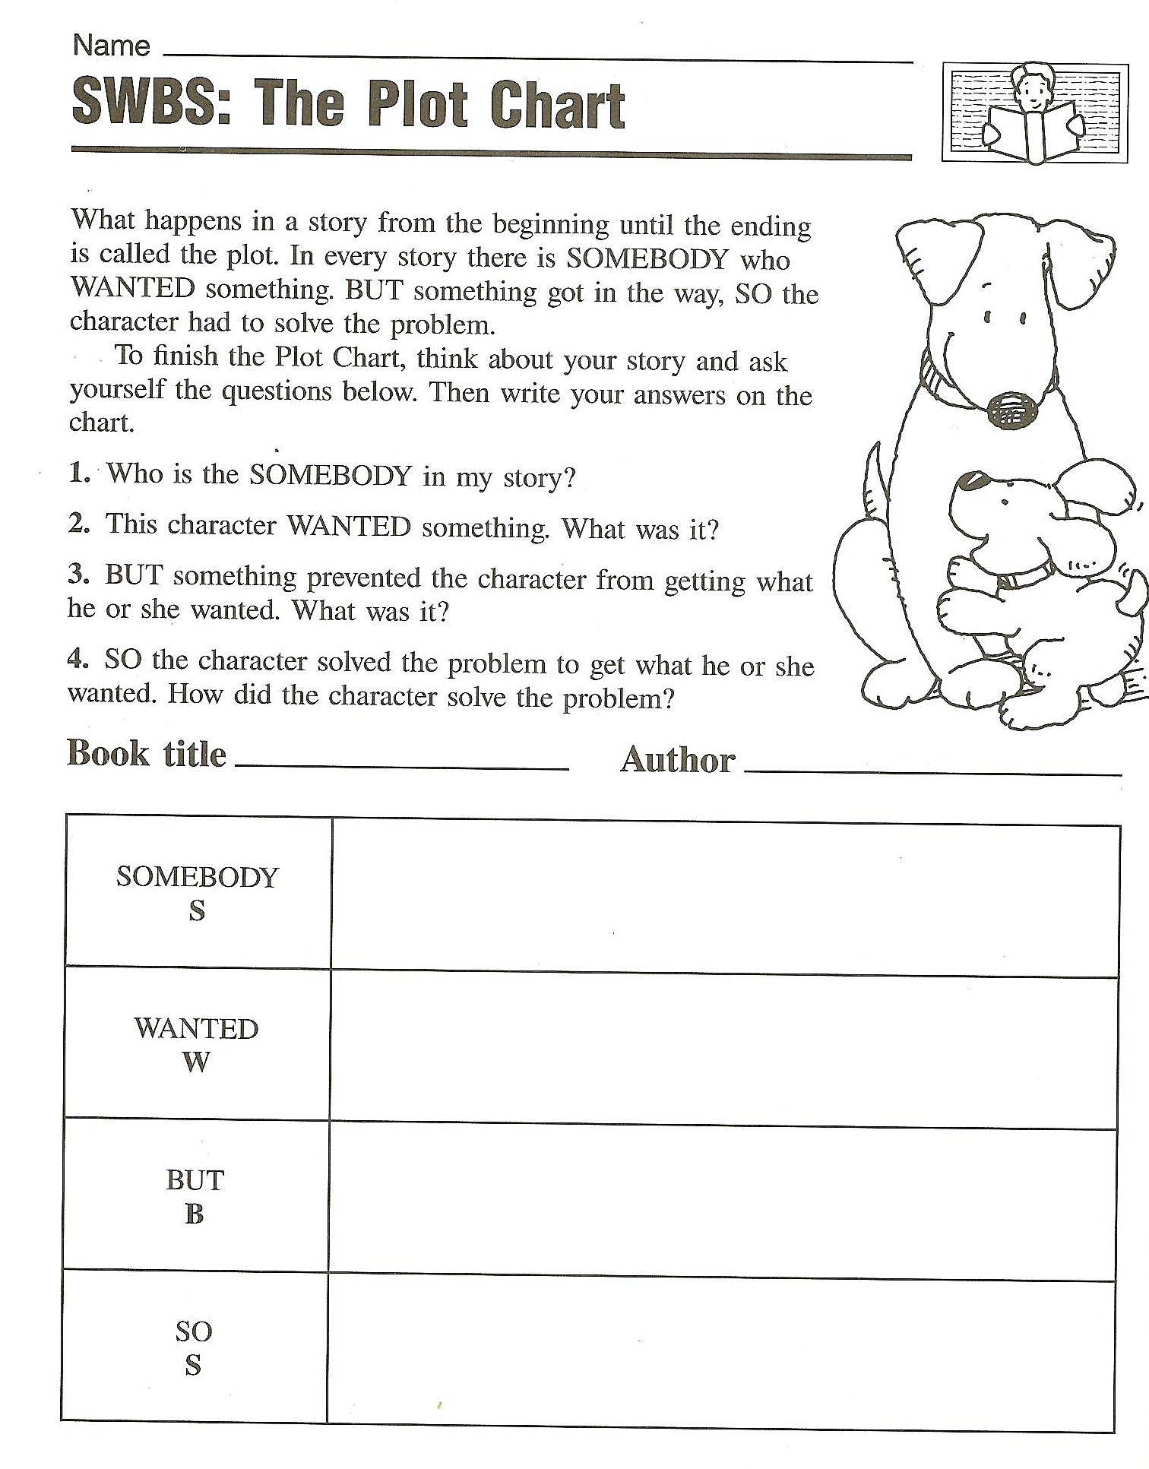
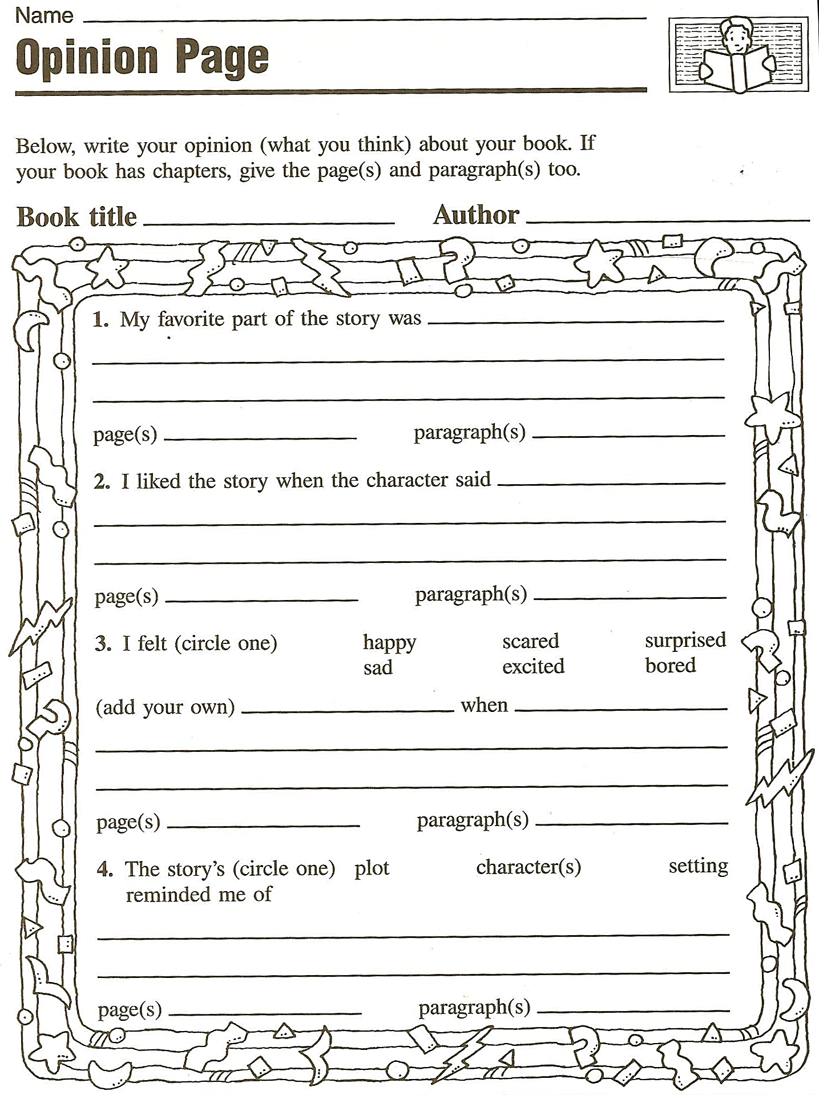 | 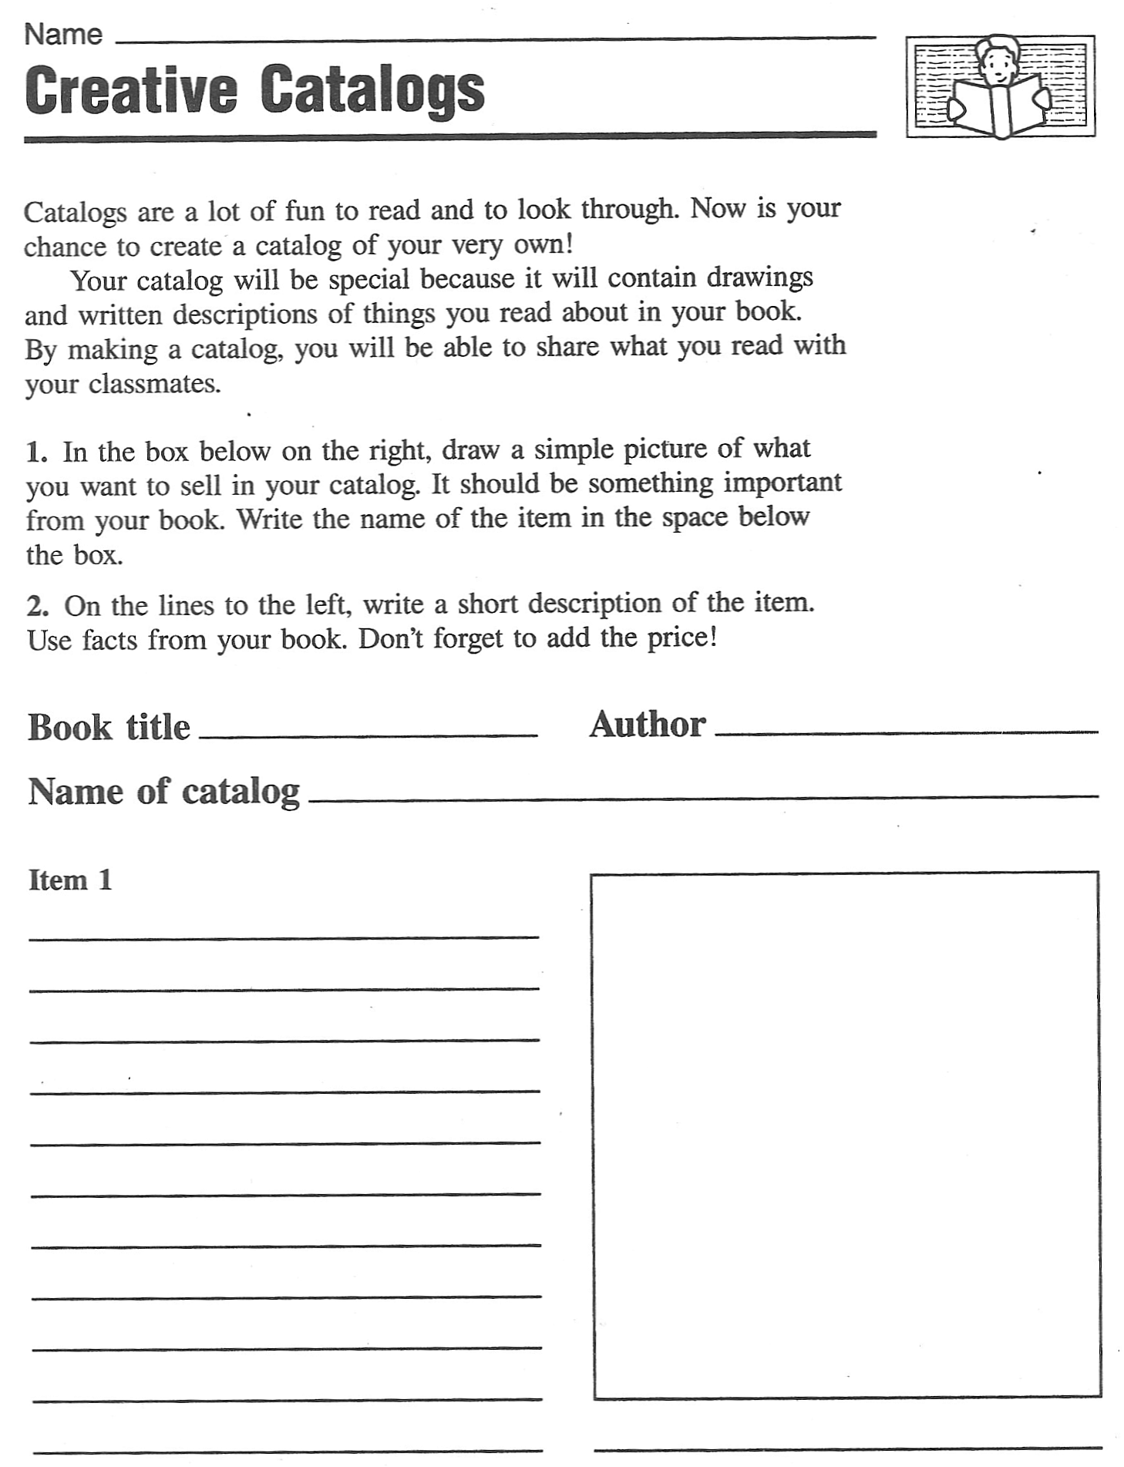  Tip: Groups can design a catalog of several pages for an interesting book.

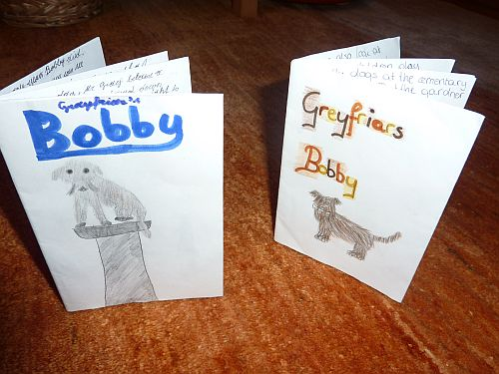
Elementary level: Origami Books

This activity can be used as one of the first reading activities. It combines listening to a story with reading comprehension and showing this in drawings.

Preparation: Select a suitable story or storybook for your learners.
Prepare a simplified version or summary of the story. Break your story into 7 parts and type it into a table. The table columns should be about 9cm wide in order to fit into the origami books.
Jumble the text pieces in the table and prepare one copy per student.

In class: Read the story or storybook to the learners without showing them the pictures. Read slowly and paraphrase tricky parts to make sure the learners understand the story well.

Hand out one A3 sheet per student and show the learners how to fold 8-page origami books from this sheet. Find detailed instructions on epep.at. (Type Origami books into the search box and scroll down to the bottom of that page.)
Instruct the learners to
- Cut out the 7 text pieces and put them in the right order.
- Check the order with the solution sheet.
- Glue the text pieces into your origami books, leave the title page free.
- Reread the text carefully and draw the scenes in great detail.(Can be finished at home.)
- Design a fitting title page.
- Practice reading the story to yourself at low voice. Then work with a partner and read the text to each other. Take turns – but do this at odd points – in the middle of a sentence. Listen VERY carefully and take over immediately where your partner has left off.

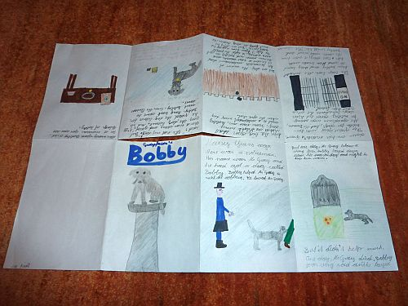 | 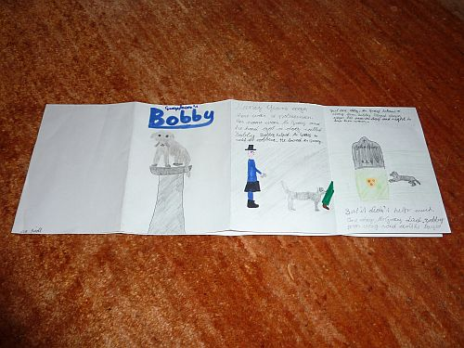
Step 1: Fold the A3 sheet to eight. Cut through the 2 center sections | Step 2: Fold horizontally
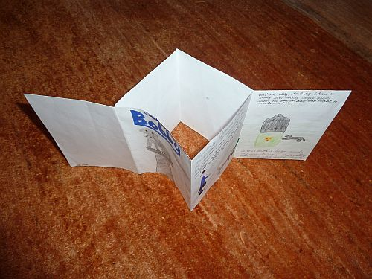 | 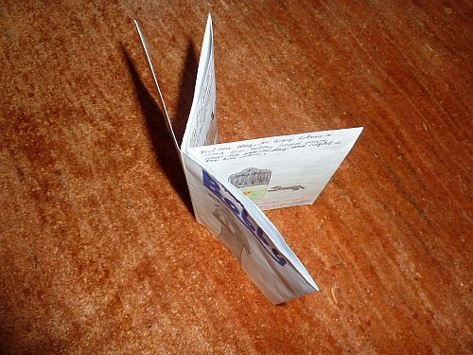
Step 3: Push left and right ends to the center | Step 4: Fold around to form a book.

Reading diaries
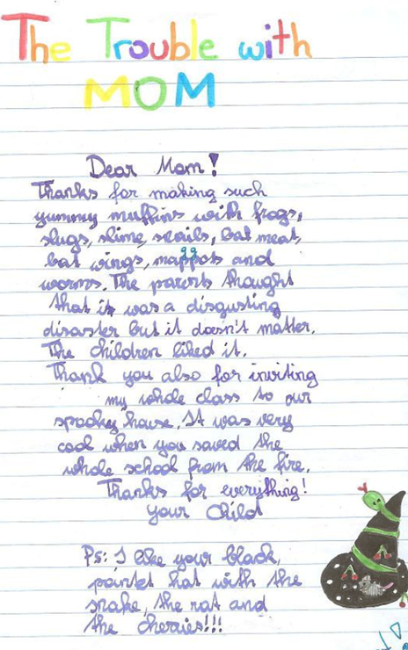

Tips for my first reading diary

For each book that you have read enter the following information:

Author:
Title of the book:
Your rating: (Tell us how you liked the book, give 1-5 stars for example)
A short summary: What happens in the story. Write 5-7 sentences
Personal Comment:
My favorite character is ….. because…
I don’t like (name of character) because...
I wonder why ….
I like/don’t like the ending, because…
Finding Feelings: Write 5 sentences.
How do the main characters feel in the book? Why?
How did the book make you feel? Why? (Choose from the faces below.)
Add a nice drawing if possible: Draw one item that plays an important role in the book.

Feelings:

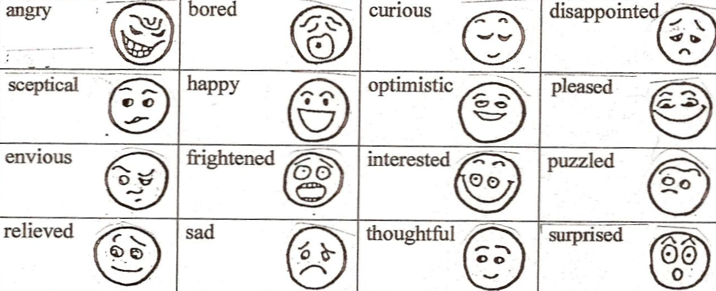

Reading Diaries: Sample pages, year 2

Letters
Twilight: The student is writing a letter to Bella: Year 3
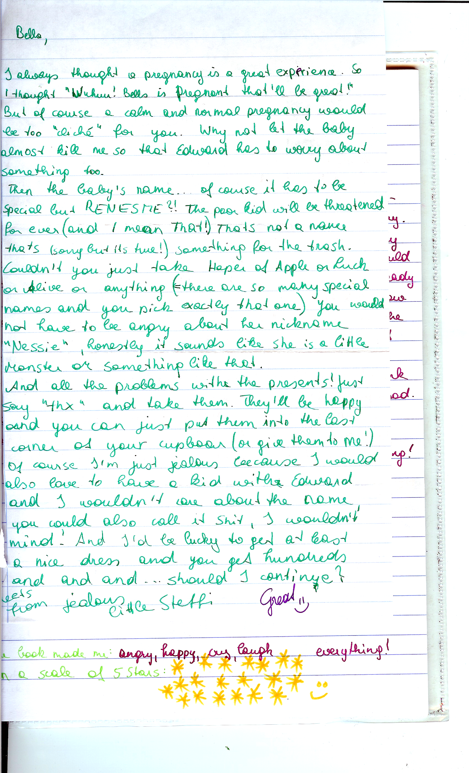

More Letters

Letters to the author or a main character

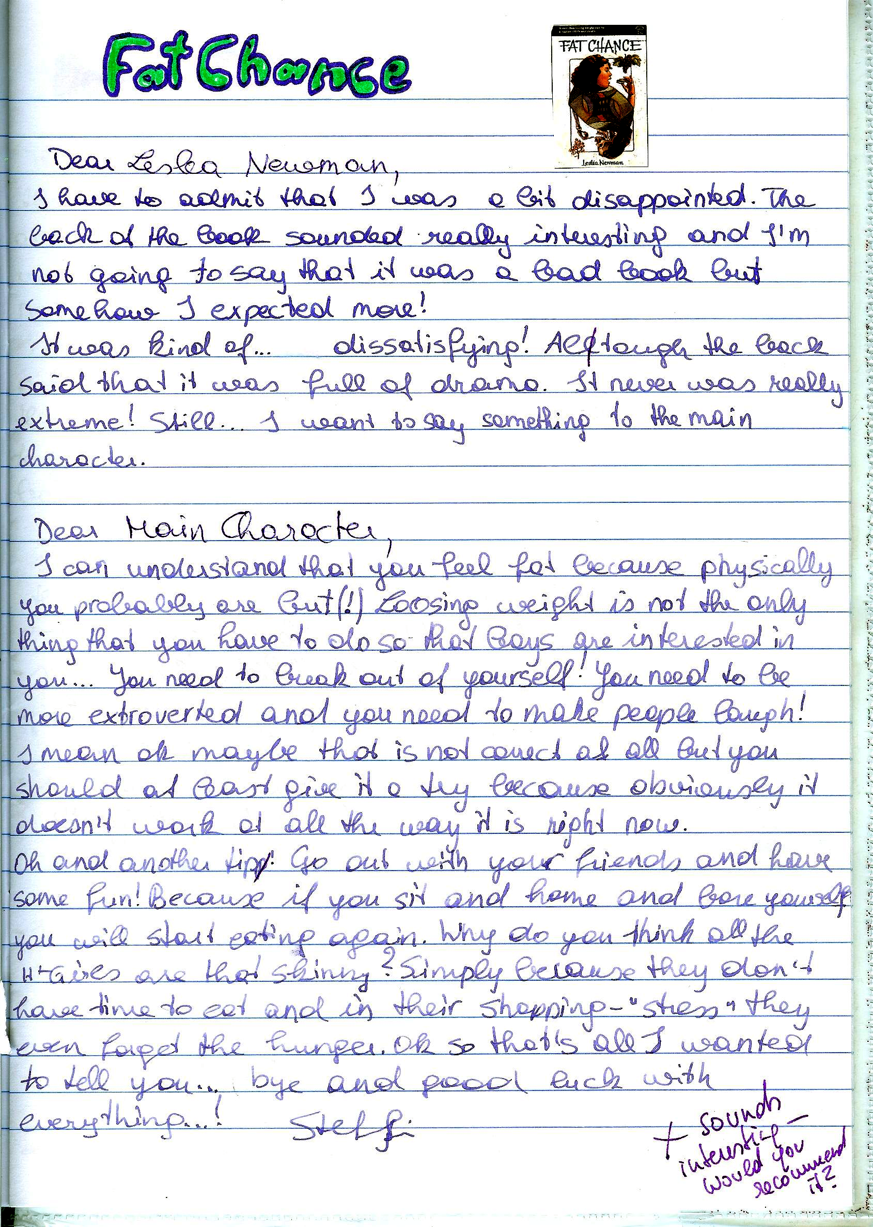

Creative Ideas

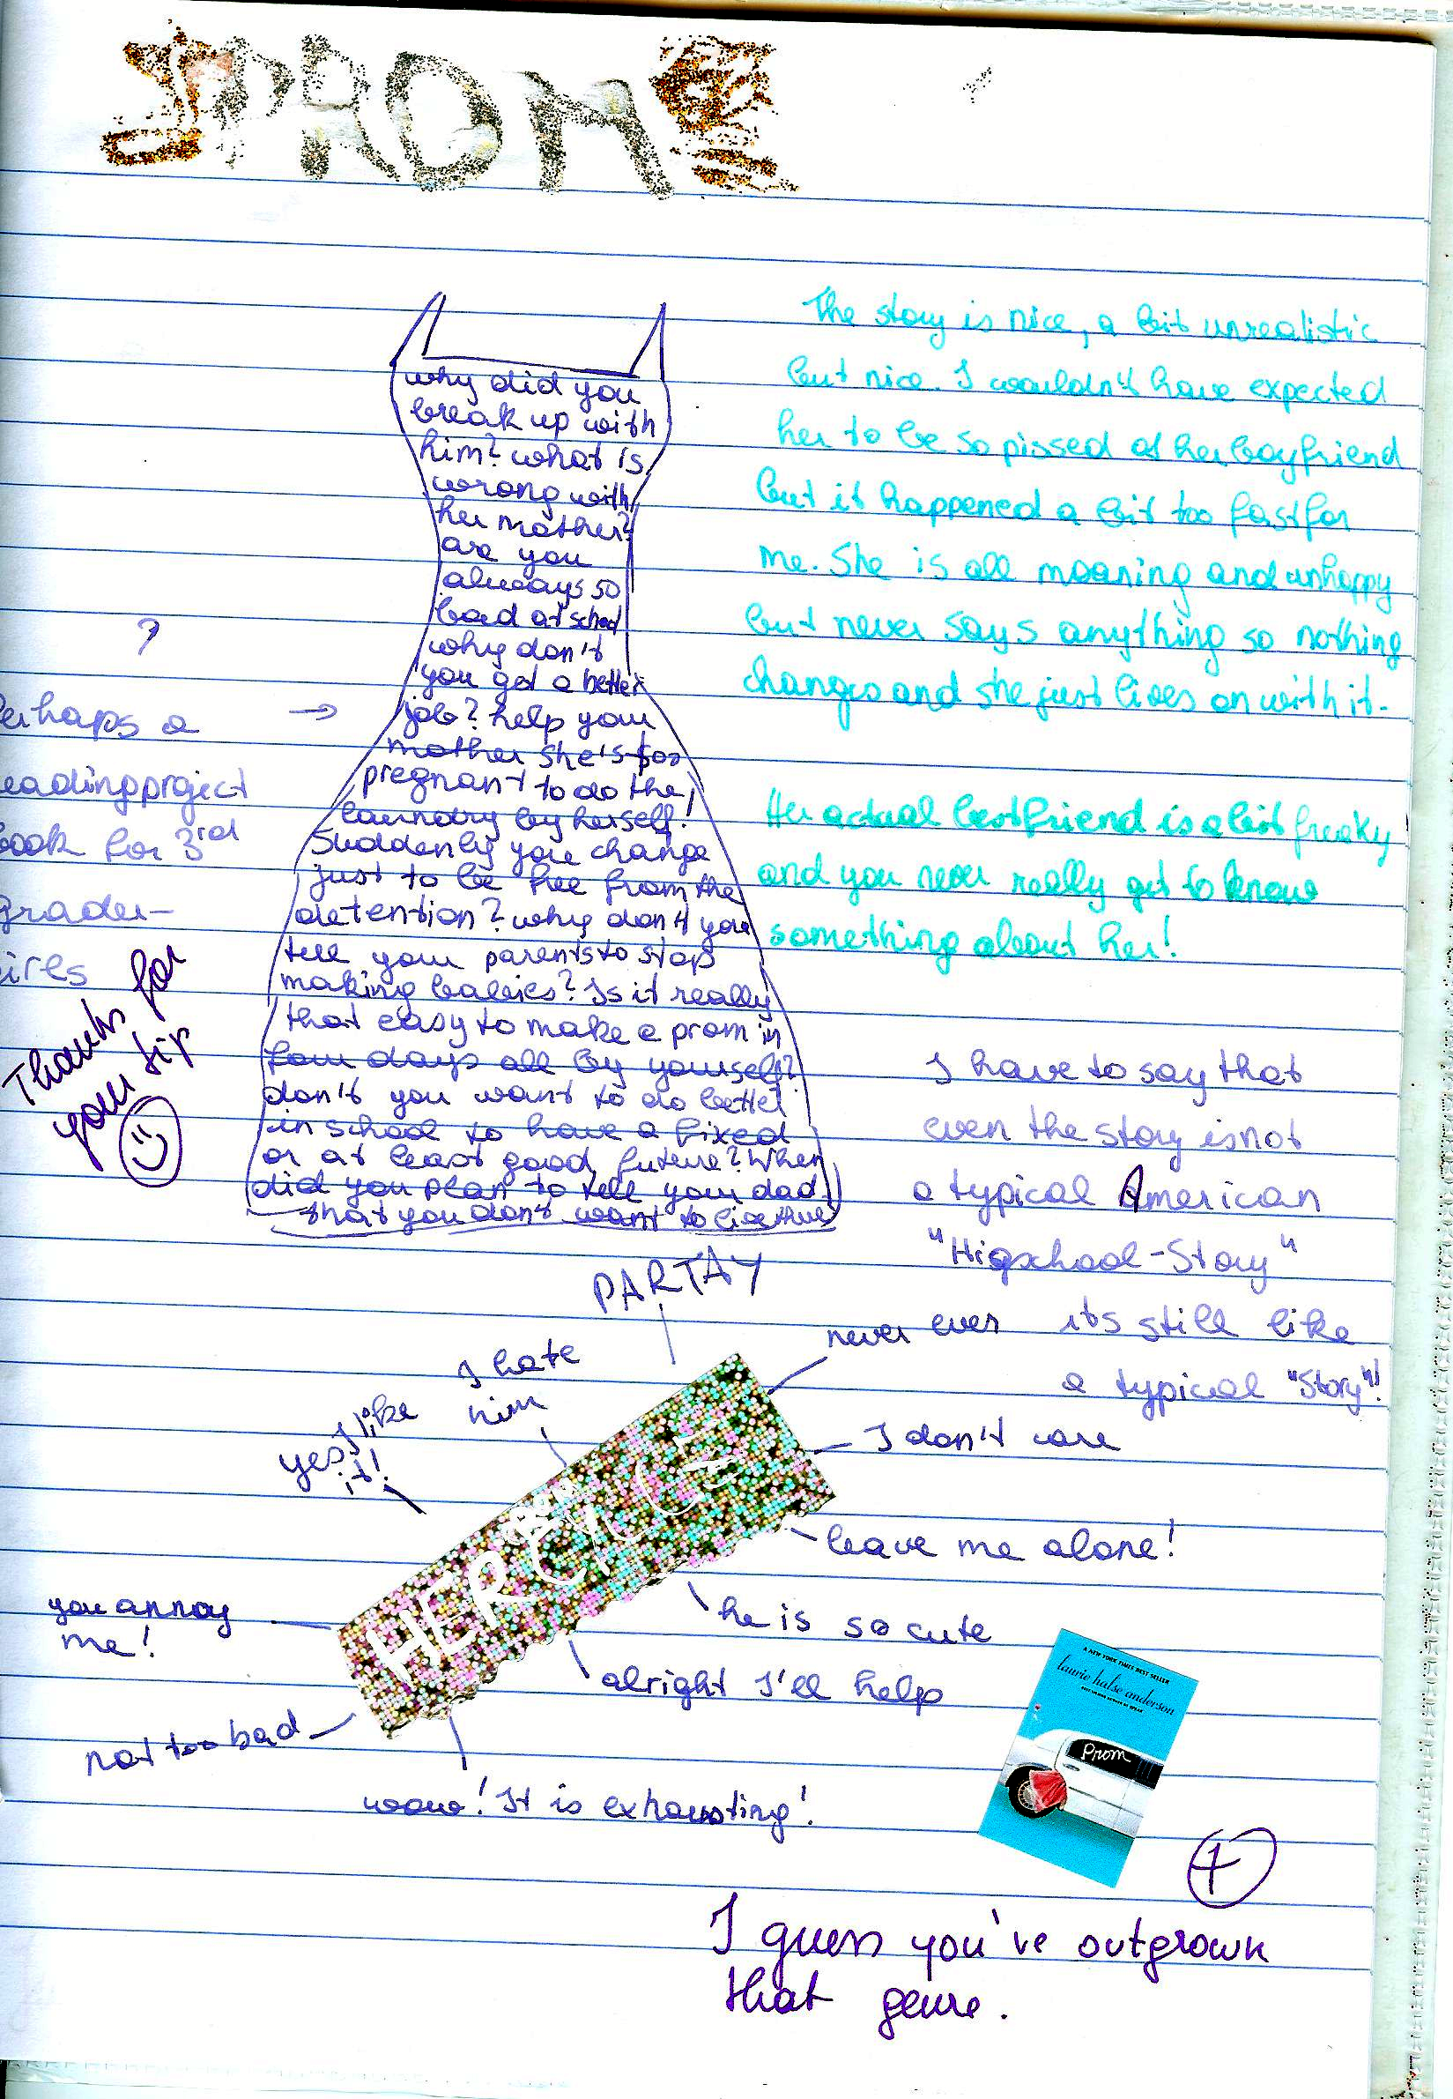

Tips for keeping a reading diary
Effective readers connect with, reflect on, and challenge the text. On your way to becoming such an effective reader use your response journal to try out some of the following tips and techniques.
Read slowly and carefully. Try to imagine the scenes as vividly as possible and try to see life through the main characters' eyes. After reading sit back and think about it for a while, then write a personal response.
Decide how much time you want to commit and stick with it (10 – 15 minutes!)
Write quickly, without worrying about spelling, punctuation, grammar…. Do not pause to think, just keep writing. As you write, follow your thoughts and ideas, do not worry about good organization and coherence. Just let your ideas flow.
Consider some of the following questions:
- Do you enjoy reading this novel or story? Why? Why not? What emotions does the book invoke: laughter, tears, smiles, anger? Record some of your reactions.
- Does the book or its characters remind you of any real life situations or people you know?
- Are the characters interesting and believable? Who is your favorite character? Why is he/she special to you? Is there a character you don't like at all? Why don't you like him/her? Would you like to be one of the characters (acquire a personality trait)? Which of the characters would you become, if you could? Why?
- What are your favorite lines/quotes? Copy them into your reading diary and explain why these passages caught your attention.
- Which are your favorite scenes in this novel? Explain why you enjoyed them.
- Make predictions: What do you think is going to happen next?
- Is the author able to hold your interest throughout the entire novel? How did he or she manage to do this? Or are you bored at times? What exactly makes the chapter/scene boring?
- Is there an idea in the book that makes you stop and think, or prompts questions? Identify the idea and explain your responses.
- Does the book leave you with questions you would like to ask? What are they? Would you like to direct your questions at a particular character? What questions would you like to ask the author of the book?
- Are you confused about what happened (or didn’t happen) in the book? What events or characters do you not understand? Does the use of language in the book confuse you?
- What changes, if any, would you have made in this novel?
- Are there any symbols, symbolic acts or names in the novel?
- Think of the main themes of the novel? What might the author be saying?
- Who else should read this book. Should anyone not be encouraged to read this book? Why?
- Would you like to read more books by this author? Have you already read other books by the author?

Types of Responses
Below you find a number of extracts typically found in response journals:
Affective responses are a kind of raw emotion or a ‘gut reaction’ you have after reading, such as anger, love, jealousy, indignation, contentment, sadness....
e.g.: I was furious when reading the Battle Royal scene. How can these people be so mean and treat a human being like that. I felt like stepping out and hitting them, or sceaming or I don’t know what. I was also shocked at how the main character didn’t even find it so terrible. (He doesn’t have a name! Maybe that has something to say as well, he is invisible and nameless???) He certainly didn’t like being treated like that and was frustrated but not as angry as I was. For him this seems to be quite normal. That makes me even more angry! I really hate these fat politicians, they are the worst hypocrites I have ever seen...
Associative Responses are analogies or associations you have when reading. There are no true and false associations, everyone has their own!!! Let your mind wander, relax (as described in the free-writing technique), this will open the doors for all your associations to flow in.
Look, for example, at the following response of a student to a line from a poem.
...“Something there is that doesn’t love a wall.”(line 1)
I remember when I was young and how I was always sent to my room for punishment of something I had done wrong. I hated being sent to my room, not in the beginning, of course, because I always thought I’d get even with my Mom and show her that I could have a lot of fun in there. As the hours went by, though, I usually ran out of things to do and therefore I would always try to think of a good story to tell sweet ole Dad abourt how mean Mom had been to me. I just hated those four blank walls; I guess that’s because I saw them so often.
or:
Little Richard’s behavior reminds me of this story I read in the newspaper last week. A little boy had played with matches and then hid in the closet because of his bad conscience and fear. Wow, that’s dangerous if little kids react like that. I guess it also has to do a lot with the fear of punishment. These kids must be hit a lot!
You might also note things that strike you as strange or just interesting such as for example this response to the beginning of the novel Song of Solomon by Tony Morrison.
It’s strange that so many characters have Biblical names: Pilate, Magdalena, First Corinthians, Mercy hospital.. (p18). What does this mean?
...
There seem to be a lot of symbols in the book: Watermark (p.11), Red velvet (p.10). I don’t know their meanings yet, maybe it’ll become clearer later.
Also note your impressions of the structure of the text. For example:
The author is constantly jumping back and forth in the lives of the characters. Slowly their history is becoming clear. It’s sometimes difficult to follow. I have to read a page or two until I realize who she is dealing with now! I wonder why she does this!
...
It’s getting worse. I am getting angry with T. Morrison. I feel she is teasing me! Why can’t she just organize her material bxetter? There must be some artistic reason or is it just to be different from the others???
Most of the time your response will be a mixture of all of these approaches. Even the examples above usually include more than just one aspect. Don’t let yourself be stiffled by trying to stick to one aspect. Just let your ideas flow! Don’t forget to write down page numbers, so you can later find exact quotes if you need them.
More examples of reading diary entries

These examples are unedited, quick responses copied from the learners’ online journals on Moodle. (years 6-7)

“The Euphio Question”– Kurt Vonnegut
The first thing I have to mention after having read „The Euphio Question“ is, that I absolutely loved the ending, probably because it was both surprising, and also funny in a way.
The story mildly reminds me of the first one we read. (Top of the food chain/T.C. Boyle) In both stories someone testifies before a commission, telling what has happened, but this story had the “action” or “plot” that I missed in Boyle’s. Although it is, on the second look unrealistic that someone would tell a story in this way before a commission (with all the dialogues and no interaction until the very end with its members), these dialogues etc. make the story easy/fun to read.
One thing I don’t quite understand is how to imagine this feeling you get when listening to the fictional device. At some parts the speaker (sociology professor) describes it as some sort of euphoria and buoyancy, while the people exposed to the sound rather seem relaxed and lazy to me.
Another thing that I didn’t like was the way Vonnegut depicted the wives of Eddie and the narrator: both husbands seem to be used to having a dinner before them when they get home. Maybe that was normal at the time the story was written, but still I can’t help frowning on this type depiction of a wife.
When you have a closer look you can spot some few small details that are a little illogical (for example how does Fred know that the time, when the “whole town went nuts”, “checks” to the second with the time when they switched on the device?) Although I know very well that there might be an explanation for these small details that I didn’t think of yet and that they are completely irrelevant for the plot of the story, I still like it, when everything is logical and makes perfect sense. (In the book I read (also written by Vonnegut) I noticed many and clearer examples of these small things that apparently didn’t fit together, especially with Billy Pilgrim’s time travels.)
I wonder what Kurt Vonnegut wanted to criticize with this short story (as he always does criticize something, that’s for sure). Maybe the fact that people try to make money out of everything possible, without paying attention to who is harmed? It is clear that he wants to say that you shouldn’t want to “buy” happiness, but still I don’t see how buying happiness (through purchasing possession for example) can be dangerous, which is his first argument (I think). This doesn’t mean that I don’t agree with the basic idea, that it is somehow pathetic how we try to become happy.
For me a good story must be/have two things: First of all a message, something to think about, or at least an entertaining story and secondly it must be written in a way that is exciting/funny etc. For me this story fulfills both requirements. (If a story is excellent on one of these two points only, the story can be great too, but if it’s merely “good” in one and mediocre in the other, I tend to forget these stories very fast.)
By Agnes V.

Three reflections on “And Our Flag Was Still There”
by Barbara Kingsolver

Paula M.
The story is about a woman talking about patriotism because her daughter has to wear red white and blue to kindergarten for a day to remember the victims of 9/11. I really liked the story because the woman,although she is american herself, critizices the overdoing of patriotism in America. She talks about extreme cases where americans get really racist towars other people just out of " loyalty to their country". I think it is a nice story because she is not really blaming anyone she is just saying that there are a lot of people overdoing it and in the end she says that the meaning of her flag is that " we´re all just people together" and I think that is a really nice way of seeing it.

Paula N:
First of all, I want to point out how much this story touched me. I actually cried a little. I cried because everything in this story seems so true to me and it's very tragic to me how certain people deal with horrible events like September 11, how they blame other innocent people simply because they might have the same religion as the ones who flew into the building, how they make important rights, that courageous people gave their lives for years, seem stupid and not necessary. But I also cried because this story gave me hope that there are people like Mrs. Kingsolver who keep their heart free from hate and blaming minorities, and who believe in the Constitution and everything that came with it and not only for white Americans but for all Americans, whether they or their grandparents immigrated or what beliefs or sexuality they have. I will suggest this story to friends and family because in my opinion this story forces you to think about the often dark truth of so-called "necessary wars for peace and freedom" but also gives you hope that there are people who want this peace and freedom peacefully and for everyone.

Johannes W.
Well, a perfect style, an interesting and well-chosen topic and an optimistic message doesn't leave so much room for associations. But still one question came to my mind immediately: "What type of text is this?" To me it is neither a short-story, nor a speech, a report or an article. It is somehow a mixture of all, isn't it? Since I am a European and actually have never left the continent actually so far, this theme of finding one country's or even one peoples values, identity and community is something rather unknown, odd, funny to me. Of course this is linked to History, I'm perfectly aware of that, but it is somehow weired but at the same time amusing to read. I liked reading it also for the nice style and the well chosen tone and language. I wasn't used to the absence of an actual plot (just the little side-track of her daughter) and also the absence of an actual description of characters, etc. But that again was creating a certain tension because I wanted to know more... I guess this was the very intention of the good and talented author and actually now, at this very moment, it comes to my mind: In my opinion this is an inner monologue... :-)

Reflections on: Paul Auster, a story from The Red Notebook

Love it! Awesome! Simply great! I cannot remember the title anymore but I had the story about a man who survived a concentration camp, while being there fell in love with a woman he had never seen before; they just wrote letters. After all, they married got children and raised them. When the oldest son was studying already, he fell in love with a girl that turns out to be the daughter of the SS officer. Nevertheless both fathers like each-other, they (their children) marry and the family leads a rich, good life.
There are three reasons why I like that story:
1.) I love the style, the language, the tone and THE LENGTH. This is one of the few short stories that really are short. But the quality is on the top and I did not at all have the feeling that I wasted time. Everything important is in, everything that is not necessary and just makes you lose time is not there - this is what I call real expertise.
2.) It is one of the so much wanted, yet so little available stories about the WWII times that is not depressing, full of pain, suffering and "victimism", trying to teach one a lesson, trying to convince one of one certain aspect or making you feel guilty of something others haven't even done... You know all of that horrifying elements are just not there, which -- for a change -- is really relaxing.
3.) This is a real story! I find it simply great to take true tales based on life and to make a novel/story/whatever out of it... And the fact that he -- the author -- had done it in such a good way is also wonderful. You see, I find that short story marvelous, perfectly enjoyable and great to read. I have hardly ever said that a very sheet of paper (that I even got in school) was an experience -- but this single page was one!
There isn't much more to say, for me; I found that an enrichment, something like a little treasure within my long course of educational existence. Thank you for that story.
By Johannes W.

Reflections on “Top of the Food Chain” by T.C. Boyle

I can't believe that the main character, who is talking to the Senator, is so indifferent to all the animals and at last people dying. It's like he doesn't care at all as long as he can say that he fulfilled his job which was to help the people to get rid of the mosquitoes. It was also unbelievable how arrogant he was and how bad he talked about the people in Borneo and how low he apparently thought about them. If he was as much smarter than the people there, I don't understand how he didn't use his wisdom to help the people instead of making everything worse for them. If he at least had been sorry I could maybe find sympathy for him but like this he just makes me want to punch him. I really would have liked to know what the Senator, he was talking to, thought about all that.
By Paula N.

Reflections on the novel Girl with a Pearl Earring
Even though it is not told sadly, to me the story was very sad. It is beautifully told, but it's depressing that Griet doesn't have even one person that she can confide in, and I don't think that anyone would be able to hide their emotions like she does. She's so shy, and sometimes i wanted her to say something or do something, for example when the friend of Johannes Vermeer comes and tries to rape her, but she just pushes him away slightly. Of course, as a maid you can't always speak your opinion, but she has to stand up for herself a little bit, at least in my opinion.
The language was beautiful. I don't know how Tracy Chevalier does it, but she never tells the emotions of anyone, but you still know exactly how they are feeling. I would have liked to have more emotions when her sister had the plague, that was the only time it was overdone in my opinion. I liked that there was not a cheesy ending, but a very realistic one that was not satisfying to Griet, but she could settle with it. As a reader, it kind of felt the same.
By Anna E.

Reflections on “ Magdalena Looking” by Tracy Chevalier

Oh my! There is so much conflict in that simple short story. First of all the women-role problem, ignorance in general, the longing for some acknowledgement, personal needs and poorness all the same.

I felt sorry for that poor little girl, Magdalena. The common theme of a talented daughter of a skilled father who is just not being noticed by him because of gender role and circumstances in which they live in is sad. You want to help them all out of their silly, maybe unnecessary but surely disappointing situation, because you see the escape -- they cannot, maybe should not.
How annoying must it be for a daughter to have a father who hardly ever looks at her, doesn't notice her, while she admires him and wants to be taught by him -- she never paints but a dot. Her abjection is typical for that miserable situation she finds herself in and the ignorance of her father, the unwanted humiliation by her father (looking at her to paint her, giving her the jewelry because of light-reflexion and not beauty) and the final uselessness of all that problematic life does cause the reader pain.
Another aspect is the actual picture that truly exists. Nobody really knows that young woman, yet she is still there, drawn in a fine way, looking very extraordinary, yet familiar. Strange and unfamiliar but at the same time interestingly pretty. I like the way the author has put a whole story around that picture, embedding the little details and relating them with an own anecdote or well explained reason. Nothing happens accidentally -- there is reason behind -- we just cannot see it most of the time. In this story we can, because she wants us to and it works. I like the atmosphere, the jigsaw-puzzle-like coming together of everything and the so very true outlook of great connection, the overall sense -- the living moment for eternity...
By Johannes W.

Now try out FREE WRITING yourself.

Read the three poems and choose one that you find interesting. Do not choose a poem that you have known and worked on before. Write down your thoughts and associations without stopping to think. Do not take your pen off the paper, just keep writing for ten minutes.
Barbie Doll
This girlchild was born as usual
and presented dolls that did pee-pee
and miniature GE stoves and irons
and wee lipsticks the color of cherry candy.
Then in the magic of puberty, a classmate said:
You have a great big nose and fat legs.
She was healthy, tested intelligent,
possessed strong arms and back,
abundant sexual drive and manual dexterity.
She went to and fro apologizing.
Everyone saw a fat nose on thick legs.
She was advised to play coy,
exhorted to come on hearty,
exercise, diet, smile and wheedle.
Her good nature wore out
like a fan belt.
So she cut off her nose and her legs
and offered them up.
In the casket displayed on satin she lay
with the undertaker's cosmetics painted on,
a turned-up putty nose,
dressed in a pink and white nightie.
Doesn't she look pretty? everyone said.
Consummation at last.
To every woman a happy ending.
Marge Piercy

Harlem
What happens to a dream deferred?
Does it dry up
like a raisin in the sun?
Or fester like a sore--
And then run?
Does it stink like rotten meat?
Or crust and sugar over--
like a syrupy sweet?
Maybe it just sags
like a heavy load.
Or does it explode?
Langston Hughes

Incident
Once riding in old Baltimore,
Heart-filled, head-filled with glee;
I saw a Baltimorean
Keep looking straight at me.
Now I was eight and very small,
And he was no whit bigger,
And so I smiled, but he poked out
His tongue, and called me, "****."
I saw the whole of Baltimore
From May until December;
Of all the things that happened there
That's all that I remember.
Countee Cullen.

News Item
Men seldom make passes
At girls who wear glasses.
Dorothy Parker

Character Profiles

Choose one interesting main character in the book/story you are reading and take a closer look at his/her personality. Who is he/she really? Look at the different levels of their personalities, starting with the environment (setting) they live in and move in towards their spiritual centers. Draw a circle diagram like the one on this page and write a few keywords or sentences into each layer of the character's personality.
Slip into the character's mind and consider the following questions:

Environment: Where does your character live/work? What is this place like? How does it affect him/her? Who else is there? How do these other people influence him/her? How does your character get along with them?
Behavior: What does your character do? List a few important or typical actions or activities of your character
Capability: What is your character good at? What strategies does he/she use in the story? Does he/she use them openly and consciously? What skills does he/she have?
Beliefs: What are your character’s basic beliefs? Think of the various ideas that he/she thinks are true, and that your character uses as a basis of daily action. Beliefs can be both permissions and limitations. (e.g.: "I am strong! The positive forces will always win!" or "I am afraid of my stronger enemy, he will certainly kill me." or "I don't do this or that because I think it's wrong.)
Identity: What are your character’s core values and his/her mission in life? What does your character want to achieve?
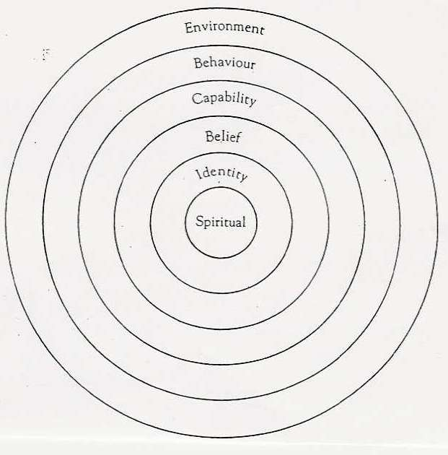
Spiritual: This is the deepest level of any character or person. Here we consider such metaphysical questions as "Why are we here? What is our purpose?" These questions are hardly ever asked or answered openly. Try to slip into your character's mind and answer these questions for him/her. What would he/she say?
Title of Book/Story ...............................................
Author: ...............................................
Character's name: ...............................................

Now do a character profile for one of the main characters in your book:
Download the full-size template from epep.at

Planning and Organizing Reading Projects

Remember this:
Look at this!
I am proud of my work.
It is cool.
I like reading

I can choose my own book.

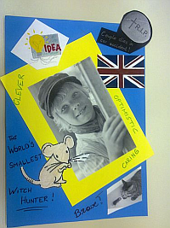


When planning a reading project for your class, consider the following aspects:
- Find suitable books: language level, different tastes and interests, season, class topic
- Book choosing: introduce the books in interesting ways (see “How to wet my students’ interest”, offer a choice for boys, girls, readoholics and reluctant readers.
- Book ordering: time, availability, price
- Pre-reading and warm-up activities: the first chapter is the most important one. If students understand who is who and what is going on, if they can relate to the characters’ dilemmas, they will want to read on. Plan some interesting opening activities to set the scene. Allow the class to read quietly for 30min or more to get into their books. Students who are reading the same book can help one another with comprehension questions. Walk around and help them get into the stories.
- Plan reading time: check other class projects (books they read in German, important test dates…) and decide on a deadline that is not too far away.
- While reading: do not give students too many while reading tasks. Such tasks are helpful if they guide the readers’ focus a bit or if they are asked to collect a few useful phrases from their reading. Don’t overdo it – too many tasks will kill the reading experience.
- Post-reading tasks: Groups meet and share their views, ideas and questions. Most reading projects will lead to some kind of PRODUCT (written or oral) such as
  - Booklets (pedagogy of the blank sheet)
  - Tasks to be completed in the reading diaries
  - Presentations in class or online
Whenever possible give students some choice concerning suitable forms of writing or presenting. Decide on a common FORMAT (e.g. design a booklet… or prepare an online presentation using MyBrainshark.com…) but allow freedom within that frame. Students will be more creative if they feel in charge.

Examples
The following pages show a few examples of tasks that can be used in reading projects. For more ideas visit epep.at. There you can also download a variety of handouts and project packages for your students.

A mini project for one double lesson
Note: in this project students were allowed to read ANY book they wanted to read. Therefore no groups could be formed
Private reading: Let’s share
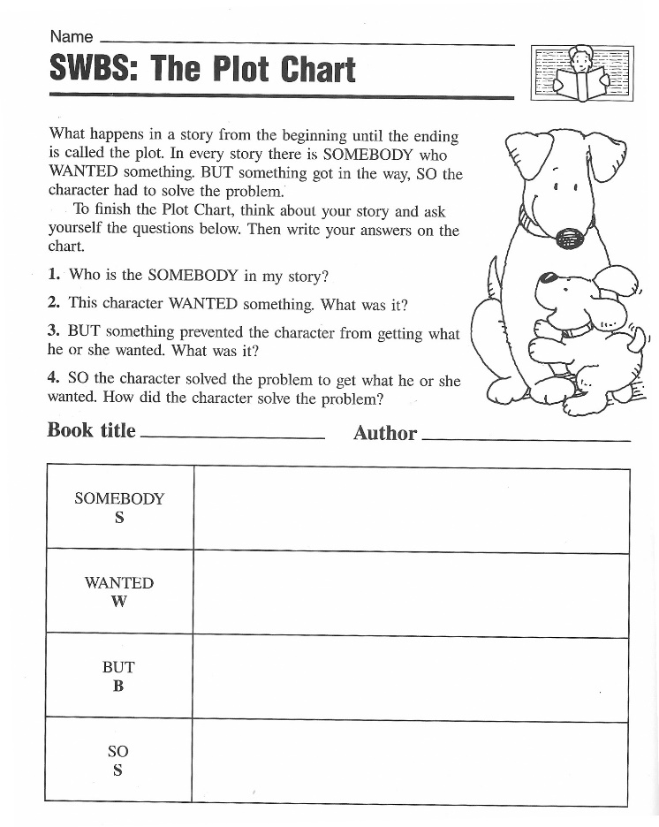
- SWBS:
The Plot Chart

From: Christine Boardman Moen, Better Than Book Reports, Scholastic, 1992

- Sum It Up
Make a sum-it-up card for your book. Fill in the blanks below.
Title:.............................................................  Author:.........................................................  Three important facts:  1.  2.  3. | Write a summary that tells the main idea.  Summary:  ........................................................................  ........................................................................  ........................................................................  ........................................................................  ........................................................................  ........................................................................  ........................................................................  ........................................................................

3.Book-Fair:
Walk around and read all the posted SWBS and SumItUp sheets. Find 3 books that have something in common with your own.

4.Grouping Books Together

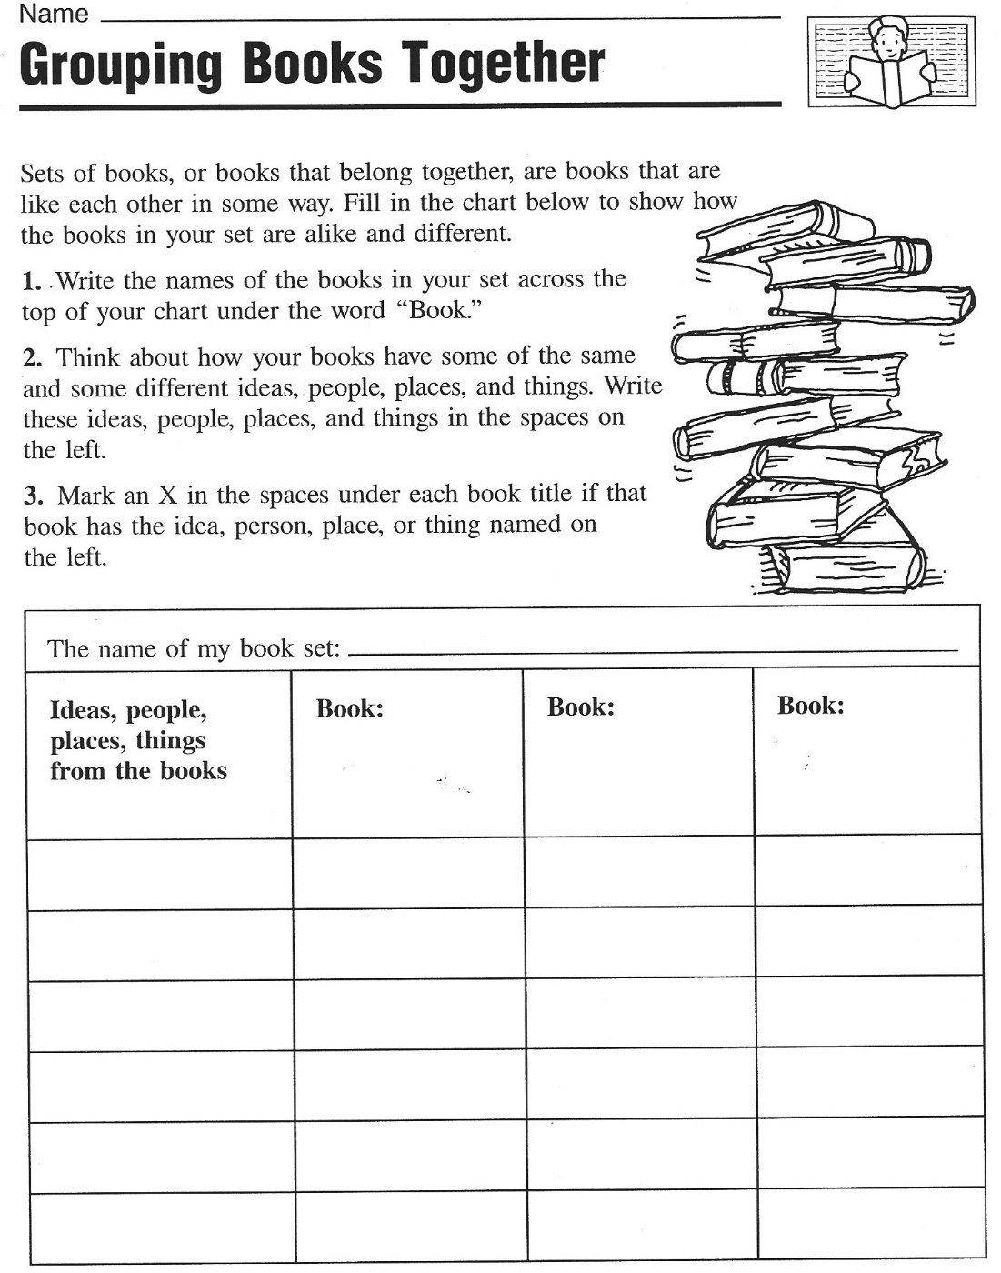
From: Christine Boardman Moen, Better Than Book Reports, Scholastic, 1992

5. Creative Catalogues: Design three A5 catalogue pages.

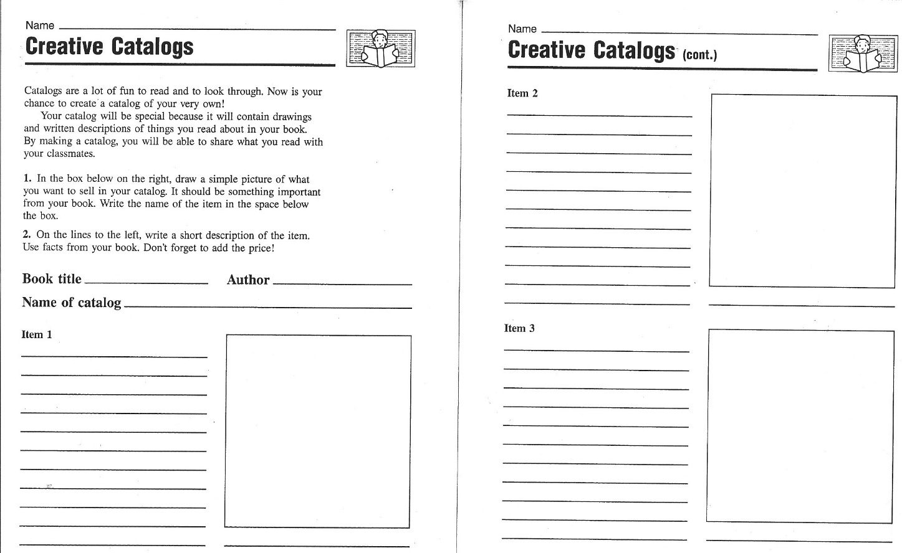
From: Christine Boardman Moen, Better Than Book Reports, Scholastic, 1992

6. Vocabulary Quilt
Choose one of your favorite new expressions from your book and write it on a piece of colored paper. Write a short, typical sentence and decorate the paper in a suitable way. Your paper must include:
- the new word written in big letters
- a typical sentence
- a drawing that will help you remember the new phrase.
We will put all our word cards together to make a Vocabulary Quilt. Please design your cards nicely.
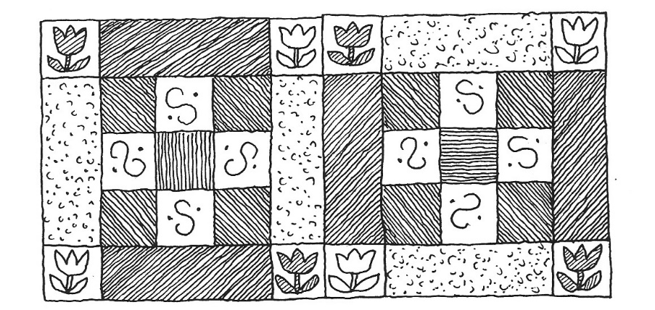

Book-sharing
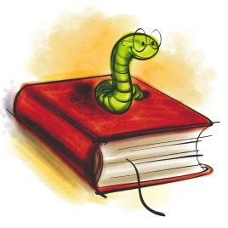
Prepare the following things for the book you have read:
5 nouns (things, objects…) | Choose 5 things that play an important role in your book and write them on the cards provided. (Example: broom, hour glass, magic potion, train, … for a Harry Potter book)
Big trouble | Choose a passage in your book where one of the main characters is in trouble, has a problem or is very sad. Practice reading this passage so you can later read it out to your group.
Happy moments | Choose a passage in your book where one of the main characters is happy. Practice reading the passage.
Important adjectives | Find three adjectives in your book that are somehow important for the story. Choose new and interesting adjectives – not words we all know. Copy the adjective on a card and write the sentence you found in the book on the BACK of the card.

Group Phase
Work in groups of 4 with classmates who have read books you do not know yet.
Guess what… | Show your noun cards and adjective cards to your friends and have them guess what the book might be about.  Ask lots of questions about your friends’ books and try to find out as much as possible about the main characters, their problems, their wishes and hopes.  Do not give away the endings and solutions of your book.
Big trouble and  Happy moments | Read the passages that you have chosen to your friends and explain why your characters feel so happy or so sad.
Important adjectives | Put all the adjective cards on the desk (only show the adjectives, not the sentences)  Copy all the adjectives on the back of this sheet and guess what the words might mean. Discuss your ideas in the group.  Then turn over the cards and look at the sentences. How can these sentences help you guess the correct meaning of the adjectives?  Now ask the students who have written the cards to explain the meaning of the word and record it in the table.
Homework | Copy the new adjectives and sentences on vocab cards and add a second sentence where you use the new adjective in a TRUE sentence.

This is what your vocab cards should look like:
Use ONE card for ONE vocab item.
Word: | Dreadful
Sentence from the book: | Their dreadful voices sounded like dentists’ drills all grinding away together.
My true sentence: | My neighbor Rosalinde has a dreadful, whiny voice.
On the back write a translation of the main parts of the sentences. Example:
Ihre schrecklichen Stimmen klangen wie Zahnarzt Bohrer…
Rosalinde hat eine schreckliche, weinerliche Stimme.
Adjective | Sentence from the book:
1
2
3
4
5
6
7
8
9
10
11
12

Reading Project

1. Choosing a book:
Look at all the books in the selection. Read the blurb (back cover) and then read the first two or three pages of each book. How many unknown words are there on each page? Can you guess the meanings? What else do you notice about the book?
- What kind of book do you think this will be? Do you think it will be science fiction, fantasy, realistic fiction, historical fiction, mystery, a crime story?
- What do you think the plot will be about? Make a one-sentence prediction for each book.
- What kinds of characters do you expect to meet in each book?
- What will the settings be like?
Write your findings in the table on the next page.
Which of the books would you like to read? Award 1 – 3 stars to the books, depending how interesting they look. Mark the stars in the first column. Then decide which book you would like to read. Write down your fist, second and third choices on a sheet of paper and stick your paper up on the book poster under the title of your first choice. As far as possible you will be given your first choice.

2. Getting ready for the book: Making predictions
While you wait for your chosen book to arrive imagine what might happen in your book. We will try a 10-minute free-writing activity in class. Write down what you expect from the book. Use the following expressions and the "will" future. Use your reading diary for all the tasks.
I hope that......
I wonder if ....
I bet that... .... will ...
I'm afraid that...
I (don't) think that...

3. The books have arrived!!! Let's start reading
Get together with your friends who have chosen the same book (3-4 students). Read quietly for 20 minutes. Read slowly and imagine the scenes and characters as vividly as possible. After 20 minutes meet to discuss your reading. Distribute the task cards in your group. Each of you is responsible for a different task. Read your task card carefully, then guide your group through the activity. Write all the questions and answers into your reading diary.

4. Homework:
Read chapters ........................................ by ...........................................................
Read slowly and carefully and mark any interesting passages in your text. Choose 3 phrases or expressions that you would like to remember and write them on vocab. cards. Then write a five minute entry (non-stop writing) into your reading diary.
Book title and | New words per page | Other comments about the book:
Type of book:
Plot prediction:

Characters:
Settings:
Type of book:
Plot prediction:

Characters:
Settings:
Type of book:
Plot prediction:

Characters:
Settings:
Type of book:
Plot prediction:

Characters:
Settings:
Type of book:
Plot prediction:

Characters:
Settings:
Type of book:
Plot prediction:

Characters:
Settings:
Task 1: Language Police  English please!!!  In this activity you are responsible for reminding your group to speak only English. Whenever you catch somebody using German show them this card. |  |  | Task 3: Character Detective  List all the characters that you have met so far. What do you know about them? Who are they? What is their role in the story? What mood are they in? Do you like/dislike them? Do you trust/mistrust them?
Task 2: New Expressions Expert  Ask each of your friends to find one new phrase or expression that they would like to remember. Highlight these phrases in your book and write them on vocab. cards. |  |  | Task 4: Where and When?  Where and when does your story play? Find a passage in your text where the setting (place and time) is described. Highlight it and copy a few important details into your reading diary.
Task 5: Asking questions

Ask each of your friends to write down one question that they have in mind now. What is it they would like to know about the book?
Share your questions and write them into your reading diary. Maybe you can answer them later or ask your teacher.

5. Reading Circle Activities

- Get together in your reading group and decide who is going to be the Language Police and Group Leader today? Remind your friends to use English only in their discussions and to stay on track ( = not digress from the topic). In case of disagreements make sure that your friends argue their point politely.

- Sharing Reading Diaries: Read each others' reading diaries and discuss your reactions to the story.

- Work with the small Discussion Prompt Cards. Sort the cards by color and put the piles face down on your desk. Take a card from the top of a pile and read it out to your classmates. If the card doesn't apply to your book at all, put it back and take a new one. Do the task carefully in your group. Write all your answers into your reading diary. When you have completed a task, take a new card from a different pile. Take turns reading the tasks out and leading the discussion. Do as many tasks as you can but do them carefully and thoroughly.

- Workshop and Homework Tasks: On the following pages you will find 13 tasks. You have one double period in class to do them. You may work alone or in a small group. Do the other activities at home. Write all your answers into your reading diary. Always write clear headings (number and name of activity).

- Reading on: Read chapter(s) ........................................... by .......................................... and write a 5-minute non-stop entry into your reading diary.

- Vocabulary Work: Collect good phrases and write 20 new vocab cards for the whole book. Hand them in with your reading diary.

Useful materials and ideas

Find more ideas on epep.at

Laura Robb, 50 Fabulous Discussion Prompt Cards:
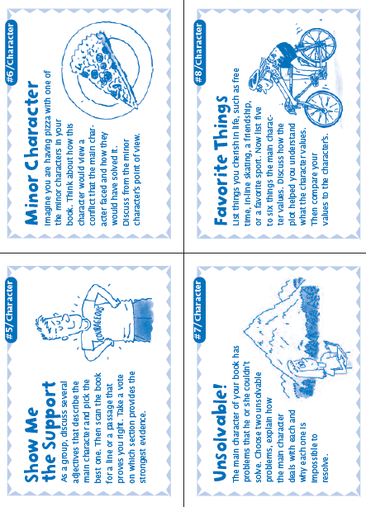
Can be used again and again. For lower intermediate speakers you might want to adapt the language a bit.

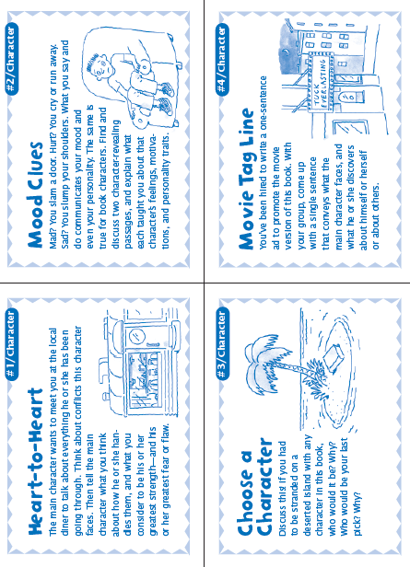
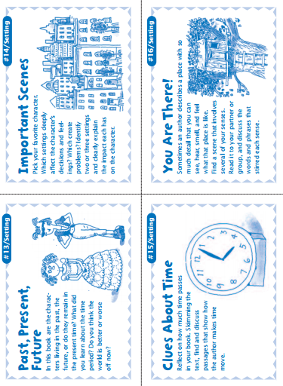

Booklets: The pedagogy of the blank sheet
These booklets are my favorite projects. The idea is based on Hannelore and Helmut Zehnpfennig’s concept of the “Didaktik des weißen Blatts” (see below). This idea can be used at all levels, from beginners to advanced learners. The results are always stunning and much more interesting than answers to teacher-created questions and tasks. They really show how students have understood a novel or a topic in general.
Didaktik des Weißen Blattes
Hannelore Zehnpfennig (Grundschullehrerin) - Helmut Zehnpfennig (Soziologe)
Im Offenen Unterricht von Hannelore Zehnpfennig werden alle Fächer zum freien
Arbeiten angeboten. Ausnahme: Sport, Musik, Religion und Kunst. Die herkömmliche
Zeit-, Raum- und Stoffstruktur wird aufgelöst. Das heißt: Raum ist individuell nutzbar,
Zeit ist individuell nutzbar für die Fächer, Stoff wird selbständig ausgesucht
Didaktik des Weißen Blattes
Der Sitzkreis zu Beginn und am Ende des Unterrichts ist freiwillig. Zehnpfenning wählt den
Weg der drastischen Einschränkung des Materials. Sie fordert eine kleine Handbibliothek
mit Nachschlagewerken und Fachbüchern zu vielen Themen, Schulbücher sind nicht
dabei. Sie können höchstens als Angebot in der Klasse aufliegen. Heute ist auch der PC
wichtige Infoquelle.
„Unser wichtigstes Arbeitsmaterial ist das weiße Blatt Papier, unseres Erachtens das
kreativste Material, das es gibt. Es stellt "wahrscheinlich die größte Herausforderung
an die Imagination der Kinder dar" stellt Peschel (1996, S.38) fest, nachdem er unsere
"Pädagogik des weißen Blattes" kennengelernt hatte. Das leere Blatt fordert oder
provoziert geradezu die kindliche Phantasie es zu füllen. Wie, das sagt ihm weder das
leere Blatt, noch sagen wir´s. Das Kind muss selber entscheiden und gestalten. Ein
Arbeitsergebnis ist zu dokumentieren, ein Sachthema zusammengefasst
darzustellen, um in ein gemeinsames Buch zu kommen. Welche Informationsquellen
benutzt werden und wie, überlassen wir vollständig dem Kind. (Zehnpfennig/Zehnpfennig
1992)“
Für die Eigenproduktion von Arbeitsblättern spricht ein gewichtiger Grund:
„Selbsterstellte Arbeitsblätter sind immer auch aktive, individuelle und 'originelle'
Lösungen von Problemen" (Zehnpfennig/ Zehnpfennig 1995c, S. 7). Und darauf legt
Zehnpfennig in ihrem Offenen Unterricht viel mehr Wert als auf die noch so korrekte
Ausfüllung eines vorgegebenen Arbeitsblatts. Weniger wichtig ist uns, ob Arbeitsblätter
ästhetisch oder didaktisch perfekt sind. Wichtig ist vor allem, dass sie von den
Kindern selbst und für andere verständlich sind. Diese Fülle an Arbeitsblättern wird
dann thematisch zu "Büchern" versammelt, wie z.B.: "Kniffelbücher" (Mathematik) oder
"Rumänien" (fächerübergreifend) und präsentiert.
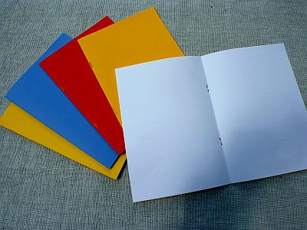
http://www.zeugner.at/files/nachlese/010909/Go_OffUnt_Didaktik_des_weissen_Blattes.pdf
The preparations and instructions are VERY simple:
Step one: Each student receives a blank booklet consisting of 3 white A4 sheets folded and stapled together like an A5 booklet. I usually use a colored sheet on the outside but this is not really necessary. In some cases I copy the title page of their book on the cover to get them started. You’ll need a long-arm stapler to produce these booklets.
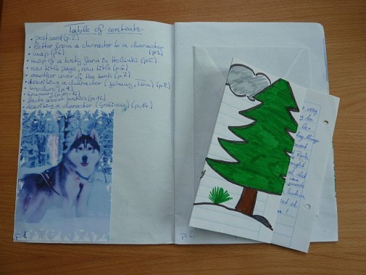
Step two:
Ask the learners to fill the booklet with anything that shows their understanding and reaction to the book they have read.
Do a short brainstorming with the class what this might mean. Students come up with many of the ideas they know from their reading diaries and presentations such as:
- Letters or postcards (from the point of view of the characters or to one of the characters), Maps showing the settings of the story,
- Travel brochures advertising the places,
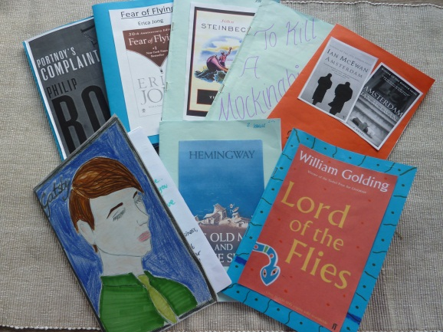
- Diary pages,
- Sociograms,
- Plot diagrams,
- Reviews for Amazon etc.
- Newspaper articles
- Creating their own title page …
Step three:
When the booklets are finished the students meet in their groups and share their products. This step can be very interesting and learners see different interpretations of the task and different reactions to the books.
Step four: Optional
Sometimes, if there is not enough time for a round of book presentations ask students to meet with 3 classmates who have read different books and find the similarities and differences of their novels.

Sample pages from such booklets

Letters and Postcards
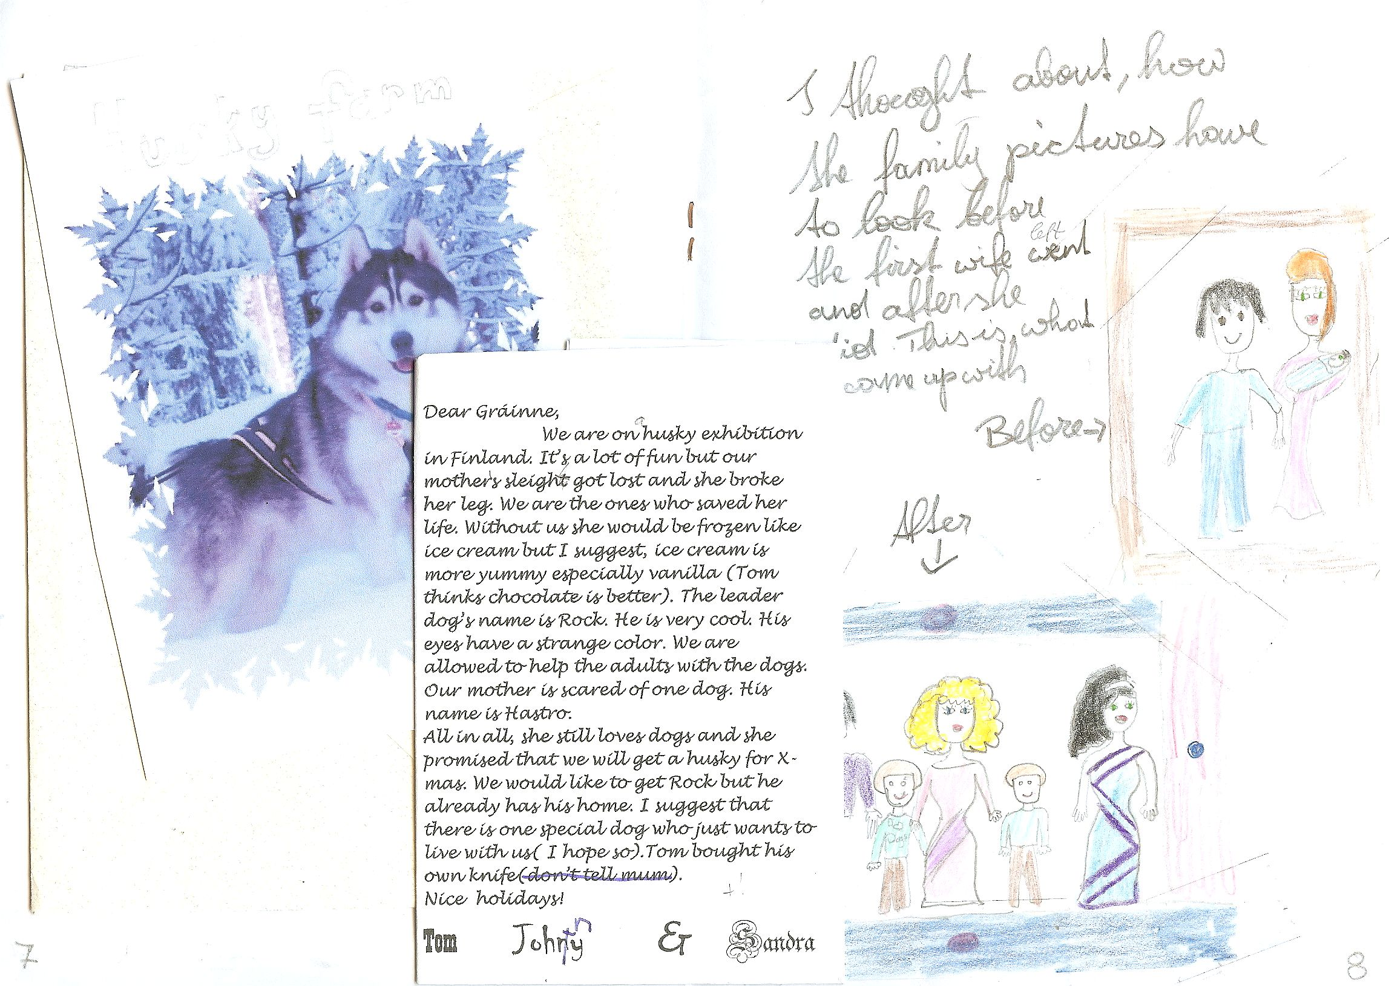
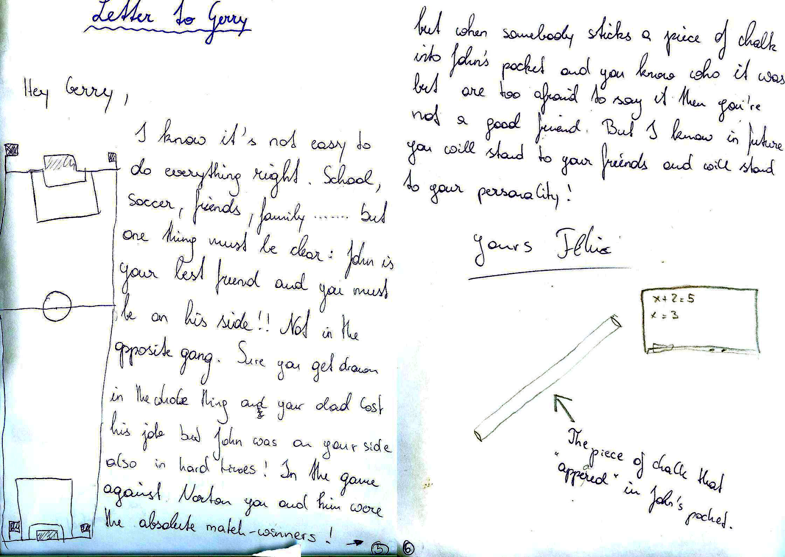

Brochures
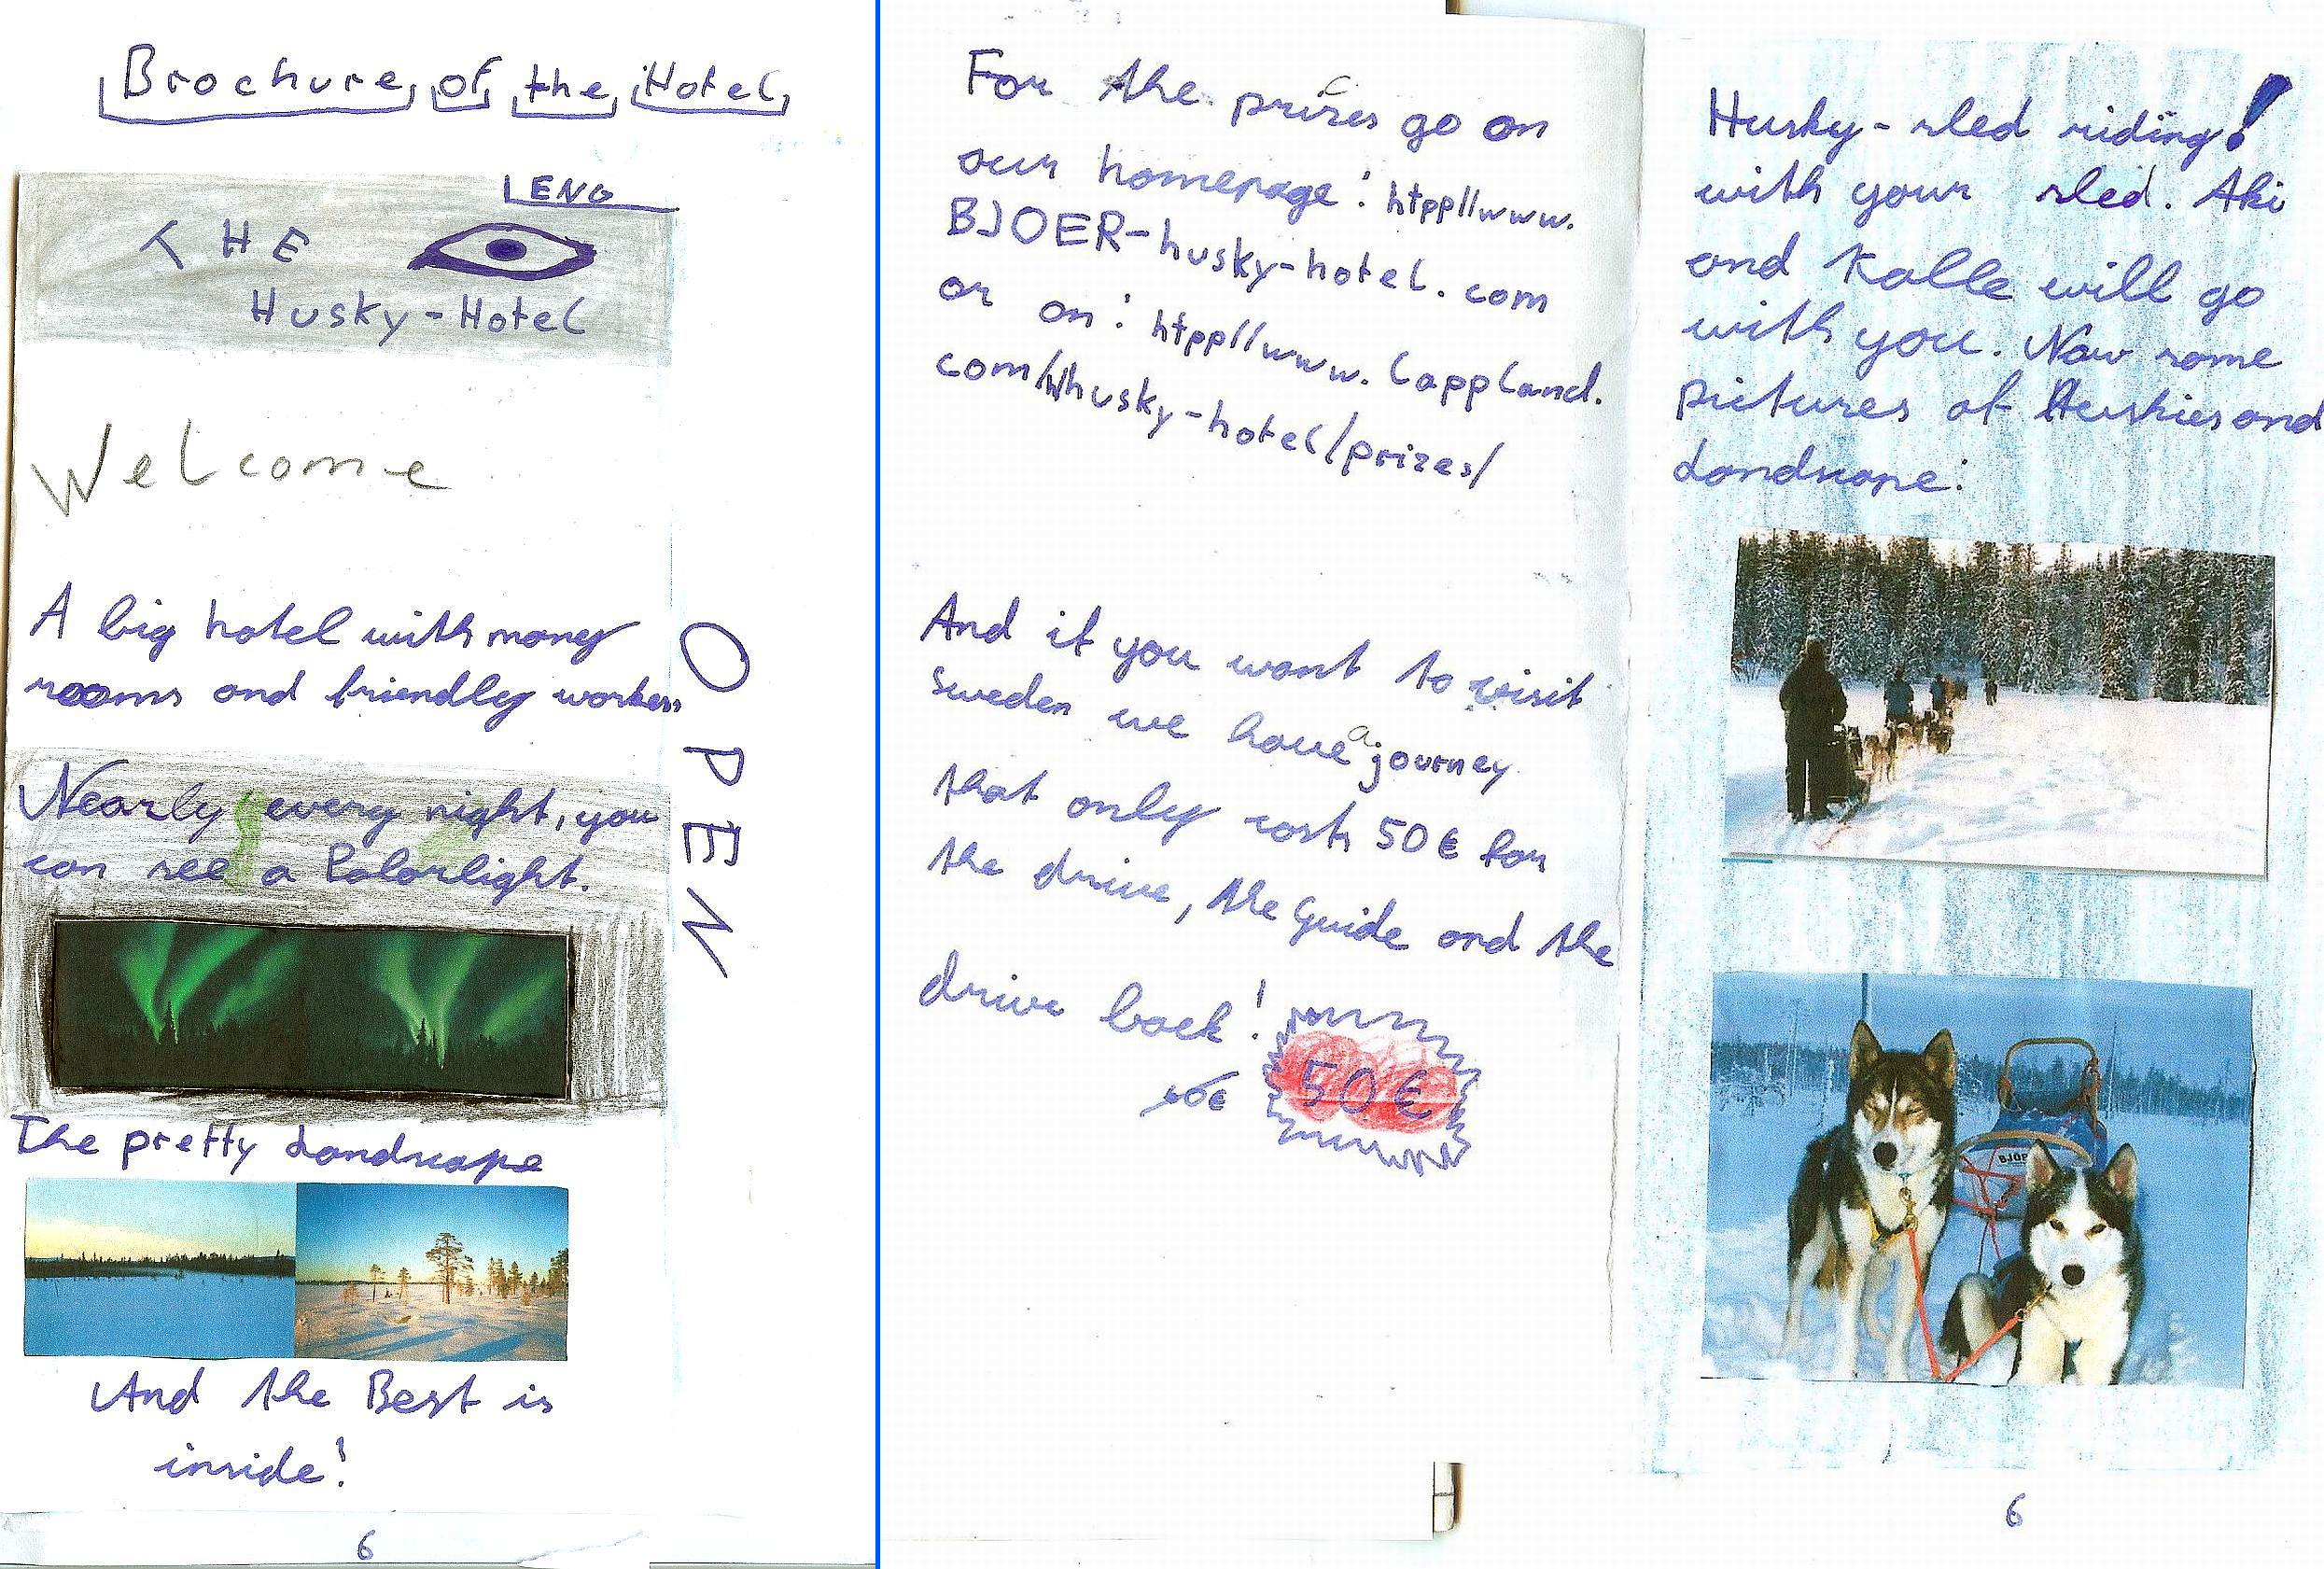

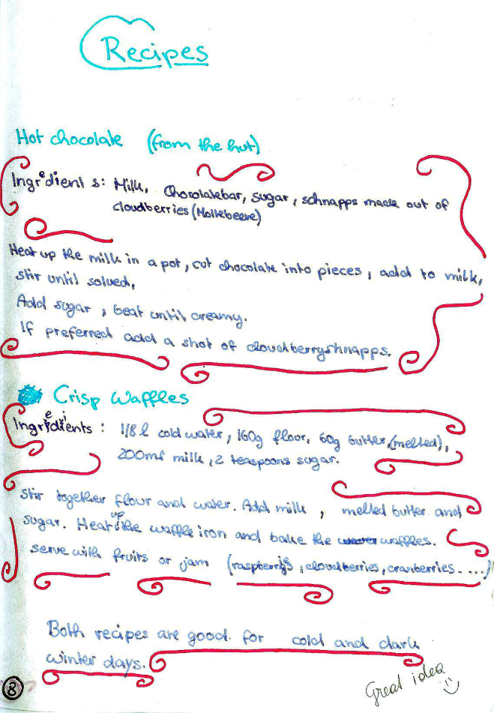
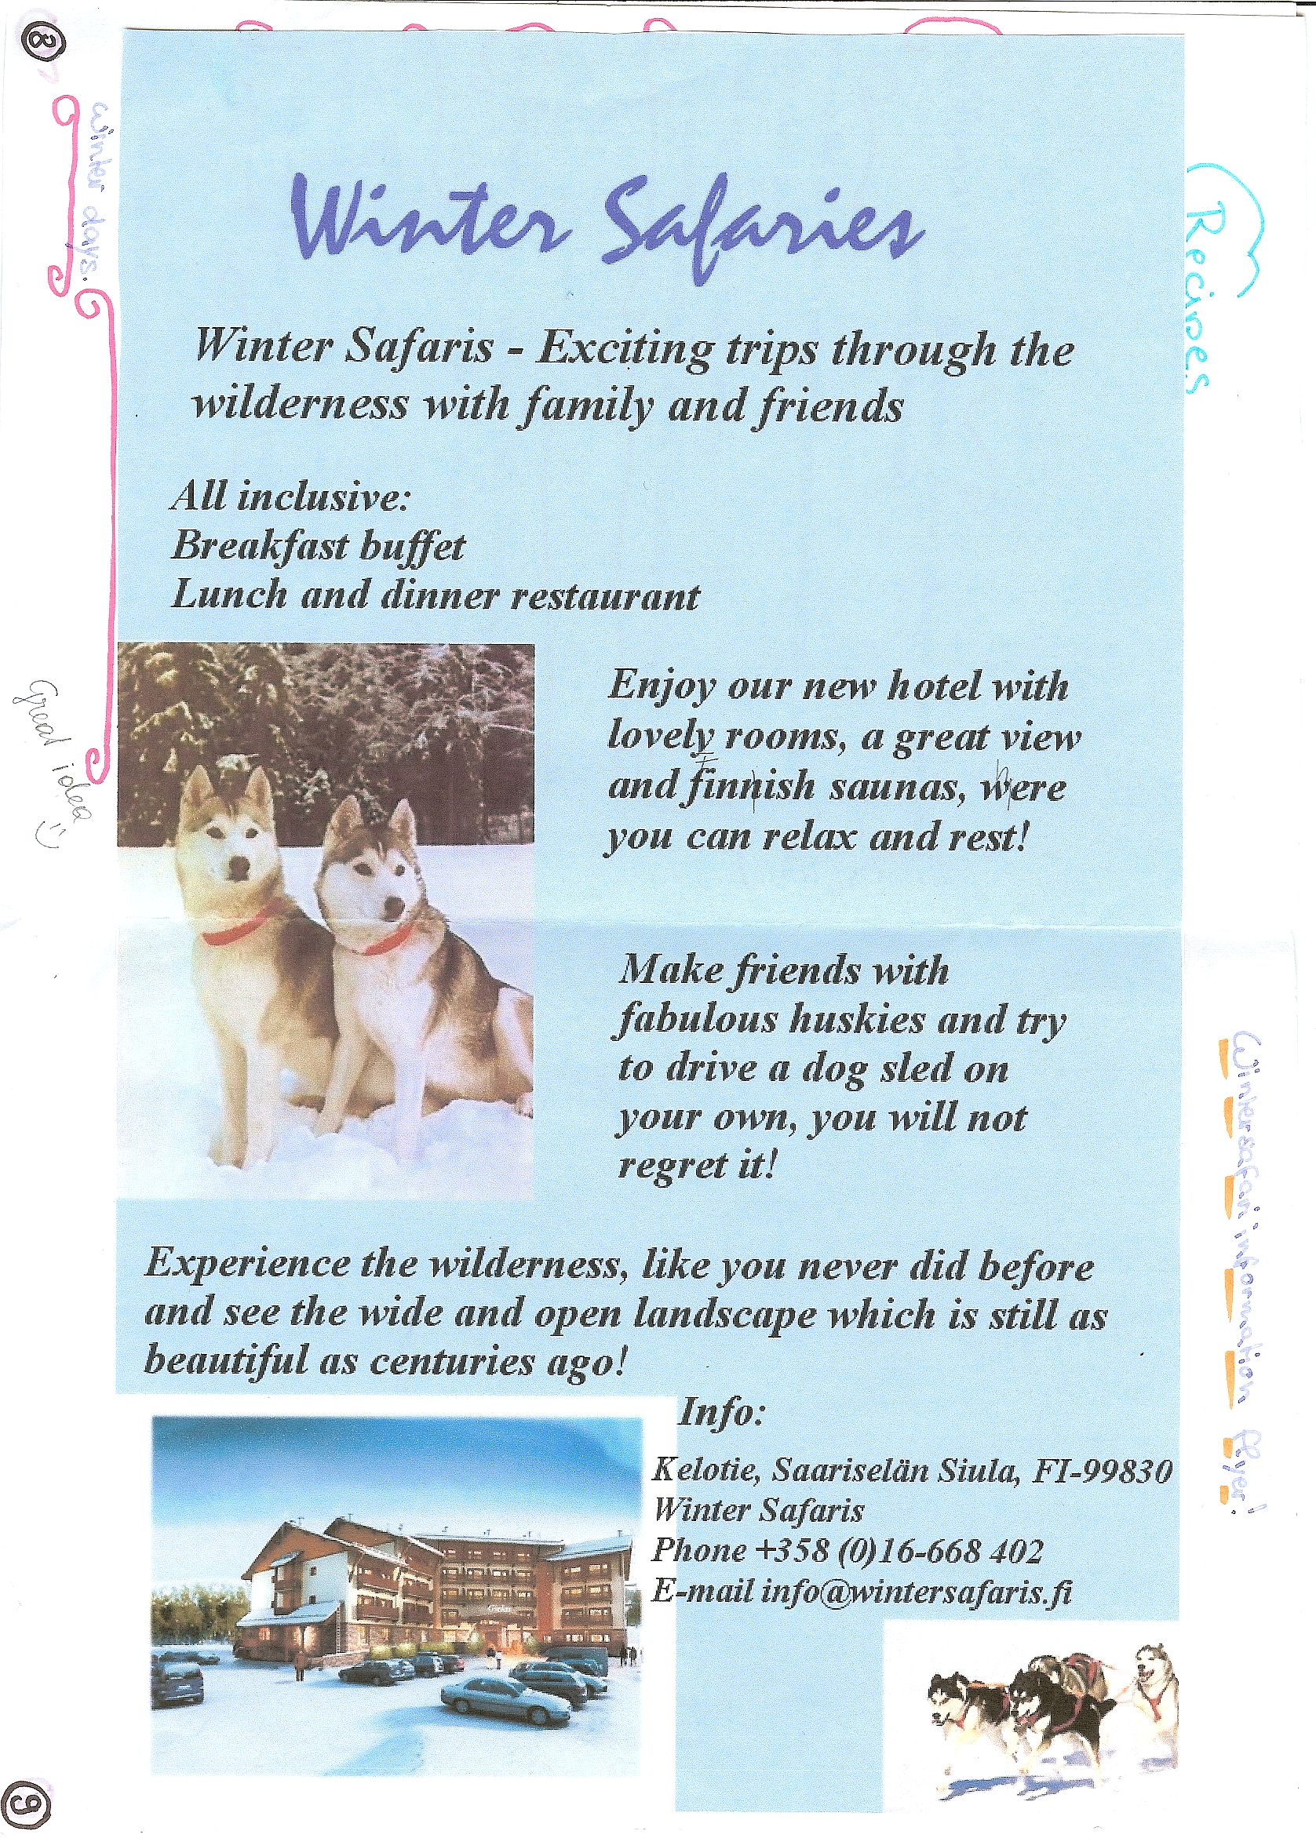

Other ideas: Recipes, Travel info,

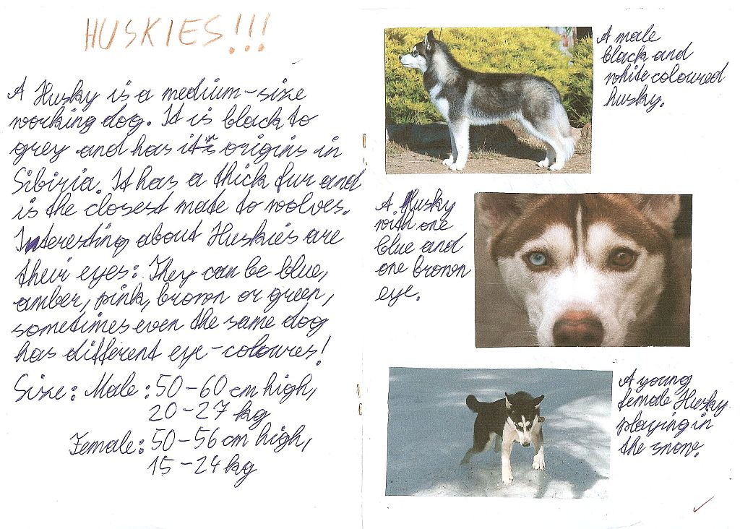

If I was…

Example from Lord of the Flies
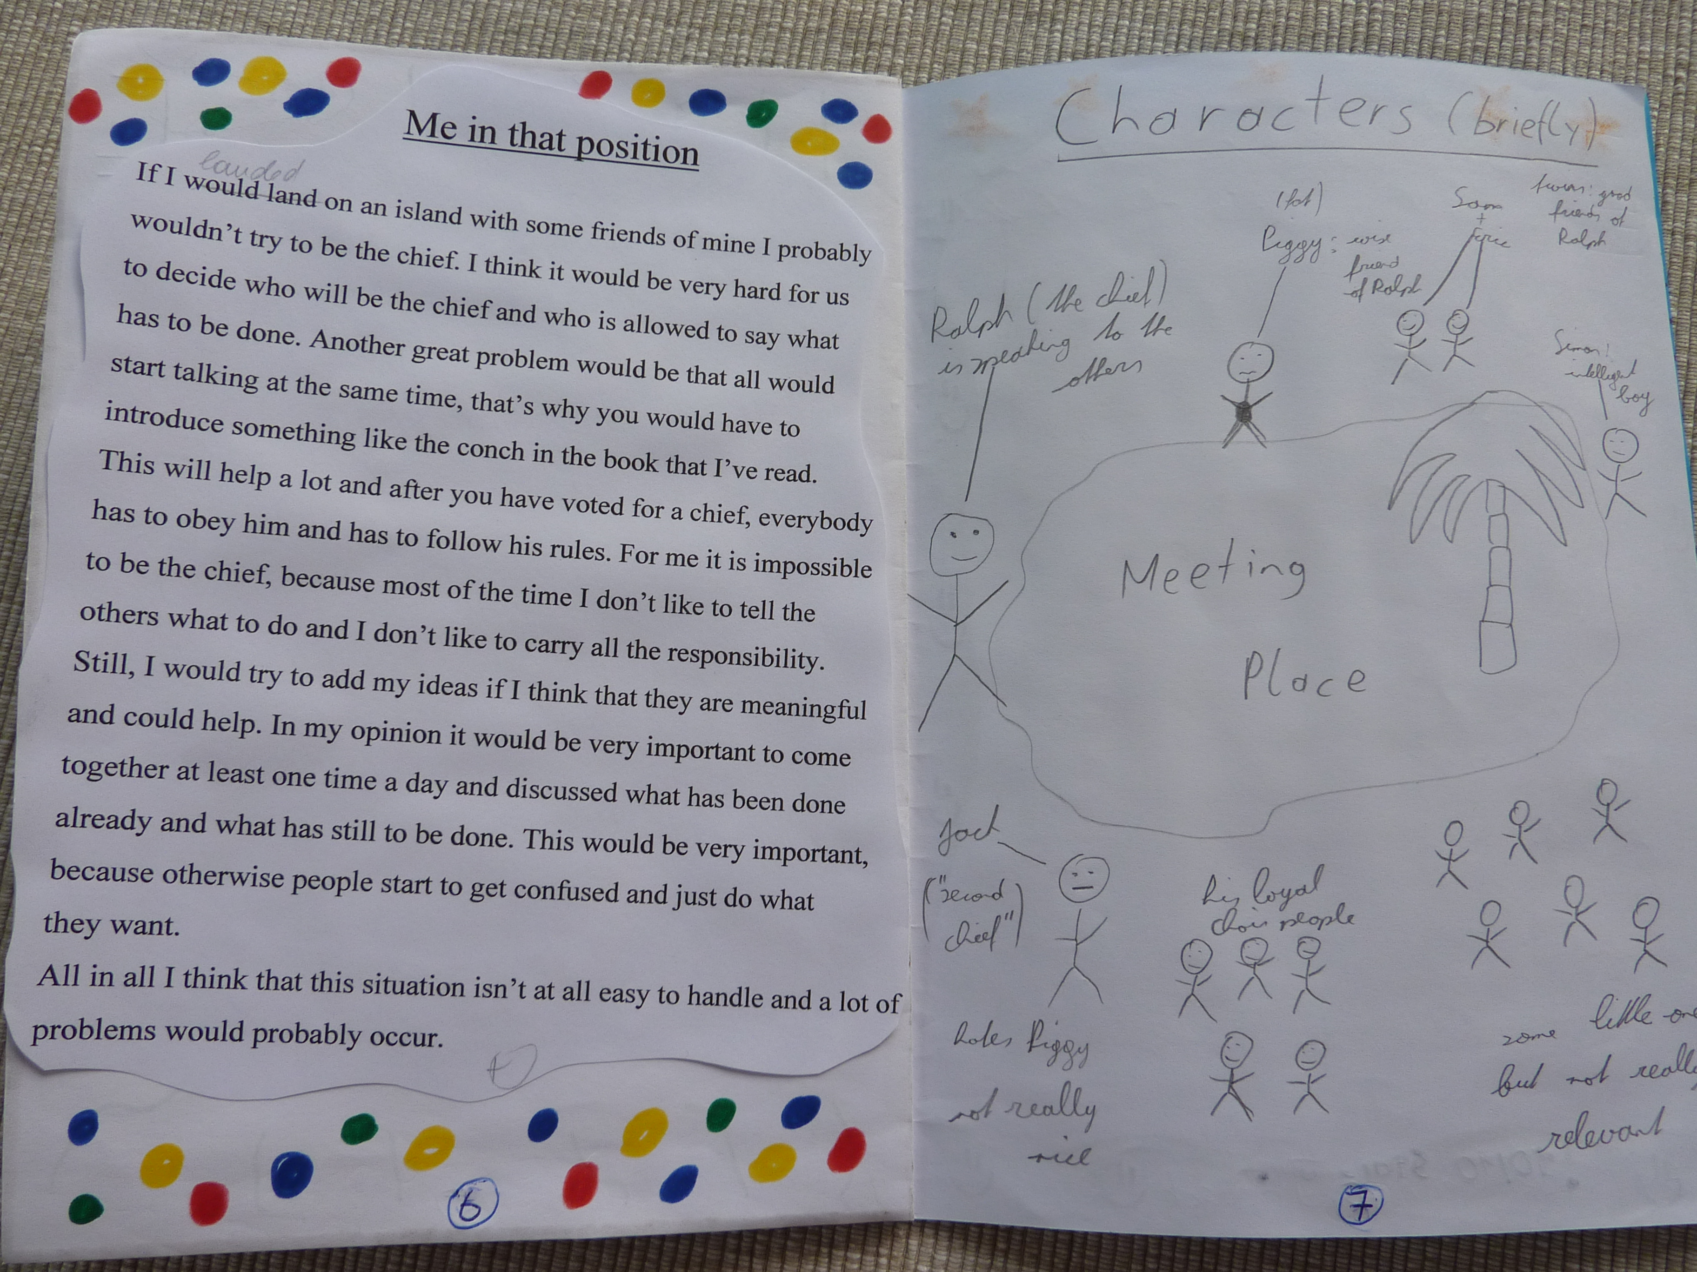

Creative Catalogues
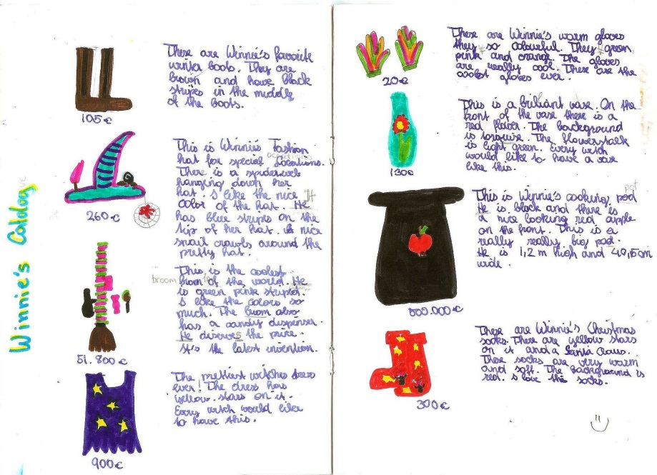

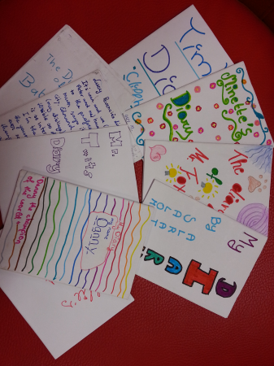
Origami books or Diaries

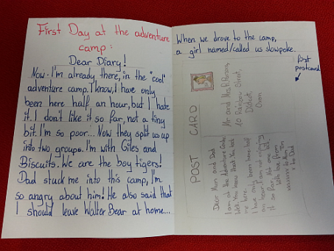
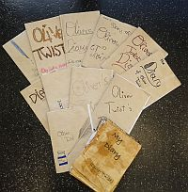

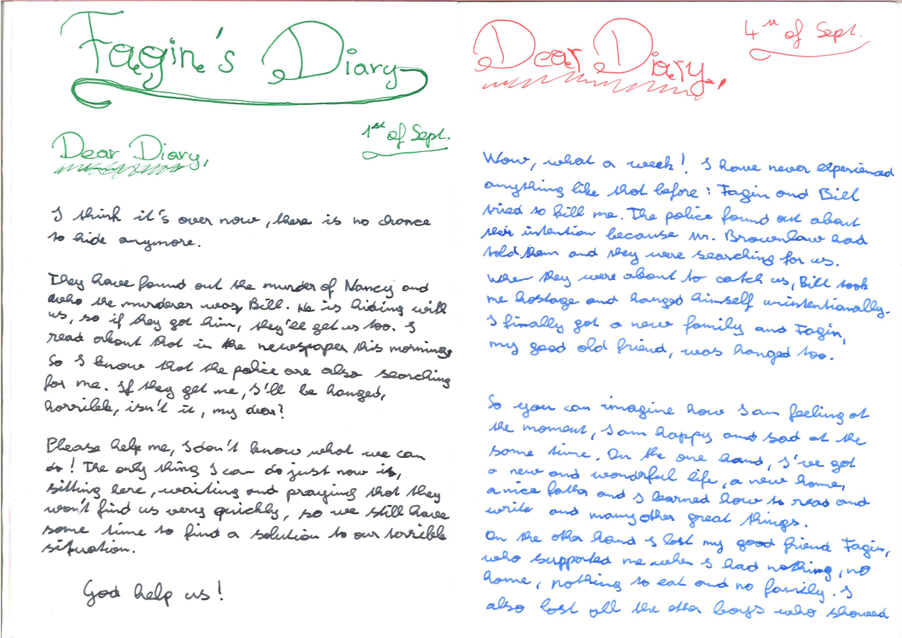

Oliver Twist:

Fagin’s diary entry and a newspaper article about the same events.
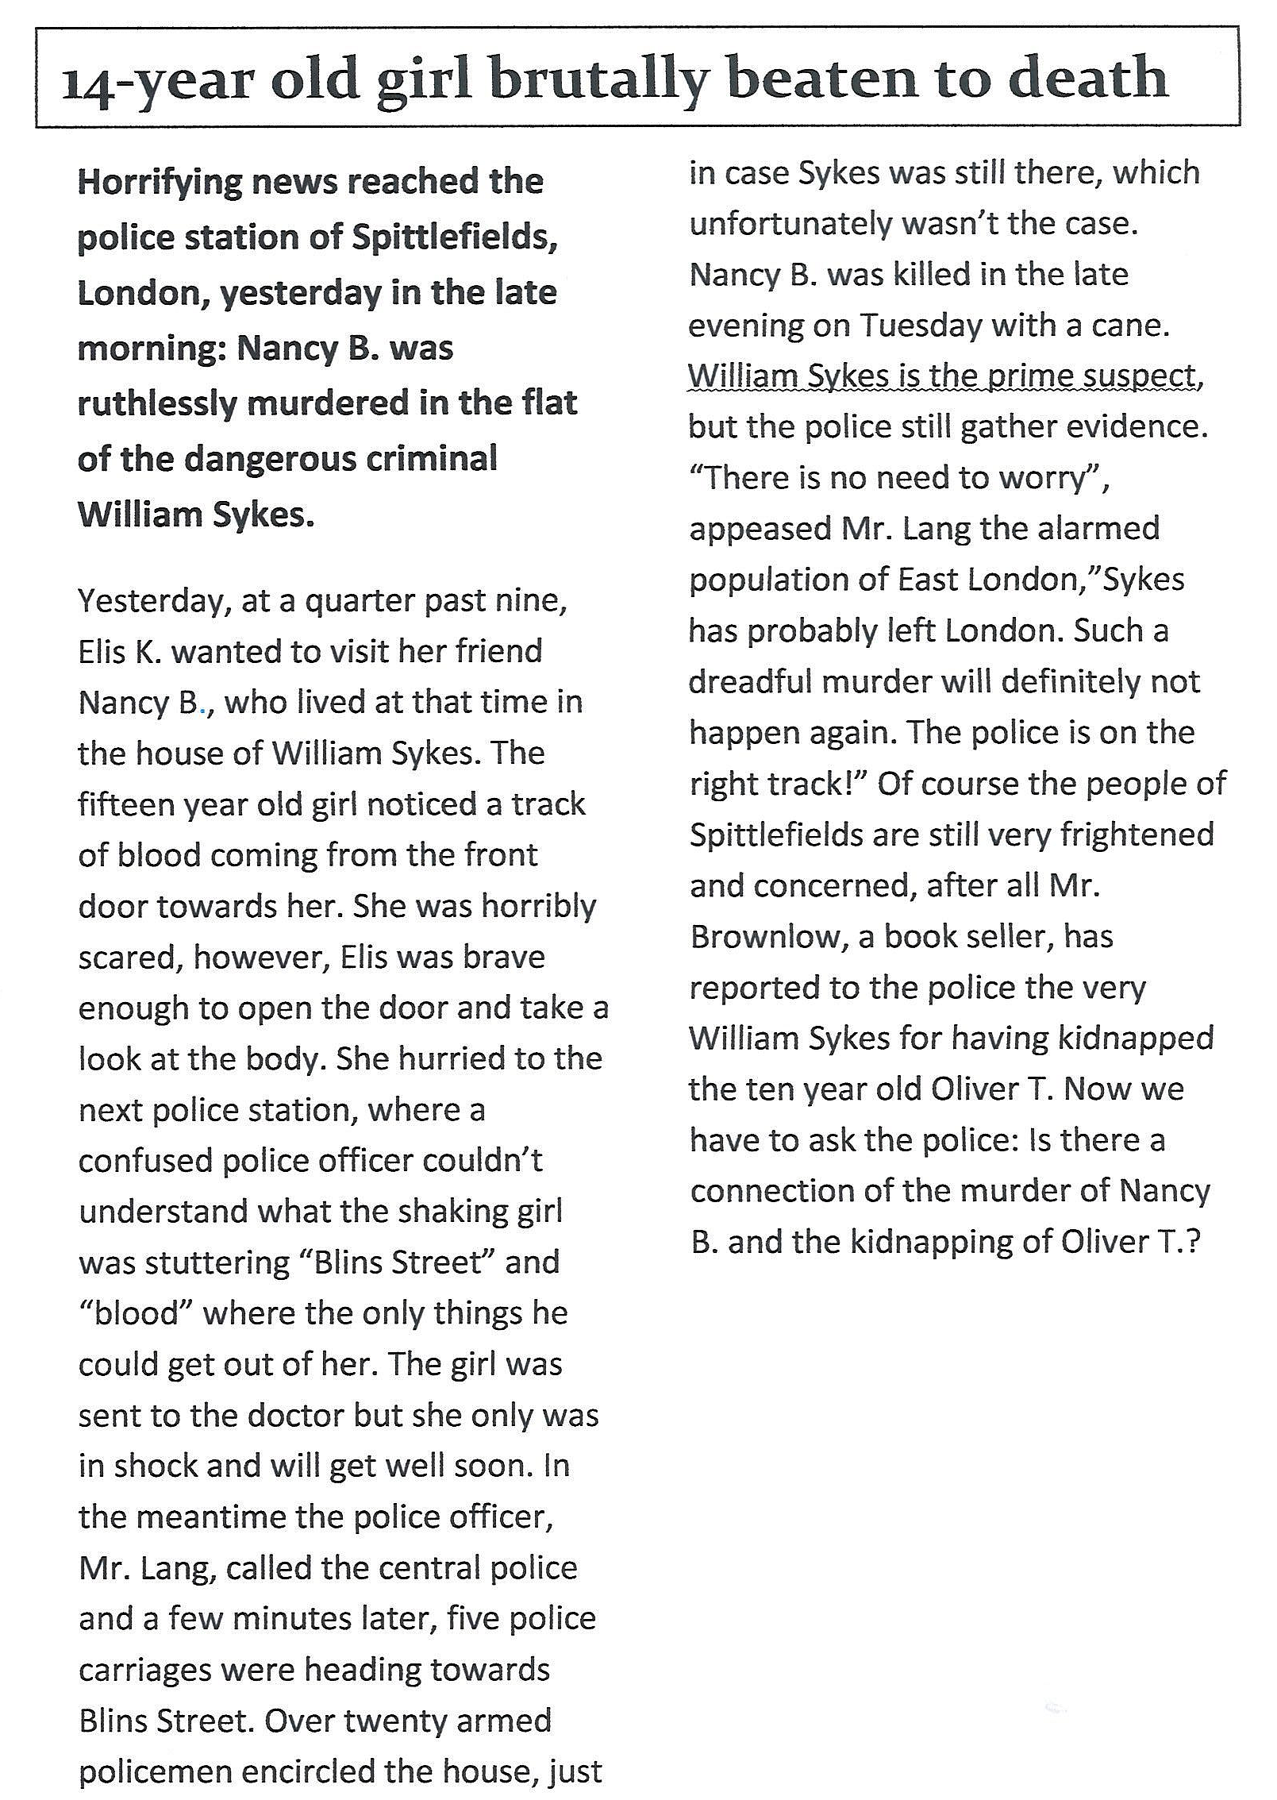

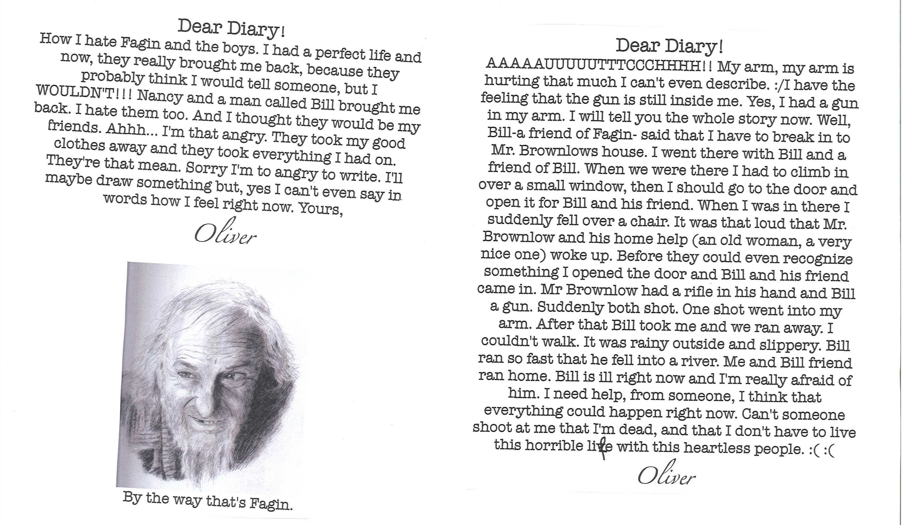

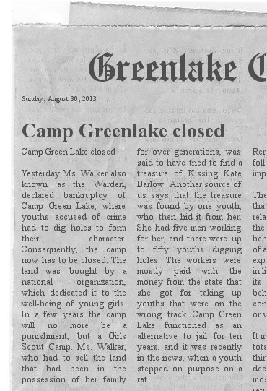
Newspaper Articles

Instructions: Choose an important moment in your book and write an article about this event for a local newspaper.
Remember: The journalist does not know everything; focus on one event – do not tell the whole story or include the characters’ private thoughts and feelings. What would the readers of the local newspaper want to know?
Tip: for the layout of a newspaper article use the online Newspaper Clippings editor : http://www.fodey.com/generators/newspaper

Plot Diagrams
Example from The Great Gatsby
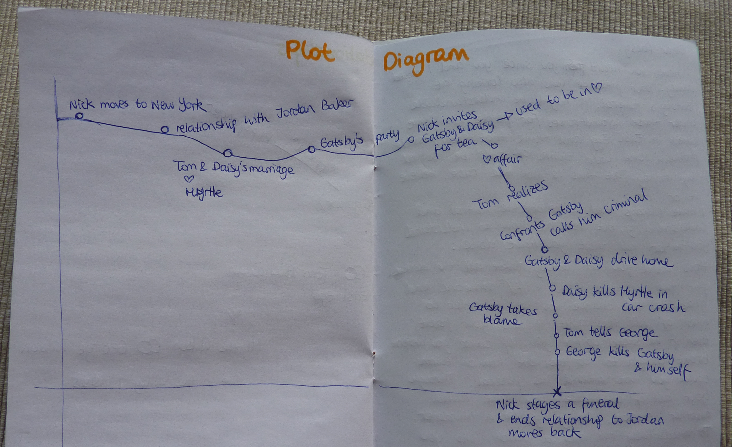

Letters to the Author
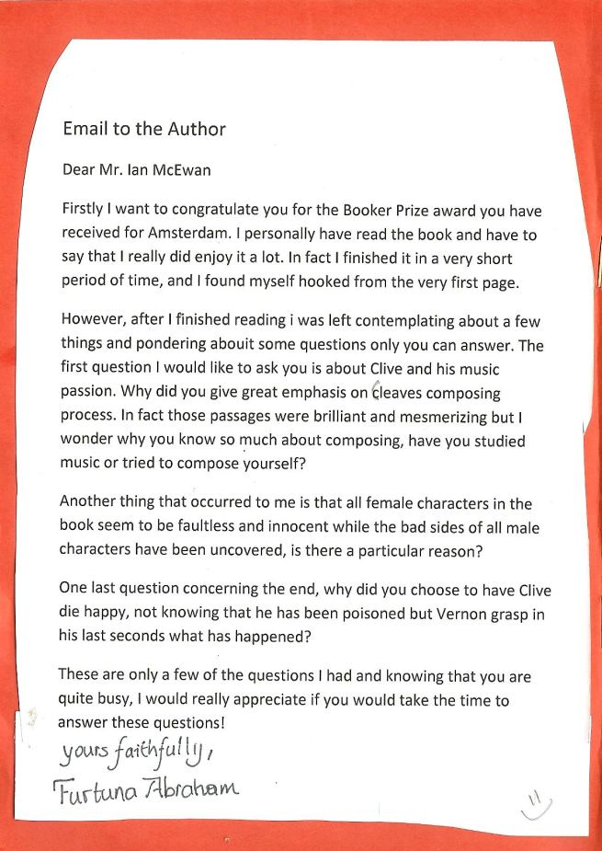

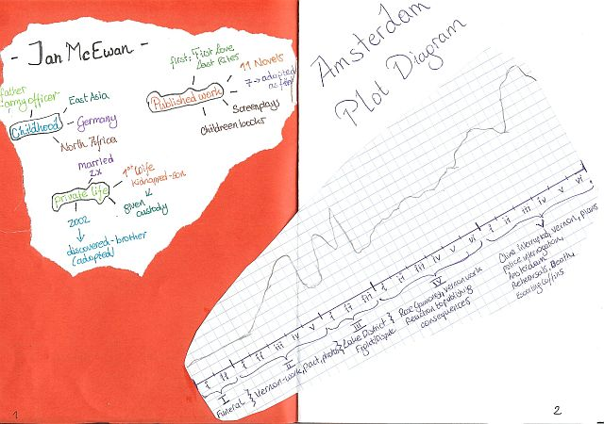
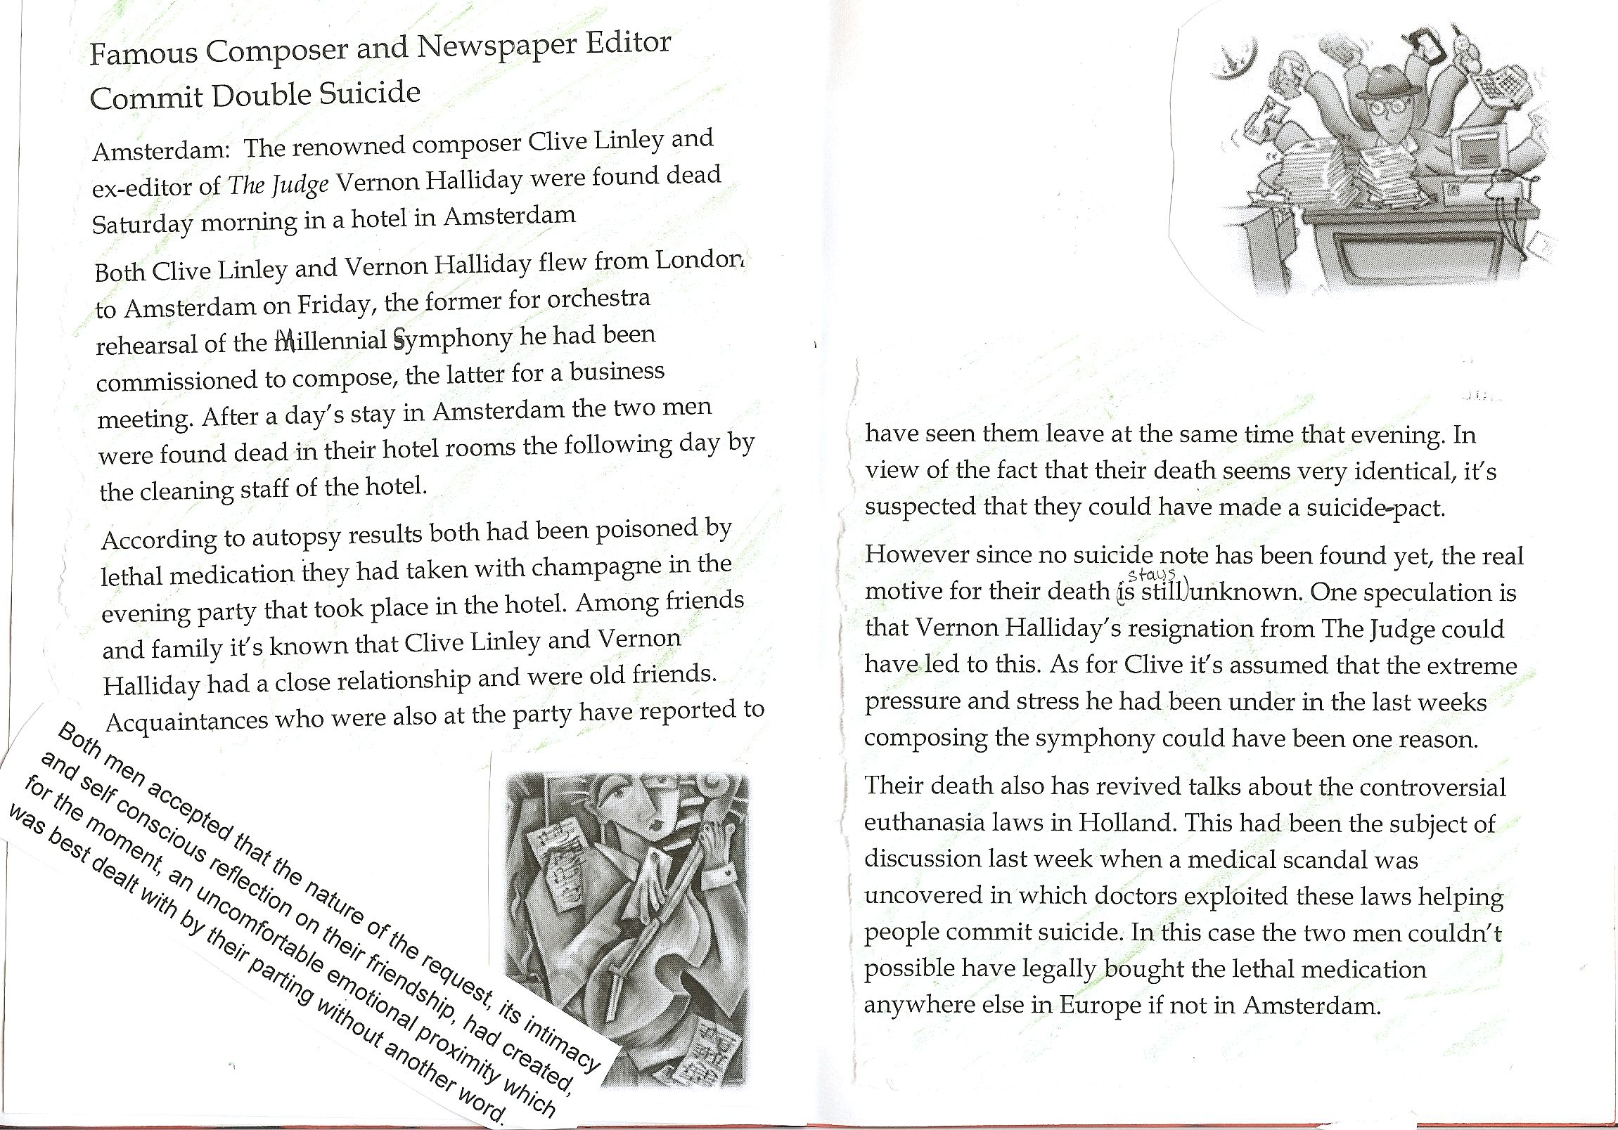
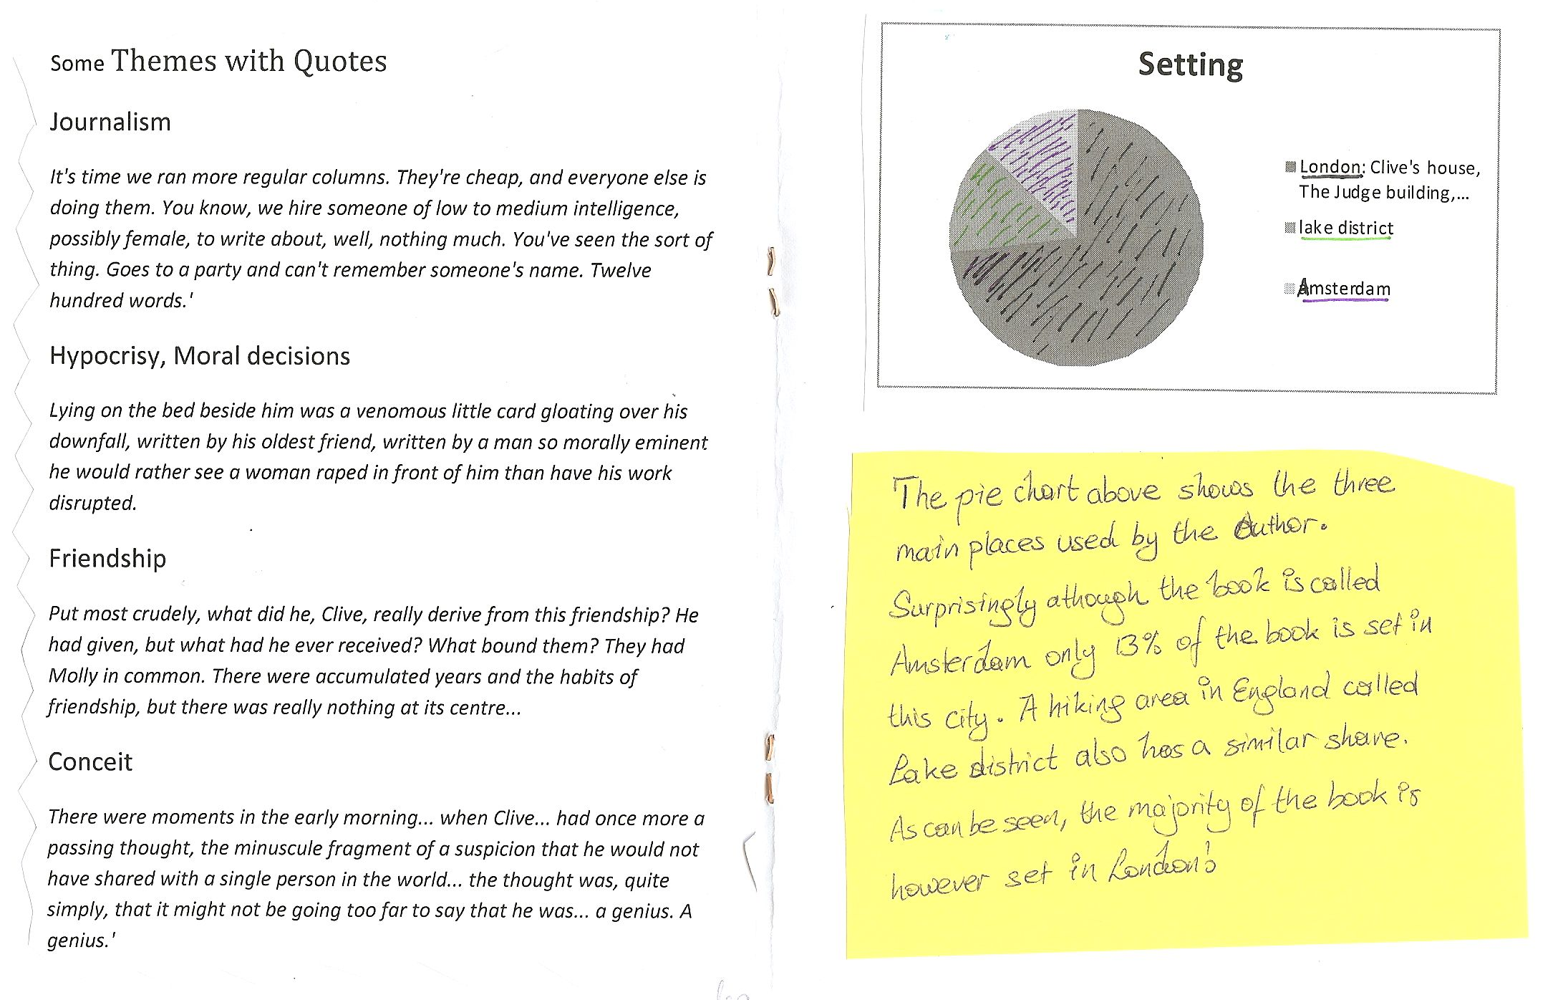
For more examples from upper-school visit the page “creative booklets” on epep.at

Ideas for Book Presentations

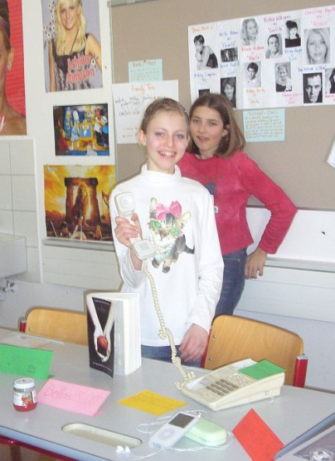
Presentations are the final and culminating point of every book project. Many of the presentation activities described in this section can be used at any level. What they all have in common is “activity”. The main goals of these presentations are
- to make the other learners interested in reading some of the books as well
- to practice presentation skills and oral skills and
- to motivate the learners to dig a bit deeper and understand more than just the plot level of a story.
What we don’t want in these presentations are learners
- reading long summaries from their sheets
- confusing the class with all the minor characters
- boring the audience with unimportant details of the author’s biography

Year 1:
From year 1 on my students present books regularly. The first presentations are no more than 2-3 minutes long and absolutely harmless. Avoid any stress and formality in these presentations and encourage the kids to do as many of them as possible. Invite the learners to present a book at the beginning of your lessons. The whole idea of these mini-presentations is to show the class that WE ALL READ and that reading books is actually fun and not hard work at all. Moreover these mini-presentations give even young learners a chance to speak in front of the whole class regularly and thus lose their fear of presenting. Reward the learners and “pay” them for each of these presentations. Everybody will get a +
After these little presentations the kids pass on the books and thus the whole process of reading starts rolling….
In a typical presentation in year one the learners
- show the book they have read (usually one of the picture books) and they
- say 5 to 7 sentences about the plot and characters in the book. If they have done one of the simple reading diary tasks, they can easily use these sentences again in the presentation. They
- tell us how they liked the book and finally,they
- write one “cool phrase” that they have learned from the book on the board and the class copies the new phrase into their vocab files.

Years 2-8 and beyond
In the course of year 2 or 3, when students do their first real book-projects, the presentations become more varied and creative. The following list of possible activities can be used at any level, up to adult literature. The depth and complexity of the results will of course depend on the age and the level of maturity of the learners.
Most of these presentations are done in groups and every student is responsible for a different activity or aspect of the book. Being responsible for it means that the student plans and prepares this part of the presentation. In some cases they will then need other members of the group to do it with them (act out a scene, take turns speaking, bring some of the props….) The presentation should be as colorful and interesting as possible and will often be assessed by the class according to a list of criteria that the class has agreed upon before.
The best and most interesting book presentations will result from intensive group-discussions with the help of Laura Robb’s discussion prompt cards and similar tasks based on ideas from the books below. Every group-member chooses a different task, possibly from a different area (plot, setting, character...) To make this easier for the students, the tasks are copied on colored cards, one color for each area. The students choose different colors and thus cover all the important aspects of their books.
A wonderful collection of tasks can be found in the following books, all available at Amazon.com

Christine Boardman Moen, Better Than Book Reports, Scholastic Teaching Resources, 2009
Laura Robb, 52 Fabulous Discussion-Prompt Cards for Reading Groups, Scholastic, 2000
Janice Szabos, Reading- A Novel Approach, Good Apple Inc. 1984.
Susan Van Zile, Awesome, Hands-on Activities for Teaching Literary Elements, Scholastic, 2001.

Sample ideas that have worked very well

Plot
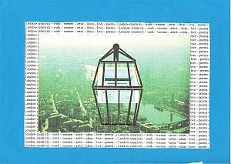
Present an alternative book cover and blurb:

Be sure the illustration relates to an important aspect of the book. Use appropriate colors to evoke the atmosphere created by the book. (Older Ss can also be asked to print out different book covers from the internet. Amazon.com usually has different editions. Ss then present the different cover designs and their own version. The class chooses their favorite one. This is a very good way to discover underlying themes and the tone of a novel.
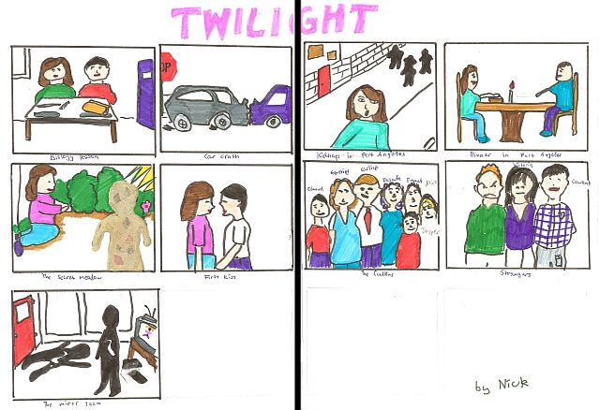
Plot on the line or Storyboard:
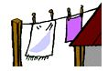
Write seven to ten main events on separate sheets. Add simple drawings and illustrations. In your presentation hang up one picture after the other using clothes-pegs and a string or stick your pictures on the board with magnets or blue-tack. Talk about each picture using your own words. Don't give away the ending.

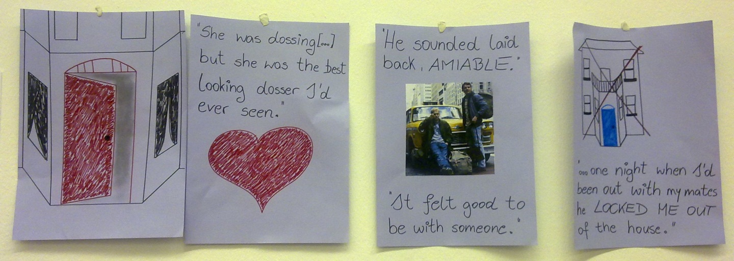
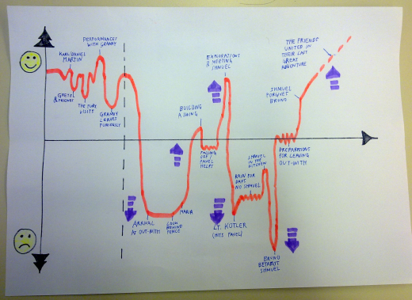

Plot diagram/ Plot mountain:
Draw a “fever curve” of the ups and downs in the novel. Peaks of suspense or conflict…., label the curve. In your presentation use your own words to explain each of the events briefly.

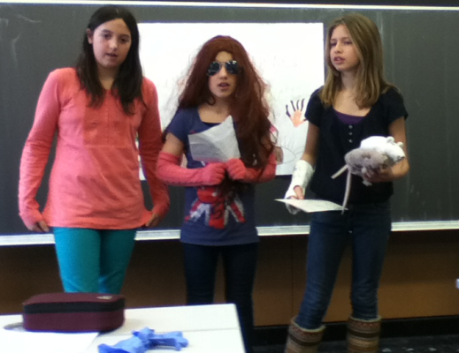
Act out a scene of your choice:
Use simple props and costumes.
This activity works best in combination with the “plot on the line” or the “plot mountain” activities. The learners act out one or two important scenes and explain at what point in the novel these scenes happen.

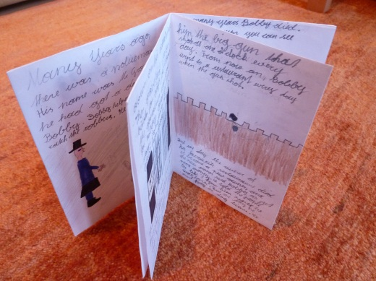
Make a plot mini-book (concertina or origami)

This activity works well for picture books or short stories that the teacher has read to the class. After listening to the story the learners design their own mini-books. They write their own version of the story and add illustrations on each page.
Variation: The learners might also write a follow-up story rather than a summary of the original story.

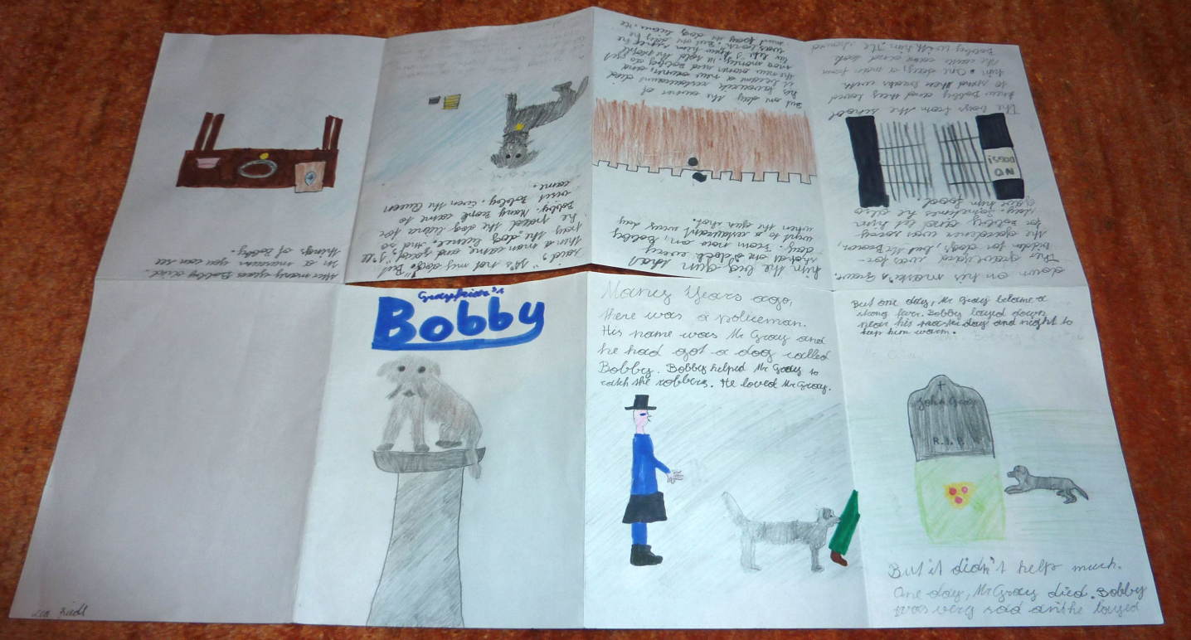

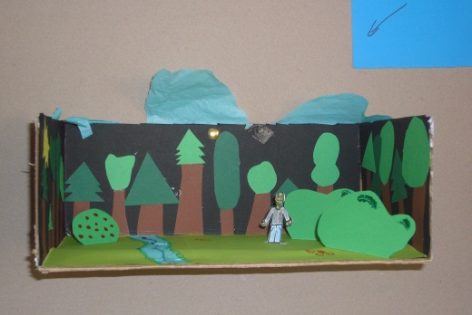

Setting
Make a setting pop-up or a painting that shows the most important place(s) in the book.
Setting murals:
several paintings glued together

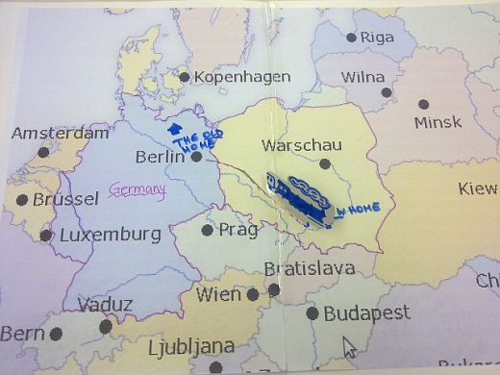
Draw a simple map of the locations in your novel. Make sure the map is large enough so your classmates can read it clearly. Attach a legend to your map. Write a paragraph that explains the importance of each location indicated on your map.

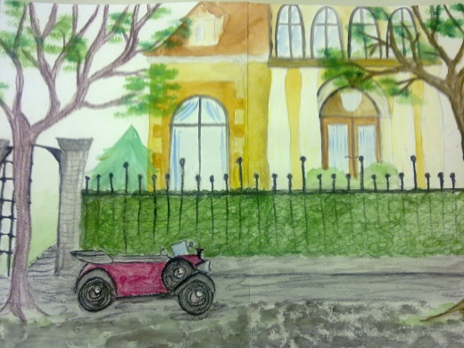

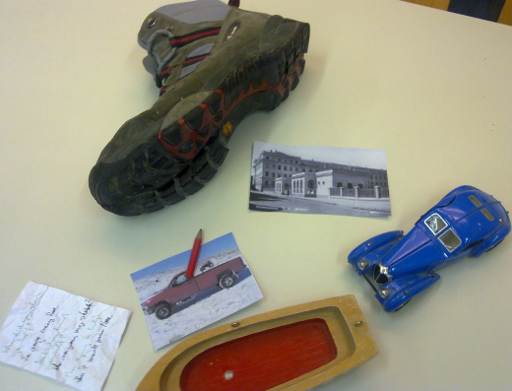
Characters
Identity bags/ character suitcase: Bring a bag full of objects that are somehow important to the main character of your book. Show them and explain their relevance.

Character T-shirts: Design a T-shirt (picture and slogan) for one of your book's characters. Show what is important to them.

Character collage: Find fitting pictures and words from magazines and present (one of) the main character(s) in a collage.
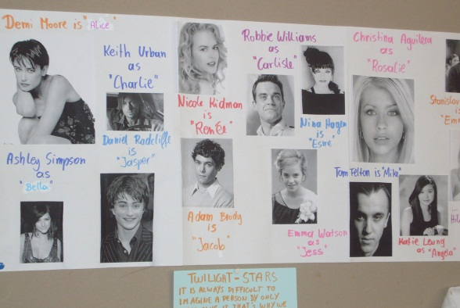
Movie Casting: Imagine that your book will be made into a movie. Choose suitable actors and actresses for each of the main characters and present them to the class. Explain why you think these actors/actresses would be ideal for these roles. What characteristics and qualities will they have to show in order to portray the characters well.

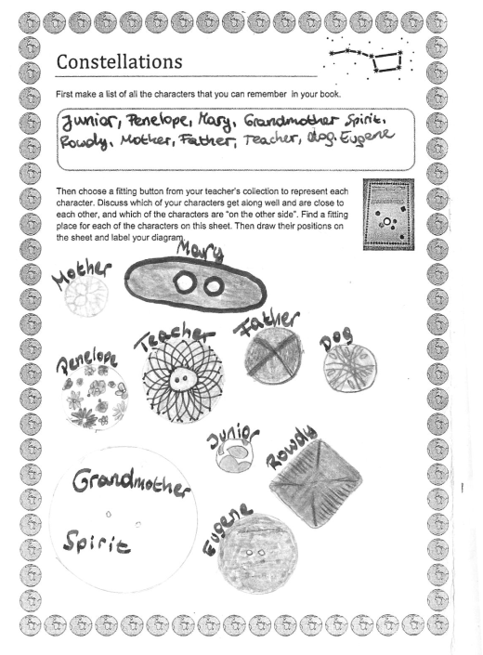
Prepare a "bubble sheet" (A3 poster) where you collect important quotes from your book. In your presentation explain who said these words and why they are important.

Sociogram: Choose suitable buttons to represent the main characters of the book. Then make a sociogram showing the relations between the characters. Show (close) friendships, rivals and enemies, good and bad characters. Compare your version with other students.

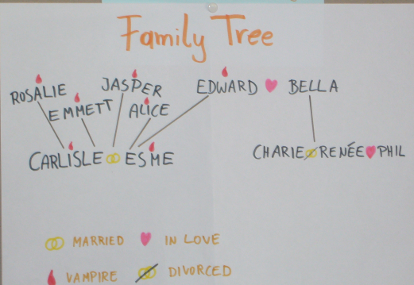
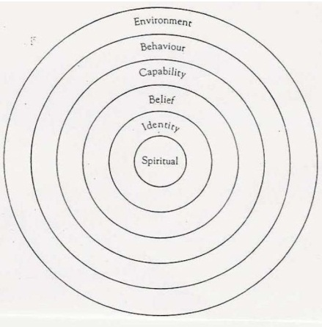

Character profiles: Look at the different levels of a main character’s personality and complete the profile circles. (Find the detailed description on epep.at)

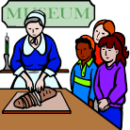
Other Ideas
Novel Museums
For the Novel Museum imagine that the characters in your book were REAL people. Our town wants to make their stories public and has, therefore, dedicated a whole room in the museum to these people and their stories. There they show real artefacts from your characters’ lives. These objects are presented nicely in showcases and on tables around the room. Each of the objects has a label explaining the importance of the item, where it is from and what role it played.
In your museum display you might show some of the following things:
Maps, short newspaper articles about what happened to your characters, diary pages, letters, objects they used during their adventures, photos, clothes they were wearing, favorite items of your characters….. or any other things that play an important role.

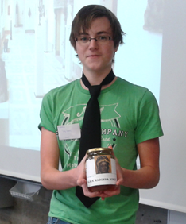
A Novel Museum: display 10 to 15 items that play a role in the book. Act like tour-guides and present the artifacts to the class. Explain the significance of each item. See detailed instructions on the right.

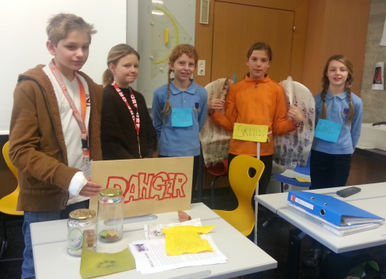

Write a poem or song-lyrics that might be used in a film or radio-play of your book. Present your poem (show it on the projector while you read it) or sing your song. Maybe other classmates can sing along or accompany you on a guitar. You can also use a karaoke CD for background music.

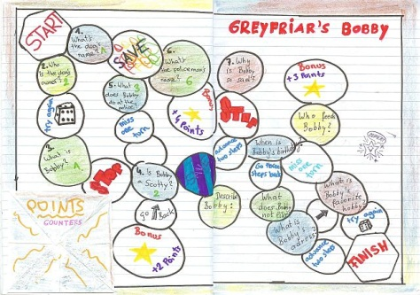
Make a board game: Design a board (use settings, plot line and events… task cards or fields… you might even make Fimo character-counters…

If class time is limited or if students are to present their private reading use the following activity:
Non-stop talking: Students stand in two concentric circles or parallel rows. The Ss in the outer circle or row talk non-stop for 1 minute (more advanced Ss can do 2-3 minutes) about the novel they have read. Ss in the inner circle/row listen. After 1 minute Ss change roles. Then the students in the outer circle move one person to the left. Do this with 3-4 partners. This activity works well for independent reading where Ss talk about different books. If they have all read the same book give out sub-tasks for each round: e.g: favorite character, least favorite character, setting(s), ending, …

Acrostic poem: Write the title of the novel downwards on a page. Then use each letter as an initial for a line about the book.
Alternative idea: If you have an idea of your own contact your teacher about it.

Older students

Older students who read modern or contemporary literature in their reading groups might also be asked to present some of the following aspects:
Short information about the author: main focus should be on typical themes or characteristic topics, style, other books… Biographical information only if relevant (e.g.: personal experiences that are reflected in the books…)

Historical or cultural background of the novel.

Make connections to the modern world:
Depending on the topics and themes of the book Ss might do tasks such as the following (designed for Brave New World or Animal Farm):
- Present the basic principals of propaganda and advertising (do an internet search)
- Give a propaganda speech about any topic of your choice. Then explain the methods you have used.
- Present the pros and cons of genetic engineering

Encourage students to prepare attractive, attention grabbing visuals for their presentations. Do not allow text on powerpoint slides. Allow only pictures or keywords and make sure the students use their own words rather than reading off prepared texts.

Presenting books online

Another great way to organize book presentations is by creating book-trailers or pecha kuchas.

For examples of book trailers go to: 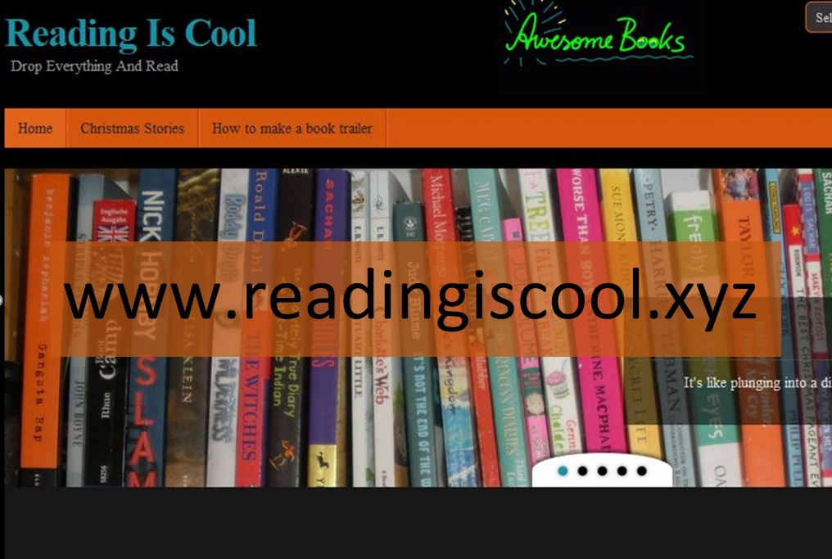

Contract

I commit myself to trying out the following two projects or activities which I have learned in this seminar.

1

2

I will try these activities within the next two months and will then share my experiences with my

colleague _____________________________________________.

My signature:

My colleague's signature:



Teacher’s comment: The text is actually a literary essay – but the student has never heard of this genre at this point.
Laura Robb and Rick Brown, 50 Fabulous Discussion Prompt Cards

