Reading is Fun

Dr. Elisabeth Pölzleitner

epep.at

Reading is fun: Getting started
Storytime for beginners
Bookmaking basics

Reading diaries
Examples from lower school
Examples from upper school
Let's try it out: Free-writing

Reading activities for narrative texts
Vocab-activities

The Chicken-Coop Monster
(sample story: basis for reading project)

Reading projects and book groups

The blank sheet
Make your own book

Ideas for book presentations

How to wet your students' appetite

Reading classics:

Books that have worked well with my students
Reading is fun!!!

- Make reading an everyday topic. Reading is fun. Reading is cool. WE all read.
- Read stories in relaxed atmosphere. Read stories as a special treat after hard work.
- Create a class library: Good bookshops are:
http://www.Amazon.de
Wolfgang Steinhauser's bookshop http://www.thebookshop.at

- Start reading whole books (picture books, stage 1 readers) as early as possible.
- Use reading logs and reading diaries to keep track of Ss reading.
- Give credit to book reports and reading
- Invite students to present books regularly, reserve space for book recommendations on pin-board.
- Create reading circles to discuss books.
- Use books for active vocabulary expansion.

You don't have to know every single word in a text.
Task:
1. Read the text and try to understand the general meaning of the story. (All the words in italics are nonsense words.)
A country girl was walking along the snerd with a roggle of milk on her head. She began saying to herself, 'The money for which I will sell this milk will make me enough money to increase my trund of eggs to three hundred. These eggs will produce the same number of chickens, and I will be able to sell the chickens for a large wunk of money. Before long, I will have enough money to live a rich and fallentious life. All the young men will want to marry me. But I will refuse them all with a ribble of the head - like this . . .'
And as she ribbled her head, the roggle fell to the ground and all the milk ran in a white stream along the snerd, carrying her plans with it.
Now look at the nonsense words again. Can you guess what they might mean?
Would you feel comfortable to read a text with as many unknown words?

The 5 Finger Rule: Students read the first and second page of a book and use their fingers to count the number of unknown words that they cannot easily guess from the context. If the number exceeds 5 unknown words per page, the text is probably too difficult for joyful reading.

Improving students’ confidence:
Encourage “top-down” reading skills rather than focusing on every unknown word:
Fast reading activities help students gain confidence and focus on content and gist.
Fast Reading: Basically skimming, give Ss 30 seconds to "read" text, collect info on board. Give them 2 - 3 minutes to read the text again (1 page), collect inf. on board. Ask Ss to write a 50 word summary of the text (in groups). Only then allow them to read the text slowly!
Try out fast-reading with the text on the next page.
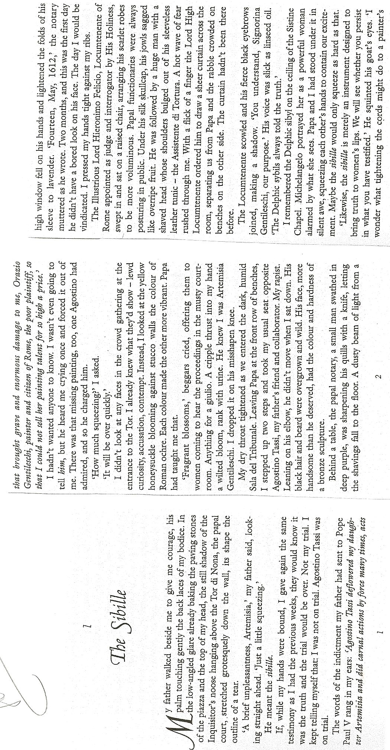
Simple Tasks for Beginners:

Story Tree:

Story Pie and All-Star Book Report:

SWBS: The Plot Chart:

Problems and Solutions:

Letters and Postcards:

Opinion Page:

Crayon Conversations:

One Person Show:
Reading Activities for Narrative Texts

Pre-reading Activities

• Pictures: Show a picture related to the text. Students guess what the text might be about. For books: show book-cover only. Ss imagine story (plan for a few minutes, then Ss mill around exchanging their invented stories. Can also be done in carousel format. To make it even more exciting: Divide class in 4 groups, show each group a different picture from the book. Then crossgroup- Ss exchange what they’ve seen and discuss what the story could be about.

• Kim’s game: Show Ss a picture for about 1 minute (best done on OHT), they jot down all the details they remember. This can also be done at a later stage in the story.

• Titles, Headlines: Give title. Have students guess what the story might be about. They might start like this: I think …. is going to…// I hope ….// I don’t want …..//

• Select 4-5 words: Write these words on board. Ask students for associated words. What might the story be about?

Reading Tasks and Activities
• Matching: • text and pictures

• Ordering pictures: For picture books, copy picture pages without text (1 set per group), read story, Ss find matching pictures, put them in correct order. Then compare.
• Ordering jumbled sentences or paragraphs: Cut into strips if possible

• Two in one stories: cut up two short texts, mix. Ss sort and reconstruct the two stories (Works well with the short texts from children’s books

• Text Market: Cut text into N (e.g. 5) pieces . Provide enough cut copies of the text for each student to be able to put together one complete version. Hand out pieces randomly. Each student has N pieces, some of them might be the same. In order to complete their text they will have to exchange those that are surplus for those that they need. In order to do this Ss sell their unwanted pieces as if tey were in a market. They walk around describing their pieces, shouting out offers… The only rule of the game is that text pieces must never be shown before they are exchanged. Students can even lie about the content of their pieces.
When the students have bought all N pieces of the text they sit down and reconstruct the text.
Note: may be quite chaotic at first, noise dies down as more Ss have bought all the pieces. Fast Ss can then help others.

• Gapfilling: any short text, leave out words or phrases. Leave space where the word is missing

• Gapfinder: Leave out words but don't leave any empty space (more difficult). Ss have to find out where a word is missing and write it in. Print texts with double line spacing for this exercise or leave a margin where Ss can write the missing words.

• C-test: print first half of each word, Ss complete the text.

• Picture corrections: Separate the picture and the text. Change the text so that it represents things slightly differently from the picture. Students spot the mistakes and correct the pictures!!!

• Draw a picture: Listen to the story, imagine the scenes in detail, then draw or paint a scene…

• Carousel: Divide your story into 6 to 8 short pieces. Copy sets on different colors, enough pieces to serve the whole class. Distribute the pieces randomly. Students with the same color go together, then meet another group of a different color. The two groups build two concentric circles. (Do this in the hallway or any open area) Then the two students facing each other exchange their story bits (they must not show the cards). After one minute (more or less, depending on the length of the texts) the students in the outer circle move one person to the left. The new partners now exchange the content of their pieces… Do this until the students have heard the content of all the pieces.

• Answer questions: Students write questions for another group

• For further ideas (esp. ideas for novels) see “Ideas for Book Presentations”

TEXT MARKET
Potatoes
retold by S. E. Schlosser
Teacher instructions: Use for TEXT MARKET. Copy one sheet for each student, cut up. Hand out titles and task boxes to everybody. Shuffle all other cards and hand out 4 to each student. Ss must not show their cards to others. They buy and sell cards as described in the TEXT MARKET activity. (Reading Activities sheet) Students who have got all 4 parts then glue the slips on a worksheet in the correct order and do the follow-up tasks.

We here in Idaho are right proud of our potatoes. Our fields are so chock full of potatoes that you can hear them grumbling when you stick your ear on the ground. "Roll over, you’re crowding me," they say.

Potatoes grow bigger in Idaho than anywhere else. Once, a greenhorn asked me for a hundred pounds of potato. I set him straight real fast. I don't believe in cutting into one of my potatoes. "You buy the whole potato, or you take your business elsewhere," I told him.

Why do our potatoes grow so big? Well, it’s because we feed them like family. Cornmeal and milk every day for breakfast, lunch and dinner. You should taste my wife's mashed potatoes! They are the creamiest mashed potatoes in the whole United States. It’s all the milk our potatoes drink while they’re growing. Makes them so creamy that all my wife needs to do is just boil them and mash them up.

Sometimes, the size of our potatoes creates a problem for the farmers. One fellow I know got trapped for eight hours beneath a potato. His wife came looking for him when he was late to dinner. She had to get the neighbors to help roll it off. But that's just they way it goes when you're farming potatoes in Idaho.

How does the storyteller describe potatoes in Idaho?
Idaho potatoes are:

Design an ad for Idaho potatoes. Be creative. Use your computer or handwrite and draw your ad. Decorate it nicely.

GAPFINDER

Frozen Dawn
retold by
S. E. Schlosser
Gapfinder: Some words have been lost in this text. Write the missing words in the margin and put numbers to indicate where the words should go.
Example:
One winter, it was so (1) that the dawn froze solid. The sun got caught two ice blocks, and the earth iced up so much that it couldn't turn. The first of sunlight froze halfway over the mountain tops. They looked like yellow icicles dripping towards the ground.  Now Davy Crockett was headed home after a successful night hunting when the dawn froze up so solid. Being a smart, he knew he had to do something quick or the earth was a goner. He had a freshly killed bear on his back, so he whipped it off, climbed right up on those rays of and began beating the hot bear carcass against the ice blocks which were squashing the sun. Soon a gush of hot oil burst out of the bear and it melted the. Davy gave the sun a good hard kick to get it started, and the sun's heat unfroze the earth and started it spinning again. So Davy lit his pipe on the sun, shouldered the bear, slid himself down the sun rays before they and took a bit of sunrise in his pocket. | 1) cold

Quantifying the story // Half the story
Dictate the following story to the class. Stop several times and ask the students to visualize/describe or quantify the sentences. Ss write their answers. Then pairs or small groups compare their versions.

The Farmer
A curious tourist, after passing a huge field of carrots alongside the road, stopped and asked the farmer what he did with his large crop.
How large is the field? Describe what you see. Amount of carrots?
‘Well,’ said the farmer, scratching his chin, ‘I’ll tell you what we do.’
Describe the farmer.
‘We eat what we can and what we can’t eat we can.’
The man went back to his car with a puzzled look on his face and said to his wife, ‘I think he must be crazy.’
Describe the man.
‘He said they ate what they could and what they couldn’t they could.’

Exploiting texts for vocabulary expansion:

Choosing vocab: Students choose 3-5 new phrases that they want to remember and write them on vocab cards.

Lexical Furniture: put the new phrases in suitable places in your house/home. E.g: the verb “to separate” would go into the kitchen, under the sink, because there I separate my waste….

Connect a Pair
Sensible Words
Word Webs
Acrostic Puzzles see the following pages for details
Personal Properties
Wordcycle
Word Search
Crosswords

Vocabulary List: Choose 2 phrases from your picture book and write them on the board. We will use them to try out some of the vocb.activities.

Connect A Pair

Select 10 phrases from your vocab-collection. Write them in the first column.
Then form 5 pairs that have some connection. Explain your connecting idea in the second column.
1 a gloomy old place | +3: this gloomy old place had a high fence, the gates were padlocked.
2 he sat about grumbling all day | +4: maybe the grandfather was grumpy and sat about grumbling all day while Granny was working hard and was worn out with all the work...
3 the gates were padlocked | 
4 Granny was worn out with all the work
now add your own...

Word Cycle
Select 10 words from your collection. Write one of them in the first circle. Find a connection with another one of your words and write it into the second circle. Make a short note of their relationship. Then connect word 2 with another word on your list. Continue around the circle. Make up crazy connections between the neighbors-- but make sure all your words fit in somewhere. It is not necessary that all your words fit into one "story" -- just form connections between the neighbors.

Reading Diaries: Young Learners
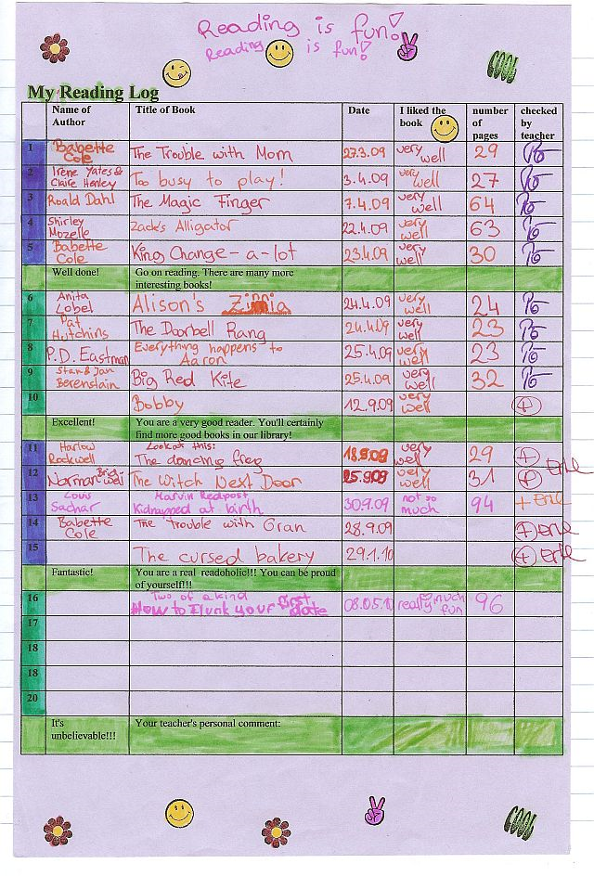
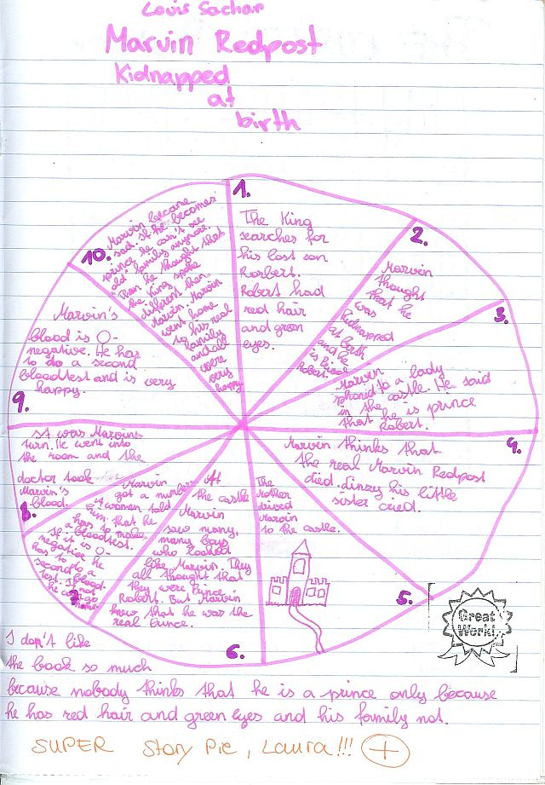
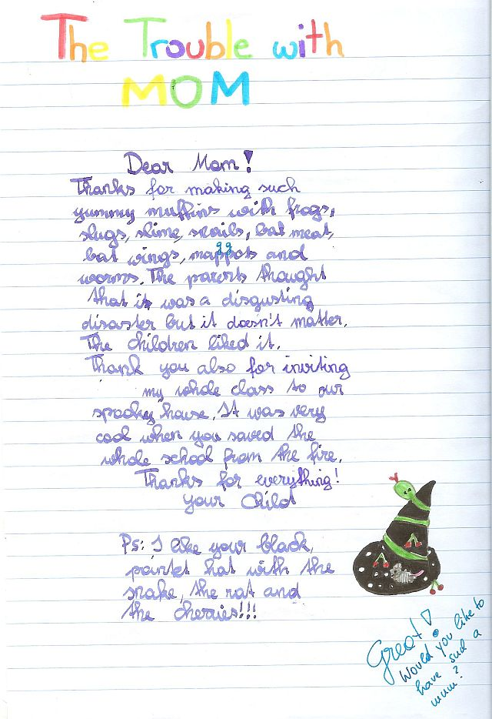
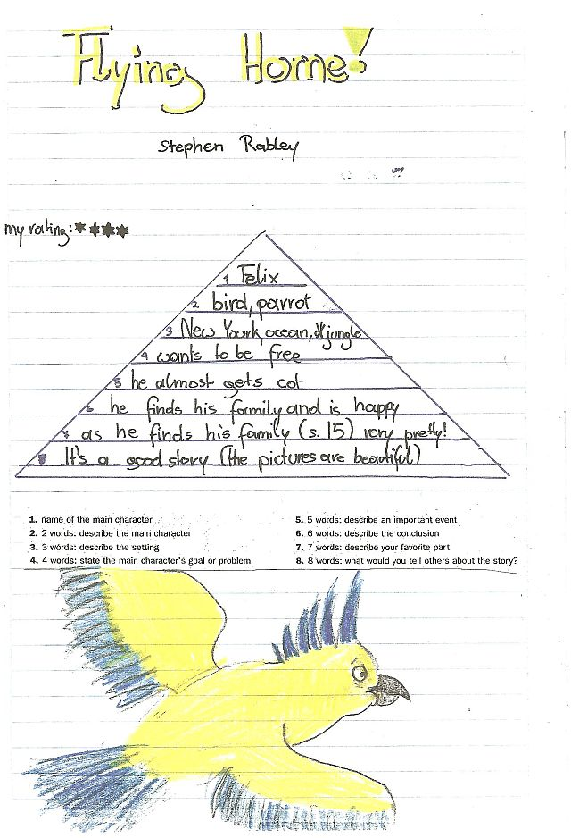


Reading Diaries: Sample pages, year 2
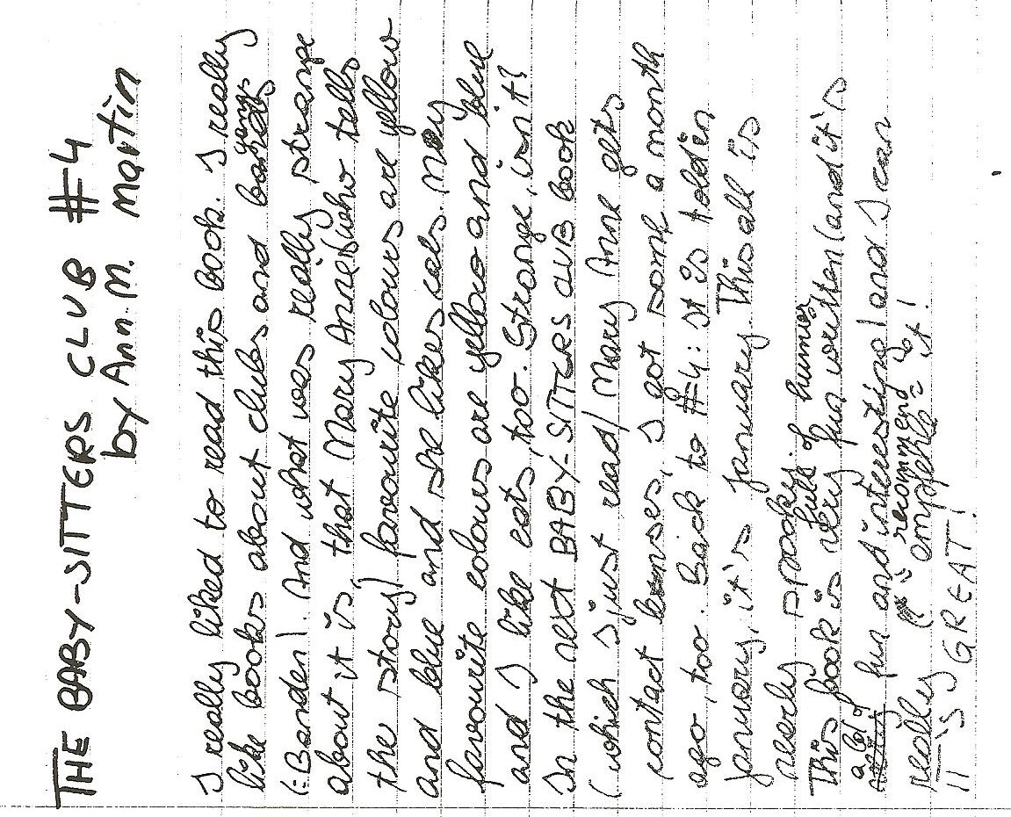
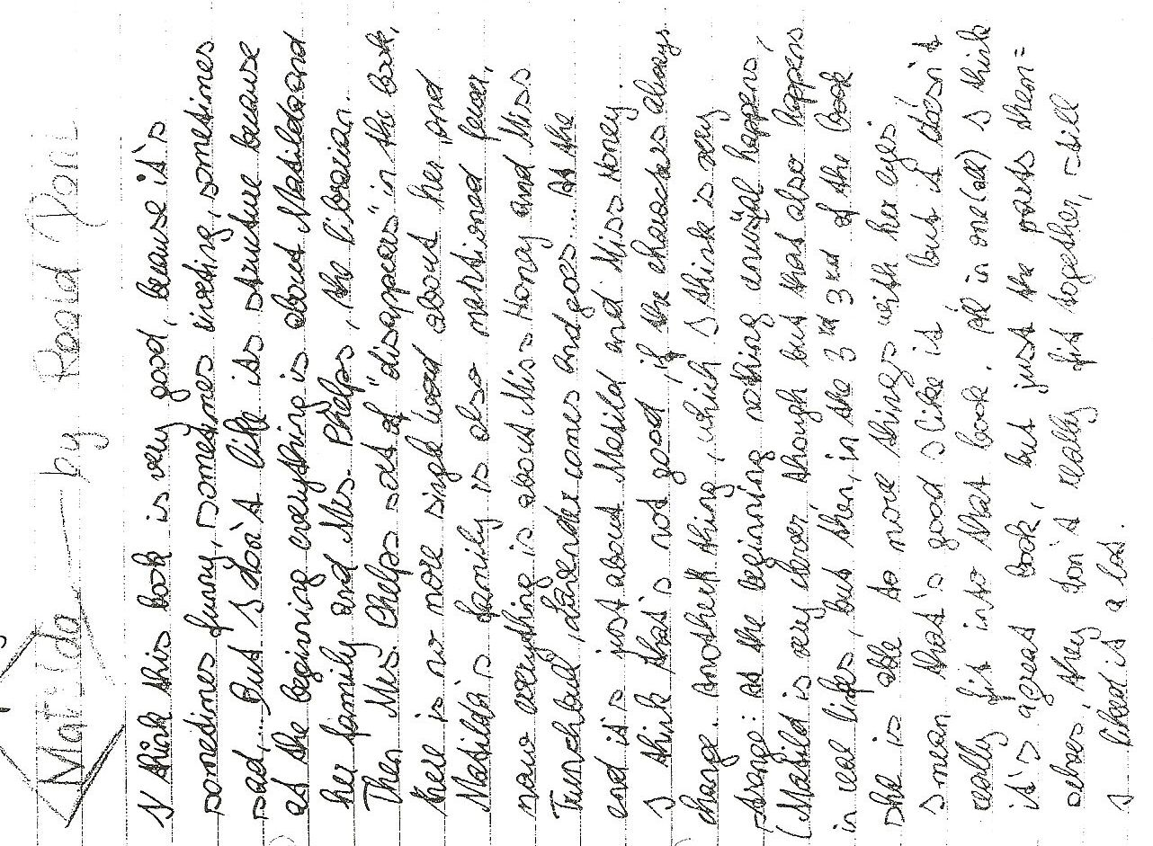

Tips for keeping a reading diary
Effective readers connect with, reflect on, and challenge the text. On your way to becoming such an effective reader use your response journal to try out some of the following tips and techniques.
Read slowly and carefully. Try to imagine the scenes as vividly as possible and try to see life through the main characters' eyes. After reading sit back and think about it for a while, then write a personal response.
Decide how much time you want to commit and stick with it (10 – 15 minutes!)
Write quickly, without worrying about spelling, punctuation, grammar…. Do not pause to think, just keep writing. As you write, follow your thoughts and ideas, do not worry about good organization and coherence. Just let your ideas flow.
Consider some of the following questions:
- Do you enjoy reading this novel or story? Why? Why not? What emotions does the book invoke: laughter, tears, smiles, anger? Record some of your reactions.
- Does the book or its characters remind you of any real life situations or people you know?
- Are the characters interesting and believable? Who is your favorite character? Why is he/she special to you? Is there a character you don't like at all? Why don't you like him/her? Would you like to be one of the characters (acquire a personality trait)? Which of the characters would you become, if you could? Why?
- What are your favorite lines/quotes? Copy them into your reading diary and explain why these passages caught your attention.
- Which are your favorite scenes in this novel? Explain why you enjoyed them.
- Make predictions: What do you think is going to happen next?
- Is the author able to hold your interest throughout the entire novel? How did he or she manage to do this? Or are you bored at times? What exactly makes the chapter/scene boring?
- Is there an idea in the book that makes you stop and think, or prompts questions? Identify the idea and explain your responses.
- Does the book leave you with questions you would like to ask? What are they? Would you like to direct your questions at a particular character? What questions would you like to ask the author of the book?
- Are you confused about what happened (or didn’t happen) in the book? What events or characters do you not understand? Does the use of language in the book confuse you?
- What changes, if any, would you have made in this novel?
- Are there any symbols, symbolic acts or names in the novel?
- Think of the main themes of the novel? What might the author be saying?
- Who else should read this book. Should anyone not be encouraged to read this book? Why?
- Would you like to read more books by this author? Have you already read other books by the author?
Sample Responses: years 7 and 8

Below you find a number of extracts typically found in response journals:

Affective responses are a kind of raw emotion or a ‘gut reaction’ you have after reading, such as anger, love, jealousy, indignation, contentment, sadness....
e.g.: I was furious when reading the Battle Royal scene. How can these people be so mean and treat a human being like that. I felt like stepping out and hitting them, or sceaming or I don’t know what. I was also shocked at how the main character didn’t even find it so terrible. (He doesn’t have a name! Maybe that has something to say as well, he is invisible and nameless???) He certainly didn’t like being treated like that and was frustrated but not as angry as I was. For him this seems to be quite normal. That makes me even more angry! I really hate these fat politicians, they are the worst hypocrites I have ever seen...

Associative Responses are analogies or associations you have when reading. There are no true and false associations, everyone has their own!!! Let your mind wander, relax (as described in the free-writing technique), this will open the doors for all your associations to flow in.
Look, for example, at the following response of a student to a line from a poem.
...“Something there is that doesn’t love a wall.”(line 1)
...
I remember when I was young and how I was always sent to my room for punishment of something I had done wrong. I hated being sent to my room, not in the beginning, of course, because I always thought I’d get even with my Mom and show her that I could have a lot of fun in there. As the hours went by, though, I usually ran out of things to do and therefore I would always try to think of a good story to tell sweet ole Dad abourt how mean Mom had been to me. I just hated those four blank walls; I guess that’s because I saw them so often.
or:
Little Richard’s behavior reminds me of this story I read in the newspaper last week. A little boy had played with matches and then hid in the closet because of his bad conscience and fear. Wow, that’s dangerous if little kids react like that. I guess it also has to do a lot with the fear of punishment. These kids must be hit a lot!

You might also note things that strike you as strange or just interesting such as for example this response to the beginning of the novel Song of Solomon by Tony Morrison.
It’s strange that so many characters have Biblical names: Pilate, Magdalena, First Corinthians, Mercy hospital.. (p18). What does this mean?
...
There seem to be a lot of symbols in the book: Watermark (p.11), Red velvet (p.10). I don’t know their meanings yet, maybe it’ll become clearer later.

Also note your impressions of the structure of the text. For example:
The author is constantly jumping back and forth in the lives of the characters. Slowly their history is becoming clear. It’s sometimes difficult to follow. I have to read a page or two until I realize who she is dealing with now! I wonder why she does this!
...
It’s getting worse. I am getting angry with T. Morrison. I feel she is teasing me! Why can’t she just organize her material bxetter? There must be some artistic reason or is it just to be different from the others???

Most of the time your response will be a mixture of all of these approaches. Even the examples above usually include more than just one aspect. Don’t let yourself be stiffled by trying to stick to one aspect. Just let your ideas flow! Don’t forget to write down page numbers, so you can later find exact quotes if you need them.

Technical Tip:
It’s a good idea to leave a margin in your response journal. When going over your material later, you can make little comments in the margin that help you organize your writing. Depending on your reading and topics you might, for example, mark all the “references to religion” in the margin, or you might want to mark all the places where you got angry with a certain character or all the instances where your main character was cheated by someone....

Free Writing:

Harlem by Langston Hughes  What happens to a dream deferred?  Does it dry up  like a raisin in the sun?  Or fester like a sore--  And then run?  Does it stink like rotten meat?  Or crust and sugar over--  like a syrupy sweet?  Maybe it just sags  like a heavy load.  Or does it explode? | Harriet Beecher Stowe by Dorothy Parker  The pure and worthy Mrs. Stowe  Is one we all are proud to know  As mother, wife, and authoress-  Thank God, I am content with less!

Barbie Doll by Marge Piercy
This girlchild was born as usual
and presented dolls that did pee-pee
and miniature GE stoves and irons
and wee lipsticks the color of cherry candy.
Then in the magic of puberty, a classmate said:
You have a great big nose and fat legs.
She was healthy, tested intelligent,
possessed strong arms and back,
abundant sexual drive and manual dexterity.
She went to and fro apologizing.
Everyone saw a fat nose on thick legs.
She was advised to play coy,
exhorted to come on hearty,
exercise, diet, smile and wheedle.
Her good nature wore out
like a fan belt.
So she cut off her nose and her legs
and offered them up.
In the casket displayed on satin she lay
with the undertaker's cosmetics painted on,
a turned-up putty nose,
dressed in a pink and white nightie.
Doesn't she look pretty? everyone said.
Consummation at last.
To every woman a happy ending.

