ENG 01
©Elisabeth Pölzleitner
Uni-Graz and PH Steiermark  
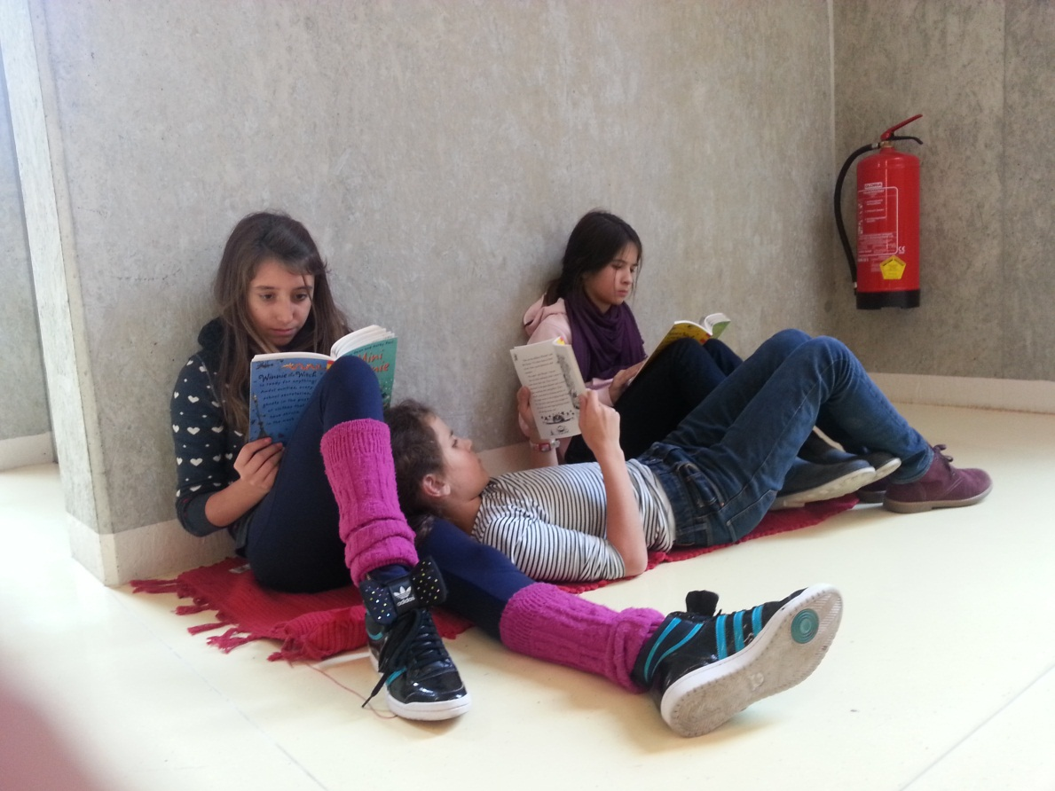
Reading is fun
Ideas for using children’s books and young adult literature in secondary school.

Table of Contents
Table of Contents 2
Resources 4
Further Reading 4
Getting started 5
The ten commandments of teaching reading 5
Purpose of reading 5
Culture versus culture 6
Language: Expansion of vocabulary and grammar 6
How do we read? 7
Reading is fun: Story-time for beginners 9
How do we start? 9
Basic reading tasks for beginners 10
More useful ideas from 11
Reading activities for narrative texts (elementary) 12
Pre-reading activities 12
While reading and post reading tasks and activities 12
Examples 13
Reading Diaries 15
Reading diaries for young learners 15
Tips for my first reading diary 16
Reading Diaries: Sample pages, year 2 17
Letters 18
Creative Ideas 20
Tips for keeping a reading diary 21
Types of Responses 22
Now try out FREE WRITING yourself. 27
Character Profiles 28
Teaching Activities for Advanced Literary Texts 29
The Humbugs, by Kurt Vonnegut 29
Planning and Organizing Reading Projects 31
A mini project for one double lesson 32
Book sharing 35
Reading Project 37
Useful materials and ideas for book groups 41
Booklets for all ages 42
Sample pages from my students’ booklets 44
Letters and Postcards 44
Brochures 45
Other ideas: Recipes, Travel info, 46
If I was… 46
Creative Catalogues 47
Origami books or Diaries 48
Oliver Twist: Fagin’s diary entry and a newspaper article about the same events. 49
Newspaper Articles 50
Plot Diagrams 51
Letters to the author 52
Ideas for Book Presentations 53
Year 1: 53
Years 2-8 and beyond 54
Plot 54
Setting 56
Characters 57
Other 58
Timesaver Idea 58
Older students 59
Reading projects for advanced readers 60
Useful tasks for upper-school reading projects 60
Red cards – Green cards 60
Telling Passages 61
Points of View: What I would have done... 61
Venn Diagram 61
Good Expressions 62
Alternative title and cover 62
A sample project for upper-school reading: 62
Great Literature for Advanced Students 64
A taste of poetry 65
Poetry ideas for young learners 65
Recipe Poems 65
Acrostic Poems 65
Haiku 67
Concrete Poems 67
Limericks 69
Ideas for Using Poetry in Upper School 70
Examples of short poetry projects 72
Writing Haikus: Snapshots of America 72
Found Poetry 74
Let’s LOOK at Imagist Poetry 75
Parodies 76
Works Cited 78
Other useful Sources: 78

Resources

This handout is meant to give you an overview of the topics and ideas discussed in the seminar. Add your personal notes and comments and do not worry about messing up any of the tasks that you might want to use in school. Some materials in this handout have been reduced in size in order to save paper. All the materials can be downloaded in full size from my website: www.epep.at.

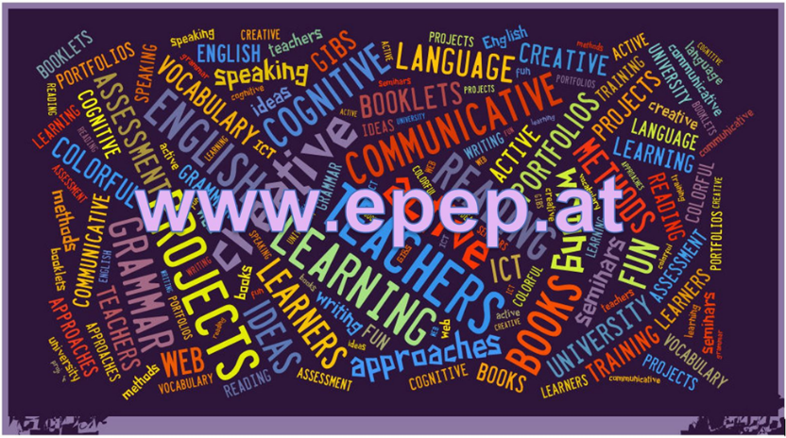

This page contains lots of creative teaching ideas, downloadable worksheets and links to useful books and other materials for teachers.

Further Reading
There, you will also find links to excellent, useful books on teaching literature on epep.at -- Reading – Further Reading
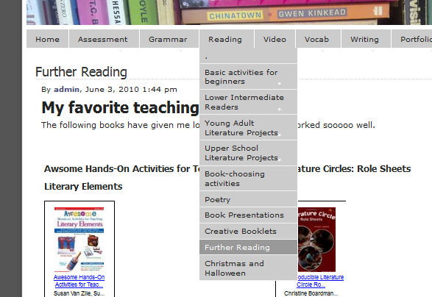

Getting started

The ten commandments of teaching reading
- Make reading an everyday topic. Reading is fun. Reading is cool. WE all read.
- Read stories in relaxed atmosphere. Read stories as a special treat after hard work.
- Create a class library:
- Start reading whole books (picture books, stage 1 readers) as early as possible.
- Use reading logs and reading diaries to keep track of Ss reading.
- Give credit to book reports and reading
- Invite students to present books regularly, reserve space for book recommendations on pin-board.
- Create reading circles to discuss books.
- Use books for active vocabulary expansion.
- Allow as much free choice as possible. Consider different reading tastes and reading abilities.

Purpose of reading

Brainstorm the multiple purposes of reading in the foreign language classroom.

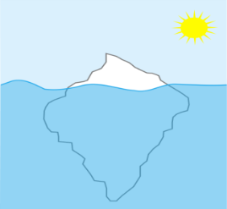
Culture versus culture

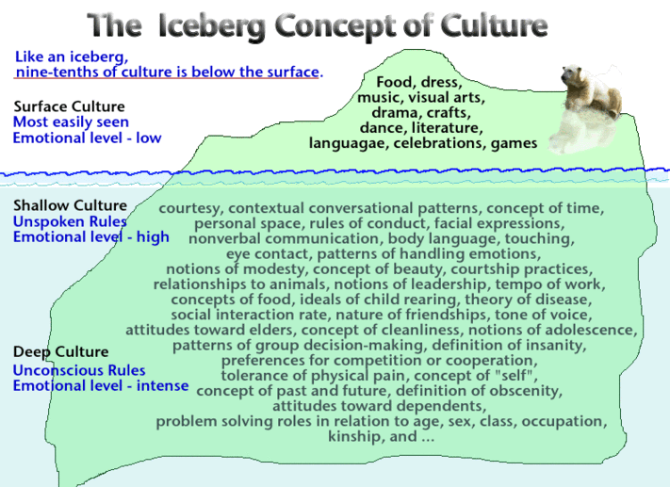
(Indiana Department of Education 2012)

Language: Expansion of vocabulary and grammar

Reading ACTIVELY involves the whole brain. We make connections and associations between language and concepts in our memory. Reading activities (pre- while- post –reading activities) enrich these processes and strengthen the newly developed neural networks.

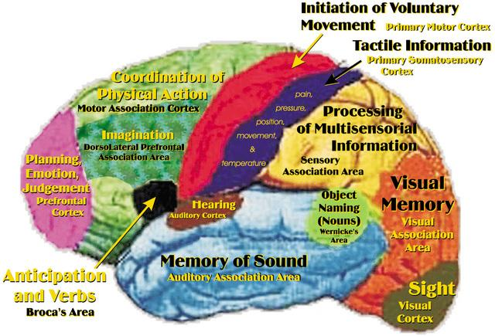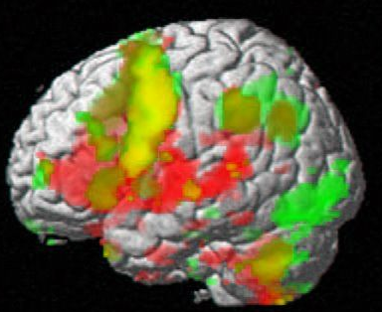

How do we read?
- Skimming: quickly running one's eyes over a text to get the gist of it.
- Scanning: quickly going through a text to find a particular piece of information.
- Extensive reading: reading longer texts, usually for one's own pleasure. This is a fluency activity, mainly involving global understanding
- Intensive reading: reading shorter texts to extract specific information.

NOTE: The different ways of reading are not mutually exclusive.
Example: We often skim through a passage to see what it is about before deciding whether it is worth scanning a particular paragraph for the information one is looking for. In real life reading purposes vary constantly. Therefore, exercise types should also vary according to the text studied and the purpose of reading it. It would be highly artificial to work on a page of classified ads and propose exercises that require detailed reading of every single advertisement.

You don't have to know every single word in a text.
Read the text and try to understand the general meaning of the story. (All the words in italics are nonsense words.)
A country girl was walking along the snerd with a roggle of milk on her head. She began saying to herself, 'The money for which I will sell this milk will make me enough money to increase my trund of eggs to three hundred. These eggs will produce the same number of chickens, and I will be able to sell the chickens for a large wunk of money. Before long, I will have enough money to live a rich and fallentious life. All the young men will want to marry me. But I will refuse them all with a ribble of the head - like this . . .'
And as she ribbled her head, the roggle fell to the ground and all the milk ran in a white stream along the snerd, carrying her plans with it.

Now look at the nonsense words again. Can you guess what they might mean?
Would you feel comfortable to read a text with as many unknown words?

The 5 Finger Rule: Students read the first and second page of a book and use their fingers to count the number of unknown words that they cannot easily guess from the context. If the number exceeds 5 unknown words per page, the text is probably too difficult for joyful reading.

Improving students’ confidence: Encourage “top-down” reading skills rather than focusing on every unknown word: Fast reading activities help students gain confidence and focus on content and gist.

Classroom procedures:
Important: Reading is a silent activity --- encourage silent reading.

Why? Work with a partner and collect arguments why students should read silently and on their own.

Can you think of any exceptions? When and where would it be meaningful to read a text aloud?

Fast Reading:
Basically skimming, give Ss 30 seconds to "read" text, collect info on board. Give them 2 - 3 minutes to read the text again (1 page), collect inf. on board. Ask Ss to write a 50 word summary of the text (in groups). Only then allow them to read the text slowly!
Try out fast-reading with following text.


The UK will be part of a new mission to remove pieces of debris from space, and will help build a new 'space junk claw'.
The claw, which will be the first satellite to remove litter from space, has been described as 'vital technology' to help with the mission.
It will be part of a mission called Clearspace-1, which is planned for 2025 and is the first space mission dedicated to removing existing objects in orbit... so a pretty big first step towards a cleaner space environment!
Why does space need to be cleaned?
For fourteen billion years, between the big bang and the autumn of 1957, space was sparkling clean.
But since 1957, us humans have put almost 10,000 satellites into the sky, and most of those are now defunct or destroyed.
That means there are now an estimated 160 million objects in orbit around Earth- and most of those are "space junk".
Space junk is debris that comes in all sorts of different shapes and sizes. It could be old rocket bodies, or a camera, or a household item dropped by an astronaut!

NASA
Things that have been dropped by astronauts in space are classed as space junk
Science Minister Amanda Solloway said: "We plan to be at the forefront of efforts to track and remove this junk, and I am delighted that technology supporting this pioneering ambition is going to be made right here in Britain."
The junk claw will use a pincer motion to collect debris, before giving it a controlled re-entry into Earth's atmosphere, meaning it will be able to decompose safely and away from life.
UK Aerospace and defence company, Elecnor Deimos, will design Clearspace-1's Attitude and Orbit Control System (AOCS) which will orientate and position the satellite to help grab the space junk, using power generators, thrusters and antennas.
Earlier in 2020, the UK Space Agency announced several new investments through its space surveillance and tracking (SST) programme. The aim is to get better at tracking and monitoring space junk that could potentially be dangerous if it collided with satellites, or even the International Space Station.
In 2018, 186 miles above the Earth, a British satellite sent a net into orbit to show how to capture space dehttps://www.bbc.co.uk/newsround/54972283bris. This was part of a mission to test the methods of cleaning up space junk.
BBC, Newsround online: https://www.bbc.co.uk/newsround/54972283, Nov. 18, 2020

Reading is fun: Story-time for beginners

How do we start?
Which of these stories would you like to hear? Ask questions to find out what they are about.
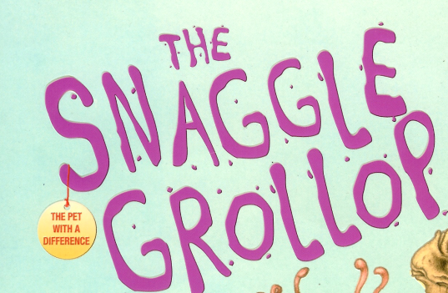 | 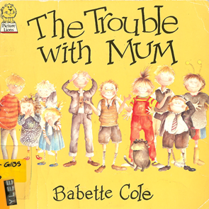
Find the teacher’s notes and the student materials for these activities on www.epep.at
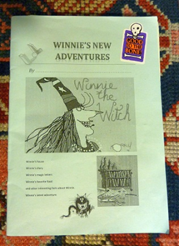
There you will also find other suitable picture books for beginners.

Picture books that have worked well in my classes:

Babette Cole, The Trouble with Mom
The Troule with Gran
Prince Cinders
Princess Smartypants
The Smelly Book
Valerie Thomas and Korky Paul, Winnie the Witch
Daniel Postgate, The Snagglegrollop
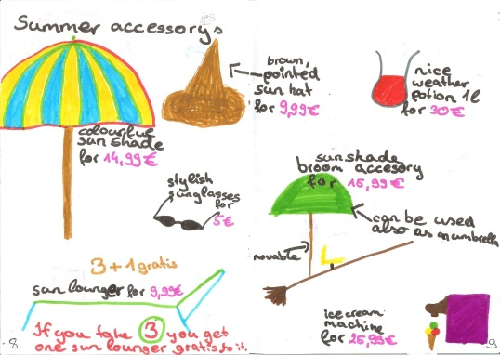
Julia Donaldson, The Gruffalo
Michael Foreman, All the King’s Horses
Richard Brassey, Greyfriar’s Bobby
Simon James, Dear Mr. Blueberry
Peggy Parish, Amelia Bedelia goes Camping
Shirley Mozelle, James Watts, Zack’s Alligator
Angela MCAllister, Monster Pet
Jackie French, Diary of a Wombat
Norman Bridwell,, The Witch next door
Find these and other suitable books on epep.at, Storybooks for beginners

Basic reading tasks for beginners

The purpose of these tasks is to make the learners read parts of the text in detail and use some of the new language actively. These tasks should be short and easy – we do not want to spoil the fun of reading.
Find the printable worksheets on www.epep.at  Book Chat:  Choose your favorite page in the book and describe it to your teacher or co-teacher.  What do you see?  What is happening in the picture?  Write a Postcard  Imagine you are one of the characters and write a postcard to a good friend. Tell your friend where you are and what it is like there. (no past tense necessary for this task!) Draw a picture on the front side of your card. | 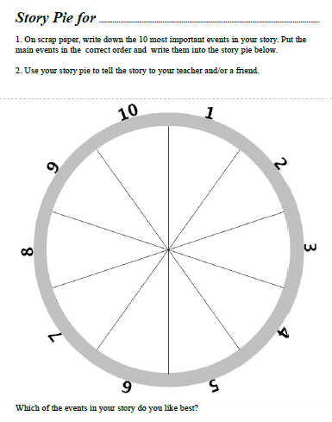
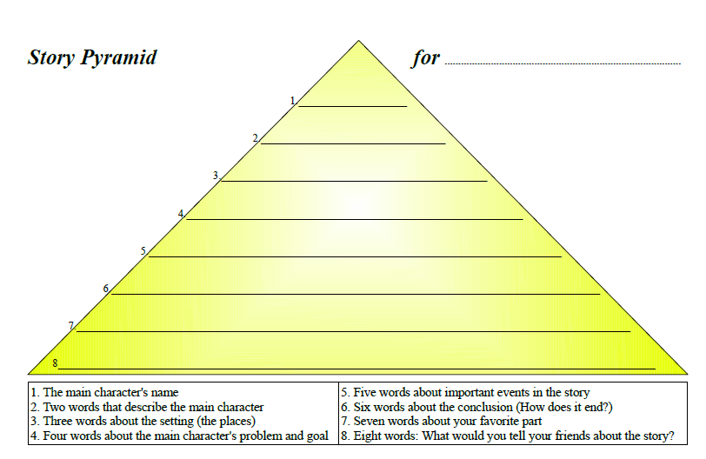 | 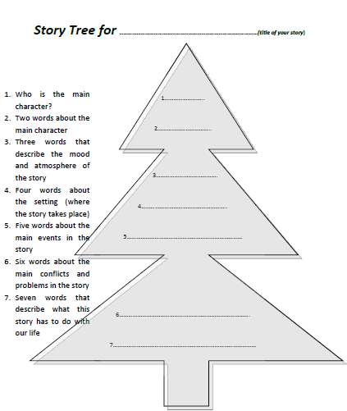

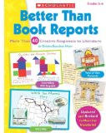
More useful ideas from
Find this and similar books in our library or get your own copy. Find a link on epep.at
Christine Boardman Moen (Boardman Moen 1992)
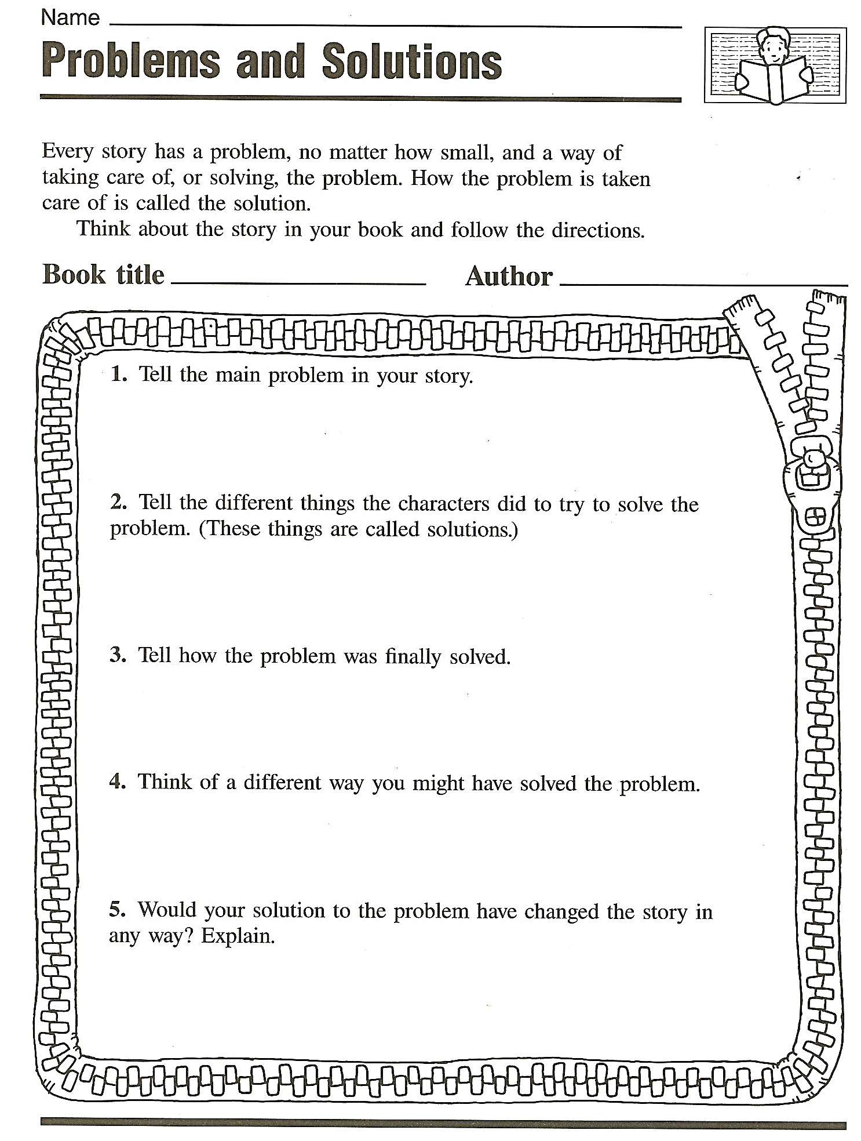 | 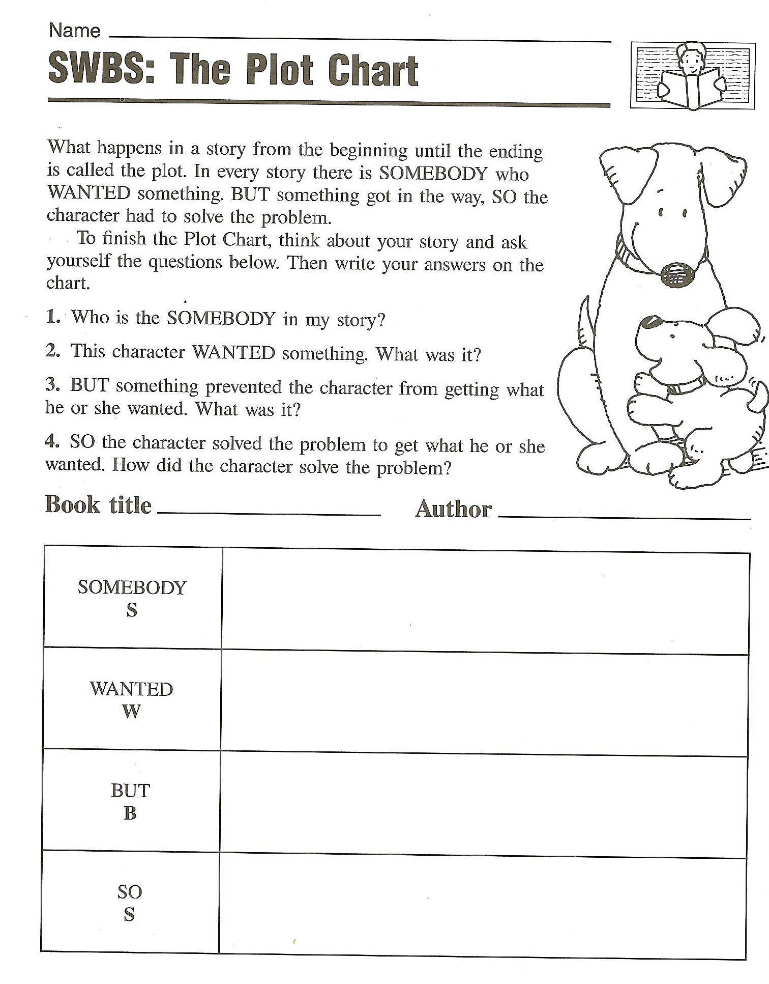
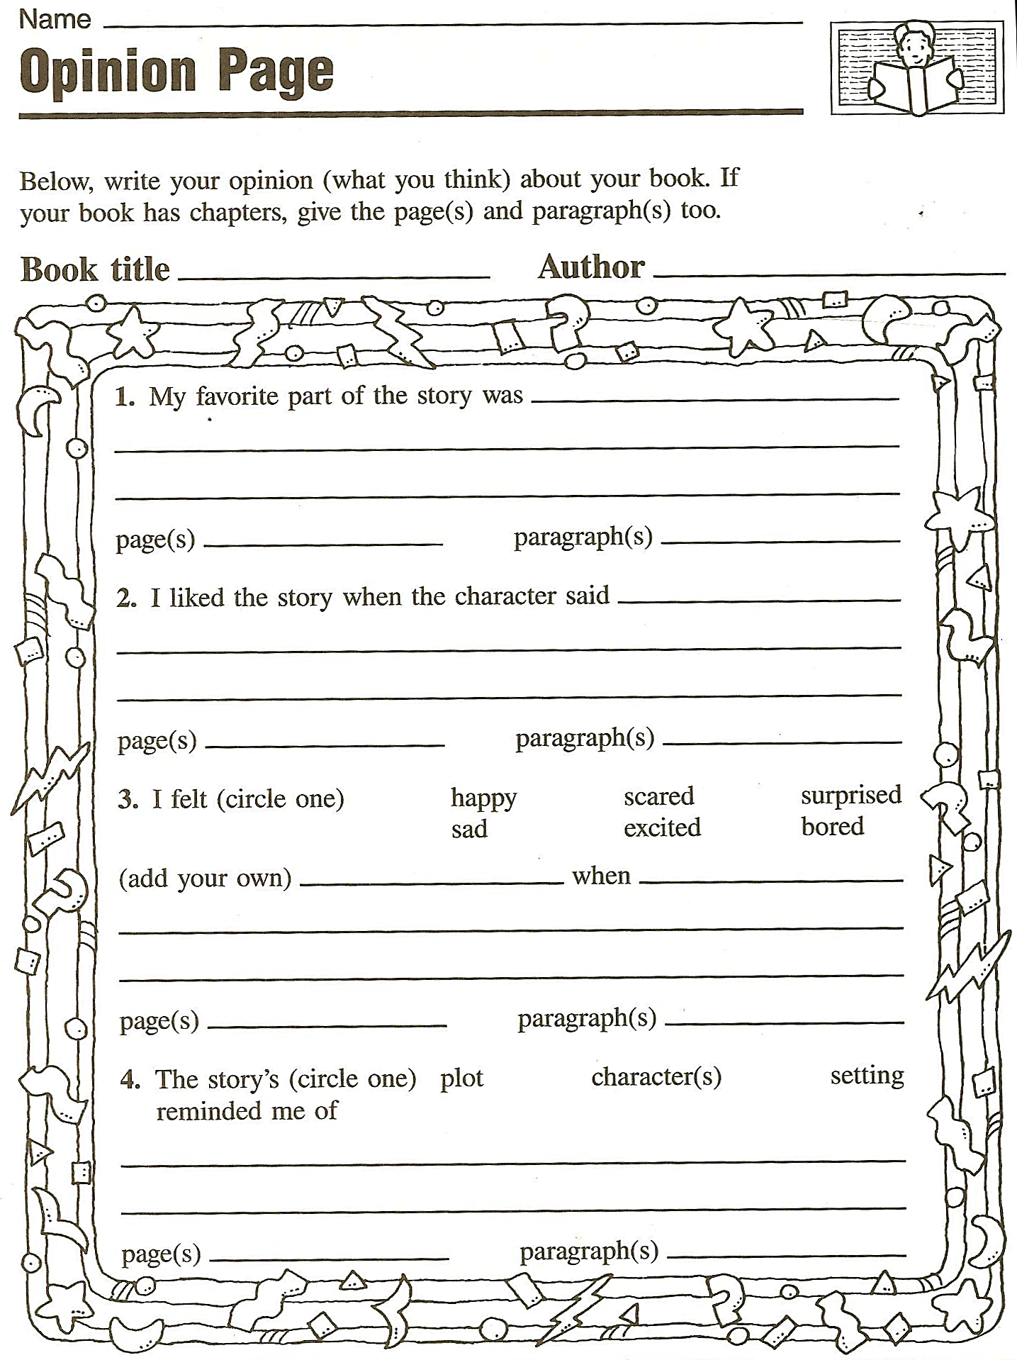 | 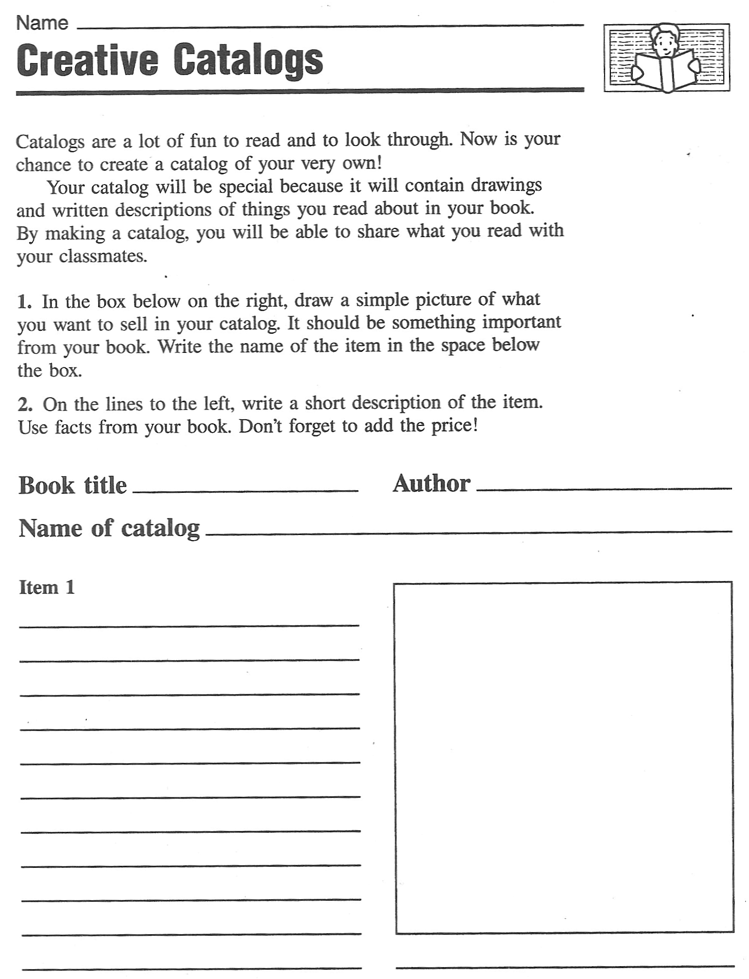  Tip: Groups can design a catalog of several pages for an interesting book.

Reading activities for narrative texts (elementary)

Pre-reading activities
- Pictures: Show a picture related to the text. Students guess what the text might be about. For books: show book-cover only. Ss imagine story (plan for a few minutes, then Ss mill around exchanging their invented stories. Can also be done in carousel format. To make it even more exciting: Divide class in 4 groups, show each group a different picture from the book. Then crossgroup- Ss exchange what they’ve seen and discuss what the story could be about.
- Kim’s game: Show Ss a picture for about 1 minute (best done on OHT), they jot down all the details they remember. This can also be done at a later stage in the story.
- Titles, Headlines: Give title. Have students guess what the story might be about. They might start like this: I think …. is going to…// I hope ….// I don’t want …..//
- Select 4-5 words: Write these words on board. Ask students for associated words. What might the story be about?

While reading and post reading tasks and activities
- Matching: text and pictures
- Ordering pictures: For picture books, copy picture pages without text (1 set per group), read story, Ss find matching pictures, put them in correct order. Then compare.

- Ordering jumbled sentences or paragraphs: Cut into strips if possible

- Two in one stories: cut up two short texts, mix. Ss sort and reconstruct the two stories (Works well with the short texts from children’s books

- Text market: Cut text into N (e.g. 5) pieces. Provide enough cut copies of the text for each student to be able to put together one complete version. Hand out pieces randomly. Each student has N pieces, some of them might be the same. In order to complete their text they will have to exchange those that are surplus for those that they need. In order to do this Ss sell their unwanted pieces as if they were in a market. They walk around describing their pieces and swapping them for the ones they need. The most important rule of the game is that text pieces must never be shown before they are exchanged. When the students have bought all N pieces of the text they sit down and reconstruct the text. Note: The market-phase may be quite chaotic at first, noise dies down as more Ss have bought all the pieces. Fast Ss can then help others.

- Gap filling: any short text, leave out words or phrases. Leave space where the word is missing.

- Gap finder: Leave out words but don't leave any empty space (more difficult). Ss have to find out where a word is missing and write it in. Print texts with double line spacing for this exercise or leave a margin where Ss can write the missing words.

- C-test: print first half of each word, Ss complete the text.

- Picture corrections: Separate the picture and the text. Change the text so that it represents things slightly differently from the picture. Students spot the mistakes and correct the pictures!!!
- Draw a picture: Listen to the story, imagine the scenes in detail, then draw or paint a scene…
- Carousel: Divide your story into 6 to 8 short pieces. Copy sets on different colors, enough pieces to serve the whole class. Distribute the pieces randomly. Students with the same color go together, then meet another group of a different color. The two groups build two concentric circles. (Do this in the hallway or any open area) Then the two students facing each other exchange their story bits (they must not show the cards). After one minute (more or less, depending on the length of the texts) the students in the outer circle move one person to the left. The new partners now exchange the content of their pieces… Do this until the students have heard the content of all the pieces.
- Writing and answering questions: Students write questions for another group
- For further ideas (esp. ideas for novels) see epep.at
Text market

Examples
Potatoes
retold by S. E. Schlosser
Teacher instructions: Use for TEXT MARKET. Copy one sheet for each student, cut up. Hand out titles and task boxes to everybody. Shuffle all other cards and hand out 4 to each student. Ss must not show their cards to others. They buy and sell cards as described in the TEXT MARKET activity. (Reading Activities sheet) Students who have got all 4 parts then glue the slips on a worksheet in the correct order and do the follow-up tasks.

We here in Idaho are right proud of our potatoes. Our fields are so chock full of potatoes that you can hear them grumbling when you stick your ear on the ground. "Roll over, you’re crowding me," they say.

Potatoes grow bigger in Idaho than anywhere else. Once, a greenhorn asked me for a hundred pounds of potato. I set him straight real fast. I don't believe in cutting into one of my potatoes. "You buy the whole potato, or you take your business elsewhere," I told him.

Why do our potatoes grow so big? Well, it’s because we feed them like family. Cornmeal and milk every day for breakfast, lunch and dinner. You should taste my wife's mashed potatoes! They are the creamiest mashed potatoes in the whole United States. It’s all the milk our potatoes drink while they’re growing. Makes them so creamy that all my wife needs to do is just boil them and mash them up.

Sometimes, the size of our potatoes creates a problem for the farmers. One fellow I know got trapped for eight hours beneath a potato. His wife came looking for him when he was late to dinner. She had to get the neighbors to help roll it off. But that's just they way it goes when you're farming potatoes in Idaho.

How does the storyteller describe potatoes in Idaho?
Idaho potatoes are:

Design an ad for Idaho potatoes. Be creative. Use your computer or handwrite and draw your ad. Decorate it nicely.

Frozen Dawn
retold by
S. E. Schlosser
Gap finder
Gapfinder: Some words have been lost in this text. Write the missing words in the margin and put numbers to indicate where the words should go.
Example:
1
One winter, it was so that the dawn froze solid. The sun got caught two ice blocks, and the earth iced up so much that it couldn't turn. The first of sunlight froze halfway over the mountain tops. They looked like yellow icicles dripping towards the ground.  Now Davy Crockett was headed home after a successful night hunting when the dawn froze up so solid. Being a smart, he knew he had to do something quick or the earth was a goner. He had a freshly killed bear on his back, so he whipped it off, climbed right up on those rays of and began beating the hot bear carcass against the ice blocks which were squashing the sun. Soon a gush of hot oil burst out of the bear and it melted the. Davy gave the sun a good hard kick to get it started, and the sun's heat unfroze the earth and started it spinning again. So Davy lit his pipe on the sun, shouldered the bear, slid himself down the sun rays before they and took a bit of sunrise in his pocket. | 1: cold

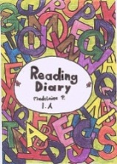
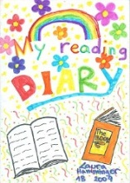
Reading Diaries

Reading diaries for young learners
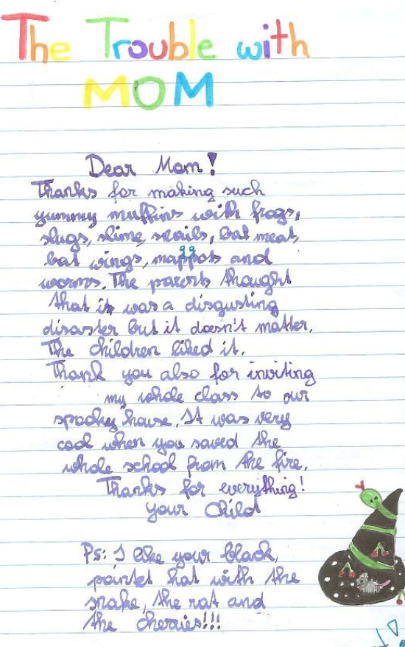

Tips for my first reading diary

For each book that you have read enter the following information:

Author:
Title of the book:
Your rating: (Tell us how you liked the book, give 1-5 stars for example)
A short summary: What happens in the story. Write 5-7 sentences
Personal Comment:
- My favorite character is ….. because…
- I don’t like (name of character) because...
- I wonder why ….
- I like/don’t like the ending, because…

Finding Feelings: Write 5 sentences.
How do the main characters feel in the book? Why?
How did the book make you feel? Why? (Choose from the faces below.)

Add a nice drawing if possible: Draw one item that plays an important role in the book.

Feelings:

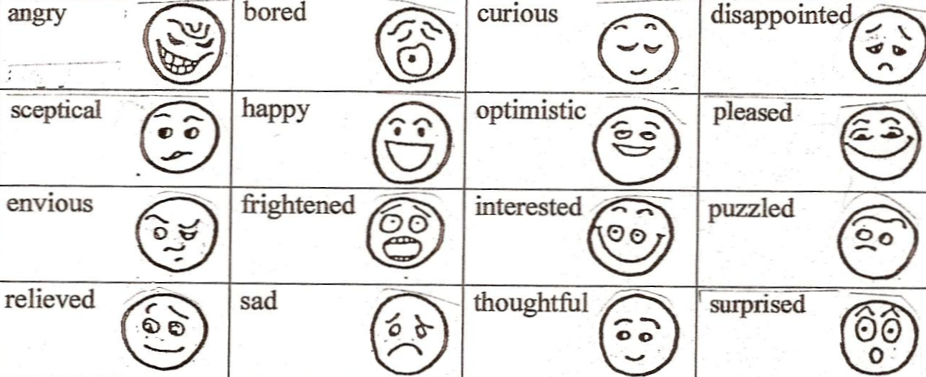

Reading Diaries: Sample pages, year 2

Letters
Twilight: The student is writing a letter to Bella: Year 3
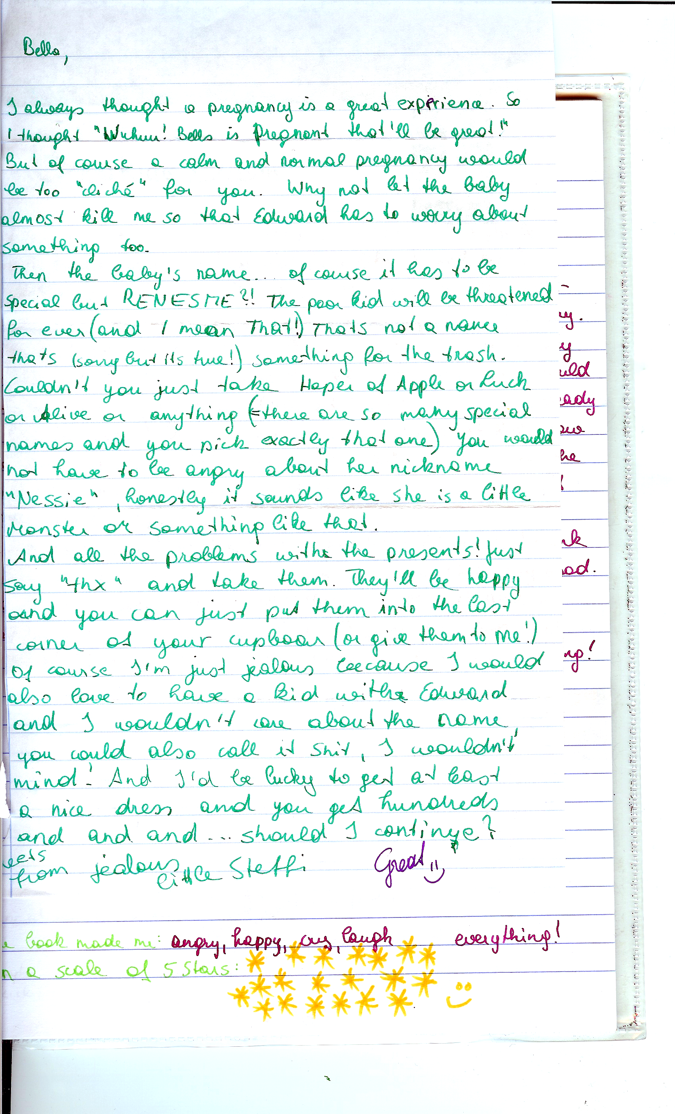

More Letters:
  - Letters to the author or a main character
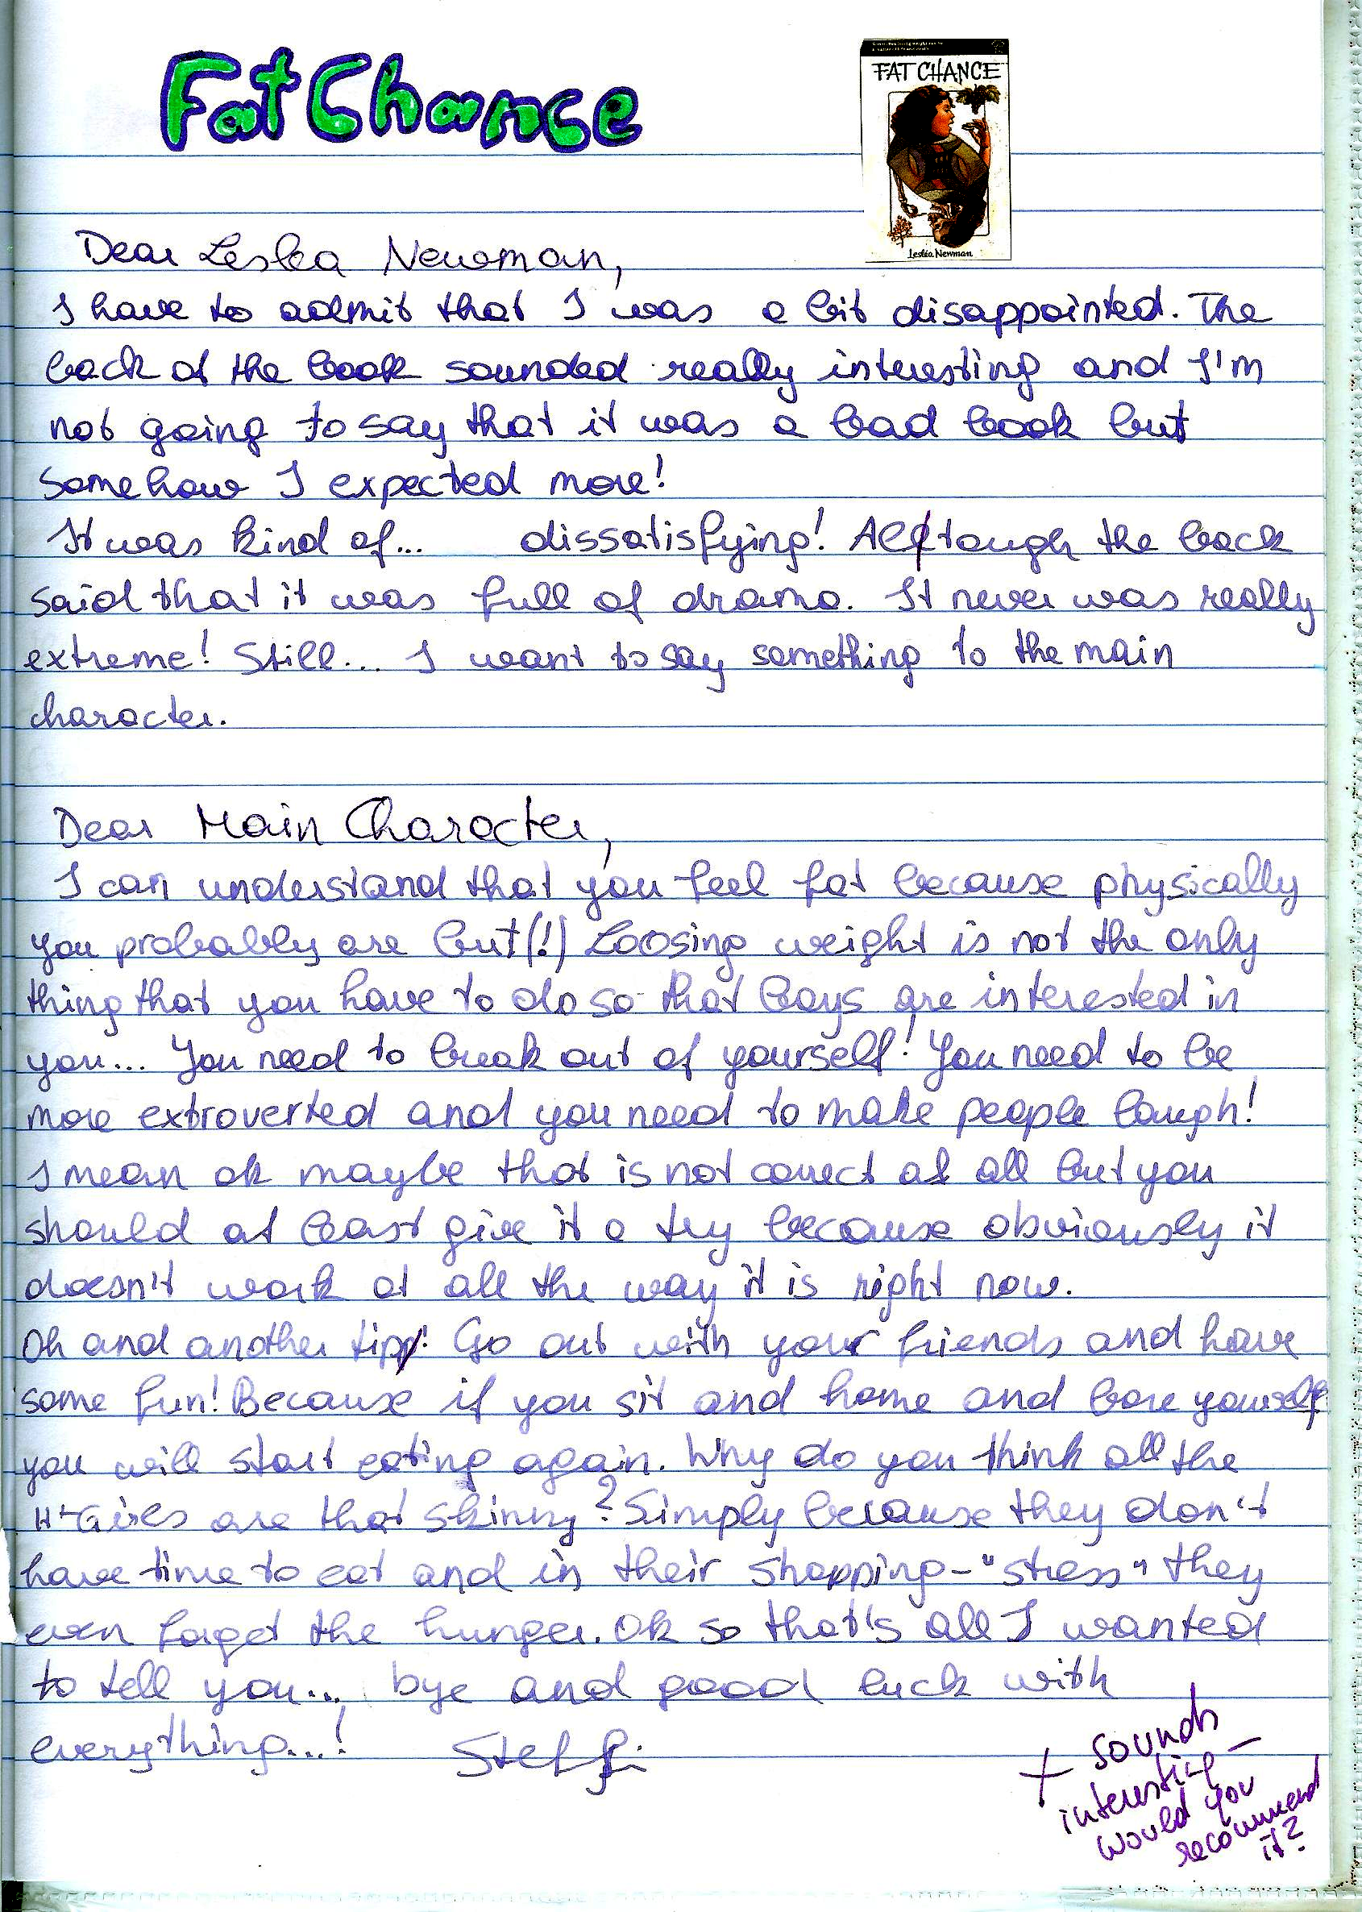

Creative Ideas
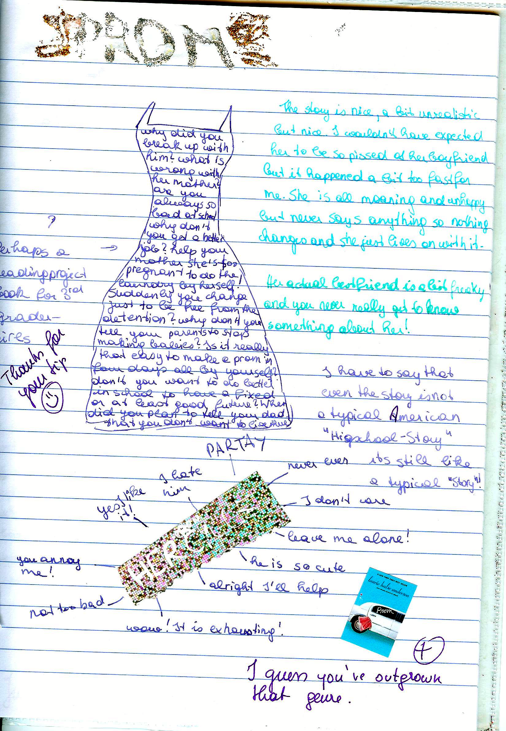

Tips for keeping a reading diary
Effective readers connect with, reflect on, and challenge the text. On your way to becoming such an effective reader use your response journal to try out some of the following tips and techniques.
Read slowly and carefully. Try to imagine the scenes as vividly as possible and try to see life through the main characters' eyes. After reading sit back and think about it for a while, then write a personal response.
Decide how much time you want to commit and stick with it (10 – 15 minutes!)
Write quickly, without worrying about spelling, punctuation, grammar…. Do not pause to think, just keep writing. As you write, follow your thoughts and ideas, do not worry about good organization and coherence. Just let your ideas flow.
Consider some of the following questions:
- Do you enjoy reading this novel or story? Why? Why not? What emotions does the book invoke: laughter, tears, smiles, anger? Record some of your reactions.
- Does the book or its characters remind you of any real life situations or people you know?
- Are the characters interesting and believable? Who is your favorite character? Why is he/she special to you? Is there a character you don't like at all? Why don't you like him/her? Would you like to be one of the characters (acquire a personality trait)? Which of the characters would you become, if you could? Why?
- What are your favorite lines/quotes? Copy them into your reading diary and explain why these passages caught your attention.
- Which are your favorite scenes in this novel? Explain why you enjoyed them.
- Make predictions: What do you think is going to happen next?
- Is the author able to hold your interest throughout the entire novel? How did he or she manage to do this? Or are you bored at times? What exactly makes the chapter/scene boring?
- Is there an idea in the book that makes you stop and think, or prompts questions? Identify the idea and explain your responses.
- Does the book leave you with questions you would like to ask? What are they? Would you like to direct your questions at a particular character? What questions would you like to ask the author of the book?
- Are you confused about what happened (or didn’t happen) in the book? What events or characters do you not understand? Does the use of language in the book confuse you?
- What changes, if any, would you have made in this novel?
- Are there any symbols, symbolic acts or names in the novel?
- Think of the main themes of the novel? What might the author be saying?
- Who else should read this book. Should anyone not be encouraged to read this book? Why?
- Would you like to read more books by this author? Have you already read other books by the author?

Types of Responses
Below you find a number of extracts typically found in response journals:
Affective responses are a kind of raw emotion or a ‘gut reaction’ you have after reading, such as anger, love, jealousy, indignation, contentment, sadness....
e.g.: I was furious when reading the Battle Royal scene. How can these people be so mean and treat a human being like that. I felt like stepping out and hitting them, or sceaming or I don’t know what. I was also shocked at how the main character didn’t even find it so terrible. (He doesn’t have a name! Maybe that has something to say as well, he is invisible and nameless???) He certainly didn’t like being treated like that and was frustrated but not as angry as I was. For him this seems to be quite normal. That makes me even more angry! I really hate these fat politicians, they are the worst hypocrites I have ever seen...
Associative Responses are analogies or associations you have when reading. There are no true and false associations, everyone has their own!!! Let your mind wander, relax (as described in the free-writing technique), this will open the doors for all your associations to flow in.
Look, for example, at the following response of a student to a line from a poem.
...“Something there is that doesn’t love a wall.”(line 1)
I remember when I was young and how I was always sent to my room for punishment of something I had done wrong. I hated being sent to my room, not in the beginning, of course, because I always thought I’d get even with my Mom and show her that I could have a lot of fun in there. As the hours went by, though, I usually ran out of things to do and therefore I would always try to think of a good story to tell sweet ole Dad abourt how mean Mom had been to me. I just hated those four blank walls; I guess that’s because I saw them so often.
or:
Little Richard’s behavior reminds me of this story I read in the newspaper last week. A little boy had played with matches and then hid in the closet because of his bad conscience and fear. Wow, that’s dangerous if little kids react like that. I guess it also has to do a lot with the fear of punishment. These kids must be hit a lot!
You might also note things that strike you as strange or just interesting such as for example this response to the beginning of the novel Song of Solomon by Tony Morrison.
It’s strange that so many characters have Biblical names: Pilate, Magdalena, First Corinthians, Mercy hospital.. (p18). What does this mean?
...
There seem to be a lot of symbols in the book: Watermark (p.11), Red velvet (p.10). I don’t know their meanings yet, maybe it’ll become clearer later.
Also note your impressions of the structure of the text. For example:
The author is constantly jumping back and forth in the lives of the characters. Slowly their history is becoming clear. It’s sometimes difficult to follow. I have to read a page or two until I realize who she is dealing with now! I wonder why she does this!
...
It’s getting worse. I am getting angry with T. Morrison. I feel she is teasing me! Why can’t she just organize her material bxetter? There must be some artistic reason or is it just to be different from the others???
Most of the time your response will be a mixture of all of these approaches. Even the examples above usually include more than just one aspect. Don’t let yourself be stiffled by trying to stick to one aspect. Just let your ideas flow! Don’t forget to write down page numbers, so you can later find exact quotes if you need them.
More examples of reading diary entries

(years 6-7) These examples are unedited, quick responses copied from the learners’ online journals on Moodle.
“The Euphio Question”– Kurt Vonnegut
The first thing I have to mention after having read „The Euphio Question“ is, that I absolutely loved the ending, probably because it was both surprising, and also funny in a way.
The story mildly reminds me of the first one we read. (Top of the food chain/T.C. Boyle) In both stories someone testifies before a commission, telling what has happened, but this story had the “action” or “plot” that I missed in Boyle’s. Although it is, on the second look unrealistic that someone would tell a story in this way before a commission (with all the dialogues and no interaction until the very end with its members), these dialogues etc. make the story easy/fun to read.
One thing I don’t quite understand is how to imagine this feeling you get when listening to the fictional device. At some parts the speaker (sociology professor) describes it as some sort of euphoria and buoyancy, while the people exposed to the sound rather seem relaxed and lazy to me.
Another thing that I didn’t like was the way Vonnegut depicted the wives of Eddie and the narrator: both husbands seem to be used to having a dinner before them when they get home. Maybe that was normal at the time the story was written, but still I can’t help frowning on this type depiction of a wife.
When you have a closer look you can spot some few small details that are a little illogical (for example how does Fred know that the time, when the “whole town went nuts”, “checks” to the second with the time when they switched on the device?) Although I know very well that there might be an explanation for these small details that I didn’t think of yet and that they are completely irrelevant for the plot of the story, I still like it, when everything is logical and makes perfect sense. (In the book I read (also written by Vonnegut) I noticed many and clearer examples of these small things that apparently didn’t fit together, especially with Billy Pilgrim’s time travels.)
I wonder what Kurt Vonnegut wanted to criticize with this short story (as he always does criticize something, that’s for sure). Maybe the fact that people try to make money out of everything possible, without paying attention to who is harmed? It is clear that he wants to say that you shouldn’t want to “buy” happiness, but still I don’t see how buying happiness (through purchasing possession for example) can be dangerous, which is his first argument (I think). This doesn’t mean that I don’t agree with the basic idea, that it is somehow pathetic how we try to become happy.
For me a good story must be/have two things: First of all a message, something to think about, or at least an entertaining story and secondly it must be written in a way that is exciting/funny etc. For me this story fulfills both requirements. (If a story is excellent on one of these two points only, the story can be great too, but if it’s merely “good” in one and mediocre in the other, I tend to forget these stories very fast.)
By Agnes V.

Three reflections on “And Our Flag Was Still There” by Barbara Kingsolver

Paula M.
The story is about a woman talking about patriotism because her daughter has to wear red white and blue to kindergarten for a day to remember the victims of 9/11. I really liked the story because the woman,although she is american herself, critizices the overdoing of patriotism in America. She talks about extreme cases where americans get really racist towars other people just out of " loyalty to their country". I think it is a nice story because she is not really blaming anyone she is just saying that there are a lot of people overdoing it and in the end she says that the meaning of her flag is that " we´re all just people together" and I think that is a really nice way of seeing it.

Paula N:
First of all, I want to point out how much this story touched me. I actually cried a little. I cried because everything in this story seems so true to me and it's very tragic to me how certain people deal with horrible events like September 11, how they blame other innocent people simply because they might have the same religion as the ones who flew into the building, how they make important rights, that courageous people gave their lives for years, seem stupid and not necessary. But I also cried because this story gave me hope that there are people like Mrs. Kingsolver who keep their heart free from hate and blaming minorities, and who believe in the Constitution and everything that came with it and not only for white Americans but for all Americans, whether they or their grandparents immigrated or what beliefs or sexuality they have. I will suggest this story to friends and family because in my opinion this story forces you to think about the often dark truth of so-called "necessary wars for peace and freedom" but also gives you hope that there are people who want this peace and freedom peacefully and for everyone.

Johannes W.
Well, a perfect style, an interesting and well-chosen topic and an optimistic message doesn't leave so much room for associations. But still one question came to my mind immediately: "What type of text is this?" To me it is neither a short-story, nor a speech, a report or an article. It is somehow a mixture of all, isn't it? Since I am a European and actually have never left the continent actually so far, this theme of finding one country's or even one peoples values, identity and community is something rather unknown, odd, funny to me. Of course this is linked to History, I'm perfectly aware of that, but it is somehow weired but at the same time amusing to read. I liked reading it also for the nice style and the well chosen tone and language. I wasn't used to the absence of an actual plot (just the little side-track of her daughter) and also the absence of an actual description of characters, etc. But that again was creating a certain tension because I wanted to know more... I guess this was the very intention of the good and talented author and actually now, at this very moment, it comes to my mind: In my opinion this is an inner monologue... :-)
Reflections on: Paul Auster, a story from The Red Notebook

Love it! Awesome! Simply great! I cannot remember the title anymore but I had the story about a man who survived a concentration camp, while being there fell in love with a woman he had never seen before; they just wrote letters. After all, they married got children and raised them. When the oldest son was studying already, he fell in love with a girl that turns out to be the daughter of the SS officer. Nevertheless both fathers like each-other, they (their children) marry and the family leads a rich, good life.
There are three reasons why I like that story:
1.) I love the style, the language, the tone and THE LENGTH. This is one of the few short stories that really are short. But the quality is on the top and I did not at all have the feeling that I wasted time. Everything important is in, everything that is not necessary and just makes you lose time is not there - this is what I call real expertise.
2.) It is one of the so much wanted, yet so little available stories about the WWII times that is not depressing, full of pain, suffering and "victimism", trying to teach one a lesson, trying to convince one of one certain aspect or making you feel guilty of something others haven't even done... You know all of that horrifying elements are just not there, which -- for a change -- is really relaxing.
3.) This is a real story! I find it simply great to take true tales based on life and to make a novel/story/whatever out of it... And the fact that he -- the author -- had done it in such a good way is also wonderful. You see, I find that short story marvelous, perfectly enjoyable and great to read. I have hardly ever said that a very sheet of paper (that I even got in school) was an experience -- but this single page was one!
There isn't much more to say, for me; I found that an enrichment, something like a little treasure within my long course of educational existence. Thank you for that story.
By Johannes W.

Reflections on “Top of the Food Chain” by T.C. Boyle

I can't believe that the main character, who is talking to the Senator, is so indifferent to all the animals and at last people dying. It's like he doesn't care at all as long as he can say that he fulfilled his job which was to help the people to get rid of the mosquitoes. It was also unbelievable how arrogant he was and how bad he talked about the people in Borneo and how low he apparently thought about them. If he was as much smarter than the people there, I don't understand how he didn't use his wisdom to help the people instead of making everything worse for them. If he at least had been sorry I could maybe find sympathy for him but like this he just makes me want to punch him. I really would have liked to know what the Senator, he was talking to, thought about all that.
By Paula N.

Reflections on the novel Girl with a Pearl Earring
Even though it is not told sadly, to me the story was very sad. It is beautifully told, but it's depressing that Griet doesn't have even one person that she can confide in, and I don't think that anyone would be able to hide their emotions like she does. She's so shy, and sometimes i wanted her to say something or do something, for example when the friend of Johannes Vermeer comes and tries to rape her, but she just pushes him away slightly. Of course, as a maid you can't always speak your opinion, but she has to stand up for herself a little bit, at least in my opinion.
The language was beautiful. I don't know how Tracy Chevalier does it, but she never tells the emotions of anyone, but you still know exactly how they are feeling. I would have liked to have more emotions when her sister had the plague, that was the only time it was overdone in my opinion. I liked that there was not a cheesy ending, but a very realistic one that was not satisfying to Griet, but she could settle with it. As a reader, it kind of felt the same.
By Anna E.

Reflections on “ Magdalena Looking” by Tracy Chevalier

Oh my! There is so much conflict in that simple short story. First of all the women-role problem, ignorance in general, the longing for some acknowledgement, personal needs and poorness all the same.

I felt sorry for that poor little girl, Magdalena. The common theme of a talented daughter of a skilled father who is just not being noticed by him because of gender role and circumstances in which they live in is sad. You want to help them all out of their silly, maybe unnecessary but surely disappointing situation, because you see the escape -- they cannot, maybe should not.
How annoying must it be for a daughter to have a father who hardly ever looks at her, doesn't notice her, while she admires him and wants to be taught by him -- she never paints but a dot. Her abjection is typical for that miserable situation she finds herself in and the ignorance of her father, the unwanted humiliation by her father (looking at her to paint her, giving her the jewelry because of light-reflexion and not beauty) and the final uselessness of all that problematic life does cause the reader pain.
Another aspect is the actual picture that truly exists. Nobody really knows that young woman, yet she is still there, drawn in a fine way, looking very extraordinary, yet familiar. Strange and unfamiliar but at the same time interestingly pretty. I like the way the author has put a whole story around that picture, embedding the little details and relating them with an own anecdote or well explained reason. Nothing happens accidentally -- there is reason behind -- we just cannot see it most of the time. In this story we can, because she wants us to and it works. I like the atmosphere, the jigsaw-puzzle-like coming together of everything and the so very true outlook of great connection, the overall sense -- the living moment for eternity...
By Johannes W.

Now try out FREE WRITING yourself.
Read the four poems and choose one that you find interesting. Do not choose a poem that you have known and worked on before. Write down your thoughts and associations without stopping to think. Do not take your pen off the paper, just keep writing for ten minutes.
Barbie Doll
This girlchild was born as usual
and presented dolls that did pee-pee
and miniature GE stoves and irons
and wee lipsticks the color of cherry candy.
Then in the magic of puberty, a classmate said:
You have a great big nose and fat legs.
She was healthy, tested intelligent,
possessed strong arms and back,
abundant sexual drive and manual dexterity.
She went to and fro apologizing.
Everyone saw a fat nose on thick legs.
She was advised to play coy,
exhorted to come on hearty,
exercise, diet, smile and wheedle.
Her good nature wore out
like a fan belt.
So she cut off her nose and her legs
and offered them up.
In the casket displayed on satin she lay
with the undertaker's cosmetics painted on,
a turned-up putty nose,
dressed in a pink and white nightie.
Doesn't she look pretty? everyone said.
Consummation at last.
To every woman a happy ending.
Marge Piercy

Harlem
What happens to a dream deferred?
Does it dry up
like a raisin in the sun?
Or fester like a sore--
And then run?
Does it stink like rotten meat?
Or crust and sugar over--
like a syrupy sweet?
Maybe it just sags
like a heavy load.
Or does it explode?
Langston Hughes

Incident
Once riding in old Baltimore,
Heart-filled, head-filled with glee;
I saw a Baltimorean
Keep looking straight at me.
Now I was eight and very small,
And he was no whit bigger,
And so I smiled, but he poked out
His tongue, and called me, "****."
I saw the whole of Baltimore
From May until December;
Of all the things that happened there
That's all that I remember.
Countee Cullen.

News Item
Men seldom make passes
At girls who wear glasses.
Dorothy Parker

Character Profiles
Character Profiles

Download the full-size template from epep.at
Choose one interesting main character in the book/story you are reading and take a closer look at his/her personality. Who is he/she really? Look at the different levels of their personalities, starting with the environment (setting) they live in and move in towards their spiritual centers. Draw a circle diagram like the one on this page and write a few keywords or sentences into each layer of the character's personality.
Slip into the character's mind and consider the following questions:

Environment: Where does your character live/work? What is this place like? How does it affect him/her? Who else is there? How do these other people influence him/her? How does your character get along with them?
Behavior: What does your character do? List a few important or typical actions or activities of your character
Capability: What is your character good at? What strategies does he/she use in the story? Does he/she use them openly and consciously? What skills does he/she have?
Beliefs: What are your character’s basic beliefs? Think of the various ideas that he/she thinks are true, and that your character uses as a basis of daily action. Beliefs can be both permissions and limitations. (e.g.: "I am strong! The positive forces will always win!" or "I am afraid of my stronger enemy, he will certainly kill me." or "I don't do this or that because I think it's wrong.)
Identity: What are your character’s core values and his/her mission in life? What does your character want to achieve?
Spiritual: This is the deepest level of any character or person. Here we consider such metaphysical questions as "Why are we here? What is our purpose?" These questions are hardly ever asked or answered openly. Try to slip into your character's mind and answer these questions for him/her. What would he/she say?
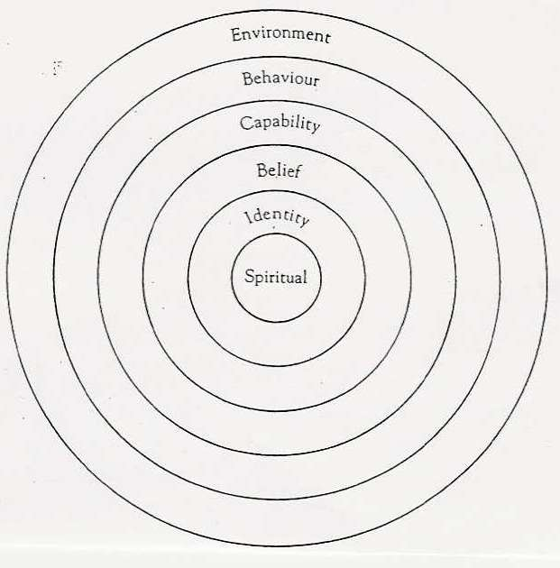
Title of Book/Story ...............................................
Author: ...............................................
Character's name: ...............................................

Now do a character profile for one of the main characters in your book.

Teaching Activities for Advanced Literary Texts
  - Working with Short stories

In order to help learners understand and appreciate literary texts they need some guidance in the form of pre- while- and post-reading tasks. Have a look at the example on the following example of a short reading unit based on a short story.

Consider the following issues:
- Is your text appropriate for the age group (language, content)
- What are your purpose and learning objectives (introducing a book, a topic, … language…)
- How can you catch the learners’ interest (pre-reading task)
- How can you ensure that the learners will be doing most of the work (rather than you explaining the text to them)?
- How can you integrate different skills and activity types, group and individual work…
The original student handout was larger to give the learners more space for their answers.

The Humbugs, by Kurt Vonnegut
  - Brainstorming:
Make a large Venn diagram on an A4 page and enter your ideas about ART and HUMBUG. What is art for you? Where are the limits of art? What is the purpose of art? How do you recognize a painting is “art” or “humbug”?
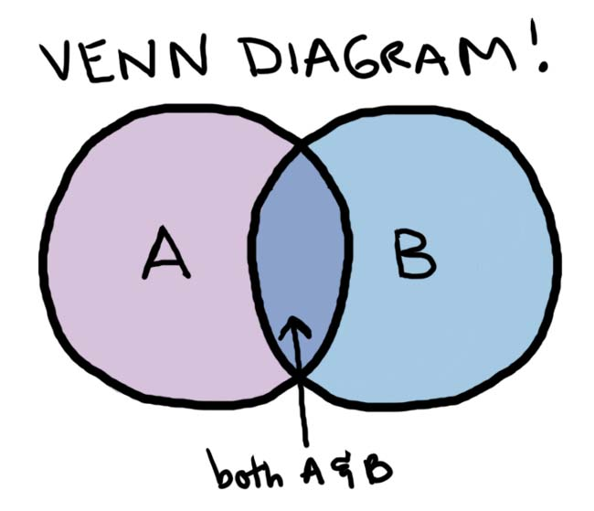
Humbug
ART

What’s in a name? Who might these characters be? What do the names tell you about the men?
Durling Stedman:

John Lazarro:

Read the first part of the story. While reading highlight any references to art and artists. Use two colors for Stedman’s and Lazarro’s art.

Sketch the two paintings and describe them


The artists: What do we know about the two artists?

Durling Stedman | John Lazarro

Continue the story: Read the story as far as p. 243.
Group A: Watch Durling Stedman painting “with soul” for a change. Describe exactly what you see him doing. Look for details that show how he feels about what he is doing. Continue the story and try to stay in the same style.
Group B: Watch John Lazarro painting a picture “of something that really looks like something”. Describe exactly what you see him doing. Look for details that show how he feels about what he is doing. Continue the story and try to stay in the same style.
Write about half a page (typed and upload your text to moodle.
Then read the rest of the story and compare it to your own version.

The two paintings:
What is special about these paintings? What do the two paintings show about the artists’ characters?

Vocabulary
The author has used lots of good collocations in the story.
Examples: to meet a payroll, a thunderstruck woman , affectionate, bewildered housewives
Look up the main words in COCA and find at least one additional usage example for each one.
Then collect 10 more collocations from the story and look up the main words in COCA. Find one or two examples how to use them and write all the new phrases into your vocab book.

Planning and Organizing Reading Projects
It is cool.
I like reading

Remember this:
Look at this!
I am proud of my work.
I can choose my own book.

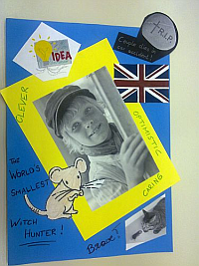

When planning a reading project for your class, consider the following aspects:
- Find suitable books: language level, different tastes and interests, season, class topic
- Book choosing: introduce the books in interesting ways (see “How to wet my students’ interest”, offer a choice for boys, girls, readoholics and reluctant readers.
- Book ordering: time, availability, price
- Pre-reading and warm-up activities: the first chapter is the most important one. If students understand who is who and what is going on, if they can relate to the characters’ dilemmas, they will want to read on. Plan some interesting opening activities to set the scene. Allow the class to read quietly for 30min or more to get into their books. Students who are reading the same book can help one another with comprehension questions. Walk around and help them get into the stories.
- Plan reading time: check other class projects (books they read in German, important test dates…) and decide on a deadline that is not too far away.
- While reading: do not give students too many while reading tasks. Such tasks are helpful if they guide the readers’ focus a bit or if they are asked to collect a few useful phrases from their reading. Don’t overdo it – too many tasks will kill the reading experience.
- Post-reading tasks: Groups meet and share their views, ideas and questions. Most reading projects will lead to some kind of PRODUCT (written or oral) such as
  - Booklets (pedagogy of the blank sheet)
  - Tasks to be completed in the reading diaries
  - Presentations in class or online
Whenever possible give students some choice concerning suitable forms of writing or presenting. Decide on a common FORMAT (e.g. design a booklet… or prepare an online presentation using MyBrainshark.com…) but allow freedom within that frame. Students will be more creative if they feel in charge.
  - Examples
The following pages show a few examples of tasks that can be used in reading projects. For more ideas visit epep.at. There you can also download a variety of handouts and project packages for your students.

A mini project for one double lesson
Note: in this project students were allowed to read ANY book they wanted to read. Therefore no groups could be formed.
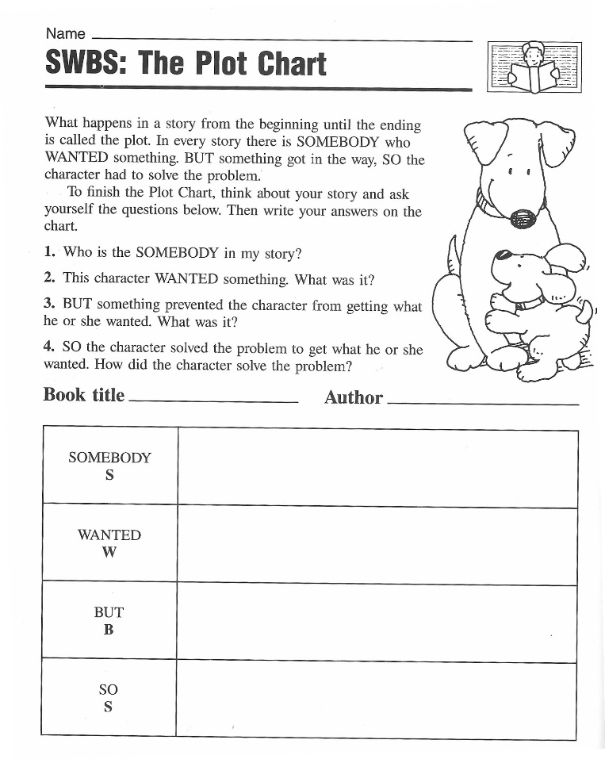

- SWBS: The Plot Chart

(Boardman Moen 1992)

2.Sum It Up
Make a sum-it-up card for your book. Fill in the blanks below.
Title:.............................................................  Author:.........................................................  Three important facts:  1.  2.  3. | Write a summary that tells the main idea.  Summary:  ........................................................................  ........................................................................  ........................................................................  ........................................................................  ........................................................................  ........................................................................  ........................................................................  ........................................................................

3.Book-Fair:
Walk around and read all the posted SWBS and SumItUp sheets. Find 3 books that have something in common with your own.

4.Grouping Books Together

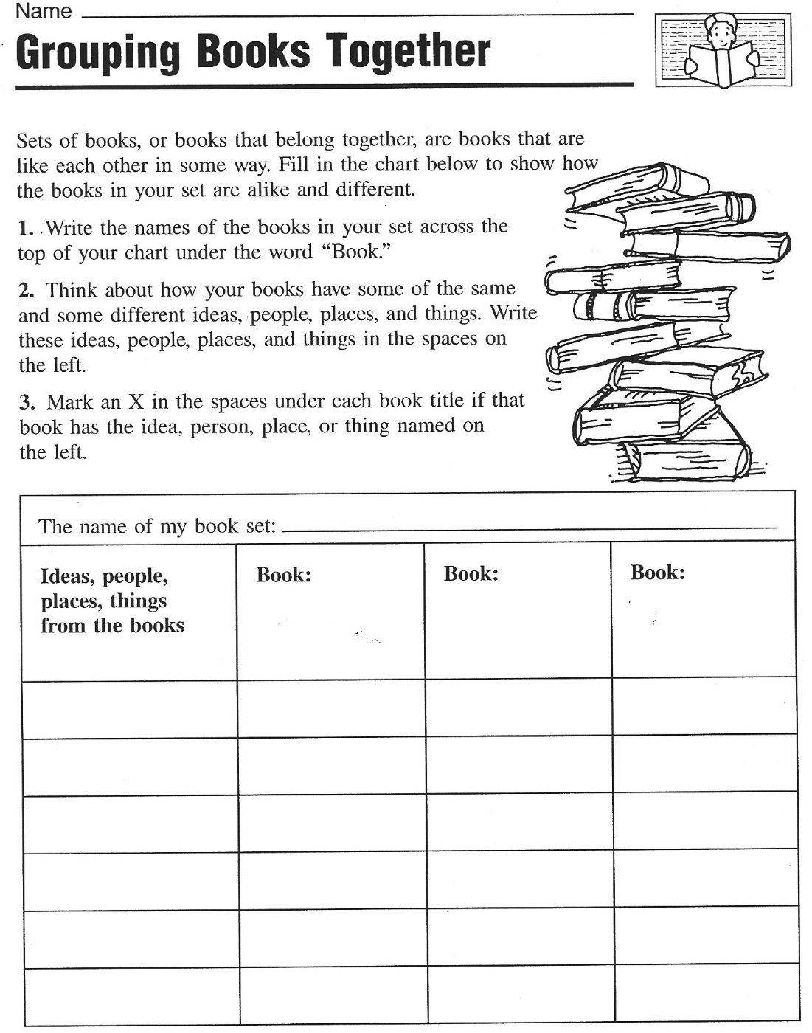
(Boardman Moen 1992)
5.Creative Catalogues: Design three A5 catalogue pages.

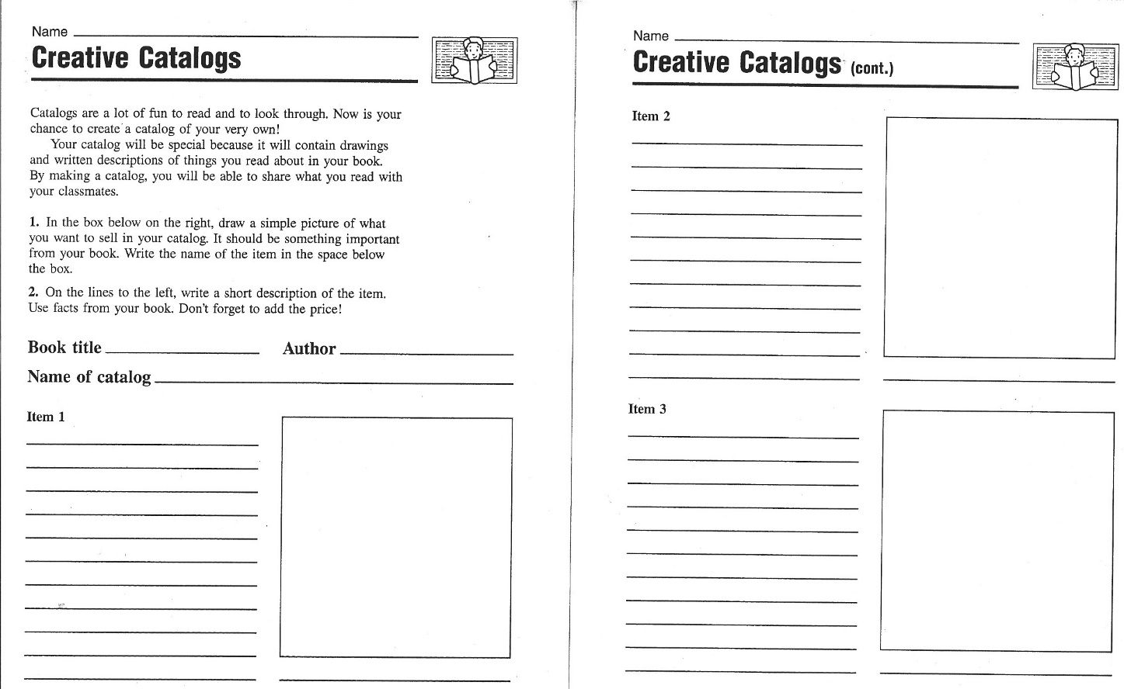
(Boardman Moen 1992)

6. Vocabulary Quilt
Choose one of your favorite new expressions from your book and write it on a piece of colored paper. Write a short, typical sentence and decorate the paper in a suitable way. Your paper must include:
- the new word written in big letters
- a typical sentence
- a drawing that will help you remember the new phrase.
We will put all our word cards together to make a Vocabulary Quilt. Please design your cards nicely.
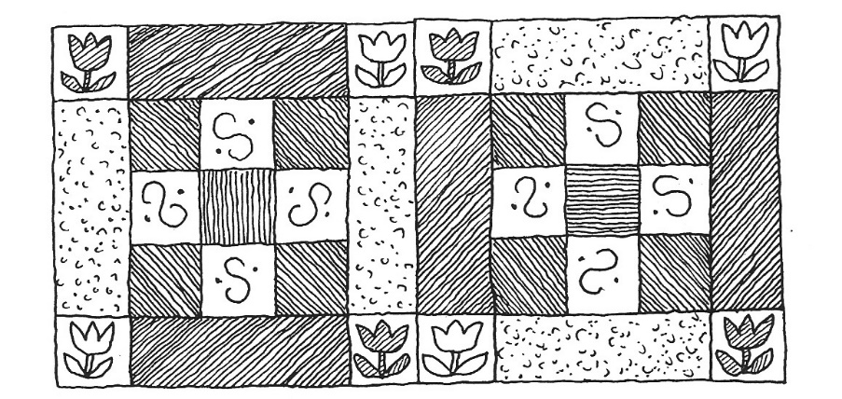

Book sharing

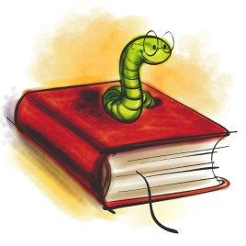
Prepare the following things for the book you have read:
5 nouns (things, objects…) | Choose 5 things that play an important role in your book and write them on the cards provided. (Example: broom, hour glass, magic potion, train, … for a Harry Potter book)
Big trouble | Choose a passage in your book where one of the main characters is in trouble, has a problem or is very sad. Practice reading this passage so you can later read it out to your group.
Happy moments | Choose a passage in your book where one of the main characters is happy. Practice reading the passage.
Important adjectives | Find three adjectives in your book that are somehow important for the story. Choose new and interesting adjectives – not words we all know. Copy the adjective on a card and write the sentence you found in the book on the BACK of the card.

Group Phase
Work in groups of 4 with classmates who have read books you do not know yet.
Guess what… | Show your noun cards and adjective cards to your friends and have them guess what the book might be about.  Ask lots of questions about your friends’ books and try to find out as much as possible about the main characters, their problems, their wishes and hopes.  Do not give away the endings and solutions of your book.
Big trouble and  Happy moments | Read the passages that you have chosen to your friends and explain why your characters feel so happy or so sad.
Important adjectives | Put all the adjective cards on the desk (only show the adjectives, not the sentences)  Copy all the adjectives on the back of this sheet and guess what the words might mean. Discuss your ideas in the group.  Then turn over the cards and look at the sentences. How can these sentences help you guess the correct meaning of the adjectives?  Now ask the students who have written the cards to explain the meaning of the word and record it in the table.
Homework | Copy the new adjectives and sentences on vocab cards and add a second sentence where you use the new adjective in a TRUE sentence.

This is what your vocab cards should look like:
Use ONE card for ONE vocab item.
Word: | Dreadful
Sentence from the book: | Their dreadful voices sounded like dentists’ drills all grinding away together.
My true sentence: | My neighbor Rosalinde has a dreadful, whiny voice.
On the back write a translation of the main parts of the sentences. Example:
Ihre schrecklichen Stimmen klangen wie Zahnarzt Bohrer…
Rosalinde hat eine schreckliche, weinerliche Stimme.
Adjective | Sentence from the book:
1
2
3
4
5
6
7
8
9
10
11
12

Reading Project
1. Choosing a book:
Look at all the books in the selection. Read the blurb (back cover) and then read the first two or three pages of each book. How many unknown words are there on each page? Can you guess the meanings? What else do you notice about the book?
- What kind of book do you think this will be? Do you think it will be science fiction, fantasy, realistic fiction, historical fiction, mystery, a crime story?
- What do you think the plot will be about? Make a one-sentence prediction for each book.
- What kinds of characters do you expect to meet in each book?
- What will the settings be like?
Write your findings in the table on the next page.

Which of the books would you like to read? Award 1 – 3 stars to the books, depending how interesting they look. Mark the stars in the first column. Then decide which book you would like to read. Write down your fist, second and third choices on a sheet of paper and stick your paper up on the book poster under the title of your first choice. As far as possible you will be given your first choice.

2. Getting ready for the book: Making predictions
While you wait for your chosen book to arrive imagine what might happen in your book. We will try a 10-minute free-writing activity in class. Write down what you expect from the book. Use the following expressions and the "will" future. Use your reading diary for all the tasks.

I hope that......
I wonder if ....
I bet that... .... will ...
I'm afraid that...
I (don't) think that...

3. The books have arrived!!! Let's start reading
Get together with your friends who have chosen the same book (3-4 students). Read quietly for 20 minutes. Read slowly and imagine the scenes and characters as vividly as possible. After 20 minutes meet to discuss your reading. Distribute the task cards in your group. Each of you is responsible for a different task. Read your task card carefully, then guide your group through the activity. Write all the questions and answers into your reading diary.

4. Homework:
Read chapters ........................................ by ...........................................................
Read slowly and carefully and mark any interesting passages in your text. Choose 3 phrases or expressions that you would like to remember and write them on vocab. cards. Then write a five minute entry (non-stop writing) into your reading diary.
Book title and | New words per page | Other comments about the book:
Type of book:
Plot prediction:

Characters:
Settings:
Type of book:
Plot prediction:

Characters:
Settings:
Type of book:
Plot prediction:

Characters:
Settings:
Type of book:
Plot prediction:

Characters:
Settings:
Type of book:
Plot prediction:

Characters:
Settings:
Type of book:
Plot prediction:

Characters:
Settings:
Task 1: Language Police  English please!!!  In this activity you are responsible for reminding your group to speak only English. Whenever you catch somebody using German show them this card. |  |  | Task 3: Character Detective  List all the characters that you have met so far. What do you know about them? Who are they? What is their role in the story? What mood are they in? Do you like/dislike them? Do you trust/mistrust them?
Task 2: New Expressions Expert  Ask each of your friends to find one new phrase or expression that they would like to remember. Highlight these phrases in your book and write them on vocab. cards. |  |  | Task 4: Where and When?  Where and when does your story play? Find a passage in your text where the setting (place and time) is described. Highlight it and copy a few important details into your reading diary.
Task 5: Asking questions

Ask each of your friends to write down one question that they have in mind now. What is it they would like to know about the book?
Share your questions and write them into your reading diary. Maybe you can answer them later or ask your teacher.

5. Reading Circle Activities

- Get together in your reading group and decide who is going to be the Language Police and Group Leader today? Remind your friends to use English only in their discussions and to stay on track ( = not digress from the topic). In case of disagreements make sure that your friends argue their point politely.

- Sharing Reading Diaries: Read each others' reading diaries and discuss your reactions to the story.

- Work with the small Discussion Prompt Cards (Robb 2000). Sort the cards by color and put the piles face down on your desk. Take a card from the top of a pile and read it out to your classmates. If the card doesn't apply to your book at all, put it back and take a new one. Do the task carefully in your group. Write all your answers into your reading diary. When you have completed a task, take a new card from a different pile. Take turns reading the tasks out and leading the discussion. Do as many tasks as you can but do them carefully and thoroughly.

- Workshop and Homework Tasks: On the following pages you will find 13 tasks. You have one double period in class to do them. You may work alone or in a small group. Do the other activities at home. Write all your answers into your reading diary. Always write clear headings (number and name of activity).

- Reading on: Read chapter(s) ........................................... by .......................................... and write a 5-minute non-stop entry into your reading diary.

- Vocabulary Work: Collect good phrases and write 20 new vocab cards for the whole book. Hand them in with your reading diary.

Useful materials and ideas for book groups

Find more ideas on epep.at

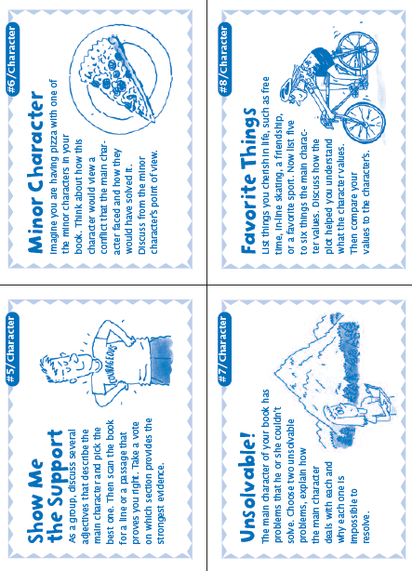
50 Fabulous Discussion Prompt Cards: (Robb 2000)
Can be used again and again. For lower intermediate speakers you might want to adapt the language a bit.

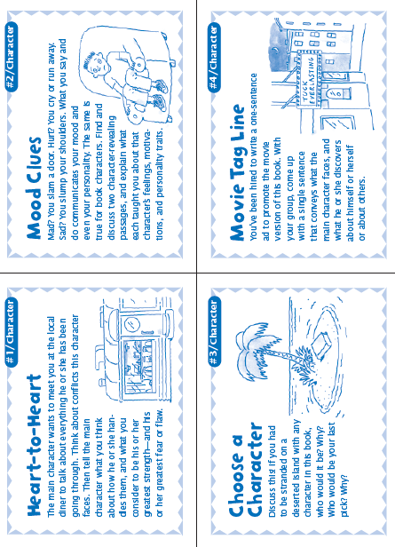
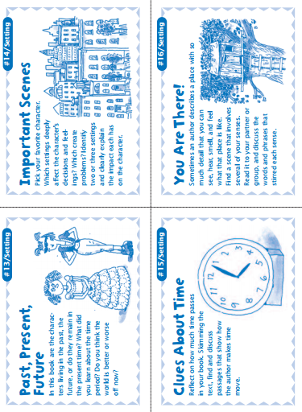

Booklets for all ages
  - The pedagogy of the blank sheet
These booklets are my favorite projects. The idea is based on Hannelore and Helmut Zehnpfennig’s concept of the “Didaktik des weißen Blatts” (see below). This idea can be used at all levels, from beginners to advanced learners. The results are always stunning and much more interesting than answers to teacher-created questions and tasks. They really show how students have understood a novel or a topic in general.
Didaktik des Weißen Blattes
Hannelore Zehnpfennig (Grundschullehrerin) - Helmut Zehnpfennig (Soziologe)
Im Offenen Unterricht von Hannelore Zehnpfennig werden alle Fächer zum freien
Arbeiten angeboten. Ausnahme: Sport, Musik, Religion und Kunst. Die herkömmliche
Zeit-, Raum- und Stoffstruktur wird aufgelöst. Das heißt: Raum ist individuell nutzbar,
Zeit ist individuell nutzbar für die Fächer, Stoff wird selbständig ausgesucht
Didaktik des Weißen Blattes
Der Sitzkreis zu Beginn und am Ende des Unterrichts ist freiwillig. Zehnpfenning wählt den
Weg der drastischen Einschränkung des Materials. Sie fordert eine kleine Handbibliothek
mit Nachschlagewerken und Fachbüchern zu vielen Themen, Schulbücher sind nicht
dabei. Sie können höchstens als Angebot in der Klasse aufliegen. Heute ist auch der PC
wichtige Infoquelle.
„Unser wichtigstes Arbeitsmaterial ist das weiße Blatt Papier, unseres Erachtens das
kreativste Material, das es gibt. Es stellt "wahrscheinlich die größte Herausforderung
an die Imagination der Kinder dar" stellt Peschel (1996, S.38) fest, nachdem er unsere
"Pädagogik des weißen Blattes" kennengelernt hatte. Das leere Blatt fordert oder
provoziert geradezu die kindliche Phantasie es zu füllen. Wie, das sagt ihm weder das
leere Blatt, noch sagen wir´s. Das Kind muss selber entscheiden und gestalten. Ein
Arbeitsergebnis ist zu dokumentieren, ein Sachthema zusammengefasst
darzustellen, um in ein gemeinsames Buch zu kommen. Welche Informationsquellen
benutzt werden und wie, überlassen wir vollständig dem Kind. (Zehnpfennig/Zehnpfennig
1992)“
Für die Eigenproduktion von Arbeitsblättern spricht ein gewichtiger Grund:
„Selbsterstellte Arbeitsblätter sind immer auch aktive, individuelle und 'originelle'
Lösungen von Problemen" (Zehnpfennig/ Zehnpfennig 1995c, S. 7). Und darauf legt
Zehnpfennig in ihrem Offenen Unterricht viel mehr Wert als auf die noch so korrekte
Ausfüllung eines vorgegebenen Arbeitsblatts. Weniger wichtig ist uns, ob Arbeitsblätter
ästhetisch oder didaktisch perfekt sind. Wichtig ist vor allem, dass sie von den
Kindern selbst und für andere verständlich sind. Diese Fülle an Arbeitsblättern wird
dann thematisch zu "Büchern" versammelt, wie z.B.: "Kniffelbücher" (Mathematik) oder
"Rumänien" (fächerübergreifend) und präsentiert.
gop
http://www.zeugner.at/files/nachlese/010909/Go_OffUnt_Didaktik_des_weissen_Blattes.pdf
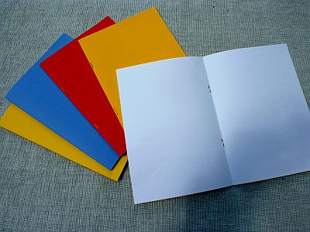
The preparations and instructions are VERY simple:
Step one: Each student receives a blank booklet consisting of 3 white A4 sheets folded and stapled together like an A5 booklet. I usually use a colored sheet on the outside but this is not really necessary. In some cases I copy the title page of their book on the cover to get them started. You’ll need a long-arm stapler to produce these booklets.
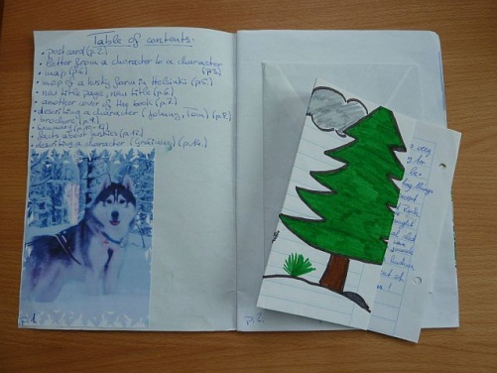
Step two: Ask the learners to fill the booklet with anything that shows their understanding and reaction to the book they have read.
Do a short brainstorming with the class what this might mean. Students come up with many of the ideas they know from their reading diaries and presentations such as:
- Letters or postcards (from the point of view of the characters or to one of the characters), Maps showing the settings of the story,
- Travel brochures advertising the places,
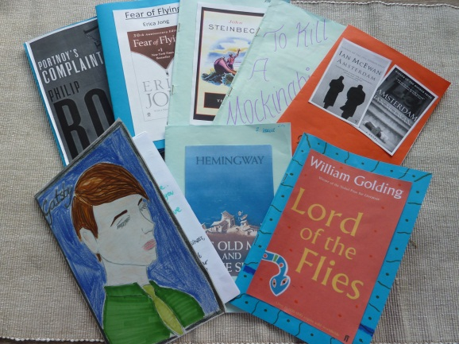
- Diary pages,
- Sociograms,
- Plot diagrams,
- Reviews for Amazon etc.
- Newspaper articles
- Creating their own title page …

Step three: When the booklets are finished the students meet in their groups and share their products. This step can be very interesting and learners see different interpretations of the task and different reactions to the books.

Step four: Optional
Sometimes, if there is not enough time for a round of book presentations ask students to meet with 3 classmates who have read different books and find the similarities and differences of their novels.

Sample pages from my students’ booklets

Letters and Postcards
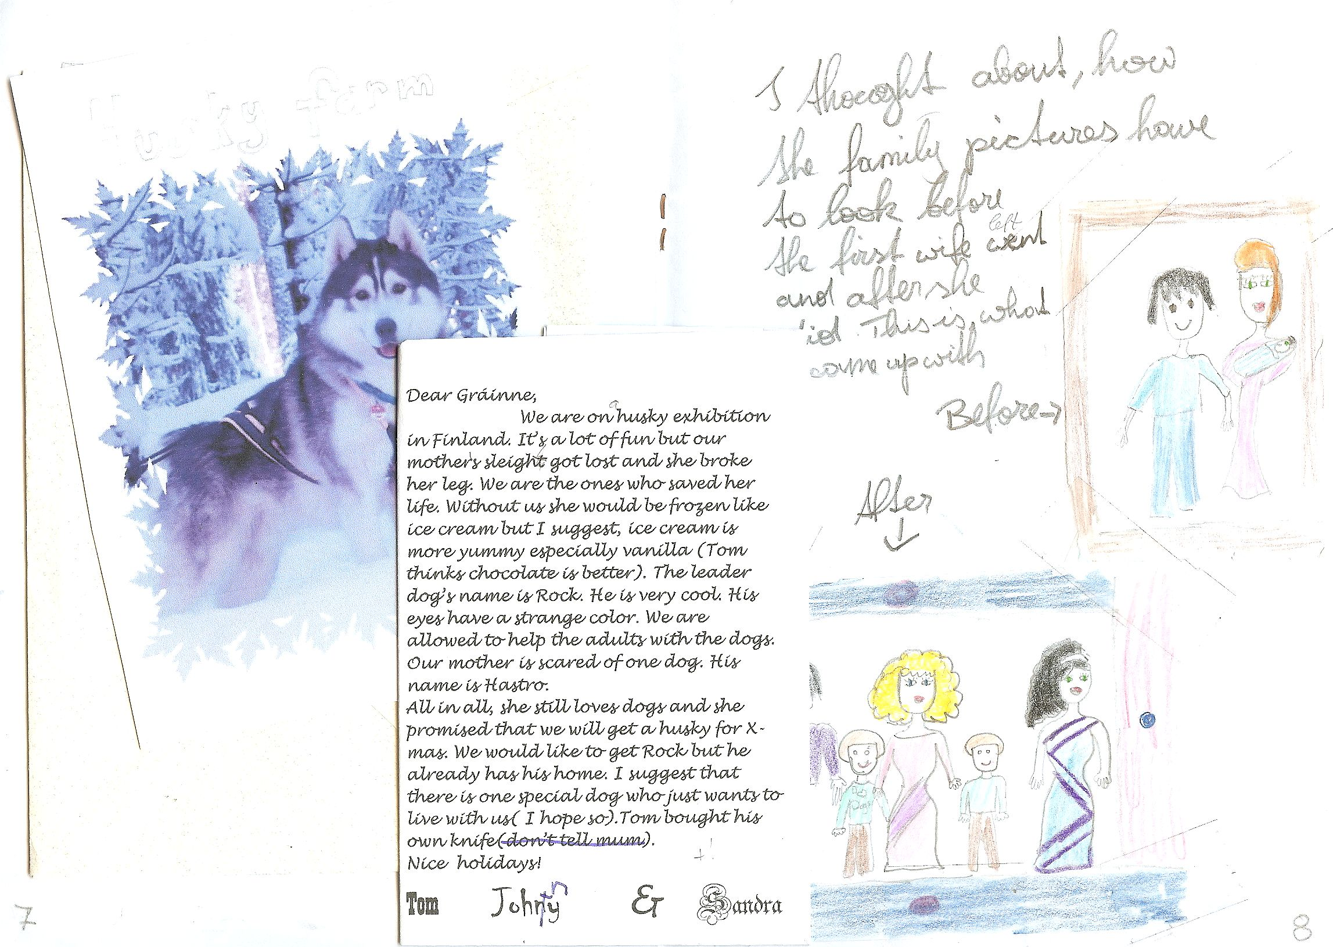

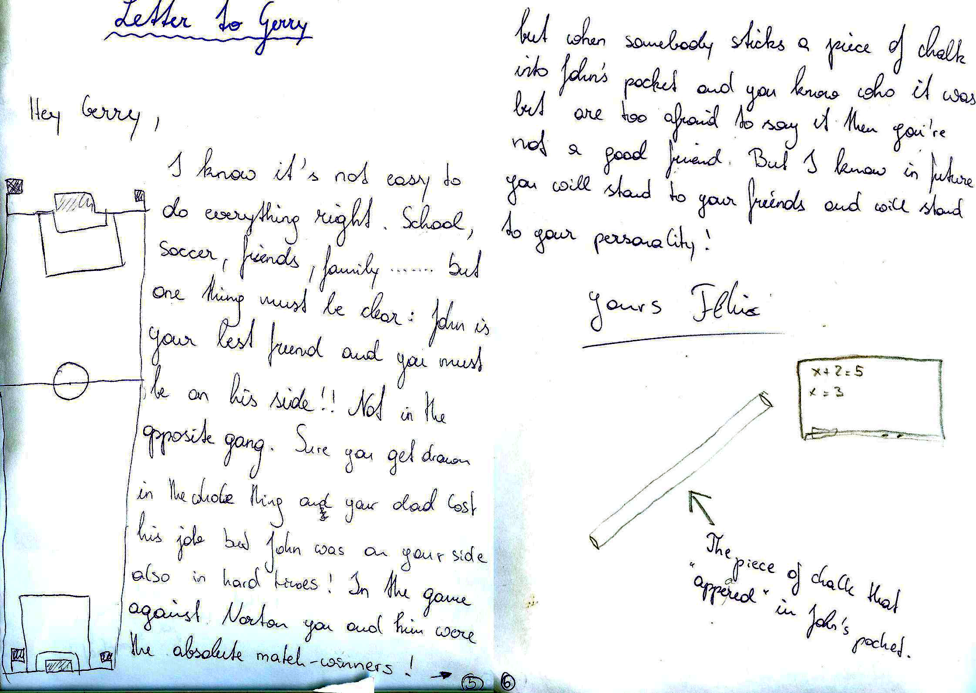

Brochures
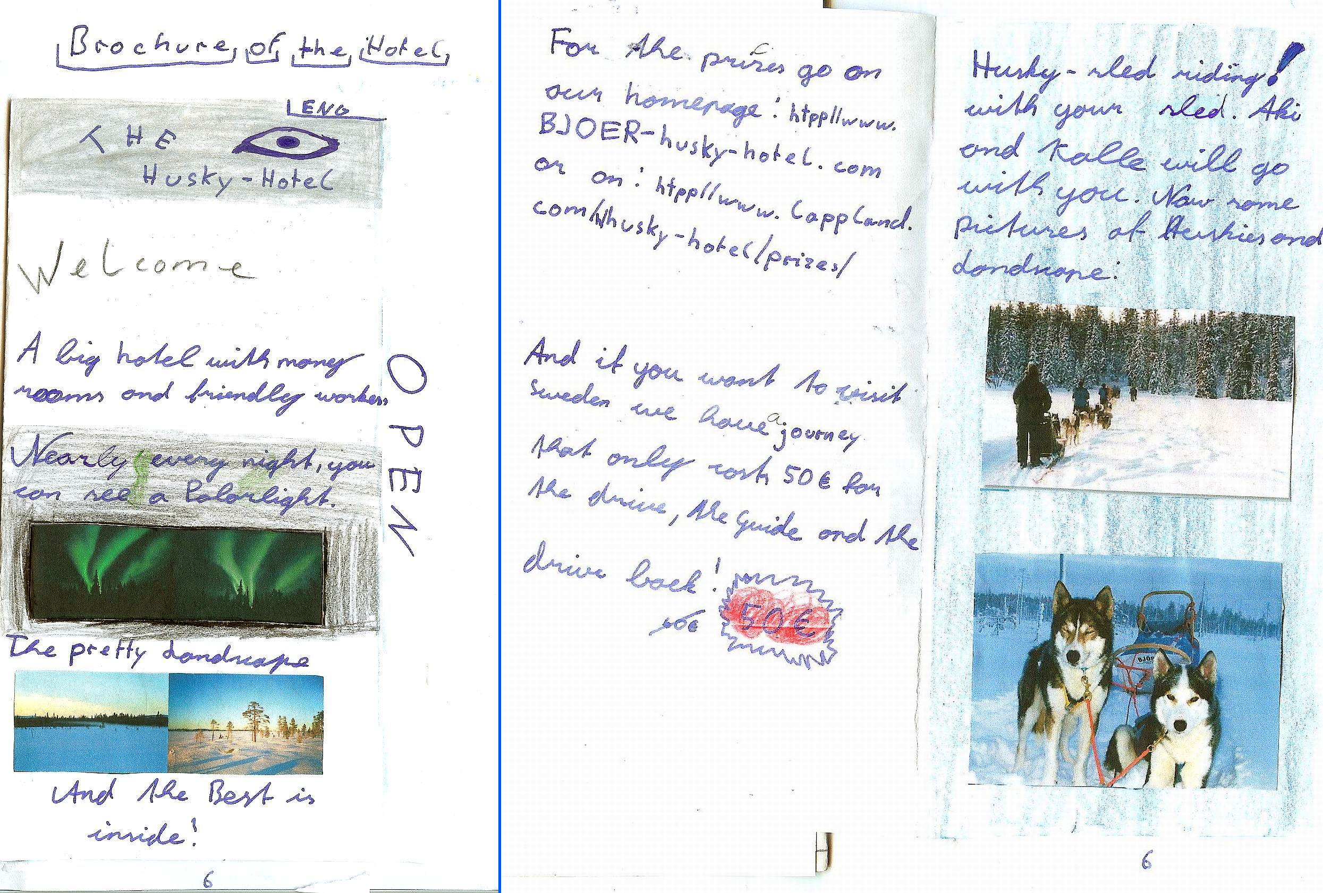

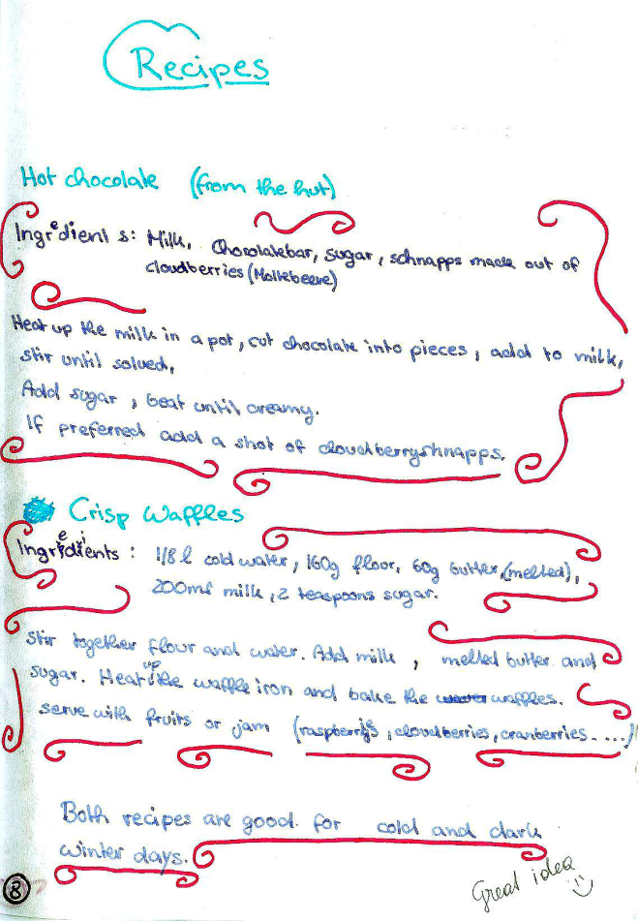
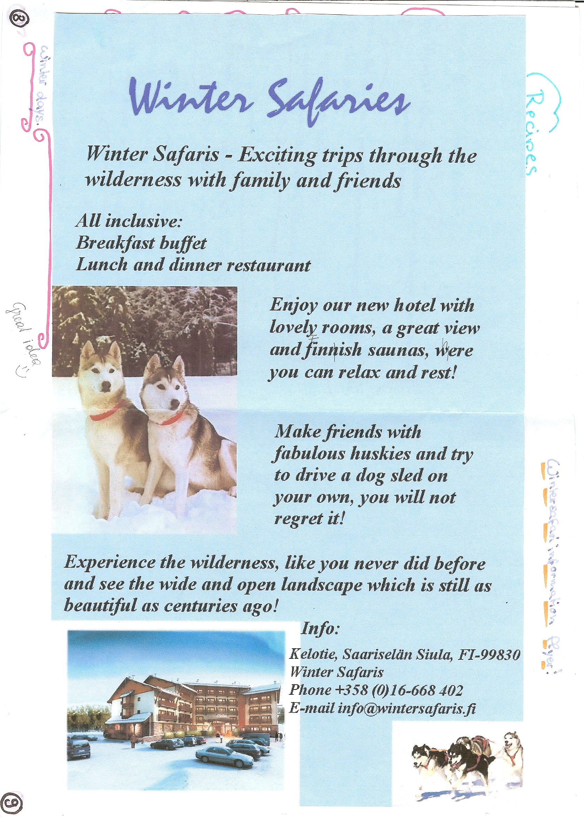

Other ideas: Recipes, Travel info,
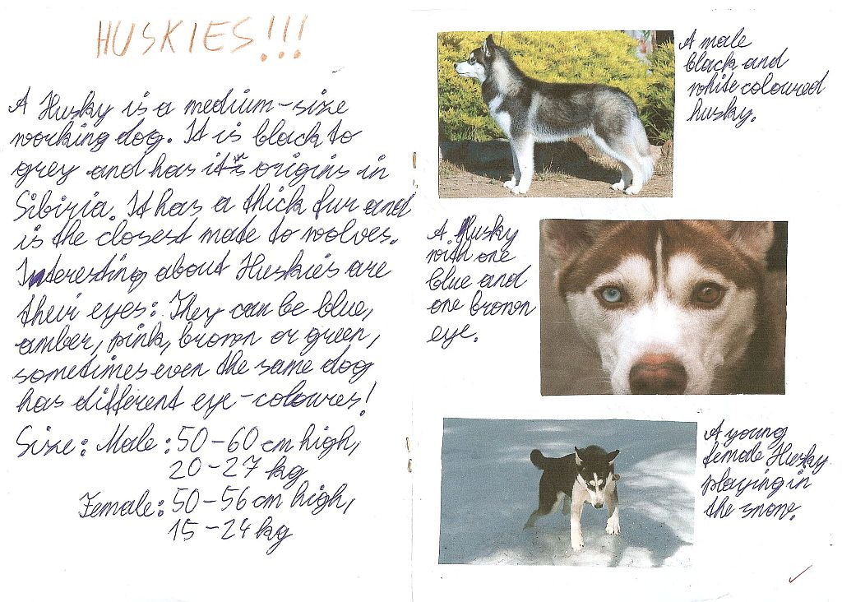

If I was…
Example from Lord of the Flies
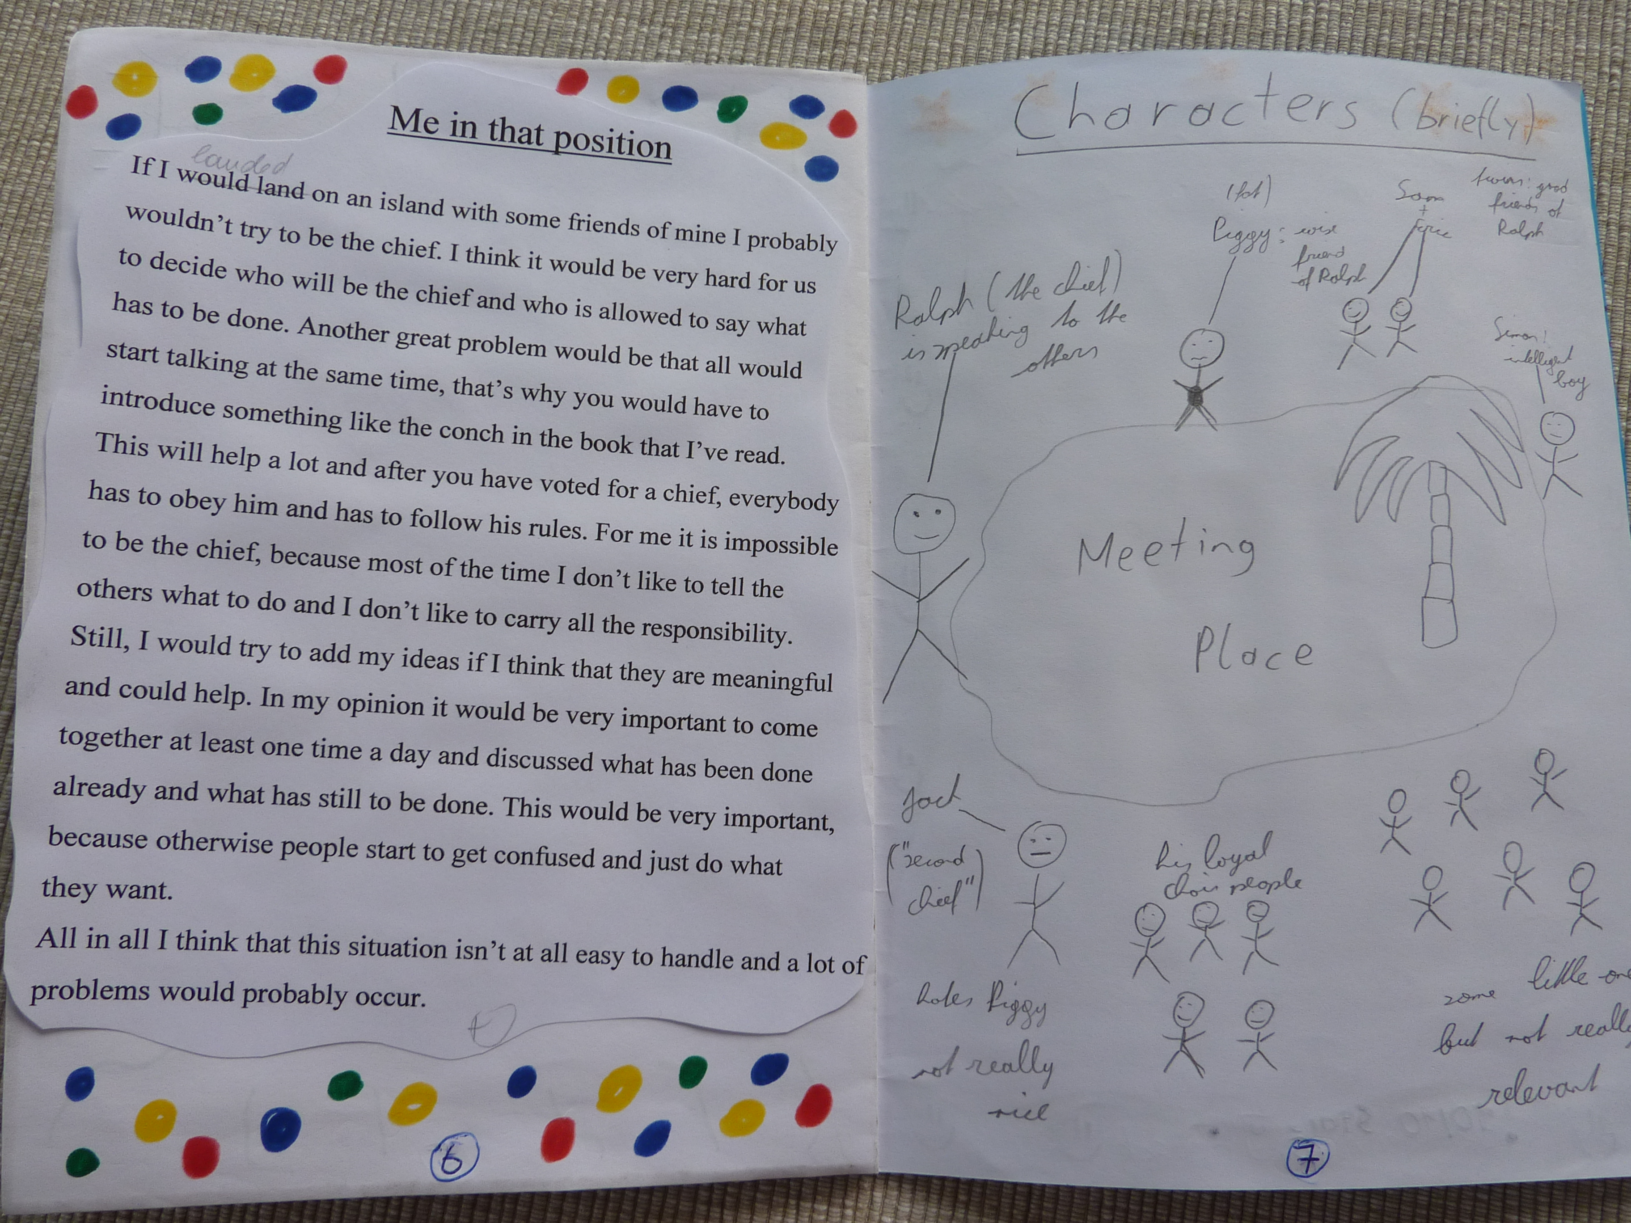

Creative Catalogues
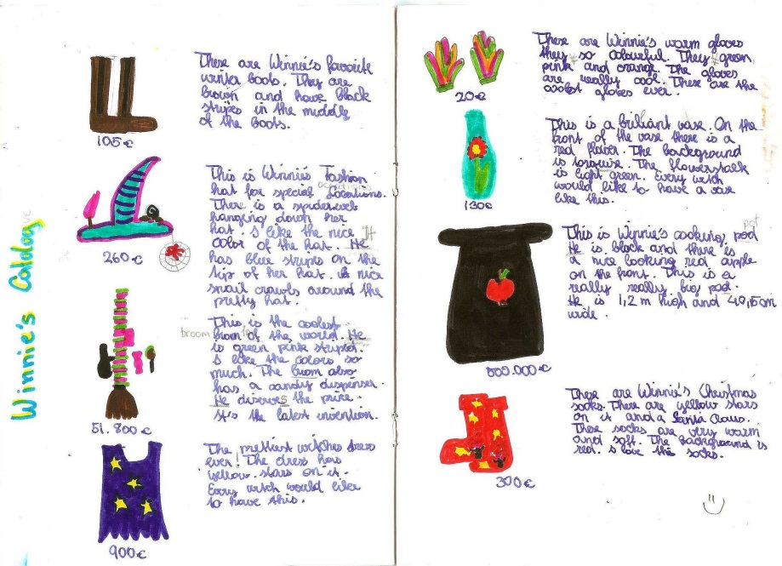

Origami books or Diaries

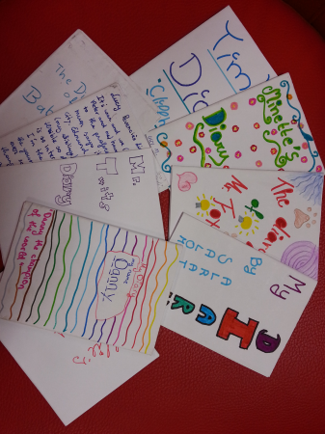
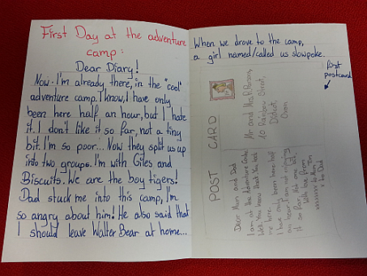
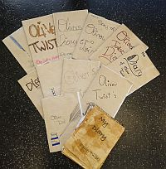

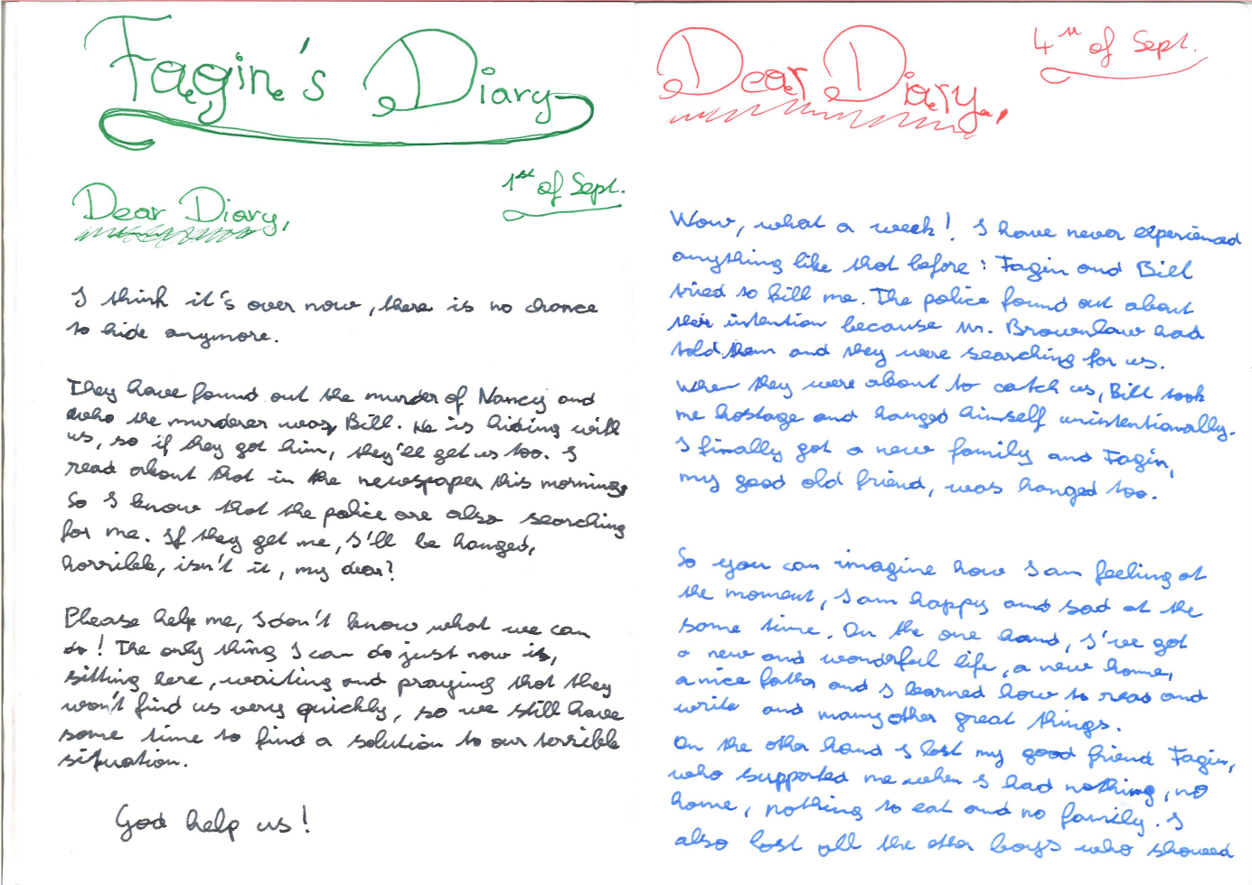

Oliver Twist: Fagin’s diary entry and a newspaper article about the same events.
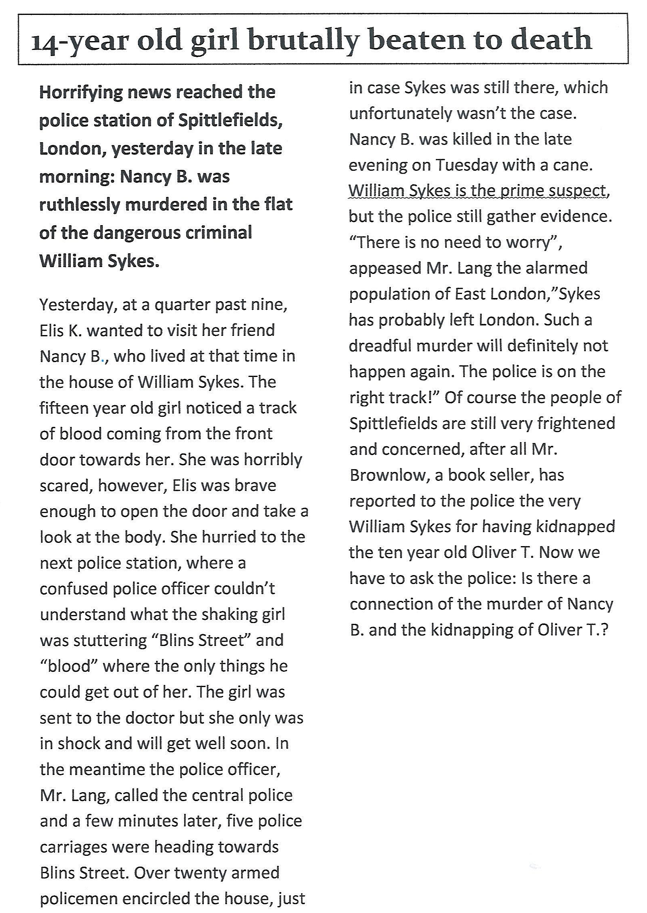

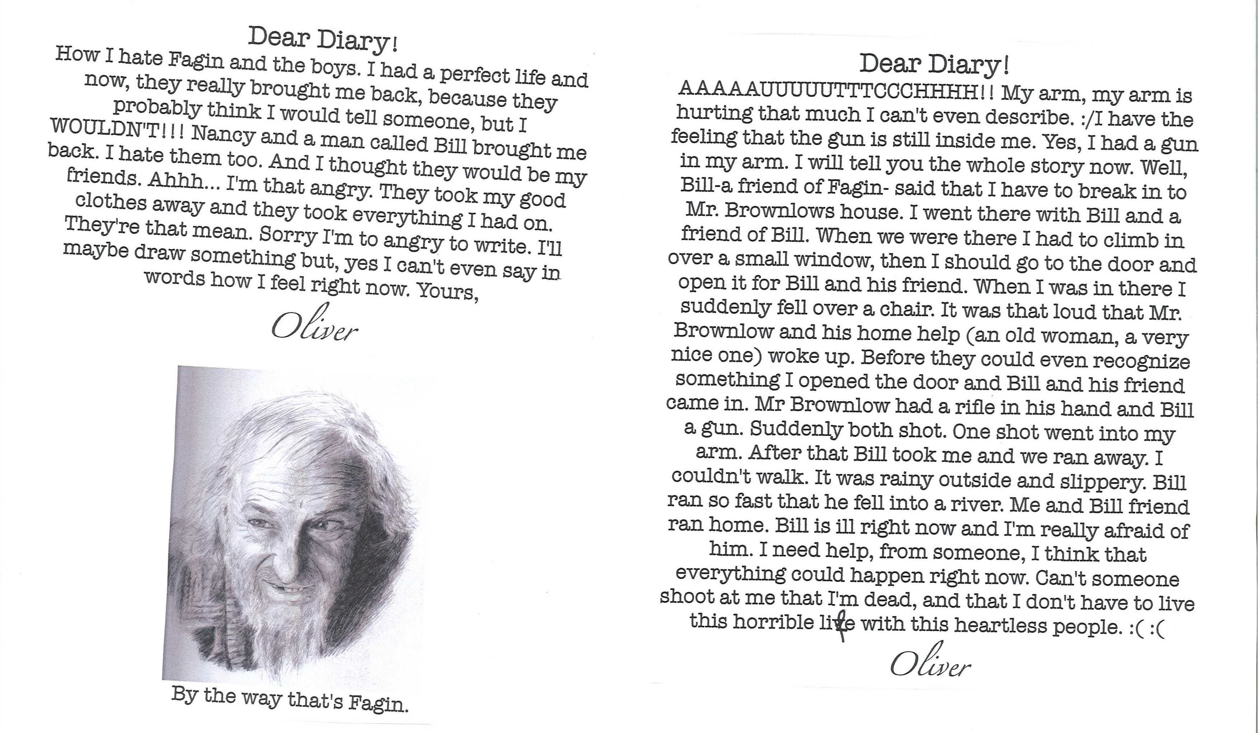

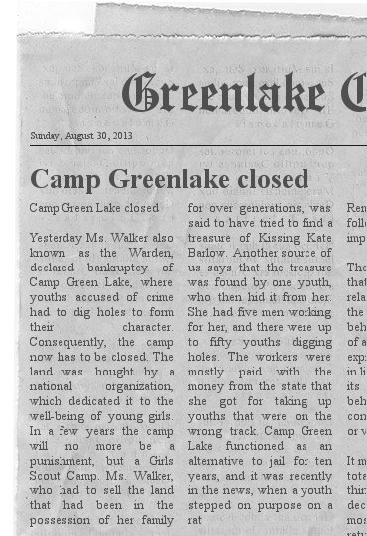
Newspaper Articles
Instructions: Choose an important moment in your book and write an article about this event for a local newspaper.
Remember: The journalist does not know everything; focus on one event – do not tell the whole story or include the characters’ private thoughts and feelings. What would the readers of the local newspaper want to know?
Tip: for the layout of a newspaper article use the online Newspaper Clippings editor : http://www.fodey.com/generators/newspaper

Newspaper article for Ian McEwan, Amsterdam
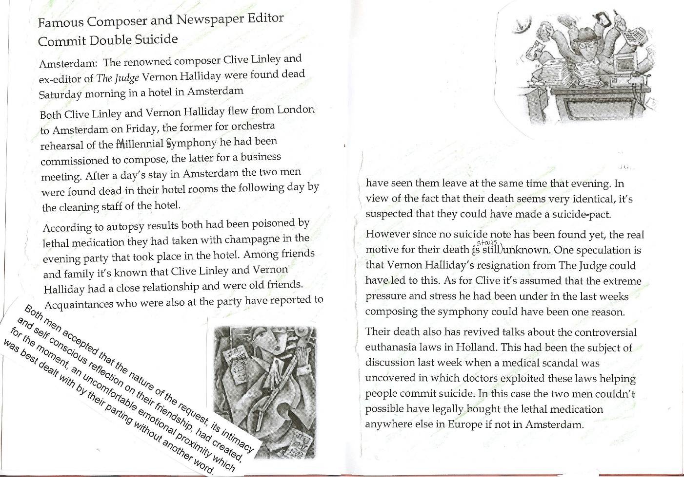

Plot Diagrams
Example from The Great Gatsby
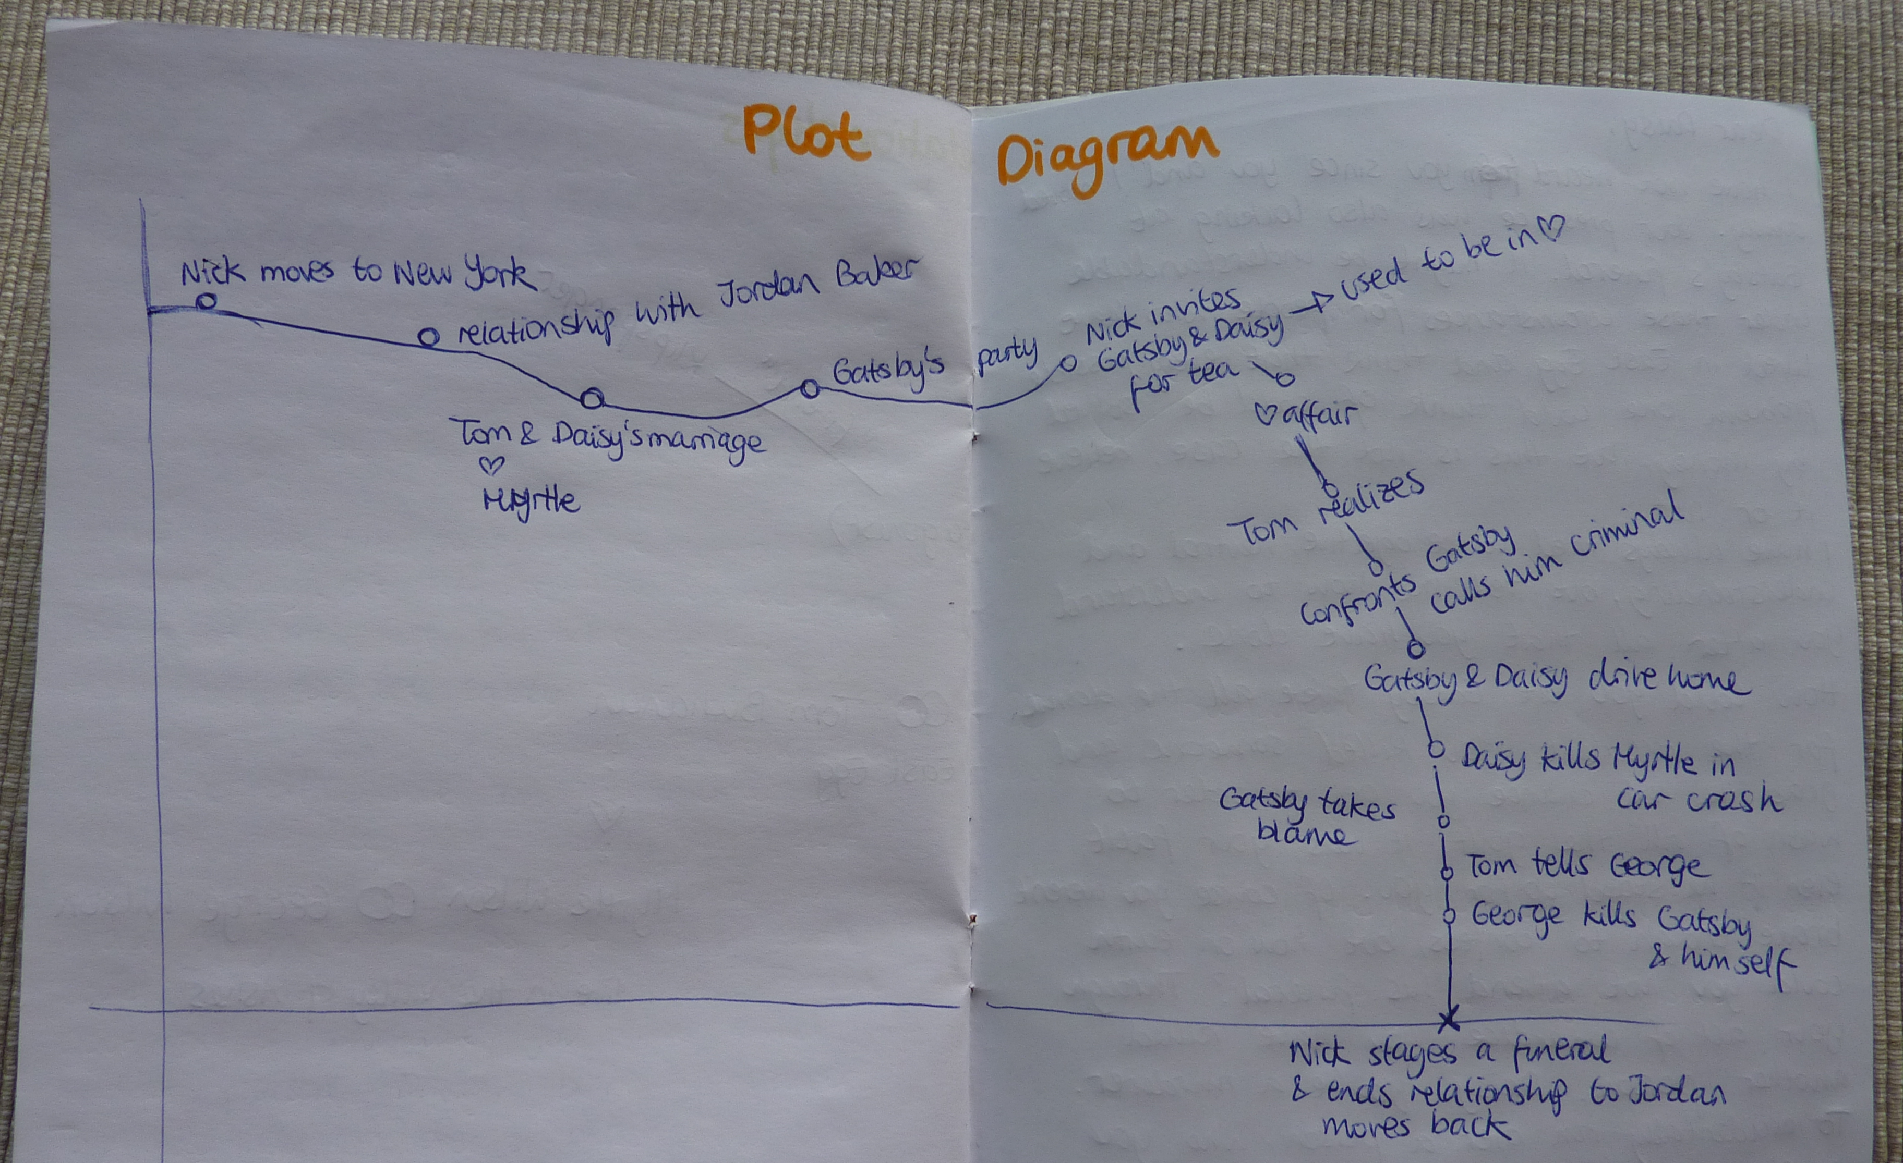

Example from Amsterdam
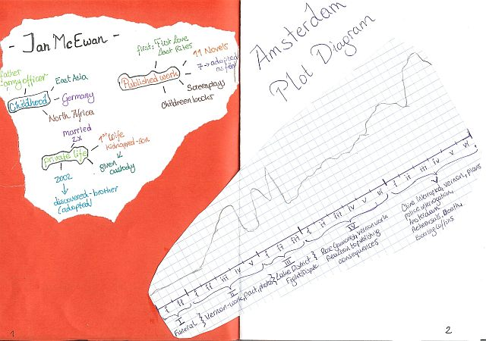

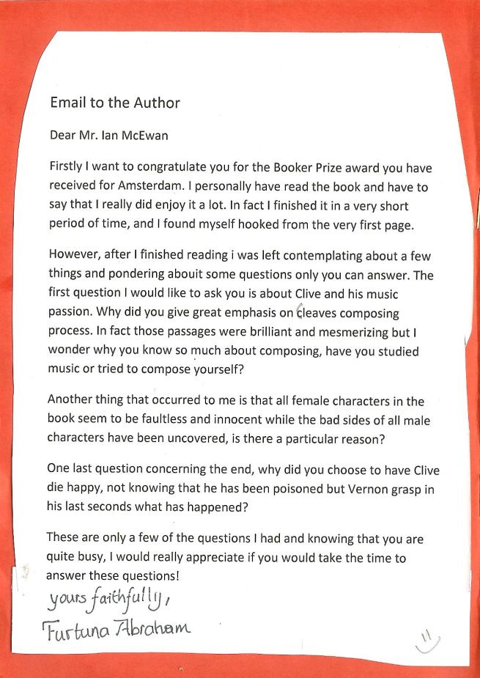
Letters to the author
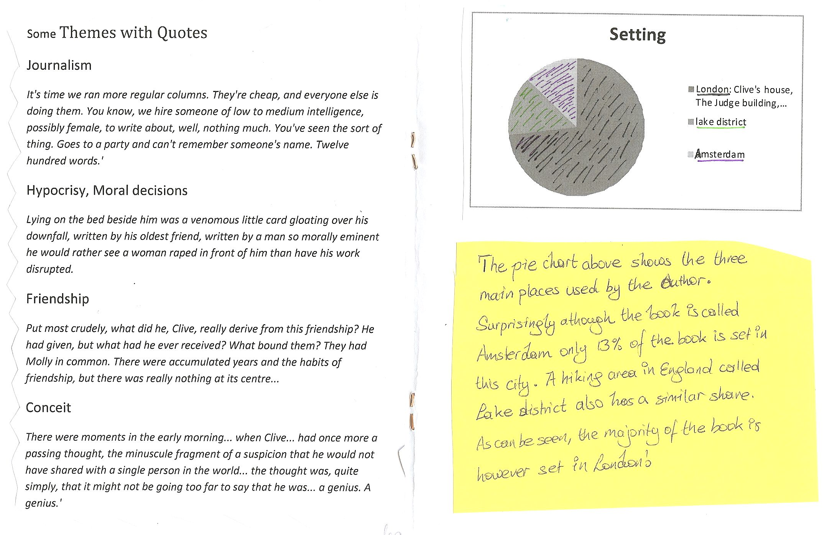
For more examples from upper-school visit the page “creative booklets” on epep.at

Ideas for Book Presentations
Presentations are the final and culminating point of every book project. Many of the presentation activities described in this section can be used at any level. What they all have in common is “activity”. The main goals of these presentations are
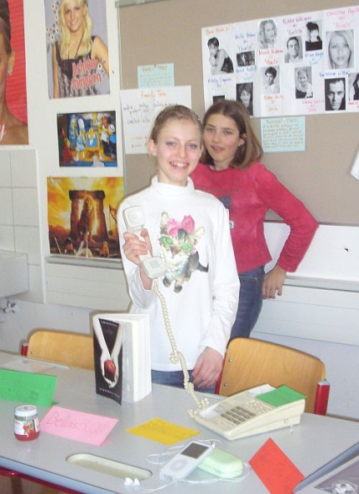
- to make the other learners interested in reading some of the books as well
- to practice presentation skills and oral skills and
- to motivate the learners to dig a bit deeper and understand more than just the plot level of a story.
What we don’t want in these presentations are learners
- reading long summaries from their sheets
- confusing the class with all the minor characters
- boring the audience with unimportant details of the author’s biography

Year 1:
From year 1 on my students present books regularly. The first presentations are no more than 2-3 minutes long and absolutely harmless. Avoid any stress and formality in these presentations and encourage the kids to do as many of them as possible. Invite the learners to present a book at the beginning of your lessons. The whole idea of these mini-presentations is to show the class that WE ALL READ and that reading books is actually fun and not hard work at all. Moreover these mini-presentations give even young learners a chance to speak in front of the whole class regularly and thus lose their fear of presenting. Reward the learners and “pay” them for each of these presentations. Everybody will get a +
After these little presentations the kids pass on the books and thus the whole process of reading starts rolling….
In a typical presentation in year one the learners
- show the book they have read (usually one of the picture books) and they
- say 5 to 7 sentences about the plot and characters in the book. If they have done one of the simple reading diary tasks, they can easily use these sentences again in the presentation. They
- tell us how they liked the book and finally,they
- write one “cool phrase” that they have learned from the book on the board and the class copies the new phrase into their vocab files.

Years 2-8 and beyond
In the course of year 2 or 3, when students do their first real book-projects, the presentations become more varied and creative. The following list of possible activities can be used at any level, up to adult literature. The depth and complexity of the results will of course depend on the age and the level of maturity of the learners.
Most of these presentations are done in groups and every student is responsible for a different activity or aspect of the book. Being responsible for it means that the student plans and prepares this part of the presentation. In some cases they will then need other members of the group to do it with them (act out a scene, take turns speaking, bring some of the props….) The presentation should be as colorful and interesting as possible and will often be assessed by the class according to a list of criteria that the class has agreed upon before.
The best and most interesting book presentations will result from intensive group-discussions with the help of Laura Robb’s discussion prompt cards and similar tasks based on ideas from the books below. Every group-member chooses a different task, possibly from a different area (plot, setting, character...) To make this easier for the students, the tasks are copied on colored cards, one color for each area. The students choose different colors and thus cover all the important aspects of their books.
A wonderful collection of tasks can be found in the following books, all available at Amazon.com
Christine Boardman Moen, Better Than Book Reports, Scholastic Teaching Resources, 2009
Laura Robb, 52 Fabulous Discussion-Prompt Cards for Reading Groups, Scholastic, 2000
Janice Szabos, Reading- A Novel Approach, Good Apple Inc. 1984.
Susan Van Zile, Awesome, Hands-on Activities for Teaching Literary Elements, Scholastic, 2001.

Sample Ideas that have worked very well:

Plot
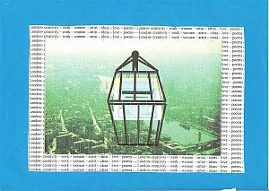
Present an alternative book cover and blurb:

Be sure the illustration relates to an important aspect of the book. Use appropriate colors to evoke the atmosphere created by the book. (Older Ss can also be asked to print out different book covers from the internet. Amazon.com usually has different editions. Ss then present the different cover designs and their own version. The class chooses their favorite one. This is a very good way to discover underlying themes and the tone of a novel.
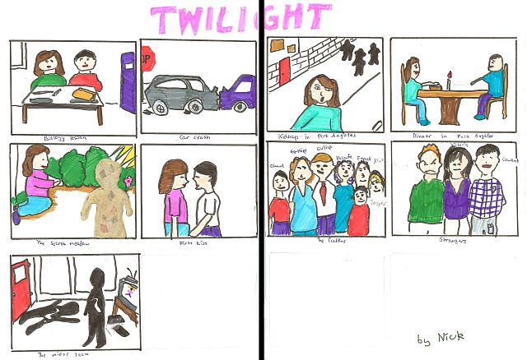
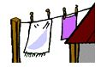
Plot on the line or Storyboard: Write seven to ten main events on separate sheets. Add simple drawings and illustrations. In your presentation hang up one picture after the other using clothes-pegs and a string or stick your pictures on the board with magnets or blue-tack. Talk about each picture using your own words. Don't give away the ending.

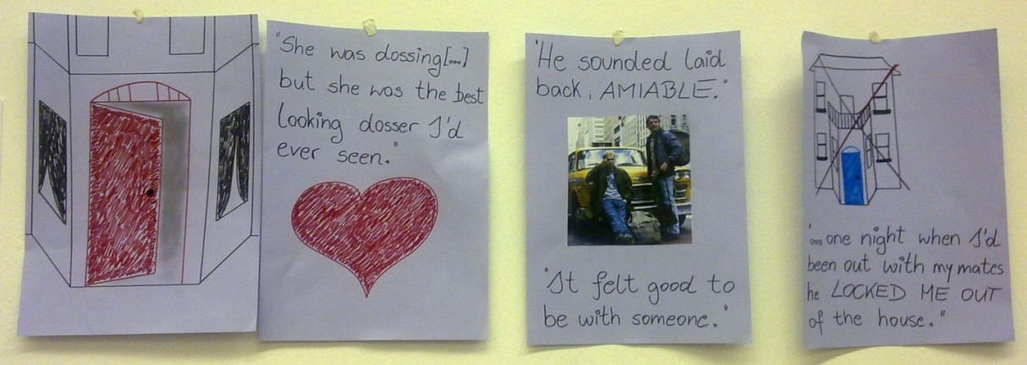

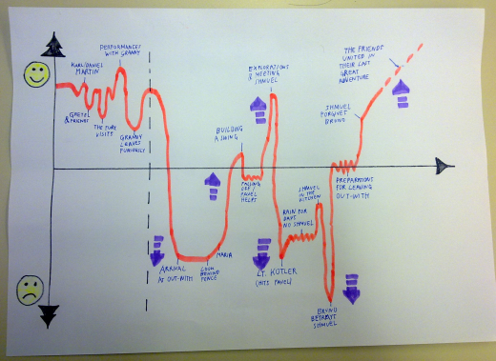
Plot diagram/ Plot mountain: Draw a “fever curve” of the ups and downs in the novel. Peaks of suspense or conflict…., label the curve. In your presentation use your own words to explain each of the events briefly.

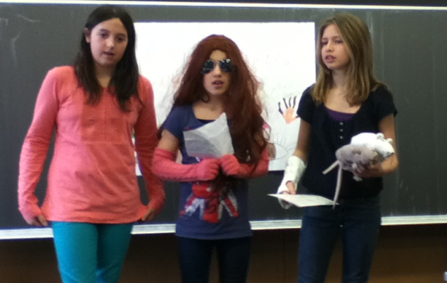
Act out a scene of your choice. Use simple props and costumes.
This activity works best in combination with the “plot on the line” or the “plot mountain” activities. The learners act out one or two important scenes and explain at what point in the novel these scenes happen.

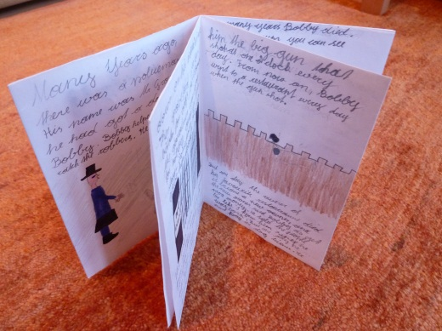
Make a plot mini-book (concertina or origami)
This activity works well for picture books or short stories that the teacher has read to the class. After listening to the story the learners design their own mini-books. They write their own version of the story and add illustrations on each page.
Variation: The learners might also write a follow-up story rather than a summary of the original story.

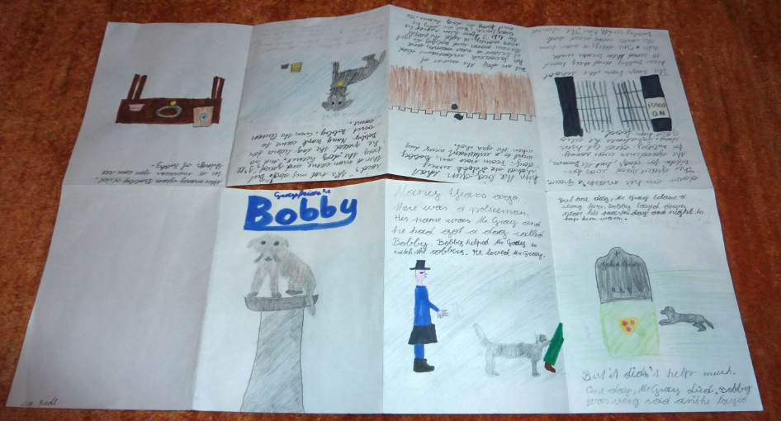

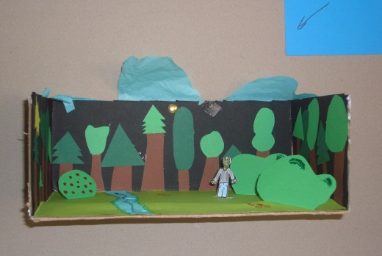
Setting
Make a setting pop-up or a painting that shows the most important place(s) in the book.

Setting murals: several paintings glued together

Draw a simple map of the locations in your novel. Make sure the map is large enough so your classmates can read it clearly. Attach a legend to your map. Write a paragraph that explains the importance of each location indicated on your map.

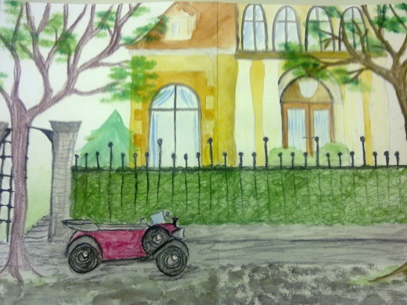
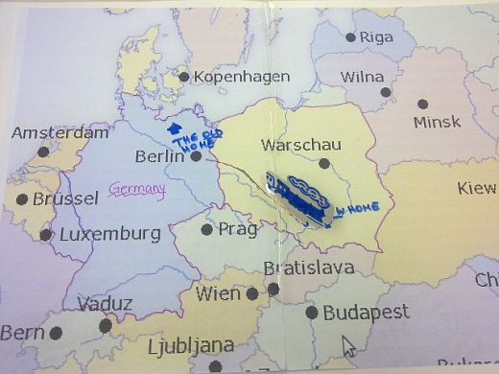

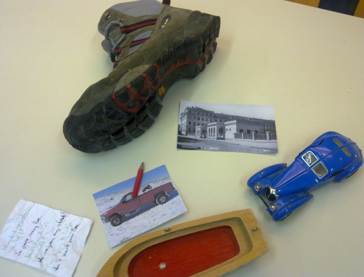
Characters
Identity bags/ character suitcase: Bring a bag full of objects that are somehow important to the main character of your book. Show them and explain their relevance.

Character T-shirts: Design a T-shirt (picture and slogan) for one of your book's characters. Show what is important to them.

Character collage: Find fitting pictures and words from magazines and present (one of) the main character(s) in a collage.

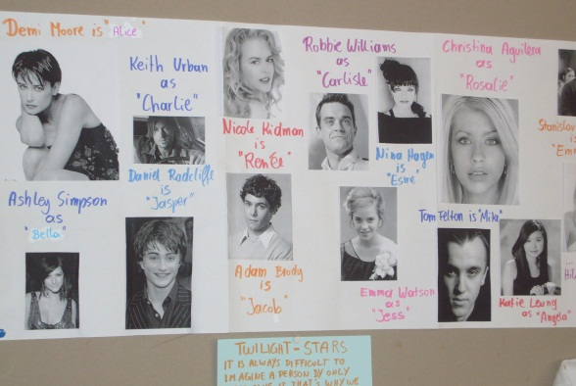
Movie Casting: Imagine that your book will be made into a movie. Choose suitable actors and actresses for each of the main characters and present them to the class. Explain why you think these actors/actresses would be ideal for these roles. What characteristics and qualities will they have to show in order to portray the characters well.

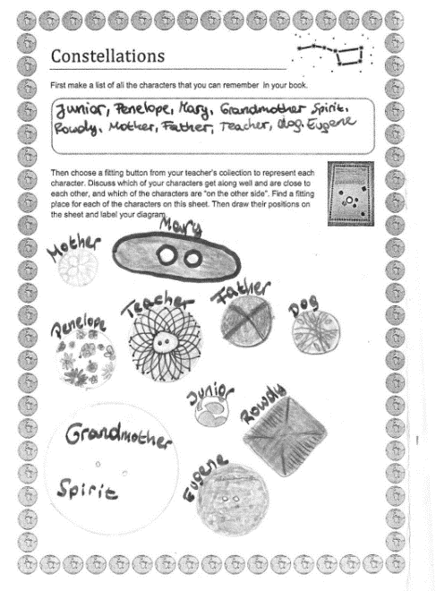
Prepare a "bubble sheet" (A3 poster) where you collect important quotes from your book. In your presentation explain who said these words and why they are important.

Sociogram: Choose suitable buttons to represent the main characters of the book. Then make a sociogram showing the relations between the characters. Show (close) friendships, rivals and enemies, good and bad characters. Compare your version with other students.
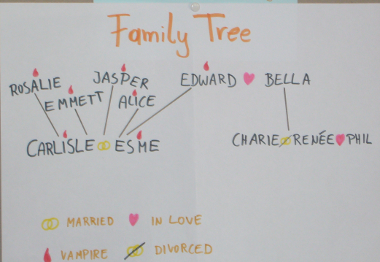

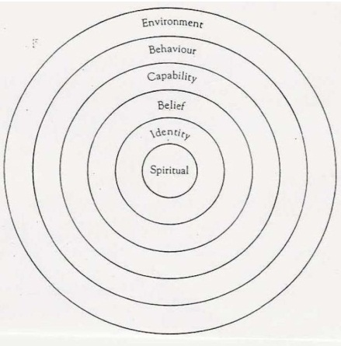
Character profiles: Look at the different levels of a main character’s personality and complete the profile circles. (Find the detailed description on epep.at)

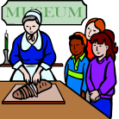
Other
Novel Museums
For the Novel Museum imagine that the characters in your book were REAL people. Our town wants to make their stories public and has, therefore, dedicated a whole room in the museum to these people and their stories. There they show real artefacts from your characters’ lives. These objects are presented nicely in showcases and on tables around the room. Each of the objects has a label explaining the importance of the item, where it is from and what role it played.
In your museum display you might show some of the following things:
Maps, short newspaper articles about what happened to your characters, diary pages, letters, objects they used during their adventures, photos, clothes they were wearing, favorite items of your characters….. or any other things that play an important role.

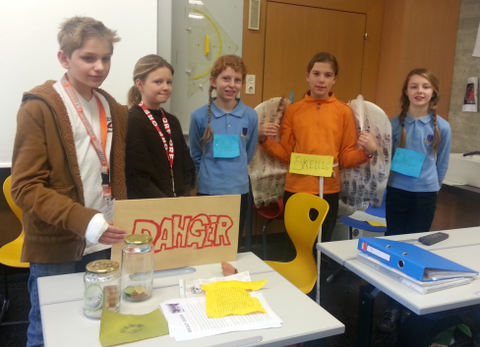
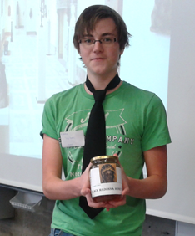
A Novel Museum: display 10 to 15 items that play a role in the book. Act like tour-guides and present the artifacts to the class. Explain the significance of each item. See detailed instructions on the right.

Write a poem or song-lyrics that might be used in a film or radio-play of your book. Present your poem (show it on the projector while you read it) or sing your song. Maybe other classmates can sing along or accompany you on a guitar. You can also use a karaoke CD for background music.
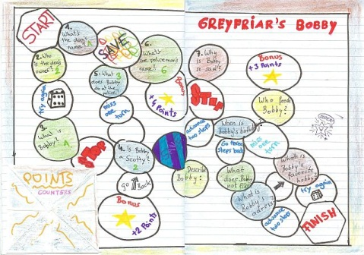
Make a board game: Design a board (use settings, plot line and events… task cards or fields… you might even make Fimo character-counters…

Timesaver Idea
If class time is limited or if students are to present their private reading use the following activity:

Non-stop talking: Ss stand in two concentric circles or parallel rows. The Ss in the outer circle or row talk non-stop for 1 minute (more advanced Ss can do 2-3 minutes) about the novel they have read. Ss in the inner circle/row listen. After 1 minute Ss change roles. Then the students in the outer circle move one person to the left. Do this with 3-4 partners. This activity works well for independent reading where Ss talk about different books. If they have all read the same book give out sub-tasks for each round: e.g: favorite character, least favorite character, setting(s), ending, …

Acrostic poem: Write the title of the novel downwards on a page. Then use each letter as an initial for a line about the book.
Alternative idea: If you have an idea of your own contact your teacher about it.

Older students

Older students who read modern or contemporary literature in their reading groups might also be asked to present some of the following aspects:

Short information about the author: main focus should be on typical themes or characteristic topics, style, other books… Biographical information only if relevant (e.g.: personal experiences that are reflected in the books…)

Historical or cultural background of the novel.

Make connections to the modern world: Depending on the topics and themes of the book Ss might do tasks such as the following (designed for Brave New World or Animal Farm):
- Present the basic principals of propaganda and advertising (do an internet search)
- Give a propaganda speech about any topic of your choice. Then explain the methods you have used.
- Present the pros and cons of genetic engineering
Encourage students to prepare attractive, attention grabbing visuals for their presentations. Do not allow text on powerpoint slides. Allow only pictures or keywords and make sure the students use their own words rather than reading off prepared texts.

Online book presentations on readingiscool.xyz

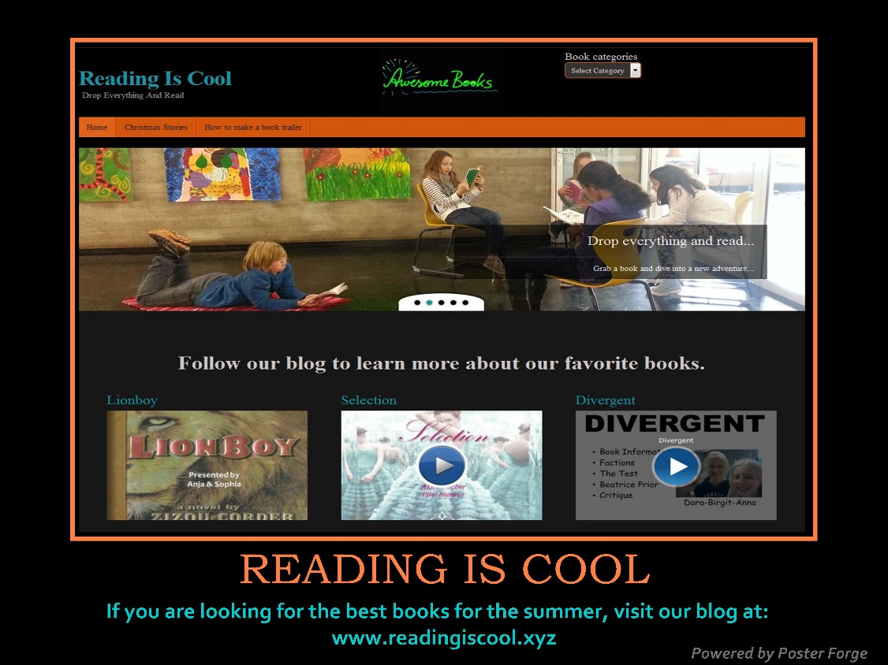

Reading projects for advanced readers

After reading lots of young adult literature and working in book groups in order to understand more than just the plots of their books, my students are ready for REAL LITERATURE. At GIBS this happens towards the end of year 5 — if you do not teach in a bilingual school, year 7 will probably be a better choice.

When reading literature our main focus is still on seeing and understanding the world through other people’s eyes and getting to know other cultures, lifestyles and times.
Students who have enjoyed good young adult literature and have realized that books actually help them understand the world a bit better will use these skills when reading adult literature as well. We spend only little time analyzing formal aspects of literature or discussing symbolism and author’s biographies.
We rather ask ourselves questions such as:
- What does this book tell me about life in a certain place or at a certain time?
- What is the character’s problem?
- What would I do in this situation? Have I experienced anything similar?
- Could this happen in our country and time?
The basic organization of the book projects is similar to those in earlier years. My students choose one of the books of the project, they keep a reading diary and then work in their reading-groups. In the end they present the book to the class using creative and interesting activities to engage their audience.
Classes who have had a lot of experience with reading projects in lower and middle school need very little guidance and hardly any worksheets for these book projects. Open ended tasks like the booklets can still be used and will be filled with age-appropriate texts and ideas. Other classes with less experience might need more detailed instructions and step-by-step activities in order to understand and appreciate a novel.

Useful tasks for upper-school reading projects


Red cards – Green cards
Hand out 5 red cards and 5 green cards per student.
Instructions: Work with 2-3 partners who have read the same novel.

Red question cards: Write 5 questions that you haven’t been able to answer when reading the book. Think of real questions you have – not boring “comprehension questions”.

Green cards: Write 5 interesting features/elements that you have come across in your novel: (clear statements about themes, characters, plot development, style and tone, setting, …)

Sign your cards, then put your cards in the middle and check if there are any similarities …
Discuss the green cards first, then try to find answers for your red question cards. Write your answers and discussion notes into your reading diary
If you need additional info, check the internet, the library, or ask your teacher(s)

Telling Passages
Choose two passages from your novel that you find particularly interesting and telling.
What do these passages tell us about the character(s) and/or the conflict in this story?
Practice reading these two passages so you can later read them to your group-members clearly and distinctly.
Read the two passages to your group-members and explain why you chose them.

Points of View: What I would have done...
Think about one of the main characters in the novel you have just read. Think of their actions, decisions and opinions. Do you disagree with any of them? Fill in the following diagram and explain what you would have done differently and how this would have influenced the story.
How would this have influenced the story?
My point of view:
What I would have done:
Character’s name:
Actions/Decisions

How would this have influenced the story?
If ................. had ..........................

Venn Diagram
Compare the different novels you have read in your group and find the common core as
well as the differences. Enter your findings into a Venn Diagram (Use a separate sheet to draw a
full-page diagram)



Good Expressions
Find five good expressions that you would like to remember and fill in vocab-cards from them.
Then share them with your group-mates and transfer all the new phrases of your group into your vocab-books.

Word: Color/Picture/Doodle

Sentence I found in my reading:

Second example sentence from my dictionary:

Useful collocations:

Alternative title and cover
Think of a new title for a new edition of your book and make a quick sketch of a fitting cover page. Find examples in chapter 8, page 54.

A sample project for upper-school reading:

The following example shows a typical mix of post reading task for advanced learners.
These kinds of tasks work well with all kinds of contemporary literature.

Tasks for Book Circles

- Questions: What are the unsolved loose ends of the novel? What made you think and is still on your mind? Is there anything you did not understand? Do you have any questions you would like to ask the author/ a character/ a classmate/ a teacher? Write down all these questions on the cards provided by your teacher.

- Meet in your book circles and put all your questions in the middle. Discuss all your question- cards, try to answer them. Call your teacher or co-teacher if you need help.

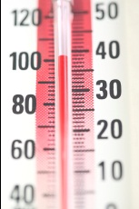
- Fill in the character profile for the main characters

- Hot or Cold? Compare and discuss your reactions to the novel. What made you hot? What left you cold?

- Prepare your presentation:
Your presentation must be really professionally done this time. Collect information about the following aspects of the novel. Decide who is going to present them and what is the most efficient order to present these features.
  - Author and background (time, setting…) (only RELEVANT information)
  - Brief plot info (approx. 7 bits of information) on a plot mountain or plot diagram.
Info about plot development (chronological, flashbacks, inner monologue, stream of consciousness, point of view…)
  - Use your Hot and Cold info: how did you react to these events? Would your personal feelings curve be parallel to the plot curve or would it be different at any points?
  - Main characters: (visualize, give main personality traits)
decide whether it makes more sense to present the characters first, or do that after or parallel to the plot overview.) Use your character profiles info. Does the main character develop in any way?
  - Other narrative features relevant in the novel:
  - Setting: how important is the setting? What role does it play? Make sure your classmates can really visualize it.
  - Point of view: how does the point of view influence our perception of the story? Does it change throughout the novel?
  - Symbolism – and Theme : how does the title emphasize the theme? Have you come across any symbolic objects or actions? What do they stand for?
  - Style and tone: How do style and tone support the theme?
- Homework:
Design an original book cover and a blurb for the novel (each of you individually). Draw/paint/write on an A4 sheet and present your ideas as part of the presentation. Consider the following questions: How can my cover show the main theme? How can I capture the tone without using words? Use colors, symbolic elements, settings… to show rather than tell the audience what the book is really about. Don’t discuss your ideas with your friends in class. This will limit your creativity. It will be interesting to see different interpretations of the same novel.

Great Literature for Advanced Students
For detailed projects and work-packages designed for specific novels or plays, go to Great Literature for Advanced Students on epep.at. There you will find my students’ favorite novels and printable worksheets for some of the books. Some of these packages are very detailed and extensive. They are meant to be completed by a group of students, not by an individual. The learners work on the projects in class (usually 3-4 hours) and each group-member contributes one or two writing tasks to the final project. The writing tasks are done at home. By sharing the work, the students get a wider understanding of the novel without having to invest an ungodly amount of time into the project.
EXPLORATION TASK: Work with a partner and look at the materials and tasks for the “Modern Classics” project displayed in class. Compare the project materials for the different books and see how much they overlap and in what ways they are different. Notice how these tasks can help the learners understand the novels beyond the plot level and get a first idea of more professional ways of interpreting and understanding a novel. Keep in mind that the learners could choose to read one of the novels and will then get to know the others during the presentations. Do not force a whole class to read your favorite classic novel -- it might be the last one your students will ever read.
Collect ideas for tasks that can be used at this level. (All projects can be downloaded from epep.at)

A taste of poetry

Poetry ideas for young learners

Read the following poems with a partner and find out the characteristics of the different types of poems. Underline the typical features in the sample poems and write your own “RULE” for each of the poems.
Then try your hand at writing your own poems.

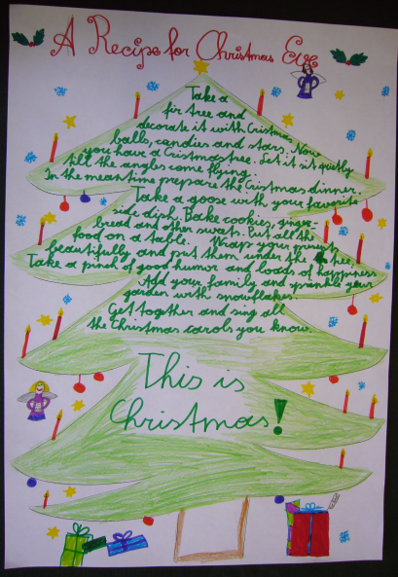
Recipe Poems

Recipe for a dragon

Take a head as red-hot as fire,
A body as tough as steel
And spikes and claws as sharp as razor blades.

Add scales that cover the body like a knight in armor,
Wings as strong as a fighter plane
And a tail that whips and thrashes the air

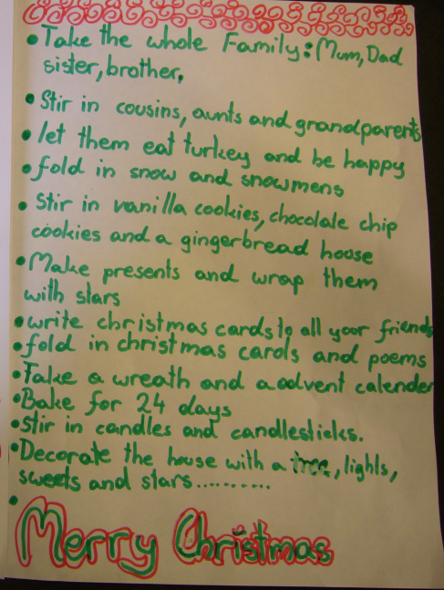
Decorate with eyes flashing like lightening,
Teeth as cold as icicles

Stir in breath as fiery as a volcano.
Put in a hot oven
And bake for a hundred years –
And you have made a DRAGON!
BEWARE!

Typical ingredients of a recipe poem:

Now follow the recipe format to write your own poem: You might write a recipe for spring, summer, autumn or winter or any other recipe you want to try.

Acrostic Poems
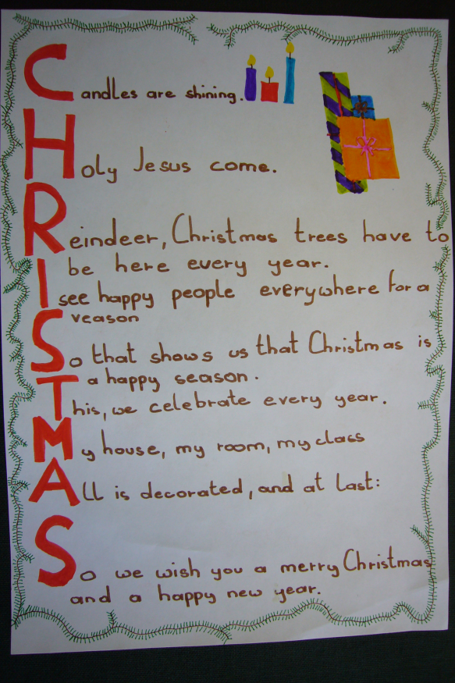
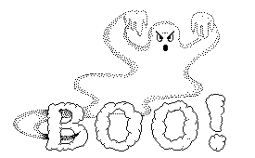

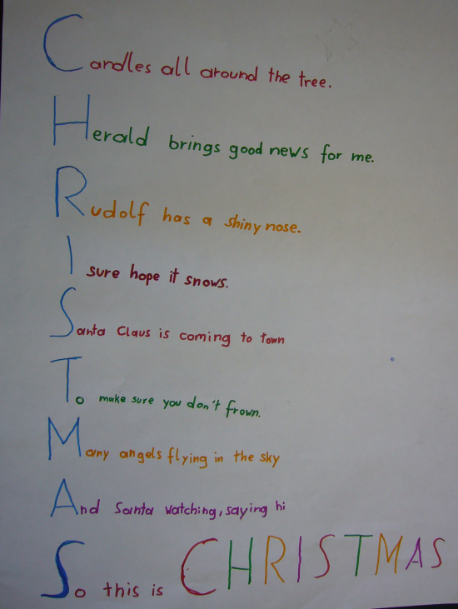
Halloween is dark and spooky
And all the ghosts and goblins are out at night
Lots of terrifying animals come out of hide-aways
Lots of frightening dreams
Oh! Halloween is spooky
What a frightening time
Every spooky animal you could imagine
Even the pumpkins are lit
No little girl or boy should go out on Halloween.
By Charlotte.

Typical ingredients and rules of acrostic poems:

Now try your hand at writing your own acrostic poem. You might want to write about yourself, using your name as a title. Other good topics are special holidays or seasons, places etc.

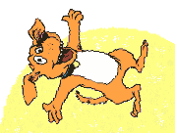
Haiku
Examples:
I lie belly-up
In the sunshine, happier than
You ever will be.
Dopey McWilliams

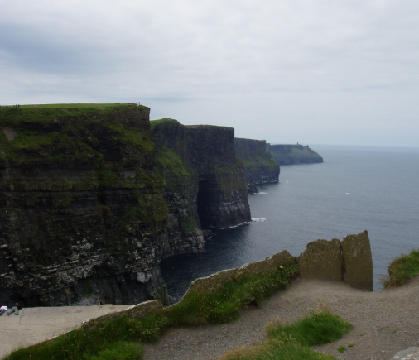
Baby chicks at rest.
Eggs pilfered from Mother’s nest
And it’s so yummy!
Dopey McWilliams

The Cliffs of Moher
The majestic cliffs
The water beneath shining
And glittering bright

The waves roaring loud
Down there, at the cliff’s firm foot
Never will move

I look down the cliff
I cannot make out its foot
It seems so endless
Clemens M. Schreiner

peanut butter and jelly
white bread triangles
and their intestines clutch to
my small childhood heart.

thelma dawn esprit

Typical ingredients and rules of a haiku:
Form:

Content:
Haikus usually paint pictures. They are like verbal snapshots and concentrate on a single moment or picture. They don’t tell stories.
Now write your own haiku. Choose a powerful picture or photograph to give you ideas.

Concrete Poems

Examples:

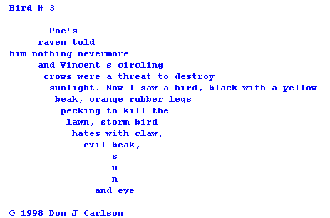
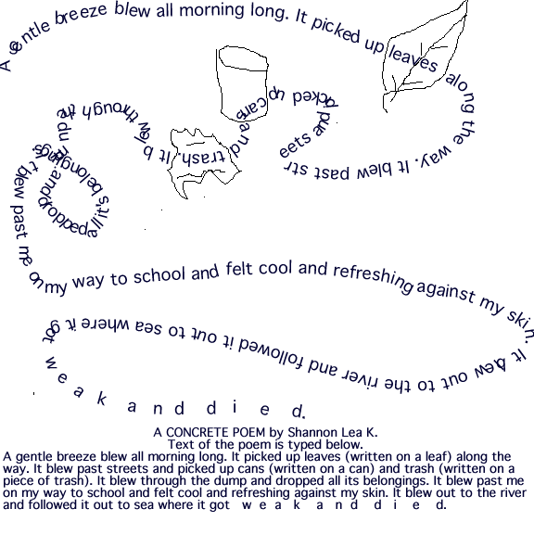

http://www.schools.pinellas.k12.fl.us/educators/tec/pravda3/concrete.html

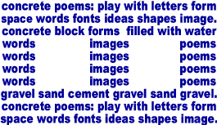

Typical ingredients and rule for concrete poems:

Now try writing your own concrete poem.

Limericks

The limerick is a humorous poem with a very special form and rhythm. The form was popularized by Edward Lear in the 19th century. The name of the verse form is derived from county in SW Ireland, in the province of Munster. Its capital city is Limerick situated on the River Shannon.
Read the following limericks and choose your favorite one. Learn it by heart.

There was a young lady of Riga
Who smiled as she rode on a tiger;
They returned from the ride
With the lady inside,
And the smile on the face of the tiger.

Anonymous

There was a young lady from Hyde,
Who ate a green apple and died,
While her lover lamented,
The apple fermented,
and made cider inside her inside.

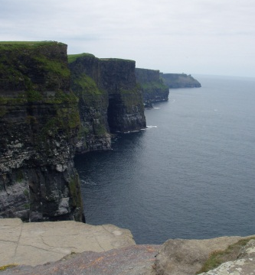

There once was a child named Lou
who never liked eating his stew
his mother got mad
she said he was bad
'cause he said that it tasted like poo

There was once a boy whose name was Noah
He went to the high cliffs of Moher
He wanted to see more
But he fell off the shore
And that’s the sad story of Noah

Viki Muster, 14

Then figure out the typical form of a limerick:
1st words:

Number of lines and rhyme (use letters to illustrate that)

Rhythm (illustrate the rhythm by stress marks: - /-/)

Write your own limerick.

Ideas for Using Poetry in Upper School
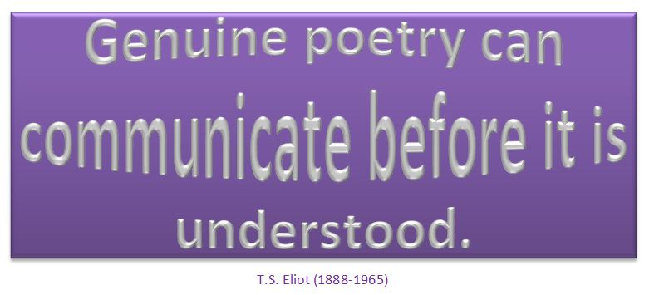
Introduction to Poetry
by Billy Collins

I ask them to take a poem
and hold it up to the light
like a color slide
or press an ear against its hive.
I say drop a mouse into a poem
and watch him probe his way out,
or walk inside the poem’s room
and feel the walls for a light switch.
I want them to waterski
across the surface of a poem
waving at the author’s name on the shore.
But all they want to do
is tie the poem to a chair with rope
and torture a confession out of it.
They begin beating it with a hose
to find out what it really means.
(Collins 2014)
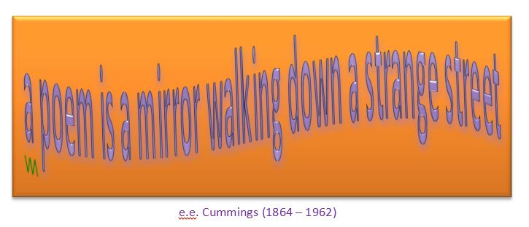
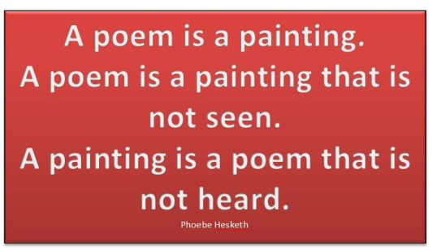

- Pick a poem: hang lots of poems up on a clothes line (use pegs). Students walk around, read lots of poems and pick one they like.

- Painting a poem: Students choose a poem (e.g. in the activity “pick a poem”) and try to express the same idea in a painting. Bring watercolors, water soluble wax crayons, paper, brushes, cups and a rag to clean up the mess.
Langston Hughes
Harlem
What happens to a dream deferred?
Does it dry up
like a raisin in the sun?
Or fester like a sore--
And then run?
Does it stink like rotten meat?
Or crust and sugar over--
like a syrupy sweet?
Maybe it just sags
like a heavy load.
Or does it explode?
Example:
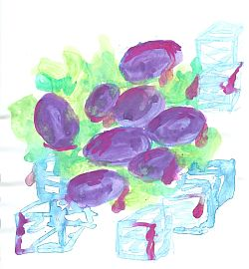
William Carlos Williams
This Is Just to Say
I have eaten
the plums
that were in
the icebox
and which
you were probably
saving
for breakfast
Forgive me
they were delicious
so sweet and
so cold

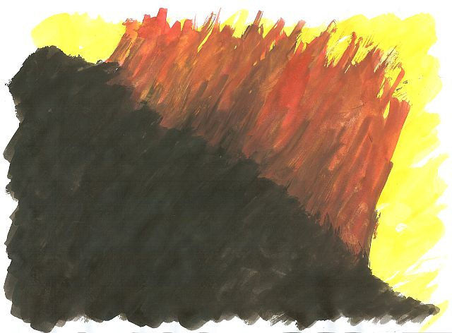

- Writing poems: students choose an object (sea-shell, stone, plastic toys, postcard….) and collect ideas on a sheet. Only single words are allowed. (10min) Then write a poem using (only) the words they have collected. Give the students a choice of formats e.g.: recipe poem, haiku, acrostic poem, limerick, visual poem…(see previous section)

- Line-breaking: Type a poem as run-on text. Ask students to rearrange the lines in form of a poem and decide where to break the lines. Compare different student versions, then show original and discuss the effects of the different versions.

- Sonnets: Teach typical rhyme and rhythm of sonnets, then cut up a sonnet – students reassemble it correctly.

- Working with parodies: Show students some parodies of famous poems (e.g. Roger Tagholm, Poems not on the Underground (Tagholm 2001)). Students choose a famous poem and write their own parody. Students may use internet poetry pages to find famous poems and parodies.

- Poem into short story: Find 3-4 poems where the speaker has a clearly identifiable problem. Students choose one poem and write a short story based upon it. The speaker of the poem becomes the protagonist of their short story.

- Themes in Poetry: Collect several poems around a theme (war poems, love and lust poems, dreams and nightmares, civil rights, growing up, family, …) Do some of the above tasks.

- Poems and Paintings: Find famous poems that have inspired artists to paintings and vice versa. E.g: Icarus poems and paintings: Students read and discuss the myth, read different poems and discuss the different interpretations of the myth, then match poems with fitting paintings or paint their own. The following website is a great source of Icarus paintings: (http://www.island-ikaria.com/multimedia/ikarosart.asp)

- Use a painting (arts postcards or images of artwork on projector), students interpret the scene (collect ideas….) then write a poem or a short story about it. Hopper paintings work very well for this task (e.g.: The Automat...)

- Found poems: Hand out a recent newspaper article, advertisement or other prose text. Students highlight words they like and then use some of these words to make a poem. No extra words must be used. (The topic can be kept or changed, e.g. using a tourist brochure to praise or criticize tourism or a place…) See examples on page 74.

Examples of short poetry projects

Writing Haikus: Snapshots of America

After our trip to America we will produce a collection of our memories in the form of haikus.
A haiku is a minimalist form of poetry. The writer has 17 syllables through which to convey an experience.
A haiku is like a written snapshot. It recreates the atmosphere of a moment in 3 lines (5 syllables, 7 syllables, 5 syllables). Modern English haikus do not always follow this rule very strictly.
The content of a haiku is typically, but not always, focused on a small but important moment in a person’s everyday life. Part of writing a haiku is finding the ‘awe’ that is usually passed by without notice – the act of creating a haiku is the act of focusing our attention more closely than we might otherwise do. It is like a picture in close-up.
Sometimes haikus deal with important realizations (epiphanies) in a person’s life. Read the following examples and try to visualize the scenes and take in the atmosphere or understand the important realization.
Midday hush  the rasp of a mallard  calling his mate  Ray Rasmussen | on every icicle’s tip  a drop  of sunlight  Alexey Andreyev
street musicians resting –  red maple leaf  lands on the keyboard | second husband  painting the fence  the same green  Carol Montgomery p.
Tompkins Square –  an old man teaches Tai-Chi  to a crowd of pigeons  Paul Mena | a supermarket  in someone’s cart – beef, beer,  flowers and a child  Alexey Andreyev
what is that building?  cobble-stoned streets, glass canyons.  I’m tired. My feet hurt.  Margaret Hinchcliffe | with a flourish  the waitress leaves behind  rearranged smears  Dee Evetts
sunrise  I forget my side  of the argument  George Swede | thundering surf  seagull cries on the  bitter winds  Stonecrow

During our trip: Walk around with open eyes and take in all the little things that contribute to the atmosphere of a place or situation. Take mental snapshots as well as pictures of little things with your camera.

After the trip, go through your pictures and memories and choose one specific moment. Capture your impression in a haiku. Layout your haiku nicely and add your picture.
All your haikus will be collected in our book “Snapshots of America” and the best ones will be published in the GIBS yearbook.

More examples of haikus

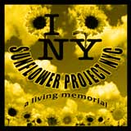
What it’s about
The Sunflower Project NYC started in the Spring of 2002 as a living memorial planting project to remember the people lost on September 11th, to honor their families, to thank the people everywhere who contributed to the recovery, and to make our world better, one patch at a time.
The idea is for individuals, groups and communities to create their own sunflower memorials everywhere—to remember and honor life with living, growing symbols of renewal and hope.

A fork in my bag.  Next to my comb some wet seeds.  Armed and dangerous. | Armed with black seeds  I glance around furtively  then complete my task
Dig hole with chopstick  Make sure seed goes into hole  Mission accomplished | Look at me strangely  Wonder why I'’ poking dirt  Doesn'’ everyone?
Watering something?  Not me, I just spilled water...  for the seventh time | Planting sunflowers.  Large Federal Agent says  "“et'’ see some ID"”
In New York, Cher can  strut nude-—o notice. Plant seeds?  People stop. What'’ that? | Small dog and small mind  in tow, local Tree Lady  watches me closely.
online: site no longer available

Found Poetry

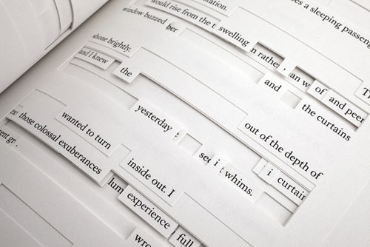
Found poetry is the rearrangement of words or phrases taken randomly from other sources (such as clipped newspaper headlines, bits of advertising, handwritten cards …) in a manner that gives the rearranged words a completely new meaning.
A famous example of found poetry – or “found writing” is Jonathan Safran Foer’s book Tree of Codes, which is based on The Street of Crocodiles by Bruno Schulz. Foer has used it as a canvas, cutting into and out of the pages, to arrive at an original new story.
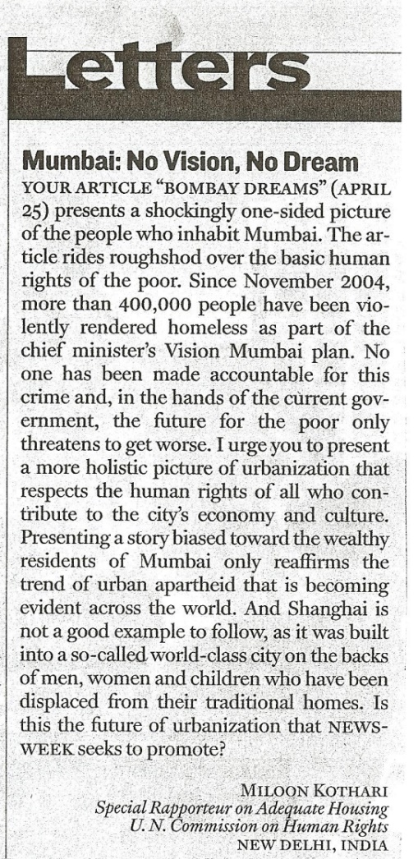
The following examples written by GIBS students of year 7 are based on two letters to the editor of Newsweek.
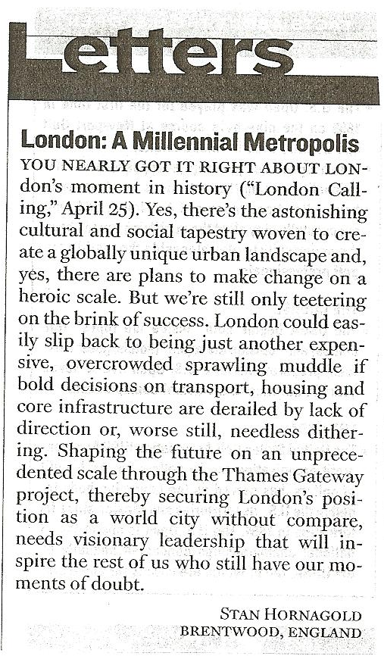

London
Inspiring world city without compare
Globally unique urban landscape
Cultural tapestry woven to create
Change on a heroic scale

But we are still only teetering on the brink
derailed by lack of direction
another expensive,
overcrowded muddle,
full of doubt.
Bombay Dreams of Urbanization
on the backs of
men
women
and
children
displaced
and
homeless.
Who is to blame?

Let’s LOOK at Imagist Poetry

Imagism was a brief, complex yet influential poetic movement of the early 1900s, a time of reaction against late nineteenth-century styles in poetry as well as painting and architecture which was flowery and ornate.
In contrast, imagist poems are very short and describe one pure image or emotion. Imagist poets avoid any superfluous word. The image itself is the meaning.
- Read the following Imagist poems and try to imagine the scenes in detail. Share your mental images with a partner or small group.
- Choose your favorite poem and do the task “art beyond sight” on the next page.

In a Station of the Metro

The apparition of these faces in the crowd;
Petals on a wet, black bough.

Ezra Pound
The Red Wheelbarrow

so much depends
upon

a red wheel
barrow

glazed with rain
water

beside the white
chickens.

William Carlos Williams

The City

In the morning the city
Spreads its wings
Making a song
In stone that sings.

In the evening the city
Goes to bed
Hanging lights
Above its head.

Langston Hughes

The Toaster

A silver-scaled dragon with jaws flaming red
Sits at my elbow and toasts my bread.
I hand him fat slices, and then, one by one,
He hands them back when he sees they are done.

William Jay Smith

Apartment House

A filing cabinet of human lives
Where people swarm like bees in tunnelled hives,
Each to his own cell in the covered comb,
Identical and cramped -- we call it home.

Gerald Raftery

Parodies
Read the following famous sonnets and their parodies. Then choose a sonnet (online) and write your own parody.
Sonnet at Journey’s End
Shall I compare thee to a ticket collector?
Thou art more lovely and more even tempered
(‘T would not be hard!)
Rough hands do take the darling tickets of May
And one’s yearly Season hath all to short a date.
Sometimes my photocard is checked
Other times I am waved through at the gate:
This inconsistency doth leave me perplex’d
But ‘tis not the traveller’s place to question why,
For I know that at my journey’s end –
(Despite snow that doth have some error and
Leaves that lieth where they shouldst not) –
I shall find thee waiting by our fire’s grate,
And thy eternal summer shall never fade
Even though Knapp’s boys often make me late.
(Tagholm 2001, 49)
Composed upon Oxford Street
Earth has plenty to show more fair:
Dull would he be of soul who could enjoy
Sights so grating in their commerciality:
This Street now doth, like an old rag, defile
The beauty of the morning; noisy, full,
Shops, department stores, burger bars and boutiques lie
Open unto the pavement, and to the sky;
All tacky and glittering in the fume-filled air.
Often did sun more beautifully bless
In his first splendour valley, rock or hill;
Ne’er saw I, and felt, a cacophony so deep!
The buses do charge at their own sweet will:
Dear God! The very pigeons seem tawdry and cheap;
And beneath the Street Londoners on the Central feel ill!
(Tagholm 2001, 17)
William Shakespeare, SONNET 18
Shall I compare thee to a summer's day?
Thou art more lovely and more temperate:
Rough winds do shake the darling buds of May,
And summer's lease hath all too short a date:
Sometime too hot the eye of heaven shines,
And often is his gold complexion dimm'd;
And every fair from fair sometime declines,
By chance or nature's changing course untrimm'd;
But thy eternal summer shall not fade
Nor lose possession of that fair thou owest;
Nor shall Death brag thou wander'st in his shade,
When in eternal lines to time thou growest:
So long as men can breathe or eyes can see,
So long lives this and this gives life to thee.
Composed Upon Westminster Bridge,
September 3, 1802
William Wordsworth
Earth has not anything to show more fair:
Dull would he be of soul who could pass by
A sight so touching in its majesty:
This City now doth, like a garment, wear
The beauty of the morning; silent, bare,
Ships, towers, domes, theatres, and temples lie
Open unto the fields, and to the sky;
All bright and glittering in the smokeless air.
Never did sun more beautifully steep
In his first splendour, valley, rock, or hill;
Ne'er saw I, never felt, a calm so deep!
The river glideth at his own sweet will:
Dear God! the very houses seem asleep;
And all that mighty heart is lying still!
-- William Wordsworth

To come or not to come: that is the question:
Whether ‘tis nobler in the mind to suffer
The looks and questions of well-meaning teachers
Or to take refuge in your bed
And by ignoring end them? To sleep; to nodd off,
No more; and by dreaming to say we end the workshops,
The exams, the thousand questionings
That school is heir to, ‘tis an escape devoutly to be wish’d.
To dream, to have a kip,
To sleep; perchance to miss another day: ay, there’s the rub...
(PÖ, for one of her students. With apologies to you know who.)

Contract

I commit myself to trying out the following two projects or activities which I have learned in this seminar.

1

2

I will try these activities within the next two months and will then share my experiences with my

colleague: (name) _________________________________(e-mail: )___________________________

My signature: _____________________________________

My colleague’s signature: ____________________________

Works Cited
Bassnett Susan, Grundy Peter. 1993. Language through Literature. Essex: Longman Resource Books.
Boardman Moen, Christine. 1992. Better Than Book Reports. Scholastic Professional Books.
Collins, Billy. 2014. Poetry Foundation.org. Accessed 2 27, 2014. http://www.poetryfoundation.org/poem/176056#poem.
Council of Europe. 2007. EPOSTL: European Portfolio for Student Teachers of Languages. Strassbourg: Council of Europe Publishing.
Indiana Department of Education. 2012. 03. Accessed 03 2013. http://crossculturalargentina.files.wordpress.com/2012/03/icebergculture.gif.
Robb, Laura. 2000. 50 Fabulous Discussion Prompt Cards. New York: Scholastic.
Szabos, J. 1984. Reading, A Novel Approach. Good Apple Inc.
Tagholm, Roger. 2001. Poems not on the Underground: A parody edited by "Straphanger". London: The Windrush Press.

Other useful Sources:
USEFUL WEBSITES:
http://epep.at/ Elisabeth Pölzleitner’s website for language teachers
http://rezensionen.schule.at/ Christian Holzmann’s website with reviews of literature for classroom use which are organized according to themes.
http://www.ala.org/alsc/ American Library Association: Association of Library Services to Children
http://www.ala.org/yalsa/ American Library Association: Young Adult Library Services Association
http://www.bookcentre.ca/ Canadian Children’s Book Centre (CCBC)
http://gws.ala.org/category/literature-languages Links to authors’ & illustrators’, expanding the classics, favorite children’s stories websites and more.
http://www.clcd.com/ Children’s Literature Comprehensive Database
http://people.ucalgary.ca/~dKbrown/ The Children’s Literature Web Guide – Internet Resources Related to books for Children and Young Adults
http://www.education.wisc.edu/ccbc/ The Cooperative Children’s Book Center, University of Wisconsin-Madison
http://www.cynthialeitichsmith.com/
http://americanindiansinchildrensliterature.blogspot.co.at/ American Indians in Children’s Literature provides perspectives and analysis of indigenous peoples in children’s and young adult books.
http://www.fairrosa.info/ Fairrosa Cyber Library of Children’s Literature
http://www.reading.org/ International Reading Association
http://comminfo.rutgers.edu/professional-development/childlit/ChildrenLit/index.html Kay E. Vandergrift’s children literature page
http://comminfo.rutgers.edu/professional-development/childlit/ Kay E. Vandergrift’s Special Interest Page
http://www.usbby.org/index.htm /
The United States Board on Books for Young People (USBBY) serves as the U.S. national section of the International Board on Books for Young People (IBBY), which was founded to promote international understanding and good will through books for children and adolescents.
http://ccb.lis.illinois.edu/guide.html The Center for Children Books
http://www.carolhurst.com/index.html

Teacher’s comment: The text is actually a literary essay – but the student has never heard of this genre at this point.

