Rod Bolitho
https://www.youtube.com/watch?v=FvdEWt10yQk
Elephants in the Classroom:
Idiom: the elephants in the room… are issues that are too big and too important to be ignored, they have to be dealt with.
3 Elephants in the Classroom
- Tradition
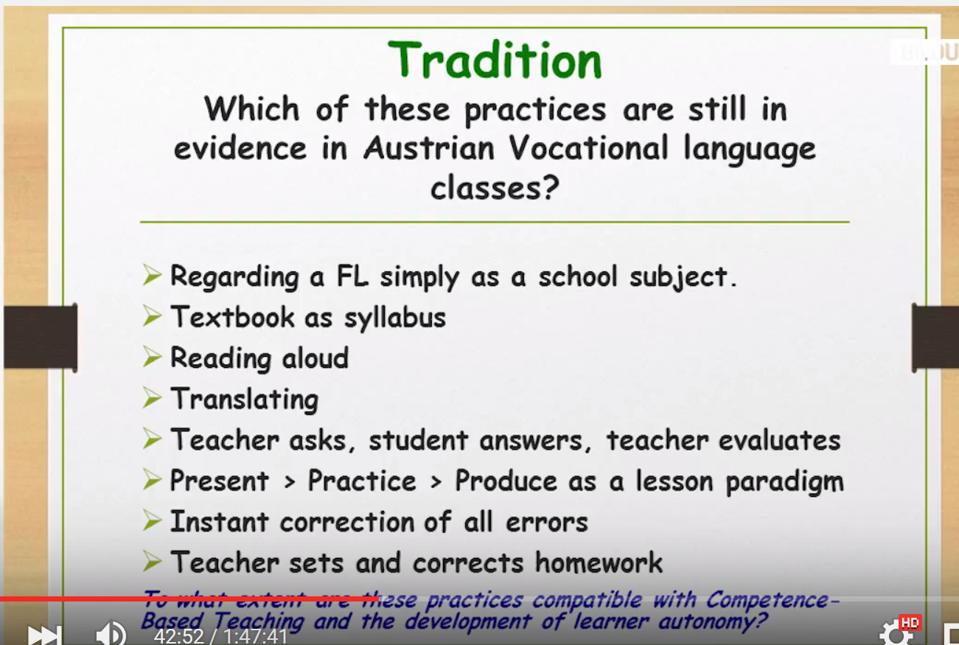
- Standards
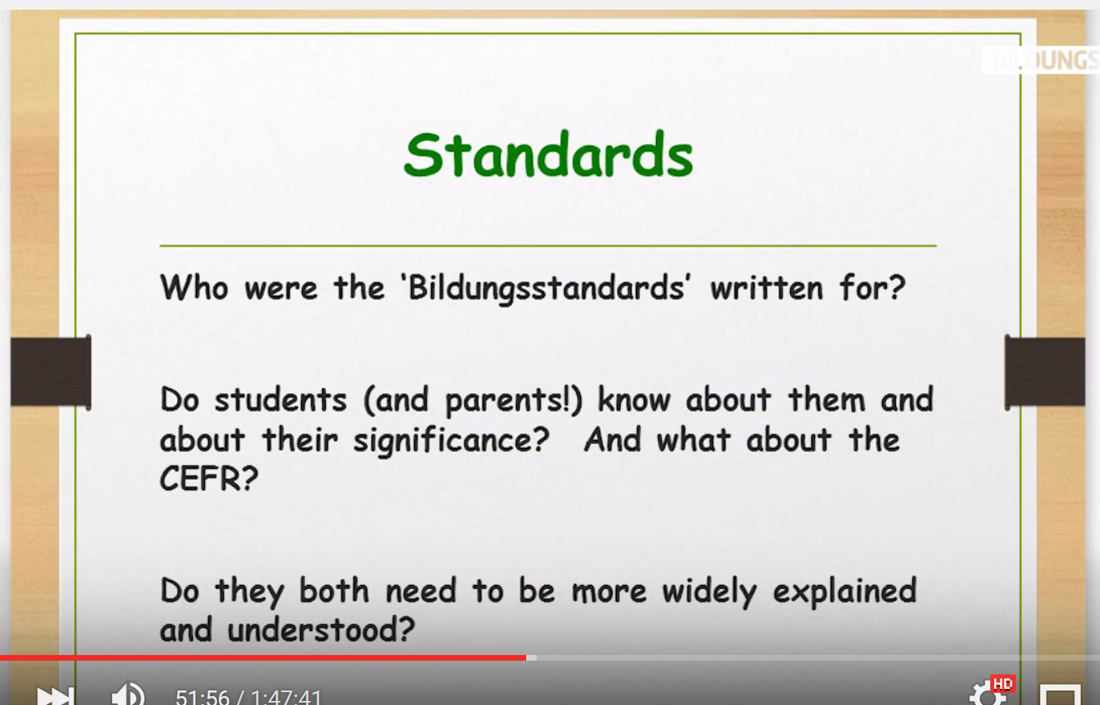
- Assessment Practices
