Teaching Vocabulary Efficiently
  - Dr. Elisabeth Pölzleitner
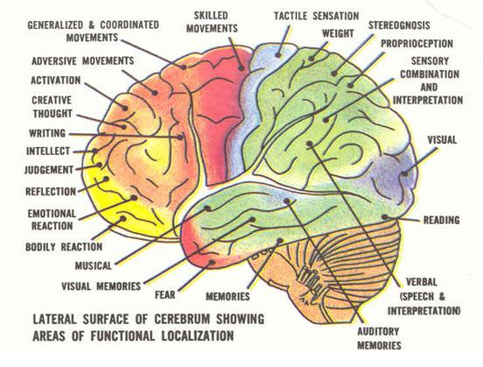

Figure 1: (Lee, 2011)

Figure 2: (Tanushree, 2011)

Types of Memory (Stevick, 1996)
Draw a sketch of these processes.
short term memory | - recall within 15-18 seconds  - unintentional, unconscious  - electrically disruptible storage
working memory or “The Worktable” (Stevick, 1996, S. 27) | - gives access to whatever is currently in the electrically disruptible short term memory (Stevick, 1996, S. 29).  - We can use this memory intentionally, to repeat items, to compare things … (strategies)  - limited capacity, influenced by the “affective filter”  - capacity can be increased by “chunking” (Stevick, 1996, S. 31)  - the chunks increase in size as the student gains in experience
long term memory | - can store an amazing amount and variety of information for a long time  - no direct access, content can only be modified by activities on the “Worktable”. Stevick describes a “two-way traffic between the Worktable and the Files (which is) both continuous and complex. Configurations of sensory data are constantly appearing on the Worktable and evoking the retrieval of various kinds of memories from the Files. These memories in turn work with the other material on the Worktable to trigger the formation of new configurations for storage in the Files, and so on. “ (Stevick, 1996, S. 30)
declarative memory (Stevick, 1996, S. 32 f.) | - conscious, articulable, explicit knowledge  - not all learning starts with declarative knowledge (e.g. child learning to walk, swim, speak…)  - can lead to procedural knowledge by doing sth. (knitting, driving…)  - explicit knowledge (the ability to recite the rules) is quickly lost (e.g. position of letters on keyboard – vs. typing)
procedural memory | - implicit knowledge, e.g. driving, knitting, patterns and regularities of language  - cannot be articulated (only by painstakingly reconstituating the rules)  - can be influenced by activity on the Worktable
episodic memory  (Stevick, 1996, S. 37) | - memories of specific situations, including information about different context aspects (place, time, emotions, sounds…..)  - contains personal, dated, autobiographical experiences
semantic memory | - general knowledge of concepts and meanings  - includes information about what usually belongs together (context, collocations, sensations…)
purposes, motifs, intentions | - purposes, motifs and intentions strongly influence the processes on the Worktable and thus have a strong effect on the learning outcomes (Stevick, 1996, S. 7)  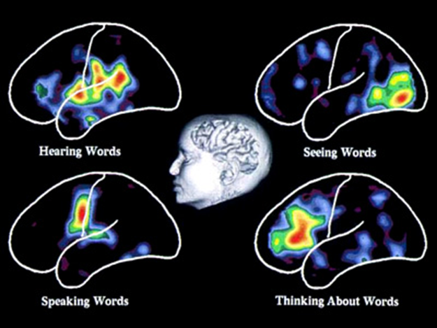  - only relevant information is processed, the rest (99% or more) is discarded immediately
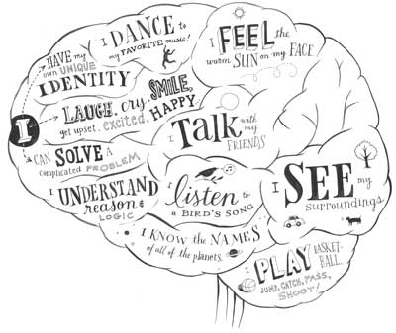

Figure 3: (Living with Alzheimer's, 2011)
Figure 4: (Brain-Functions, 2009)


In recent years educators have explored links between classroom teaching and emerging theories about how people learn. Exciting discoveries in neuroscience and continued developments in cognitive psychology have presented new ways of thinking about the brain-the human neurological structure and the attendant perceptions and emotions that contribute to learning. Explanations of how the brain works have used metaphors that vary from the computer (an information processor, creating, storing, and manipulating data) to a jungle (a somewhat chaotic, layered world of interwoven, interdependent neurological connections).

Implications for Teaching
Recent Research Suggests | Teaching Suggestions
The brain performs many functions simultaneously. Learning is enhanced by a rich environment with a variety of stimuli. | Present content through a variety of teaching strategies, such as physical activities, individual learning times, group interactions, artistic variations, and musical interpretations to help orchestrate student experiences.
Learning engages the entire physiology. Physical development, personal comfort, and emotional state affect the ability to learn. | Be aware that children mature at different rates; chronological age may not reflect the student's readiness to learn.  Incorporate facets of health (stress management, nutrition, exercise) into the learning process.
The search for meaning is innate. The mind's natural curiosity can be engaged by complex and meaningful challenges. | Strive to present lessons and activities that arouse the mind's search for meaning.
The brain is designed to perceive and generate patterns. | Present information in context (real life science, thematic instruction) so the learner can identify patterns and connect with previous experiences.
Emotions and cognition cannot be separated. Emotions can be crucial to the storage and recall of information. | Help build a classroom environment that promotes positive attitudes among students and teachers and about their work.  Encourage students to be aware of their feelings and how the emotional climate affects their learning.
Every brain simultaneously perceives and creates parts and wholes. | Try to avoid isolating information from its context. This isolation makes learning more difficult.  Design activities that require full brain interaction and communication.
Learning involves both focused attention and peripheral perception. | Place materials (posters, art, bulletin boards, music) outside the learner's immediate focus to influence learning.  Be aware that the teacher's enthusiasm, modeling, and coaching present important signals about the value of what is being learned.
Learning always involves conscious and unconscious processes. | Use "hooks" or other motivational techniques to encourage personal connections.  Encourage "active processing" through reflection and metacognition to help students consciously review their learning.
We have at least two types of memory: spatial, which registers our daily experience, and rote learning, which deals with facts and skills in isolation. | Separating information and skills from prior experience forces the learner to depend on rote memory.  Try to avoid an emphasis on rote learning; it ignores the learner's personal side and probably interferes with subsequent development of understanding.
The brain understands best when facts and skills are embedded in natural spatial memory. | Use techniques that create or mimic real world experiences and use varied senses. Examples include demonstrations, projects, metaphor, and integration of content areas that embed ideas in genuine experience.
Learning is enhanced by challenge and inhibited by threat. | Try to create an atmosphere of "relaxed alertness" that is low in threat and high in challenge.
Each brain is unique. The brain's structure is actually changed by learning. | Use multifaceted teaching strategies to attract individual interests and let students express their auditory, visual, tactile, or emotional preferences.
Source: From "Understanding a Brain-Based Approach to Learning and Teaching" by R. N. Caine and G. Caine, October 1990, Educational Leadership, 48(2), pp. 66-70. Copyright 1990 by Association for Supervision and Curriculum Development (ASCD). Adapted by Southwest Educational Development Laboratory (SEDL

(Caine & Caine, 1990)


Using the Memory Efficiently
Figure 5: (Flickr, 2009)

Networks of Meaning:

The ISM Model
According to Ahsen’s ISM model (Ahsen, 1984) our memory stores “multisensory images” consisting of Images, Somatic responses and Meanings (ISM). These three elements are constantly interacting and interlocking. In general it can be said, that what has been experienced personally is most memorable and will have the most visual and somatic elements attached, followed by richly imagined input, and lastly by input that has only been understood form words. (Stevick, 1996, S. 49)

Images:
- visual stimuli, things we have actually experienced
- mental images, things we have actively imagined
- imagery derived from descriptions in words
Somatic response:
- our body’s reaction to the sensory images (skeletal, muscular, endocrine changes…)
- may be very strong or fleeting and negligible, depending on the input

Meaning:
- includes the full spectrum including lexical meaning, expectations, involvements, purposes
- example: What does the word “bakery” include for you?

VMIs: Voice Movement Icons
The research of Macedonia also shows that meaningful multisensory input leads to better learning of new items. (Macedonia & Müller, 2011)

How to create multisensory images in the learners’ brains

Dos and Don'ts
- students select useful phrases from meaningful contexts | - never teach single words
- when writing vocab always write phrases rather than individual words | - discourage learners from writing vocab lists in the traditional 2-column vocab-books
- practice collocations
- use all the senses (see activities on the next page)
- make learners say the new phrases out loud several times
- when writing vocabulary use lots of space for each new item so learners can add collocations, sample sentences, doodles etc.
- translating a phrase is often more helpful than long and complex definitions in the target language

Vocabulary Practice Session
Work with a partner (no big groups, please)

1. VMIs: Choose 10 difficult phrases from your vocab-collection and find fitting voice-movement-icons for them. Play with these VMIs. Make the moves, your partner says the words, find a rhythm…

2. Doodling: Open your vocab collection on the first page, start with the first phrase of student A. Read out the phrase and imagine a scene around it. Try to visualize it, see a clear picture or situation. Then draw a quick and simple doodle/symbol/logo that somehow represents your phrase. Explain your doodles to each other. Do they have anything in common?
Now it’s student B`s turn. Role a die and land on a new phrase on your first vocab page. Design new doodles for this phrase…
Do this for 5 phrases each.

3. Colors: Keep rolling the die to select random phrases.
For the next 10 phrases (5 of student A, 5 of student B) choose a typical color that reminds you of the phrase. Again try to visualize as much as possible. Explain your choice of color to each other.

4. Sounds: For the next 10 phrases try to “listen” to your phrases. What do you hear? Can you hear any background noises (e.g. For the phrase “Black Americans were discriminated against.” You might hear shouting, gunfire, rioting, sighs, crying…) Be creative and list all the sounds and noises you can imagine “around” your phrase.

5. Opposites: Find opposites or “diagonal opposites” for 10 recent phrases in your collection.

6. Usage -- Find a second example: Choose 10 new phrases from the texts we have recently read. Find a second example of the word’s usage in your MLD (or freesearch.co.uk) and add these to your collection.

7. Lexical Furniture: Find suitable places for 10 new phrases in your home and discuss them with your partner(s)Lexical Furniture:
Imagine your phrases are pieces of furniture. Where would you put them in your house? E.g.: I’d put the “scientist” into my bathroom, because it is white and sterile like a lab.
I’d put the phrase “the amount of water vapor will increase…” in my kitchen or bathroom. When I take a shower, there is a lot of water vapor in the air, when I boil water for pasta, the water vapor or steam rises from the pot.

Teaching and Revising Vocabulary

1. Active Vocabulary versus Passive Vocabulary: Making inferences and reducing anxiety
We all understand a lot more words than we will ever use! Ss should be aware of this fact. They need not know every single word in a text. Language is very redundant -- we can guess the meaning of unknown words by making inferences.
Practice making inferences by asking Ss to guess the meaning of unknown words (with the help of context clues, using their knowledge of word roots, pre- and suffixes, other languages....)
Fast-reading helps lower Ss anxiety of new and unknown words!!! There is no time to worry about them.
Cloze texts and C-tests also show the Ss that you need only part of the text to reconstruct the meaning.

2. Studying New Vocabulary

Vocabulary box:
Pro: By working with the vocab. box Ss regularly revise difficult words rather than going through endless lists of known words as they do with vocab. books. They use their hands and “manipulate” each expression
Con: Cardfiles may be messy, they are hard to check. Tip: Ss write the new words on cards and keep this new set in the very front of the box for the teacher to check. Only then can the cards be moved back! Also ask willing parents to help check the box!

Procedure:
Students write their new words on cards (A8) . The cards only contain one expression! The nicer they are the better!!! (Depending on the level of your students, encourage them to use some of the techniques below: drawing words, write yourself in, shapes, calligraphy, collocations, synonyms, antonyms...) SS then put the cards in the first category:

1. New Words I Want to Learn.

When studying vocab. the students work with the cards and are allowed to move them into the next category if they know the item and can spell it correctly. The following categories are titled:

front of card: German translation and/or drawing/doodle of the word
back of card: English word (always used in a short personalized sentence or a collocation:
e.g: “I’ve never been to GreeceH.” “Our English teacher is very strict”)



2. Recent words I know

3. Words I know well

(will eventually be stored in a shoe-box when vocab.box is full)


Working with the box:

Important: Practice this in class several times. Then students will do it at home.

Step 1. Walk and Talk
Students take a selection of new cards and walk up and down the hallway speaking the new phrases out loud. They try to find a rhythm for each phrase and repeat it many times until it sounds natural to them. For difficult phrases they also find a voice-movement-icon (VMI) that they associate with the word.

Step 2: Write and check
Students read the German phrase on a card and write the English translation into their vocab-practice books. Then turn over the card and check + correct if necessary.
The teacher can easily check the work by collecting the vocab-practice books from time to time.

Vocab Books and Vocab Cards
Word: Color/Picture/Doodle

Sentence I found in my reading:

Second example sentence from my dictionary:

Useful collocations:

Word: Color/Picture/Doodle

Sentence I found in my reading:

Second example sentence from my dictionary:

Useful collocations:

Word: Color/Picture/Doodle
provide
Sentence I found in my reading:
Monsanto provides the seeds for 90% of the world's genetically modified crops.
Second example sentence from my dictionary:
The Red Cross provides food and shelter for the refugees.
Useful collocations:
to provide accommodation, services,
the website provides answers to...
dinner is kindly provided by the club
He provided us with a lot of useful information

Word: Color/Picture/Doodle
sizzling
Sentence I found in my reading:
Witches hate children with sizzling and red-hot hatred
Second example sentence from my dictionary:
The sausages and burgers sizzled on the barbecue
Useful collocations:
sizzling hot
a frying pan of sizzling oil

Word: Color/Picture/Doodle
criticism
Sentence I found in my reading:
The government has received a lot of criticism for increasing taxes

Second example sentence from my dictionary:
Scientists have raised strong criticisms of creationist ideas.

Useful collocations  receive criticism  express criticism  provoke criticism  respond to criticism  avoid criticism | heavy criticism  constructive criticism  severe criticism  fierce criticism  bitter criticism

Read the following text and collect 10 useful collocations
Then prepare vocabulary cards for 5 of them.

The World According to Monsanto' - Exposing One of the Most Evil Corporations on Earth
- The Real News Network, June 23, 2008
Straight to the Source
Monsanto is a world leader in industrial agriculture, providing the seeds for 90 percent of the world's genetically modified crops. In an interview with The Real News Network, filmmaker Marie-Monique Robin discussed her recent film 'The World According to Monsanto' in which she exposes many of Monsanto's controversial practices, from concealing knowledge of toxicity of PCBs to producing genetically modified seeds and related herbicides.
Monsanto has a long history of manufacturing dangerous products. In 1949, an explosion in Nitro, a Monsanto factory in the US, caused 228 workers to develop an extremely disfiguring illness caused by dioxin, a highly toxic by-product of 2,4,5-T, a powerful herbicide manufactured in the factory.
Monsanto's product Roundup, an herbicide which Monsanto advertised as biodegradable, is still sprayed on crops by unprotected farmers in Paraguay even though Monsanto has already been convicted twice of false advertising for the product.
Robin also denounces Monsanto for not only denying that it ever heard of Agent Orange, a herbicide sprayed by the US Army on crops during the Vietnam war and which Monsanto had in fact manufactured, but also for manipulating scientific studies to hide links between Agent Orange and cancer.
According to Robin, Monsanto has bought fifty seed companies in the last ten years. In a clip from Robin's film, physicist and ecologist Dr. Vandana Shiva warns: "Once [Monsanto has] established the norm that seed can be owned as their property, we will depend on them. If they control seed they control food. It's more powerful than bombs. This is the best way to control the populations of the world."
In a Monsanto declassified file is found the sentence, "we can't afford to lose one dollar of business" even as toxicity of PCBs was discussed. This, Robin says, sums Monsanto's philosophy rather well.
Watch the full interview here: "The World According to Monsanto"
CONTACT: The Real News Network Alain Latour, 416-916-5202 smcommunications@therealnews.com
Read the following text and collect 5 useful collocations for lower intermediate learners.
Then prepare vocabulary cards for them.

A Note about Witches
from Roald Dahl, The Witches

In fairy-tales, witches always wear silly black hats and black cloaks, and they ride on broomsticks. But this is not a fairy-tale. This is about REAL WITCHES.
The most important thing you should know about REAL WITCHES is this. Listen very carefully. Never forget what is coming next.
REAL WITCHES dress in ordinary clothes and look very much like ordinary women. They live in ordinary houses and they work in ORDINARY JOBS.
That is why they are so hard to catch.
A REAL WITCH hates children with a red-hot sizzling hatred that is more sizzling and red-hot than any hatred you could possibly imagine.
A REAL WITCH spends all her time plotting to get rid of the children in her particular territory. Her passion is to do away with them, one by one. It is all she thinks about the whole day long. Even if she is working as a cashier in a supermarket or typing letters for a businessman or driving round in a fancy car (and she could be doing any of these things), her mind will always be plotting and scheming and churning and burning and whizzing and phizzing with murderous bloodthirsty thoughts.

Whole class activities for practicing collocations

Remember: the best way to learn new vocabulary is to use it actively in meaningful contexts. This is best done in a task-based approach where students work on a project actively and produce a high quality product. These products can be oral (interviews, radio-shows, presentations) or written (project books, articles, diaries…). By preparing their products in groups the students will be using the language more actively and they will speak and hear the new expressions many times and thus integrate them well into their existing networks.
Find ideas for such projects on epep.at: Reading projects, book-making, booklets, interviews, presentations, blogs…

Once in a while, it might still be helpful to do specific vocab-activities in class. The following games might be used for this purpose.

As Easy as Possible (Lewis, 2000, p. 104)

Two teams are competing against another. You will need one collocation dictionary per group.
Give each team a list of 10 nouns which are headwords in the collocation dictionary. Choose nouns that are appropriate to the level and interests of the learners.
Groups get 10 minutes to prepare: They list 5 common collocates from the dictionary for each noun.
Team A then slowly read out their collocates while team B try to guess the noun. Team B may write down the collocates as they are being read out.
If they guess correctly after one collocate, Team A scores 5 points, if they need 2 collocates team A scores 4 points and so on.
Teams A and B take turns guessing and reading their lists.

The Collocation Game: adapted from (Lewis, 2000, p. 104)
Prepare a list of nouns with lots of verb or adjective collocates.
Tell the learners that all the words in one list collocate with the same noun. They have to guess that noun.
When they think they know the noun, they stand up/or say “Bingo” and write the noun on their sheet.
This game can be played in teams or as a whole class. Learners collect points for their teams or for themselves.

Odd verb out
One verb in each line does not collocate with the noun. Cross out the one which does not fit.
- accept ,act on ,disregard ,follow ,ignore, make ,solicit, take ADVICE
- come up with, do, expect, get, require, supply AN ANSWER
- build up, close down, set up, put off ,take over ,wind up A BUSINESS
- deal with, do, examine, ignore, reject, respond to A COMPLAINT
- accept, answer ,come in for, give rise to ,make, reject CRITICISM
- describe, do, enjoy, have, recall ,share AN EXPERIENCE
- crash, finish ,hire, park, repair, run, service, start ,write off A CAR
- arrange, do, gatecrash, go to, have ,throw A PARTY

Vocabulary Quilt
Choose one of your favorite new expressions from your book and write it on a piece of colored paper. Write a short, typical sentence and decorate the paper in a suitable way. Your paper must include:
- the new word written in big letters
- a typical sentence
- a drawing that will help you remember the new phrase.
We will put all our word cards together to make a Vocabulary Quilt. Please design your cards nicely.

More Vocab Activities for groups

Synonyms:
Three essays, each pair gets one only
- Work with a partner. With the help of your dictionary find suitable synonyms for 10 words or phrases in the text.
- Write a list of these synonyms on a sheet in random order.
- Pass your text and the list of synonyms on to another group. Ask them to find the matching phrases in the text and write them next to your synonyms on the list
- Then work on the lists you get from the other two groups.

Oral Gaps:
Work with a partner. First read through one of the essays very carefully and make sure you know all the words. Use your dictionary. Together underline all the fancy expressions that you might not be able to use actively yourself.
Now take turns. Read a paragraph to your partner and stop before each underlined word. Ask your partner to supply the word…

Blackout
Hand out a page of text that is interesting and suitable for the learners. Allow students to read it and ask any vocab questions they might have. Make sure the learners understand the text.
Pairs then start blacking out parts of words and sentences with thick black markers. They read and re-read the text and keep blacking out more and more letters and words.
How far can they go --- and still read the text?
Option: The pair that can black out most wins a prize.

Try this with the following text:

Learning vocabulary by reading
The way you learned very many of the words in your own language was by meeting them in the books and magazines you read. The context of a new word in a sentence or story was often enough for you to guess the meaning. Meeting the word again and again in your reading helped you learn it for use in your own speaking and writing. Doing lots of extra reading for pleasure - both fiction and non-fiction - is an excellent way to learn new English words, too. But choose books that you find quite easy to read. Difficult stories or texts that you struggle to understand will not help you to develop your vocabulary the natural way. But remember: to learn new words from reading you have to read A LOT!

Whole Class Games:
- Bingo
- Domino-Race (Classrooom phrases)
- Find your partner

Group Games and Activities:

Boardgames
- Voctivity
- Stare
- The House Game
- Personality Traits
- Animals that begin with...

Card games
- Triangles
- Speed Matching
- Pairs
- Happy Families
- Twins

Voctivity

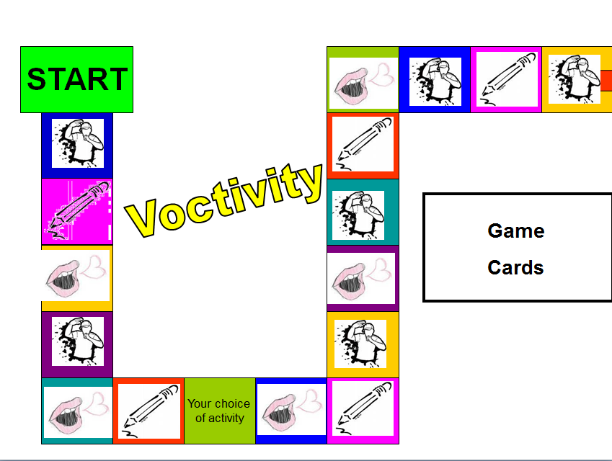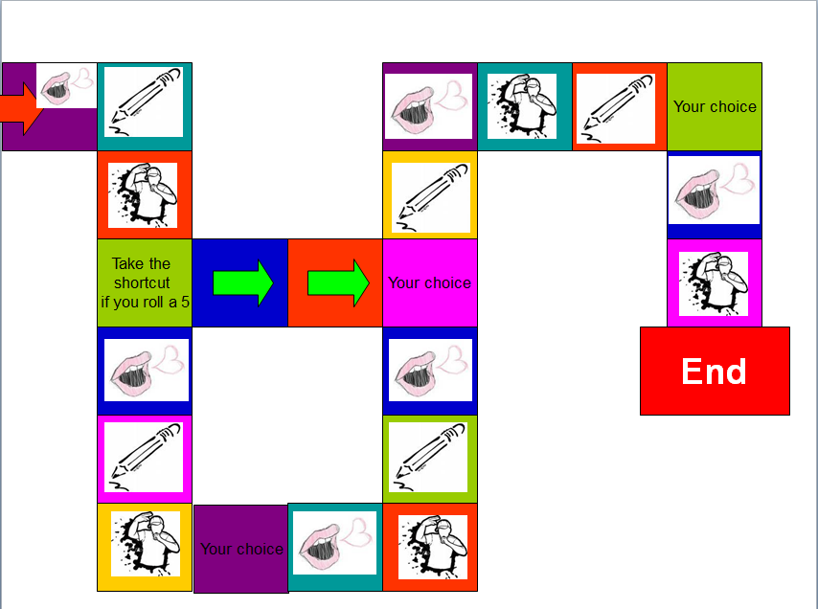

Rules of the Game:
Write or choose 5 new vocab cards per person. Put them in the center. Use these cards as in the game “Activity”. Act, draw or paraphrase the word or phrase on your card. The player who guesses what you are showing may go next.
If you find the game very difficult, go through all the cards before you play and make sure you understand all the phrases that your friends have chosen.

You can download this and other games from the vocab section on my homepage: http://epep.at

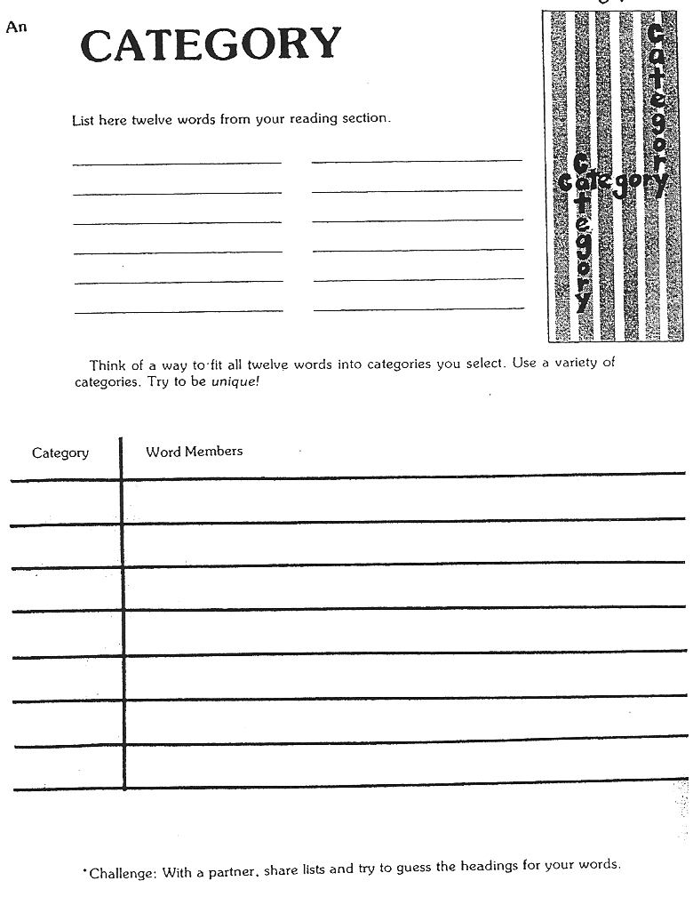
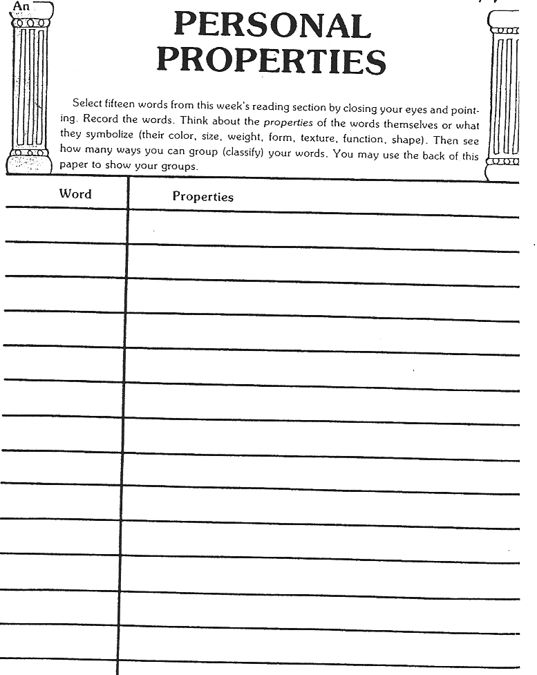

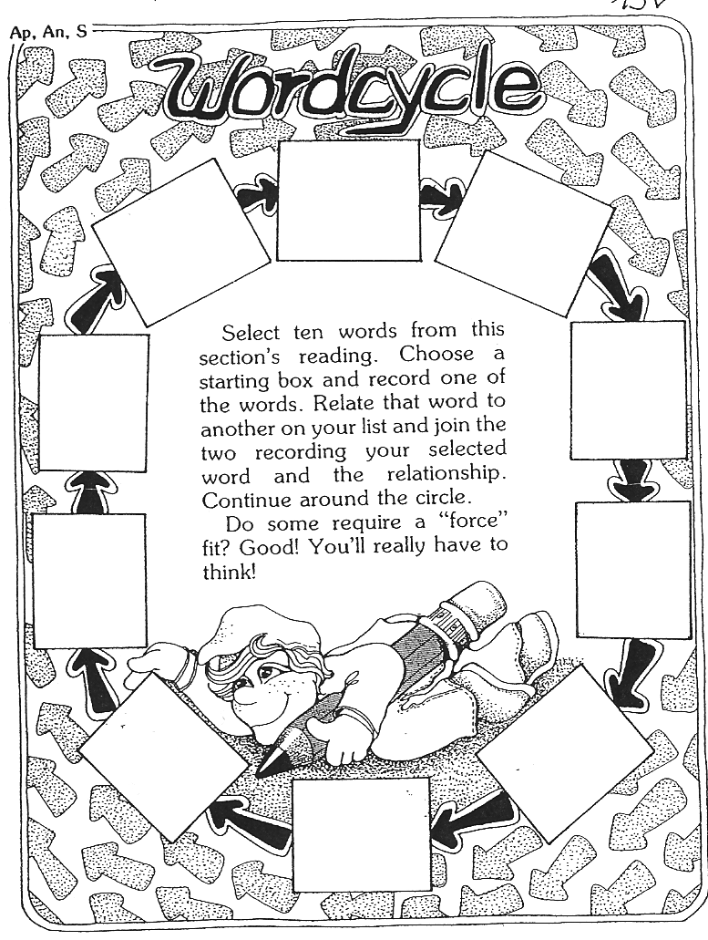

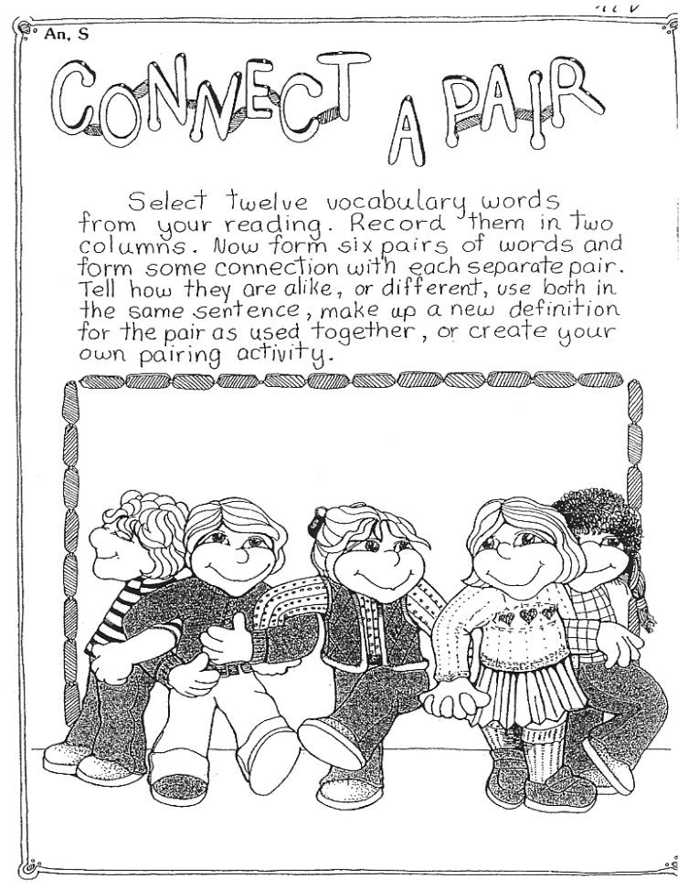

Find these and many more excellent activities in Janice Szabos et al., Reading, A Novel Approach, Good Apple Inc., 1984 (Szabos & Filkins, 1984)
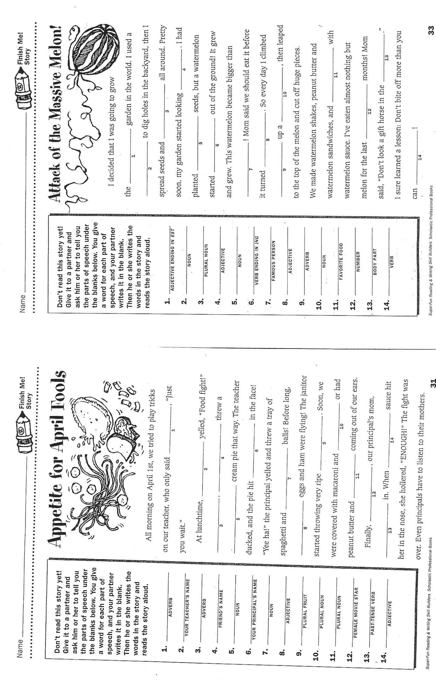

Source: Super-Fun Reading &Writing Skill Builders, (Scholastic Professional Books, 1999)

Testing Vocabulary

Remember: Use 99% of your class-time for teaching and only 1% for testing. If you teach a lot and students are ACTIVELY using the language in class, they will learn a lot more than by studying vocab for a test or revision. In task-based learning the students will meet and use the new vocabulary items many times in order to complete a project. By doing these activities they will build multidimensional networks as discussed above and will thus integrate the new vocabulary into their permanent storage. Encourage the learners to choose items they find useful and want to remember and transfer these on vocab cards or into their vocab books.
In some cases a short vocab revision might still be useful. Just like teaching vocab, always test vocabulary IN MEANINGFUL CONTEXT.

What do you want to test? For a good presentation about testing vocabulary, go to
http://www.slideshare.net/songoten77/testing-vocabulary
You will also find the link on the vocab page on http://epep.at
- Word recognition and comprehension?
- Word usage?
- Word building and word form?
- Spelling?

Useful test-formats:
- Describe the picture: (e.g.: picture of classroom// Name 10 things you see in Sally’s pencil case// What is Peter wearing today? // Describe the atmosphere of the picture. For more advanced students use postcards, pictures from the textbooks… Describing a picture can also be used as an oral vocab exam.
- Writing short text passages or dialogues: (e.g.: Give weather symbols, students write forecast for the following days.//

- Gap filling: Give the first letter or a jumbled version of the missing word where the first and last letters are correct. If a student knows the word he/she will immediately recognize it, if the student doesn’t know the word, these letters won’t help much.
  - Try this: Arocdnicg to rsceearch at Cmabrigde Uinervtisy, it deosn’t mttaer in waht oredr the ltteers in a wrod are, the olny iprmoatnt tihng is taht the frist and lsat ltteer are in the rghit pcale. The rset can be a toatl mses and you can sitll raed it wouthit pobelrm. Tihs is buseace the huamn mnid deos not raed ervey lteter by istlef, but the wrod as a wlohe.

- Oral Vocab Revisions: Students bring their vocab box, teacher asks 10 random cards while the class is working on other things.

- Crosswords: Use very clear clues or pictures.

- Matching and multiple-choice: not recommended – It is very difficult to produce good tests. If you really want to use these, check this website for ready-made tests:
  - http://www.vocaboly.com/vocabulary-test/
- Textwriting: In the new assessment scales “lexical and structural range” are important criteria for assessment. Make this visible for the learners. Always give feedback on style and range of vocabulary. Do not only mark the wrong expressions. This will lead to avoidance strategies. Reward and praise experimenting with language, even if the outcome is not yet perfect.

Works Cited
Ahsen, A. (1984). ISM: The triple code model for imagery and psychophysiology. Journal of Mental Imagery, 8(4), 15-43.
Caine, R., & Caine, G. (1990). Understanding a Brain-Based Approach to Learning and Teaching. Educational Leadership, 48(2), 66-70.
Lewis, M. (2000). Teaching Collocation. Heine.
Macedonia, M., & Müller, K. (2011). The impact of iconic gestures on foreign language word learning and its neural substrate. Human Brain Mapping, 982-998.
Scholastic Professional Books. (1999). Super-Fun Reading and Writing Skill Builders. Scholastic Professional Books.
Stevick, E. W. (1996). Memory, Meaning and Method. Boston: Heinle.
Szabos, J., & Filkins, V. (1984). Reading, A Novel Approach. Good Apple Inc.

Image Sources:
Tanushree. (2011, 03 04). Retrieved 11 06, 2011, from India Talkies: http://www.indiatalkies.com/2011/03/brain-functions-based-familys-genes.html
Lee, R. (2011, 10 06). Flickr. Retrieved 11 06, 2011, from http://dickinsonn.ism-online.org/files/2011/10/Neurons-in-the-brain-illustration-by-Rebecca-Lee-on-flickr.jpg
becindonesia.com. (2009, 07). Retrieved 11 6, 2011, from http://www.becindonesia.com/smg/wp-content/uploads/2009/07/Brain-Functions.jpg
Flickr. (2009, 03 21). Retrieved 11 06, 2011, from Flickr: http://www.cogiscent.com/wp-content/themes/thesis/rotator/neural%20network%20rotator.jpg
Living with Alzheimer's. (2011, 08 06). Retrieved 11 06, 2011, from alz.org: http://www.alz.org/living_with_alzheimers_your_brain.asp

Useful Books for Teaching Vocabulary
Buchers, S. (2007). Vocabulary Cartoons II. Punta Gorda FL: New Monic Books.
Gough, C. (2002). English Vocabulary Organizer. Andover, UK: Heinle, Cengage Learning.
McCarthy, M., & Felicity, O. (2008). Academic Vocabulary in Use. Cambridge: Cambridge University Press.
McCarthy, M., & O'Dell, F. (2007). English Phrasal Verbs in Use, Advanced. Cambridge: Cambridge University Press.
Morgan, J., & Rinvolucri, M. (1986). Vocabulary, Resource Books For Teachers. Oxford: Oxford University Press.
Redman, S., & Ellis, R. (1989). A Way With Words, Book 1. Cambridge: Cambridge University Press.
Ridzka, B., Channell, J., Putseys, Y., & Ostyn, P. (1981). The Words You Need. London: Macmillan .
Scholastic Professional Books. (1999). Super-Fun Reading and Writing Skill Builders. Scholastic Professional Books.
Szabos, J., & Filkins, V. (1984). Reading, A Novel Approach. Good Apple Inc.
Woolard, G. (2005). Key Words for Fluency, Intermediate. London: Thomson.

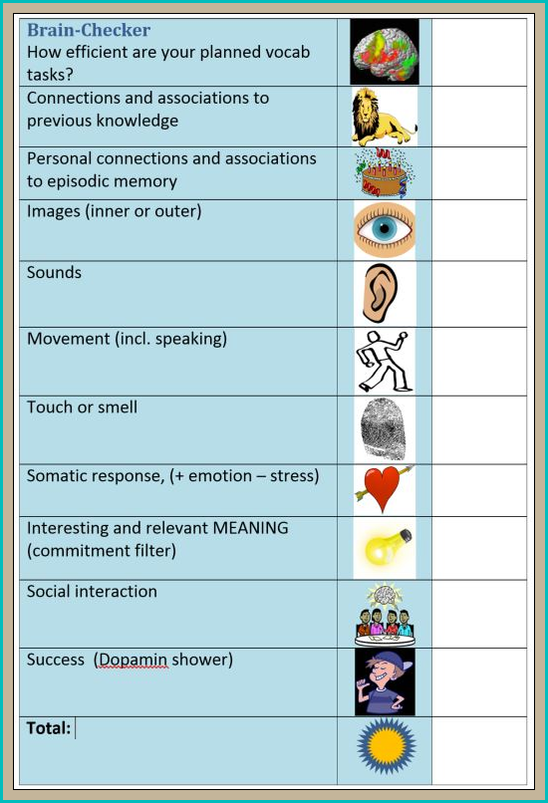

Older students can also add a few collocates.

