Solutions and Teacher' Notes

Story: reada them the story at the beginning --- later see if they have rememberd the empotional content better than the rest:
Neurodidaktik, p.68

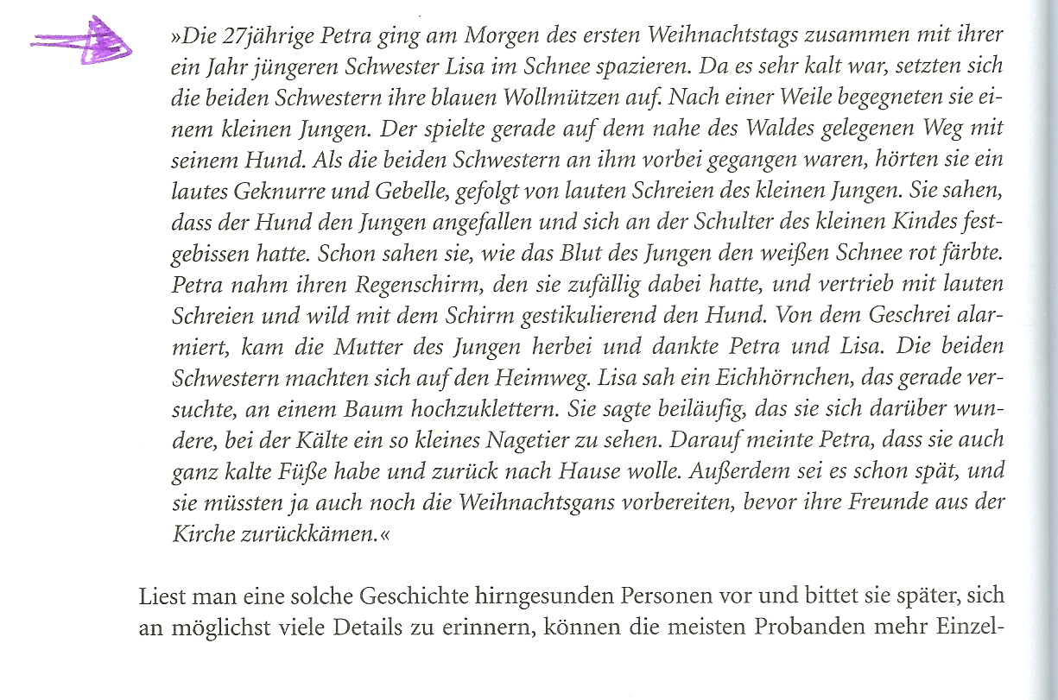

A Wound and an Injury
stab wound
internal injuries
Oxford Collocations Dictionary for Students of English, 2nd edition
wound noun
adjective
deep , serious , severe
fatal
a fatal gunshot ~
minor
flesh
Despite the large amount of blood, it was only a flesh ~.
clean
gaping , open
surgical
bleeding , festering ( often figurative ) , infected
The animal died from an infected ~.
face , head , leg , etc.
bullet , gunshot , knife , shrapnel , stab
multiple
He had suffered multiple stab ~s to his chest.
entry , exit
The exit ~ made by the bullet was much larger than the entry ~.
puncture , slash
She suffered numerous slash and puncture ~s to her arms and upper body.
old
war
His old war ~s still ached in certain weathers.
self-inflicted ( often figurative )
The President's self-inflicted ~s have called his credibility into question.
emotional , psychological
verb + wound
inflict
receive , suffer , suffer from
examine , probe
bandage , clean , cleanse , cover , dress , treat
nurse

Oxford Collocations Dictionary for Students of English, 2nd edition
injury noun
adjective
appalling ( esp. BrE ) , bad , catastrophic , devastating , horrendous , major , nasty , serious , severe , terrible
crippling
fatal
multiple
extensive
minor , slight , superficial
traumatic
acute
old
lingering ( esp. AmE ) , nagging , niggling ( esp. BrE ) , recurring
long-term
permanent
Researchers have determined that heading a football can cause permanent ~.
career - ending ( esp. AmE ) , career - threatening , season - ending ( esp. AmE ) ( all sports )
accidental
internal
visible
facial , head , knee , leg , spinal , etc.
burn , whiplash
sports , sports - related
industrial , work - related

Oxford Collocations Dictionary for Students of English, 2nd edition
earthquake noun
adjective
big , great , huge , large , major , massive , powerful , severe , strong
devastating
minor , small
undersea , underwater
the tsunami caused by an undersea ~
verb + earthquake
cause , trigger
experience
The area has not experienced a major ~ in more than 700 years.
feel
I don't understand why we felt the ~ and you didn't.
survive , withstand
The school was built to withstand ~s.
predict
You can't accurately predict ~s.
record
It was the biggest ~ ever recorded in the US.
earthquake + verb
happen , hit (sth) , occur , strike (sth)
The ~ hit the city at two in the morning.
rock sth , shake sth
The ~ shook buildings throughout the business district.
destroy sth , devastate sth , kill sb , leave sb homeless
cause sth
measure sth
an ~ measuring 5.8 on the Richter scale
earthquake + noun
activity
an organization which monitors ~ activity
zone
survivor , victim
damage
prediction
hazard , risk
preposition
in a/the ~
The building was destroyed in an ~.
phrases
the epicentre / epicenter of an ~
the evacuation of coastlines within 600 miles of the earthquake's epicentre/epicenter
the magnitude of an ~
© Oxford University Press, 2009

Oxford Collocations Dictionary for Students of English, 2nd edition
victim noun
adjective
hapless , helpless , innocent , poor , unfortunate , unwilling
He defrauded his innocent ~s of millions.
unsuspecting , unwitting
easy
Tourists are easy ~s for pickpockets.
passive
willing
In his fantasies, women became passive and sometimes even willing ~s.
intended , potential
The intended ~s were selected because they seemed vulnerable.
alleged
primary
Boys are the primary ~s of corporal punishment.
child , elderly , young
the child ~s of the war
female , male
civilian
injured
AIDS , cancer , heart-attack , plague , stroke
burn ( esp. AmE ) , burns ( BrE )
genocide , Holocaust
bomb , bombing
accident , crash
disaster , earthquake , famine , flood , hurricane , tsunami
The government is sending aid to flood ~s.
abuse , assault , crime , domestic - violence , homicide ( esp. AmE ) , identity-theft , incest , kidnap , lynching ( esp. AmE ) , murder , rape , terror , torture , etc.
The helpline takes calls from child-abuse ~s.
the failure to protect domestic-violence ~s

verb + victim
be , become , fall
ways to avoid becoming a ~ of fraud
Her son fell ~ to tuberculosis.
portray sb as
In his trial, he tried to portray himself as the ~ of an uncaring society.
aid , assist , help
rescue , save
treat
choose , select , target
He targeted younger ~s, often single women.
identify
Not all ~s have been identified yet.
bury
victim + verb
die
survive (sth)
suffer (sth)
The ~ suffered severe cuts to the upper lip.
Oxford Collocations Dictionary for Students of English, 2nd edition
survive verb
adverb
well
The frescoes have ~d remarkably well.
Seedlings ~ better in stony soil.
barely , hardly
The islanders could barely ~ without an export crop.
just , just about , narrowly
I can just about ~ on what I earn.
He narrowly ~d several assassination attempts.
(for) long
Nobody can ~ long without water.
still
Only one copy of the book still ~s.
miraculously
A young boy miraculously ~d a 25 000-volt electric shock.
somehow
verb + survive
struggle to
poor people struggling to ~
be able to , can , manage to
expect ( sb / sth ) to
Doctors did not expect him to ~ the night.
hope to
She cannot hope to ~ long in power.
be likely to , be unlikely to
be lucky to
Lung cancer patients are lucky to ~ for five years.
enable sb to , help sb (to)
preposition
as
Will she ~ as party leader?
from
Very little has ~d from this period of history.
into
Very few of the children ~d into adult life.
on
They ~d on roots and berries.
through
She ~d through two world wars.
to
Four of their five chickens ~d to adulthood.
until
The original apple tree ~d until 1911.
phrases
the only surviving … , the sole surviving …
the only surviving member of her family
~ and prosper , ~ and thrive
Companies need to keep to deadlines if they are to ~ and thrive.
~ intact , ~ unscathed
Few buildings ~d the war intact.

As Easy as Possible: (from Teaching Collocation, Michael Lewis, Ed. Heine, 2000, p.104)

Two teams are competing against another. You will need one collocation dictionary per group.
Give each team a list of 10 nouns which are headwords in the collocation dictionary. Choose nouns that are appropriate to the level and interests of the learners.
Groups get 10 minutes to prepare: They list 5 common collocates from the dictionary for each noun.
Team A then slowly read out their collocates while team B try to guess the noun. Team B may write down the collocates as they are being read out.
If they guess correctly after one collocate, Team A scores 5 points, if they need 2 collocates team A scores 4 points and so on.
Teams A and B take turns guessing and reading their lists.

examination: revise for, re-sit, pass, fail, take
language: foreign, spoken, written, sign, strong
job: apply for, look for, get, lose, hold down
rules: obey, stick to, bend, explain, change
smell: delisious, disgusting, awful, terrible, horrible
interested: not remotely, extremely, seriously, vaguely, definitely

The collocation game: adapted from Lewis, p. 104

Prepare a list of nouns with lots of verb or adjective collocates.
Tell the learners that all the words in one list collocate with the same noun. They have to guess that noun.
When they think they know the noun, they stand up/or say “Bingo” and write the noun on their sheet.
This game can be played in teams or as a whole class. Learners collect points for their teams or for themselves.

plain, dark, white, bitter, milk, bar of chocolate
collect, provide, volunteer, conceal, gather, withhold information
test, advance, build, outline, put forward, corroborate a theory
huge, growing, profitable, export, domestic, black market
miss, take, catch, board, hijack, fly, charter, land plane
administer, set, give, pass, fail, study for, grade test

