Brain-Checker  How efficient are your planned vocab tasks? | 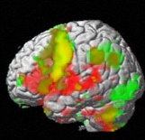
Connections and associations to previous knowledge | 
Personal connections and associations to episodic memory | 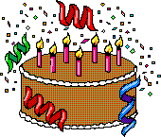
Images (inner or outer) | 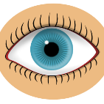
Sounds | 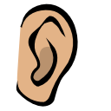
Movement (incl. speaking) | 
Touch or smell | 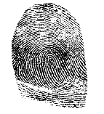
Somatic response, (+ emotion – stress) | 
Interesting and relevant MEANING (commitment filter) | 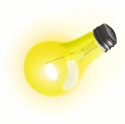
Social interaction | 
Success (Dopamin shower) | 
Total:

Brain-Checker
How efficient are your planned vocab tasks?
Connections and associations to previous knowledge
Personal connections and associations to episodic memory
Images (inner or outer)

Sounds

Movement (incl. speaking)

Touch or smell

Somatic response, (+ emotion – stress)

Interesting and relevant MEANING (commitment filter)
Social interaction

Success (Dopamin shower)

Total:

Brain-Checker
How efficient are your planned vocab tasks?
Connections and associations to previous knowledge
Personal connections and associations to episodic memory
Images (inner or outer)

Sounds

Movement (incl. speaking)

Touch or smell

Somatic response, (+ emotion – stress)

Interesting and relevant MEANING (commitment filter)
Social interaction

Success (Dopamin shower)

Total:

Brain-Checker
How efficient are your planned vocab tasks?
Connections and associations to previous knowledge
Personal connections and associations to episodic memory
Images (inner or outer)

Sounds

Movement (incl. speaking)

Touch or smell

Somatic response, (+ emotion – stress)

Interesting and relevant MEANING (commitment filter)
Social interaction

Success (Dopamin shower)

Total:

Brain-Checker
How efficient are your planned vocab tasks?
Connections and associations to previous knowledge
Personal connections and associations to episodic memory
Images (inner or outer)

Sounds

Movement (incl. speaking)

Touch or smell

Somatic response, (+ emotion – stress)

Interesting and relevant MEANING (commitment filter)
Social interaction

Success (Dopamin shower)

Total:

Brain-Checker
How efficient are your planned vocab tasks?
Connections and associations to previous knowledge
Personal connections and associations to episodic memory
Images (inner or outer)

Sounds

Movement (incl. speaking)

Touch or smell

Somatic response, (+ emotion – stress)

Interesting and relevant MEANING (commitment filter)
Social interaction

Success (Dopamin shower)

Total:

Brain-Checker
How efficient are your planned vocab tasks?
Connections and associations to previous knowledge
Personal connections and associations to episodic memory
Images (inner or outer)

Sounds

Movement (incl. speaking)

Touch or smell

Somatic response, (+ emotion – stress)

Interesting and relevant MEANING (commitment filter)
Social interaction

Success (Dopamin shower)

Total:

Brain-Checker
How efficient are your planned vocab tasks?
Connections and associations to previous knowledge
Personal connections and associations to episodic memory
Images (inner or outer)

Sounds

Movement (incl. speaking)

Touch or smell

Somatic response, (+ emotion – stress)

Interesting and relevant MEANING (commitment filter)
Social interaction

Success (Dopamin shower)

Total:

Brain-Checker
How efficient are your planned vocab tasks?
Connections and associations to previous knowledge
Personal connections and associations to episodic memory
Images (inner or outer)

Sounds

Movement (incl. speaking)

Touch or smell

Somatic response, (+ emotion – stress)

Interesting and relevant MEANING (commitment filter)
Social interaction

Success (Dopamin shower)

Total:

