Planning Engaging Writing Tasks
 | - Is the task authentic? Do similar texts exist in the real world?
 | - What is the purpose of the text(s)?  - Who is the audience?
 | - Is the task challenging and does it require deep processing (world and language)?
 | - Does the task invite learners to make personal connections (interest, personal experiences)?
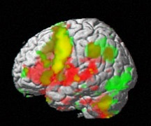 | - Does the task involve several skills, channels and several types of intelligence (M.I.)?
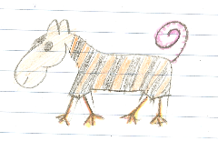 | - Does the task invite creativity?
 | - Can the learners make some choices (content, topic, format/type of product)?
 | - Does the task lead to a product that the students can be proud of?
 | - Is the product shared with an audience (class, school, public)?
©E. Pölzleitner

