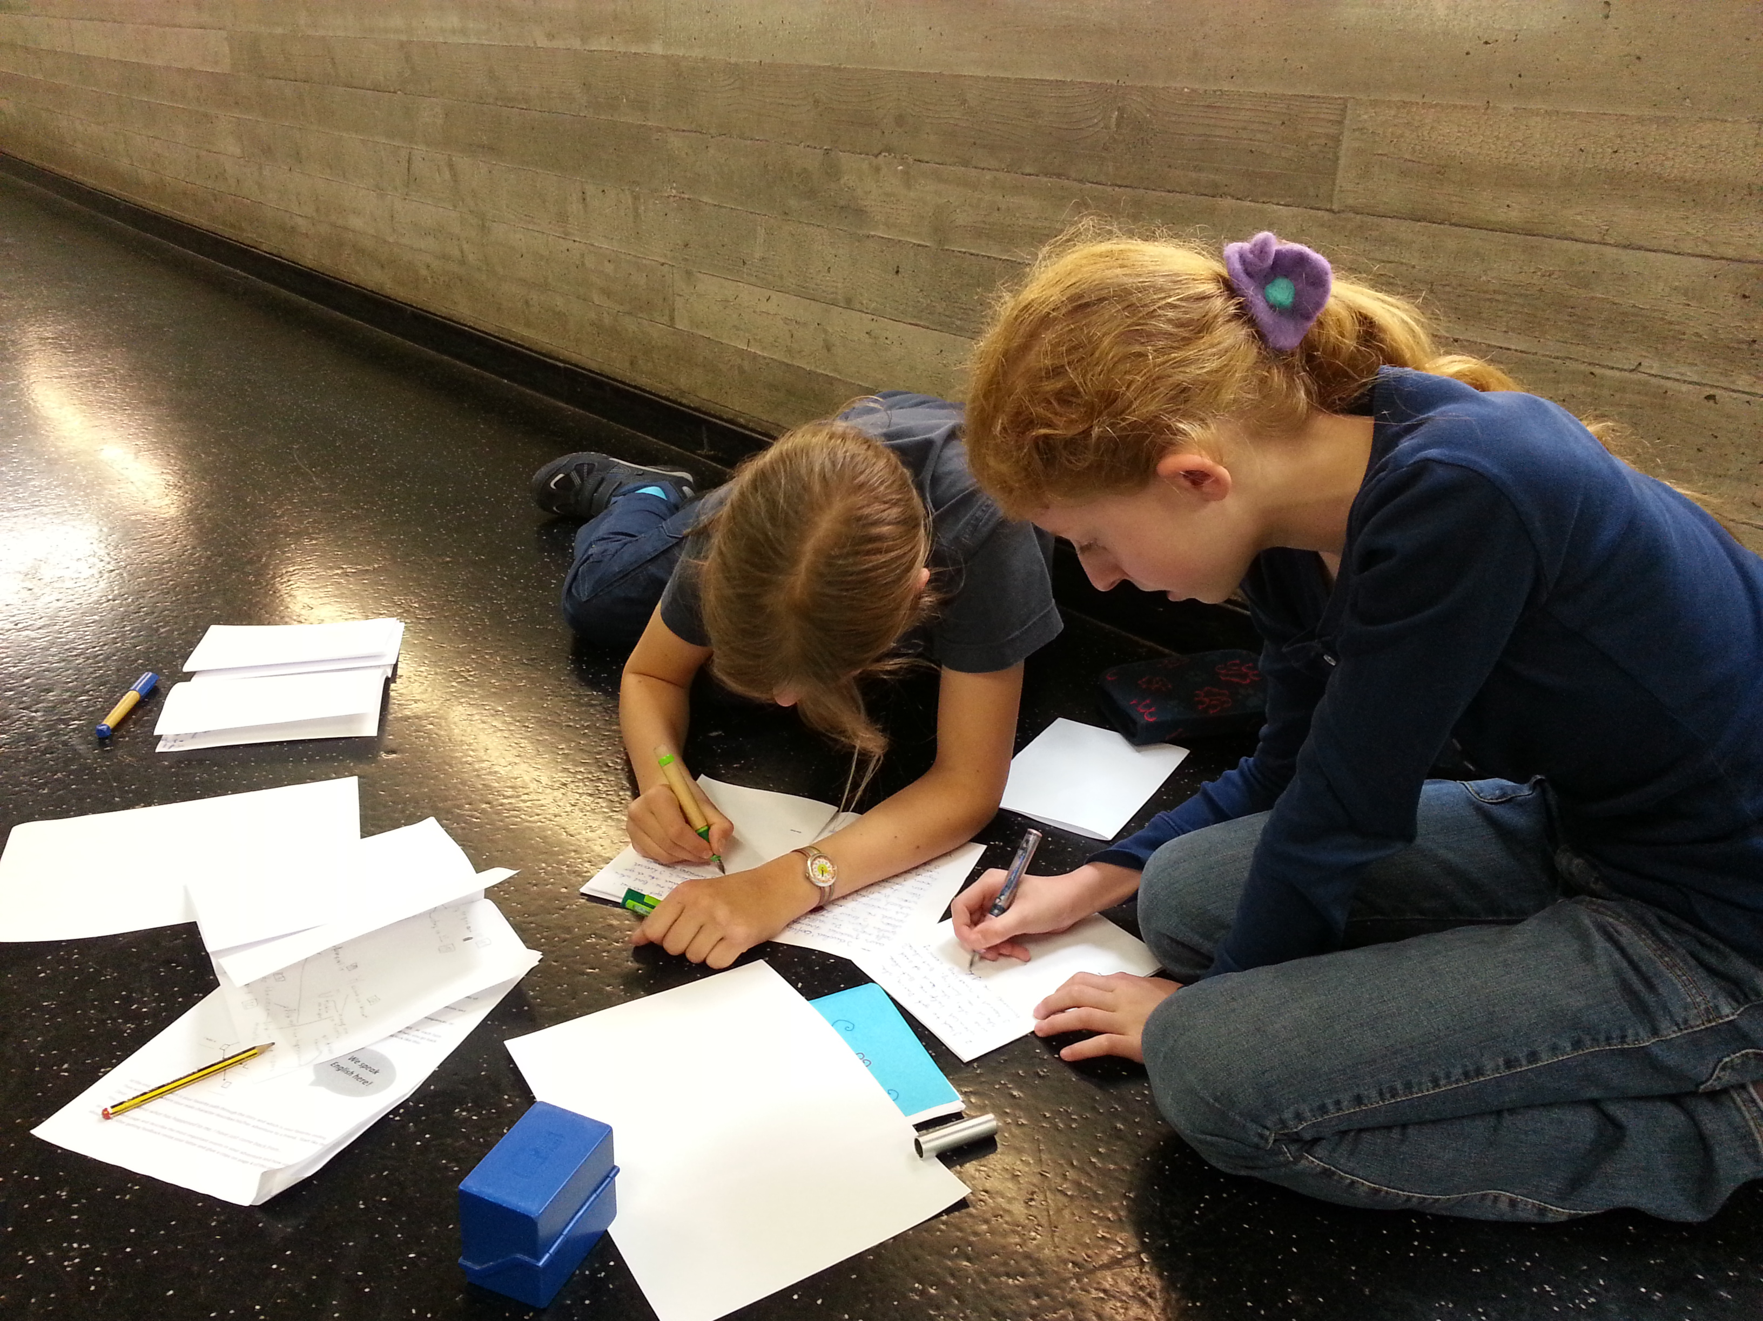
Teaching Writing
Between Creativity and Task Achievement
Elisabeth Pölzleitner | [Date] | PH-Steiermark and KF-Uni-Graz

Writing for an Audience

Table of Contents
Overview of the BIFIE Text-types 4
EPOSTL: What teachers should be able to do… 5
How can we reach these goals? 6
One Step Back: How does our brain learn? 6
Making it matter 6
7
Early Starts: 7
That’s Me: 7
Me Books 7
Free Homework 7
Mini-books Online 7
Origami Storybooks 8
Die Didaktik des leeren Blattes: Diaries, Booklets, Catalogues… 9
9
Fair 9
Writing for an audience: MAGAZINES and NEWSPAPERS 11
Recipe for a good magazine article 11
Magazine Projects 11
The Newspaper Generator 12
A short newspaper writing project for intermediate learners. Time needed: 2hrs 13
Teaching writing to advanced learners 15
The Writer’s Workshop 16
Peer Conferencing: 16
What makes a good, spooky story? 17
Peer Editing Form: Essay 18
Peer Conference: Magazine Texts 19
A general peer editing form 20
Examples of Basic Peer Feedback: 21
21
More advanced feedback samples (year 7 and 8) 22
Story-writing Projects 23
Find further ideas and materials for story writing on epep.at 24
Portfolio Work and Portfolio Assessment 25
What is a portfolio? 25
Folders and Title Pages 25
Table of Contents 25
Letter to the Reader 26
Text Samples and Reasons for Choice 26
Reflections about each piece 27
Portfolio Assessment 28
1. Peer evaluation 28
2. Self evaluation 29
3. Assessment by the teacher 30
Summary: Advantages of Portfolio-work 30
Portfolio Literature I can recommend: 30
Appendix: Assessment Scales 31

You will find downloadable worksheets and examples of all the projects on epep.at

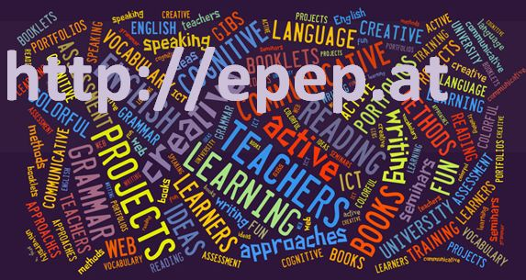

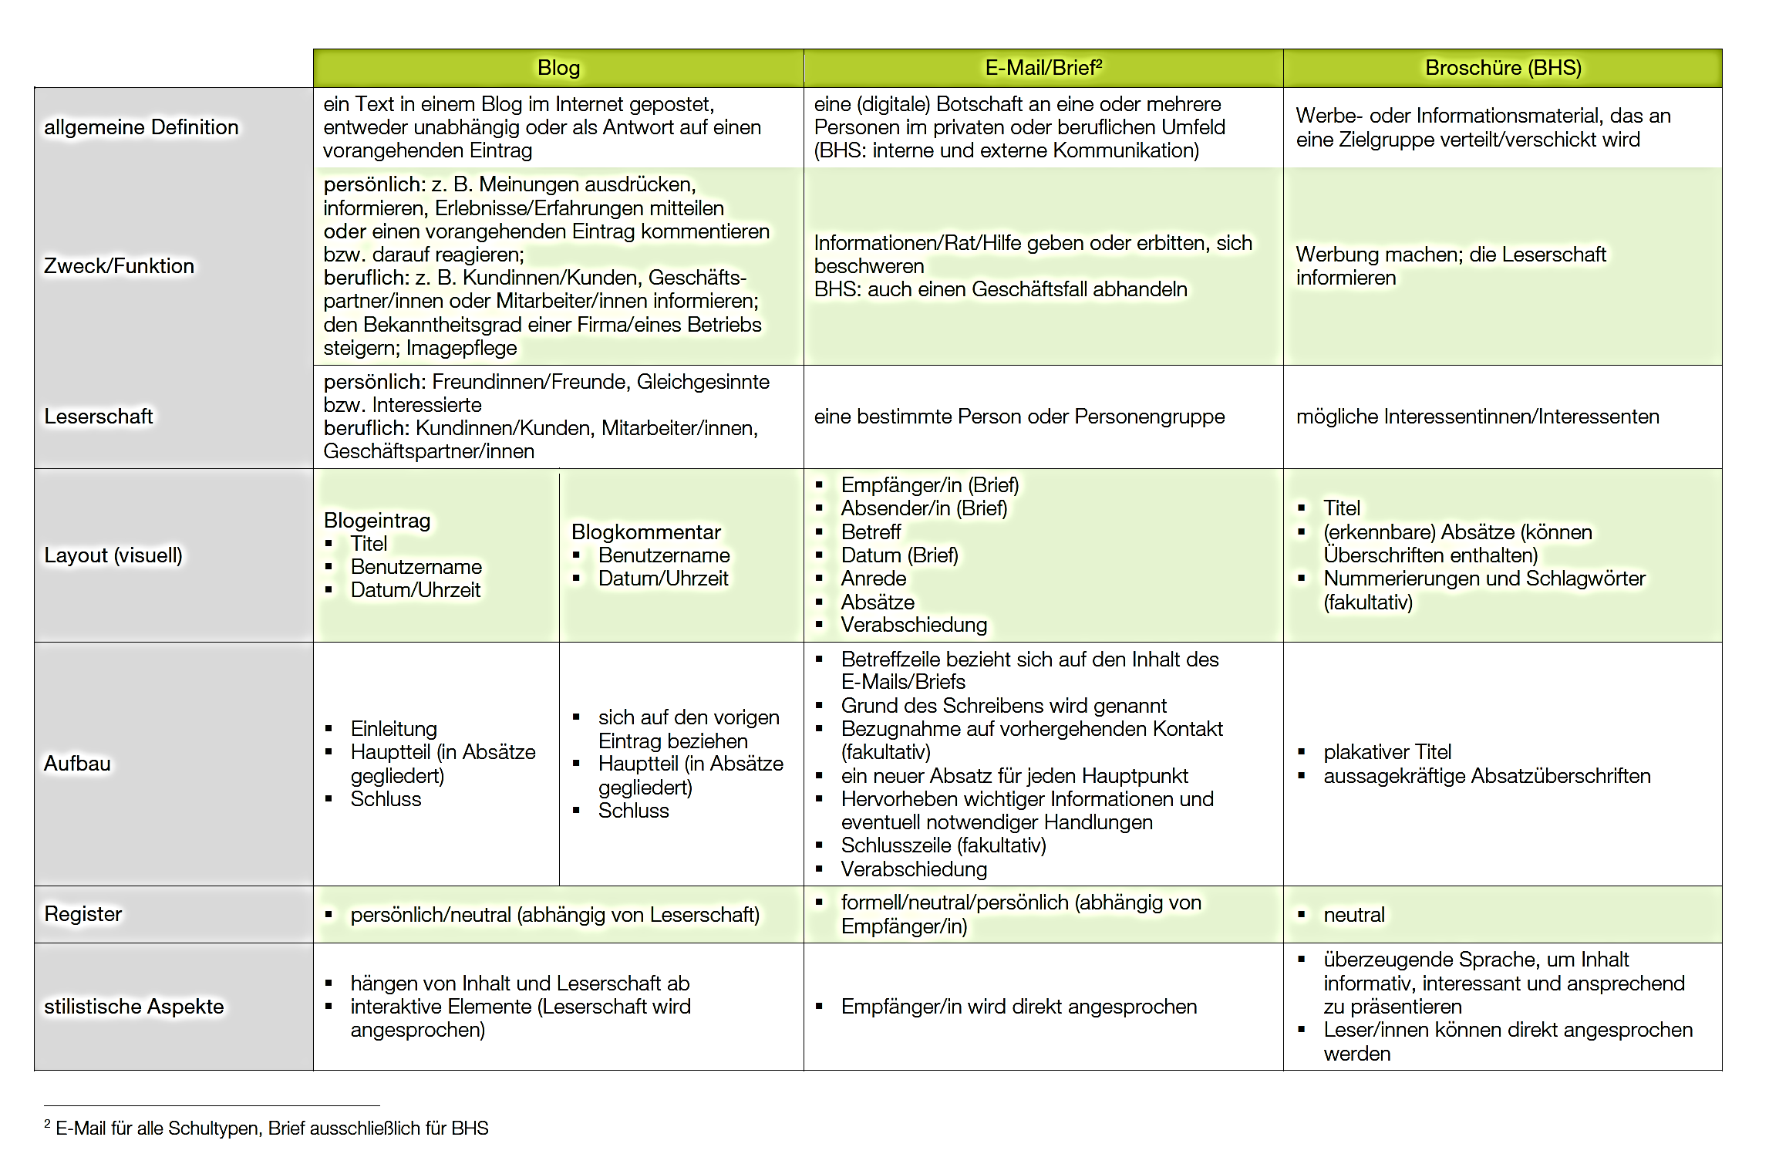
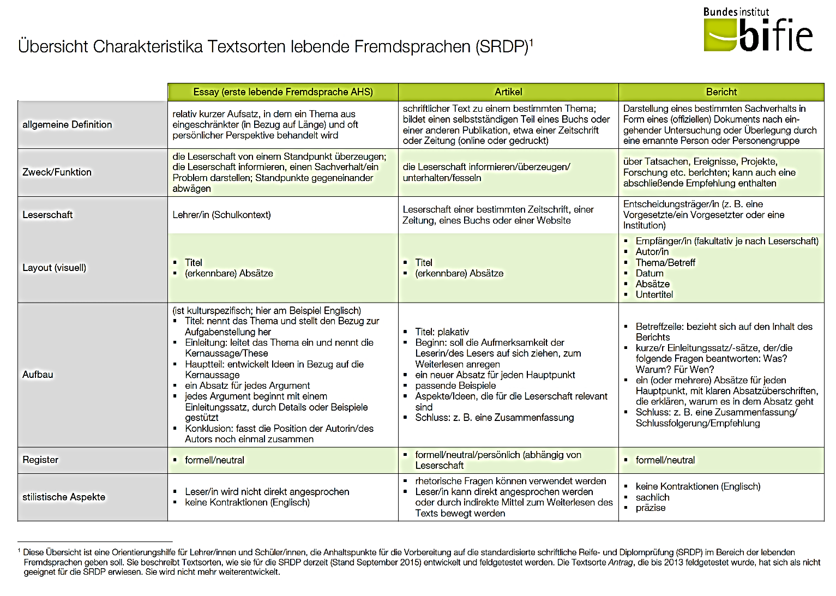
Overview of the BIFIE Text-types

EPOSTL: What teachers should be able to do…

Writing/Written Interaction

- I can evaluate and select meaningful activities to encourage learners to develop their creative potential.
- I can evaluate and select a range of meaningful writing activities to help learners become aware of and use appropriate language for different text types (letters, stories, reports etc.).
- I can evaluate and select texts in a variety of text types to function as good examples for the learners’ writing.
- I can evaluate and select a variety of materials to stimulate writing (authentic materials, visual aids etc.).
- I can evaluate and select activities which help learners to participate in written exchanges (emails, job applications etc.) and to initiate or respond to texts appropriately.
- I can help learners to gather and share information for their writing tasks.
- I can help learners to plan and structure written texts (e.g. by using mind maps, outlines etc.).
- I can help learners to monitor, reflect on, edit and improve their own writing.
- I can use peer-assessment and feedback to assist the writing process.
- I can use a variety of techniques to help learners to develop awareness of the structure, coherence and cohesion of a text and produce texts accordingly.
- I can evaluate and select a variety of techniques to make learners aware of and use spelling patterns and irregular spelling.
- I can evaluate and select writing activities to consolidate learning (grammar, vocabulary, spelling etc.).

How can we reach these goals?

How can we reach these goals? What has worked well? Where do you see need for improvement and fresh ideas?
I could use some new ideas in these areas… |  | These ideas have worked well…

One Step Back: How does our brain learn?

Making it matter



Learning is a “global event”, it involves the entire person
What is personally relevant to the learner and what has been richly imagined is more memorable than what has only been understood from words
New knowledge (ideas, concepts, words…) must be constructed by the learner and integrated into his/her existing networks.
Multisensory, multidimensional input will help learning:
ISM: Images + Somatic response + Meaning
How can we create writing tasks that matter?

FIP: Format, Imagination and Pride

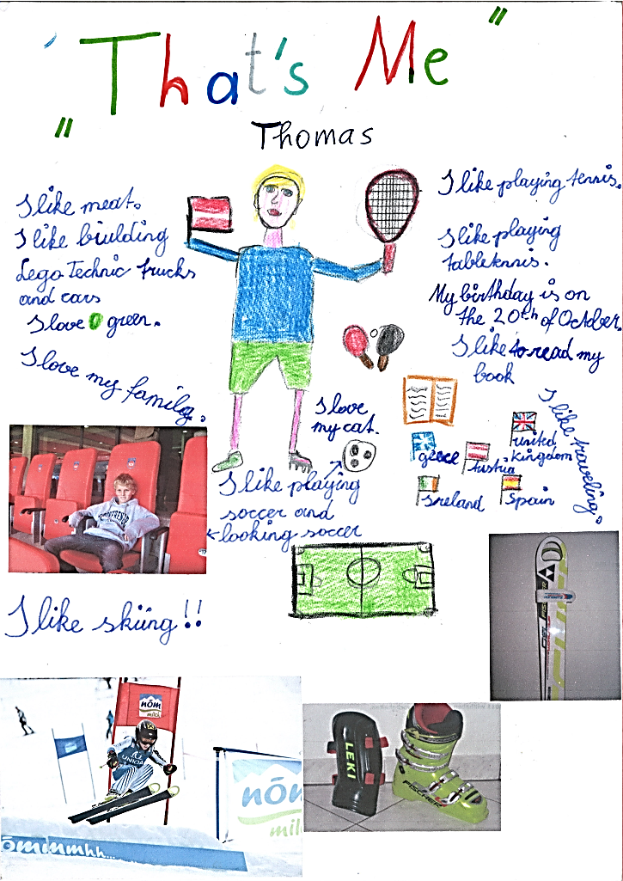
Early Starts:

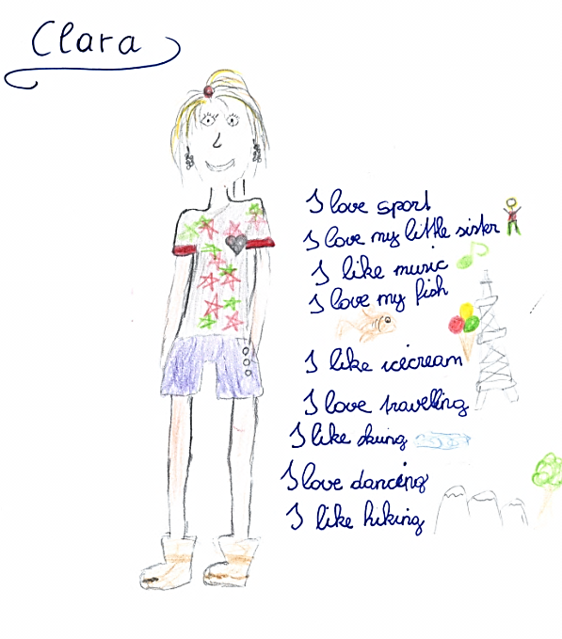
That’s Me:

Me Books

Free Homework

The learners decide what they want to write about.
The teacher gives the frame (approximate length, deadline…) but the learners decide what they want to write about. Common topics are personal events, experiences, hobbies, interests.
The learners communicate something that is important to them, therefore the texts are usually much longer and more interesting than written homework set by the teacher.

When writing about hobbies or interests they often surf online before writing their texts and find English pages about their chosen topic and thus improve their reading comprehension and expand heir vocabulary.

Mini-books Online

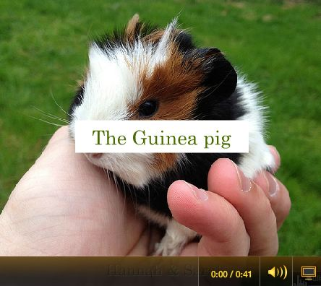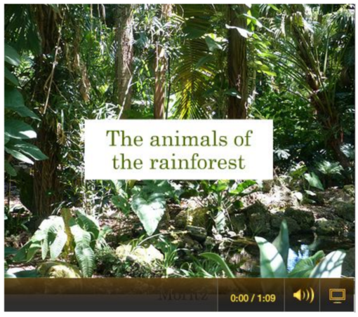

Origami Storybooks

Producing stories in these little books is certainly more motivating than writing a story into one’s homework book. Young learners write very creative, long stories and actively seek feedback and language tips in order to produce high quality books that they are proud of.
These books are easy to fold and highly motivating for the learners.

Basic book folding: All you need is an A3 sheet and a pair of scissors.
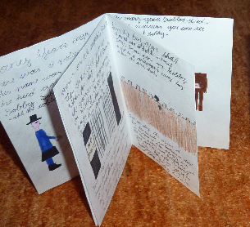
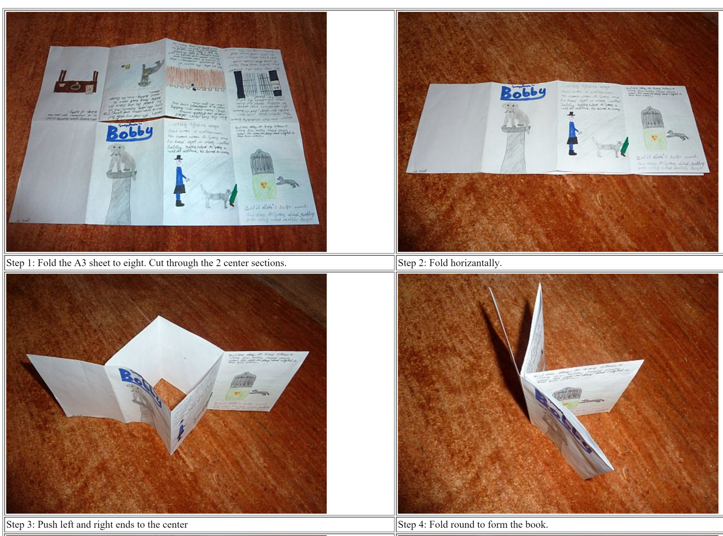

More book folding formats for creative story projects:
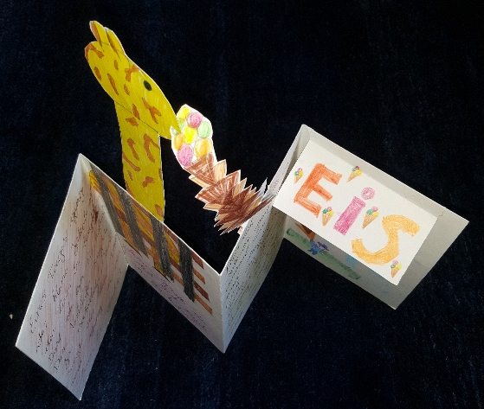
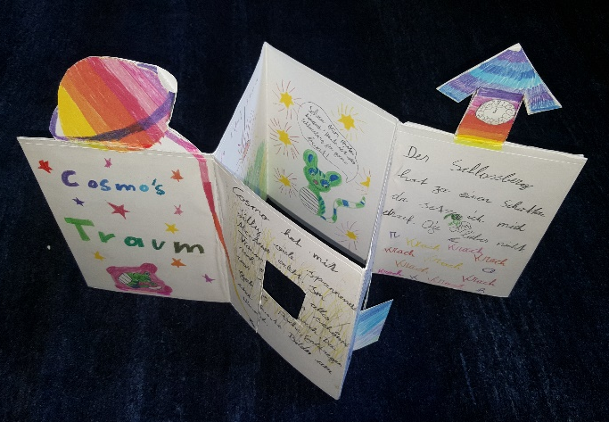

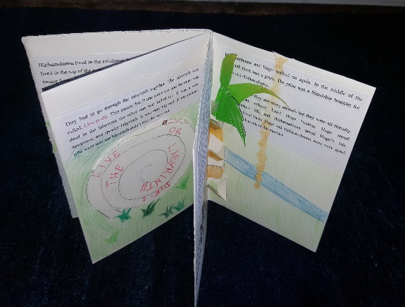

Die Didaktik des leeren Blattes: Diaries, Booklets, Catalogues…

„Unser wichtigstes Arbeitsmaterial ist das weiße Blatt Papier, unseres Erachtens das
kreativste Material, das es gibt. Es stellt "wahrscheinlich die größte Herausforderung
an die Imagination der Kinder dar" stellt Peschel (1996, S.38) fest, nachdem er unsere
"Pädagogik des weißen Blattes" kennengelernt hatte. Das leere Blatt fordert oder
provoziert geradezu die kindliche Phantasie es zu füllen. Wie, das sagt ihm weder das
leere Blatt, noch sagen wir´s. Das Kind muss selber entscheiden und gestalten. Ein
Arbeitsergebnis ist zu dokumentieren, ein Sachthema zusammengefasst
darzustellen, um in ein gemeinsames Buch zu kommen. Welche Informationsquellen
benutzt werden und wie, überlassen wir vollständig dem Kind. (Zehnpfennig/Zehnpfennig
1992)“
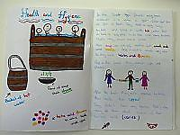
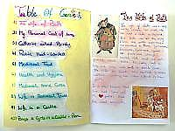

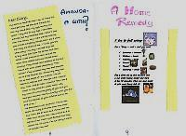

Fair
Have a look at the booklets displayed on the tables and collect information about the following topics.

Accuracy and
Common Mistakes
Range of Vocabulary
Creativity
Commitment
Effort
Text-types

Appreciating the learners’ work

Choose one of the booklets and write a feedback card for the learner. Show your appreciation of the student’s effort and motivation to create a perfect product.

What do you like about the product?
What tips for improvement can you give the student?

Use the front of the card to give feedback about the content, organization, layout and other features that have caught your interest.

On the back of the card write 3-5 concrete language tips for the learner.

Your Turn: Think of a class/topic/theme/unit where you could use this idea.

Writing for an audience: MAGAZINES and NEWSPAPERS

Developing and using text writing recipes

Recipe for a good magazine article

Find examples of recent student magazines on epep.at

Find the instructions sheet for the learners on epep.at

Magazine Projects

Schüler arbeiten in Kleingruppen (ca. 4) an regelmäßigen Ausgaben einer Zeitschrift.
1. Gruppen finden sich und bestimmen Namen des Magazins.

2. Gruppen bestimmen die Arbeitsverteilung und Teamrollen:
editor in chief (zuständig für Inhalt, Inhaltsverzeichnis und “editorial letter”
assistant editor (sammelt alle Beiträge und korrigiert die Sprache)
timekeeper (erinnert die Gruppe an Termine und Zeitplan)
chief layouter (erstellt die Titelseite, “bindet” die Zeitschrift und macht Feinschliff am Layout)

3. Gruppen erhalten Termine: Endtermin für Fertigstellung sowie 3-4 Termine (à 20-30 Minuten) für peer conferences und erstellen einen Zeitplan. Richtwert: Jeder Schüler schreibt drei Beiträge für eine Monatsausgabe. Die Schüler planen wer welche Beiträge übernehmen wird und bis wann diese fertig sein müssen. Die konkrete Schreibarbeit wird zu Hause (an Stelle von free homework) gemacht.

4. Conferences: In den peer conferences werden die jeweils fertigen Beiträge in der Gruppe kommentiert. Die Gruppenmitglieder machen Verbesserungs- und Korrekturvorschläge (vor allem auch inhaltlicher und struktueller Art). Die Arbeitsatmosphäre in der Gruppe soll positiv sein, es geht darum ein möglichst gutes, gemeinsames Produkt zu erstellen, nicht den Text des anderen schlecht zu machen. In diesem Rahmen gelingt positives feedback besonders gut. Die Schüler sind offen für Kritik.
Wichtig: Termine für diese conferences müssen klar angesagt werden damit auch wirklich alle Gruppen ihre Beiträge mitbringen! Wenn möglich alle Texte auf Computer!

5. Falls einzelne Gruppen mit den 3-4 conferences nicht auskommen, sind sie selbst dafür verantwortlich weitere Termine in Pausen oder nach der Schule (oder per e-mail) auszumachen...

6. Fertigstellung und Publikation: Die fertigen Magazines (am einfachsten in Plastikschnellheftern geheftet) werden in der Klasse präsentiert. Im Rahmen eines workshops können die Schüler in den neuen Ausgaben lesen.
Oder: Lesetisch (nett gestalten) einrichten und Magazines dort auflegen.

The Newspaper Generator

This page has been created with the Newspaper Clipping Image Generator

Just fill in the dialog boxes for name of paper, date, title and the text, click GENERATE and copy the jpg file into your word-file.

www.fodey.com/generators/newspaper/snippet.asp

A short newspaper writing project for intermediate learners. Time needed: 2hrs

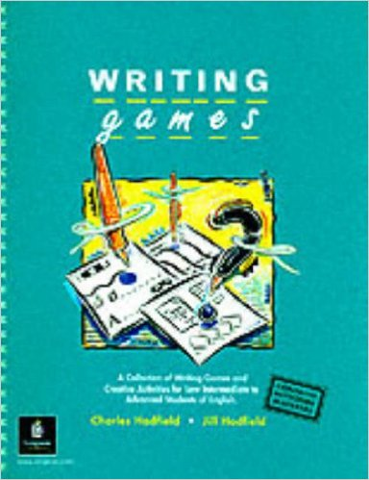
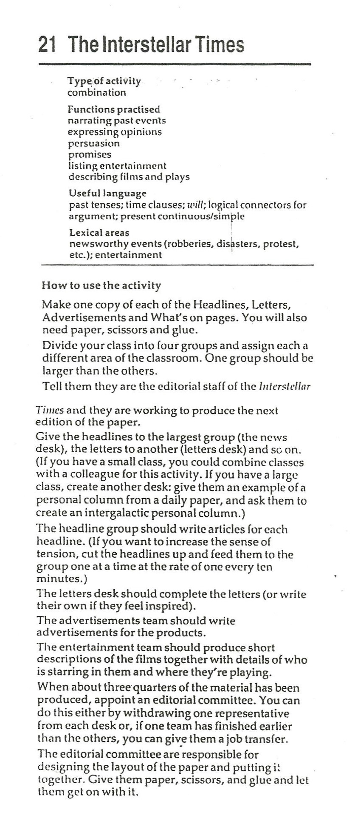
Buy this book, it is full of excellent ideas.
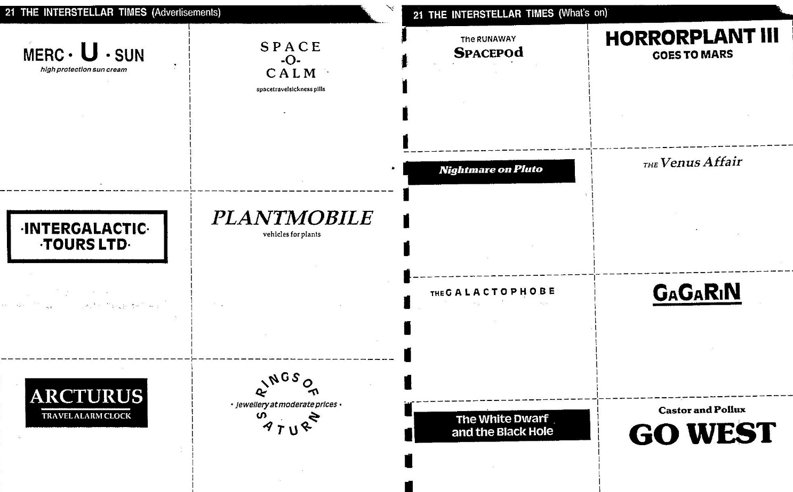
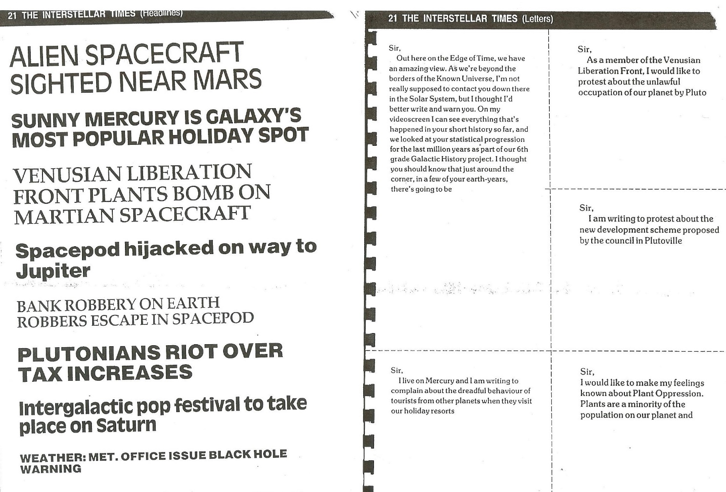

Teaching writing to advanced learners

Find teaching materials and worksheets for article writing and other text-types for advanced learners on epep.at
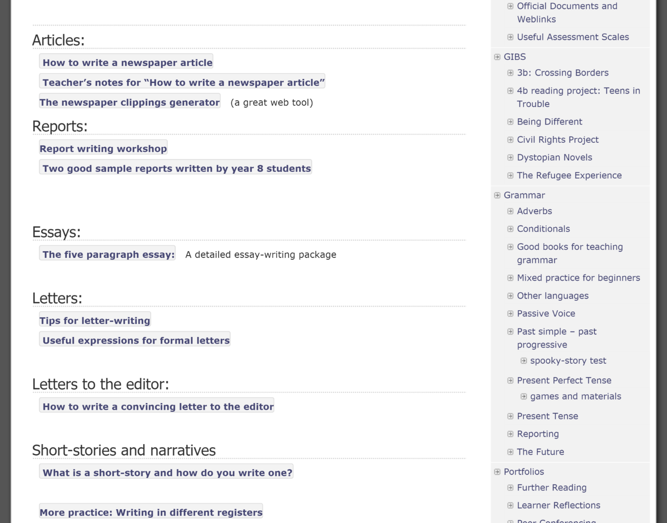
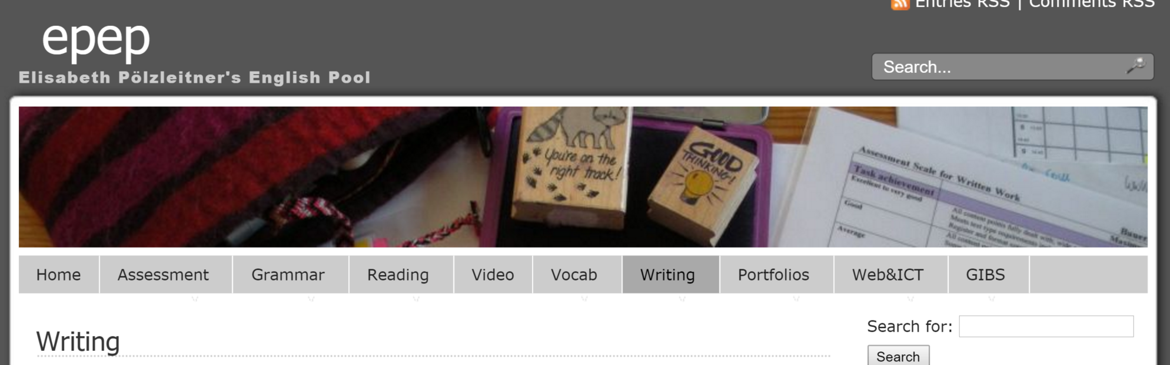




The Writer’s Workshop

Peer Conferencing:
Peer conferencing can be very helpful for both parties. The author of the text will get helpful feedback on different levels and the feedback giver will learn to read a text critically. Depending on the specific genre and aims of the writing task, both learners will focus on different aspects of a text such as formal aspects, accuracy, content, organization, register etc.

Peer conferencing is not easy for learners and must be introduced and practiced as a specific skill. The first peer-comments may be very flattering, unspecific or even aggressive. Students who have received helpful feedback from their teacher, will easily learn this skill by imitating their teacher's feedback behavior. It also helps to give students clear feedback rules and to teach an introductory skills-lesson on giving feedback using one text and inviting the class to suggest improvements.
The following peer-conference forms may also be helpful in the beginning stages or after introducing a new genre. Each of these forms focuses on a particular text-type and guides the learners through the important features of this genre. After a few rounds of guided feedback, most learners will be able to give helpful, constructive feedback without the help of such forms.

Look at the feedback forms and the free learner comments on the following pages. Then design a short feedback form for a text that your own students are going to write in the near future. What criteria might be helpful?

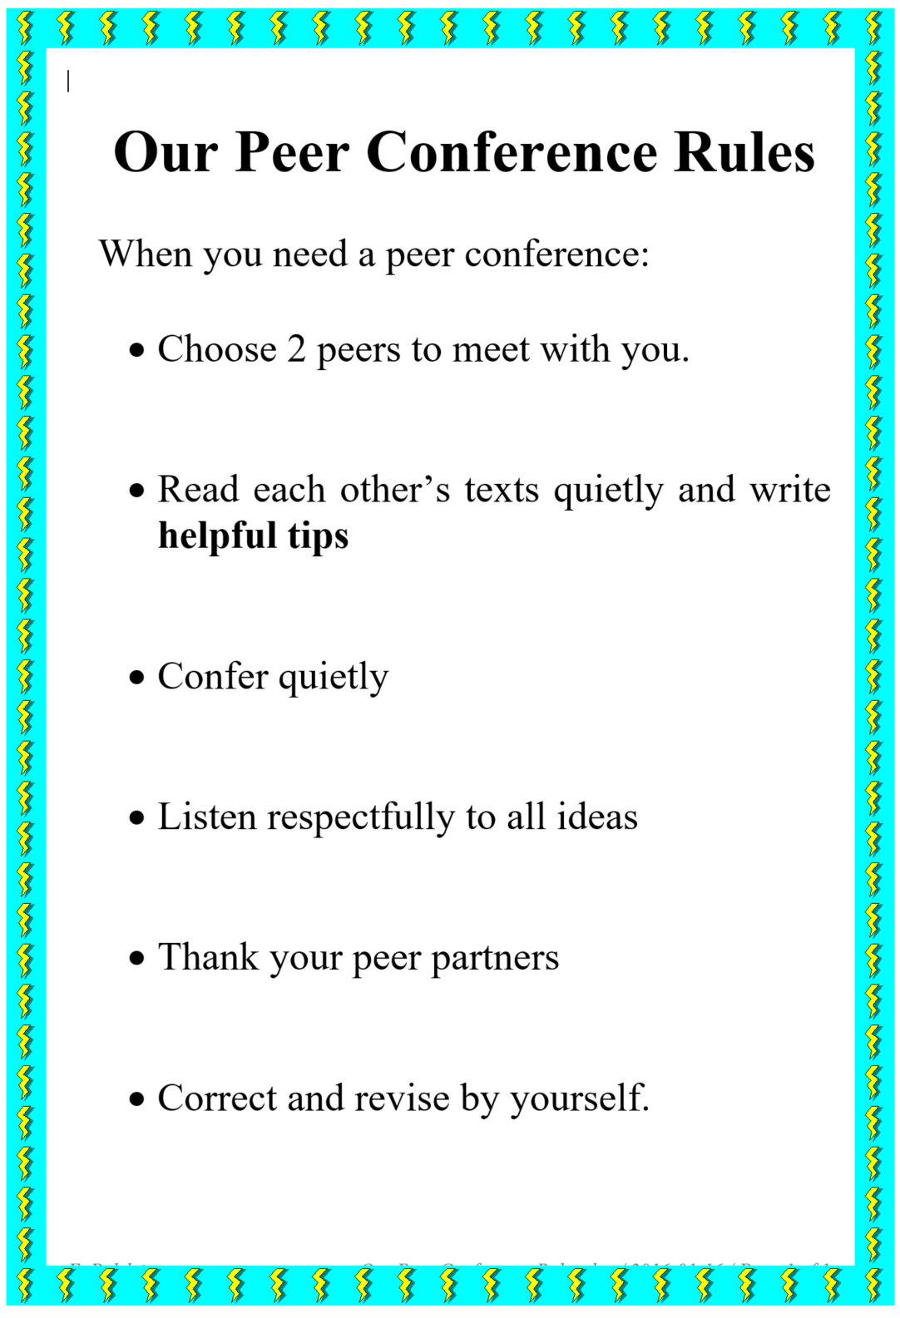


What makes a good, spooky story?

Check if your story (or your partner’s story) meets all the following criteria.

Criteria | You can give up to 3 stars for each category.   If you only give 1-2 stars explain what could be improved and how this can be done best.
Title: The story has a promising, spooky title.

Setting and Vocab:
The setting is described well.
I can hear spooky sounds and I can see the scene in front of my eyes. The writer has used lots of good, spooky vocabulary.
Grammar: The setting/background is described in the past progressive tense (the moon was shining…)
Grammar: The actions /events are told in the past simple tense. (the door flew open, lightning struck…)
Characters: The characters react like normal human beings. We can see that they are scared and they have good reasons for their actions.
Ending and suspense: I am surprised by the ending – it is not predictable. The story is interesting to read – it is full of suspense (Spannung).
Further tips:
How else could this story be improved?

Peer Editing Form: Essay

Peer editor's name: Title of paper:

Title:  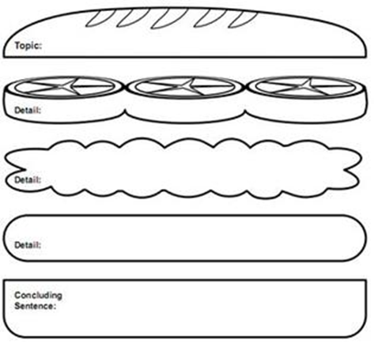 | Is my title clear and telling? How could I improve it?
 | Is my introduction clear and interesting? What could I do to show the relevance of the topic more clearly?
Can you find my thesis statement? Is it clear and convincing?
Does it contain all the main arguments? What is missing? What should I add?
Does my 2nd paragraph start with a topic sentence?
Does the paragraph stick to ONE topic or does it digress? Are my examples and arguments valid and clear?
Have I used appropriate link-words?
Does my 3rd paragraph start with a topic sentence?
Does the paragraph stick to ONE topic or does it digress? Are my examples and arguments valid and clear?
What can I do to make them more convincing?
Does my 4th paragraph start with a topic sentence?
Does the paragraph stick to ONE topic or does it digress? Are my examples and arguments valid and clear?
What can I do to make them more convincing?
Conclusion: Is my conclusion convincing? Does it restate my main arguments clearly?
Have I managed to convince YOU?
What else could I do to get my message across even more clearly?
Range of Vocab and Grammar:
Can you suggest any phrases that will make my essay sound more professional and idiomatic?
Have I used neutral or formal language?
Can you find any contractions or colloquial terms that need to be replaced?
 | Accuracy: Can you find and correct any language mistakes?

Peer Conference: Magazine Texts

Give your text and this form to a classmate. Ask him or her to read through your text. Then tell this person to answer the questions below. Ask your friend to provide you with specific comments that will help you improve your text.
Peer editor's name: Date:________________________________

Title of text:

Comments, Suggestions, Tips
Is my text interesting? Does it hold your attention? What could I add to make it more interesting?

Is my text clearly organized or are you confused at any point? Where? Is there anything you do not quite understand?

Is the introduction strong and interesting? Do you want to read on? How could I improve it?

Do you have enough information? Should I add anything? What?

Is my conclusion convincing? How could I improve it?

Does the title fit the text? Does it sound interesting? Can you think of a better title?

Have I quoted my sources properly?

Have I used correct language (grammar and spelling)? Can you give me any language tips?

How do you like the layout and presentation of my text? What could be improved?

Please use the back for further comments.

A general peer editing form
Peer feedback for …………

Peer editor’s name: Date:

Title of the text:

- Things I like best about this piece of writing are

- To make your text better , I suggest that you

Examples of Basic Peer Feedback:
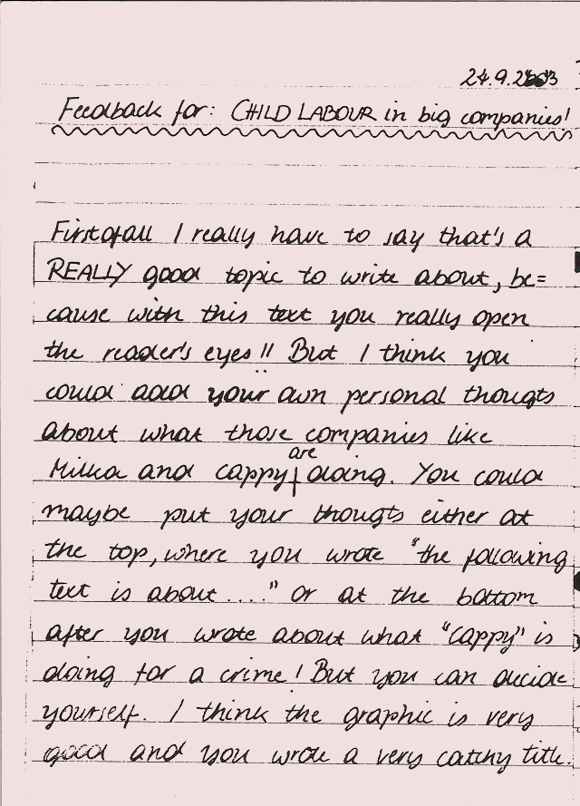
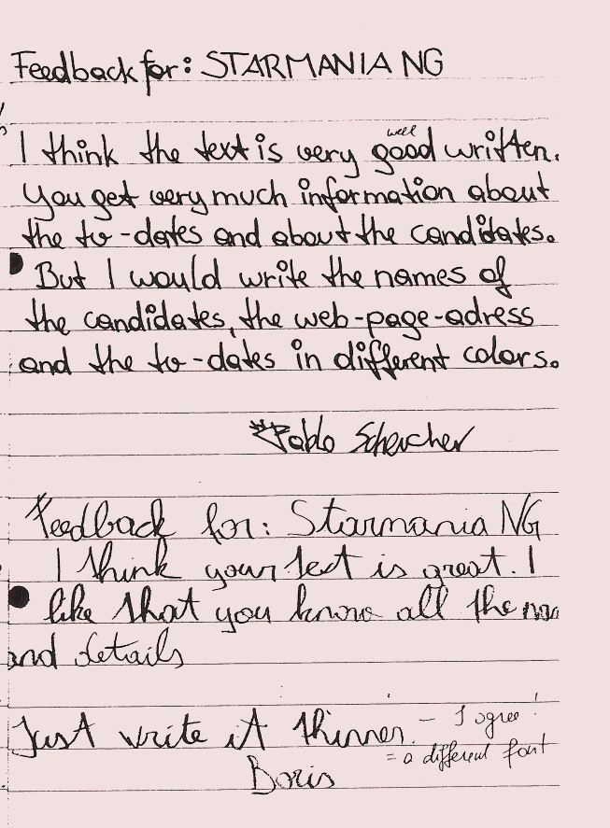
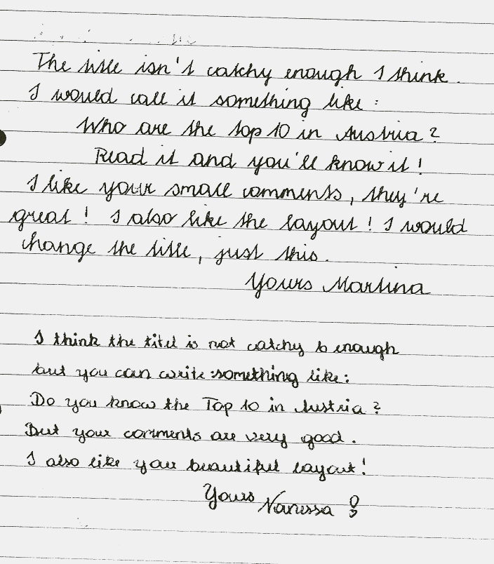
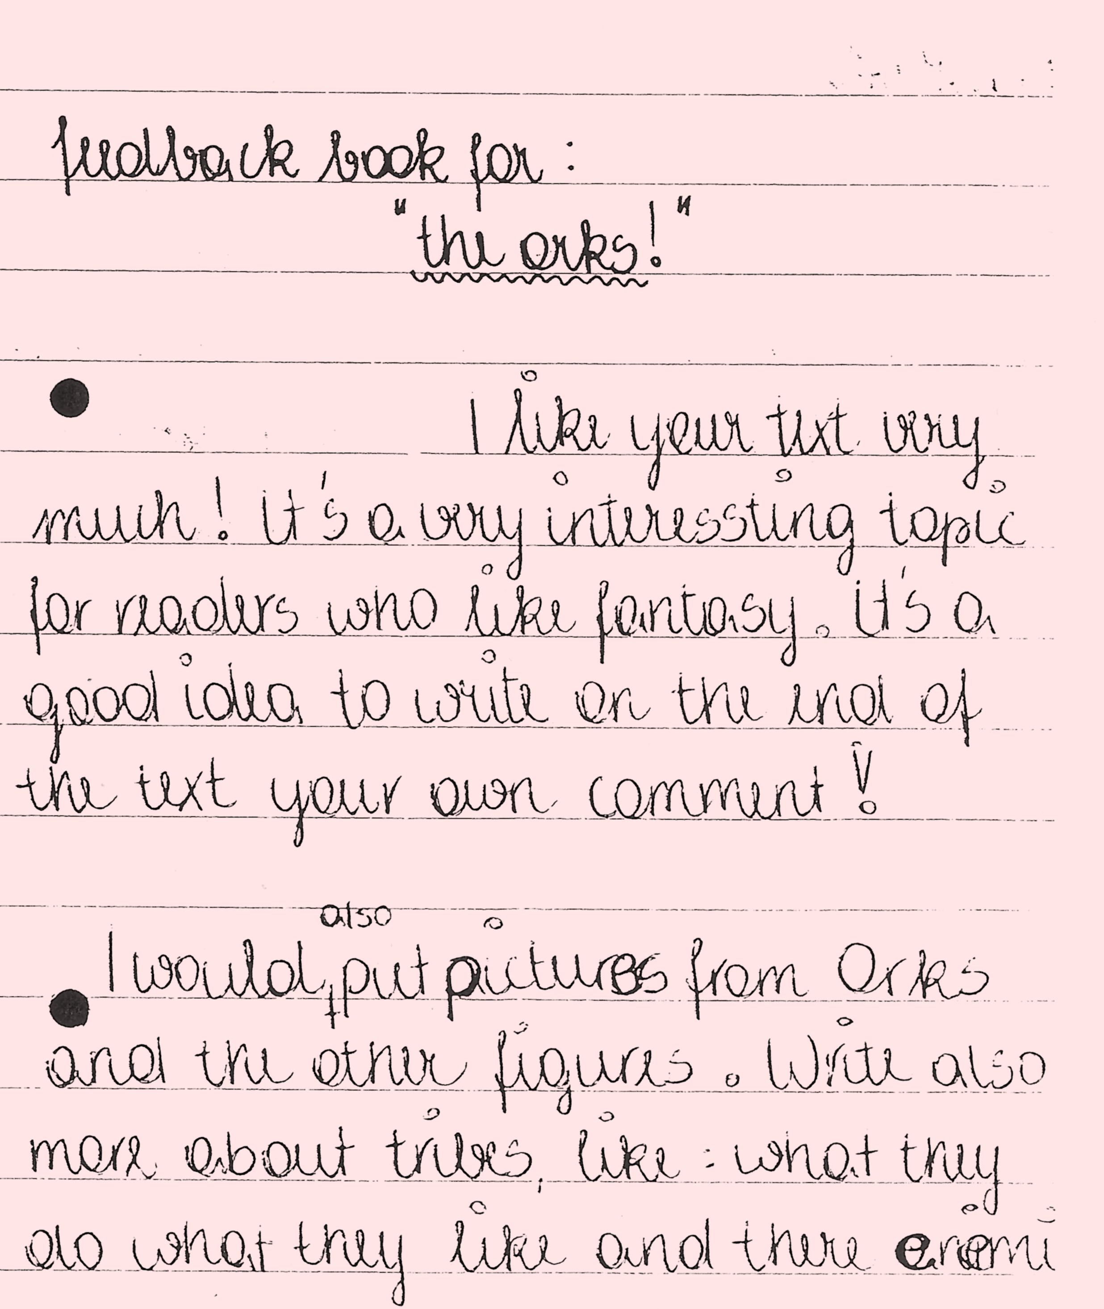

More advanced feedback samples (year 7 and 8)
Dear Xin,
I find your story very confusing indeed. It's well written and all, good vocab, but the content is confusing. So are the characters, if you can call them that. Who on earth are Sue and Dan, are they Anthony's parents? What Anthony's father says at the end is totally unexpected, and doesn't seem to fit to the rest of the story. 'Gay people don't go to heaven. Anthony you know that? You can pray for them, but it won't help.' According to that sentence it would seem that a friend of Anthony's is gay, and Anthony is praying form him. You definitely have to explain a little more, the story isn't coherent. And the end is very abrupt as well, and leaves the reader (me anyways) very confused. The scene where he and his brother are running, and Anthony's bible hits the mud seems to be more connected to his promise not to cry rather than being an indication that he's gay. So, you should try and make the whole thing a bit clearer, and if Anthony is supposed to be gay, then make him gay.
All in all the story is good, but confusing and incoherent. The language and so on and so forth is great as usual, there are still some small mistakes, but nothing too bad. So work on it a bit, and it'll be great!
Ben
Writer's answer to his friend's tips:
I really have to admit, that this sort of correction/first feedback was of great help to me. To be honest it helped more than I had expected. Despite the obvious fact that the reader found some mistakes, this exercise even encouraged me to read through the text again after some while and even to find some mistakes by myself. I guess the reason for this is that if you leave the text for at least 24 hours and afterwards read through it again, you may see some extracts from a different and more objective point of view.
All in all I included all the corrections made by my first reader, apart from the word 'opponent' (on the first page), for which I didn't manage to find another similar and more fitting word.
Dear Christoph,
I can see very well that the hectic atmosphere of a metropolitan area like New York has inspired you. The main character comes across very good, he is a perfect 'victim' of Wall Street. I also think that the mobile phone as the symbol for his society fits perfectly. What you could add are some street names. You could think of some street or place which stands for his behavior like Times Square or something close to Wall Street. At the end you could describe the fact that he feels irrelevant more indirectly. Instead of letting him scream his situation out you could portrait him being lost in the City and feeling out of touch with the rest of the world. Besides this I really have no complains, well done.
Arno
Dear Sarah,
I have just finished reading your story and I find it really good. It was unpredictable and unexpected . At the parts where Paul is afraid you used short sentences and I think that has a good effect! Also the description in the beginning is very good.
Maybe you could describe Paul more and also put more description into the part when the neighbor comes into his room. Like maybe, 'the door creaked and the footsteps got louder...' so there is more suspense. Otherwise I enjoyed reading your story.
Victoria

Story-writing Projects

Recipe for Spooky Stories
These ingredients have been collected by the students after reading a few spooky stories.
Ingredients:

Spooky Background | Spooky places: cemetery, castle, dark cellars or basements, dark forest, lonely streets, small village, moving shadows…foggy night in October/ November, Halloween…  spooky sounds :the leaves are rustling, the door is creaking, you hear footsteps, the wind is howling, the owl is hooting, the rain is drumming on the windows, a child is screaming,
Spooky Characters | ghosts, spiders, witches, children, gravedigger, owl is hooting, scull, skeleton, bones, dogs, rats, black cats, mice, ravens,  …
New Grammar | past progressive form: to describe the background (the owl was hooting, the moon was shining, it was raining...)
Other ingredients and useful phrases | Surprise ending, danger, child is afraid (he has goosebumps, his hair stands on end, he screams, he hides, his heart beats like mad, he shivers,

Find further ideas and materials for story writing on epep.at

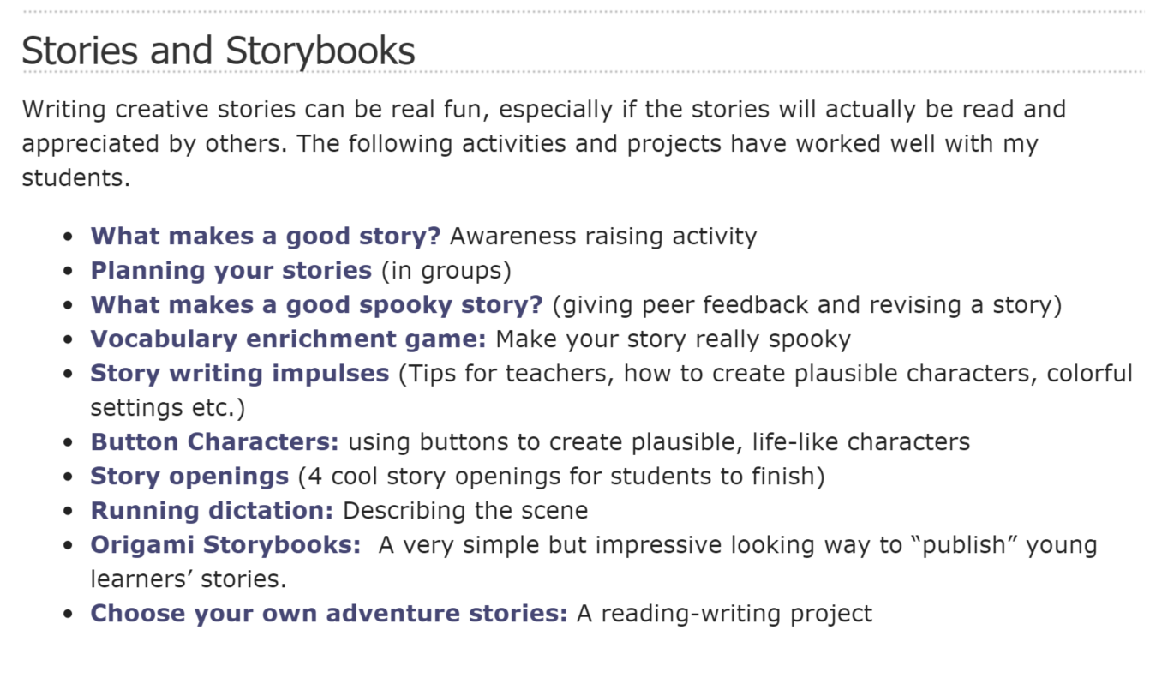

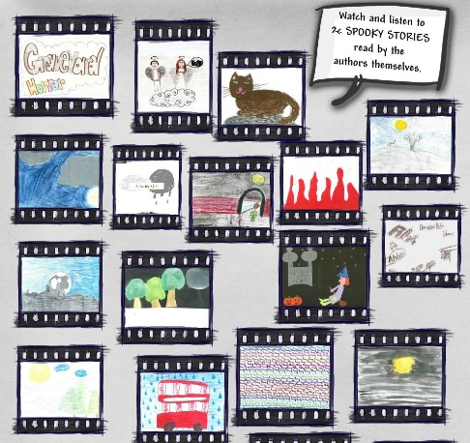 | 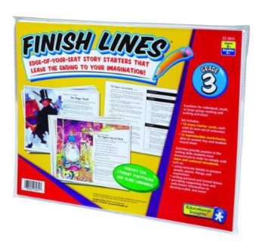
Spooky Stories (to practice the past progressive) | Finish Lines grade 3 and Finish Lines grade 5
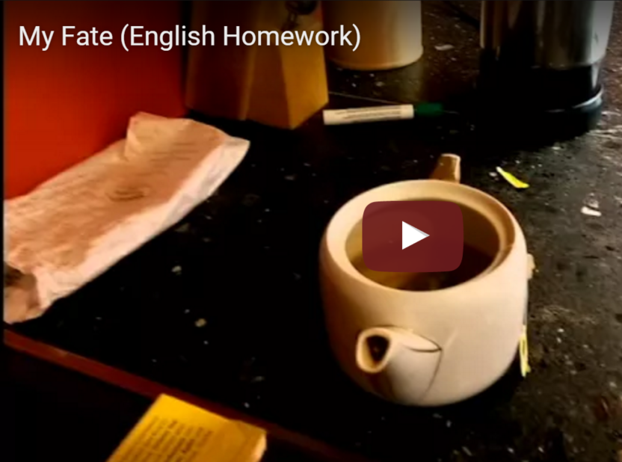 | 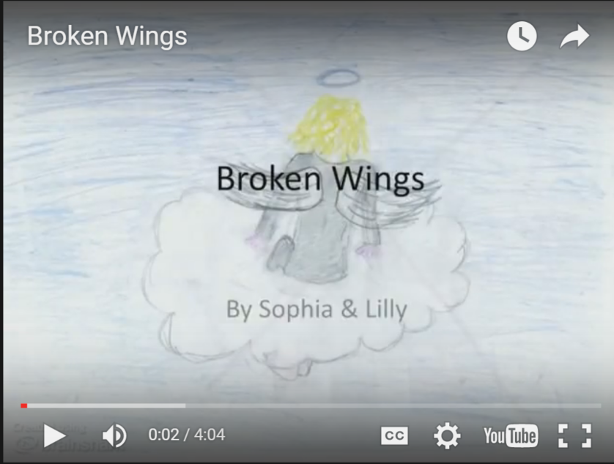
Personification Stories | Christmas Stories

Portfolio Work and Portfolio Assessment

Working with portfolios has changed my role as a teacher dramatically in the last few years. I have finally managed to involve the students actively in the learning process. My students have become more aware of their strengths and weaknesses and have learned to set their own goals. At the end of the semester they are proud of their progress and achievements.
Let me explain the basic principles of portfolio work, and make you interested in this multi-dimensional form of assessment.

What is a portfolio?
A reading-writing portfolio is an organized and purposefully selected collection of work that shows a student's achievements, effort, growth and attitudes in the area of reading and writing. The portfolio includes a statement of the portfolio purpose (Letter to the Reader), a variety of writing samples, reasons or criteria for the selection of each piece and examples of self-reflections on the student's work.

What does this mean in everyday school-life?
When looking at a student portfolio you will typically find the following contents:
- a personally designed title page and folder
- a letter to the reader
- a table of contents
- a variety of samples showing different achievements and skills
- reflections and reasons for choosing each of these samples
- assessment and feedback (self-assessment, peer-assessment, teacher-assessment and feedback)
Let us look at each of these in turn.

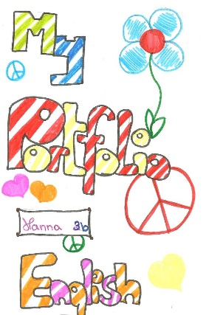
Folders and Title Pages
When looking at student portfolios you will first notice the wide variety of title pages that the students produce. Students must understand that "a Portfolio is a window into the writer's mind"
In their portfolios they try to present themselves, their personalities, their interests, thoughts and attitudes. This can already be seen in the title pages and folders that they design.

Table of Contents
Good organizational and structuring skills are very important, especially in open teaching environments. Students must learn to organize their materials clearly for themselves as well as for others. In portfolio work students have to collect their work in the course of the semester and eventually present samples of their work in the portfolio. Students choose these samples to prove that they have acquired certain skills and mastered specific teaching objectives. In the portfolio they present these samples in a clearly organized way. This obviously includes a table of contents. Very often students also choose to use additional structuring techniques, such as colored paper for reflections, headings, dividing sheets etc. to help the readers find their way through the portfolio.

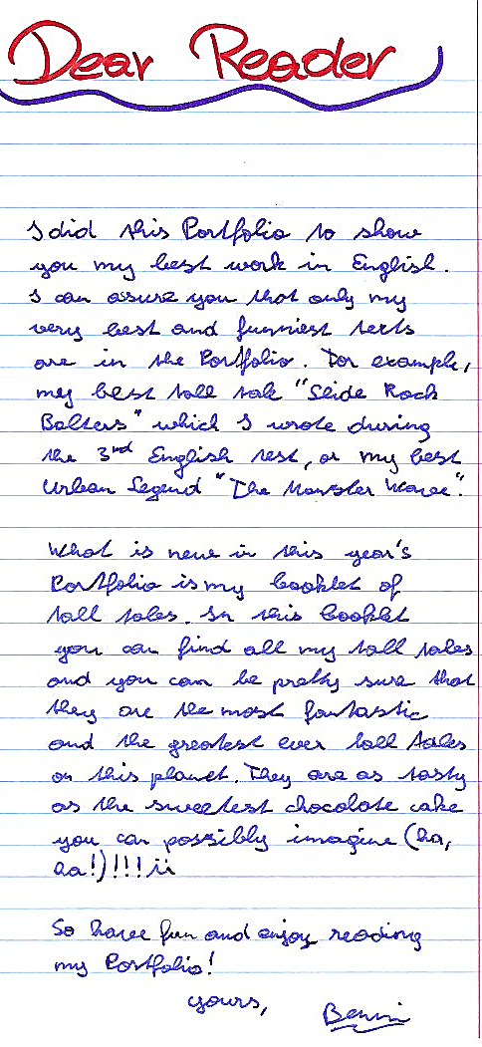
Letter to the Reader

The heart and soul of every portfolio is the letter to the reader, which usually follows the table of contents. In this letter the student states the portfolio purpose and reflects upon her development and learning process in the course of the semester or year. The letter to the reader is the first item we read, but it is the last item that the student writes. It can only be written after choosing the samples of work that exemplify the student's progress and achievements. In the letter to the reader the students reflect upon their special strengths and interests, the different teaching objectives of the class and their level of achievement, their growth and improvement in certain areas, factors that have contributed to this growth or have hindered them, their effort and motivation, their reading and writing preferences or problems... These letters focus on the students' meta-cognitive awareness of their own working strategies, habits and progress.
I have experienced that students who take time to reflect upon these aspects of their work develop a much stronger goal orientation and will be much more focused in the next semester. They see what has helped or hindered their development, they feel proud of their achievements or see the reasons for their bad results in certain areas. This awareness is the best starting point for future improvements.

Text Samples and Reasons for Choice

At the end of the semester or after a period of about 2-3 months students collect and discuss all the teaching objectives that the class has so far dealt with. We usually collect these goals in a brainstorming session and also discuss the criteria that show that a student has mastered a certain goal. Students have practiced self- and peer-evaluation in the course of the semester and should at this point have a clear understanding of quality criteria in different areas. This knowledge enables them to choose samples from their work that prove that they have reached certain goals.
In these portfolio sessions students are asked to bring all their past work to class.
In the course of the semester students have collected samples of their work such as stories, essays, letters, projects, poems, reading diaries, grammar work, error work, vocabulary work...

Using their lists of goals and objectives they go through their work and choose relevant examples. To make this process even more tangible let us look at a short list of objectives that my students came up with in their second year of English. We first brainstormed the objectives and topics and then discussed the criteria and ways to show these skills.
Topics and teaching objectives | Criteria and ways to show that I have reached this goal
writing a spooky story  spooky words | spooky setting where you can see, hear, feel with the characters,  use lots of spooky words  good motivation for the characters' actions (they must have a good reason to act as they do)  surprise ending
using the present perfect tense for experiences and achievements  and the past tense for past events | I could include some grammar exercises to show that I have learned the correct forms  I could include my text "What grade I have earned" or "My favorite star" to show that I can use the forms independently.
summarizing and paraphrasing information | I could include one of my magazine texts and copy a page from the sources that I have used. I can show how I have used my own words and how I have picked out the most important information.
giving constructive feedback | criteria: have my comments helped my friend improve his/her text?  I could include a feedback sheet that I wrote for a friend and ask her whether this was helpful
time-management | I cannot prove this in my portfolio but I can write a reflection about our magazine work. Did we always have our texts ready at the deadlines, how did we cope with time problems?...

This is only a short extract of possible goals and criteria. The list will always depend on the age and level of the students and the main focus of the teacher.
Usually it is fairly difficult for students to narrow down the number of samples. Especially eager, highly motivated students want to include too many pieces. I usually limit the samples to about five and explain that students can use one and the same sample to showcase different qualities. They can, for example, include a story and show different story writing skills such as good vocabulary, good description of the setting, lively characters, correct use of the past tense (simple and progressive), good revising and text improvement strategies (by including the drafts, peer-comments and final version)... I do not recommend to use one text for too many purposes, however. Students usually focus on one to three skills or teaching objectives in one sample.

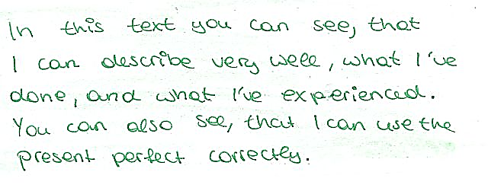
Reflections about each piece

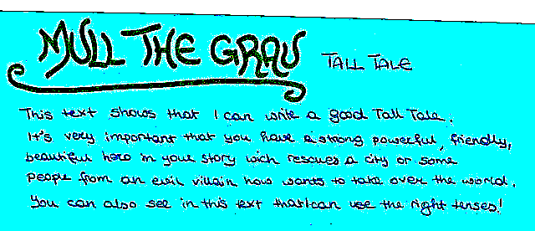
After choosing a sample students write a "Reason for choice" or "Reflection" explaining why they have chosen the piece and what they want to show with it.
These reflections (including the letter to the reader) are the key and most essential "ingredients" of a portfolio. They distinguish a portfolio from a writing folder or a collection of the best pieces of a year. It is these reflections that make portfolio work so effective in fostering motivation, pride and awareness of one's own strengths and weaknesses.
Let me warn you of two very common mistakes of teachers who begin to introduce portfolios in their classes: One common error is to leave out or reduce the importance of reflections. Meta-cognitive skills are usually not very well developed in classes and need some practice and training to develop. It will usually take one or two portfolio rounds until the majority of students have mastered this skill at an age-appropriate level. It will also depend on the teacher's experience in this area. I have noticed that my present students pick up these skills much faster than the students I taught four years ago. My own understanding and awareness in this area has grown and I have learned to communicate these more effectively. Even very simple and basic reflections can be very helpful for the students. Their awareness will grow rapidly with a little experience.
The second very common error is to define the portfolio contents for the students in too much detail. (e.g.: Your portfolio must include: ...) Students will repeatedly ask you what they should include. Answering this question for them is taking away their chance to become active and aware of their goals and learning process. It is another trap that would reduce portfolios to mere inventories or writing folders. The process of selecting the right samples is one of the most important parts of portfolio work.

Portfolio Assessment
There are several ways of assessing portfolios. One common way is to evaluate the portfolio as such and include this evaluation in the calculation of the final grade (next to test grades, class participation, homework etc). This is a safe way for teachers who are starting to work with portfolios.

After several years of portfolio experience I started to experiment with a more comprehensive, goal-oriented form of assessment. If the student's aim in the portfolio is to prove her level of achievement with respect to certain teaching objectives, then this information should be used more directly for final assessment. The assessment table below includes both, the portfolio and other information I have collected about a student's performance. Let me explain the assessment process in more detail:

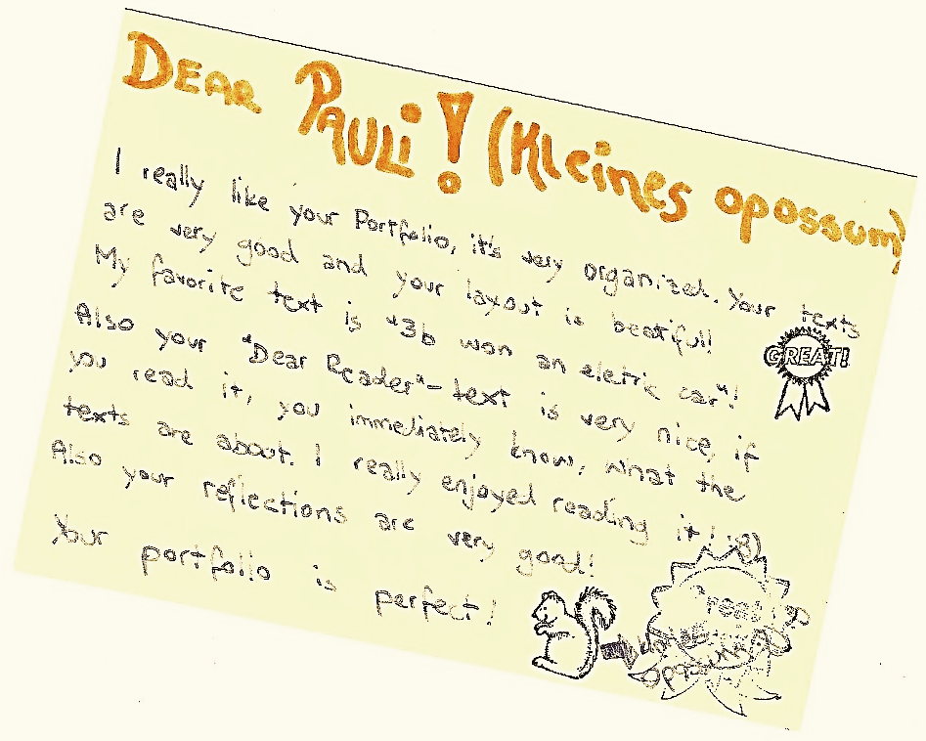
1. Peer evaluation
At the end of the semester students bring their finished portfolios to class. We spend two hours (one double period) reviewing and assessing portfolios in groups. Students work in groups of three (they choose classmates they trust but are encouraged not to work with their best friends) and quietly read each other's portfolios. Younger students are given peer reflection forms with the following cues:
- My favorite part of your portfolio is... because...
- I notice you are good at...
- I notice one of your weaker points is...
- I suggest you...
- Moreover I'd like to tell you...
As mentioned before, giving feedback is an art that students have to learn. Cues like these help the students to give constructive feedback rather than negative comments or meaningless praise. We discuss that feedback is meant to help the writer to improve her performance. Most students pick up this notion very quickly and give very helpful tips for improvement.
If I see that students find many little flaws in each other's portfolios and are highly motivated to correct them I give them an extra day to revise their work before handing in the portfolios.

Students who have had more experience in giving feedback and assessing portfolios do not need any peer reflection forms. They write long letters to their friends discussing the different aspects of the portfolios. These feedback letters very often cover exactly the same areas the teacher would have commented upon. Due to the fact that fellow students do not give grades, these comments are usually accepted more easily than the teacher's comments that are inevitably linked to the idea of marks.

2. Self evaluation
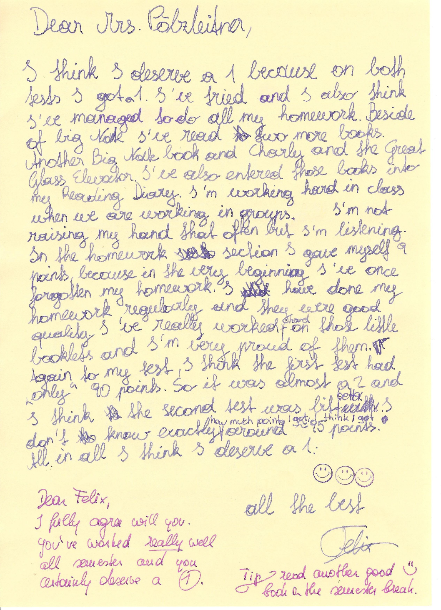
Finally students fill in a copy of the assessment sheet for the semester. This sheet includes both the portfolio and other work they have done during the semester. Students have received a copy of the assessment criteria at the beginning of the year and have been reminded of the different categories and goals at several times during the semester. Tests do not appear as an extra category on this sheet, they are seen as examples of written work where students prove that they have reached certain goals. Oral and listening skills make up a fairly small part of the final grade. This is typical of our bilingual school where oral skills are obviously very good and do not need as much structured practice as in regular language classes.
Students include their self-assessment in the back of the portfolios. They color the number of columns on the right and thus get a very clear profile of their strengths and weaknesses. Many students also write short comments (reasons for good or bad performance, likes, dislikes, resolutions for next term...) in the content boxes on the left.

3. Assessment by the teacher
In my final assessment I look at each of the categories on the assessment sheet, keeping in mind the specific teaching objectives and goals of the class. I also include my notes on the students' performance during the semester (including tests, homework, project work, presentations, etc.) In order to make assessment transparent and understandable for the students I write short verbal comments for each category. After marking the level of achievement in the respective columns I compare my assessment with the student's self-assessment. Interestingly most students tend to be stricter on themselves than I am. In case of major disagreements I would discuss the matter and explain my view. Assessment will always have a washback effect on teaching and learning. If it is not fully understood and accepted by the students they will feel like victims rather than active partners in their own learning process.

Summary: Advantages of Portfolio-work
Let me conclude by summing up the major advantages of portfolio work:
- Students see their progress and take over responsibility for their learning
- Students are proud of their work (intrinsic motivation)
- Portfolios foster self-confidence
- By choosing relevant pieces and reflecting on their work students become aware of their strengths and weaknesses. This awareness makes further growth possible.
- Personal growth counts (not only the class norm)
- Correcting and revising become meaningful
- Parents and future employers learn more about the students strengths and abilities
- Portfolios make assessment transparent and encourage communication between student and teacher
- Dynamic skills can be shown and evaluated in portfolios
- Teachers become coaches in the learning process
- Portfolios encourage goal-oriented teaching
- Portfolios are very well suited for open teaching methods (independent study, project work...)

Portfolio Literature I can recommend:

Robert J. Tierney, Portfolio Assessment in the Reading-Writing Classroom, Christopher Gordon Publishers,1991
Allan A. De Fina, Portfolio Assessment, Getting Started, Scholastic Professional Books, 1992
Marjorie Frank, Using Writing Portfolios to Enhance Instruction and Assessment, Incentive Publications, 1994
Ilse Brunner, Elfriede Schmiedinger (Hg.), Portfolio: die Alternative für die Grundschulpraxis, Veritas
Ilse Brunner, Thomas Häcker, Felix Winter (Hg.), Das Handbuch Portfolioarbeit, Kallmeyer, 2006
Ilse Brunner, Elfriede Schmidinger, Leistungsbeurteilung in der Praxis, Der Einsatz von Portfolios im Unterricht der Sekundarstufe I, Veritas

Appendix: Assessment Scales
Assessment Scale for Lower School… …… Elisabeth Pölzleitner |  |  |  | 100 |  | 30
Task Achievement |  |  | and Organization | 30 |  | 10
Excellent to very good: |  |  | Considerable variety of ideas, all content points elaborated  Independent treatment of topic  Relevant to assigned topic  Valid ideas organized clearly | 30  29  28  27 |  | 10  9
Good: |  |  | Several valid ideas,  Most content points elaborated  Adequate treatment of topic ,  Relevant to assigned topic  Valid ideas organized clearly | 26  25  24 |  | 8
Average: |  |  | Some valid ideas  Some content points elaborated  Somewhat choppy but main ideas stand out | 23  22  21 |  | 7
Fair to Poor: |  |  | Limited variety of ideas  Hardly any content points elaborated  Choppy, loosely organized,  Main ideas not always clear | 20  19  18 |  | 6
Poor to very poor |  |  | Insufficient treatment of topic,  No content point elaborated  Non-fluent, ideas often confused or disconnected, lacks logical sequencing | 17  15  13  11-0 |  | 5  0
Range of |  |  | Grammar and Vocabulary | 35 |  | 10
Excellent to very good: |  |  | Wide range of appropriate vocabulary and structures  Ambitious attempts at complex language | 35  34  33  32 |  | 10  9
Good: |  |  | Good range of appropriate vocabulary and structures  Ambitious attempts at complex language | 32  31  30  29  28 |  | 8
Average: |  |  | Adequate range of structures and vocabulary | 27  26  25  24 |  | 7
Fair: |  |  | Limited range of vocabulary and structures | 23  22  21 |  | 6
Poor to very poor: |  |  | Narrow, inadequate range of structures and vocabulary | 20  18  16  14-0 |  | 5  0
Accuracy of |  |  | Grammar, Vocabulary and Spelling | 35 |  | 10
Excellent to very good: |  |  | Accurate word/idiom choice; confident handling of appropriate constructions; hardly any errors (in areas that have been taught) | 35  34  33  32 |  | 10  9
Good: |  |  | Language is generally accurate,  a few errors, mainly in areas that have not yet been taught | 32  31  30  29  28 |  | 8
Average: |  |  | Well-formed sentences; generally accurate expression; a number of errors may be present but they do not impede with communication | 27  26  25  24 |  | 7
Fair: |  |  | Frequent errors of vocabulary, grammar or spelling  Errors may obscure communication at times | 23  22  21 |  | 6
Poor to very poor: |  |  | Frequent errors distract the reader  Frequent errors obscure communication | 20  18  16-0 |  | 5  0
 | Assessment Scale for Written Work… …Elisabeth Pölzleitner and Lucy Bauer |  |  |  | 100 |  | 40
 | Task achievement |  |  |  | 30 |  | 10
 | Excellent to very good | All content points fully dealt with; wide range of ideas relevant to task  Meets text type requirements including specified length  Register and format consistently appropriate |  |  | 30  29  28  27 |  | 10  9
 | Good | All content points dealt with; ideas relevant to task  Some inconsistencies in text type requirements  Register and format on the whole appropriate |  |  | 26  25  24 |  | 8
 | Average | Most content points dealt with; sufficient valid ideas  Several inconsistencies in text type requirements  Reasonable, if not always successful, attempt made at appropriate register and format |  |  | 23  22  21 |  | 7
 | Fair to Poor | Some content points dealt with; few valid ideas and/or repetitive  Most content points mentioned; barely meets text type requirements  Attempts at appropriate R/F are unsuccessful or inconsistent |  |  | 20  19  18 |  | 6
 | Poor to very poor | Hardly any relevant content points dealt with  Hardly any or no valid ideas  Does not meet text type requirements |  |  | 17  15  13  11-6 |  | 5-0
 | Organization | and Cohesion |  |  | 20 |  | 10
 | Excellent to very good | Valid ideas organized effectively  Variety of appropriate linking devices |  |  | 20  19  18 |  | 10  9
 | Good | Valid ideas organized clearly  Suitable linking devices |  |  | 17  16 |  | 8
 | Average | Mainly valid ideas organized adequately  Some simple linking devices |  |  | 15  14 |  | 7
 | Fair to poor | Choppy; ideas organized inadequately  Communication or purpose of writing sometimes obscured; repetitive  Rare or incorrect use of linking devices |  |  | 13  12 |  | 6
 | Poor to very poor | Confusing; ideas disconnected; lacks logical sequencing  No appropriate linking devices |  |  | 11  10-4 |  | 5-0
 | Range of | Grammar and Vocabulary |  |  | 20 |  | 10
 | Excellent to very good | Wide range of appropriate vocabulary and structures to express valid ideas efficiently  Ambitious attempts at advanced, idiomatic language |  |  | 20  19  18 |  | 10  9
 | Good | Good range of appropriate vocabulary and structures  Ambitious attempts at advanced language |  |  | 17  16 |  | 8
 | Average | Moderate range of structures and vocabulary |  |  | 15  14 |  | 7
 | Fair | Limited range of vocabulary and structures; very simple  Evidence of direct translation; interference from mother tongue |  |  | 13  12 |  | 6
 | Poor to very poor | Inadequate range of structures and vocabulary  Lack of vocabulary obscures communication; essentially translation |  |  | 11  10-4 |  | 5-0
 | Accuracy of | Grammar, Vocabulary and Spelling |  |  | 30 |  | 10
 | Excellent to very good | Accurate word/idiom choice; confident handling of appropriate constructions to communicate efficiently and concisely  Hardly any errors |  |  | 30  29  28  27 |  | 10  9
 | Good | Language is generally accurate  Possibly some errors but errors do not impede communication  Demonstrates mastery of basic grammatical structures |  |  | 26  25  24 |  | 8
 | Average | Well-formed sentences; generally accurate expression  Possibly a number of errors but errors do not impede communication |  |  | 23  22  21 |  | 7
 | Fair | Frequent errors of vocabulary, grammar or spelling  Errors may obscure communication at times |  |  | 20  19  18 |  | 6
 | Poor to very poor | Frequent errors distract the reader  Frequent errors obscure communication |  |  | 17  15  13-6 |  | 5-0

Your Turn:

Unfortunately good ideas presented in seminars tend to get lost in everyday life very quickly. Let’s change this and put some of them into practice in the next few weeks.

- Which of the ideas that have been presented in this workshop would you like to try out with your students?

Class | Topic (in my schedule or my textbook) | Writing idea:

- Which of the above plans are you going to put into practice FIRST?
Make a quick outline of your project idea and share it with a partner in this room or in your school.
Topic:

My teaching objectives:

Methods:

Marjorie Frank, Using Writing Portfolios to Enhance Instruction and Assessment

