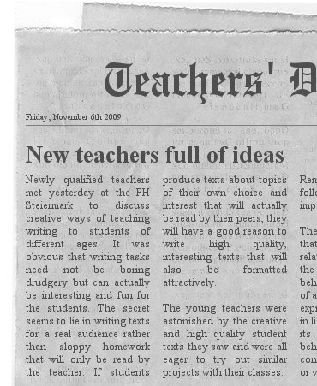

This page has been created with the Newspaper Clipping Image Generator

www.fodey.com/generators/newspaper/snippet.asp

Just fill in the dialog boxes for name of paper, date, title and the text, click GENERATE and copy the jpg file into your word-file.

