ICT and Web-tools for language teachers

Using web-tools actively

- For speaking (elevator speeches, interviews, radio shows...)
- For presenting a topic
- For brainstorming and sharing ideas
- To give the learners an audience (and therefore produce high quality work they will be proud of)
- To learn from each other
- To work independently
- To get immediate feedback

Why speaking to an audience is so efficient
Depth of processing
In order to speak about a topic and present it to the class learners must
- actively engage with the topic in order to understand it
- actively decide what is important and relevant for their presentation
- actively plan how to present it (outline)
- plan and prepare the necessary language (vocabulary)
- practice their presentation a few times – listen to themselves critically before posting their final version
- and in all these steps activate huge neural networks across their whole brains.

My favorite tools
Online books with Bookcreator.com


Audio tools
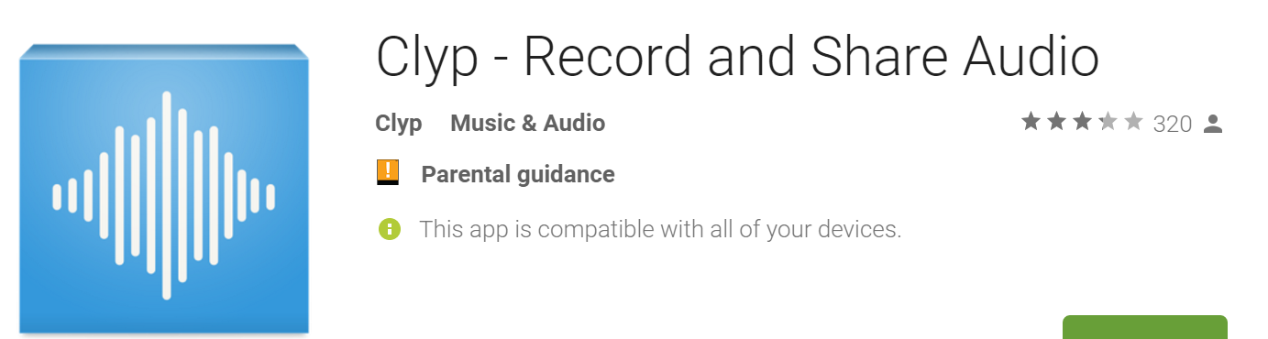


Use these for elevator speeches!!!
On phones:
  Then share via email or Moodle
Video tools

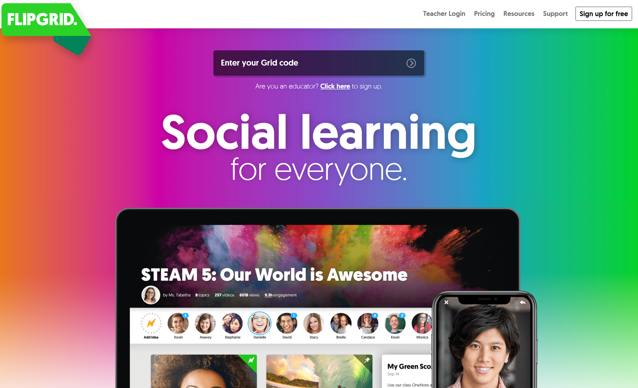



Find out more on these websites
www.liveworksheets.com

https://learningapps.org/

also try: H5P (on Moodle)

Stannard Russel’s Teacher training videos
http://www.teachertrainingvideos.com/

Lis Pölzleitner’s practical examples: epep.at – page: Web &ICT
http://epep.at/?page_id=2575

Brainstorming





Try these…
Padlet:  Your experience with web-tools | Answer Garden: A great English novel you would like to recommend | Tricider:  What do you think of Moodle? | Flipgrid:  Simple and effective | Using powerpoint to record your presentation
  https://padlet.com/lispolzleitner/bitr8efduej4 |   https://answergarden.ch/868495 |   http://www.tricider.com/brainstorming/2x7ejRwA0UV |   https://flipgrid.com/7336d8bf |   https://youtu.be/bHQPVpRkT-o
Learningapps:  Questions and answers: classroom phrases | Learningapps:  What will the weather be like? | Liveworksheets.com | My family  on liveworksheets.com | Readingiscool.xyz
  https://learningapps.org/watch?v=p8bszepkn17 |   https://learningapps.org/display?v=pnp999ctj19 |   https://www.liveworksheets.com/user/lispolzleitner |   https://www.liveworksheets.com/id/uy3487gn |   http://readingiscool.xyz

