ICT and Web-tools for language teachers

Using web-tools actively

- For speaking (elevator speeches, interviews, radio shows...)
- For presenting a topic
- For brainstorming and sharing ideas
- To give the learners an audience (and therefore produce high quality work they will be proud of)
- To learn from each other
- To work independently
- To get immediate feedback

Why speaking to an audience is so efficient
Depth of processing
In order to speak about a topic and present it to the class learners must
- actively engage with the topic in order to understand it
- actively decide what is important and relevant for their presentation
- actively plan how to present it (outline)
- plan and prepare the necessary language (vocabulary)
- practice their presentation a few times – listen to themselves critically before posting their final version
- and in all these steps activate huge neural networks across their whole brains.

My favorite tools
Screen casting tools



Audio tools
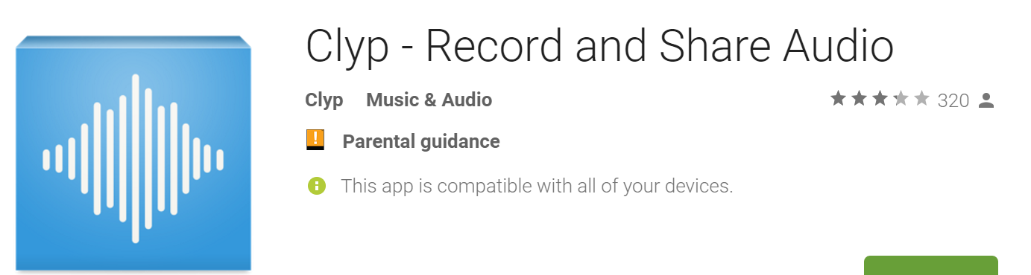


Use these for elevator speeches!!!
On phones:
  Then share via email or Moodle
Video tools

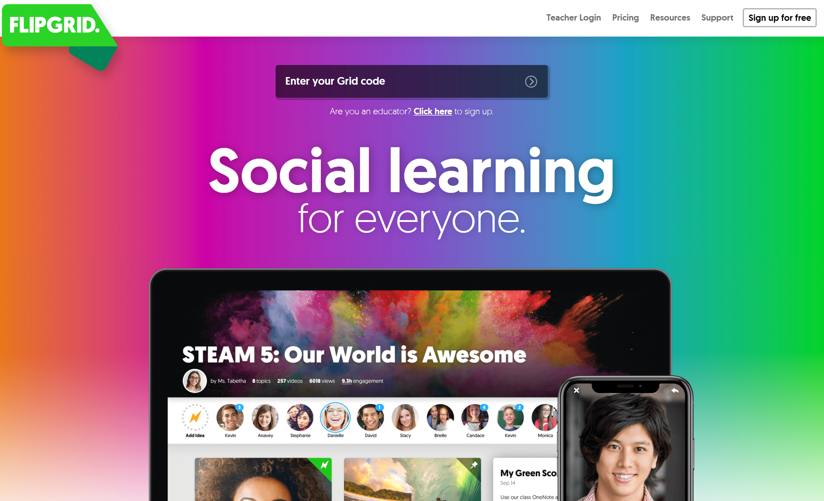



Find out more on these websites
www.liveworksheets.com

https://learningapps.org/

also try: H5P (on Moodle)

Stannard Russel’s Teacher training videos
http://www.teachertrainingvideos.com/

Lis Pölzleitner’s practical examples: epep.at – page: Web &ICT
http://epep.at/?page_id=2575

Brainstorming





