Planning brain-friendly tasks and activities
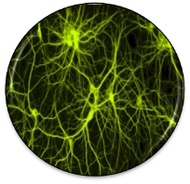 | - How am I going to activate my students‘ prior knowledge?
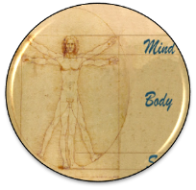 | - What am I going to do in order to create a positive, relaxed and challenging atmosphere?
 | - How can I engage the learners?  - Is the topic / text / task really interesting and relevant form my learners?  - How can I create some options or choices in order to cater for different learning preferences and multiple intelligences?
Speicherung | - How am I going to help the learners to proceduralize the new concepts?  - How can I activate episodic memory? (link to personal experiences)  - How can I create pictures in my learners‘ minds?
 | - How can I create opportunities for social interaction among the learners?
 | - How will the learners be able to see their own success and feel proud of their work?  - How will the learners present their products?
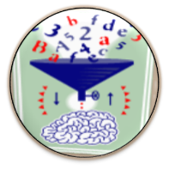 | - How am I going to create opportunities for hypothesis making?  - How am I going to prevent mindless application of the grammar rules given in the textbook?
 | - What examples of authentic communication am I going to present to my learners in order to support pattern building?  - What exercises will support pattern building?
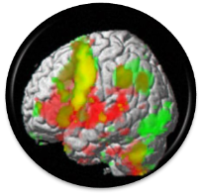 | - How can I activate different areas of my learners’ brains?
 | - How can I create opportunities for peripheral learning and unconscious learning?
©E. Pölzleitner Find examples of brain-friendly tasks on: http://www.epep.at
Planning Engaging Writing Tasks
 | - Is the task authentic? Do similar texts exist in the real world? In what context would the learners write such a text in real life?  - Is the task age-appropriate?
 | - What is the purpose of the text(s)?  - Who is the audience?
 | - Is the task challenging and does it require deep processing (world and language)?
 | - Does the task invite learners to make personal connections (interest, personal experiences)?
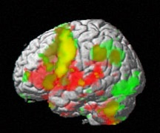 | - Does the task involve several skills, channels and several types of intelligence (M.I.)?
 | - Does the task invite creativity?
 | - Can the learners make some choices (content, topic, format/type of product)?
 | - Does the task lead to a product that the students can be proud of?
 | - Is the product shared with an audience (class, school, public)?
©E. Pölzleitner
Planning Efficient Vocabulary Activities
 | - Will the learners be making connections and associations to previous knowledge?
 | - Will the learners be making personal connections and associations to their episodic memory?
 | - Will the learners see any images (inner or outer)?
 | - Will the learners’ auditory systems be involved? Will they hear the words and phrases?
 | - Does the activity involve any movement (incl. speaking)?
 | - Does the activity involve the sense of touch or smell?
 | - Does the activity lead to a somatic response,  + emotion, – stress
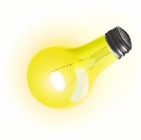 | - Is the task interesting and relevant for the learners? (Sense and Meaning)
 | - Does the activity involve any social interaction?
 | - Will the learners see their progress and experience a sense of achievement? (Dopamin shower)
 | Total:

Quick Check Grammar Chart |  | - |  | +
Learning Stages | Awareness raising
Learning Stages | Conceptualization and hpothesis building
Learning Stages | Proceduralization in scaffolded conditions
Learning Stages | Performance in real-time context
Pedagogical Principles and Communicative Criteria | Depth of processing and Complex encoding : Will the learners be mentally active and process grammar, lexis and their “world knowledge”?
Pedagogical Principles and Communicative Criteria | Commitment filter:  Will the learners’ cognitive and affective needs be met? (e.g.: curiosity, problem solving, enjoyment, fun, success)
Pedagogical Principles and Communicative Criteria | Peer and social learning and interaction:  Pair – or groupwork, sharing, oral activities, jigsaw activities…
Pedagogical Principles and Communicative Criteria | Personalisation:  Do the learners have the opportunity to draw on their personal experiences and express their own ideas?
Pedagogical Principles and Communicative Criteria | Contextualisation:  Is the exercise embedded in a clear communicative context?
Pedagogical Principles and Communicative Criteria | Authenticity of process:  Will the learners use language in natural, “language-like” ways (rather than manipulate forms)?
Pedagogical Principles and Communicative Criteria | Task-based:  Do the students fulfil a purposeful task that will have an outcome or end product?
Pedagogical Principles and Communicative Criteria | Testing versus teaching:  Does the exercise support learning or only test it?
This exercise supports learning processes… |  |  | 

