Developing Life-long Language Competences

Padlet: 

For practical parts pack / show
- manner mimes
- duration boardgames (+counters and dice)
- story flip flaps
- moebius strips
- passive pairs
- passive bricks
- our lives (past tense board)

Hands on (Fair) for writing
- Me books
- Booklets (topics)
- Storybooks (origami)
- Magazines

For READING
- Reading diaries
- Booklets (reading)

Online on epep

Writing for beginners:
- me books
- portfolios?

Intermediate Writing (and speaking)
- spooky stories
- magazines
- boolklet ideas --- quick overview – then do fair

Upper Intermediate Writing (and speaking)
- personification stories
- blog writing

READING (and presenting): show online overview,

Hands on (Fair)
- Reading Diaries
- Reading booklets
- Readingiscool

Speaking
- show speaking samples on epep web&ICT
- year 1 glogster on epep
- year 1 flexi glogster (on glogster)

- 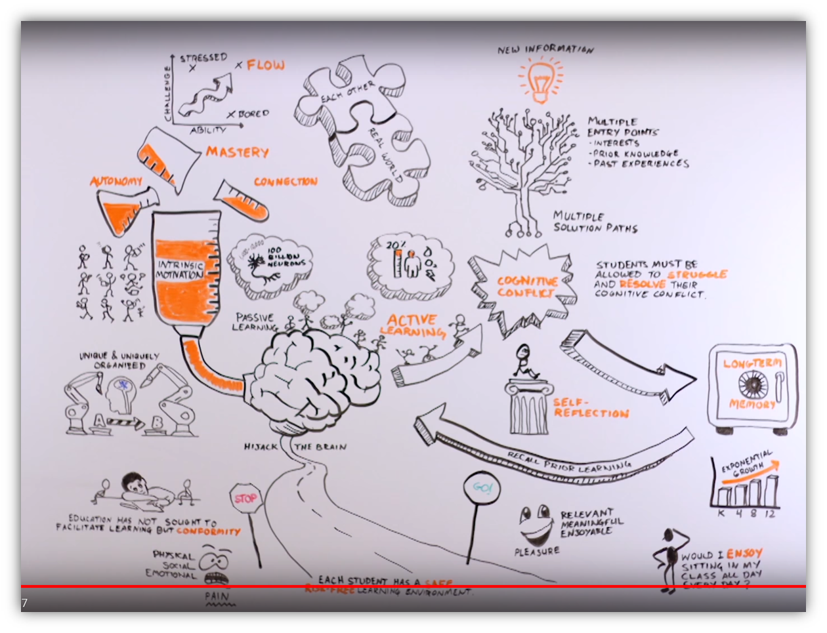
https://youtu.be/wlaG99awCD8?list=PLueQBcLj5TocErD0j9F51sISg4CfxmR9h

