www.epep.at
Offenes Lernen im Englischunterricht |
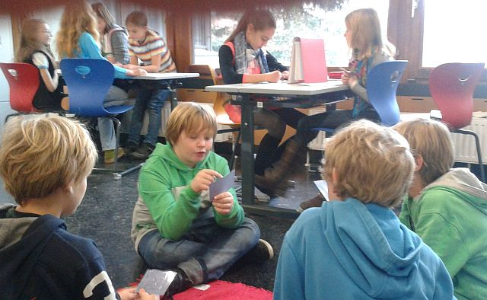
Dr. Elisabeth Pölzleitner | Self-directed Learning in the English Classroom

Self-directed Learning

in the English Classroom

14.30 – 16.00

Our starting point: 2
Who does what? 2
Falko Peschels Stufenmodell des Offenen Unterrichts 3
Our Goals 4
Skills and Competences described in the CEFR 4
How do we get there? 5
Using the Memory Efficiently 7
Networks of Meaning: 7
The ISM Model 7
Practical Examples 7
Sample Workshops 8
Learn more about useful workshop activities 11

Coffee Break: 16.00 - 16.30

16.30 -- 18.00

Making it Matter 12
That’s Me: 12
Me Books, online database entries… 12
Free Homework 12
Free Homework 12
Magazine Projects: Writing for an audience and a purpose 13
Developing and using text writing recipes 13
Recipe for a good magazine article 13
FIP: Format, Imagination and Pride 14
Appreciate students‘ work and effort 14
Diaries, Booklets, Databases 14
Open Reading Projects 15

Self-directed Learning in the English Classroom

Our starting point:

Who does what?
 | always the teacher | sometimes the students | often the students | always the students
Who chooses the topics?
Who chooses the activities?
Who prepares the materials?
Who decides when to stop an activity?
Who writes on the board?
Who operates the equipment?
Who selects the vocabulary?
Who checks the students' work?
Who explains the grammar?
Who writes the comprehension questions?
Who creates the silences?
Who gives dictations?
Who tells stories?
Who chooses the homework?
Who monitors the use of German in the classroom?
Who prepares the tests?

Why would you like to try self-directed learning? What is in your way?

Falko Peschels Stufenmodell des Offenen Unterrichts

In welchen Bereichen können Sie sich vorstellen, Ihren Unterricht zu öffnen?

 | Organisatorische Offenheit  Inwieweit können die Schüler Rahmenbedingungen ihrer Arbeit selbst bestimmen? | Methodische Offenheit  Inwieweit kann der Schüler seinem eigenen Lernweg folgen? | Inhaltliche Offenheit  Inwieweit kann der Schüler über seine Lerninhalte selbst bestimmen? | Soziale Offenheit  Inwieweit kann der Schüler in der Klasse Unterrichtsablauf, Regeln mitbestimmen? | Persönliche Offenheit  Inwieweit besteht zwischen Lehrer und Schüler bzw. Schüler und Mitschülern ein positives Beziehungsklima?
5 | Primär auf eigener Arbeitsorganisa-tion der Kinder basierender Unterricht | Primär auf „natürlicher“ Methode/ Eigenproduktion basierender Unterricht | Primär auf selbstgesteuertem/ interessengeleitetem Arbeiten basierender Unterricht | Selbstregierung der Klassengemein-schaft | Auf „Gleichberechti-gung“ abzielende „überschulische“ Beziehung
4 | Offene Rahmenvorgaben | Meist Zulassen eigener Zugangsweisen/ Lernwege der Kinder | Inhaltlich offene Vorgaben von Rahmenthemen oder Fachbereichen | Kinder können eigenverantwort-lich in wichtigen Bereichen mitbestimmen | Für Beachtung der Interessen des Einzelnen offene Beziehungs-struktur
3 | Öffnung der Rahmenvorgaben in einzelnen Teilbereichen | In Teilbereichen stärkerer Einbezug/ stärkeres Zulassen eigener Wege | In Teilbereichen stärkere Öffnung der inhaltlichen Vorgaben zu vorgegebener Form | Kinder können lehrergelenkt in Teilbereichen mitbestimmen | In bestimmten Teilbereichen/ bei bestimmten Kindern offenerer Umgang
2 | Punktuelle Öffnung der Rahmenvorgaben in einzelnen Teilbereichen | Kinderwege werden aufgegriffen, aber die Hinführung zum Normweg bestimmt das Geschehen | Kinder können aus festem Arrangement frei auswählen oder sie können Inhalte zu fest vorgegebenen Aufgaben selbst bestimmen | Schüler werden nur peripher gefragt, Lehrer weiß schon vorher, wie es laufen sollte; Kinder können in belanglosen Teilbereichen mitbestimmen | Schüler werden zeitweise angehört und dann auch beachtet
1 | Öffnung der Rahmenvorgaben kaum wahrnehmbar/ begründbar | Anhören einzelner Ideen der Kinder, aber der Lehrgang bestimmt das Geschehen | Einzelne inhaltliche Alternativen ohne große Abweichung werden zugelassen | Vorgabe von Verhaltensregeln durch Lehrer oder Schulvorgaben | Schüler werden angehört, aber der Lehrer bestimmt weiterhin das Geschehen
0 | Vorgabe von Arbeitstempo, - ort, -abfolge usw. durch Lehrer oder Material | Vorgaben von Lösungswegen/ -techniken durch den Lehrer oder Arbeitsmittel | Vorgaben von Arbeitsaufgaben /-inhalten durch Lehrer oder Arbeitsmittel | Lehrerzentrierte Vorgaben | Begründung der Beziehung durch Alter oder Rollen-/ Gruppenhierarchie
Vgl. Peschel 2002 aus: http://methodenpool.uni-koeln.de/unterricht/darstellung.html

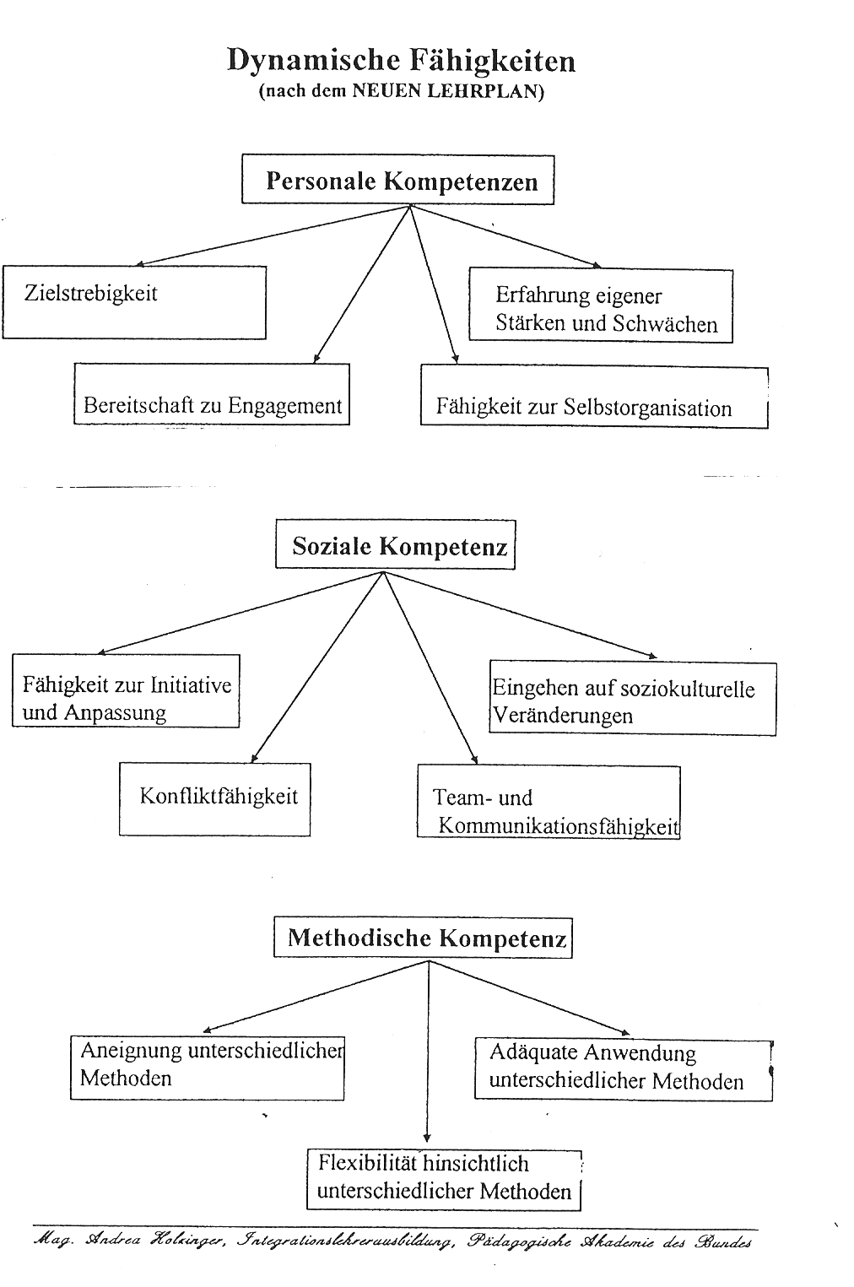
Our Goals
Preparing students for the world outside where they will need the following skills and competences:

Skills and Competences described in the CEFR
Allgemeine Kompetenzen | Declarative Knowledge  - Knowledge of the world  - Sociocultural knowledge Intercultural awareness  Skills and know-how (savoir-faire)  - Practical skills and know-how  - Intercultural skills and know-how  Existential competence (savoir-être)  - attitudes, motivations, values, beliefs, cognitive styles, personality factors  Ability to learn (savoir-apprendre)  - language and communication awareness  - general phonetic awareness and skills  - study skills  - heuristic skills (finding new info, using technologies…)
Kommunikative  Sprachkompetenzen | Linguistic competences  - lexical competence  - grammatical competence  - semantic competence  - phonological competence  - orthographic competence  Sociolinguistic competence  - linguistic markers of social relations  - politeness conventions  - expressions of folk wisdom  - register differences  - dialect and accent  Pragmatic competences  - discourse competence  - functional competence

How do we get there?


In recent years educators have explored links between classroom teaching and emerging theories about how people learn. Exciting discoveries in neuroscience and continued developments in cognitive psychology have presented new ways of thinking about the brain-the human neurological structure and the attendant perceptions and emotions that contribute to learning. Explanations of how the brain works have used metaphors that vary from the computer (an information processor, creating, storing, and manipulating data) to a jungle (a somewhat chaotic, layered world of interwoven, interdependent neurological connections).
Implications for Teaching

Recent Research Suggests | Teaching Suggestions
The brain performs many functions simultaneously. Learning is enhanced by a rich environment with a variety of stimuli. | Present content through a variety of teaching strategies, such as physical activities, individual learning times, group interactions, artistic variations, and musical interpretations to help orchestrate student experiences.
Learning engages the entire physiology. Physical development, personal comfort, and emotional state affect the ability to learn. | Be aware that children mature at different rates; chronological age may not reflect the student's readiness to learn.  Incorporate facets of health (stress management, nutrition, exercise) into the learning process.
The search for meaning is innate. The mind's natural curiosity can be engaged by complex and meaningful challenges. | Strive to present lessons and activities that arouse the mind's search for meaning.
The brain is designed to perceive and generate patterns. | Present information in context (real life science, thematic instruction) so the learner can identify patterns and connect with previous experiences.
Emotions and cognition cannot be separated. Emotions can be crucial to the storage and recall of information. | Help build a classroom environment that promotes positive attitudes among students and teachers and about their work.  Encourage students to be aware of their feelings and how the emotional climate affects their learning.
Every brain simultaneously perceives and creates parts and wholes. | Try to avoid isolating information from its context. This isolation makes learning more difficult.  Design activities that require full brain interaction and communication.
Learning involves both focused attention and peripheral perception. | Place materials (posters, art, bulletin boards, music) outside the learner's immediate focus to influence learning.  Be aware that the teacher's enthusiasm, modeling, and coaching present important signals about the value of what is being learned.
Learning always involves conscious and unconscious processes. | Use "hooks" or other motivational techniques to encourage personal connections.  Encourage "active processing" through reflection and metacognition to help students consciously review their learning.
We have at least two types of memory: spatial, which registers our daily experience, and rote learning, which deals with facts and skills in isolation. | Separating information and skills from prior experience forces the learner to depend on rote memory.  Try to avoid an emphasis on rote learning; it ignores the learner's personal side and probably interferes with subsequent development of understanding.
The brain understands best when facts and skills are embedded in natural spatial memory. | Use techniques that create or mimic real world experiences and use varied senses. Examples include demonstrations, projects, metaphor, and integration of content areas that embed ideas in genuine experience.
Learning is enhanced by challenge and inhibited by threat. | Try to create an atmosphere of "relaxed alertness" that is low in threat and high in challenge.
Each brain is unique. The brain's structure is actually changed by learning. | Use multifaceted teaching strategies to attract individual interests and let students express their auditory, visual, tactile, or emotional preferences.
Source: From "Understanding a Brain-Based Approach to Learning and Teaching" by R. N. Caine and G. Caine, October 1990, Educational Leadership, 48(2), pp. 66-70. Copyright 1990 by Association for Supervision and Curriculum Development (ASCD). Adapted by Southwest Educational Development Laboratory (SEDL

(Caine & Caine, 1990)


Using our Memory Efficiently

Networks of Meaning:

The ISM Model
According to Ahsen’s ISM model (Ahsen, 1984) our memory stores “multisensory images” consisting of Images, Somatic responses and Meanings (ISM). These three elements are constantly interacting and interlocking. In general it can be said, that what has been experienced personally is most memorable and will have the most visual and somatic elements attached, followed by richly imagined input, and lastly by input that has only been understood form words. (Stevick, 1996, S. 49)

Images:
- visual stimuli, things we have actually experienced
- mental images, things we have actively imagined
- imagery derived from descriptions in words
Somatic response:
- our body’s reaction to the sensory images (skeletal, muscular, endocrine changes…)
- may be very strong or fleeting and negligible, depending on the input
Meaning:
- includes the full spectrum including lexical meaning, expectations, involvements, purposes
- example: What does the word “bakery” include for you?

Practical Examples

The following tasks, activities and organizational arrangements can help learners use their brains efficiently to learn the new language.
After discussing and/or trying each of these tasks write down some of the advantages of each activity compared to lock-step and text-book teaching. Which of the principles of brain research do they follow?
How do these examples fit into Peschel’s dimensions of open-learning? Where would you place them?

Workshops

Free homework
and
Magazine Writing

Story Writing Projects

Reading Projects


Sample Workshops
Groups | Whole Class Tasks | Materials
 | Clothes BINGO
 | Who is Mr/Miss X? (describing people and clothes): Listen to your teacher’s description of Mr/Miss X. Who is she talking about?
 | The Clothes Auction Game  Use p. 6-7 to help you | p. 6,7  clothes pictures and paper slips
 | Workshop Tasks
 | Picture Crossword | p. 1
 | Practice Sheet: Describing People and Clothes | p. 2
 | The Wilson Gang and Three Faces: Follow the instructions of the worksheet. Underline all the new words on this sheet and write them on vocab cards. | p.3
 | Clothes: Match the clothes and jewellery with the parts of the body | p. 4
 | Describing People: Match the sentences with the pictures | p. 4
3-4 | Pairs: Play the cardgame and collect as many pairs as possible. | cardgame
pairs | Twins: Faces (Do this game after you have played PAIRS)  Work with a partner. One of you takes a twin-card A, the other one a twin-card B. Don’t show your card to your partner, it’s top secret. Findet heraus welches Gesicht verschieden ist, indem ihr abwechselnd die einzelnen Gesichter beschreibt. |   cardgame (big cards A and B)
4 | Find your family: Play the game in groups of 4. Read the instruction card. | cardgame
 | Making Dialogues: Use the cards to make a short dialogue. Copy the dialogue on a practice sheet. | dialogue cards
pairs | Chatroom: Have a short discussion with Ms Scofield.  Guessing teachers…
 | Who is it? Play the game with a partner. Use the materials carefully and put all the parts back into the box when you are finished. | Who is it?
 | Optional Tasks and Tasks for Bilingual Students
 | Partner Dictation: Work with a partner and practice dictation. Use one of the dictation cards from the box. Then switch roles. | dictation cards
For English speakers | Read: Tales of a Fourth Grade Nothing and work with the discussion prompt cards. | Book and discussion prompt cards.
Homework:
My Clothes: Write the phrases on p. 5 on vocab cards and practice them in your vocab scrapbook. | p. 5, vocab cards and voc- practice book
My favorite clothes: Write a text about your clothes for your portfolio. Use p. 5 as a model. Describe the clothes in detail and draw them. | p. 5 and portfolio
Study the clothes words on p. 6-7

GIBS School Uniform Contest  Design a school uniform for GIBS students. Draw a picture and write a text. Design uniforms for boys and girls. There is a small prize for the best design. | portfolio
Finish your workshop tasks if you haven’t finished yet.

Tasksheet 8
Whole Class | Materials
This or These | WS 1
Going to...: what are your plans? | WS 2
Peer-conferencing: ‘Meet X’… texts (from homework)
Read two of your friends’ texts and give them some tips how they could make the texts even better.
Workshop
Language Practice: Making Plans | WS 3
Holiday Plans: What are you going to do? | WS 4
The Little Mouse: Read the story to a friend or a teacher | WS 5
Grammar Practice: Simple Questions | WS 6
Reading Comprehension: Read about Rex’s daily routine and mark the statements T or F. | WS 7
Vocabulary Threes: Work in groups of three  Student A reads the first word on his/her card. Student B or C reads the definition, and then the word opposite. Continue till student A repeats his/her first word. When you have finished change cards, and do the exercise again. | Colored cards
Bookchats:
Read a picture book, design a page in your reading diary and chat about your book with your teacher or co-teacher.
Optional Tasks: Read another book and make an entry into your reading diary. Ask your teacher for little tasks.

Homework

Meet…  Find a colorful picture of a person and stick it on a sheet (or draw a picture if you prefer). Then write a rally long text (2 pages) about the person in your picture.  Describe his/her appearance (what he/she looks like),  describe the kind of clothes he/she likes wearing,  describe his/her house and his/her room,  say what he/she does during the week and at the weekend  say what he/she is going to do at Easter. | worksheet
After the peer-conference revise (überarbeiten) your “Meet…” text. Correct your little errors, use more interesting vocabulary, think of extra new ideas… Write the very best text you can for your portfolio. | worksheet and portfolio
Finish the workshop tasks if you didn’t finish in class.

Practice old and new vocabulary with your vocab box and your vocab practice-book. (Walk and Talk // Write and Check)  Hand in your vocab practice-book after Easter | Vocab box and vocab-practice book
Correct and Revise your texts “my house” and “my room”. Polish them up for your portfolio. | Portfolio
My Dream House:  Design the house of your dreams or write about the house you visited during our fantasy trip. Write a long, interesting text into your portfolio. Remember: you want to be proud of your work!!! | Portfolio

Learn more about useful workshop activities

 | Whole class activities | Materials
What is a workshop?
What are its advantages?
List a few things that you would do with the whole class.
Why would you do them with the whole class?

Workshop activities:
Try out all of the following games in small groups. Then take a minute and write down what you think are the teaching objectives behind each game. Take notes about the following questions:
- What are the goals of this game?
- What are the language requirements? (What do students need to know before this game?)
- What difficulties might students encounter?
- How could I use this game for my target group?
- Other comments you would like to discuss or questions you have about the game.
3-4 students | Pairs | Choose: What’s the time?  Describing Faces, or  Past Pairs
3-4 st. | Dominoes | Choose: What’s the time  or Finding the way
1-2 | Triangles: Put the little triangles together to make one big triangle with a double border on the outside. | House and Home  Furniture
2 (pairs) | Twins  Purple A5 cards. One of you takes card A, the other one card B. | Faces
3-4 | Snakes and Ladders | You need a board, a die, a question sheet or cards and counters
pairs or threes | Speed Matching | Choose:  Foods or  Winter Activities
Other Activities:
Browse the sample workshops and take notes of useful workshop tasks and activities.

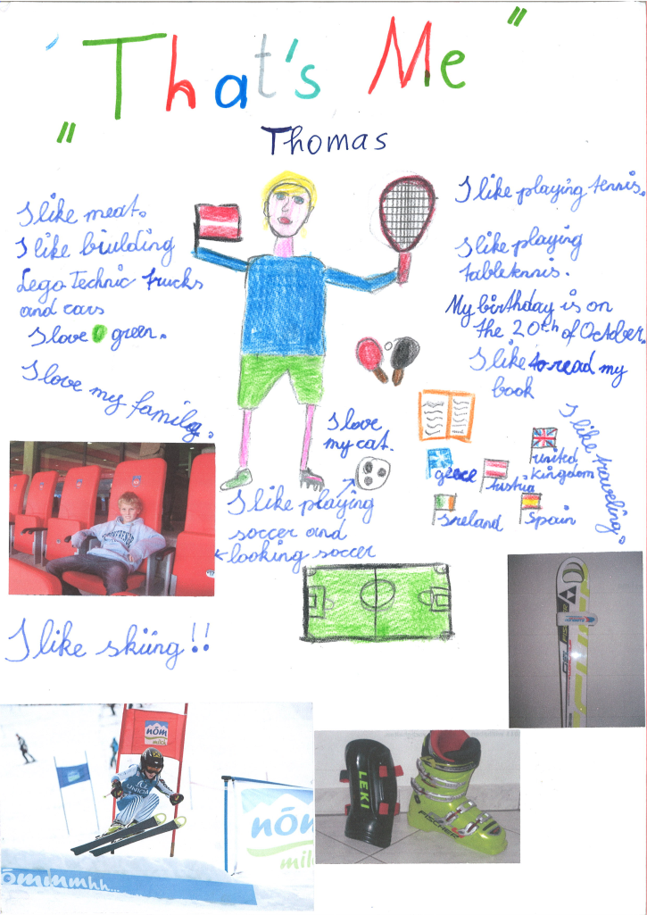
Making it Matter

That’s Me:

Me Books, online database entries…

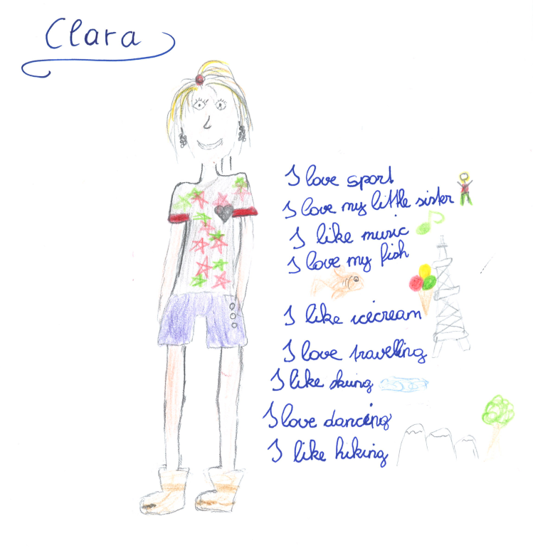

Free Homework

Free Homework

Schüler bestimmen selbst worüber sie schreiben wollen.
Vorteile: Eigenverantwortung wird gestärkt. Nicht das “blöde Thema” das der Lehrer aufgibt, sondern meine eigene Entscheidung worüber ich schreibe! Ich bestimme das Thema, die Form und die Länge! Ich bin für den Inhalt verantwortlich, ich schreibe über etwas Interessantes...
Unsere Erfahrung: Schüler sind stolz auf ihre “free homework”, diese Texte sind immer viel länger und sorgfältiger geschrieben als andere Hausübungen. Schüler präsentieren sich selbst damit!

Magazine Projects: Writing for an audience and a purpose

Developing and using text writing recipes

Recipe for a good magazine article

Schüler arbeiten in Kleingruppen (ca. 4) an regelmäßigen Ausgaben einer Zeitschrift.
1. Gruppen finden sich und bestimmen Namen des Magazins.
2. Gruppen bestimmen die Arbeitsverteilung und Teamrollen:
editor in chief (zuständig für Inhalt, Inhaltsverzeichnis und “editorial letter”
assistant editor (sammelt alle Beiträge und korrigiert die Sprache)
timekeeper (erinnert die Gruppe an Termine und Zeitplan)
chief layouter (erstellt die Titelseite, “bindet” die Zeitschrift und macht Feinschliff am Layout)

3. Gruppen erhalten Termine: Endtermin für Fertigstellung sowie 3-4 Termine (à 20-30 Minuten) für peer conferences und erstellen einen Zeitplan. Richtwert: Jeder Schüler schreibt drei Beiträge für eine Monatsausgabe. Die Schüler planen wer welche Beiträge übernehmen wird und bis wann diese fertig sein müssen. Die konkrete Schreibarbeit wird zu Hause (an Stelle von free homework) gemacht.

4. Conferences de pairs: In den peer conferences werden die jeweils fertigen Beiträge in der Gruppe kommentiert. Die Gruppenmitglieder machen Verbesserungs- und Korrekturvorschläge (vor allem auch inhaltlicher und struktueller Art). Die Arbeitsatmosphäre in der Gruppe soll positiv sein, es geht darum ein möglichst gutes, gemeinsames Produkt zu erstellen, nicht den Text des anderen schlecht zu machen. In diesem Rahmen gelingt positives feedback besonders gut. Die Schüler sind offen für Kritik.

Wichtig: Termine für diese conferences müssen klar angesagt werden damit auch wirklich alle Gruppen ihre Beiträge mitbringen! Wenn möglich alle Texte auf Computer!
5. Falls einzelne Gruppen mit den 3-4 conferences nicht auskommen, sind sie selbst dafür verantwortlich weitere Termine in Pausen oder nach der Schule (oder Telefon!) auszumachen...

6. Fertigstellung und Publikation: Die fertigen Magazines (am einfachsten in Plastikschnellheftern geheftet) werden in der Klasse präsentiert. Im Rahmen eines workshops (atelier) können die Schüler in den neuen Ausgaben lesen.
Oder: Lesetisch (nett gestalten) einrichten und Magazines dort auflegen.


FIP: Format, Imagination and Pride
Die Didaktik des leeren Blattes.

„Unser wichtigstes Arbeitsmaterial ist das weiße Blatt Papier, unseres Erachtens das
kreativste Material, das es gibt. Es stellt "wahrscheinlich die größte Herausforderung
an die Imagination der Kinder dar" stellt Peschel (1996, S.38) fest, nachdem er unsere
"Pädagogik des weißen Blattes" kennengelernt hatte. Das leere Blatt fordert oder
provoziert geradezu die kindliche Phantasie es zu füllen. Wie, das sagt ihm weder das
leere Blatt, noch sagen wir´s. Das Kind muss selber entscheiden und gestalten. Ein
Arbeitsergebnis ist zu dokumentieren, ein Sachthema zusammengefasst
darzustellen, um in ein gemeinsames Buch zu kommen. Welche Informationsquellen
benutzt werden und wie, überlassen wir vollständig dem Kind. (Zehnpfennig/Zehnpfennig
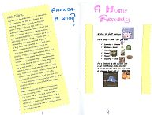
1992)“
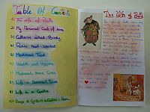

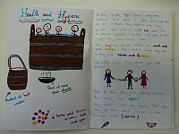

Appreciate students‘ work and effort

Diaries, Booklets, Databases

Have a look at the examples of students‘ work and appreciate their effort and motivation to create a perfect product.
Choose one of the booklets and write feedback to the student.
What do you like about the product?
What tips for improvement can you give the student?
Write 3-5 language tips.

Think of a class/topic/theme/unit where you could use this idea.

Open Reading Projects
Dos and don’ts for reading projects

Do… | Don’t…
Start offering books (picture books) as early as possible | Don’t wait until the class can read a book. Picture books will be understood even without the words.
Practice top-down reading strategies. Encourage learners to guess words from the context. | Don’t expect your students to understand every word.
Give your learners a lot of choice. They know best what interests them and what they understand without trouble. | Don’t do a class reader with the whole class. There is no book that will be right for everyone.
Organize reading groups (3-4 students who have read the same book)
Use challenging, open, real-life tasks where the learners must slip into the minds of the book-characters. | Don’t ask lots of “comprehension questions”. They are dead boring.
Ask the learners to choose a number of new vocab-phrases that they would like to remember. | Don’t ask learners to study long lists of words or to look up every unknown word in the dictionary.
Organize colorful, creative book presentations in groups
Encourage the students to produce different text types (diaries, letters, maps, postcards, newspaper articles) or to act our scenes, radio shows, interviews…songs, raps..)
Award reading and make it public
Organize regular mini book-presentations (3 min)
Introduce reading diaries (creative tasks rather than summaries)
Use Peschel’s idea of the blank sheet for reading projects. (Booklet making)

For more ideas and specific projects visit: http://epep.at Go to READING
