 |  |  |  | Number 1 – November 2007  Editor team  Julian Grünwald  Sven Kleinhapl  Felix Riesemann
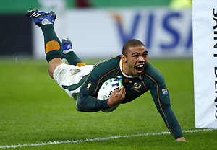 |  | Rugby World Cup 2007  Read all about rugby and the Rugby World Cup 2007 that took place in France this autumn.
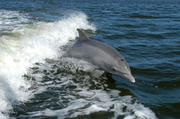  Dolphins  Our animal of the month is also the animal of the year 2007. | FIS Ski World Cup 2007/2008  Who are the favorits? Who won the first races in Sölden? 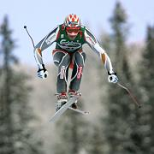 |  | 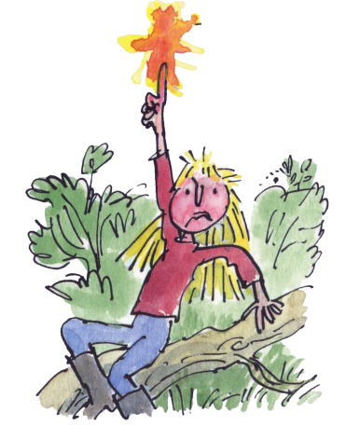  And also: a french recipe, a booktip, the date of the month and last but not least: jokes

