Page 9

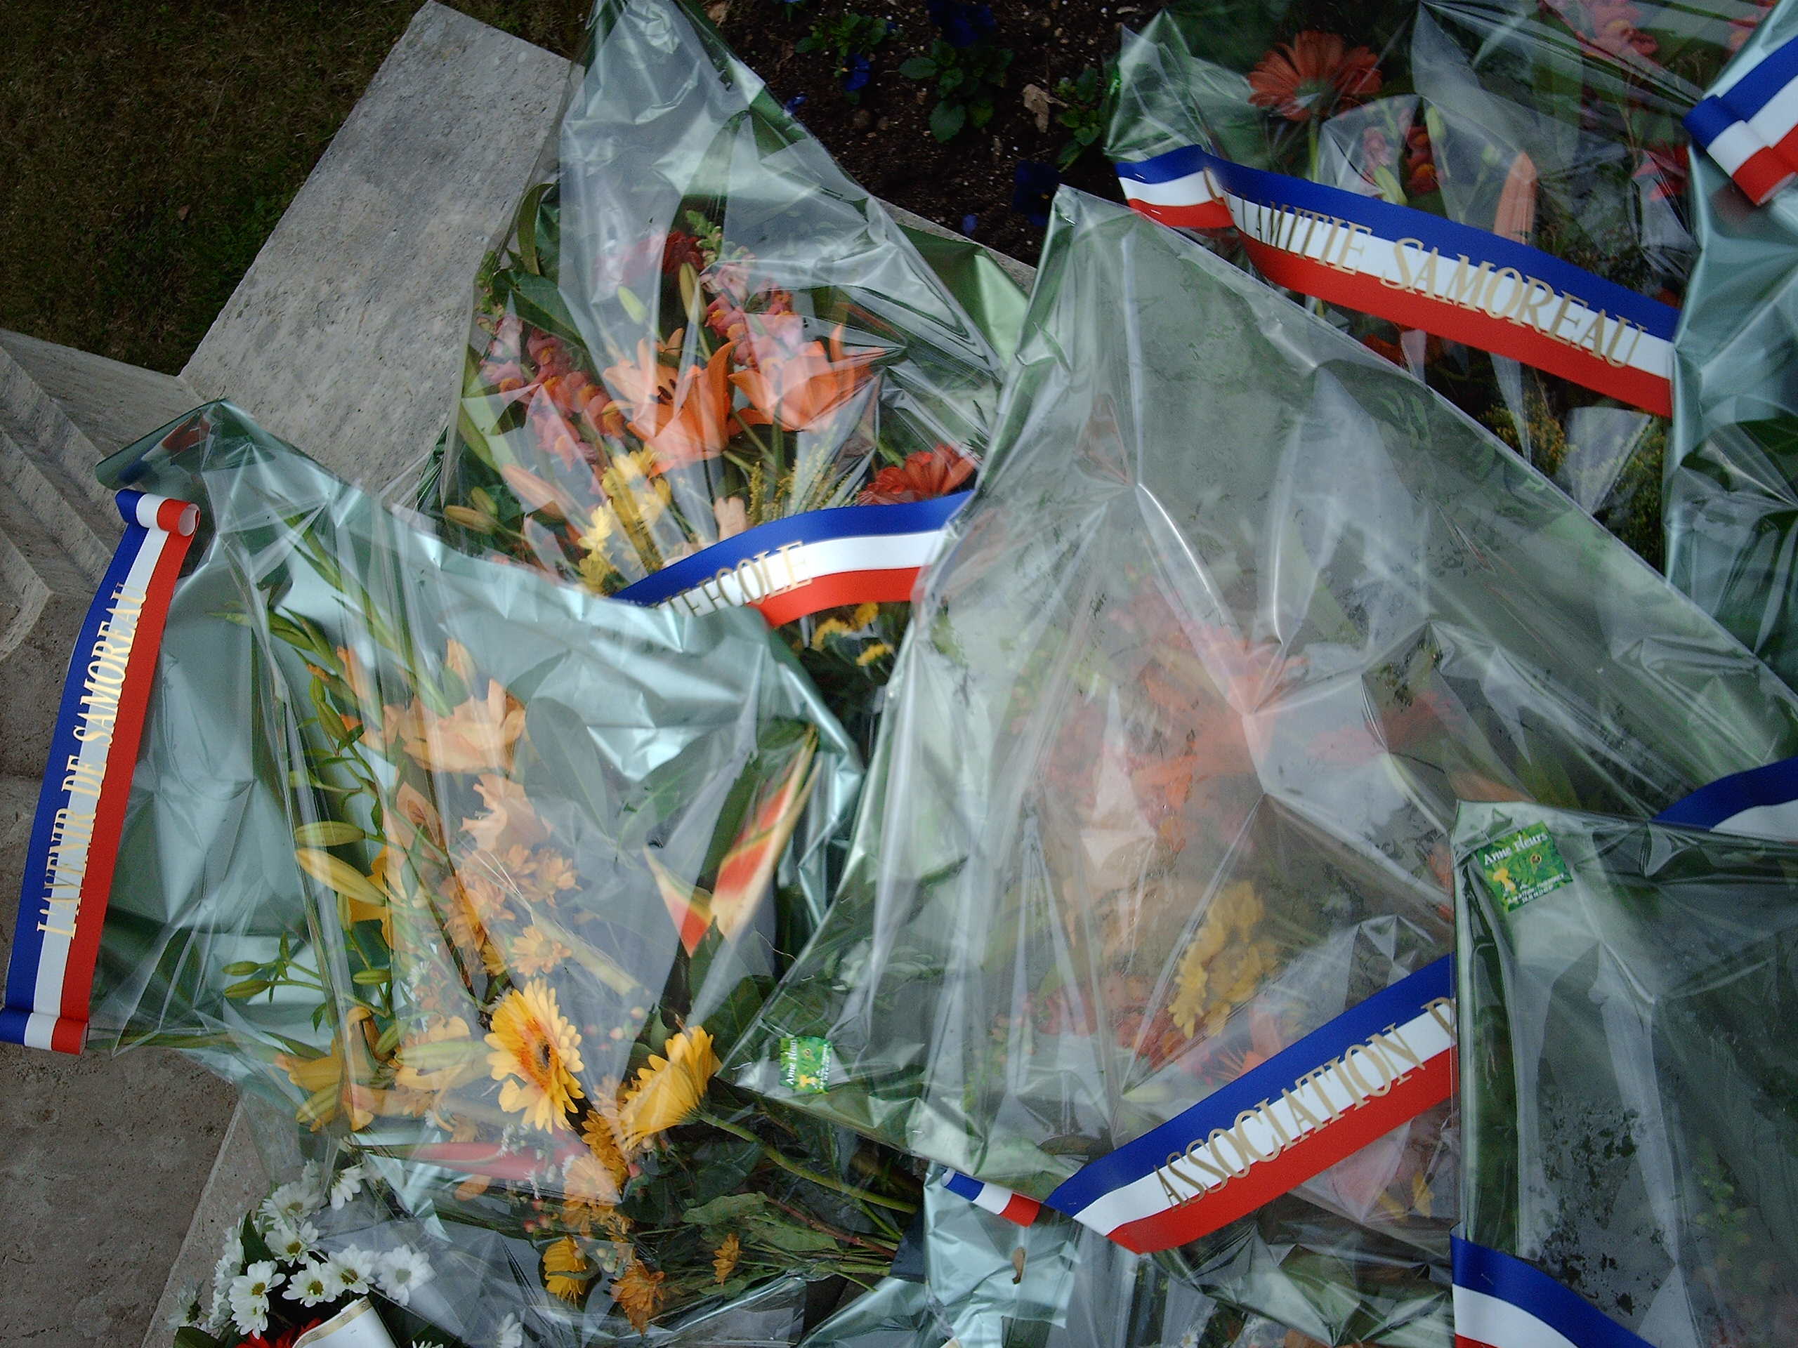
The 11th of November is a holiday in France. It is the end of the first world war (armistice - Waffenstillstand)1918.
1914: Germany and France startet the first world war: Then some countries helped Germany and some other countries helped France
1915: The first time that chemical weapons were used.
1917: The USA came and helped France and other countries against Germany and Austria.
1918: The end of the war. Ten million people died.
1919: The treaty of Versailles is signed. The German said “Diktat von Versailles” That's one reason for the second world war.
Our fotos were taken in a little town near Fontainbleau where our photo reporters live. (by Sven Kleinhapl)
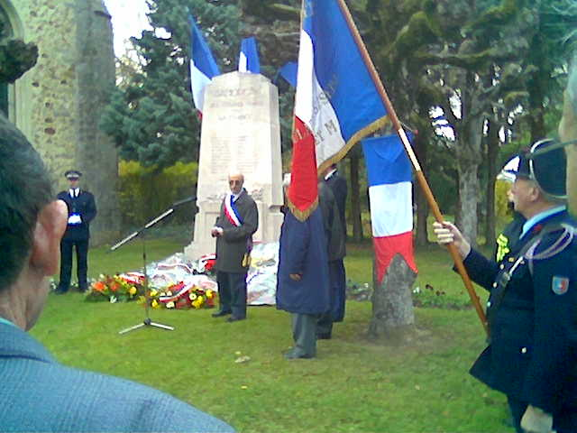
Date of the month
Recipe
Flammekueche
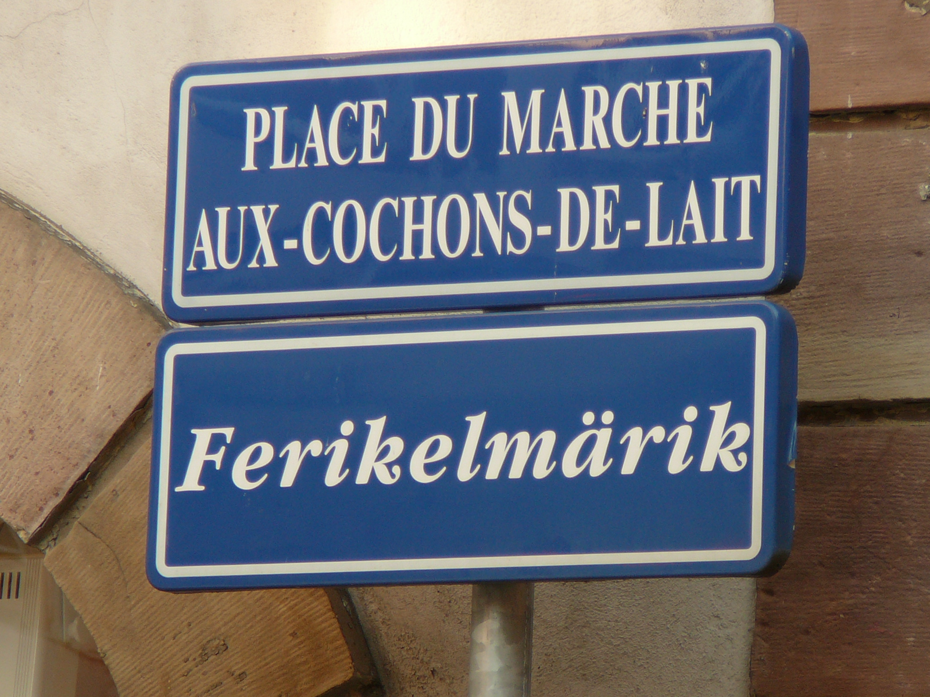
Alsace is in the NE of France. The neighboury country is Germany. They speak French and also have a German dialect. The main town is Strasbourg. Their speciality is „Flammekueche or tarte flammbée“.
Here is the recipe:
1 Pizza dough (Teig)
100g bacon stripes
1 ½ onions
20 cl créme fraîche
Roll the dough very thin. Mix créme fraîche, salt and pepper. Spread it over the pizza dough Top with onions and bacon stripes. Bake it for 15 minutes at the highest temperature possible. You can add cheese. – Bon appétit!
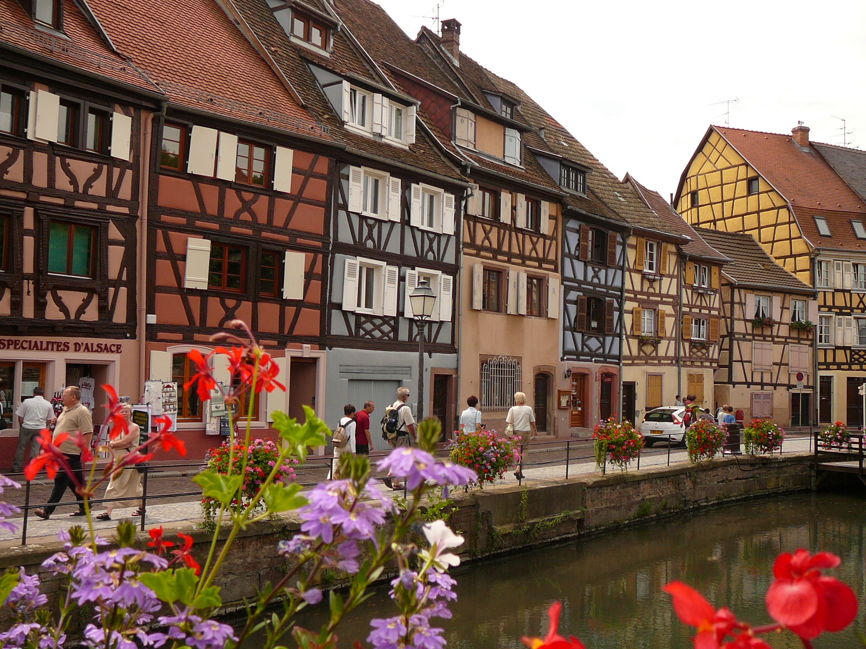
(by Sven Kleinhapl)

