Page 5

Senses:

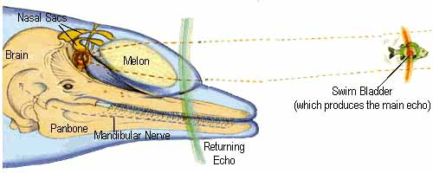
Dolphins have a cute (scharfe) eyesight and the sense of hearing is superior (überlegen) to that of humans. There is no sense of smelling, but they can taste and show preferences (Vorlieben) for certain kind of fish.

The Orca: 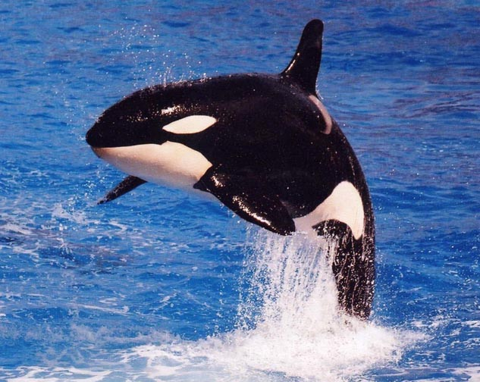
The Orca is the tallest kind of dolphin and he kills his prey cruelly (grausam). He crushes (zerquetscht) his prey, between his tounge and his palate (Gaumen), swallows the offal (Innereien) and spits out the skin.
Description:
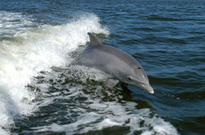
The dolphin is an aquatic mammal. He is a kind of toothed whale. The smallest dolphin, the Maui´s dolphin, is 1,2 meters long and weighs 40 kg. But the tallest dolphin, the Orca or Killer whale, can get 9,5 meters lond and weighs 10 tons. 2007 is the year of the dolphin. Dolphins can jumb 5 meters high out from the water and they are considered (werden angesehen) to be amongst the most intelligent animals.

Feeding:

Dolphins are carnivores. They feed on fish and squid.
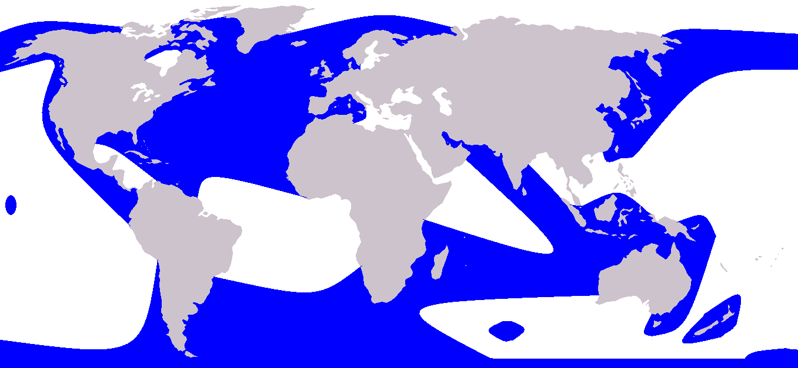
Blue : dolphins living space
DOLPHINS
by Felix Riesemann

