
Page 6
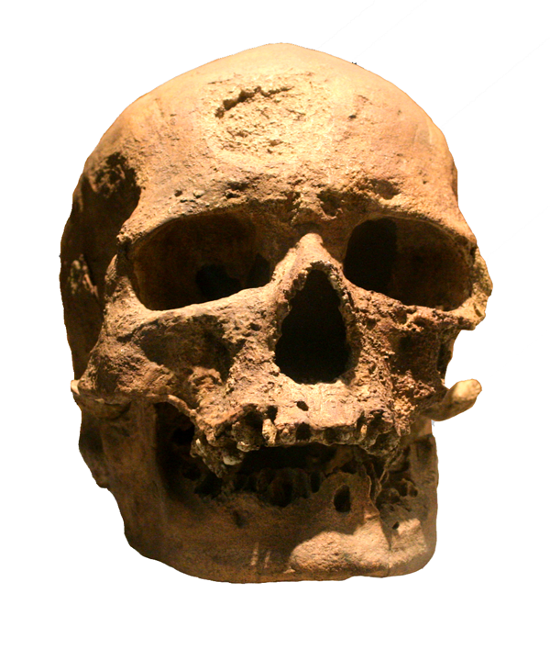
Each month we try to answer a question concerning science & nature. This time it's about the beginning of human beings.

Did you Know…?

Homo erectus 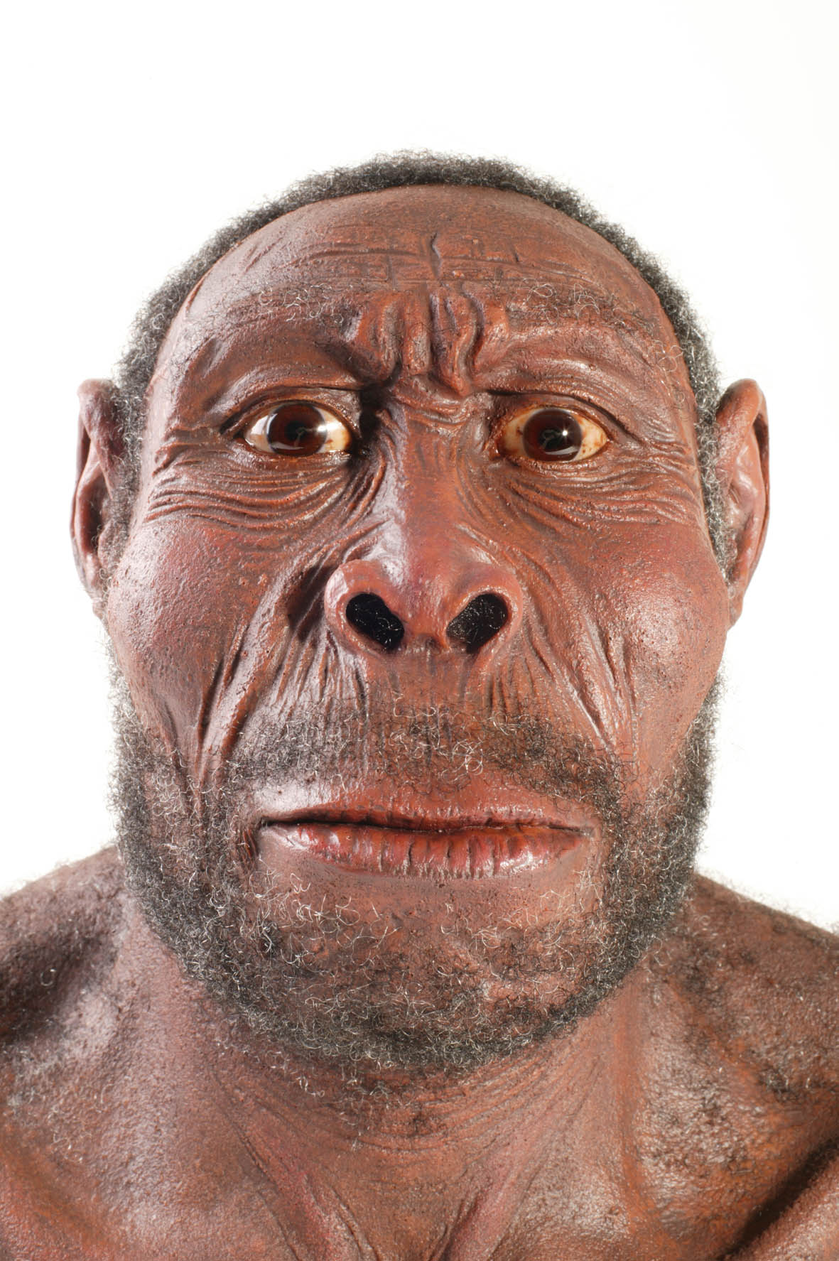
Homo erectus lived in Africa. He found out how to make fire and there are two types: 1. With a bow and a wooden stick. 2. He took two special stones.
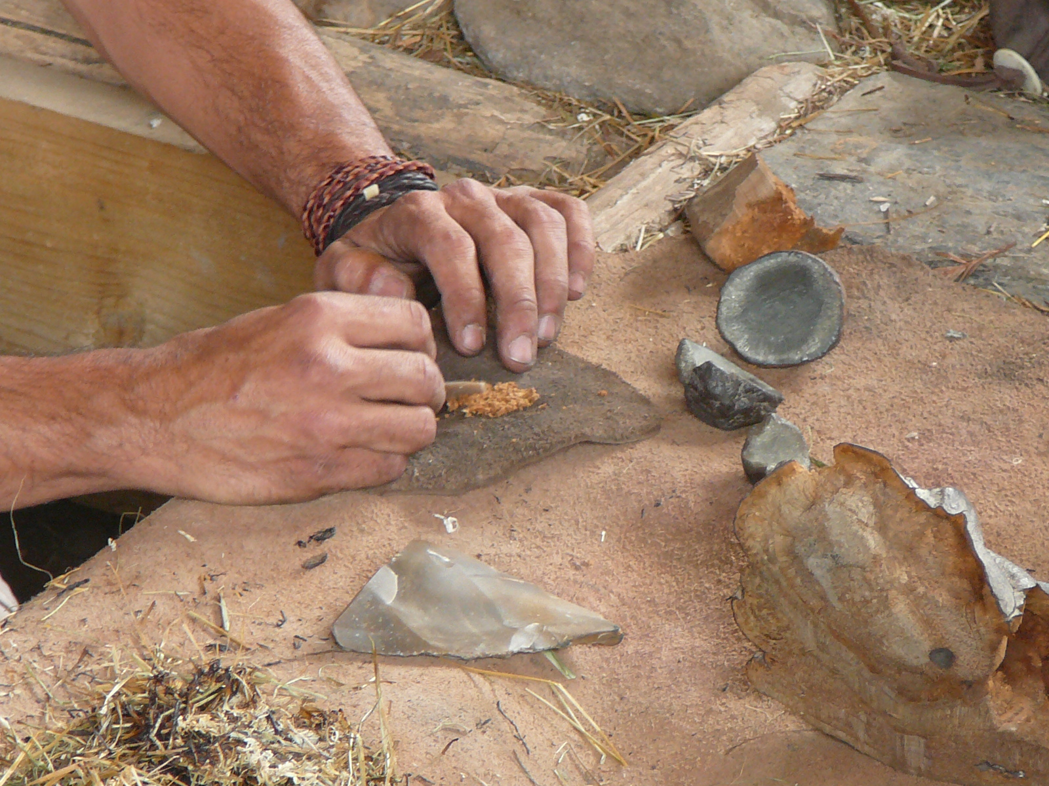 He lived in caves and ate fruits, plants, deers, mamoths, bears and fish.
Neanderthal man 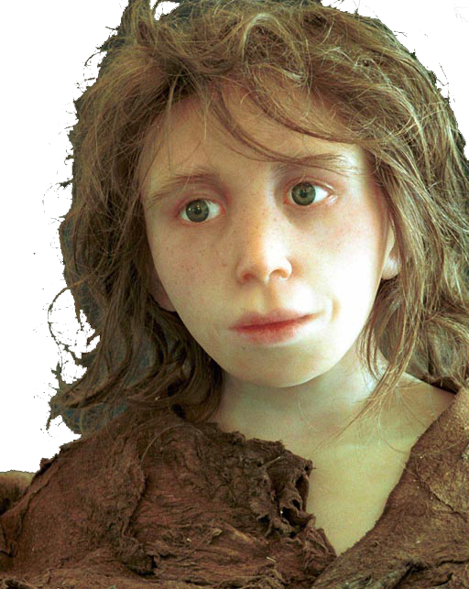
Lived in Europe and Asia. He ate fish, mamoths, bisons and deers. 30000 years later he dispared and 40000 years later Cro- Mango appared.

Cro-magnon
He lived approximately everywhere. He was an artist. He made the Venus of Willendorf. He invited the needle , the harpon and bow and arrow. He made houses out of bones and mamoth defenses (Stoßzähne). He painted the walls with horses, deers and bisons.
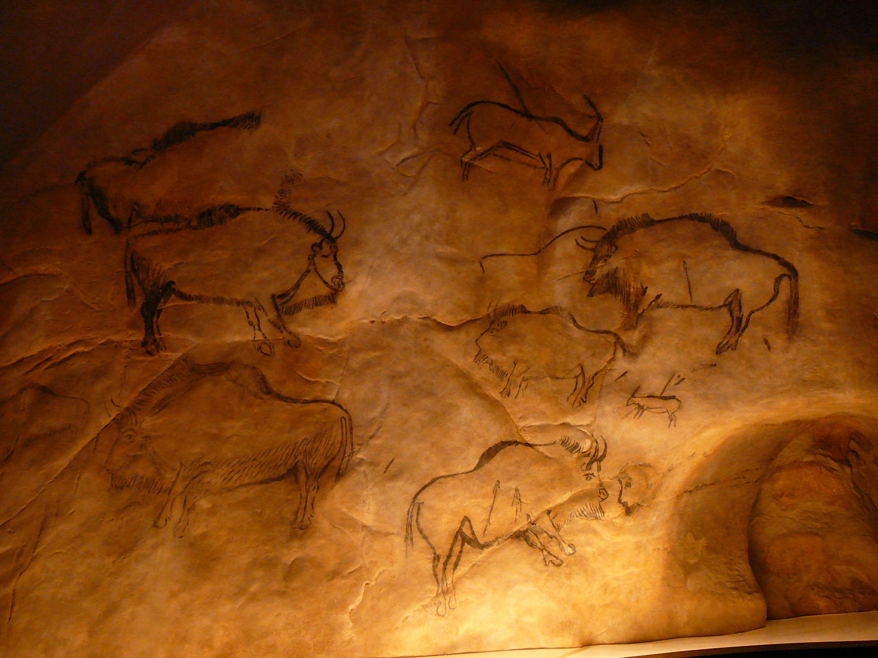 They were interested in music and made flutes (Flöten). He has a campment (Lager) near Paris.
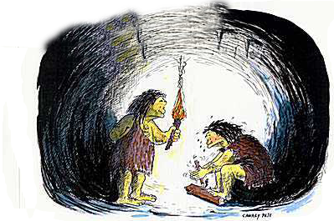
For the next magazine we need a new question. What do you want to know? – Send us your question to sven.klp@gmail.com and join a foto. Written by Sven Kleinhapl.

