

Page 12
“Dad can I read till I fall asleep?”, Sabine asks. “Okay, but no minute longer.”

Jokes
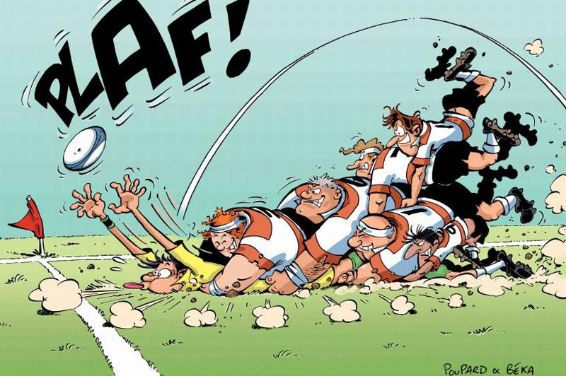
What do policemen and 500 Euros have in common? - If you need them they are not there.

“I don’t know who lives there, but they get a lot of letters.”
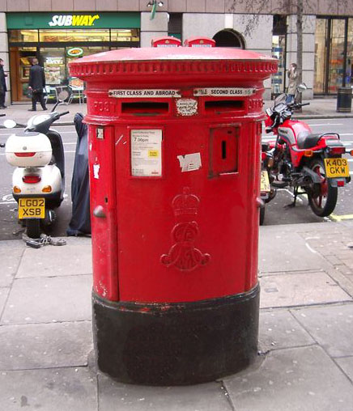

Why do we go to bed? Because the bed doesn´t come to us.
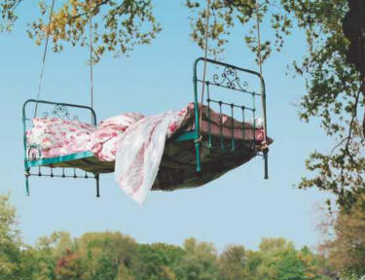

Test in Biology. On the desk there is a half covered up cage. Only the legs of the bird are visible. “How is this bird called?”, the teacher asks. “I don´t know!” “What´s your name?” “Guess!”, says the student and pulls up the trouser-legs.
