Page 3


There were many favorites this year. But the main favorites were Newzealand and Australia. In quaterfinal, France won against Newzealand and England won against Australia. In the halffinal, England won against France. Then England was the favorit.
Rugby is a brutal team ballsport. They play with an oval ball. The ball is resisting to the rain, the snow and the shocks when the players shoot the ball.
There are 15 players in a team. In each team there is a special player who is very good at shooting.
They can also make points. The highest number of points they can get with a “try”.
When a team would like to make a try, they must pass through the defense of the other

This year was the rugby world cup. It took place in France. There were ten stadions in France and two in England. There were 20 nations 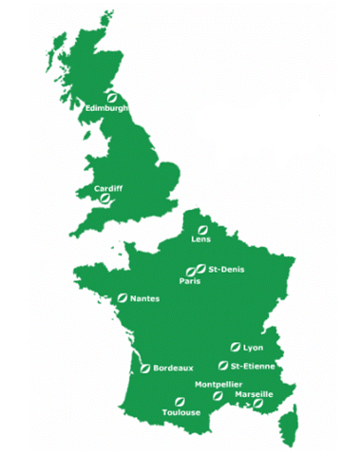 and 600 players and they played 84 matches. The final took place in Paris. The rugbymatches were played in soccer stadions.
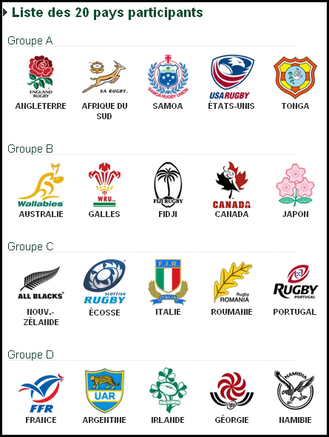

The Rugby World Cup

2007



by Sven Kleinhapl

