
Page 4

team and touch the floor behind the posts (the goal) with the ball. The team gets five points for a try. When a team made a try they can convert it. The “conversion” is a shoot wich is taken on the same line as the try. The conversion gives a team two points and the five points from the try when the ball flies through the posts. When the referee (Schiedsrichter) says that a team makes a foul, the other team gets a “penalty”. When they shoot the ball and he goes through the posts they get 3 points. Then there is another shoot. It is called “drop”: the player shoots through the posts and the team recieves 3 points.
When the referee says this player made a foul, often the players make a “scrum”. A scrum are eight players pushing against eight other players. Then a player (often the number 9) pushs the ball in the scrum and then the one team (often the team how pushes the ball in) gets the ball. The player always make fouls but not big fouls. The player passes to the player in front of him. That is a foul and they must built a scrum.
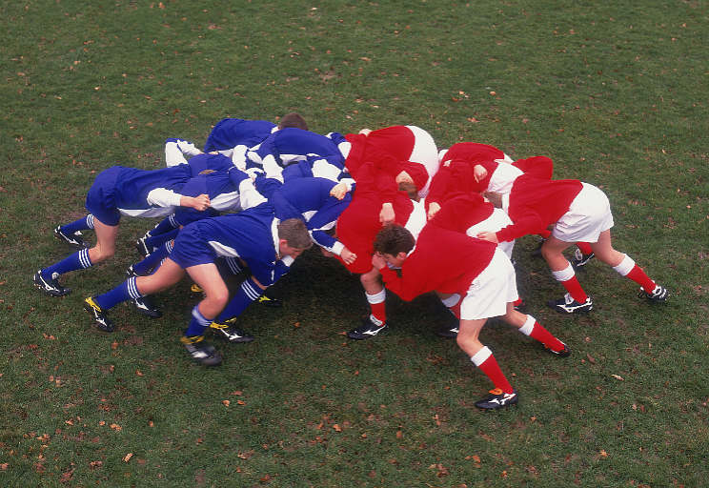
Or another foul is to hold a player who

does not touch the ball. Nambia and Tonga are the only team how got a red card. The USA got four yellow cards.
The team of Newzealand always starts with a haka. The haka is a traditional war 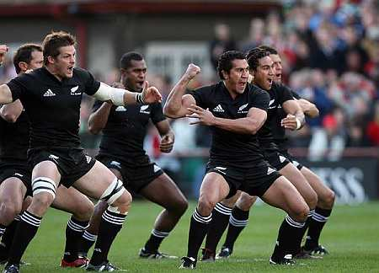 dance. It is also called Maori dance (see www.youtube.com search “haka”). They won the first rugby world cup.
The team of France won against Newzealand and lost against England in 2007 (both).
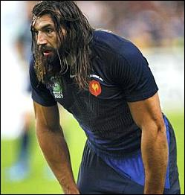
The best player of France was Chabal. He made ten points (two tries). He is 29 years old, 1,92m high and weighs 106 kg.
This year Southafrica won the final against England. The next rugby world cup is taking place in Newzealand in 2011 (4 years from now).

