FIS SKI WORLd cup 2007/2008
by Julian Grünwald
In the new ski worldcup season the main favorites (at the men) are Aksel Lund Svindal (NOR), Benni Raich (AUT) and Bode Miller (USA). All of them already won the ´big crystal ball´. The main favorites in the four disciplines (Disziplinen) are here:
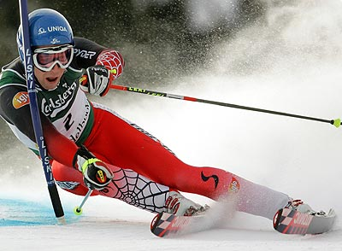
Benni Raich
Departure (Abfahrt): Didier Cuche (SUI), Bruno Kernen (SUI), Bode Miller and Michael Walchhofer (AUT).
SuperG: Aksel Lund Svindal, Christoph Gruber (AUT) and Hermann Maier (AUT).
Grand Slalom (Riesentorlauf): Aksel Lund Svindal, Masimilliano Blardone (ITA), Benni Raich and Kalle Palander (FIN).

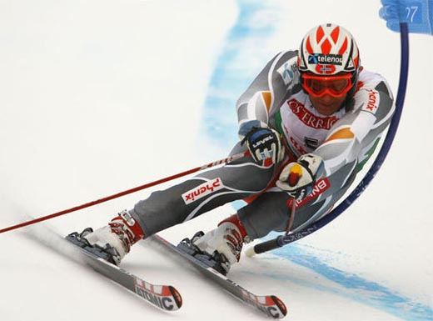
Aksel Lund Svindal
Slalom: Benni Raich, Mario Matt (AUT), Jens Byggmark (SWE), Giorgo Rocca (ITA) and Jean Baptist Grange (FRA).
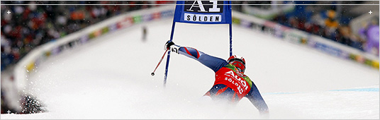
Sölden 2007
And here we have all results till now (men):
Grand Slalom (Riesentorlauf) in Sölden:
1.Aksel Lund Svindal NOR
2.Ted Ligety USA
3.Kalle Palander FIN
4.Benni Raich AUT
5.Bode Miller USA
more:
10.Matthias Lanzinger, 11.Mario Scheiber, 16.Rainer Schönfelder, 17.Mario Matt, 19.Christoph Gruber, 20.Hermann Maier (all AUT)
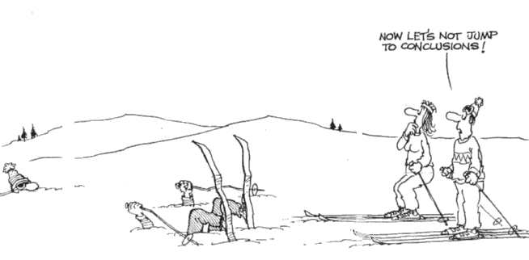
Slalom in Sölden:
1.Marc Gini SUI
2.Kalle Palander FIN
3.Manfed Mölgg ITA
4.Jean Baptist Grange FRA
5.Mario Matt AUT
more:
7.Benni Raich, 9.Rainer Schönfelder, 10.Manfred Pranger, 12.Daniel Koll, 17.Andreas Omminger, 23.Romed Baumann, 25.Rainfried Herbst (all AUT)
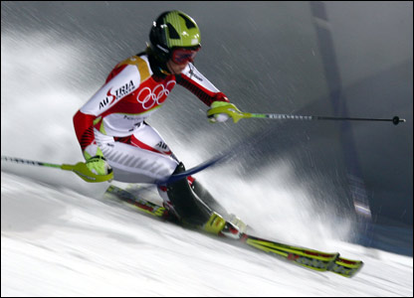
Nicole Hosp
The main favorites for the whole worldcup at the women are Nicole Hosp (AUT), Marlies Schild (AUT), Lindsey Kildow (USA) and Anja Pärson (SWE). Here there are the main favorites in the four disciplines:

Departure (Abfahrt): Lindsey Kildow, Renate Götschl (AUT) and Anja Pärson.
SuperG: Lindsey Kildow, Renate Götschl, Julia Mancuso (USA) and Anja Pärson.
Grand Slalom (Riesentorlauf): Denise Karbon (ITA), Julia Mancuso, Kathrin Zettel (AUT) and Nicole Hosp.
Slalom: Marlies Schild, Nicole Hosp, Zarka Zarobska (CZE) and Tanja Poutiainen (FIN)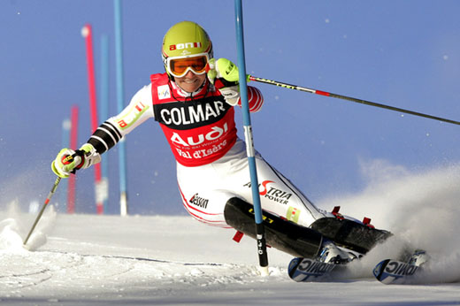
Marlies Schild
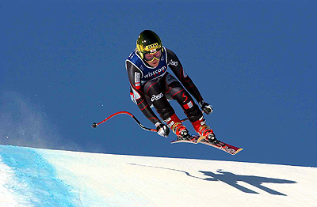
Renate Götschl
And here we have all results till now (women):
Grand Slalom (Riesentorlauf) in Sölden:
1.Denise Karbon ITA
2.Julia Mancuso USA
3.Kathrin Zettel AUT
4.Tanja Poutiainen FIN
5.Tessa Worley USA
more:
9.Elisabeth Görgl, 12.Nicole Hosp, 17.Alexandra Meissnitzer, 19.Marlies Schild, 24.Stefanie Köhle (all AUT)

Slalom in Sölden:
1.Marlies Schild AUT
2.Nicole Hosp AUT
3.Chiara Costazza ITA
4.Resi Stiegler USA
5.Veronica Zuzulova SVK
more:
17.Kathrin Zettel AUT

Legend: AUT-Austria, NOR-Norway, USA-USA, ITA-Italy, FIN-Finland, SVK-Slovakia, SWE-Sweden, FRA-France, CZE-Czech Republic

Page 7


