Page 8

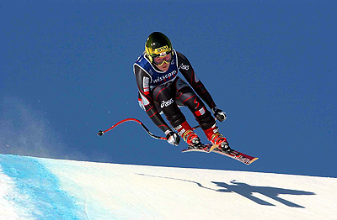
Renate Götschl
And here we have all results till now (women):
Grand Slalom (Riesentorlauf) in Sölden:
1.Denise Karbon ITA
2.Julia Mancuso USA
3.Kathrin Zettel AUT
4.Tanja Poutiainen FIN
5.Tessa Worley USA
more:
9.Elisabeth Görgl, 12.Nicole Hosp, 17.Alexandra Meissnitzer, 19.Marlies Schild, 24.Stefanie Köhle (all AUT)

Slalom in Sölden:
1.Marlies Schild AUT
2.Nicole Hosp AUT
3.Chiara Costazza ITA
4.Resi Stiegler USA
5.Veronica Zuzulova SVK
more:
17.Kathrin Zettel AUT

Legend: AUT-Austria, NOR-Norway, USA-USA, ITA-Italy, FIN-Finland, SVK-Slovakia, SWE-Sweden, FRA-France, CZE-Czech Republic

more:
7.Benni Raich, 9.Rainer Schönfelder, 10.Manfred Pranger, 12.Daniel Koll, 17.Andreas Omminger, 23.Romed Baumann, 25.Rainfried Herbst (all AUT)
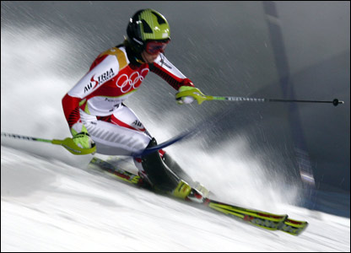
Nicole Hosp
The main favorites for the whole worldcup at the women are Nicole Hosp (AUT), Marlies Schild (AUT), Lindsey Kildow (USA) and Anja Pärson (SWE). Here there are the main favorites in the four disciplines:

Departure (Abfahrt): Lindsey Kildow, Renate Götschl (AUT) and Anja Pärson.
SuperG: Lindsey Kildow, Renate Götschl, Julia Mancuso (USA) and Anja Pärson.
Grand Slalom (Riesentorlauf): Denise Karbon (ITA), Julia Mancuso, Kathrin Zettel (AUT) and Nicole Hosp.
Slalom: Marlies Schild, Nicole Hosp, Zarka Zarobska (CZE) and Tanja Poutiainen (FIN)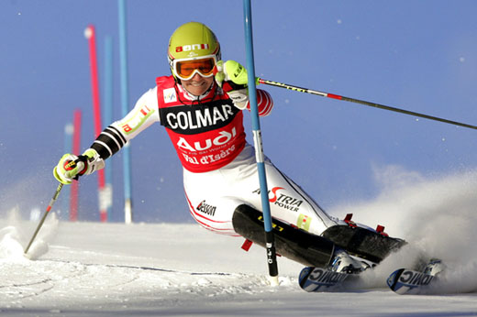
Marlies Schild

