Spooky Stories: October Year 2
These stories were written after a Halloween project where students collected lots of spooky vocabulary from stories they had read. They also worked on the past progressive tense for describing the background and circumstances in stories.

Use the assessment scale for lower school to grade these texts and put special emphasis on the feedback comments you write for the children.

Text 1: Sophie

The Skeleton

I was slowly going on the path to the graveyard. It was the last day of October, Halloween. The graveyard is the coolest place on Haloween. I was going to meat my friends there, it was the perfect place for a little meeting on the 31st of October. I was hearing leaves rustling, wind howling and twigs were breaking every step I went. Suddenly, a skeleton comes toward me. Not a dressed up childreen, a real skeleton like the one in our bigology lab. The bones knocks and it gave me a goose bumps, my knees felt like butter and my head turned hot and red. The bit light that were coming from an old latern made shadows on to the ground and this made the skeleton more spooky.
“Don't be so afraid,this is a dressed up friend”, I spoke against my fear. “Kill somebody to be a friend of main, or I will kill you!” Was this the voice of a skeleton? The spooky figure came with a knife, it wasn't a joke from my friends, this was a real skeleton and it really wanted to kill me.
I wanted to run for my life, you can't imagian how I feared but I didn't move. A icy shiver ran down my spine. Then, I know the answer. I had to bring the skeleton to the biology lap. It was really important, a life was on the game.
And then I ran like I will never run in my life again. But how can I go into the school? I had to go with the skeleton, it cut fly. “Go in here!” I said. And when I now saw into the biology lap, there were two skeletons. I don't know why.☺

A spooky Story
by Pauli
It was a dark night,k the wind was howling. Anna was walking in the graveyard along a trodden, winding path. There stood a little graveyardhouse the door opened with a rusty, heavy creak.
It made her hair stand up straight.
Anna walked in the little graveyardhouse and there was a growling dog with glaring eyes.
Anna shouted: “Aaa help!”
But what was that? The dog cries.
Anna laughed. “You are a nice dog but why do you cry?”
“ Aaaah my family is not here!” “I have to find my family.” said the dog.
“I saw winding paths in the trodden. I think a man has your family” said Anna.
“Please help me to find my family!”
“Yes, shure I help you.”
After two houers search they became tired.
Suddenly Paul (that's the name of the dog) and Anna haeard a scared laugheat: “Uaauhuhu”
I know that's enough, it's the laugh of my grandfather. Paul ran behind a big stone were the laugh came from. And behind the big stone were the hole family.

Friday the 13th
^{by Caro}
It was eleven o'clock and it was Friday the 13th. Sarah was alone at home, 'cause her parents were with their friends in the city. Sarah couldn't sleep.l Suddenly the telephone rings. She stands up and took the telephone. “Hello?” she said. “Hi Sarah!!” was the voice on the other end sying. “Do you want to sleep by me??”
“Of course, I'm coming!” Sarah answered. She took her jacket. The rain was beating against the window. Sarah took a step and then she was outside. She wondered why Sophie ask her so late!!
Sarah was going only 10 minutes to Sophie. The wind was howling, owls were hooting softly, and Sarah was walking alone along a trodden, winding path, as suddenly she heared a soft moaning. Sarah looked scared around. Suddenly she ran into something!! Sarah fell to the ground. Then she saw the thing she ran into. It was a ghost!! Sarah screamed loudly with fear. The ghost was screaming with fear. Both stopped. “Everything ok?” the ghost started.
“Yes, and you?” Sarah asked. The ghost nodded (nickte).
“What's your name?” he asked. “Sarah. And you?” Sarah answered. “I'm Caspar. I'm one of the youngest ghosts.”
“What? There are more of you?!?.”
“Of course. In this city are 1 thousand! At least!!”
“Oh my god!!” Sarah didn't believe that.
“The most of us have a party, there in this house” he pointed to a nice blue house.
“That's Sophie's house!” Sarah shouted. “I was on the way to her!!”
“Let's look” said the ghost. And so they went to Sophie.
“Ding Dong”. Sophie opened the door. “Hi, Sophie!!” said Sarah.
“I want to show you someone.” Caspar came to the front.
“Oh, welcome!” said Sophie.
Ten minutes later, Sarah and Casper were dancing in the living room, in sophie's house. “So. Tell me: why exactly today do you come with your friends?” Sarah asked.
Casper answered: “Because every year, on the 13th Friday all ghost celebrate it. I don't know why. I'm not so good in school. But I know, that they celebrate it only by children. It should be alone in a house not in the same like last year, and only from midnight till 7 o'clock, and he is in the sun, a ghost get's back!! This is for you like a sunburn” “Oh.” Sarah understood.
The funny group were dancing the whole night long. But at 6 o'clock thy have to go.
“Bye!” Sophie and Sarah were standing at the door. When the ghosts were gun, Sophie and Sarah go to bed and fell asleep.
The End
Lena's story

The last night of Isi and Susan

The wind was blowing last night. The leaves where rustling, the moon was shining. Susan and Isi where sleeping in their beds. Suddenly there was a sound in the garden. It was a horrible sound. Isi and Susan heard this sound. They where really afraid. The girls took the Decke and throught it over their backs. The sound gets louder and louder. Suddenly a monster look into the room where Isi and Susan are. The monster broke the wall of Isi's room. Now the monster comes into this room. Isi and Susan scream under the Decke, jumped out of their beds and crall under their beds. So the monster can't see the two girls. But the monster throught the bed out into the grass of the garden. He took the two girls and hold it up into the air. Now the monster ate the two girls. This was the last night of Isi and Susan.

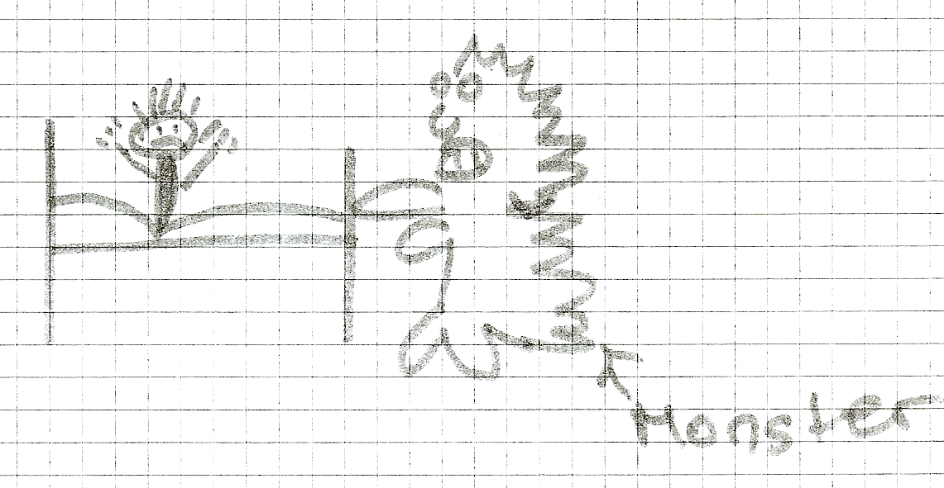
Ramina's story
D.D.D
Double Death Dreams

It was almost midnight and Mia's parents were sleeping. The only one who wasn't sleeping, was Mia. She was laying in her bed. But what did she do? Mia was shivering and shaking in her bed and couldn't move even not 1cm. Half a hour ago she was hearing voices. She almost believed on ghosts, which she normally found stupid. But at this night it wasn't stupid even not for Mia.
“Uuuuu! Grrrrr!” She heard again. Suddenly the light was gone and the room went pitch black. She wanted to take the candle to make light again, but she couldn't move from shiver and shake. But ahhhh! The light went on by itselves and Mia saw a shadow.
A knife, she tought. Then she saw a black man with a blody knife. He was coming closer and closer and suddenly...”Hehhhhh”, he made a wound on her belly and went on. “Ahhhh!” She screamed and woke up with the voice of her Mom. But the wound was still on Mia's belly. She cried, but nobody came to help her.
“Mia!!! Wake up! School!!!”
“Huhhh,” Mia said and saw that it was again a dream and tought: “Double Death Dreams!” and went happy to school.

